# Worksheet 6 Reverse Polish Notation Answers

# Task 1

1. Convert to Reverse Polish Notation by numbering: (e – f) + a^b * g

( e – f ) + a ^ b * g

1 3 2 9 4 6 5 8 7

e f – a b ^ g * +

1. Convert to Reverse Polish Notation by bracketing: g * (f + e) / h

g * ( f + e ) / h

( ( g * ( f + e ) ) / h )

( ( ( g ( f e + ) * ) h / )

g f e + * h /

1. Convert to Reverse Polish Notation by any method: 12 * v – 8 * v - 5

( ( 12 * v ) – ( 8 * v ) ) – 5

12 v * 8 v * - 5 -

1. Check your answer by bracketing

12 v * 8 v * - 5 -

( ( 12 v *) ( 8 v * ) - ) 5 - )

12 * v – 8 * v - 5

# Task 2

1. Create a binary tree for 6 * a * (~4 + 8 * a), with the second * at the root. (~ is unary minus)
   1. Show pre-order traversal (Polish Notation, prefix)
   2. Show in-order traversal (infix)
   3. Show post-order traversal (Reverse Polish Notation, post-fix)

Add brackets as required

(6 * a) * (-4 + (8 * a))

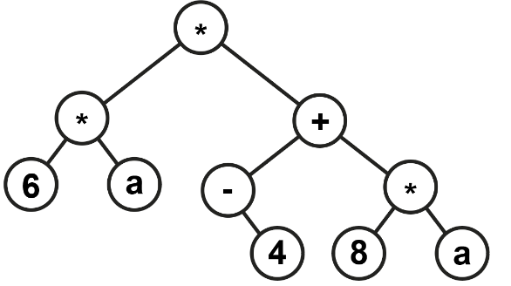

Pre-order traversal: * * 6 a + - 4 * 8 a

In-order traversal: 6 * a * - 4 + 8 * a

Post-order traversal: 6 a * 4 – 8 a * + *

# Task 3

6. Convert the following expression from RPN to infix using the scanning method.

b c * a c * - b a c * / +

(b * c)

(b*c)(a * c)

(b * c) – (a * c)

(b * c) – (a * c) b (a * c)

(b * c) – (a * c) (b / (a * c))

(b * c) – (a * c) + (b / (a * c))

7. Convert the following expression from RPN to infix using the bracketing method.

a b c + c a ^ - /

a (b c +) (c a ^) - /

a ((b c +) (c a ^) -) /

(a ((b c +) (c a ^) -) /)

(a ((b + c) - (c ^ a)) /)

(a / ((b + c) - (c ^ a)))

a / ((b + c) - (c ^ a))

# Task 4

8. Evaluate RPN by stack: 3 2 * 4 5 * +

* + If the token is an operand, push it on the stack
  + If the token is operator, pop required number of operands from stack; perform the operation; push the result

Note: when popping operands, pop right operand first and left operand second

|  |  |  |
| --- | --- | --- |
| **Stack** | **Pop, execute, push** | **3 2 * 4 5 * +** |
| 2  3 | 6 = 3 * 2 | 3 2 * |
| 6 |  | 3 2 * 4 5 |
| 5  4  6 | 20 = 4 * 5 | 3 2 * 4 5 * |
| 20  6 |  | 3 2 * 4 5 * |
| 26 | 26 = 6 + 20 | 3 2 * 4 5 * + |

26 = (3 * 2) + (4 * 5)