Section 1.4: Turing machines
TuringKara
Download Kara from http://www.swisseduc.ch/compscience/karatojava. If this is not working after you have downloaded it make sure you have the Java Run-Time Environment installed – you can download the latest version at http://java.sun.com/j2se/downloads
When you open Kara you will be asked which Kara environment you would like, make sure you select the TuringKara environment.
There is help available in the TuringKara program (click on the ? symbol); your teacher will also be able to provide you with more information on how to use it.
TuringKara does not implement a formal Turing machine. It has a two-dimensional tape and also allows multiple tape head movements for a transition. However, these changes are not significant – they just simplify the solution to many problems which allows you to get an idea of how a Turing machine works before you move on to solving problems with a formal Turing machine.
When you open the program you will be shown the two-dimensional tape (called the World in TuringKara). Here you can place your input to the Turing machine (the input string).
Learning to use TuringKara
To place symbols on to the tape select the symbol (symbols are on the right-hand side under ‘World’) and then click on the square that you want the symbol to be placed in. There are seven different symbols that you can make use of, they have no particular meaning and

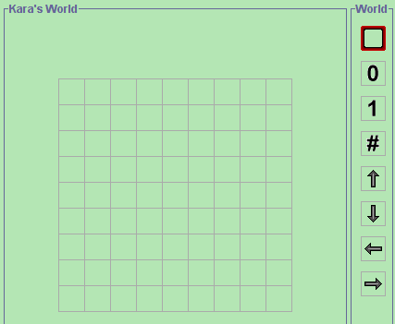

you can use them to represent whatever you would like. When you have added your inputs to the tape you should click on the red square icon (the observation window) and then click on a square on the tape (Kara’s World). The square you clicked on is now the starting position of the observation window (the read/write head).

Set up the tape as shown below (Figure 04 in the Student Book):

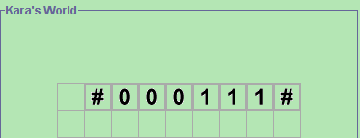
After you have set up the tape you now need to create the finite state machine. Click on the Programming button to do this. You will be taken to a new window where you can specify the states and transitions in the FSM.

Set the finite state machine up as shown below:

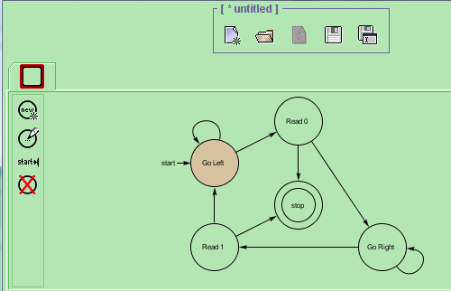
Clicking on this icon will add a state (you will be asked to give it a name).
Clicking on this will make the selected state the start state.
Sometimes when you add a state it cannot be seen. If this happens right click on the background, select ‘Choose Layout’ and then ‘fit diagram’.

To put transitions on just click on a state (the outer part of the state will change colour (as shown right) and then, while holding the mouse button down, move the mouse pointer to the end state.
If you want to move a state on the screen click on the middle of the state and then drag it to where you want it. The middle of the state will change colour as you are doing this.
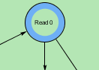

You have now specified the initial state of the tape, and drawn states and transitions for the FSM. You now need to specify the inputs and outputs associated with each of the transitions. To do this you will use the bottom half of the TuringKara Programming Window.

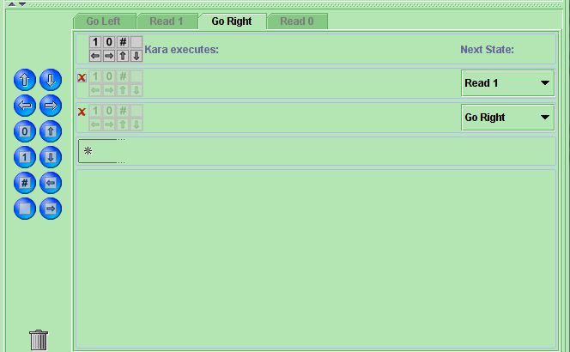
There will be one tab for each of the states in your FSM (except the stop state).
There will then be one row for each outgoing transition from the selected state.
This shows the end state of the transition (and will have been set up for you).
The red cross will delete the transition.

To set inputs (triggers) for the transition, click on the relevant icons to the right of the red x.

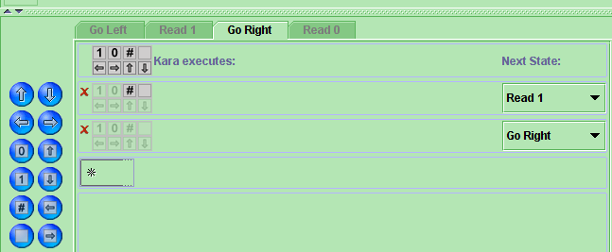
The icons will change colour when clicked.
The image to the left shows that for the transition from state ‘Go Right’ to the state ‘Read 1’ the triggers are ‘#’ and ‘□’.

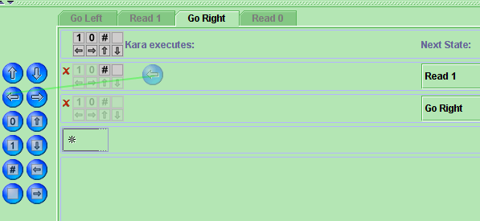
The big blue icons are used to specify the outputs associated with a trigger. Using the mouse, drag and drop the required icon – as shown in these images.

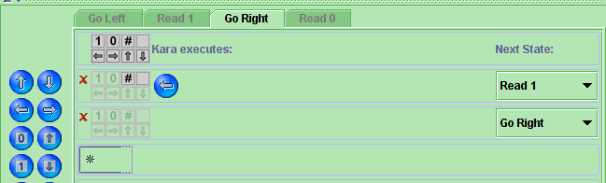
You can have a series of outputs if you want (the order of the outputs is important – so make sure that you get this correct). The four blue icons at the top are used to control movement of the read/write head (observation window), the other icons are used to indicate output symbols to write on to the tape.
Set up the transitions as indicated by the table below:
Current state | New state | Input | Output
Go Left | Go Left | 1, 0 | ←
Go Left | Read 0 | #, € | →
Read 0 | Go Right | 0 | € →
Read 0 | Stop | 1, #, €
Go Right | Go Right | 1, 0 | →
Go Right | Read 1 | #, € | ←
Read 1 | Go Left | 1 | € ←
Read 1 | Stop | 0, #, € | #

When you have done this you are now ready to run the TuringKara machine that you have created. Make sure you can see both the World (the tape) and the programming (the FSM) windows and then click on the play button at the bottom of the World Window.
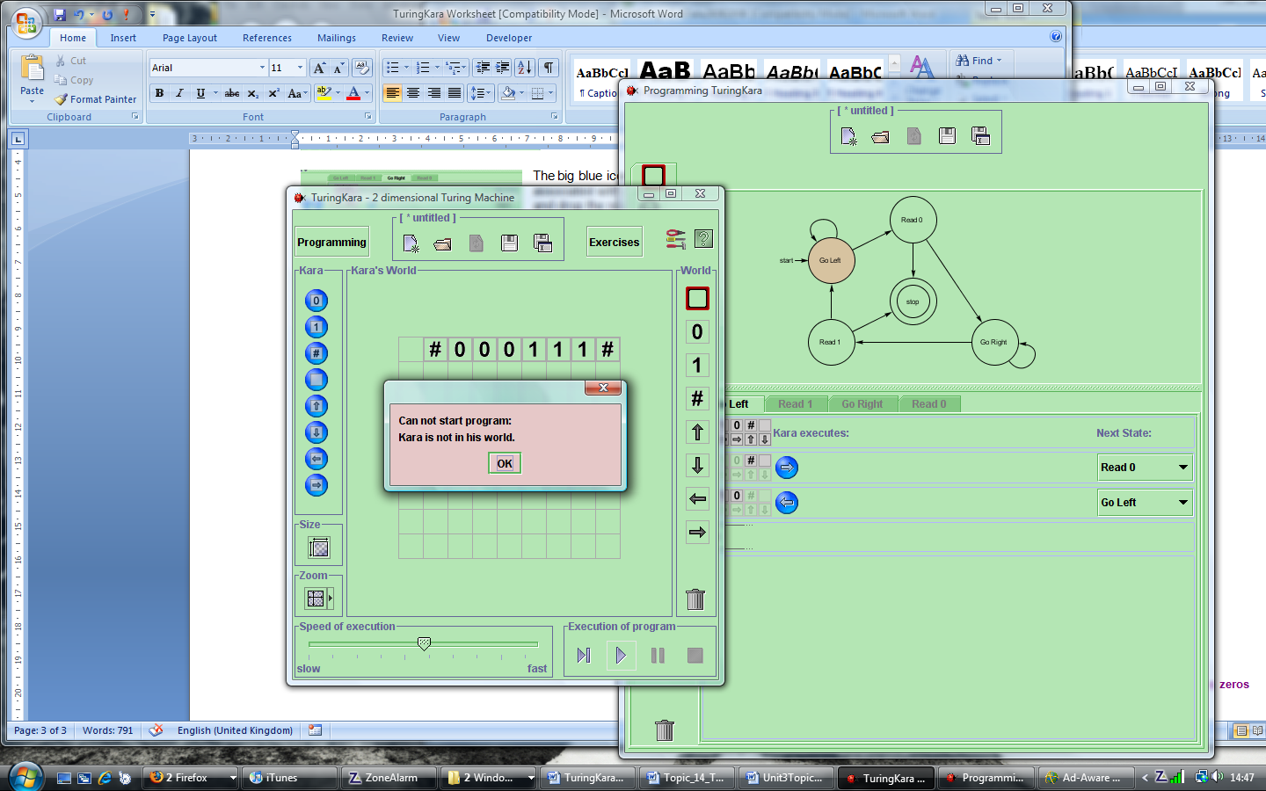
If you see this message:then you have not given the read/write head (observation window) a start position.
TuringKara will take you step by step through the Turing machine – showing the way the tape changes and the path taken through the FSM. The speed of the simulation can be adjusted if it is too fast. If you have set up everything properly it will stop with the tape looking like this:
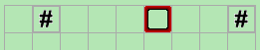
Exercises
- Using the TuringKara machine you have just set up, see what happens when the following input strings are given on the tape:
  - #0011#
  - #00011#
  - #00111#
Describe how the contents of the tape show if there are a number of 0s followed by an equal number of 1s.
- Adjust the TuringKara machine so that it checks if there are a number of 1s followed by an equal number of 0s.
- Set up a new TuringKara machine that performs the AND logical bitwise operator on two rows of binary numbers. More details of this activity can be found in the Student Book.
You will need to be able to set up two outputs on a transition (output depends on the trigger). To do this click on the * to create a new transition and then change the next state as shown.
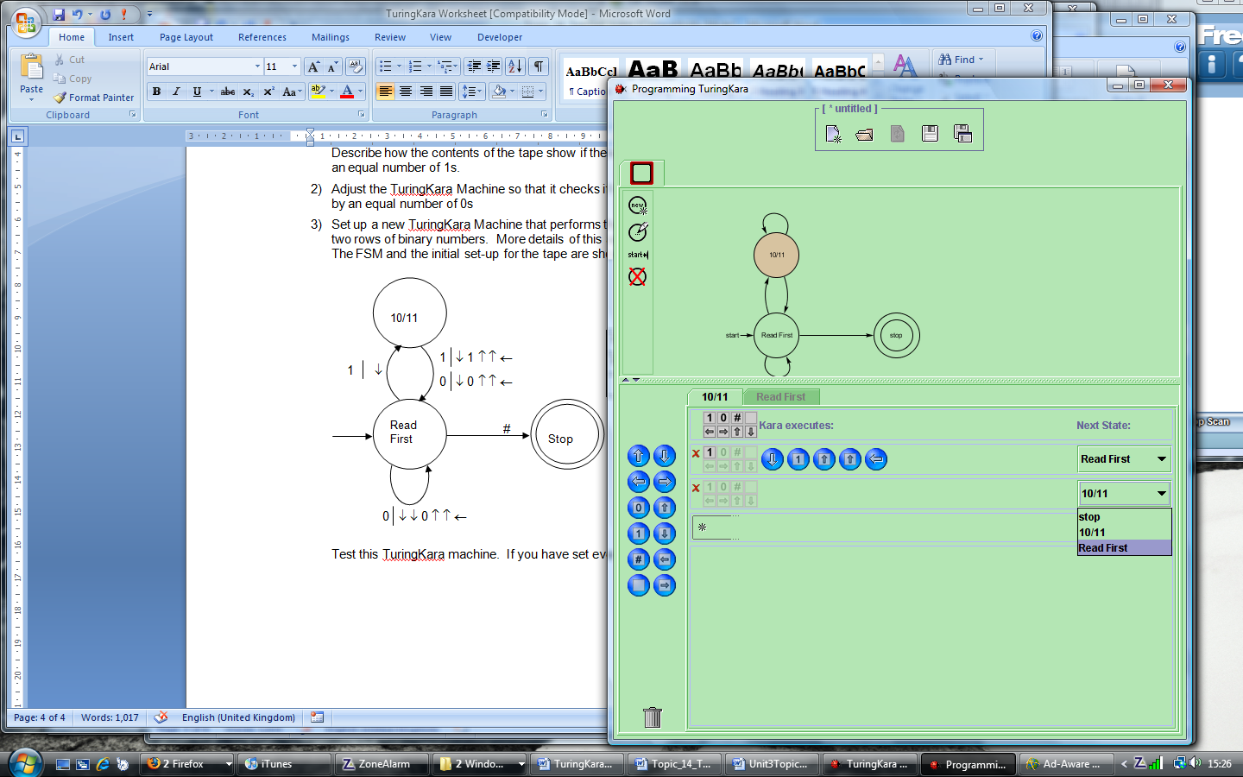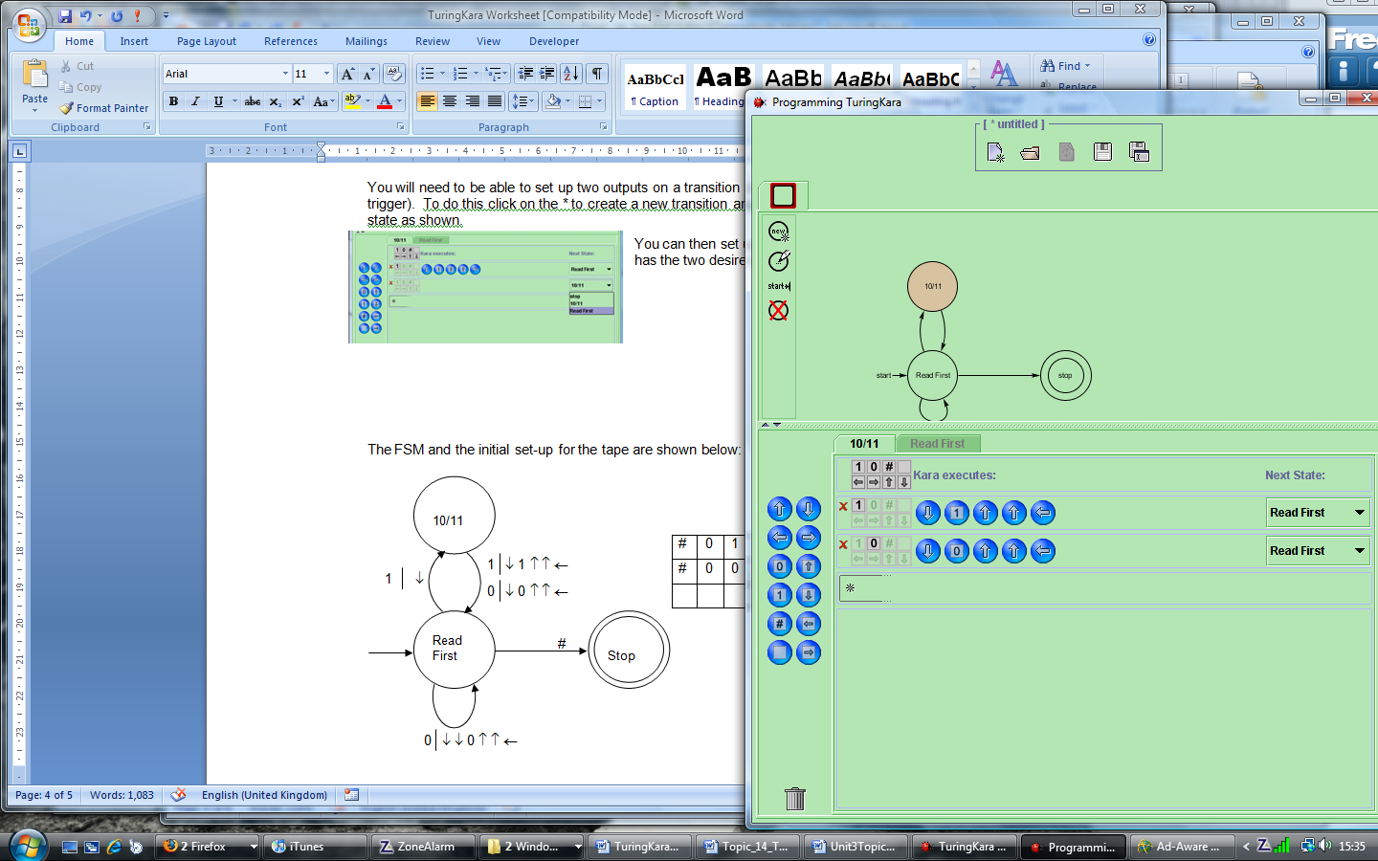
Note that the two rows have the same end state (but different inputs and outputs).
You can then set up the transition so that it has the two desired outputs.
The FSM and the initial set up for the tape are shown below:
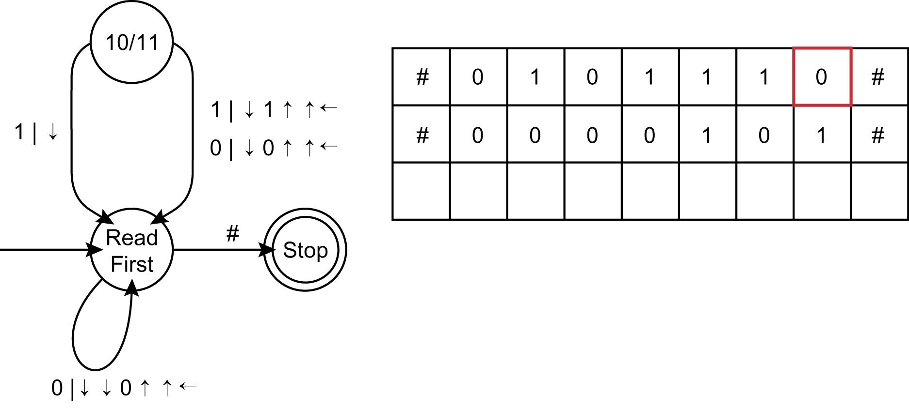
Test this TuringKara machine. If you have set everything up correctly the tape should look like the image below when the program stops running.
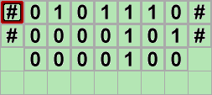
Try a few other starting values on the tape and check that they all work as expected.
- Adapt, and test, the TuringKara machine that you created in Question 3 so that it applies the AND operator to three binary numbers (you should put a ‘1’ in a column only if all three binary numbers had a ‘1’ in that column).
- Create a TuringKara machine that applies the OR logical bitwise operator to two binary numbers.
Extension
Create a TuringKara machine that takes two binary numbers (consisting of the same number of bits) and adds them together. It should work on any reasonable number of bits. There are many different ways of solving this problem: one way is to use six states (needed to cope with when you have a carry and when you don’t have a carry). You could also use fewer states if you record carry bits on the two-dimensional tape itself. The observation window (read/write head) should end up on the most significant bit of the answer.
The image below shows one tape set-up that you should use to test your machine with:
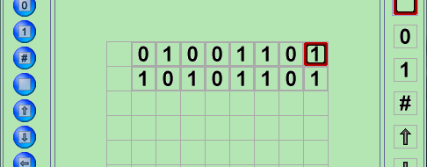
You should also test it with numbers that will cause carry (i.e. the answer needs one more bit than the original numbers used).

