Image result for godalming college logo

**Geography Department Physical and Human Enrolment Tasks**

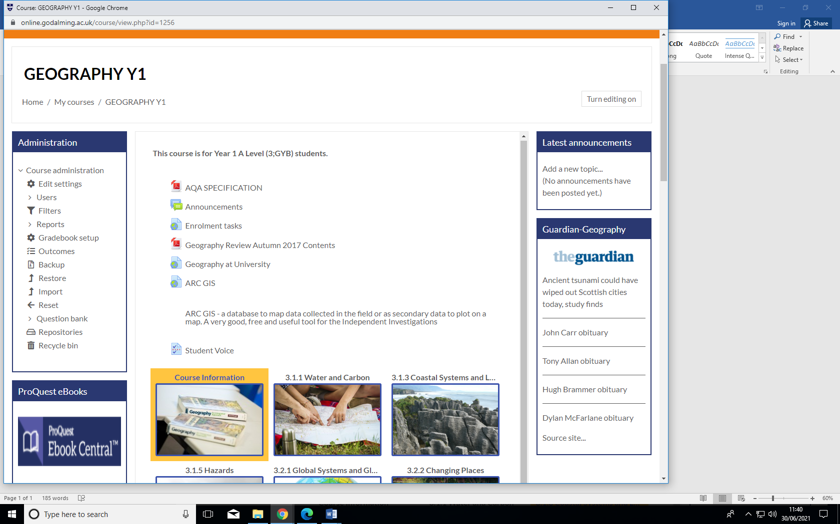

Go to Godalming Online – **Geography Y1 and click on the link to Enrolment Tasks**

**Physical Geography Task**

In Physical Geography this term you will be studying the topic Coastal Systems and Landscapes.

It focuses on coastal zones - dynamic environments which develop by the interaction of winds, waves, currents and terrestrial and marine sediments. You will develop an informed appreciation of the beauty and diversity of coasts and their importance as human habitats.

Go to Godalming Online – **Geography Y1 and click on the link to Enrolment Tasks. Open up the document ‘Where has our beach gone.pdf’**

Carefully read the article titled ‘*Where has our beach gone? The impacts of the UK’s 2014 storms’*. Make a table with two columns and summarise the evidence of the **causes** of the storms and **effects** of the storms.

Then answer the following questions:

1. Explain what caused the unusually high waves during the 2013/14 winter.
2. Make a table comparing the economic, environmental and social impacts of the storms.
3. Explain how the beach material (sand, pebbles, boulders, etc.) can end up going in three different directions.
4. How can coastal processes be measured during extreme storms? Use *Box 2* to help you.

**YOU CAN TYPE OR HAND-WRITE YOUR ANSWERS. PLEASE BRING ALONG TO YOUR FIRST GEOGRAPHY LESSON.**

**Human Geography Task**

In Human Geography this term you will be studying the topic Changing Places.

It focuses on people’s engagement with places, their experience of them and the qualities they ascribe to them, all of which are of fundamental importance in their lives. The topic includes the study of two places, one of which is local and one is distant. Your local study has to be on Godalming.

1. Look carefully at the case study on Woking, Surrey. Use this case study as a guide and complete a similar case study for Godalming. The Godalming Museum website is particularly useful for information but you may find other websites with other relevant information.
2. Access the following website [www.nomisweb.co.uk](http://www.nomisweb.co.uk) and click on 2011 ward profile. Type Godalming Holloway into the search bar where it says postcode or place name and complete the relevant columns in the data table provided.

Do the same for Godalming Central and Ockford and then write a brief report comparing the statistics that you have found out.

|  |  |  |  |
| --- | --- | --- | --- |
|  | Godalming Holloway | Godalming Central and Ockford | England and Wales |
| % Unemployed |  |  | 7.6 |
| % Level 4 qualifications and above |  |  | 29.7 |
| % Long term sick or disabled |  |  | 4.6 |

1. Access the [www.datashine.org.uk](http://www.datashine.org.uk) website and type in GU7 into the postcode. Explore the different categories of information in the drop down menus. You may wish to focus on factors such as housing tenure, ethnic group, methods of transport to work. Identify the two wards that you completed data for in the previous task (you will need to refer back to the nomis website and visually match the areas).
2. Print screen 2 maps of your choice and copy them into a word document.
3. Annotate the maps to show differences you have discovered between Godalming Central and Central and Ockford.

**YOU CAN TYPE OR HAND-WRITE YOUR ANSWERS. PLEASE BRING ALONG TO YOUR FIRST GEOGRAPHY LESSON.**

**PLEASE PRINT ALL WORK OUT AND BRING ALONG TO YOUR FIRST GEOGRAPHY LESSON**