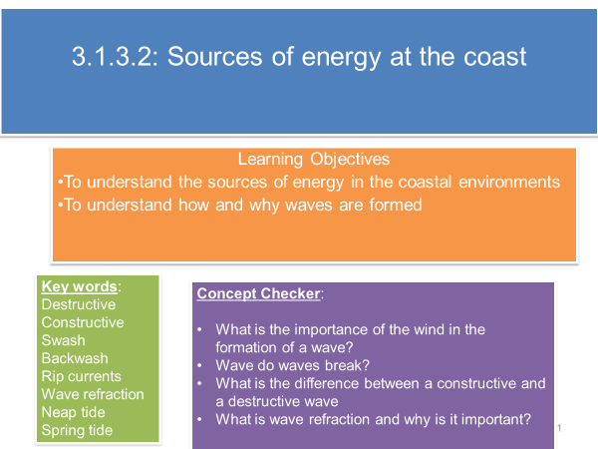

**There are 3 sources of energy**

1. **Wind**
2. **Waves**
3. **Tides and currents**

**The Wind**

**What causes the wind?**

* Although waves can be generated by tectonic activity or underwater landslides creating tsunami, they are mostly formed by wind.
* Wind is the movement of air from one place to another, from high pressure to low pressure.
* In the UK the prevailing wind is from the SW. These winds blow over a broad expanse of the Atlantic Ocean and have the potential to transfer a great deal of energy to the waves that approach the UK.

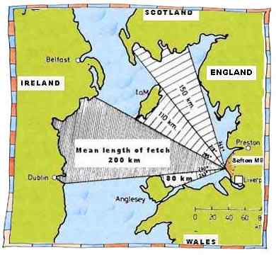 

**Use this diagram to explain how fetch influences erosion rates in the UK.**

**Which areas of the coast are more vulnerable to erosion?**

**Why is the prevailing wind a significant factor?**

A number of factors affect wave energy:

1. The strength of the wind
2. The duration of the wind – the longer the wind blows the more powerful the waves will become
3. The fetch – the distance of open water over which the wind blows.

The longest fetch in the UK extends for over 3000km across the Atlantic Ocean to Brazil.

**The Waves**

**What causes the waves?**

* Waves are created by the transfer of energy from the wind blowing over the surface of the sea. As the strength of the wind increases so too does the frictional drag and the size of the waves.

**The characteristics of a wave**

Definitions for:-

* Crest
* Wavelength
* Wave height
* Trough
* Wave period

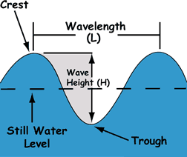

<https://www.youtube.com/watch?v=dv_Sis0Hntk>

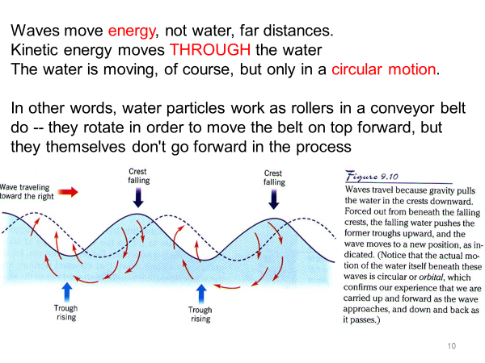

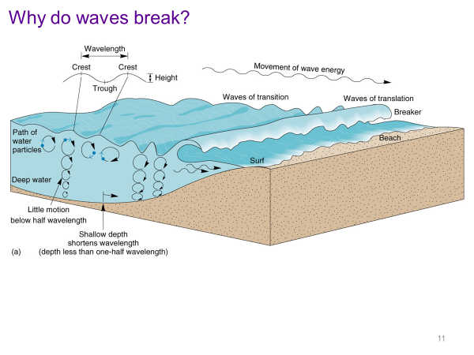

<https://www.youtube.com/watch?v=dv_Sis0Hntk>

**Use the information from the video clip and the diagram above to explain in your own words what happens when waves reach the coast.**

**Annotate the following diagrams to identify the different characteristics of constructive and destructive waves using the information from the powerpoint slides.**

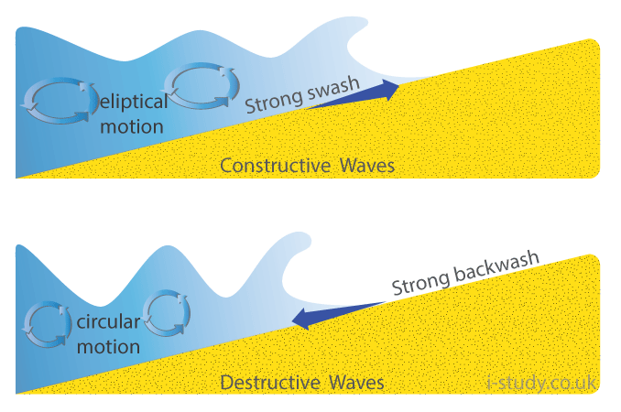



**Read the information on beaches and waves: an example of negative feedback and create a flow diagram to summarise the information. (Oxford p107). (You may wish to recap the concept of negative feedback from handout 1)**

[**https://www.bing.com/videos/search?q=wave+refraction&&view=detail&mid=C05DB806D1181EB8B04CC05DB806D1181EB8B04C&&FORM=VRDGAR**](https://www.bing.com/videos/search?q=wave+refraction&&view=detail&mid=C05DB806D1181EB8B04CC05DB806D1181EB8B04C&&FORM=VRDGAR)

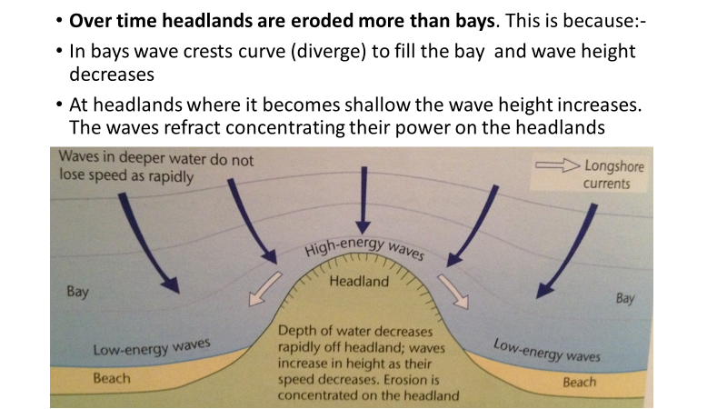

**Read the information on wave refraction p109 Oxford textbook.**

**What is wave refraction and how does it demonstrate the concept of negative feedback?**

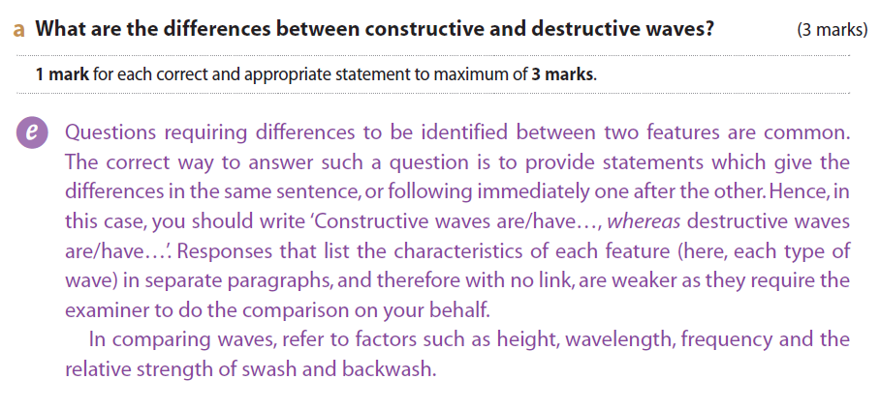

**FLIP LEARNING TASK FOR NEXT LESSON –** Research high and low energy coasts using Hodder p 95 and create a table of differences to bring to your next lessons