

**TASK A Definitions:**

Littoral Cell

Sediment Budget



**TASK B Questions on Sediment Sources and Transfer:**

Short video on ‘[where coastal sediment comes from](https://www.youtube.com/watch?v=HHcFiI8rx_g)’

The coastline must receive inputs of sediment, where does it come from?



Complete the diagram below:

**The sediment cells act as systems with sources (inputs), processes and sinks (outputs).**

**Identify the inputs and outputs from this diagram.**

**Inputs Processes Outputs**

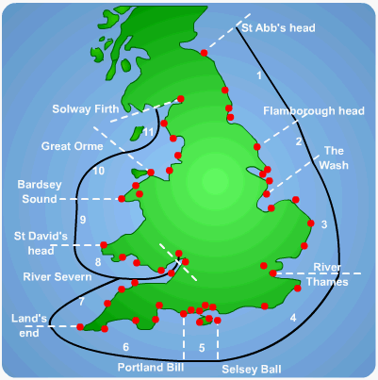

Research has suggested that sediment movements occur in distinct areas or sediment cells within which inputs and outputs are balanced.

Along the coastline of England and Wales, 11 of these sediment (or littoral) cells have been identified.

The sediment cells are separated from other areas by well-defined boundaries, such as headlands and stretches of deep water.

Within sediment cells, longshore transport of material redistributes sediment within the coastal system so that sediment is gained from eroding sections of the coastline, called ‘**sources**,’ and lost to sections experiencing deposition, called **‘sinks**.’ **Sources of sediment** include coastal cliff erosion, river erosion and deposition at the mouths of rivers and shoreward movement of offshore sediments by tides and waves. **Sediment sinks** include the accumulation of material at the back of beaches such as sand dunes; loss of sediment to the offshore zone during storm conditions and sediment sinks also occur where transport paths meet causing deposition, for example estuaries (river meets the sea).

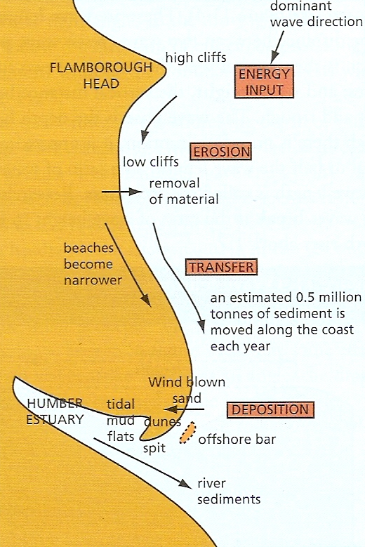

***Sediment cell example:***

One such sediment cell stretches from Flamborough Head to the Wash on England’s eastern coastline. This cell can be further sub-divided into two parts, one north of the Humber estuary and one south.

***Implications of sediment cells:***

Sediment cells have important implications for geomorphological processes and coastal landforms. The amount of sediment gained from the sources and lost to the sinks can be quantified, and a sediment budget can be made to highlight variations in the amount of source and sink sediments. This is an invaluable tool for assessing the causes of coastal change, such as the effect of artificial structures on beach erosion. Thus the concept of sediment cells is the basic unit of shoreline management in England and Wales. **Read pages 112-113**

**Diagram to show the processes occurring in the sediment cell between Flamborough Head and the wash.**

***Problems with sediment cell concept:***

However there are problems with the sediment cell approach. The cells are based upon the movement of coarser particles, rather than the movement of suspended fine material. It is easy for fine sediments to find their way around headlands into neighbouring cells. Therefore cell boundaries in such a dynamic system cannot be fixed and static (closed system) as the sediment cell concept suggests.

**READ and Highlight**: Sediment sinks, why sediment budgets are a useful tool, and the problem with the sediment cell concept

**TASK C: Questions on Factors Affecting the Sediment Cell Budget**

**Case Study 1: Cape Naturaliste to Moore River – Western Australia.**

The main processes occurring within this sediment cell are as follows:

* Starting in the south at Cape Naturaliste, longshore drift moves material from the Cape, northwards towards the Moore River.
* Material is deposited at certain locations along the stretch of coastline as spits, tombolos and bars.
* Material is picked up by waves and currents travelling seaward and is carried out from the shore, but a large amount of this sediment is intercepted by incoming waves and carried back towards the shore. Some sediment is lost from the cell in offshore deposition.
* Loss of sediment is replenished by clastic sediments deposited by rivers where they enter the ocean in the shallow bay areas. This is added to by shoreline weathering and mass movement of cliffs. Deposited sediments will then be carried along the coast by longshore drift.

**Describe the sediment cell concept. Use evidence from page 3.**

**With reference to Fig. 2, how can people affect the equilibrium of a sediment cell?**

**Case Study 2: South Downs**

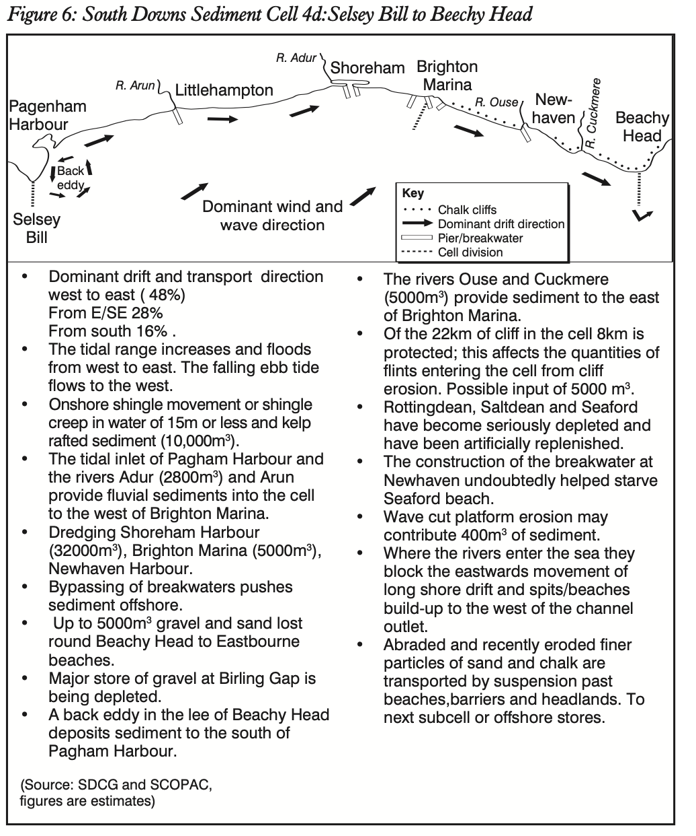

**Identify the sources, transfers and sinks within the South Downs sediment cell. How might human activity have affected this cell?**

**....................................................................................................................................................................................................................................................................................................................................................................................................................................................................................................................................................................................................................**

**....................................................................................................................................................................................................................................................................................................................................................................................................................................................................................................................................................................................................................**

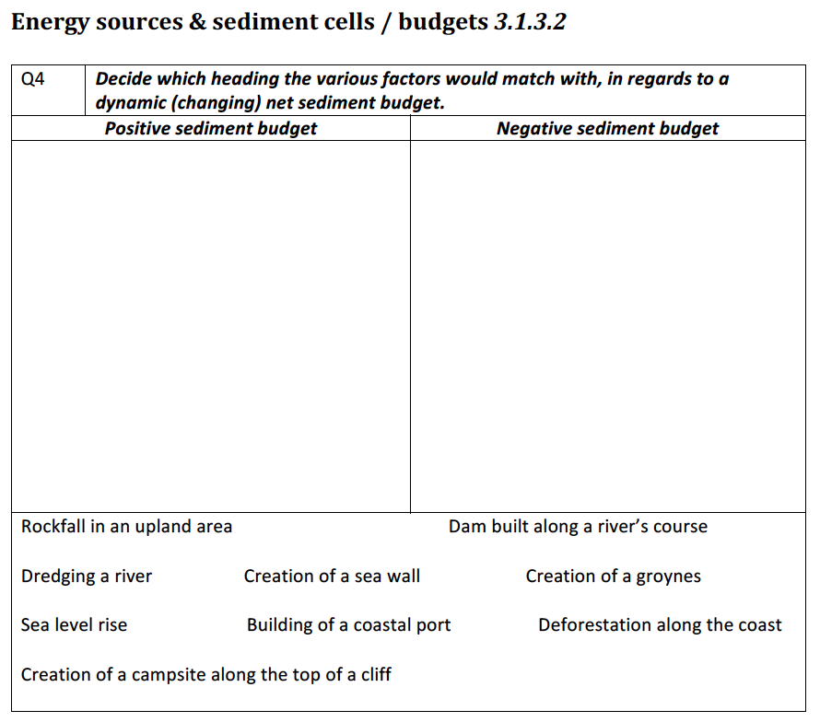

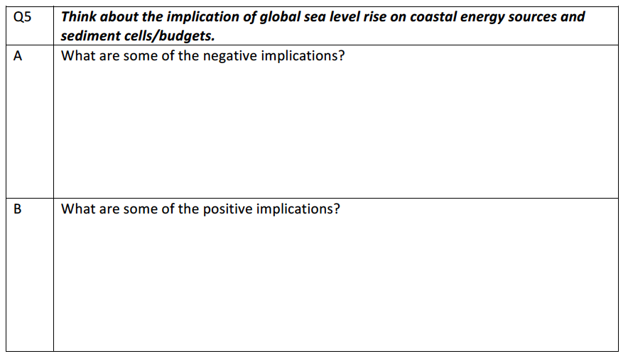

**TASK D - Further research / Independent Learning**

Read the textbook pages 110 to 113 and add to your notes on sediment sources, cells and budgets. Complete Activity 2 as a revision of the sediment cell concept.