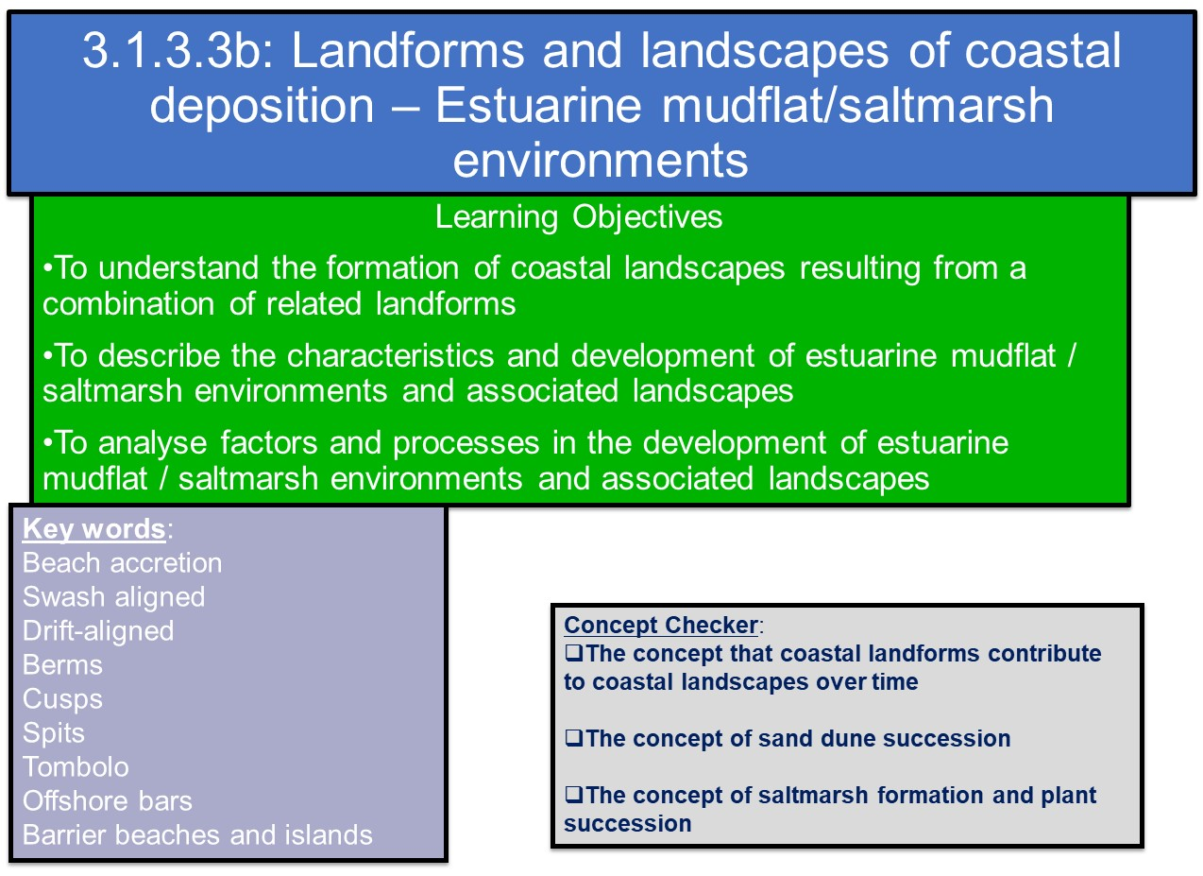

Depositional features at the coast may be temporary (beach cusps) or longer-lasting (spits), but others are transformational; they undergo change from one form to another over relative short periods of time measured in decades. Environmental habitats at the coast alter as a result of plant succession.

Mudflats and Salt Marshes

Salt marshes forms in coastal areas that already have mud flats. They usually form in areas that are well sheltered, such as creeks, inlets and estuaries where fine sediments can be deposited. They also form behind spits and artificial sea defences where tidal waters can flow gently and deposit fine sediments.

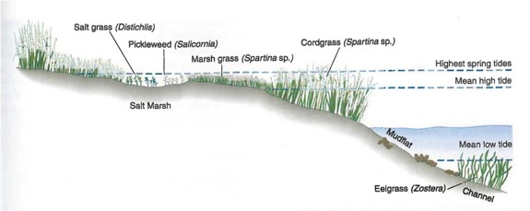

- Mudflats at the edges of estuaries are frequently zones of net deposition of fine sediment. Over time these may evolve into saltmarsh ecosystems with colonisation by plants that can tolerate high salt conditions and frequent inundation at high tide and exposure at low tide.
- Submerged and semi-submerged plants trap more sediment and reduce water velocity leading to increased deposition. (This is a form of positive feedback)
- Plant life-cycles deposit decaying material on top of which new plants grow, gradually raising the height of the saltmarsh.
- As height increases, saline conditions reduce, inundation is less frequent and different seral stages occur towards a climax community.
- Plant succession occurring in conditions of water is termed a hydrosere. A sub-set occurring in salt (as opposed to fresh) water is known as a halosere.

Salt marshes are exposed at low tide and at least partially flooded at high tide, so only salt resistant forms of vegetation can grow there. They are typically very flat, with numerous muddy channels and creeks cutting through them, making them very dangerous places to be as the tide comes in.

Watch the first 2 minutes of the video clip: https://www.youtube.com/watch?v=LGOECERzlws
How can saltmarshes be beneficial to people and the environment?

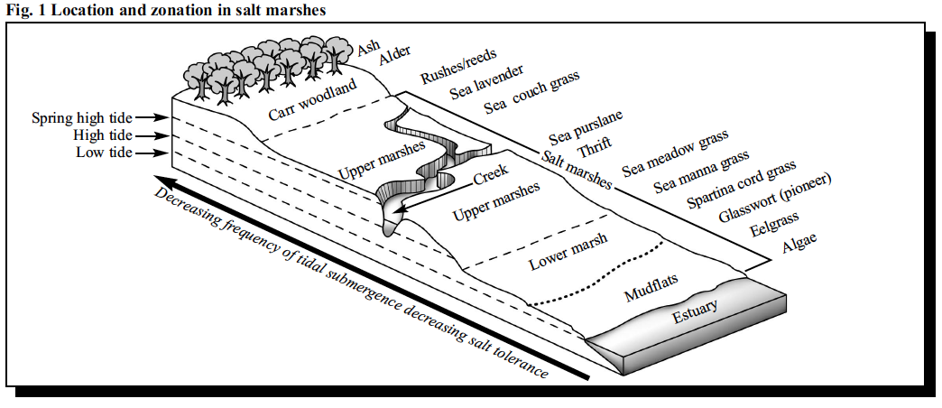
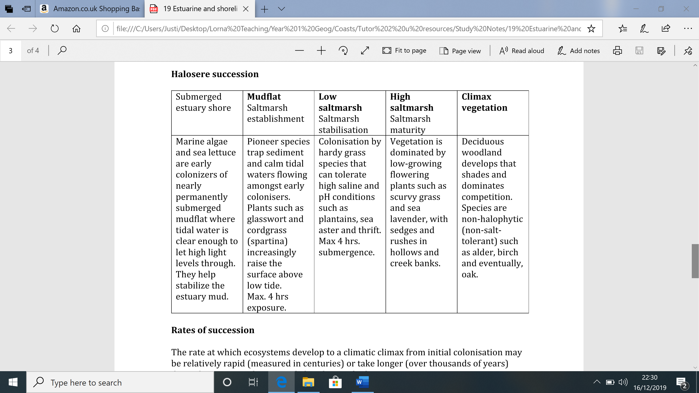

TASK:

- Using the information on pages 1 and 2, annotate the diagram to explain how a halosere develops.

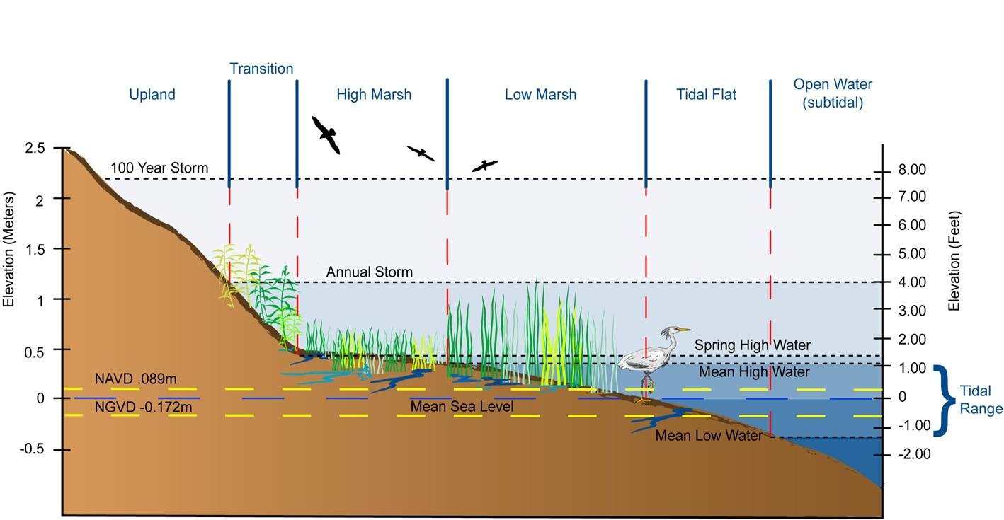

- What are the key factors that will affect the development and sustainability of a saltmarsh environment? Watch the video of an estuarine environment beyond the UK: saltmarshes in the USA: https://www.youtube.com/watch?v=3HXyTMnj7ac

- Outline the threats facing saltmarshes in the UK, both directly and indirectly. Do you consider these threats to be more related to natural or human causes?

Exam Style Question

- Explain the development of a saltmarsh (4 marks)

Complete the questions below: Estuarine and shoreline successions

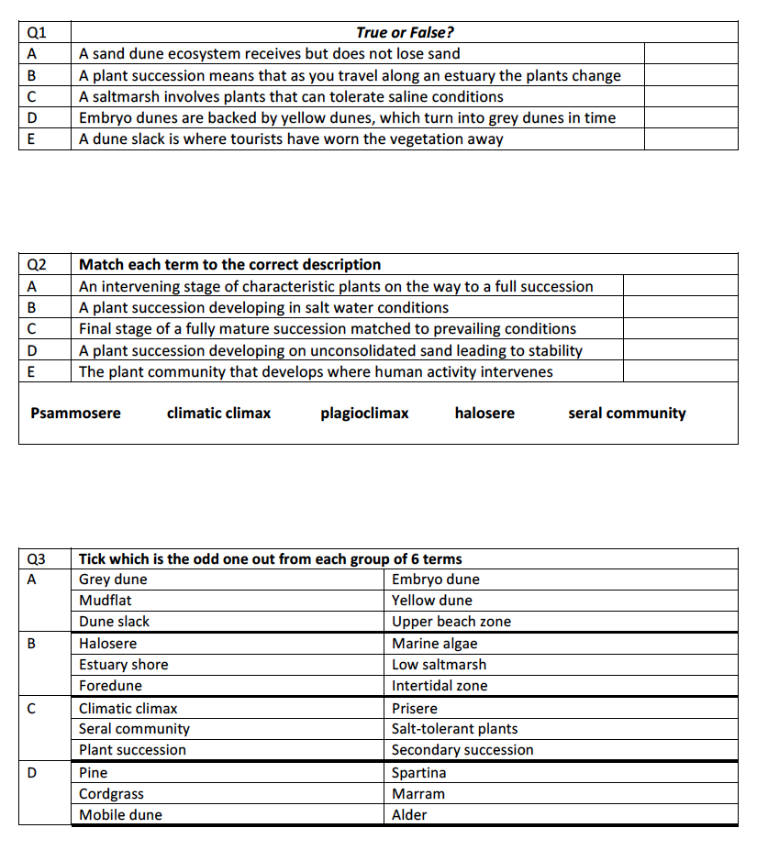

CASE STUDIES: Estuarine and shoreline successions

- Case study comparison (see Godalming Online Folder 9 Estuarine and Saltmarsh Environments or TEAMS assignment):

Using the Severn Estuary Case Study of a salt marsh area and the case study of Key Haven Marshes:
  - compare its value as an ecosystem and
  - the threats facing it.

 | Key Haven marshes | Severn Estuary
Ecosystem importance
Threats facing marsh

Further reading / research to understand saltmarsh environments

Estuarine mudflats in Pembrokeshire (useful for researching a case study) (http://www.pembrokeshirecoast.wales/Default.asp?PID=149)
Background information on mudflats
(http://www.geography-site.co.uk/pages/physical/coastal/mudflats.html)
Summary of saltmarshes
(http://www.geography-site.co.uk/pages/physical/coastal/saltmarsh.html)
Simple animation illustrating the locational relationship between mudflats and saltmarshes (https://oceanservice.noaa.gov/education/kits/estuaries/media/supp_estuar06a_saltmarsh.html)
Video of estuarine environments in Cardigan Bay in west Wales (https://www.youtube.com/watch?v=LGOECERzlws)
Estuarine environment beyond the UK: saltmarshes in the USA (https://www.youtube.com/watch?v=3HXyTMnj7ac)
Videos giving aerial views of estuarine mudflat (http://www.gettyimages.co.uk/detail/video/crossing-morecambe-bay-stock-video-footage/558298865) and salt marsh landscapes at Morecambe Bay.(http://www.gettyimages.co.uk/detail/video/morecambe-bay-stock-video-footage/559381239)
http://www.theseashore.org.uk/theseashore/Saltmarsh%20Section/Saltmarsh%20introduction.html

