COASTAL MANAGEMENT – PART 2: SUSTAINABLE APPROACHES
Figure (a). Land use at the coast
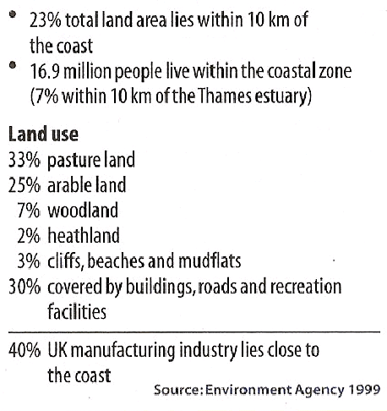
Using the information from Figure (a) explain why we need to protect the coastline.

Introduction - Sustainable approaches to coastal flood and erosion management
Some soft engineering schemes adopt sustainable principles, but they tend to be focused a particular stretch of coastline. Increasingly management authorities are looking at holistic management plans for significant stretches of coastline.
Policies have been adapted by the UK Government to make coastal management more sustainable and policies have developed at a global level to create a common and integrated approach around the world.
- Shoreline Management Plans
Introduced in 1995, 22 SMPs around England and Wales. An SMP works with the concept of littoral cells, or sediment cells along the coast. Each cell is managed either as a whole unit or a sub-unit. The SMP does not take account of other activities beyond the shoreline, so ICZM has now been adopted by many coastlines around the world
- Integrated Coastal Zone Management (Coast AND activities)
Originated from the UN Earth Summit of Rio De Janeiro in 1992 (Agenda 21). The European Commission have developed a framework to promote ICZM to manage the fine balance between people, economy and environment. In 2013, the EC launched the maritime spatial planning (MSP) framework to support ICZM.

- Shoreline Management Plans

What is the aim of the SMP?
To provide the basis for sustainable coastal defence policies within a sediment cell (specified lengths of coast) and to set objectives for the future management of the coastline.
Their aim is to identify the most sustainable approach to managing the different sections of coastline in the short term (0-20 years), medium term (20-50 years) and the long term (50-100 years)
They are funded mostly by the national government agency – DEFRA, along with the Environment Agency and local councils.
Using the images below and the textbook, describe each of the four strategy options and outlines what types of coastal defence might be used for each:

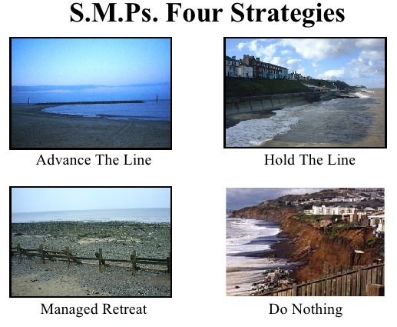

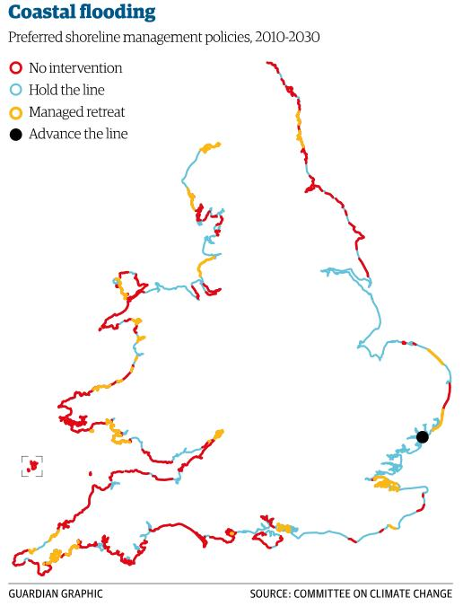
What factors will determine which of the above strategies is designated along the coast? For example, why hold the line?

What issues might arise if different sections of coastline are designated different strategies?

Tables 1 and 2 show different ways of looking at costs and benefits at the coast.
Table 1. A simple view of costs and benefits:
 | CONSIDERATIONS | BENEFITS | COSTS
£ | Economic considerations |  | e.g. Building and maintaining the coastal defences
 | Social considerations | e.g. Security and peace of mind | e.g. Increased problems of access to beaches
e | Environmental considerations | e.g. Rarely beneficial unless ‘soft’ engineering
- Complete Table 1 by filling in the missing examples (2 marks)

Table 2. A simple cost-benefit calculation for three coastal defence options:
Options | Benefits | Damage | Costs | Benefit/ Cost Ratio
1. Do nothing | X | £650, 000 | X | X
2. ‘Holding the line’ along the whole section of the coast. | £650, 000 | £0 | £1, 000, 000 | 0.65
3. Protect some places but not others along the coast | £600, 000 | £50, 000 | £350, 000 | 1.5

- Explain why decision makers might choose option 3 in Table 2. (2marks)
.......................................................................................................................................................
......................................................................................................................................................
.......................................................................................................................................................
- Identify the circumstances in which ‘do nothing’ (Option 1) would be the preferred option. (2 marks)
.......................................................................................................................................................
.......................................................................................................................................................
.......................................................................................................................................................
- Explain why it may be difficult to put value on some costs or benefits. (2 marks)
.......................................................................................................................................................
.......................................................................................................................................................
.......................................................................................................................................................
- Holderness Coastal Flood Risk and Erosion Management
Defending Holderness – the challenges of sustainable management? Complete Holderness Case Study Part 2
HOLDERNESS – the challenges represented in sustainable management of the Holderness Coast

The table of aims in The Holderness SMP – score the importance of each one out of 5. Pick 5 of these aims from the table below to memorise for the exam and be prepared to discuss their relative importance.
Holderness Case Study – challenges for sustainable management

Discuss the following questions and think how this applies to your case study on the Holderness Coast:

- Suggest what factors influence the choice of coastal defence strategy. For example, why might traditional approaches to coastal management, such as some of the hard management strategies, be important in management of the coast?

- What do you understand by the term ‘sustainable approaches’ to coastal management?

- With the greatest challenge of climate change - what are the most important approaches to coastal management and why?
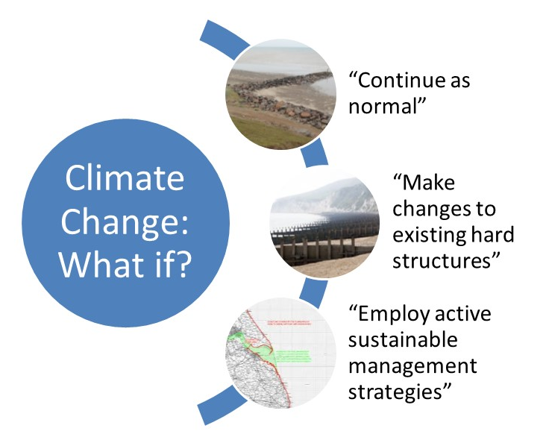

- Integrated Coastal Zone Management
A systems perspective recognises that an action in one location is likely to have an impact elsewhere. The development of ICZM plans takes this as a basis for holistic (all components taken into account) planning.
The coastal zone is not only a place for natural marine processes and habitats but shoreline activities, inshore and offshore operations and inland activities that output at the coast through drainage systems that flow into the coastal zone.
The key aim of ICZM planning is to co-ordinate all the potential pressures and conflicts of interest at the coast and manage them fairly, responsibly and sustainably. Specifically:
  - Monitoring, information-gathering and recording of what is taking place at the coast
  - Identifying and involving all stakeholders (who may change with time)
  - Agreeing co-ordinated plans that allow key objectives for stakeholders to be met
  - Following sustainable strategies
  - Managing the natural and human systems responsibly
  - Considering changes to coastal systems and anticipating likely impacts
  - Adapting plans accordingly

ICZM Holderness
It is important to involve all stakeholders across the different sectors
Watch the video on Odisha and use this and the links to help you answer the questions below.
- Why is an integrated coastal management is needed? (use the link:
http://www.coastalwiki.org/wiki/The_Integrated_approach_to_Coastal_Zone_Management_(ICZM))

- How can people and economic activity put pressure on coastal environments? (use the link: http://www.coastalwiki.org/wiki/The_Integrated_approach_to_Coastal_Zone_Management_(ICZM))

- What are the origins of ICZM? (Use the European Commission on AGENDA 21 link: http://ec.europa.eu/environment/iczm/index_en.htm )

- What are the specific issues facing coastal environments in the future?

- Who are the stakeholders, who should be considered when thinking about coastal management?

- How can ICZM be viewed as a cyclical process? (http://ec.europa.eu/environment/iczm/index_en.htm )

Other important links on ICZM:
- 20min interview with Dr. Burbridge from Newcastle University on ICZM: https://www.youtube.com/watch?v=g3uD-m6DPcc

Exam Style Questions
Read Oxford textbook pages 142-143, Hodder textbook pages 122-124, and use the information to answer the question below.
- Assess the advantages of integrated management plans such as Shoreline Management Plans (SMPs) and Integrated Coastal Zone Management (ICZM) [9 marks]

20-mark questions to plan:
- ‘Shoreline management/integrated coastal zone management can effectively tackle the expected eustatic sea level change and associated threat to coastal landscapes over the coming decades.’ To what extent do you agree with this view? (A level 2019) [20 marks]

- ‘Sustainable approaches to coastal management will become more important than traditional approaches in dealing with the impacts of climate change.’ To what extent do you agree with this view? [20 marks] AS 2018

- BUG the question (Box the command word, Underline the Geography, Glance back at the question)
- How would you answer the question…….make a plan consider the 4Cs – (Command word, Content, Case Study, Conclusion):

Use one of the essay planning formats to help you. Choose one that works for you!

