3.1.5.2 Plate Tectonics

Earth structure and internal energy sources. Plate tectonic theory of crustal evolution: tectonic plates; plate movement; gravitational sliding; ridge push, slab pull; convection currents and seafloor spreading.

Watch the clip on the ‘Structure of the Earth’ [Structure of the Earth (timeforgeography.co.uk)](https://timeforgeography.co.uk/videos-list/plate-tectonics/structure-planet-earth/)

Use the following link to help label the diagram below of the structure of the earth and complete the table to show the properties of continental and oceanic crust. <http://www.coolgeography.co.uk/A-level/AQA/Year%2013/Plate%20Tectonics/Plate%20tectonics/Tectonics.htm>



|  |  |  |
| --- | --- | --- |
|  | Continental crust | Oceanic crust |
| Thickness |  |  |
| Age |  |  |
| Density |  |  |
| Composition |  |  |

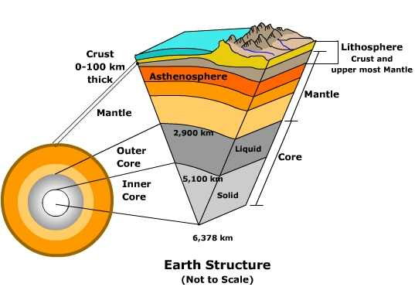

What is the difference between the lithosphere and the asthenosphere?

Lithosphere

Asthenosphere

**The importance of the core as a source of energy**

The core’s internal heat is the major cause of the Earth’s activity. Some of this heat may be primeval – retained by the ball of dust and gas from which the Earth evolved. But we now know that by far the greatest source of heat energy within the Earth is derived directly from radioactivity. Natural radioactive decay of uranium, thorium, potassium and other elements provides a continuous but slowly diminishing heat supply. The Earth is a vast nuclear power station!

* Whilst scientists are agreed that the plates move they continue to debate the mechanisms which drive the movement.
* Until recently, the dominant theory suggested the heat from the core was transferred to the Earth’s surface via large convection currents in the asthenosphere. The heated magma spreads out under the lithospheric plates and begins to cool which cause them to become denser and start to sink downwards.

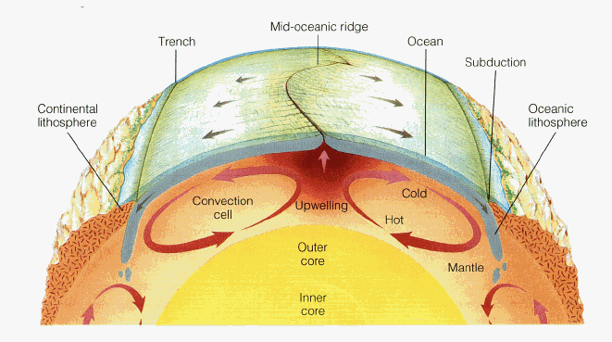

* However, many scientists do not believe that convection explains the massive forces needed to move the plates. Instead they have suggested two alternative hypotheses; gravitational sliding - ridge push and slab pull. These are the contemporary theories to explain the movement of the earth’s crust.

[**https://www.youtube.com/watch?v=RA2-Vc4PIOY**](https://www.youtube.com/watch?v=RA2-Vc4PIOY) **– Video clip on Alfred Wegener’s theory of continental drift.**

What is Wegener’s theory?

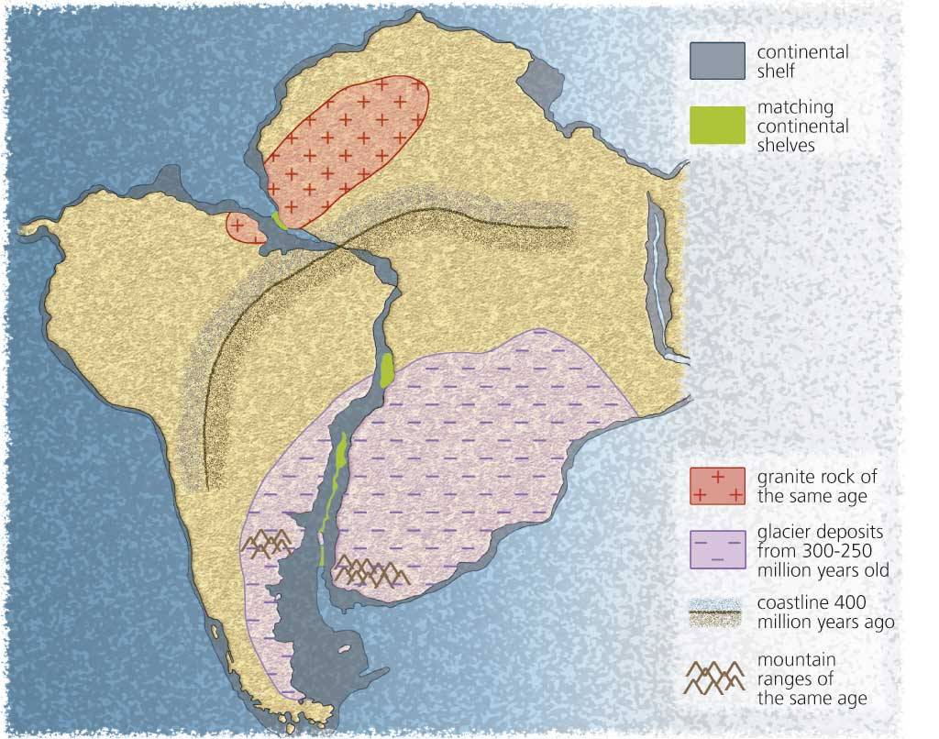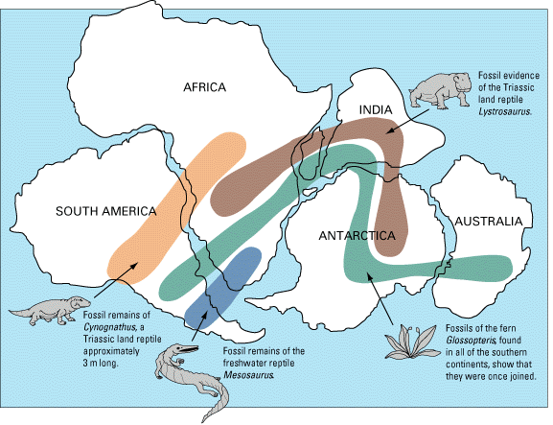

Explain how each of these images provide evidence for Alfred Wegener’s theory.

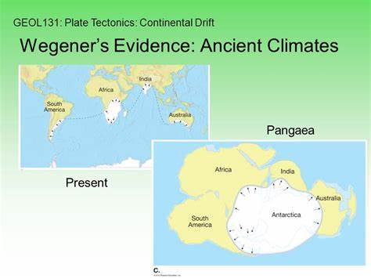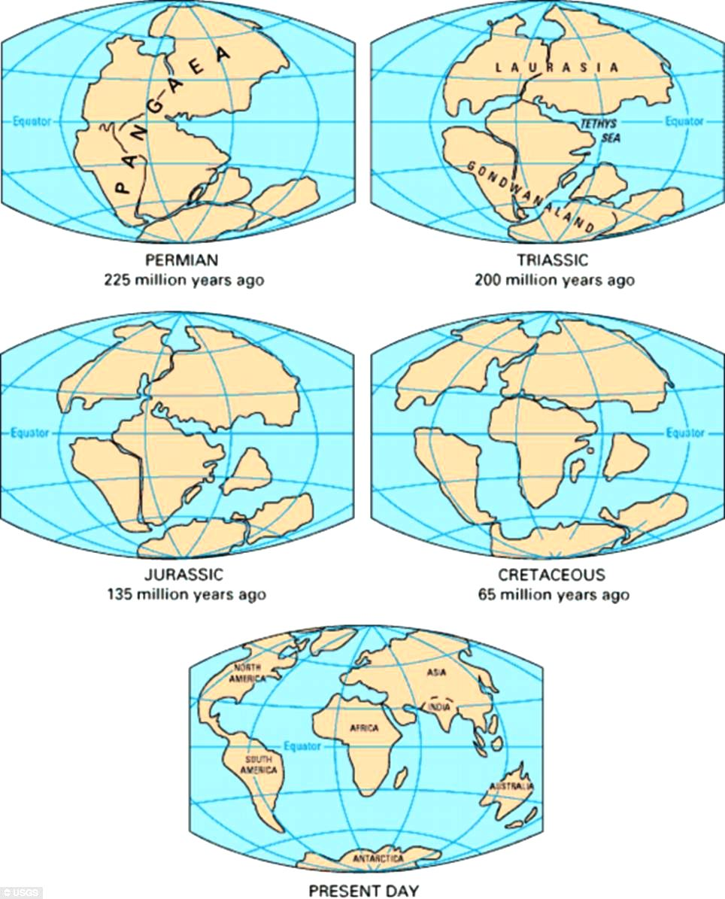

**Ridge-push (gravitational Sliding) and slab-pull.**

Scientists believe that it is not convection currents alone causing plate movement. Two further ideas have become accepted mechanisms for plate movement: *ridge push* (gravitational sliding) and *slab pull.*

Ridge push = at spreading centres where plates are **moving apart**, such as the mid-Atlantic ridge.

Slab pull = at **subduction zones** where one plate is pulled down into the mantle.

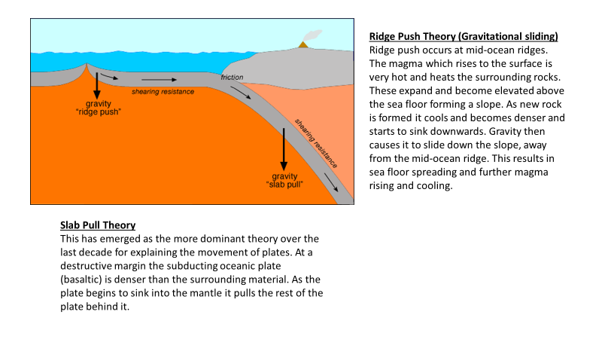<https://www.youtube.com/watch?v=kwfNGatxUJI> – video clip explaining the ridge push and slab pull theories

**Exam Question:** Outline the process of slab pull in relation to plate movement (4) *(AS 2018)*

[**https://www.youtube.com/watch?v=GyMLlLxbfa4**](https://www.youtube.com/watch?v=GyMLlLxbfa4) **– Harry Hess**

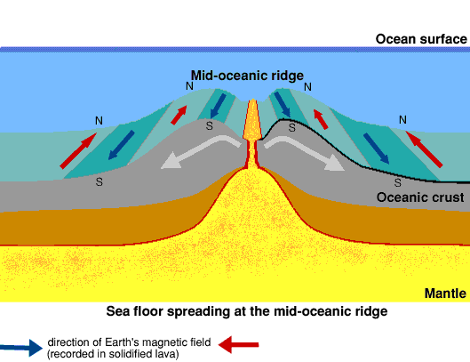**Evidence of sea floor spreading – paleomagnetism**

Harry Hess, an American geologist studied the age of the rocks on the floor of the Atlantic Ocean, finding that the ______________ were in the middle (Iceland) and the ______­­­__________ ­­­nearest the USA and the Caribbean.

The rate of spreading is estimated to be at 5cm per year. This has been confirmed by palaeomagnetism.

Every 400,000 years or so, the Earth’s ______________ field switches ____________, causing the magnetic north and south poles to swap. Magnetite (iron oxide) in lava erupted onto an ocean floor records the Earth’s magnetic orientation at that time. Sea floor spreading from mid-ocean ridges is shown by mirror-image patterns of ‘switches’ or__________.

Reversals oldest youngest polarity magnetic

**Does the evidence for sea-floor spreading support Wegener’s theory of continental drift? Explain your answer**

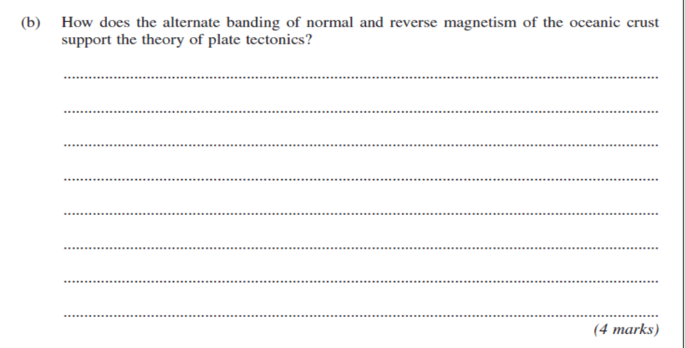



[Dynamic Earth Interactive - Annenberg Learner](https://www.learner.org/series/interactive-dynamic-earth/)

An excellent interactive website. Complete the activities in the introduction, earth structure and plate tectonics section.