**3.1.5.5 Storm Hazards**

* **The nature of tropical storms and their underlying causes. Forms of storm hazard: high winds, storm surges, coastal flooding, river flooding and landslides. Spatial distribution, magnitude, frequency, regularity, predictability of hazard events.**
* **Impacts: primary/secondary, environmental, social, economic, political. Short and long-term responses: risk management designed to reduce the impacts of the hazard through preparedness, mitigation, prevention and adaptation.**
* **Impacts and human responses as evidenced by TWO recent tropical storms in contrasting areas of the world.**

**What is a tropical storm and how are they formed?**

Tropical revolving storms (hurricanes, cyclones and typhoon) are intense weather systems, rotating around a centre of very low pressure (c. 950mb). They develop in the tropics, measure 200-700km across, and give rise to roughly circular inward-spiralling wind motion and sustained wind speeds of over 75mph.

Watch the following clip and complete the following: <https://www.youtube.com/watch?v=HFD3EE3mlAE>

Where are the following found?

Cyclones _________________________________________________

Typhoons ________________________________________________

Hurricanes _______________________________________________

Hurricanes draw their energy from ________________ seas and only develop when the temperatures are over ____________°C (major storms 28°C)

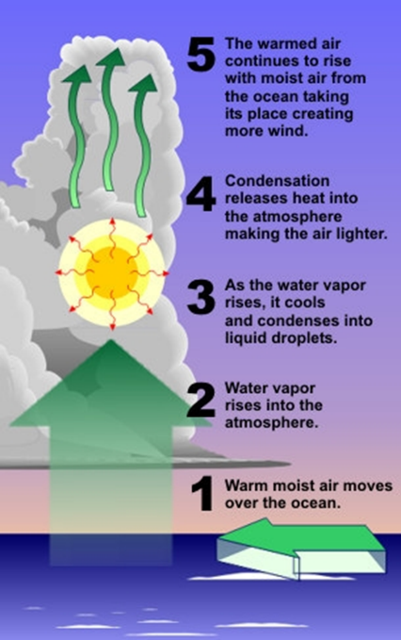Hurricanes can only develop around the latitudes of _________________________________ north of the equator. Here, there is a converging of the easterly trade winds and a plentiful supply of _________________, leading to the development of _______________________.

What is latent heat? In your own words explain the role that latent heat has in the development of tropical storms

These trade winds are on a curved path due to the rotation of the earth. This is known as the ______________________________.

At what wind speed does a tropical storm become a category 1 hurricane/cyclone/typhoon? _________________

What scale are hurricanes measured on? _____________________________

What is the clear zone in the centre of a hurricane called? _________________. What are conditions like here? _______________________.

Where is the most destructive part of the hurricane? ________________________________

What wind speeds does a category 5 exceed? _______________________

Other than strong winds what other hazards do tropical storms create? _________________________________

____________________________________________________________________________________________

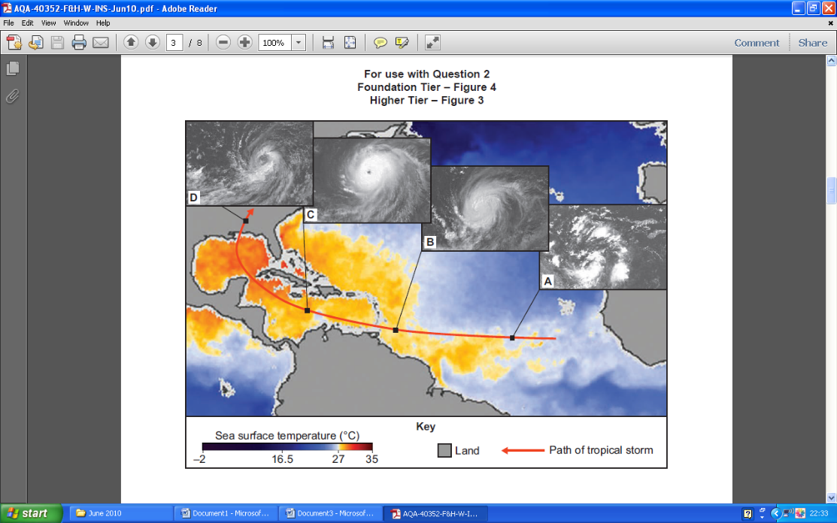

A=Embryo / birth

B=Developing

C=Mature

D= Declining

Identify the stage of the storm:

With sea surface temperatures over 27°C, warm air rises and starts to spin: ________________

Clusters of thunderstorms drift over warm ocean waters: ___________

As the tropical storm moves over land, it loses its source of energy and weakens: _______________

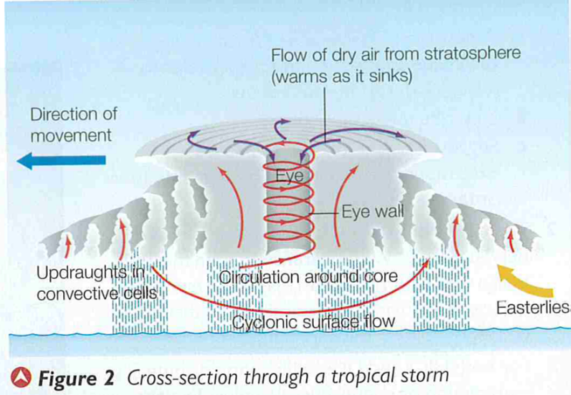As the tropical storm moves over the ocean, it picks up more warm air, wind speeds increase and it grows in size: ______________

Why are there alternating bands of rain? (video clip)

Where is rainfall the heaviest?

Why might a slow tracking tropical storm cause more damage?

*Add an explanation of how each condition contributes to the development of the storm.*

* Sea temperature of 27°C or above;
* An ocean depth of at least 70m;
* A location at least 5° north or south of the Equator;

* Atmospheric instability;
* Uniform winds.

**What is the spatial distribution of tropical storms?**

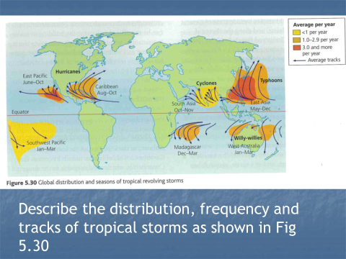

Analyse figure 5.30. Include information on frequency, location, direction of movement and seasons/time of year.

How does the distribution shown in the map link with the conditions needed for tropical storms to develop?

**How is the magnitude, or intensity, of tropical storms measured?**

Tropical storms are measured on the **Saffir-Simpson scale**, a five-point scale based upon central pressure, wind speed, storm surge and damage potential.

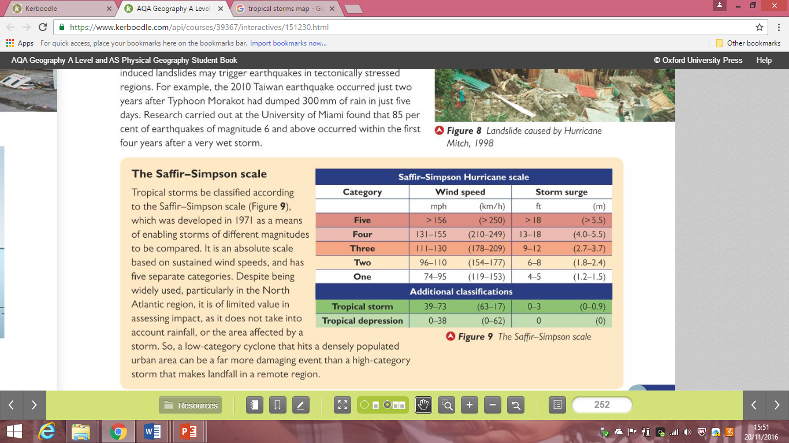Hurricanes reaching Category 3 and higher are considered major hurricanes because of their potential for significant loss of life and damage.

Category 1 and 2 storms are still dangerous, however, and require preventative measures. In the western North Pacific, the term "super typhoon" is used for tropical cyclones with sustained winds exceeding 150 mph.

What disadvantages are there of the Saffir-Simpson scale in assessing the impact of a storm? (What does it not take into account that can have an impact on the storm’s effects?)

**Tropical storm regularity and predictability.**

Tropical storms can be predicted in the same way meteorologists predict the weather.

Northern hemisphere tropical storm season: _________________________________

Southern hemisphere tropical storm season: _________________________________

NOAA (US National Oceanographic and Atmospheric Administration) publishes a prediction of hurricane activity for the forthcoming season. It uses indicators such as ______________­­­________ temperatures, ____________________ conditions and short term _______________________ such as El Niño and ____________ to suggest the number of storms likely.

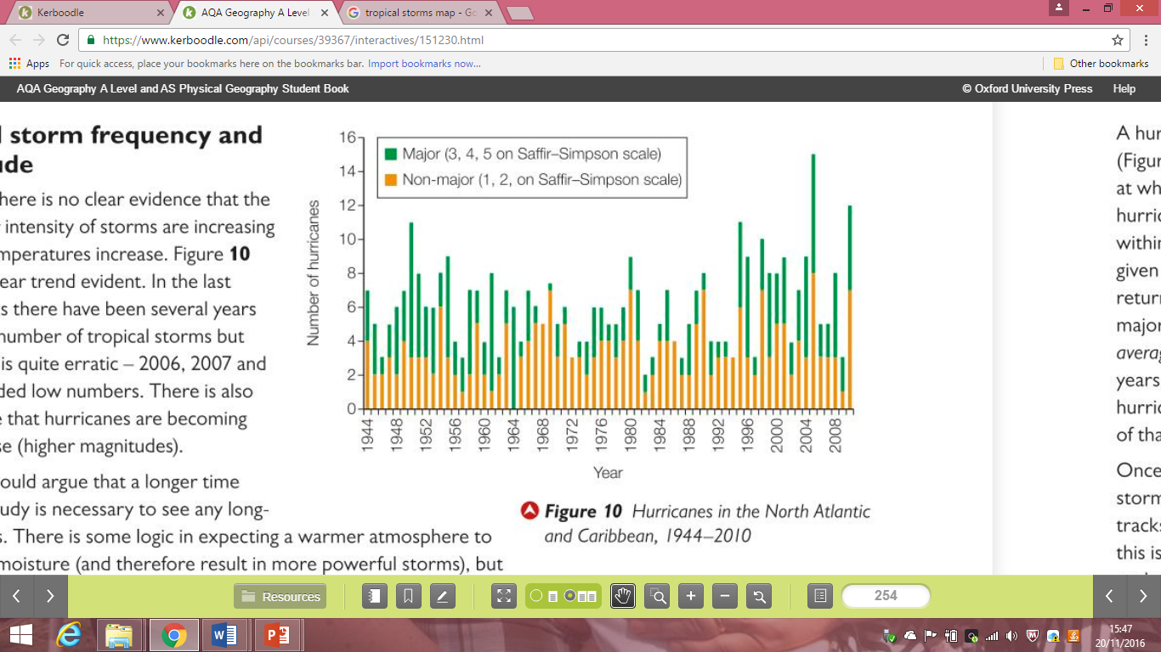

Look at both graphs. Is there any evidence that hurricanes are becoming more frequent?

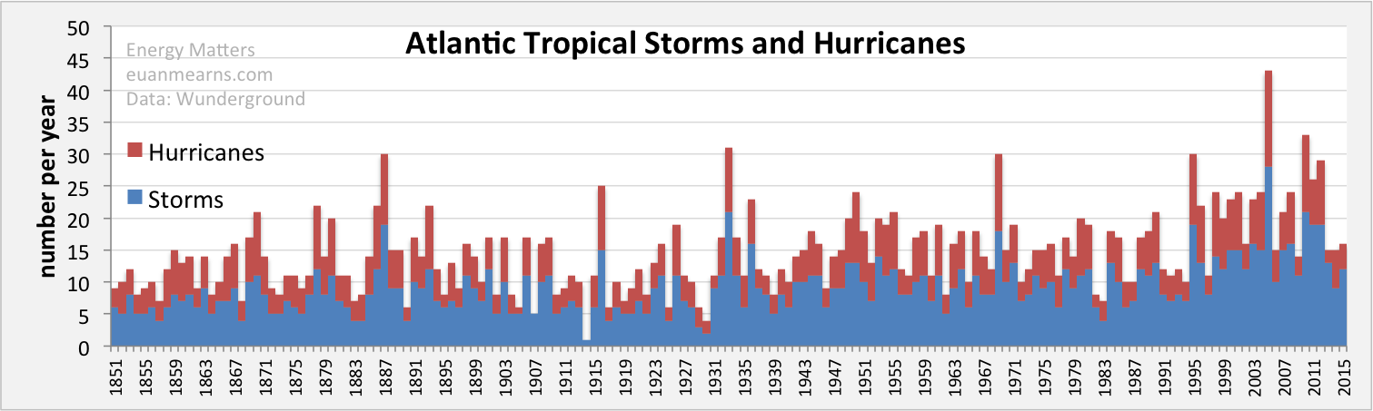

**What are the hazards associated with tropical revolving storms? Complete this table using information from p252-253 Oxford textbook**

|  |  |  |
| --- | --- | --- |
| **Hazard** | **Explanation and impacts** | **Rank the hazard in terms of extent of potential damage/death/ Justify your ranking.** |
| **Strong winds** |  |  |
| **Storm surges** |  |  |
| **Coastal and river flooding** |  |  |
| **Landslides** |  |  |

**What might impact on the vulnerability of people to storm events?**

**Storm hazards question practice:**

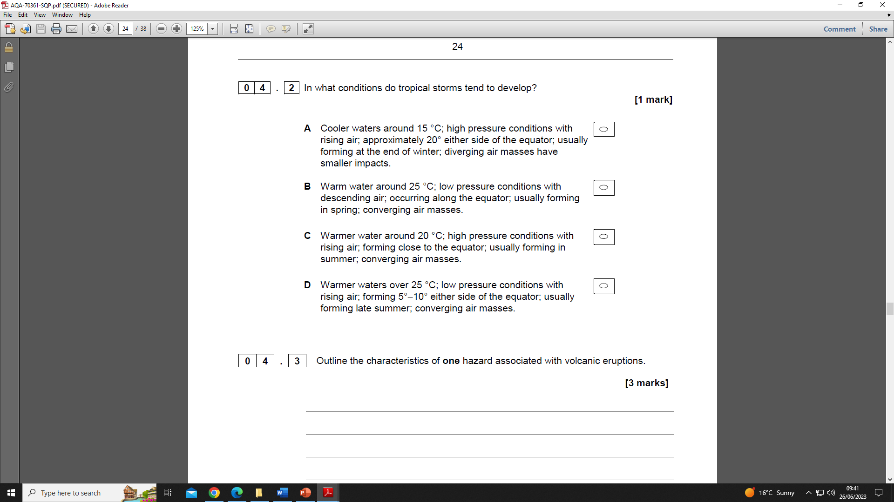

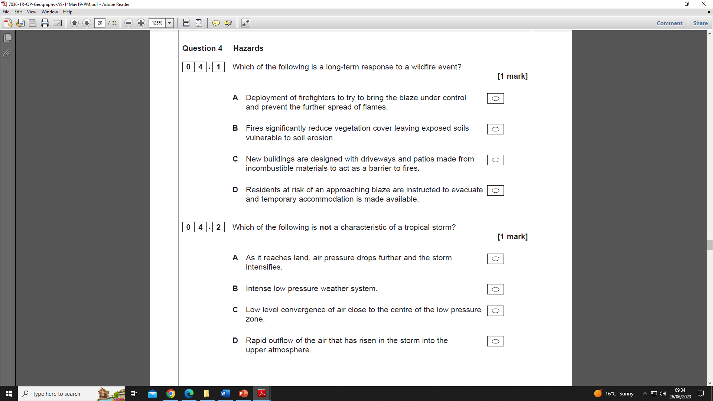

**Outline causes of a storm surge. (4 marks)**

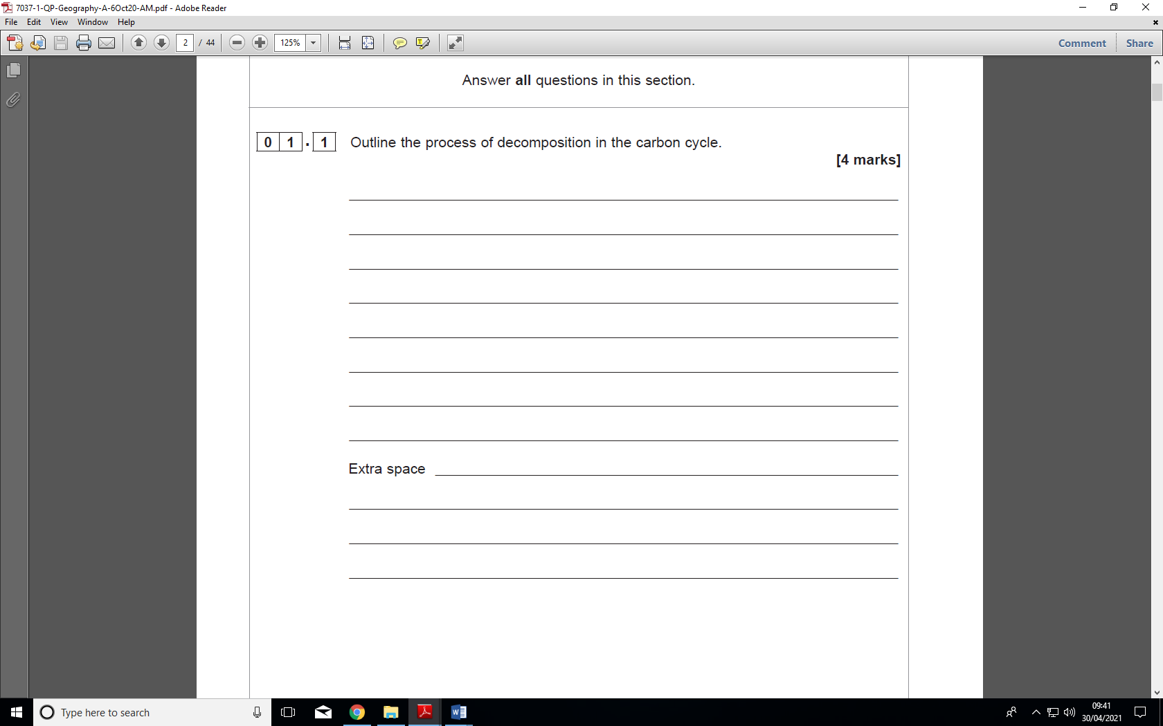

**Figure 1** shows tropical storm basins where storms occur on a regular basis.

**Figure 1**

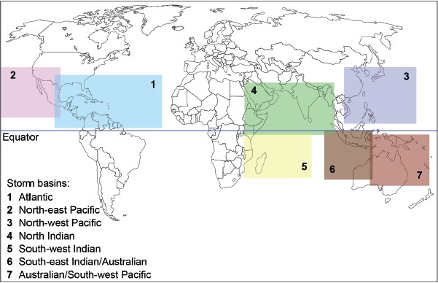

**Figure 2** shows data about the frequency of storm events in each tropical storm basin between 1981 and 2010.

**Figure 2**

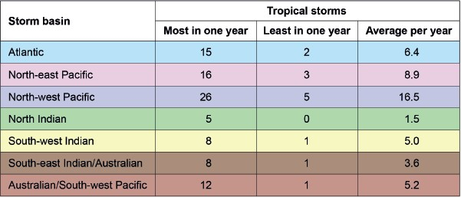

Analyse the data shown in **Figure 1** and **Figure 2**.

**[6 marks]**