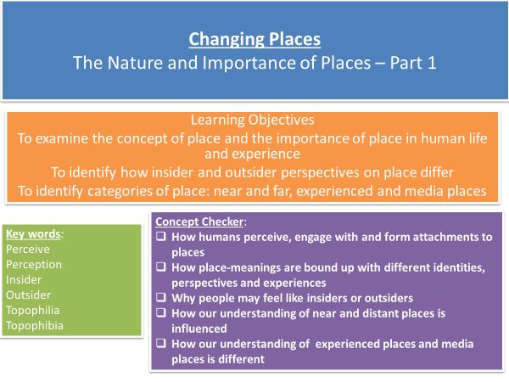

**Official definition:**

**Q - What do you think is meant by place?**

* **Places do not need to have a fixed location e.g. a cruise ship or a website but may invoke a sense of belonging.**
* **History can give a sense of place e.g. where ancestors are from and so a sense of belonging is invoked even if it has not been visited e.g. Rome.**
* **Places are dynamic and are subject to constant change in their structure and meaning e.g. Stratford changing due to the Olympics.**
* **Places are influenced from outside as people, ideas and objects pass in an out of a place**

**Examine the following images. How and why might people’s sense of place of these places vary?**

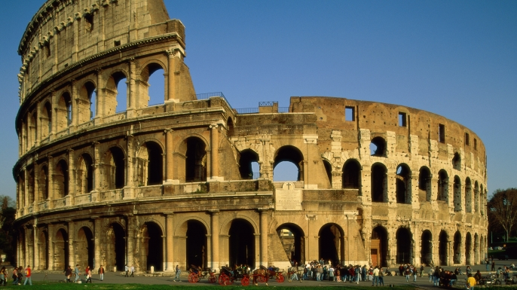

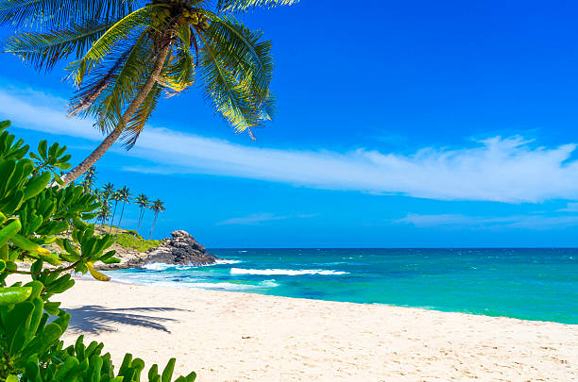

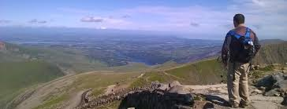

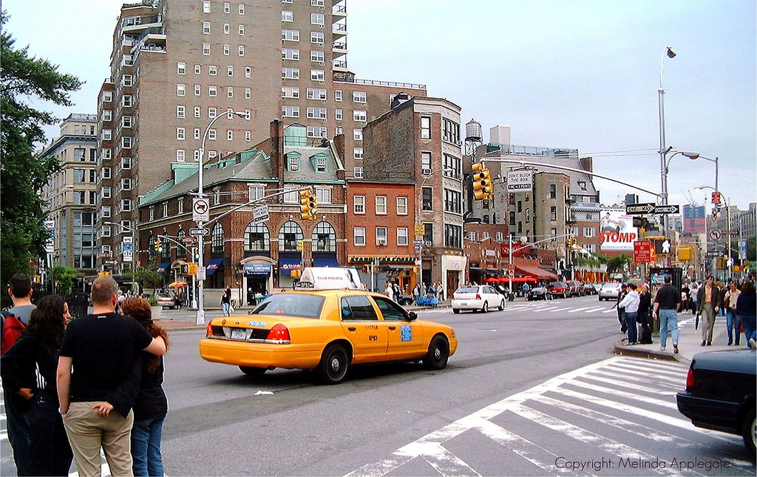

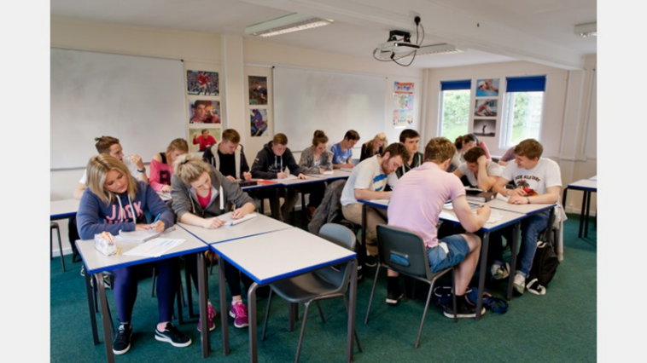

**What influences people’s sense of place?**

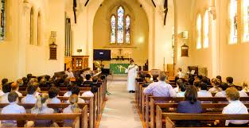 

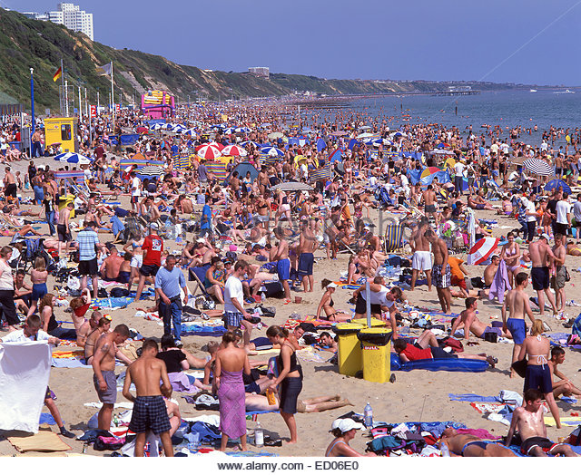

**How might different concepts of place lead to conflict? In pairs/groups come up with a list of possible conflicts – think of the previous images shown**

* The depth of feeling (attachment) we have for a place is influenced by the depth of our knowledge and understanding of it – this attachment increases with age, as we learn more about our home.
* Our attachment to a place is also influenced by the quality or intensity of experience we have there. The more enjoyable or safe the experience then the greater the attachment

**How is your sense of place for where you live different to a place that you have been on holiday?**

**Topophilia:** a strong sense of place or love of particular places e.g. **____________________**

**Topophibia:** a fear or dread of certain places e.g**. ________________________________**

**Insiders and outsiders**

* Our sense of place can be so strong that it can be a central part of our identity
* Sense of place can vary in scale so that we can feel identity from own home village/town/city to nation/continent

**What makes people feel like they are outsiders in a place?**

**List as many ideas as you can as to why some people may not feel that they ‘belong’ in a place**

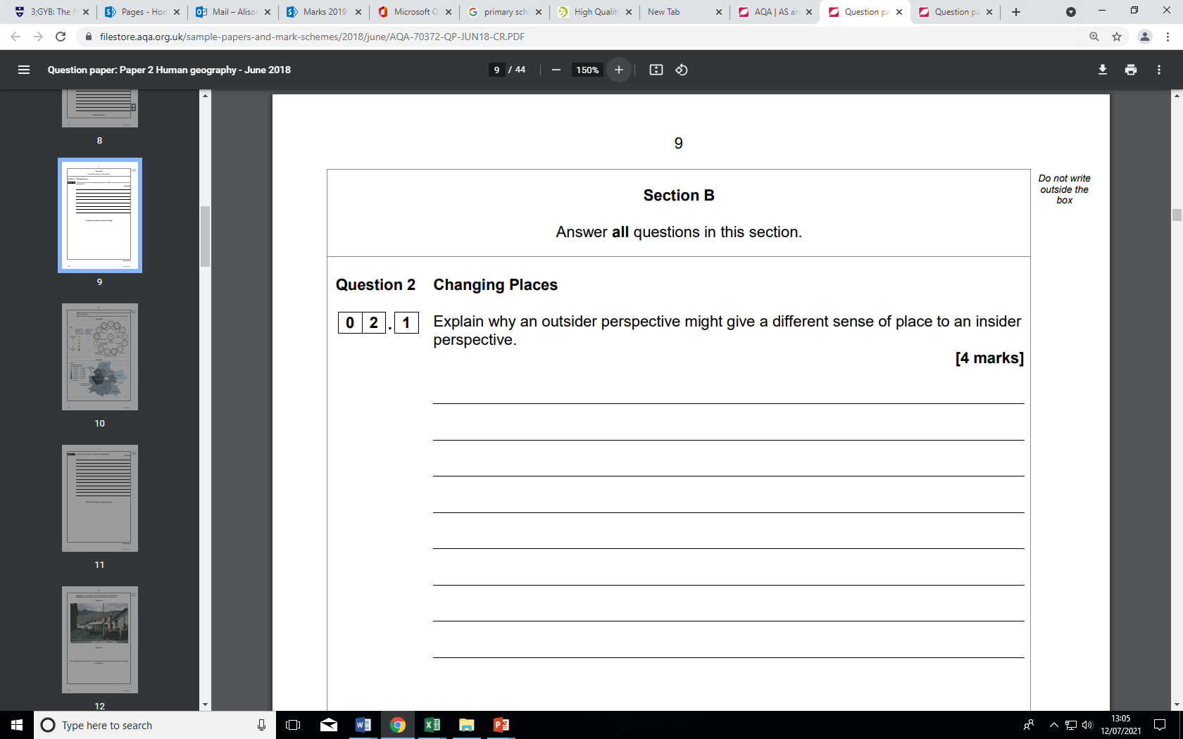

**Our perspective of place can change over time.**

**An area of town may be busy and feel safe during the day and deserted and threatening at night**

**Task:**

**Can you think of other examples where perceptions of place have changed over time?**

**Near and Far Places**

The terms ‘near’ and ‘far’ can have 2 potential meanings when it comes to place. They could refer to:

1)

2)

Some places can feel more familiar than others. ‘Geographically near’ places do not automatically foster identities of familiarity and belonging and that in these days of globalised culture, travel and media far-off places are not automatically strange, uncomfortable or different.

**Think of an example for this ………………**

* The concept of near and far often leads to a ‘them and us’ attitude
* This can sometimes lead to perceived differences that lead to racist attitudes
* Racist ideologies have been used to justify atrocities committed in wars and by colonial powers, including the British e.g. British in India

**Can you think of any ways in which we, in the UK, compare ourselves to others? Are these comparisons fair/accurate?**

**Experienced Place and Media Place**

**Definition of experienced place –**

**Definition of media place –**

People travel more today than in the past and therefore have more real life experiences of places. People have a greater emotional attachment to places that they have experienced.

When in a place all the senses are stimulated – smell, taste, sight, hearing and so a greater understanding of a place is gained. Experience turns undifferentiated space into place

**Complete a spider diagram** of all the types of media which influence our sense of space

**For each of them – evaluate their strength and weaknesses in establishing a sense of place**

If we go on a virtual field trip on the World Wide Web, is the sense of place (place meaning) we gain less valid than if we had visited in person? **Discuss.**

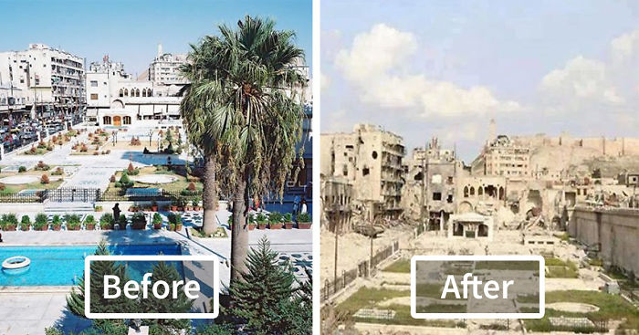

**Exam style question:**

**How might sense of place vary between individuals and over time? (6 marks)**

**You will need to give examples in your answer as evidence.**

**Aleppo – Syria**

**An example of a changing sense of place. Are our views biased?**

**Research and find some contrasting media images of the same place**

**Find some articles on places that have differing views – think about reviews on places visited**

**Flip Learning Task - find out what is meant by the following:-**

* **Clone town**
* **Glocalisation – McDonalds**
* **Bristol pound**