**Name:**

**Urban Policy and Regeneration in Britain since 1979**

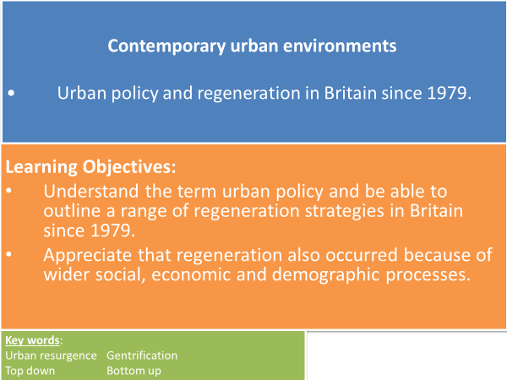

**TASK: Match the correct key term to the definition.**

**Top down Urban Resurgence Gentrification Bottom up**

* **_______________________** – the development of an area after a period of decline.
* **_______________________** – the renewal of an area leading to an influx of affluent people.
* **_______________________** – when the decision to undertake projects or developments is made by a central authority such as government with little or no consultation with the local people whom it will affect.
* **­­­­­­­­­­­­­­­­­_______________________** – when local people are consulted and supported in making decisions to undertake projects or developments that meet one or more of their specific needs.

**Urban Policy in the UK since 1979**

From the 1950s to the 1970s the UK’s cities were in decline demographically and economically.

* Urban policy relates to the strategies chosen by local or central government to manage the development of urban areas and reduce urban problems.
* Regeneration has been a key element of urban policy since the 1980’s.
* Early strategies focussed on **‘top-down’** economic regeneration subsequent policies recognised a more holistic approach tackling economic, social and environmental problems from the **‘bottom-up’** was needed.

**TASK: Read the details of urban policies below. Identify if they are more ‘top down’ or ‘bottom-up’.**

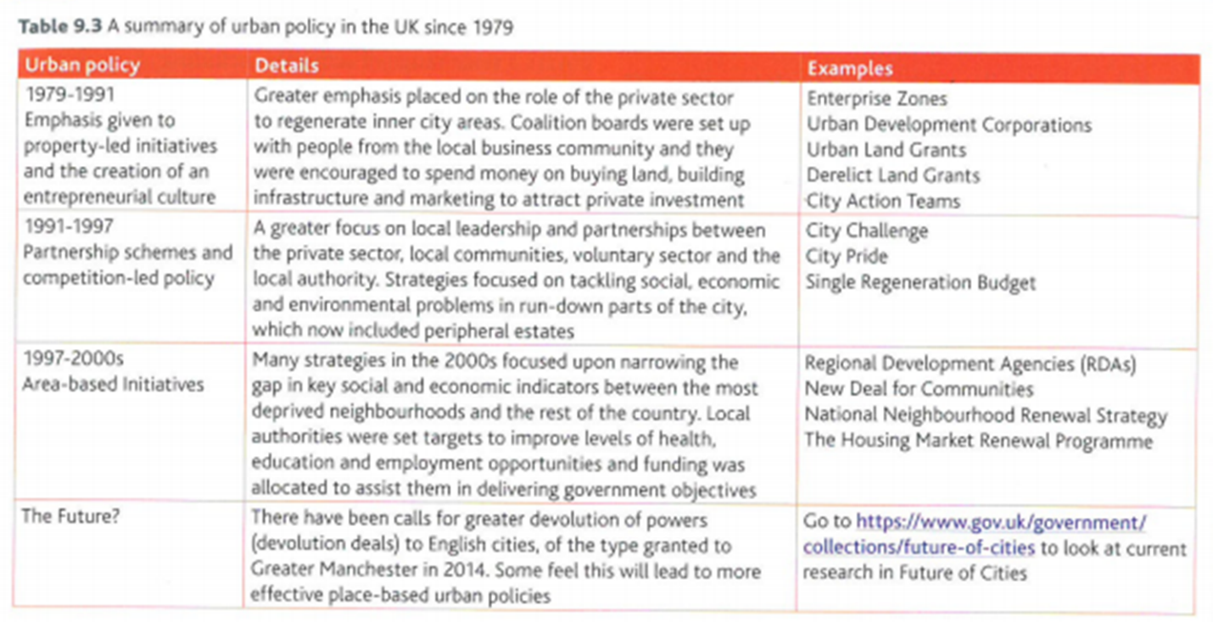

**Regeneration policy: Urban Development Corporations (1980s)**

* Urban development Corporations (UDC’s) set up in 1980’s & 1990’s.
* Responsible for physical, economic and social regeneration of selected inner city areas with large amounts of derelict and vacant land.
* Given planning approval powers over & above local authority.
* To spend public money to buy land, build infrastructure and marketing to attract private investment. Intention for private investment to be 4/5 times greater than public investment.

**Case Study – London Docklands**

**TASK: Watch the video clip and make detailed notes on *reasons* for the decline in the London docklands and *how* the area has been re-generated through re-development.** <http://www.youtube.com/watch?v=eWkmDyEN70U&feature=related>

**Map showing London Docklands Development Corporation (LDDC) area and Transport in 2000**

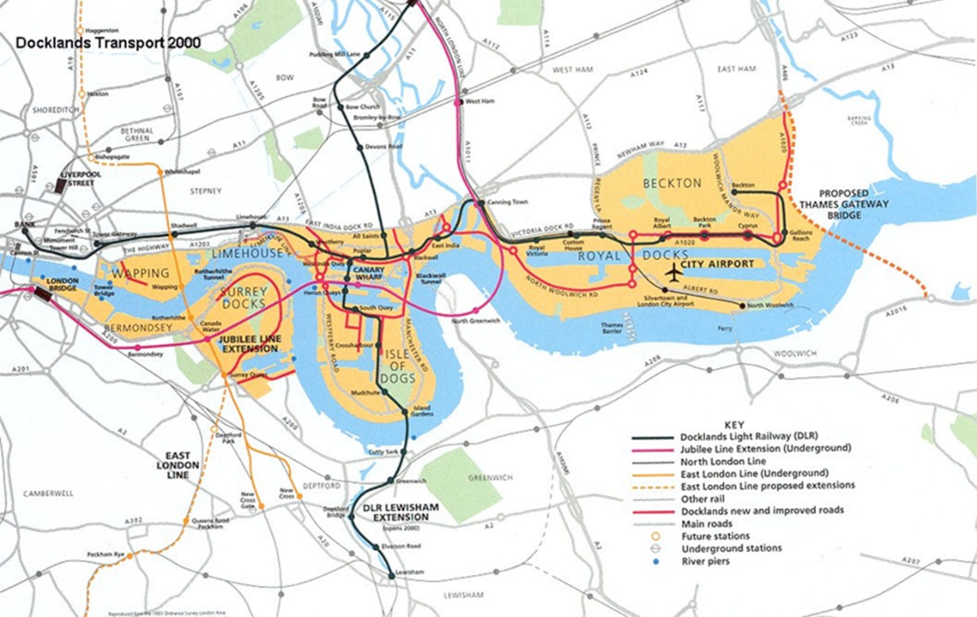

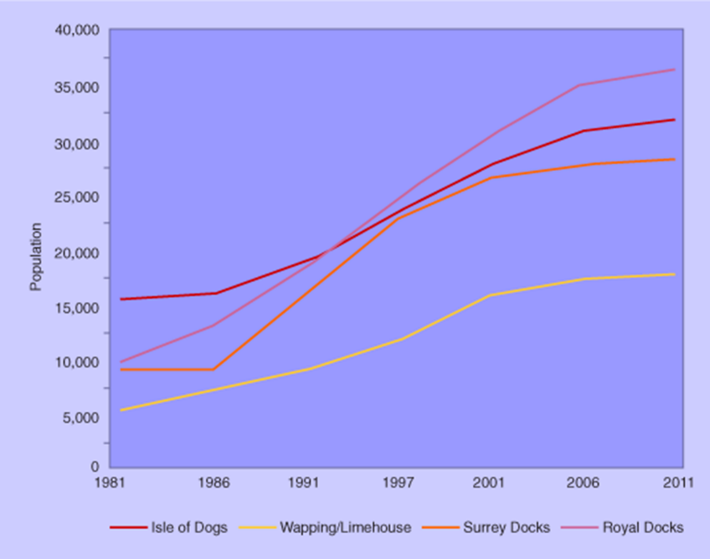

**TASK: Analyse the graph to show population change within different areas of London Docklands. (PADL)**

**Regeneration policy: City Challenge (1990s)**

* City Challenge Partnerships – shift of funding mechanisms to competitive bidding.
* Local authority propose imaginative project, form a partnership in local inner-city area with the private sector and the local communities.
* Partnership submits a 5-year plan to central government in competition with other inner-city areas.
* Local authorities had to bid competitively to be awarded funding for projects.
* The most successful schemes combined social aims with economic and environmental outcomes.
* By 1993 over 30 City Challenge Partnerships had been established and accounted for over 20% of expenditure on inner-city regeneration.

**Case Study - Hulme, Manchester**

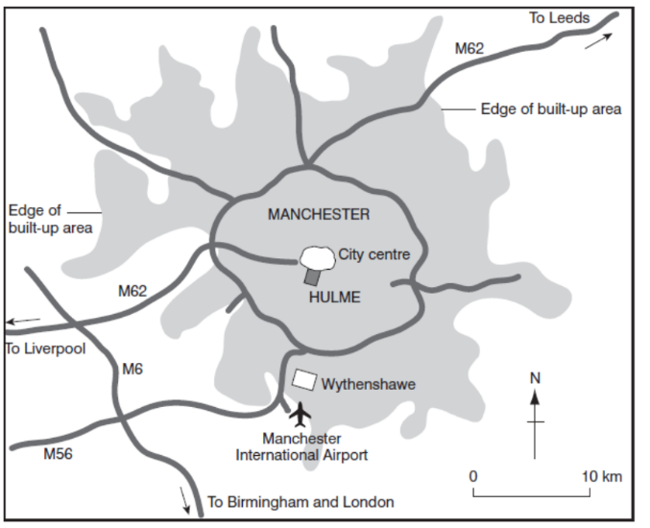

**TASK: Watch the video clips and make notes on why regeneration was needed and outcomes in Hulme, Manchester.**

<https://www.youtube.com/watch?v=Iy_4ZPPD-cE>

**Regeneration policy: New Deal for Communities (2000s)**

* New Deal for Communities (NDC) is a regeneration programme for some of England’s most deprived areas.
* Local NDC partnerships were established for each regeneration area to ensure that change is community led.
* Initially in 1998, 17 local partnerships were announced, later increased in 1999 with the establishment of a second round of 22 partnerships, increasing the total number to 39.

**Case Study - New East Manchester**

* One of the first established Urban Regeneration Companies, New East Manchester Ltd is a partnership initiative between Manchester City Council, the North West Development Agency and the communities of East Manchester.

**Location maps of East Manchester**

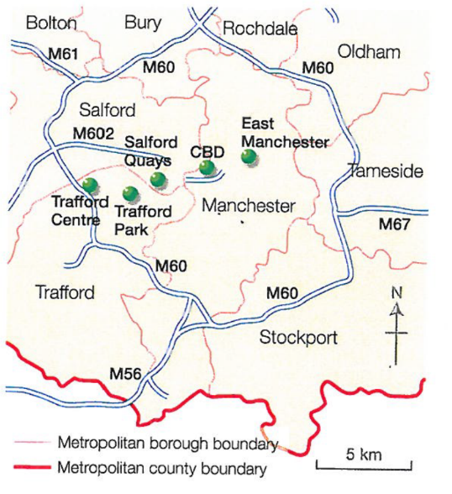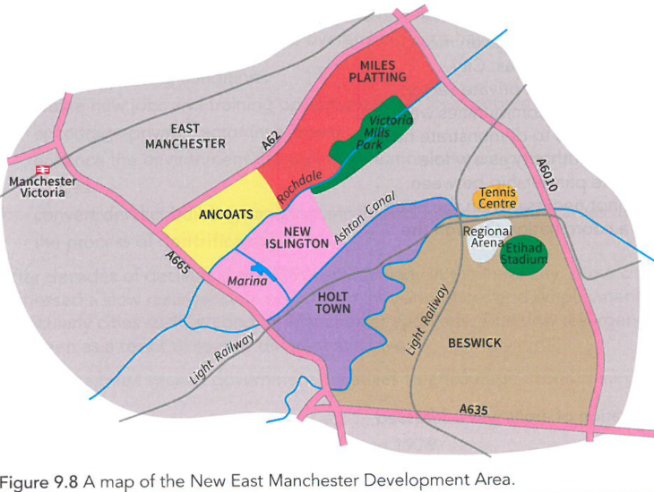

**TASK: Watch the clip and make notes on why regeneration was needed and outcomes in the New Islington area of East Manchester.**

[**https://www.youtube.com/watch?v=rmbZ8pCWYnE**](https://www.youtube.com/watch?v=rmbZ8pCWYnE)

**CASE STUDY TASK: Produce a set of notes for each of the following regeneration schemes. You need to ensure you have answered all the questions and tasks. The PowerPoint, resources (GOL) and content in this booklet will help you with your task and the level of detail required.**

|  |  |  |
| --- | --- | --- |
| **Regeneration policy: Urban Development Corporations(1980s) London Docklands**  Resource ‘[Inner Cities: Case Study - Regeneration of the London Docklands](http://geobytesgcse.blogspot.com/2007/03/inner-cities-case-study-regeneration-of.html)’. | **Regeneration policy: City Challenge (1990s)**  **Hulme, Manchester**  Resources: GeoActive ‘Inner City Regeneration: Hulme, Manchester’ and ‘Hulme Ten Years on’ Word document. | **Regeneration policy: New Deal for Communities (2000s)**  **New East Manchester**  Resource: ‘New East Manchester’ Word document. |
| When and why did London Docklands go into to decline? Quote location details and facts to give characteristics of the deprivation in your answer.  What are UDC’s and how do they work? What organisations were involved in the regeneration of the London Docklands? Give details of all those involved.  What have been the changes to the area? Consider environmental, economic regeneration and social changes.  Identify the successes and criticisms of the London Docklands redevelopment.  Use the internet to find photographs of the area before and after regeneration. Annotate these to show improvements to London Docklands.  In your opinion has this regeneration scheme been a success? Use case study detail and the table on the next page to justify your view. | When and why did Hulme go into to decline? Give location details, facts, figures and statistics to give characteristics of the deprivation in your answer.  What are City Challenge schemes and how do they work? Who were the partners involved in Hulme City Challenge? Give details of all those involved.  Give details of impacts of the re-development of Hulme under the following headings – the buildings, landscaping, communications, population, community and services, un-employment, crime and a new image.  What have been the impacts of regeneration?  Use the internet to find photographs of the area before and after regeneration. Annotate these to show improvements to Hulme.  In your opinion has this regeneration scheme been a success? Use case study detail and the table on the next page to justify your view. | When and why did East Manchester go into decline? Give location details, facts and figure to give characteristics of the deprivation in your answer.  What are New Deals for Communities Partnerships and how do they work? Who were the partners involved in East Manchester regeneration? Give details of all those involved.  Give details of the re-development of East Manchester regeneration. Consider environmental, economic and social regeneration.  Use the internet to find photographs of the area before and after regeneration. Annotate these to show improvements to East Manchester.  In your opinion has this regeneration scheme been a success? Use case study detail and the table on the next page to justify your view. |

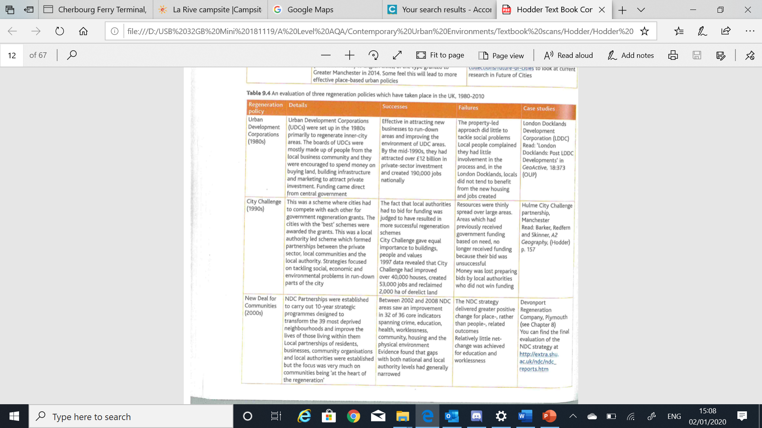

**Exam Style Questions**

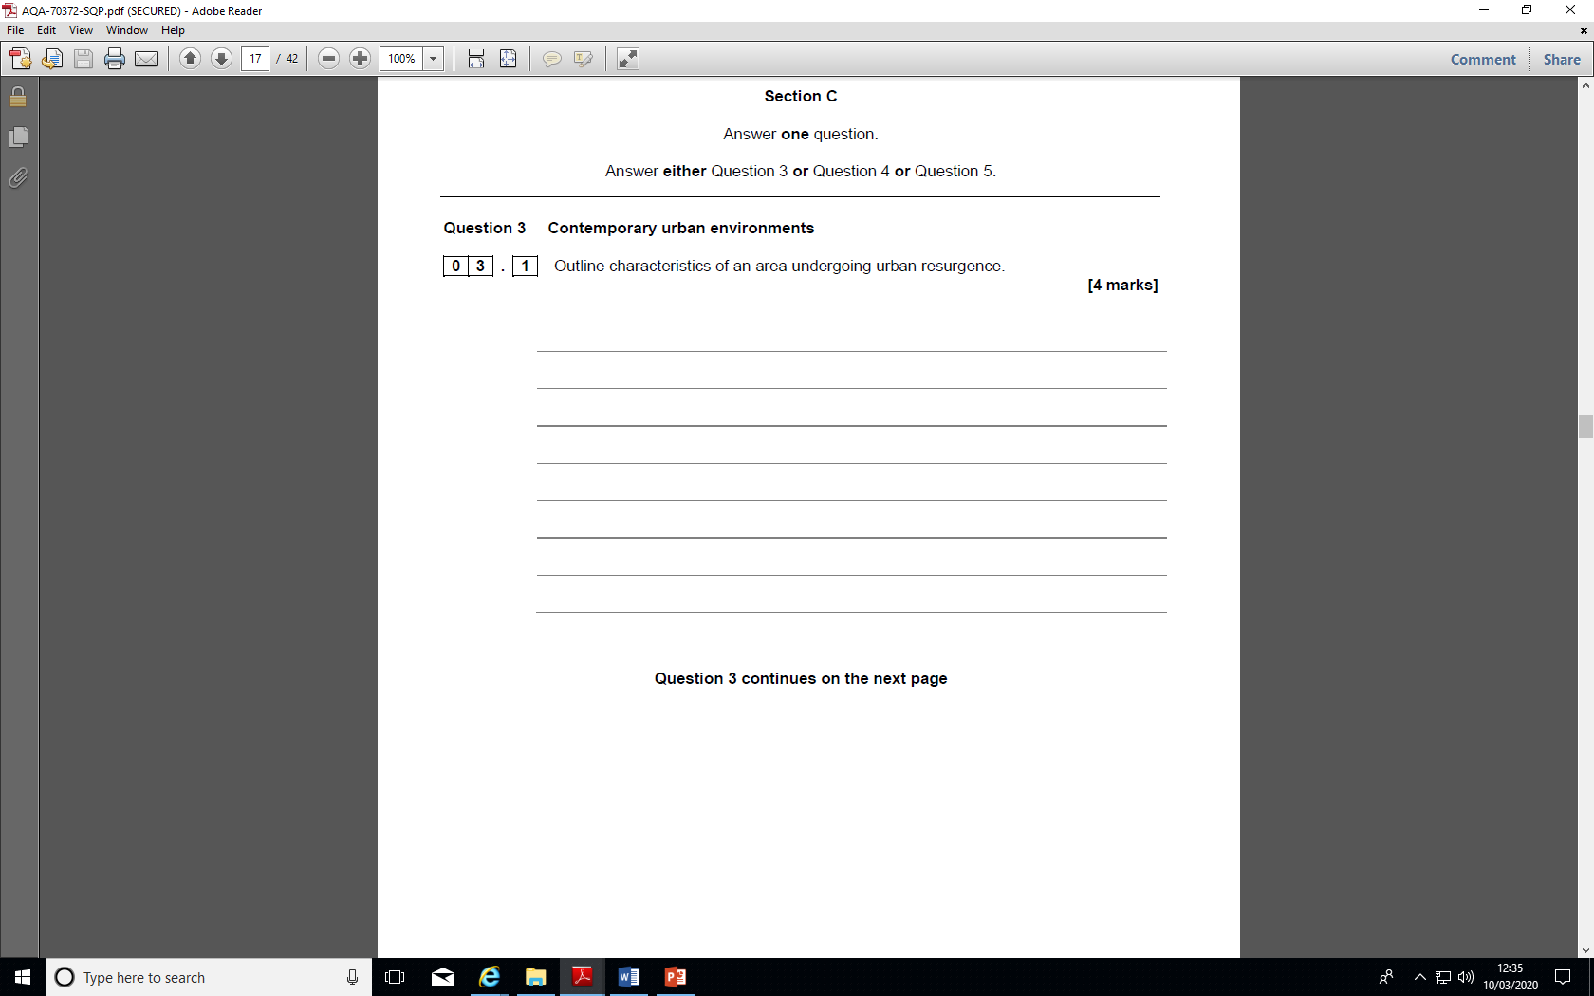

**Evaluate the different urban policies put in place in Britain since 1979. (20 marks)**