**Name:**

**New Urban Land Uses and the Concept of the Post-Modern Western City**

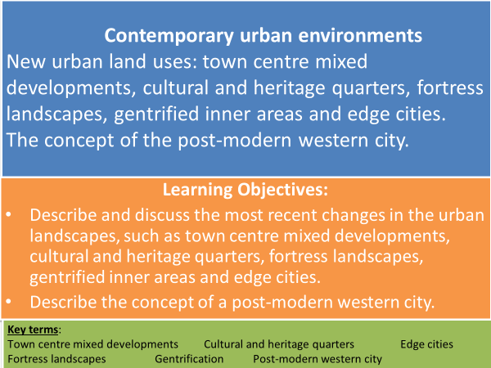

**New urban land uses**

**Recent changes in the urban land uses include:**

**Town centre mixed developments -** redeveloping town centres with a combination of residential, commercial, cultural, institutional, or industrial uses. These functions are designed to be physically and functionally integrated with free-flowing pedestrian access. E.g. The Shard, London.

**Cultural and heritage quarter -** to promote growth in cities many UK cities have developed cultural and heritage areas or quarters. These focus on cultural or heritage themes, e.g. arts and the creative industries in order to regenerate them. E.g. Manchester Northern Quarter.

**Fortress landscapes -** city developments that integrate greater security into the design of the building or landscape.

**Edge cities** - self-contained settlements with a concentration of business, shopping and entertainment outside the traditional central business district.

**Gentrified inner areas -** the process of renewal and rebuilding accompanying the influx of middle-class or affluent people into deteriorating areas that often displaces poorer residents.

**TASK: Watch the clip and make notes on the history of Birmingham’s Jewellery quarter and what it has to offer.** [**My Bham: Hidden Gems - Jewellery Quarter - Bing video**](https://www.bing.com/videos/search?q=cultural+and+heritage+quarter+birmingham&&view=detail&mid=6200F0B2D0CD8903E84B6200F0B2D0CD8903E84B&&FORM=VRDGAR)

**TASK: Watch the clip and make notes on how the Meadowell Estate is designing out crime.** [**https://www.bbc.co.uk/programmes/p00xd3xx**](https://www.bbc.co.uk/programmes/p00xd3xx)

**TASK: Use Hodder text book p394-397 to answer the following questions:**

* Identify functions other than retailing that **Town Centre Mixed Developments** include.
* What development has happened in the City Centre Quarter of Exeter?
* What are the 2 pre-requisites **Cultural and Heritage Quarters** must have?
* Using your notes from the video clip – how does Birmingham’s Jewellery Quarter meet these pre-requisites?
* Give 3 reasons why **Gentrification** happens.
* What are concerns about gentrification?
* Name 5 strategies adopted by **Fortress Landscapes** to reduce crime in urban areas.
* What are **Edge Cities** a result of and why is Los Angeles an example of an urban area with Edge Cities?
* What features are Edge Cities developed close to and what amenities do Edge Cities have?
* Which New Urban Landscapes could form the notion of ‘insiders’ and ‘outsiders’? Justify your answer.

**Gentrified Inner City Areas - Notting Hill, London**

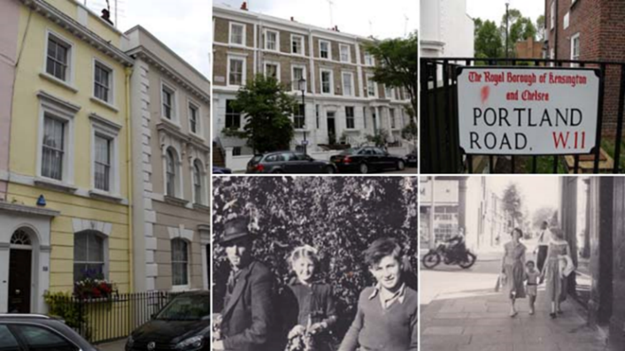

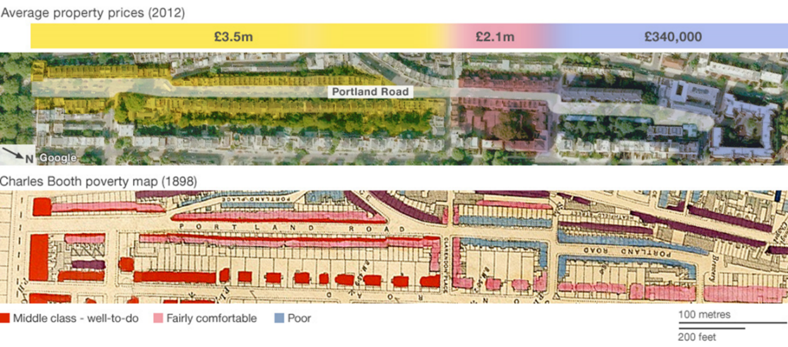

**TASK: Watch ‘The Secret History of our Streets’ on e-stream #8399 about Portland Road, Notting Hill. (26 mins – 50). Make notes on the following and include evidence:**

* How have the socio-economic groups of the residents changed over time?
* How are residents ‘segregated’?
* List the types of services are on Portland Road? How have they changed? Who are these targeted at?
* How have property prices changed over time?

**TASK:** **Note down costs and benefits of gentrification. Link to *insiders* and *outsiders* from Changing Places topic.**

**What is a postmodern city?**

The postmodern city is an urban form associated with changes in urban structure, architectural design and planning and reflects the changed social and economic conditions of the late twentieth century in some western cities.

**The characteristics of modern and post-modern cities**

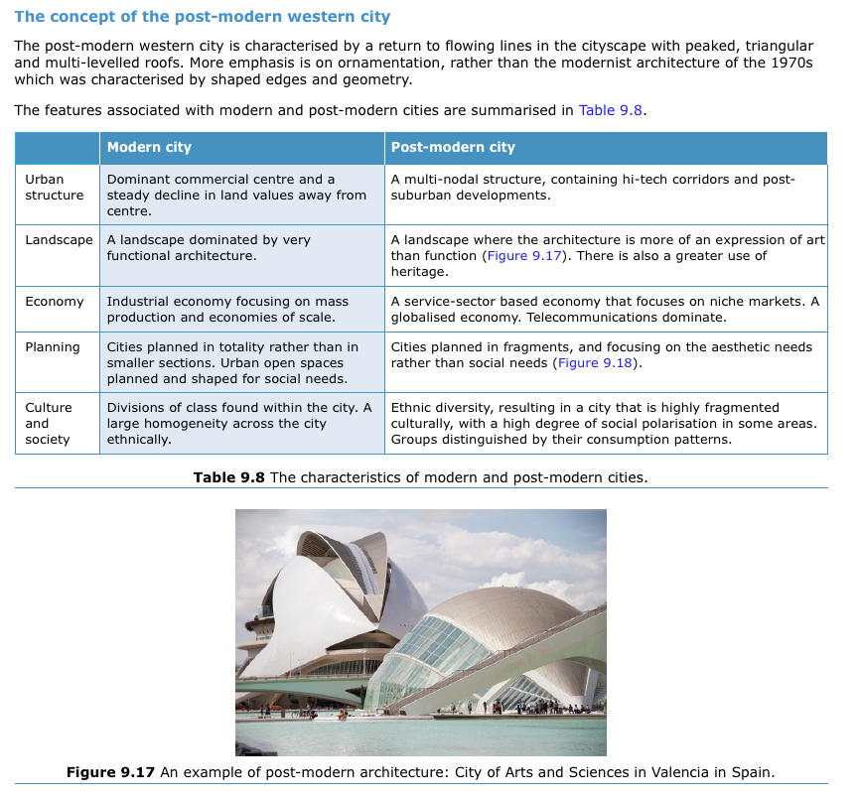

**TASK: Study the table – why do you think that African cities are not described as postmodern?**

**TASK: Use pages 138 and 143 Oxford text book to complete the table.**

* **What evidence supports Las Vegas being a postmodern city?**
* **To what extent does the city of Los Angeles show characteristics of postmodernism?**

|  |  |  |  |
| --- | --- | --- | --- |
|  | **Post -modern city characteristics** | **Las Vegas – evidence of being a postmodern city** | **Los Angeles – evidence of characteristics of postmodernism** |
| **Urban Structure** | **A multi-nodal structure containing high tech corridors and post-suburban developments.** |  |  |
| **Landscape** | **A landscape where the architecture is more of an expression of art than function. There is also a greater use heritage.** |  |  |
| **Economy** | **A service-sector based economy that focuses on niche markets. A globalised economy. Telecommunications dominate.** |  |  |
| **Planning** | **Cities planned in fragments, and focusing on the aesthetic needs rather than social needs.** |  |  |
| **Culture & Society** | **Ethnic diversity resulting in a city that is highly fragmented culturally with a high degree of social polarisation in some areas. Groups distinguished by their consumption patterns.** |  |  |

* **Using the evidence in the table does Los Angeles have any similarities with postmodern Las Vegas?**

**TASK: Complete the following Exam Style Questions.**

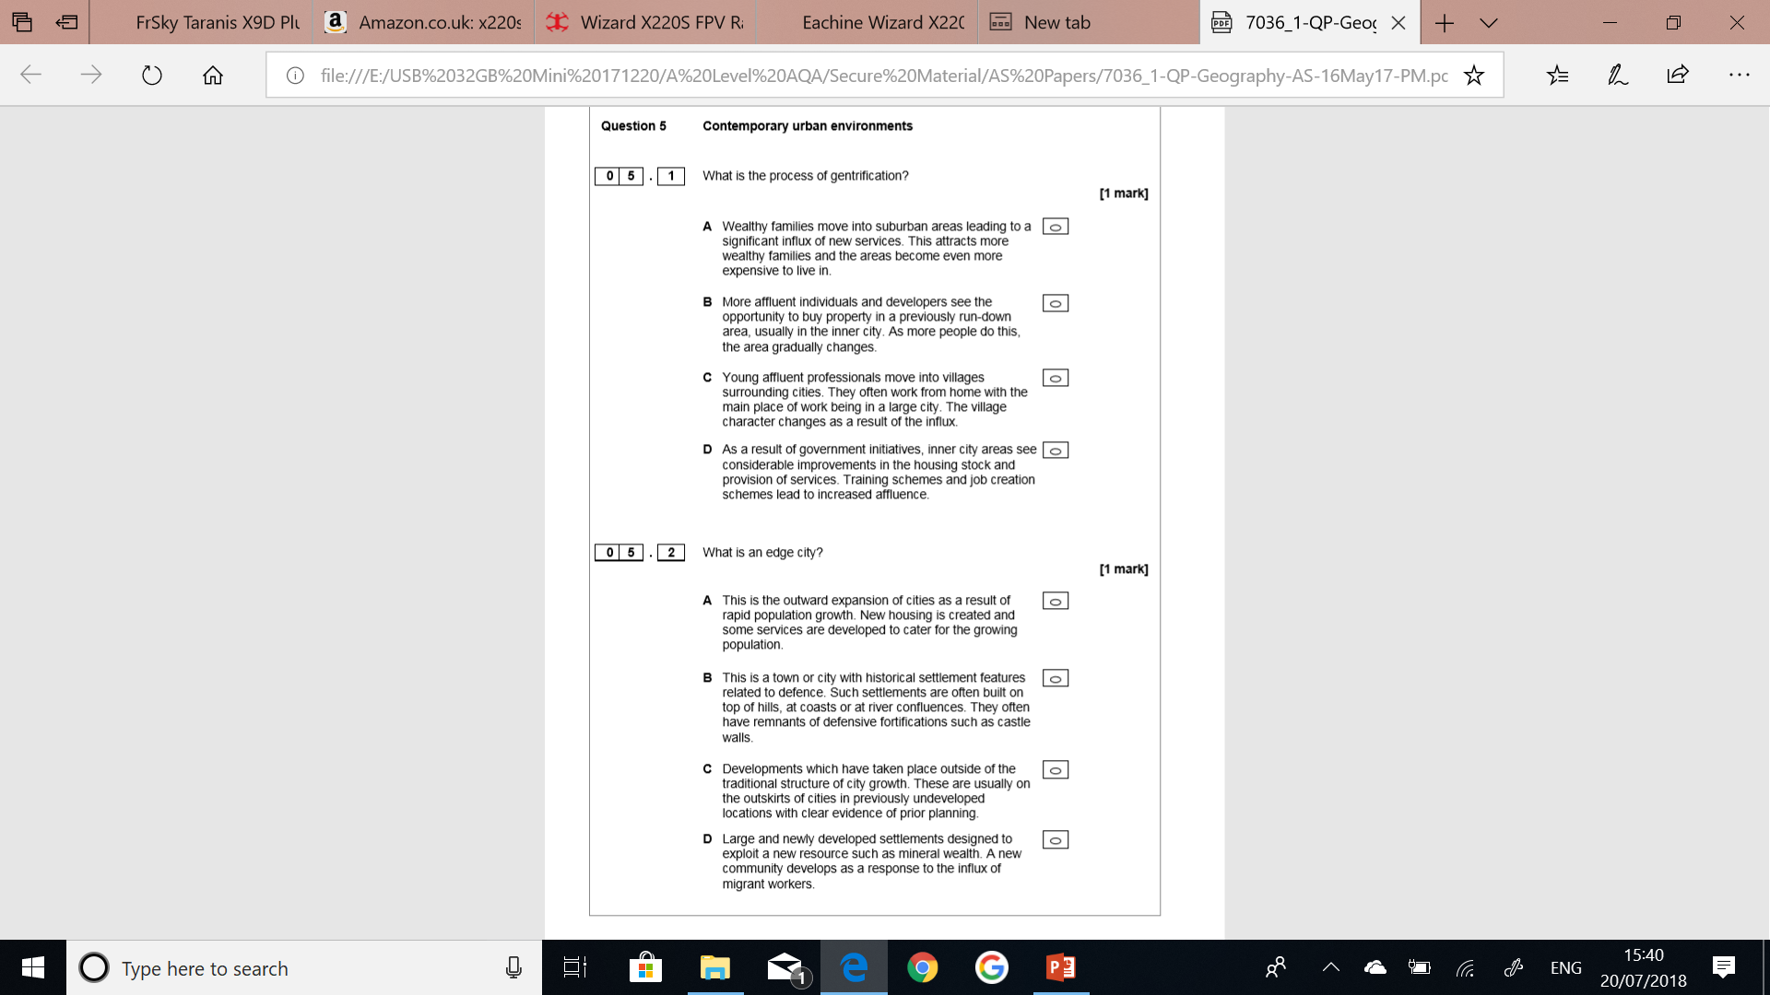



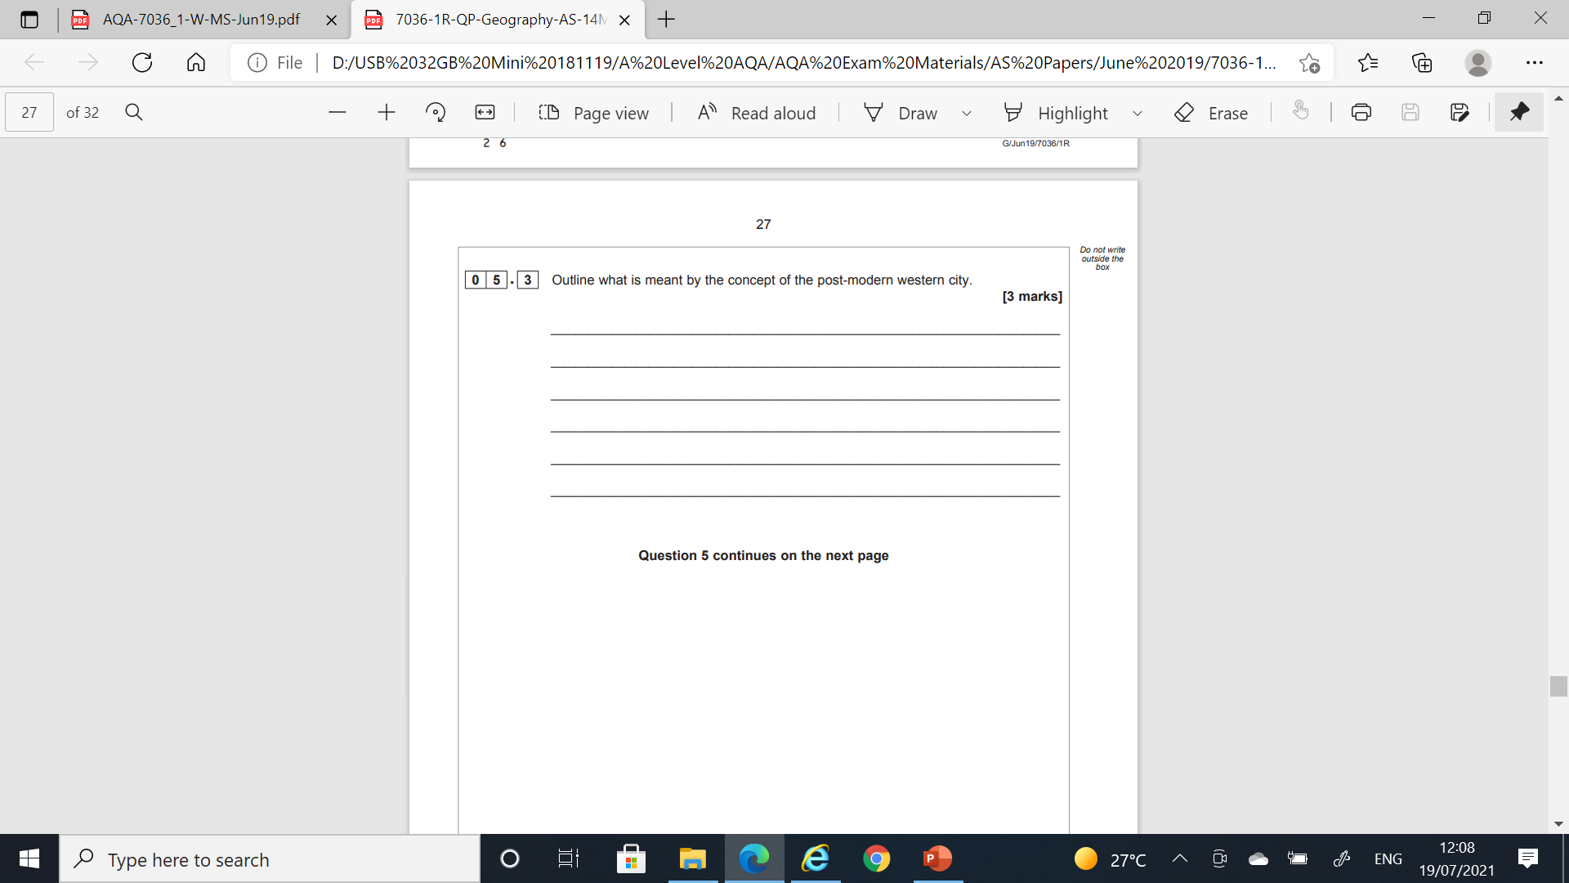

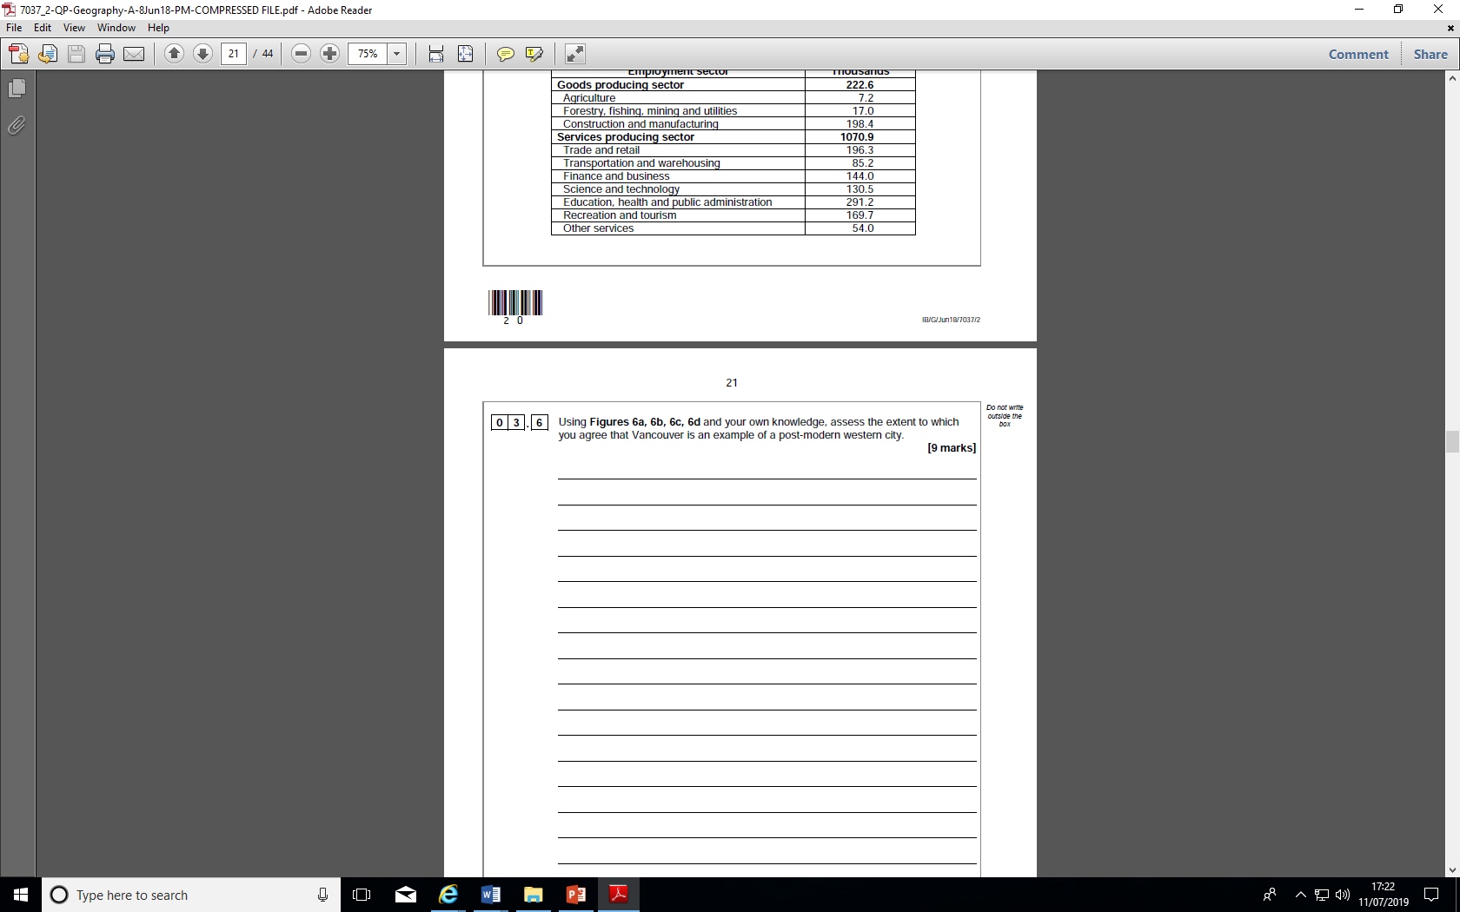

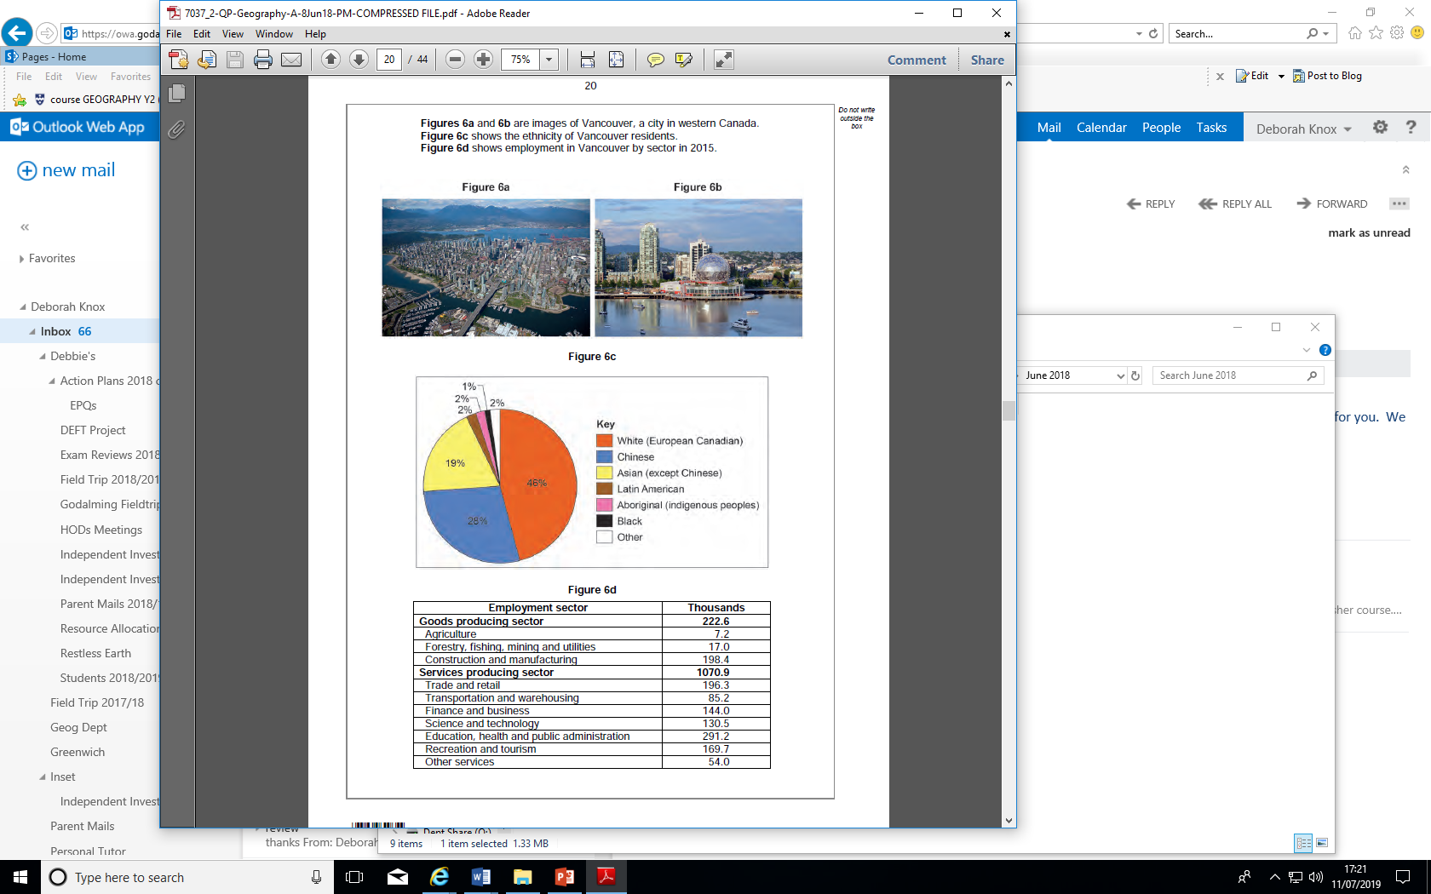

**Extension Tasks.**

* What are the ethical issues surrounding certain groups being excluded from particular places? Why has this happened?
* What is postmodernism? What evidence of postmodernism exists in UK cities or is it just an “American” thing?