**The following is taken from an example investigation on the AQA website**

**ttps://filestore.aqa.org.uk/resources/geography/AQA-70373-NEA-C.PDF**

How do the characteristics of the beach and sediment vary along Chesil Beach on the Jurassic Coast, Dorset?

How the title links to the specification content Chesil Beach is a coastal depositional landform (a Tombolo or Barrier Beach) This links to the specification as it will be an investigation into a depositional landform on the coast so links in with Coastal Systems and Landscapes – in particular it links with 3.1.3.2 Systems and Processes as it looks at a high energy coast and the processes of deposition also 3.1.3.3 Coastal Landscape Development – as it is looking at a depositional landform and also the role of sea level change as this was involved in the original formation of Chesil Beach.

Chesil Beach is depositional landform in Dorset and lies on the Jurassic Coast World Heritage Site. It is sometimes described as a Tombolo and sometimes as a barrier beach. The landform has obvious changes from one end to the other and this is what I am hoping to investigate in this piece of work. Chesil Beach lies between Burton Bradstock in the west and Portland in the east. It is 18 miles long and up to 200 metres wide. It is 15 m high in some places and contains 180 billion pebbles. (Dorset Wildlife Trust figures). Between Abbotsbury and Weymouth, the beach does not lie exactly along the coast but has trapped water behind to create the Fleet which is about 8 miles long.

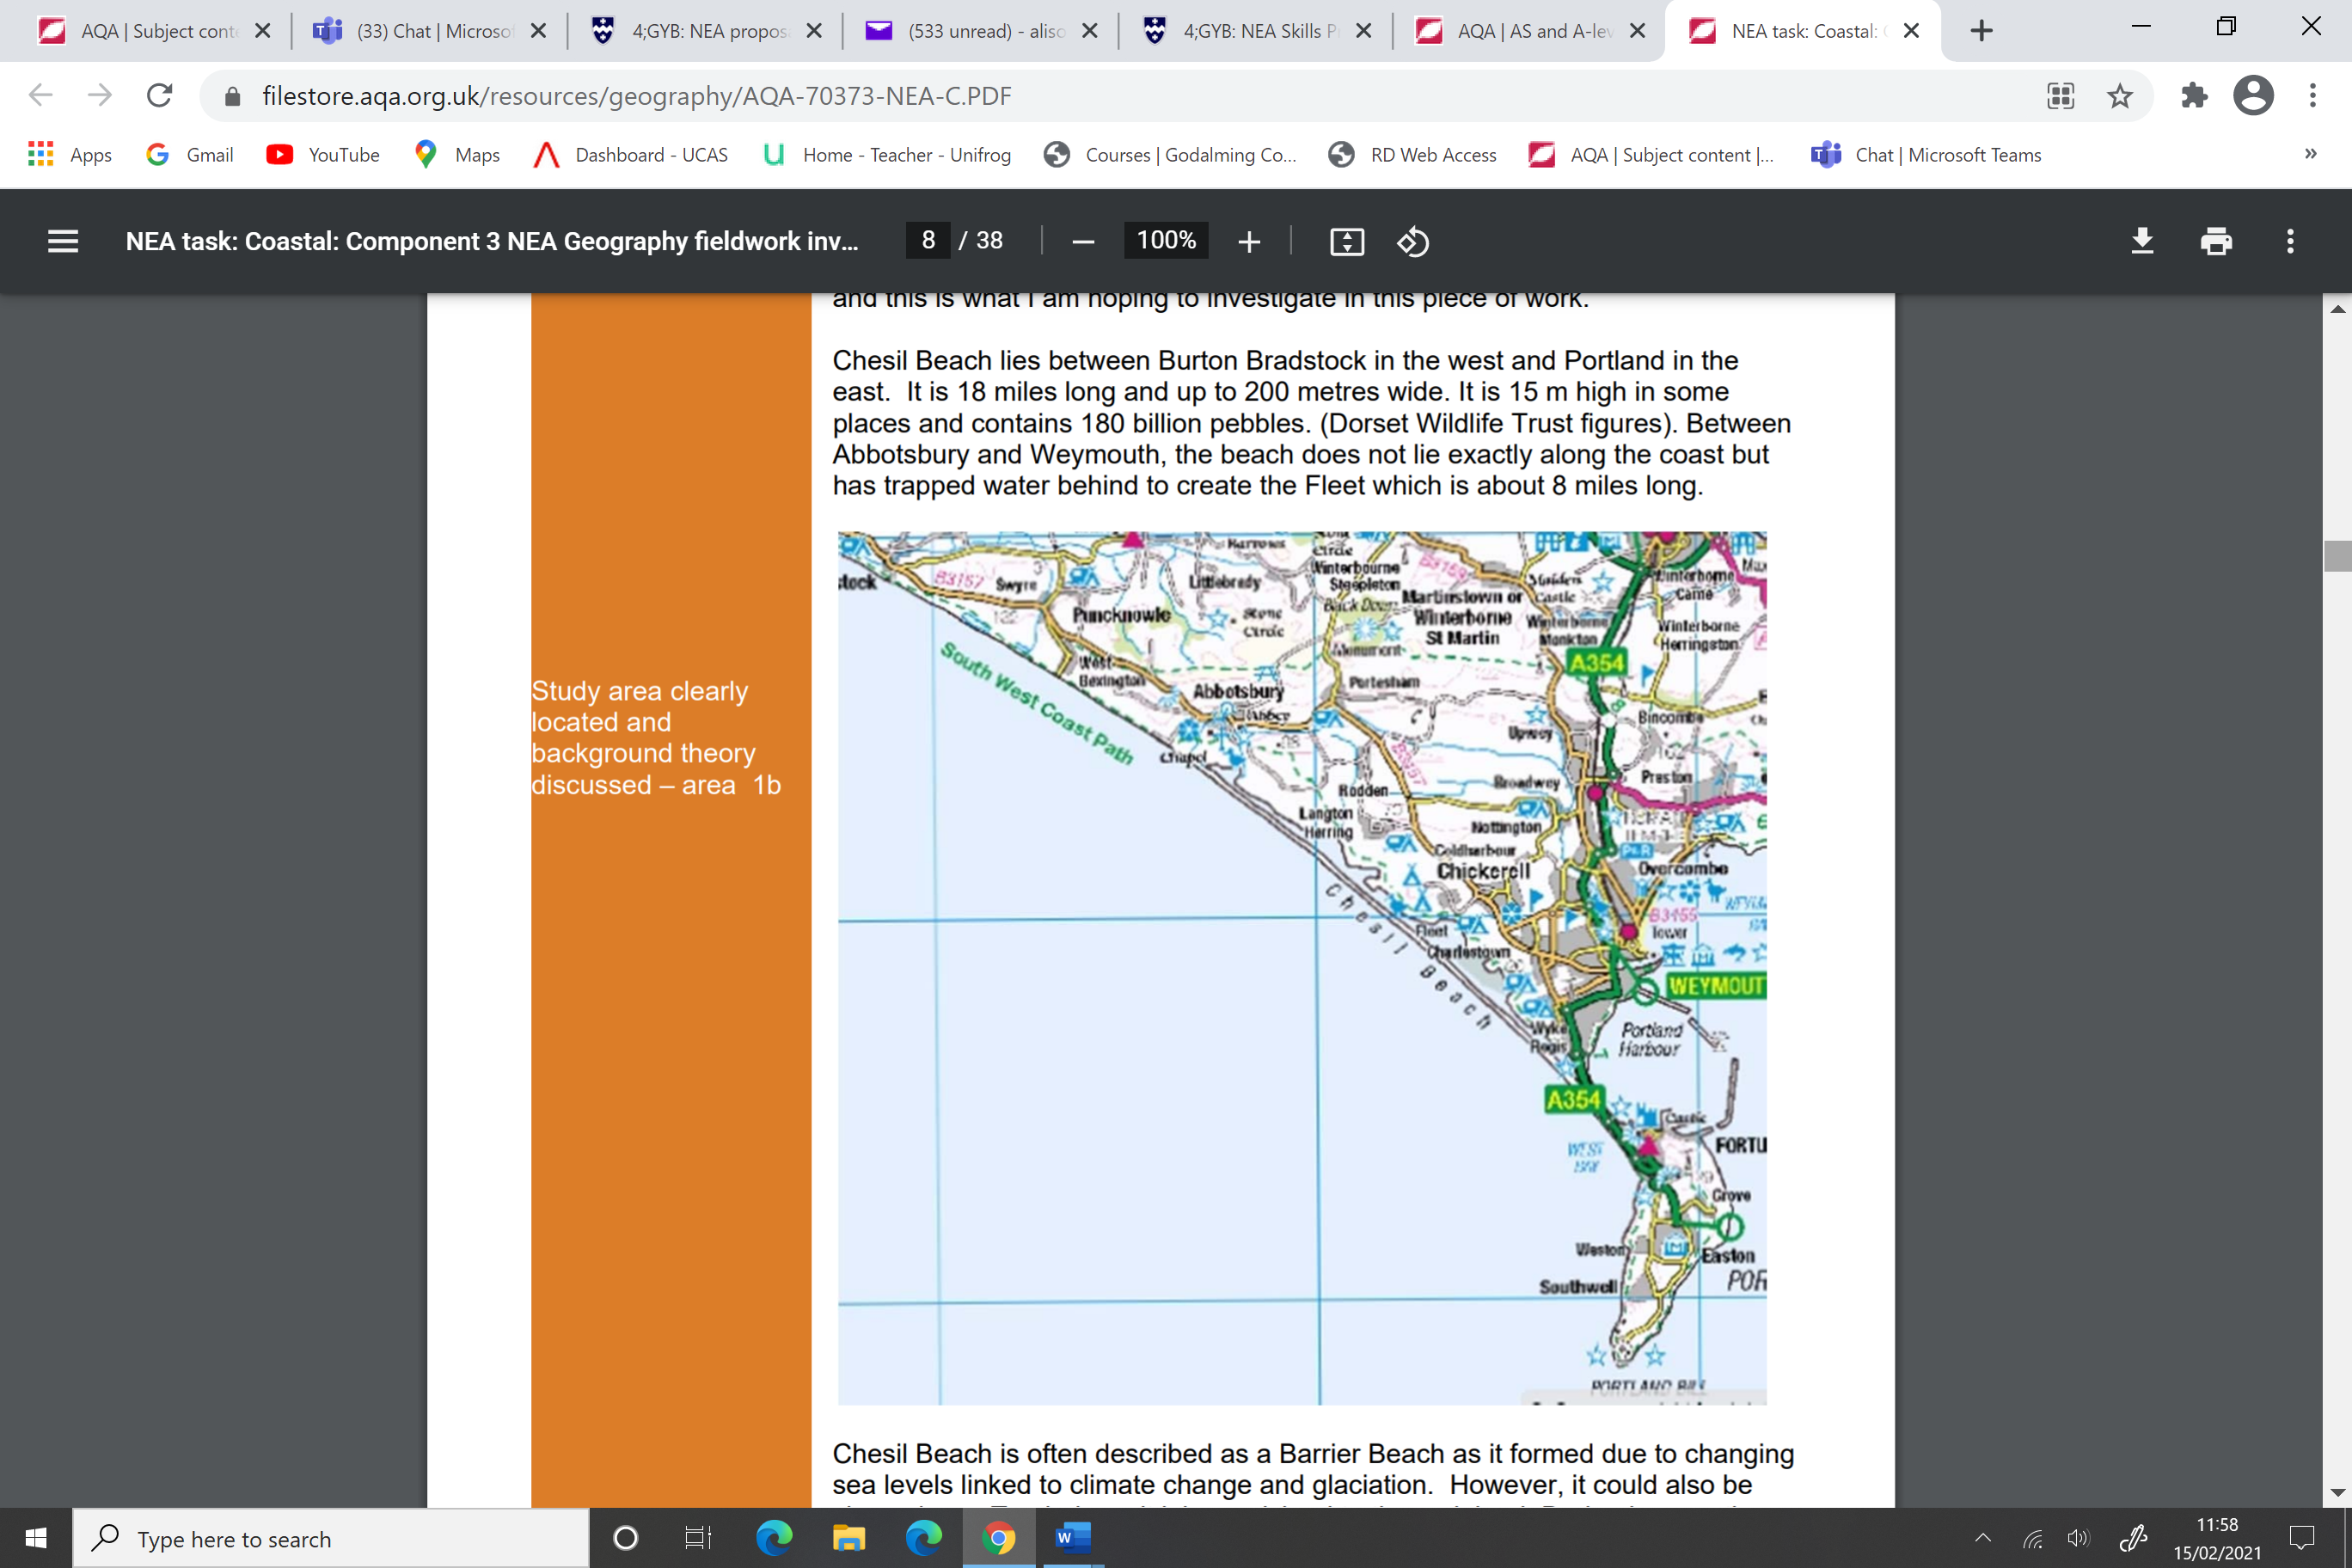

Chesil Beach is often described as a Barrier Beach as it formed due to changing sea levels linked to climate change and glaciation. However, it could also be classed as a Tombolo as it joins an island to the mainland. During ice age times, (about 25,000 years ago) the sea level was much lower and the edge of the sea would have been further away from the present-day coast. On the land lots of rock was broken up by weathering and erosion and carried into the sea by ice, meltwater and rivers. This resulted in a large volume of rock on the sea bed. As the sea level rose about 10,000 years ago at the end of the ice age the rock material was carried up with the rising sea level and deposited along the coast to form Chesil Beach. Over time the action of the waves has moved the shingle around along the beach by longshore drift and also helped to smooth the pebbles through attrition. So, the beach was formed by long ago processes but is being molded by current processes. There are approximately 180 billion pebbles making up Chesil Beach (Dorset Wildlife Trust).

This section of the coast is a High Energy Coast and it is exposed to powerful wind and waves from south west. The power of waves is affected by the wind as they are created by the wind. The power is a result of the wind strength, length of time the wind has blown and also the fetch – the distance over which the wind has blown. Wind and waves along this stretch of the coast have formed over the Atlantic and can have a fetch of up to 7,000 kilometres. The predominant direction of longshore drift is from the west to the east and this moves the pebbles in that direction as shown by the scopac map below.

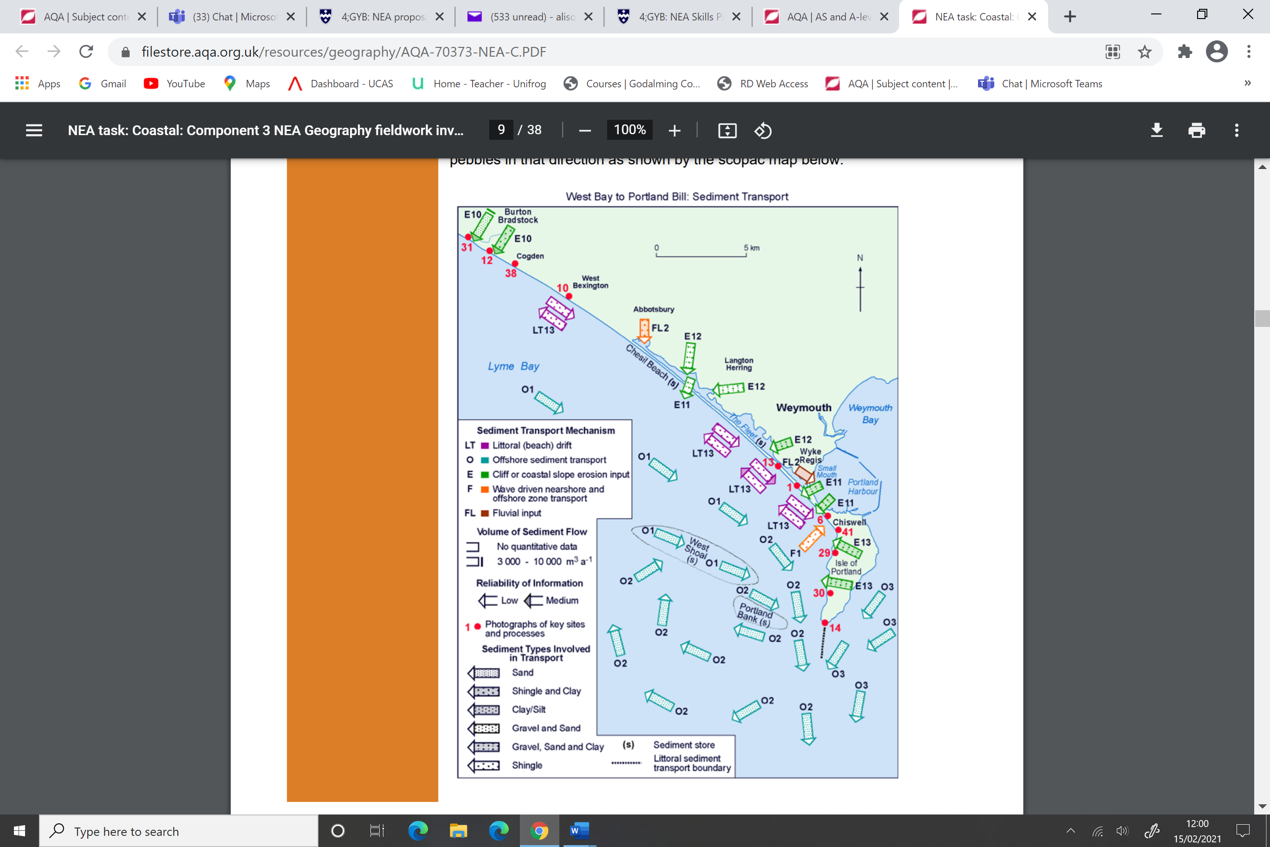

However, sometimes there is a weaker, less common direction of longshore drift going from east to west. This picks up only the smaller pebbles so over time there has been sorting of pebbles along the beach with the largest near Portland the smallest near Burton Bradstock. Local folklore says that fisherman, sailors and smugglers who knew this coast well could pick up a handful of pebbles and know exactly where they were by the size of the sediment even if they were in the fog. It is also thought (Dorset Wildlife Trust) that bigger pebbles are more easily moved by longshore drift which would also result in the sorting of pebbles along the beach. As part of the course we have studied coastal landscapes and looked at the role of wind and waves in the formation of landforms, including depositional landforms. I am hoping to have a better understanding of these processes by carrying out this investigation.

I have made several predictions or hypotheses:-

1. The size of sediment will increase from north-west to south-east along the beach – this will be due to the sorting of the sediment by longshore drift 2. The gradient of the beach increase from north-west to south-east – shingle and pebbles beaches tend to have steeper gradients than sandy beaches so I would expect to see the gradient increase as the size of beach material increases 3. Chesil Beach will be exposed to powerful wind and waves from the southwest – I expect to find that the wind and waves hitting Chesil Beach are very powerful as it is a high energy coast and I expect they will have a big influence on the beach