**Guildford Fieldtrip Preparatory Work**

**Aims**

* To create survey forms to be used on the Guildford Fieldtrip
* To choose suitable sampling points
* To consider the risk assessments and ethical considerations needed for an urban study

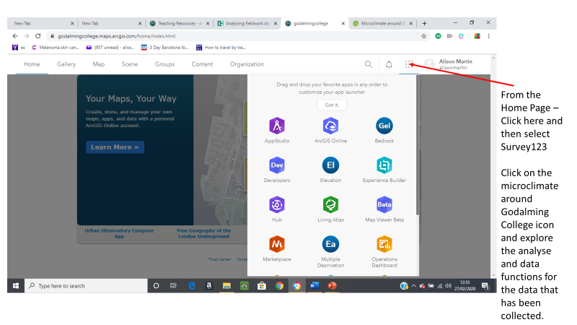

**Guildford Fieldtrip – to investigate**

* How does central Guildford vary in land use, quality of the environment, footfall and/or characteristics of cultural quarters. (Comparing the High Street and North Street)
* How does land use change from the centre of Guildford to the outskirts?
* How do social, economic and environmental factors vary between two residential areas?
* How does the urban land use in central Guildford vary and is regeneration required in some areas?
* How does Guildford show evidence of sustainability?

**Data collection methods to be used in Guildford**

You will be working in groups of 3-4 people to complete the required survey forms for this fieldtrip. You will need to discuss how things should be done and allocate tasks to individual members of your group. It is important that you discuss what needs to go into the forms and where your sampling points will be before doing any individual work.

The survey forms will then need to be shared with team members.

* Environmental quality surveys
* Land use surveys
* Pedestrian counts
* Housing decay surveys
* Retail value assessments
* Photographs
* Questionnaires
* Sustainability index

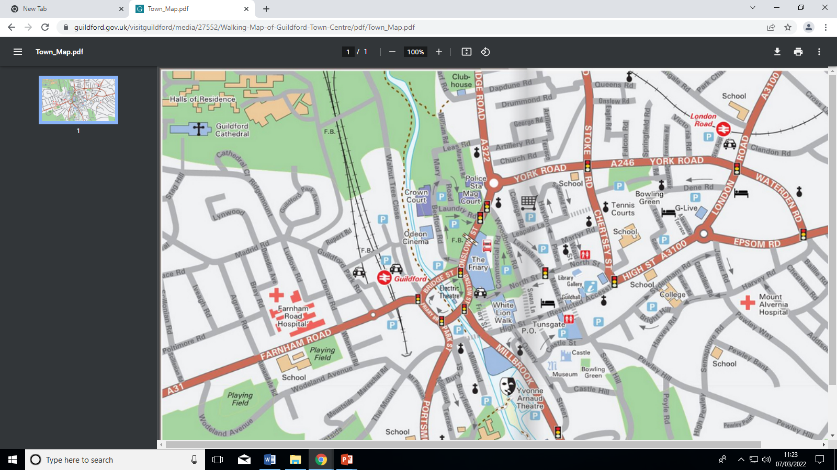**Recording Land Use Function**

Meeting Point 10am

The Friary

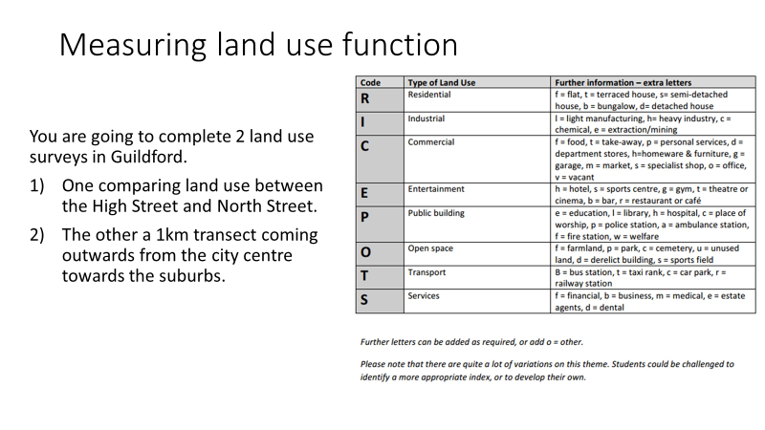

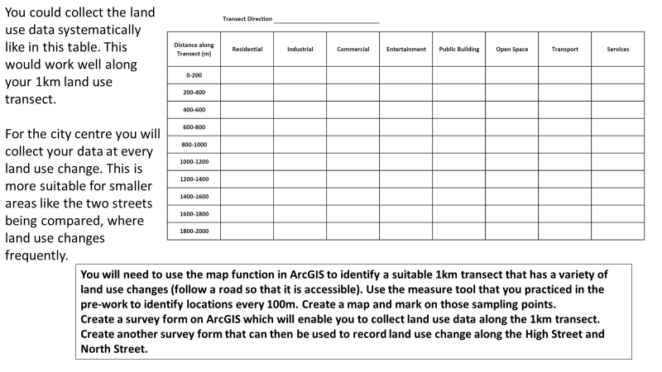

**You will need to use the map function in ArcGIS to identify a suitable 1km transect that has a variety of land use changes (follow a road so that it is accessible). Use the measure tool that you practiced in the pre-work to identify locations every 100m. Create a map and mark on those sampling points.**

**Tasks 1 & 2**

**Create a survey form on ArcGIS which will enable you to collect land use data along the 1km transect.**

**Create another survey form that can then be used to record land use change along the High Street and North Street.**

**Measuring Environmental Quality**

An environmental quality survey uses an observer’s judgements to assess environmental quality against a range of indicators. Often, they work on a sliding scale of quality (like 1 to 5) to represent less good to good. Alternatively, you can use a Bi-polar scale (like -5 to +5) to indicate a negative assessment through to a positive assessment, with 0 representing neither good nor bad.

As it is based on personal judgements the data collected using environmental quality surveys is *subjective.* Benchmarking the scoring between different observers will help reduce this subjectivity.

Sampling for environmental quality surveys within a study:

Either an overall judgement of an area – walk around the whole area and then complete the survey as a summary or at a number of points within the area – which may be selected using a random, systematic or stratified sample

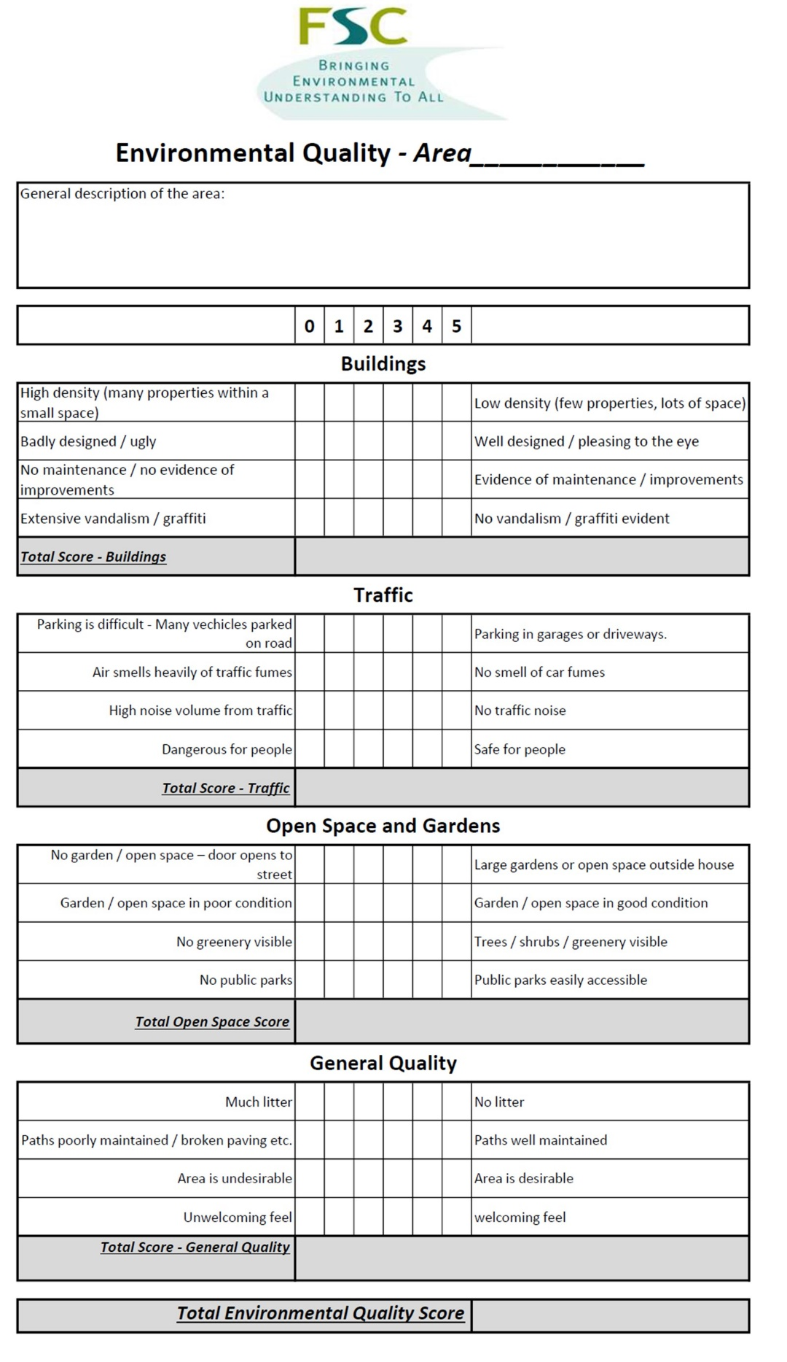

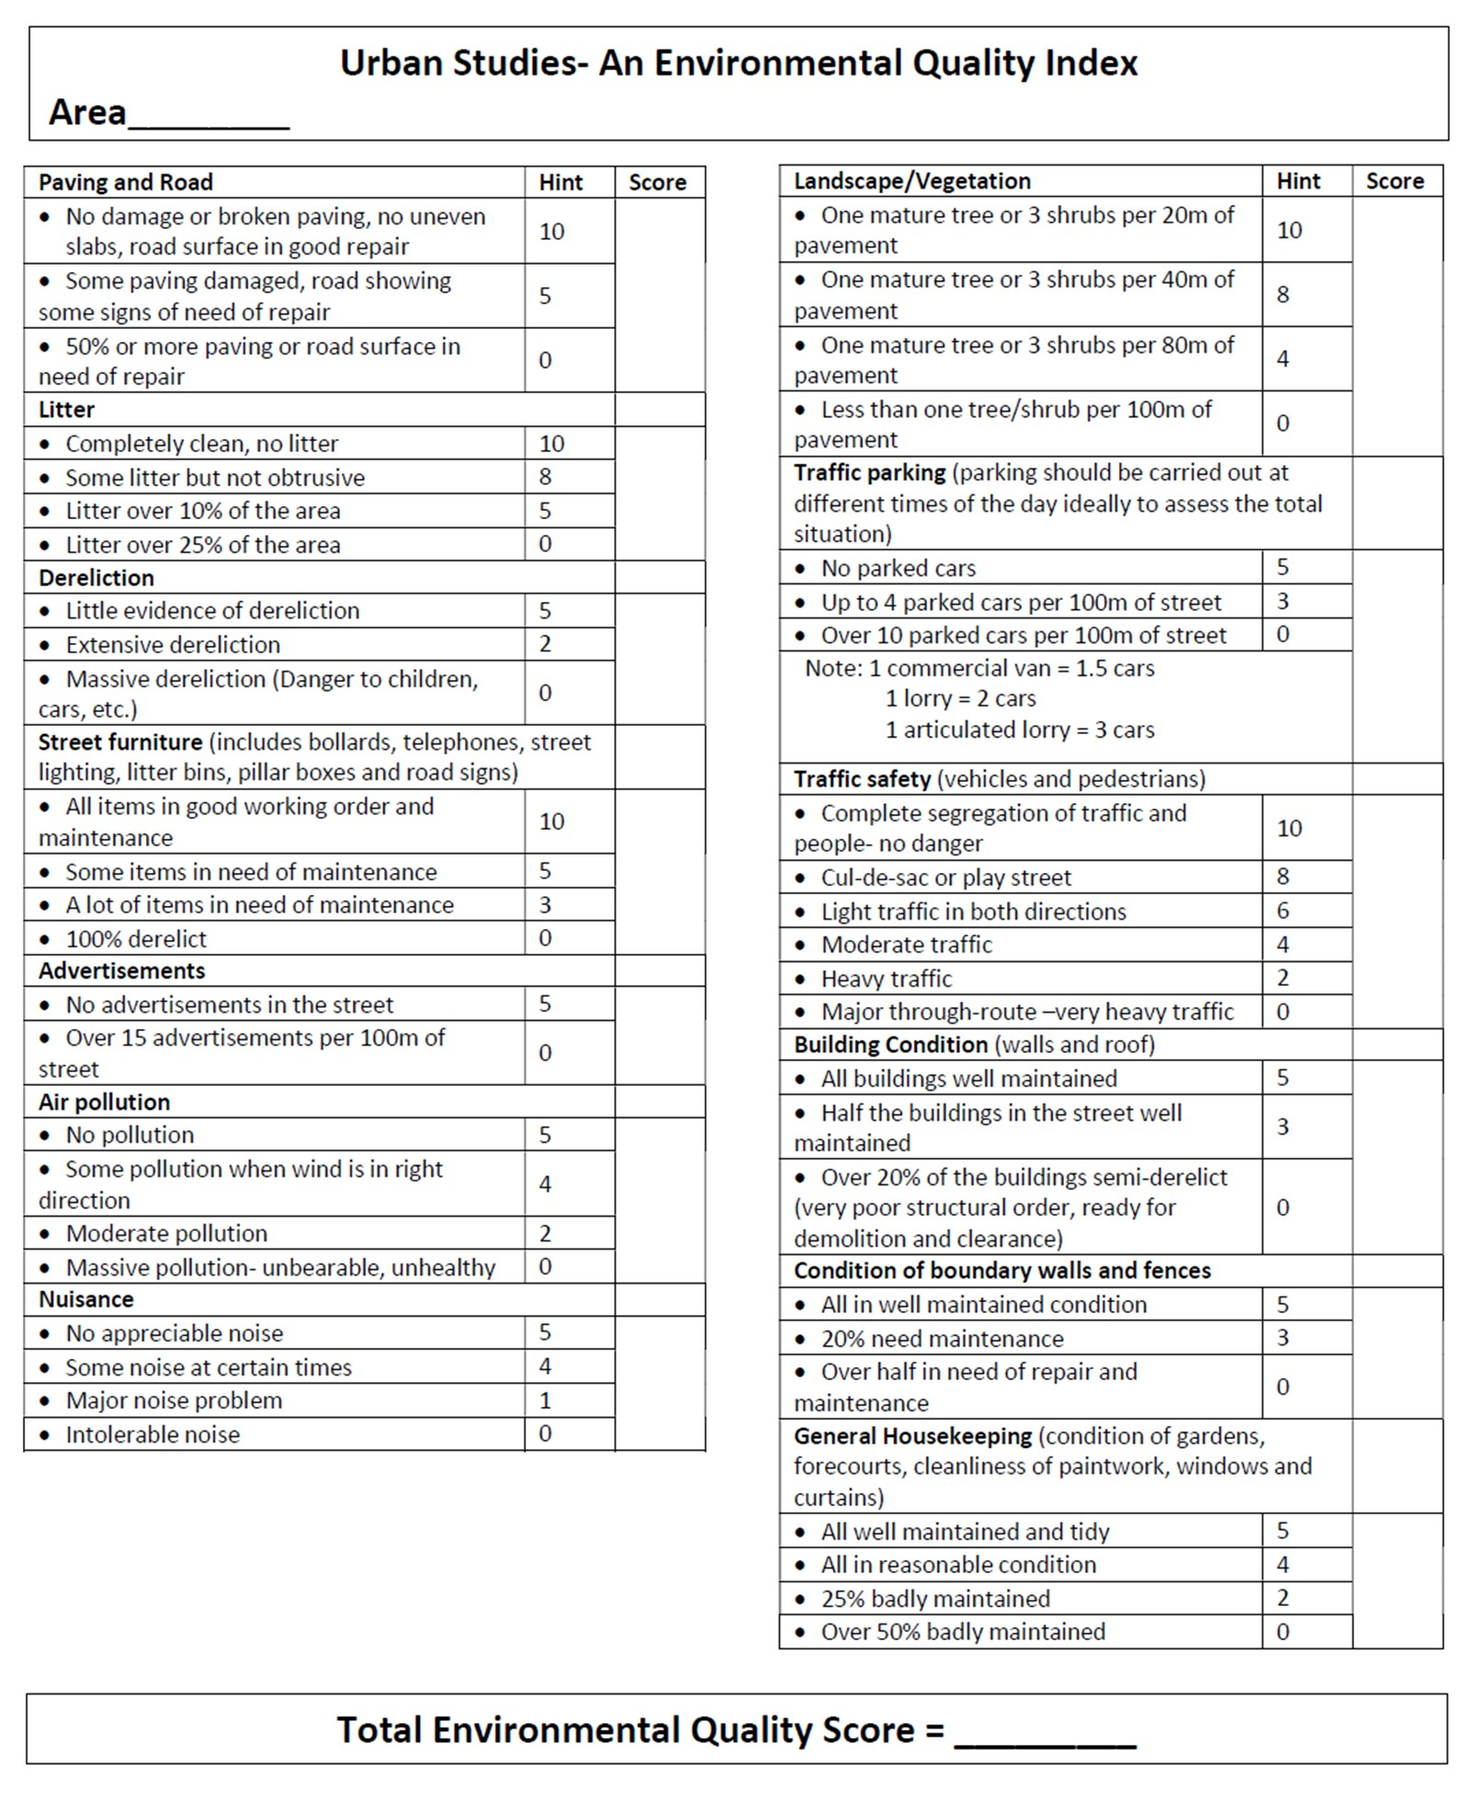

**Task 3**

**Create a survey form to collect information to examine the environmental quality of two contrasting areas. You could choose to do it between two areas of the town centre or two different streets north of York Road. You have examples of two different environmental quality surveys above – think about which questions will be most relevant for your chosen areas. Include the ability to record photographs in your surveys.**

**Pedestrian Surveys - advice from Field Studies Council (FSC)**

* Think about the which day of the week to count pedestrians. Pedestrian numbers are likely to be higher on a Saturday or Sunday then during the week, during school holidays, during dry weather and if there is a popular event happening in the city centre
* Time of day is also important. Pedestrian numbers are likely to be higher during "rush hours" (like 8am-9am) or shift changes and during office lunchtime. Around 11am and 2.30pm are often good times to choose.
* You need at least 20-25 survey points. Choose survey points across the city centre. If you are working in groups, each group can walk different routes across the city centre.
* This is up to you, but make sure that you survey in the same way each time. Think about how long to count pedestrians for - 2 minutes is enough. If your survey points are close together (perhaps every 100 metres), you might be able to do 3 or 4 pedestrian counts in 10 minutes. Whether to count people on one side of the road or both sides of the road - if you are working in groups, different members of the group could count different sides of the road, with someone else holding a stopwatch.

**Task 4**

**Decide where you are going to do your pedestrian surveys. This is a learning exercise and so you do not need to do the number of survey points recommended above. Instead choose four locations (You may wish to choose locations in the two study areas used for the retail survey) and create a survey form to collect this data.**

**Retail Value**

An indicator that regeneration might be required in an area is to look at the retail value. This might also be a useful form of data collection for investigations linked to clone town surveys and sense of place or whether an area would benefit from regeneration. There are likely to be areas of higher and lower retail quality in Guildford City Centre. One way in which this can be done is to choose a study area, then score each shop within the area as follows:-

Shop type Score

**Task 5**

**Identify two areas of Guildford City Centre where comparisons of retail value can be made.**

**Create a survey form on ArcGIS that you can use to collect this data.**

Department store 5

High street chain 4

Independent specialist shop 3

Convenience store 2

Charity shop 1

Vacant retail premises 0

**Housing Decay Survey**

You can also measure the condition of housing. Make sure that you sample houses fairly. You might, for example, choose to sample two streets picked at random, and then sample house numbers 5, 15 and 25 on each street. (Guidance from the FSC) Alternatively you could sample every 5th house. Whatever you choose to do you will need to be able to justify it.

**Task 6**

**Study a map of the area north of York Road and select two residential streets that you can survey that you believe will have different characteristics. You will need to use ArcGis Maps (street view), datashine, rightmove to research and select the streets.**

**Decide what sampling strategy are you going to use (systematic, stratified or random) and create a survey form on ArcGIS to collect this data. Include the ability to include a photographic image of sample sites.**

**(Print off hard copies of the sample sites to bring as a back-up on the day)**



**Is Guildford active, inclusive, and safe?**

**Questionnaires - Convenience sampling** - Select people who are easy to reach, e.g. questioning/giving out a questionnaire to the first 100 people you see in the High Street on a particular morning.

**Example questions:**

* Do you live in Guildford?
* Do you think Guildford is a safe area?
* Do you feel as if there is good community spirit in Guildford?
* Do you think there are active and approachable police in Guildford?
* Do you think there are low levels of antisocial behaviour in Guildford?

**Task 7**

**Decide on the questions you are going to ask.**

**Decide where you are going to do your questionnaires.**

**This is a learning exercise and so you do not need to do a large number of questionnaires.**

**Instead choose one/two locations where footfall will be high and create a survey form on ArcGIS to collect this data.**

**Sustainability Index**

When building sustainable areas or communities, geographers can use Egan’s Wheel to assess how sustainable the community or idea being developed is. The sustainability index can be used to investigate whether Guildford is a sustainable community.

|  |  |
| --- | --- |
| **Site details (criteria)** | **5 strongly agree – 1 strongly disagree (Total out of 35)** |
| Site 1  Site 2  Site 3 |  |
| Access to a full range of shopping facilities and services (toilets, litter bins etc). |  |
| Landscape and open space (evidence of public access to open spaces) |  |
| Urban environment (pleasant area and clean and tidy) |  |
| Cultural heritage (historical buildings protected from development) |  |
| Living accommodation (evidence of people living in centre – above shops, central flats etc) |  |
| Health, security and feeling of safety (CCTV cameras, security guards, police) |  |
| Transport efficiency (buses etc, cycle routes, bike locks etc). |  |
| Score – Total out of 35 |  |

**TASK 8**

**Decide where you are going to do your surveys.**

**This is a learning exercise so choose *two* locations**

**Create a survey form on ArcGIS to collect this data.**

**Think about the different data collection methods that you will be piloting on the Guildford Fieldtrip. Which of the methods could help you to answer each of these questions?**

* How does central Guildford vary in land use, quality of the environment, footfall and/or characteristics of cultural quarters.
* How does land use change from the centre of Guildford to the outskirts?
* How do social, economic and environmental factors vary between two residential areas?
* How does the urban land use in central Guildford vary and is regeneration required in some areas?
* How does Guildford show evidence of sustainability?

**Ethical Issues**

There are ethical issues that need to be addressed for all fieldwork trips e.g. not asking sensitive personal information when completing questionnaires and ensuring that all responses are confidential.

* What ethical considerations might we need to take when completing housing decay surveys, completing questionnaires and taking photographs in busy areas?

**Risk Assessment**

|  |  |  |  |
| --- | --- | --- | --- |
| Risk | Level of threat (1-5 with 5 being high) | Likelihood of occurrence  (1-5 with 5 being high) | Strategy to minimise threat |
|  |  |  |  |
|  |  |  |  |
|  |  |  |  |
|  |  |  |  |
|  |  |  |  |

Creating a survey

Go into survey 123 and click on create new survey

Click on ‘Using the web designer’

Enter a name and a tag

Create questions for your survey form

Save

Publish

To create a group

Click on groups

Create group

Enter a name and tag for the group

Where it says ‘who can view this group’ click on only group members (all other options should remain the same)

Click on create group button

Invite users

To share your survey with your group so that they can collect the data (will not let them view the results of the survey)

Go back to Survey 123

Find the icon for your newly created survey

Click on the padlock symbol

Where is says ‘Who can submit to this survey?’ click on the following groups option and then your newly created group.

Save

To give your group access to the results

Go to Survey 123

Click on collaborate

Click on viewer

Click on ‘Who can view the results of the survey?’ and then select your group