**Q1.**

**Figure 1** shows a tweet about a protest in Grasmere, a village located in the Lake District National Park.

**Figure 1**

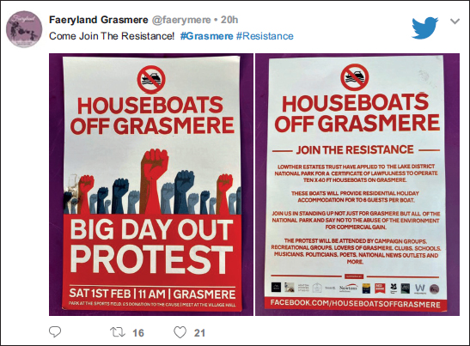

**Figure 2** shows a news report about the protest in Grasmere.

**Figure 2**

|  |
| --- |
| **Protesters to mass at Grasmere ‘to save beauty of the Lakes’**  Earlier this month more than 200 people gathered in the village of Grasmere to object to plans by Lowther Estate, which owns the lake, to moor 10 holiday yachts on its shores. Proposals include allowing holidaymakers to stay on the boats overnight, accommodating up to six people for a week, and allowing them to freely navigate Grasmere.  Local people say commercialisation will destroy the beauty and tranquillity of the national park for future generations. The lake is overlooked by Dove Cottage – home of William Wordsworth – who described Grasmere as “the loveliest spot that man hath ever found”.  Andy Astle, 62, a retired Royal Mail manager who has lived in the village for almost five decades, and Joe Nichols, also a local resident, said they had been forced to act to protect the national park as a public space and save its heritage.  Nichols said he expected thousands of people to join the protest. He said, “Over the last two years Lowther Estate have desperately tried to exploit the land for commercial gain at the expense of the environment.” He added: “We can no longer tolerate the constant attempted abuse of areas which should be protected by those who own them.”  David Bliss, chief executive of Lowther Estate, argues that the yachts do not constitute a new development. “The first thing is that they are definitely not houseboats and they already exist on Windermere, Ullswater and Derwentwater, and the second is that they are not detrimental to the area. They will complement other boats already used in Grasmere,” he said. |

Using **Figure 1**, **Figure 2** and your own knowledge, to what extent do you agree that place-meaning is based on different perspectives?

**[6 marks]**

_______________________________________________________________________

_______________________________________________________________________

_______________________________________________________________________

_______________________________________________________________________

_______________________________________________________________________

_______________________________________________________________________

_______________________________________________________________________

_______________________________________________________________________

_______________________________________________________________________

_______________________________________________________________________

_______________________________________________________________________

_______________________________________________________________________

**Q2.**

**Figure 1** is from a website dedicated to Crickhowell, a town in Wales.

**Figure 1**

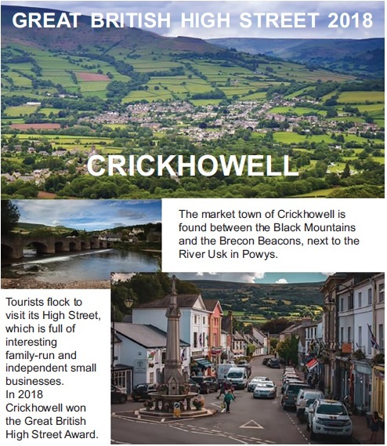

**Figure 2** is a news article about Crickhowell.

**Figure 2**

|  |
| --- |
| **Crickhowell named ‘Best Place to Live in Wales’ by Sunday Times**  Crickhowell in Powys, in the shadow of Table Mountain, has been attracting visitors since the 16th Century. Now its thriving high street and community spirit has seen it named the Best Place to Live in Wales, according to the Sunday Times.  The landlord of the Bridge End Inn said he fell in love with Crickhowell more than 30 years ago. “There are beautiful villages everywhere but there’s something unique about Crickhowell,” he said. “The residents and tourists come together, it’s a little bit of magic.”  The owner of a local bookshop said: “It’s all about the community, people take time to talk to each other here. Businesses work together, rather than compete, to make sure we all succeed.” |

Using **Figure 1** and **Figure 2**, analyse the representations of place.

**[6 marks]**

_______________________________________________________________________

_______________________________________________________________________

_______________________________________________________________________

_______________________________________________________________________

_______________________________________________________________________

_______________________________________________________________________

_______________________________________________________________________

_______________________________________________________________________

_______________________________________________________________________

_______________________________________________________________________

_______________________________________________________________________

_______________________________________________________________________

**Q3.**

With reference to a place you have studied, evaluate the usefulness of quantitative data sources such as statistics and maps in representing the lived experience of a place.

**[20 marks]**

**Q4.**

Describe **one** way in which corporate bodies can try to influence or create specific place meanings.

**[3 marks]**

_______________________________________________________________________

_______________________________________________________________________

_______________________________________________________________________

_______________________________________________________________________

_______________________________________________________________________

_______________________________________________________________________

**Q5.**

‘External agencies always focus on endogenous place characteristics when attempting to create specific place-meaning.’

Assess the extent to which you agree with this view.

**[20 marks]**

**Q6.**

The extract below shows information published online by the London National Park City movement, a charitable trust that launched London as the first National Park City in July 2019.

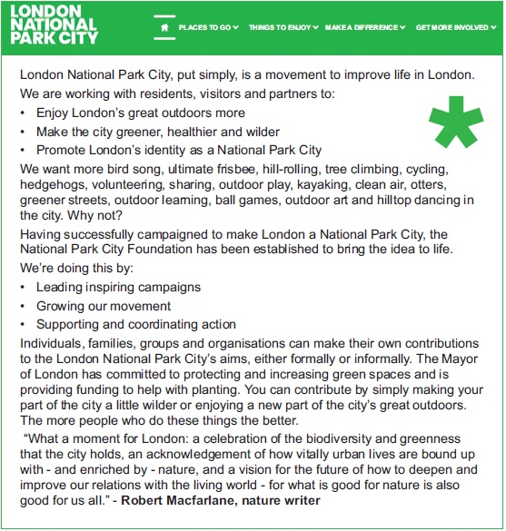

Using the extract and your own knowledge, evaluate attempts to influence specific place meanings.

**[6 marks]**

_______________________________________________________________________

_______________________________________________________________________

_______________________________________________________________________

_______________________________________________________________________

_______________________________________________________________________

_______________________________________________________________________

_______________________________________________________________________

_______________________________________________________________________

_______________________________________________________________________

_______________________________________________________________________

_______________________________________________________________________

_______________________________________________________________________

**Q7.**

**Figure 1** is an extract from Salford City Council about the Salford Quays regeneration project.

**Figure 2** is an advertisement from an urban regeneration company.

**Figure 3** is a recent photograph of Salford Quays.

**Figure 1**

|  |
| --- |
| From major developments to city parks, revitalised waterways and green spaces, Salford is being rebuilt and now more people than ever before are choosing it as a place to live, work, invest in and visit. It is also investing in its transport infrastructure, both to improve connectivity and to support the sustainable growth of the city.  Salford is connecting the city and its residents to the growing opportunities in and around the area and helping to secure jobs, investment and a regeneration focus towards those areas in greatest need. |

**Figure 2**

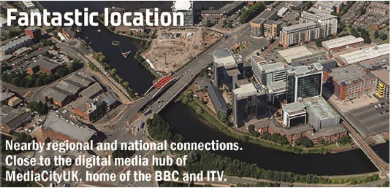

**Figure 3**

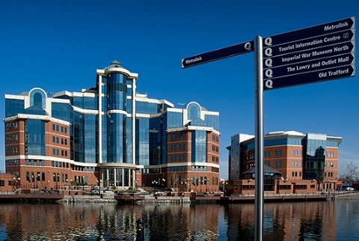

Using evidence from **Figure 1**, **2** and **3**, analyse the way in which this place is represented.

**[6 marks]**

_______________________________________________________________________

_______________________________________________________________________

_______________________________________________________________________

_______________________________________________________________________

_______________________________________________________________________

_______________________________________________________________________

_______________________________________________________________________

_______________________________________________________________________

_______________________________________________________________________

_______________________________________________________________________

_______________________________________________________________________

_______________________________________________________________________

**Q8.**

**Figure 1**

**A painting of Manchester in 1946 by LS Lowry**

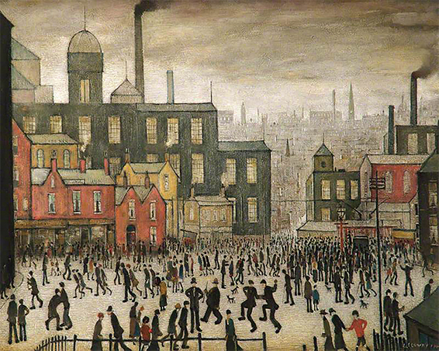

Using **Figure 1** and your own knowledge, examine endogenous factors contributing to the character of this place.

**[6 marks]**

___________________________________________________________________

___________________________________________________________________

___________________________________________________________________

___________________________________________________________________

___________________________________________________________________

___________________________________________________________________

___________________________________________________________________

___________________________________________________________________

___________________________________________________________________

**Q9.**

The box below contains lyrics from ‘Wickerman’, a song about Sheffield performed by the band Pulp.

|  |
| --- |
| Just behind the station, before you reach the traffic island, a river runs thru’ a concrete channel. I took you there once; I think it was after the Leadmill. The water was dirty & smelt of industrialisation Little mesters coughing their lungs up & globules the colour of tomato ketchup. But it flows. Yeah, it flows. Underneath the city thru’ dirty brickwork conduits Connecting white witches on the Moor with pre-raphaelites down in Broomhall. Beneath the old Trebor factory that burnt down in the early seventies. Leaving an antiquated sweet-shop smell & caverns of nougat & caramel. Nougat. Yeah, nougat & caramel. And the river flows on. Yeah, the river flows on beneath pudgy fifteen-year olds addicted to coffee whitener And it finally comes above ground again at Forge Dam: the place where we first met. |

Using the lyrics and your own knowledge, assess the usefulness of sources such as this in representing a place.

**[6 marks]**

_______________________________________________________________________

_______________________________________________________________________

_______________________________________________________________________

_______________________________________________________________________

_______________________________________________________________________

_______________________________________________________________________

_______________________________________________________________________

_______________________________________________________________________

_______________________________________________________________________

_______________________________________________________________________

_______________________________________________________________________

_______________________________________________________________________

**Q10.**

Assess the view that only qualitative data can represent ‘insider’ perspectives on a place.

**[9 marks]**

___________________________________________________________________

___________________________________________________________________

___________________________________________________________________

___________________________________________________________________

___________________________________________________________________

___________________________________________________________________

___________________________________________________________________

___________________________________________________________________

___________________________________________________________________

___________________________________________________________________

___________________________________________________________________

___________________________________________________________________

**Q11.**

**Figure 1** was painted in 1935. It shows the High Level Bridge across the River Tyne, and some housing and industry in Gateshead.

**Figure 2** is a photograph of the same place taken in April 2015.

**Figure 1**

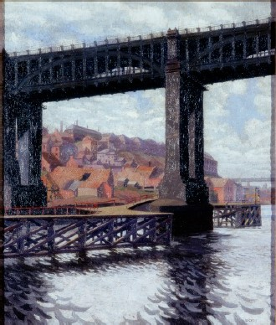

**Figure 2**

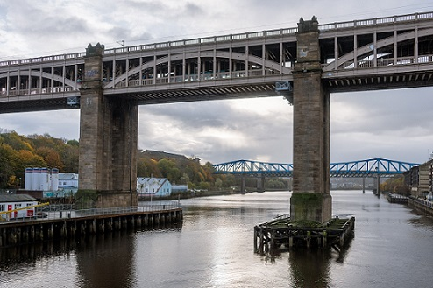

Evaluate the usefulness of **Figure 1** and **Figure 2** in showing the nature and extent of **either** economic change **or** demographical and cultural change in this area.

**[6 marks]**

_______________________________________________________________________

_______________________________________________________________________

_______________________________________________________________________

_______________________________________________________________________

_______________________________________________________________________

_______________________________________________________________________

_______________________________________________________________________

_______________________________________________________________________

_______________________________________________________________________

_______________________________________________________________________

_______________________________________________________________________

_______________________________________________________________________

**Q12. SECURE MATERIAL**

© The Francis Frith Collection

**Q13.**

Name **one** place that you have studied.

Name **one** artistic source (e.g. painting, song, text) and explain how it helped you to develop your knowledge and understanding of that place.

**[3 marks]**

_______________________________________________________________________

_______________________________________________________________________

_______________________________________________________________________

_______________________________________________________________________

_______________________________________________________________________

_______________________________________________________________________

**Q14. SECURE MATERIAL**

**Q15.**

**Figure 1** is taken from ‘The Pictorial Guides to the Lake District’ by Alfred Wainwright. It is a hand-drawn sketch of the area north / north-east of Skelwith Bridge.

**Figure 2** is taken from the Ordnance Survey 1:50000 map of the same area.

**Figure 1**

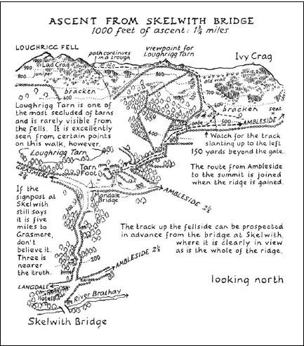

**Figure 2**

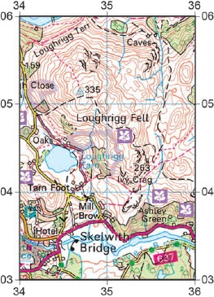

Contrast the usefulness of **Figures 1** and **2** in representing the physical geography of the area north / north-east of Skelwith Bridge.

**[6 marks]**

_______________________________________________________________________

_______________________________________________________________________

_______________________________________________________________________

_______________________________________________________________________

_______________________________________________________________________

_______________________________________________________________________

_______________________________________________________________________

_______________________________________________________________________

_______________________________________________________________________

_______________________________________________________________________

_______________________________________________________________________

_______________________________________________________________________

**Q16.**

Which **one** of the following is an example of where place-meaning has been influenced by a local community group?

**[1 mark]**

|  |  |  |
| --- | --- | --- |
| **A** | The tourist brochure highlighted the natural features of the surrounding landscape to promote this area to visitors from overseas. |  |
| **B** | Residents had launched an initiative to persuade more local residents to cycle to work in order to reduce air pollution and traffic congestion. |  |
| **C** | The city became well known for an iconic high-rise building that was funded with regeneration money as part of a rebranding initiative |  |
| **D** | The town has been featured in the news because of an initiative started by a group of residents to make it the most sustainable town in the UK. |  |

Mark schemes

**Q1.**

**AO1** – Knowledge and understanding of how people form attachments to place. Knowledge and understanding of how place-meaning is based on different perspectives.

**AO2** – Application of knowledge and understanding to this novel situation. Interpretation of **Figure 1 and 2** to assess the extent to which place meaning in Grasmere is based on different perspectives.

Mark scheme

**Level 2 (4–6 marks)**

**AO1** – Demonstrates clear knowledge and understanding of concepts, processes, interactions and change.

**AO2** – Applies knowledge and understanding to the novel situation offering clear analysis and evaluation drawn appropriately from the context provided. Connections and relationships between different aspects of study are evident with clear relevance.

**Level 1 (1–3 marks)**

**AO1** – Demonstrates basic knowledge and understanding of concepts, processes, interactions, change.

**AO2** – Applies limited knowledge and understanding to the novel situation offering basic analysis and evaluation drawn from the context provided. Connections and relationships between different aspects of study are basic with limited relevance.

Notes for answers

The question requires an understanding of how place-meaning is based on different perspectives. Candidates must look for evidence of different perspectives within the figures and assess the extent to which place-meaning is based on these different perspectives. The question does not require candidates to assess the usefulness of the sources, so do not credit reference to subjectivity or the reliability of the sources. Reference to places other than Grasmere can be credited as AO1 knowledge. For L2 there must be reference to the figures.

**AO1**

•   Knowledge and understanding of the way humans form attachments to places and how they represent the world to others.

•   The concept of place-meaning.

•   Positionality and its impact on different perspectives.

•   Perspectives on place-meaning in places other than Grasmere.

**AO2**

•   Interpretation of **Figure 1** and **2** suggests that local people are not happy about the houseboats. The tweet is from someone in Grasmere and local people are quoted in **2**. They believe that Grasmere is ‘tranquil and beautiful’. They believe it has an environmental value which houseboats would destroy.

•   **Figure 2** suggests that the idea of a local perspective of ‘tranquillity and beauty’ is long established in Grasmere, as Wordsworth described this in his poetry.

•   There is some evidence to suggest that the perspective of a peaceful Grasmere is shared by lots of different stakeholders – from local people to politicians and poets.

•   Lowther Estates may have a different perspective on Grasmere – seeing it as an area for commercial gain. Perhaps believing that encouraging more tourism is more important than the tranquillity of the area.

•   The National Park authority must be considering the plans, and this clearly shows how corporate bodies can shape place-meaning. This is clearly impacting on the behaviour of local people who are protesting at the change.

•   Both **Figure 1** and **2** suggest that perspectives on place are emotionally driven because people form strong emotional attachments to places, and they don’t like change.

•   Candidates may come to a conclusion on the extent to which place-meaning is based on perspectives in Grasmere.

Credit any other valid assessment.

**AO1 = 2, AO2 = 4**

**[Total 6 marks]**

**Q2.**

**AO3** – Analysis of factors that contribute to a sense of place.

**Level 2 (4–6 marks)**

**AO3** – Clear analysis of the qualitative evidence provided, which makes appropriate use of data in support. Clear connection(s) between different aspects of the data and evidence.

**Level 1 (1–3 marks)**

**AO3** – Basic analysis of the qualitative evidence provided, which makes limited use of data and evidence in support. Basic connection(s) between different aspects of the data and evidence.

Notes for answers

The question requires analysis of the **qualitative data** shown in the figures. Many of the features from the Figures are implied rather than definitive, part of the nature of qualitative data.

•   The location of the town beside a river/bridge and surrounded by mountains are alluded to in both sources suggesting that physical geography and the situation of this town are important.

•   Strong community is a key factor and it is a place where ‘people talk to each other’ and ‘businesses work together’.

•   The experience of those living and working here is portrayed as overwhelmingly positive.

•   The tourists are viewed as a fully integrated group in this place. There is a suggestion of harmony between tourists and residents.

•   There is a high degree of civic pride evident in the sources. This is coupled with a sense that it is a ‘unique’ or ‘special’ place.

•   There is a sense that the town is ‘inward looking’ and not part of a more globalised world. The sources stress the importance of ‘independent’ shops rather than ‘chain’ stores.

•   There is a suggestion that the town is busy and ‘bustling’ and this is also seen in the photo evidence but at the same time ‘rural’.

•   The mention of festivals suggests that there are key annual events that have become associated with this place.

•   A long history is alluded to and the historic bridge appears to be an important aspect of place character.

•   Continuity is important in relation to a long history of tourism and shops that have been passed through the generations.

•   There is a suggestion that it is a socially and economically sound place to live and a safe place to live.

•   Some may suggest that the image of the town has been influenced by the media as it has been named ‘Best Place to Live’ by the Sunday Times and Great British High Street and may only show partial aspects of this place.

Credit any other valid approach.

**AO3 = 6**

**[Total 6 marks]**

**Q3.**

**AO1** – Knowledge and understanding of how lived experience of a place can be represented through a variety of data sources. Knowledge and understanding of a local or distant place studied and the experience(s) of people who live there.

**AO2** – Assessment of to what extent maps and statistics, or other quantitative data sources represent the lived experience(s) in the local or distant place studied.

Notes for answers

This question makes connections between different parts of the specification content on Changing Places, specifically the linking the way that maps and statistics, or other quantitative data sources represent the experience of the people living in a place. Responses should focus on evaluating the usefulness of statistics and maps, or other quantitative data sources in representing the lived experience(s) in a local or distant place they have studied.

**AO1**

•   Knowledge and understanding of the concept of place and the importance of place in human experience.

•   Knowledge and understanding of lived experiences in a local or distant place, both past and present.

•   Knowledge and understanding of how place can be represented in a variety of ways and for a variety of purposes.

•   Knowledge and understanding of how external agencies may make attempts to influence or create specific place-meanings.

•   Knowledge and understanding of a range of qualitative and quantitative sources from a local or distant place studied.

**AO2**

•   An evaluation of how useful maps and statistics (or other quantitative sources) are for representing lived experience of people in a place.

•   Evaluation of whether statistics are a useful representation of lived experience in a place. For example, census data may be seen as an accurate and reliable representation of lived experience as quantitative data is objective data, derived from full coverage of the population at regular 10-year intervals and is compiled by a reliable source (the government). It provides a variety of social and economic data that can be used to objectively analyse lived experience in a place, for example, average income levels and population structure. Some may suggest that the 10-year interval means that data becomes out-dated and this makes it a less reliable representation of lived experience.

•   Evaluation of how far other sources of statistical or mapped data such as crime data, Index of Multiple Derivation and health data are reliable and accurate representations of lived experience.

•   Statistics can be graphed or overlaid on to local maps to show possible variations in lived experience within a place. Some may suggest that mapping this data across very small areas is a reliable and accurate way to represent spatial patterns of lived experience. Others may suggest that the stark contrasts between areas on choropleth maps give a misleading representation of changes in lived experience between areas.

•   Evaluation of the usefulness of other statistical data sets. For example, it may not be possible to determine the source of all ‘Big Data’ sets and some samples may not be representative of the whole population of a place. Also, websites such as checkmystreet.co.uk, which provide reports of social and economic data in a place, may be viewed as less reliable or representative as they are selecting data for a particular purpose. Data from local surveys may give a more accurate and reliable representation of lived experience or may be seen to have a small sample size or bias.

•   Evaluation of whether statistics and maps may be manipulated by external agencies to reflect a particular lived experience in a place. For example, housing developers may market a place using a small selection of statistical indicators that show a very positive lived experience of this place. Also, there may be inaccuracies in maps, for example, historical maps that can be misleading.

•   An evaluation of how far statistics, as objective data, may not represent people’s own perceptions or views of their lived experience as they do not reflect a ‘sense of place’ or people’s own perceptions of place. It may be argued that this is more reliably represented by the use of qualitative data sources. Some maps and graphs may show qualitative data, for example, happiness levels and this may be seen to make them more representative of lived experience.

•   An evaluation of quantitative data might compare it with the use of qualitative data in representing lived experience. This is a valid approach to the evaluation, especially if there is some balance in considering the relative usefulness of both types of data.

•   A conclusion should make a judgement about the extent to which statistics and maps (or other quantitative data sources) are useful for representing lived experience of a place. Some may argue that they are very useful for representing the lived experience and others may argue that they are often not a reliable means to represent lived experience, or at best a partial representation of the lived experience of some groups or some areas within a place and that qualitative data sources may be more useful for representing lived experience. Some students may adopt a more balanced perspective and argue that some quantitative data sources are useful for representing lived experience, whilst other sources less so.

•   Any view is acceptable, as long as it is supported with reasoned argument and illustrative examples and evidence.

Credit any other valid assessment.

**Level 4 (16–20 marks)**

•   Detailed evaluative conclusion that is rational and firmly based on knowledge and understanding which is applied to the context of the question (AO2).

•   Detailed, coherent and relevant analysis and evaluation in the application of knowledge and understanding throughout (AO2).

•   Full evidence of links between knowledge and understanding to the application of knowledge and understanding in different contexts (AO2).

•   Detailed, highly relevant and appropriate knowledge and understanding of place(s) and environments used throughout (AO1).

•   Full and accurate knowledge and understanding of key concepts and processes throughout (AO1).

•   Detailed awareness of scale and temporal change which is well integrated where appropriate (AO1).

**Level 3 (11–15 marks)**

•   Clear evaluative conclusion that is based on knowledge and understanding which is applied to the context of the question (AO2).

•   Generally clear, coherent and relevant analysis and evaluation in the application of knowledge and understanding (AO2).

•   Generally clear evidence of links between knowledge and understanding to the application of knowledge and understanding in different contexts (AO2).

•   Generally clear and relevant knowledge and understanding of place(s) and environments (AO1).

•   Generally clear and accurate knowledge and understanding of key concepts and processes (AO1).

•   Generally clear awareness of scale and temporal change which is integrated where appropriate (AO1).

**Level 2 (6–10 marks)**

•   Some sense of an evaluative conclusion partially based upon knowledge and understanding which is applied to the context of the question (AO2).

•   Some partially relevant analysis and evaluation in the application of knowledge and understanding (AO2).

•   Some evidence of links between knowledge and understanding to the application of knowledge and understanding in different contexts (AO2).

•   Some relevant knowledge and understanding of place(s) and environments which is partially relevant (AO1).

•   Some knowledge and understanding of key concepts, processes and interactions and change (AO1).

•   Some awareness of scale and temporal change which is sometimes integrated where appropriate. There may be a few inaccuracies (AO1).

**Level 1 (1–5 marks)**

•   Very limited and/or unsupported evaluative conclusion that is loosely based upon knowledge and understanding which is applied to the context of the question (AO2).

•   Very limited analysis and evaluation in the application of knowledge and understanding. This lacks clarity and coherence (AO2).

•   Very limited and rarely logical evidence of links between knowledge and understanding to the application of knowledge and understanding in different contexts (AO2).

•   Very limited relevant knowledge and understanding of place(s) and environments (AO1).

•   Isolated knowledge and understanding of key concepts and processes.

•   Very limited awareness of scale and temporal change which is rarely integrated where appropriate. There may be a number of inaccuracies (AO1).

**Level 0 (0 marks)**

•   Nothing worthy of credit.

**AO1 = 10, AO2 = 10**

**[Total 20 marks]**

**Q4.**

Mark scheme

Point marked

Award 1 mark for each relevant point with extra mark(s) for developed points (d). Award 1 mark for the example of strategy given.

Notes for answers

The answer requires only one strategy by a corporate body. One mark is available for naming the strategy with subsequent marks awarded for developing the strategy and outlining how specific place meanings are created. The answer does not require a specific strategy. If they have done more than one strategy, credit the best example.

•   Corporate bodies can try to manipulate perceptions of place to make it more appealing to visitors / residents. This can be through rebranding (1).

•   Promotion can be done using slogans, adverts and brochures to advertise the new place meaning (1).

•   E.g. Hull was awarded Hull City of Culture 2017 by the Department of Culture and Media (1).

•   This was to promote arts and culture (1) to create a sense of regeneration and celebration of art in Hull (1).

•   The event is for one year and uses different slogans across the year such as ‘Roots and Routes’ (1) to celebrate migration and change in Hull (1).

•   This means that Hull’s reputation grows (1) this might attract more investment both locally and nationally (1)(d).

**AO1 = 3**

**[Total 3 marks]**

**Q5.**

**AO1** – Knowledge and understanding of endogenous and exogenous factors contributing to the characteristics of a place. Knowledge and understanding of specific attempts by external agencies to create specific place-meaning.

**AO2** – Assessment of how far external agencies use endogenous factors to create specific place-meaning. Assessment of how far external agencies use exogenous factors to create specific place-meaning.

Notes for answers

This question makes connections between different parts of the specification content on *Changing Places*, specifically linking the characteristics of places and the role of external agencies in creating place-meaning. Responses should focus on how far endogenous place characteristics have been used by external agencies to create specific place-meaning and may refer to specific qualitative evidence from distant or local places.

**AO1**

•   Knowledge and understanding of the role of external agencies in creating specific place-meaning.

•   Knowledge and understanding of exogenous and endogenous factors affecting place characteristics. Endogenous factors may include location, topography, physical geography, land use, built-environment and infrastructure, demographic and economic characteristics. Exogenous factors include relationships with other places.

•   Knowledge and understanding of how external agencies may use endogenous and exogenous factors to create specific place-meanings for specific purposes.

•   Knowledge and understanding that external agencies may include government, corporate bodies, local and community groups.

•   Knowledge and understanding of sources of qualitative evidence.

•   Knowledge and understanding of local or distant place studies.

**AO2**

•   An assessment of how far endogenous factors have been used by external agencies to create specific place-meaning.

•   Responses might examine, for example, how tourist material might attempt to create a ‘unique’ place identity by focusing on specific endogenous factors such as the local topography or important historical buildings or specific infrastructure such as leisure or shopping centres to attract specific groups of people to a place.

•   Endogenous factors may also feature heavily in local government material attempting to promote the town as a ‘unique’ place for business to invest in or in bids for regeneration money. Estate agents may highlight specific demographic characteristics of a place as a marketing tool.

•   Endogenous factors are likely to be used by external agencies when attempting to ‘market’ a place or give it a unique ‘brand’ to attract flows of people or investment.

•   An assessment of how exogenous factors (relationships with other places) may be used by external agencies to create place-meaning. For example, tourist organisations may promote the relationships with other places as an attraction e.g. the migratory history and multi-cultural heritage of an area may be used to help create place-meaning. ‘Connectivity’ and ‘accessibility’ to other places may feature in place marketing for tourists and business to create the image of a ‘dynamic’ place.

•   Local community groups may place onus on exogenous factors such as developing links with other places as part of developing place-meaning. For example, churches may promote links with ‘far’ places. Local authorities may promote ‘town-twinning’ as part of developing place-meaning.

•   Some community groups may focus on exogenous factors when attempting to create place-meaning. For example, they may promote the town as part of a ‘network’ such as the ‘transition town’ movement or a ‘sustainable’ city.

•   A conclusion should make a judgement about how far endogenous factors are used by external organisations to create specific place-meaning. Some may argue that it will depend on the purpose of creating place-meaning and may change depending on what type of external agency is creating place meaning. Some may recognise that the process of creating place meaning may change over time. These suggestions are likely to produce a more balanced conclusion.

**Credit any other valid assessment.**

**Level 4 (16–20 marks)**

•   Detailed evaluative conclusion that is rational and firmly based on knowledge and understanding which is applied to the context of the question (AO2).

•   Detailed, coherent and relevant analysis and evaluation in the application of knowledge and understanding throughout (AO2).

•   Full evidence of links between knowledge and understanding to the application of knowledge and understanding in different contexts (AO2).

•   Detailed, highly relevant and appropriate knowledge and understanding of place(s) and environments used throughout (AO1).

•   Full and accurate knowledge and understanding of key concepts and processes throughout (AO1).

•   Detailed awareness of scale and temporal change which is well integrated where appropriate (AO1).

**Level 3 (11–15 marks)**

•   Clear evaluative conclusion that is based on knowledge and understanding which is applied to the context of the question (AO2).

•   Generally clear, coherent and relevant analysis and evaluation in the application of knowledge and understanding (AO2).

•   Generally clear evidence of links between knowledge and understanding to the application of knowledge and understanding in different contexts (AO2).

•   Generally clear and relevant knowledge and understanding of place(s) and environments (AO1).

•   Generally clear and accurate knowledge and understanding of key concepts and processes (AO1).

•   Generally clear awareness of scale and temporal change which is integrated where appropriate (AO1).

**Level 2 (6–10 marks)**

•   Some sense of an evaluative conclusion partially based upon knowledge and understanding which is applied to the context of the question (AO2).

•   Some partially relevant analysis and evaluation in the application of knowledge and understanding (AO2).

•   Some evidence of links between knowledge and understanding to the application of knowledge and understanding in different contexts (AO2).

•   Some relevant knowledge and understanding of place(s) and environments which is partially relevant (AO1).

•   Some knowledge and understanding of key concepts, processes and interactions and change (AO1).

•   Some awareness of scale and temporal change which is sometimes integrated where appropriate. There may be a few inaccuracies (AO1).

**Level 1 (1–5 marks)**

•   Very limited and / or unsupported evaluative conclusion that is loosely based upon knowledge and understanding which is applied to the context of the question (AO2).

•   Very limited analysis and evaluation in the application of knowledge and understanding. This lacks clarity and coherence (AO2).

•   Very limited and rarely logical evidence of links between knowledge and understanding to the application of knowledge and understanding in different contexts (AO2).

•   Very limited relevant knowledge and understanding of place(s) and environments (AO1).

•   Isolated knowledge and understanding of key concepts and processes.

•   Very limited awareness of scale and temporal change which is rarely integrated where appropriate. There may be a number of inaccuracies (AO1).

**Level 0 (0 marks)**

Nothing worthy of credit.

**AO1 = 10**

**AO2 = 10**

**[Total 20 marks]**

**Q6.**

**AO1** – Knowledge and understanding of how external agencies, community and / or local groups create specific place meanings

**AO2** – Application of knowledge and understanding to this novel situation. Evaluation of the extract to assess how the National Park City movement is creating place-meaning.

**Level 2 (4–6 marks)**

**AO1** – Demonstrates clear knowledge and understanding of concepts, processes, interactions and change.

**AO2** – Applies knowledge and understanding to the novel situation offering clear analysis and evaluation drawn appropriately from the context provided. Connections and relationships between different aspects of study are evident with clear relevance.

**Level 1 (1–3 marks)**

**AO1** – Demonstrates basic knowledge and understanding of concepts, processes, interactions, change.

**AO2** – Applies limited knowledge and understanding to the novel situation offering basic analysis and evaluation drawn from the context provided. Connections and relationships between different aspects of study are basic with limited relevance.

Notes for answers

The question requires an understanding of how different agencies/ groups or even individuals can create new place-meanings. They may also consider how this shapes the actions of different stakeholders. There should be an attempt to evaluate. For L2 there must be reference to the extract.

**AO1**

•   Knowledge and understanding of place-meaning. Examples of place-meaning for example Blackpool – Las Vegas of the North, Torbay – English Riviera.

•   How place-meaning shapes the actions of people. Some people visit Blackpool for gambling. Lots of homes in Torbay grow palm trees which supports the Riviera place-meaning idea.

•   Evaluation of attempts to create place-meaning, for example promoting the Lake District as the home of Beatrix Potter has increased visits by Japanese tourists generating higher income for local businesses.

•   Knowledge and understanding of the London National Park City not derived from the extract. For example, a map has been created through crowdfunding showing all of London’s green areas.

**AO2**

•   Interpretation of the extract to show how it is creating place-meaning. London is being branded a National Park City, celebrating its biodiversity and greenness.

•   Interpretation of the extract to suggest how external agencies, community groups and individuals are creating place-meaning. For example, it is a community grassroots movement which has led to the branding. However, the Mayor of London has also been involved.

•   Interpretation of the extract to suggest how the National Park City movement is shaping the actions of individuals. They are promoting outdoor activities which might encourage people to go kayaking on London’s rivers.

•   Evaluation of the success of the National Park City movement. The movement is being supported by the Mayor who has provided funding for planting, so this is likely to encourage individuals to make their own gardens greener.

•   They may consider wider implications such as the future success of National Park City movement may encourage other cities to follow suit. People are being encouraged to enjoy the outdoors which may also boost the local economy.

•   Evaluation of the National Park city movement may include the possibility of it not being successful and thereby failing to have any impact on the actions of people. For example, they may note that it hasn’t actually been launched yet, so it is difficult to evaluate its success.

•   There may be comparative evaluation of attempts to create place-meaning and this would be a legitimate way to tackle the question as long as there is clear reference to the extract.

•   There may be an overall conclusion. Any reasonable conclusion is valid as long it is related to evidence derived from the extract.

Credit any other valid assessment.

**AO1 = 2, AO2 = 4**

**[Total 6 marks]**

**Q7.**

**AO3** − Analysis of the way in which this place is represented.

Mark scheme

**Level 2 (4−6 marks)**

**AO3** − Clear analysis of the qualitative evidence provided, which makes appropriate use of data in support. Clear connection(s) between different aspects of the data and evidence.

**Level 1 (1−3 marks)**

**AO3** − Basic analysis of the qualitative evidence provided, which makes limited use of data and evidence in support. Basic connection(s) between different aspects of the data and evidence.

Notes for answers

The question requires analysis of the way in which this place is represented in the photographs and the text. Level 2 answers must refer explicitly to how the place is represented.

•   All three sources suggest this is a ‘modern’ place. **Figure 1** refers to ‘Salford is being rebuilt’ and in **Figure 3** the buildings are all modern. There is evidence of some older buildings in **Figure 2**, but they are not at the forefront of the image the modern representation dominates.

•   In **Figures 1, 2** and **3** the waterways are identified as significant in place identity.

•   Represented as a place for tourists looking at the sign in **Figure 3** and **Figure 1** mentions that it is a ‘place to visit’, whereas in **Figure 2** the focus is more on this area as a place of business opportunity.

•   Salford is represented as a place with good ‘connectivity’. **Figure 1** refers to transport infrastructure, **Figure 2** to regional and national connections and **Figure 3** has signs to the Metrolink.

•   **Figure 1** represents this place in a more holistic way as a place ‘to live, work, invest and visit’, whereas **Figure 2** represents it as a good location for business and **Figure 3** is focused on tourist activity.

•   **Figure 2** represents Salford as a ‘place of media’ and this is not a representation seen in the other two sources. It could be represented in this way as a ‘selling point’.

•   **Figures 2** and **3** could be seen to give ‘outsider’ representations of this place whereas **Figure 1** mentions jobs and residents and could be seen to give a more ‘insider’ representation of this place.

•   **Figures 1** and **2** both represent this place as a ‘work in progress’ and somewhere that is not yet complete as a place.

•   **Figure 1** represents Salford as ‘sustainable’ and there is evidence of green space in **Figure 2**.

•   There are some clear similarities in how Salford is represented as a place, but the same place is also represented in different ways as the sources are for different purposes and targeted at different audiences.

•   Credit responses suggesting that the representation may be biased (especially 1 and 2) as they are from promotional material.

**AO3 = 6**

**[Total 6 marks]**

**Q8.**

**AO1** – Knowledge and understanding of the endogenous factors that contribute to the character of place. Knowledge and understanding of the concept of character of place.

**AO2** – Application of knowledge and understanding to this novel situation. Interpretation of **Figure 1** to examine endogenous factors represented in the painting.

Mark scheme

**Level 2 (4–6 marks)**

**AO1** – Demonstrates clear knowledge and understanding of concepts, processes, interactions and change.

**AO2** – Applies knowledge and understanding to the novel situation offering clear analysis and evaluation drawn appropriately from the context provided. Connections and relationships between different aspects of study are evident with clear relevance.

**Level 1 (1–3 marks)**

**AO1** – Demonstrates basic knowledge and understanding of concepts, processes, interactions, change.

**AO2** – Applies limited knowledge and understanding to the novel situation offering basic analysis and evaluation drawn from the context provided. Connections and relationships between different aspects of study are basic with limited relevance.

Notes for answers

The question requires an understanding of endogenous factors. Candidates must look for evidence of endogenous factors represented by the painting. No credit for reference to exogenous factors or other places. Similarly, the question does not require candidates to assess the usefulness of the painting, so evaluation of the painting is not creditworthy. Endogenous factors not represented in the painting can be credited as AO1 knowledge. For L2 there must be reference to **Figure 1**.

**AO1**

•   Knowledge and understanding of the of physical geography as an endogenous factor.

•   Knowledge and understanding of other endogenous factors – location, land-use, built environment, infrastructure, demographic and economic characteristics.

•   Knowledge and understanding of the concept of character of place.

**AO2**

•   Interpretation of the painting to identify endogenous factors present in the painting.

•   The built environment is densely packed showing it is an urban, built up area. The buildings in the foreground are tall and appear to be industrial buildings. They make the area look industrial.

•   The land-use appears quite mixed. The area around the square looks to have shops but the buildings behind appear more industrial. To the rear there are churches and houses – a typical urban landscape perhaps.

•   Colour is used on buildings making the area look less drab and industrial, the people look to be having fun, the demographics suggest mixed ages but predominantly workers as they are all dressed similarly.

•   The topography is flat in the foreground but the area in the background appears to rise.

•   Economically the area has a very industrial feel, there are warehouse type buildings and large chimneys giving off a lot of smoke. This is contributing to the grey skies and ‘grey’ feel of the area.

•   Credit the link between the painting and the candidate’s own perception of character is also valid. For example, the buildings and grey skies make the character of the place look foreboding.

Credit any other valid assessment.

**AO1 = 2, AO2 = 4**

**[Total 6 marks]**

**Q9.**

**AO1** – Knowledge and understanding of the usefulness of qualitative sources to represent places. Knowledge and understanding of qualitative sources used to represent local and / or distant places.

**AO2** – Application of knowledge and understanding to this novel situation. Evaluation of the question source to assess the usefulness of ‘Wickerman’ in representing Sheffield. Interprets the question source to show understanding of how the song lyrics represent place.

Mark scheme

**Level 2 (4–6 marks)**

**AO1** – Demonstrates clear knowledge and understanding of concepts, processes, interactions and change.

**AO2** – Applies knowledge and understanding to the novel situation offering clear analysis and evaluation drawn appropriately from the context provided. Connections and relationships between different aspects of study are evident with clear relevance.

**Level 1 (1–3 marks)**

**AO1** – Demonstrates basic knowledge and understanding of concepts, processes, interactions, change.

**AO2** – Applies limited knowledge and understanding to the novel situation offering basic analysis and evaluation drawn from the context provided. Connections and relationships between different aspects of study are basic with limited relevance.

Notes for answers

The question requires an understanding of how song lyrics represent places, including Sheffield and their usefulness in doing so. For L2 there must be reference to the question source.

**AO1**

•   Knowledge and understanding of how qualitative sources can represent places. For example, songs often describe changes in a place or lived experiences.

•   Examples of songs used to describe places, for example Dirty Old Town describes Salford in 1949. It describes the old industrial characteristics of the area.

•   Examples of other oral sources such as oral reminisces used to describe places. Radio 4 broadcast oral accounts of life in Park Hill flats in Sheffield describing community life.

•   Songs can be very useful in evoking strong images of an area. For example, Dirty Old Town really gives a feel for the industrial pollution, talking of the Salford wind, referring to the sulphurous smell in the area at the time.

•   However, songs are based on opinions, and can just represent a snapshot in time. Dirty Old Town no longer describes what Salford is like as there is little manufacturing present in the area today.

**AO2**

•   Interpretation of the question source to show how it represents Sheffield as an urban, industrial place. Concrete channels suggest that the river has been altered to serve the area. The ‘old Trebor factory’ suggests that de-industrialisation may have occurred.

•   Interpretation of the song lyrics suggest that the area is suffering due to its past industrialisation. ‘Little mesters coughing their lungs up’ hints at how air pollution might have caused lung disease in people living in the area. ‘Dirty brickwork’ also suggests air pollution has caused deposits on buildings.

•   Overall the song portrays a negative image of the area in Sheffield. It gives a dark underground image of a neglected area which has physical and social issues.

•   Evaluation of the usefulness of the song in representing Sheffield may consider that it does evoke the problems de-industrialisation has caused in areas like Sheffield. However, it is only referring to one area so is just a snapshot.

•   The song does consider how places change as it also useful in conveying the sense of what the area might have been like in the past. The Trebor factory made the air smell of nougat and caramel – this hints at the industrial success in the past.

•   Evaluation of the power of songs in evoking strong personal memories such as the description of the area around the Leadmill. It is very specific and ‘draws a map’ from memory in your head.

•   There may an overall evaluation of songs such as Wickerman in terms of the usefulness of songs in representing places.

**Credit any other valid assessment.**

**AO1 = 2**

**AO2 = 4**

**[Total 6 marks]**

**Q10.**

**AO1** – Knowledge and understanding of ‘insider’ perspectives on place. Knowledge and understanding of how qualitative and other data can represent place.

**AO2** – Applies knowledge to assess whether only qualitative sources can represent ‘insider’ perspectives on place.

Mark scheme

**Level 3 (7–9 marks)**

**AO1** – Demonstrates detailed knowledge and understanding of concepts, processes, interactions and change. These underpin the response throughout.

**AO2** – Applies knowledge and understanding appropriately with detail. Connections and relationships between different aspects of study are fully developed with complete relevance. Assessment is detailed and well supported with appropriate evidence.

**Level 2 (4–6 marks)**

**AO1** – Demonstrates clear knowledge and understanding of concepts, processes, interactions and change. These are mostly relevant though there may be some minor inaccuracy.

**AO2** – Applies clear knowledge and understanding appropriately. Connections and relationships between different aspects of study are evident with some relevance. Assessment is evident and supported with clear and appropriate evidence.

**Level 1 (1–3 marks)**

**AO1** – Demonstrates basic knowledge and understanding of concepts, processes, interactions and change. This offers limited relevance with inaccuracy.

**AO2** – Applies limited knowledge and understanding. Connections and relationships between different aspects of study are basic with limited relevance. Assessment is basic and supported with limited appropriate evidence.

Notes for answers

The question requires an assessment of whether only qualitative sources can represent ‘insider’ perspectives on place.

**AO1**

•   Knowledge and understanding of ‘insider’ and ‘outsider’ perspectives on place.

•   Knowledge and understanding of the use of qualitative and quantitative sources to represent place.

•   Knowledge and understanding of the concept of place and importance of place in human experience.

•   Knowledge and understanding of local and / or distant place studied.

**AO2**

•   Personal accounts obtained by interviews and questionnaires can help to establish if someone feels they ‘belong’ in a place as they document human experience of a place.

•   Qualitative sources such as text, poetry, film, art and photos may represent what it is like to be ‘inside’ that place and experience the place as an ‘insider’. However, not everyone shares this view and it may not provide a complete picture of ‘insider’ perspectives in a place.

•   Quantitative data such as census data and IMD can be mapped and help identify spatial patterns of dominant groups who have economic, social and cultural power and are more likely to experience a greater sense of belonging and an ‘insider’ perspective.

•   Place surveys often use a combination of qualitative and quantitative tools to gauge people’s perception of place and sense of belonging or being an ‘insider’.

•   ‘Qualitative’ maps may identify particular areas or places where people feel like an ‘insider’ or an ‘outsider’. These may be more useful than maps which just show quantitative socio-economic data about a place.

•   More quantifiable data from questionnaire surveys may give a wider view of ‘insider’ perspectives within a place than qualitative data from interviews. And also, interviews may be coded and subjected to quantitative analysis to gain an ‘insider’ perspective.

•   A conclusion should make a judgement about to what extent only qualitative data can represent an ‘insider’ perspective. Some may agree that qualitative data sources are more likely to be useful for representing ‘insider’ perspectives. Some may argue that quantitative sources can also be useful for this purpose. Others may take a more balanced view and suggest that both qualitative and quantitative sources can represent ‘insider’ perspectives on place.

Credit any other valid evaluation.

**AO1 = 4, AO2 = 5**

**[Total 9 marks]**

**Q11.**

**AO3** − Evaluation of how visual media represents information (captured in a moment of time) about the economic, demographic and cultural characteristics of an area.

Mark scheme

**Level 2 (4−6 marks)**

**AO3** − Clear evaluation of the qualitative evidence provided which makes appropriate use of data to support. Clear connections between different aspects of the data.

**Level 1 (1−3 marks)**

**AO3** − Basic evaluation of the qualitative evidence provided which makes limited use of data to support. Basic or limited connections between different aspects of the data.

Notes for answers

The question requires an evaluation of the usefulness of the two sources. The emphasis is on the use of geographical skills to analyse and evaluate how visual media represents information (captured in a moment of time) about the economic, demographic and cultural characteristics of an area.

**AO3**

•   Evaluation of the usefulness of the two visual sources in depicting details of the area, including evidence of settlement function, housing development, industrial land use, communications and open space.

•   Evaluation of the usefulness of the sources in indicating either economic change or demographic and cultural change over time.

•   Consideration of the limitations of the 2 sources in showing change. The photo image might be considered a more truthful representation (although this may depend on the choice of view and scale of image) whereas the artistic representation is more subjective (often a combination of the real and the imagined). Both sources have a limited perspective, so may not show much detail about change in the area. Both are a snapshot in time.

•   **Evaluation of economic change.** This is demonstrated effectively in several ways. In **Figure 1** industrial development and possibly housing is also located along the river, with more or less continuous building. Staithes for shipping are constructed into the river. The bridge construction in the foreground may imply industrial and commercial development. A further bridge is evident in the background, suggesting further development. In **Figure 2** industry by the river has changed, with earlier buildings replaced by an oil storage facility and storage sheds. The staithes have been removed or fallen into disrepair. A new bridge has been built in the distance so there are now three, implying that the area is still commercially / industrially developed, or that transport between places on either side of the river has been improved. The visual images therefore indicate significant economic change over the eighty year period.

•   **Evaluation of demographic and cultural change.** The two images are useful in showing demographic change as evidenced in housing. **Figure 1** shows closely packed housing extending up the hillside to the top of the slope. There is virtually no open space. **Figure 2** shows that housing on the hillside has gone (although there is some at the top of the hill), to be replaced by scrub and woodland. The immediate local population has therefore been reduced. Housing has a lower density and there is more green space. Close proximity to the river may have become less important for transport, work or leisure. Some cultural change can be deduced from the two images, although the level at which the degree of change can be evaluated is limited.

•   Overall evaluation of the painting in **Figure 1**, which gives an impression of both the social and economic geography of the area. The photo in **Figure 2** is probably more reliable and the detail is more precise. However, together they are even more useful, showing what has changed and what is obviously still important from the past.

**AO3 = 6**

**[Total 6 marks]**

**Q12. SECURE MATERIAL**

**Q13.**

Mark scheme

Point marked

Award 1 mark for each relevant point with extra mark(s) for developed points (d).

Notes for answers

Responses may be based on the lived experience of the poet, artist, writer etc. They may consider the insights shown by the skills of the artist or writer and make specific references (in text) or details (in pictures) to features of the area.

•   E.g. The painting of the village centre by… shows the limited size and extent of the village in 1880 compared with the present day (1).

•   The housing is dominated by small terraced cottages, with a pub and church as the focus of activity (1).

•   The people depicted in the painting appear to be farmworkers, and the land surrounding the village is predominantly arable farmland (1) and there is no sign of the development of the housing estates, school and roads which are found in the same area today (1)(d).

**AO1 = 3**

**[Total 3 marks]**

**Q14. SECURE MATERIAL**

**Q15.**

**AO3** − Interpretation of, and comparison between, the two maps. Evaluation of the usefulness of the two maps for showing features of physical geography.

Mark scheme

**Level 2 (4−6 marks)**

**AO3** − Clear evaluation of the qualitative and quantitative evidence provided, which makes appropriate use of data in support. Clear connection(s) between different aspects of the data and evidence.

**Level 1 (1−3 marks)**

**AO3** − Basic evaluation of the qualitative and quantitative evidence provided, which makes appropriate use of data in support. Basic connection(s) between different aspects of the data and evidence.

**Max Level 1 if there is no mention of physical geography or no contrast of the two sources.**

Notes for answers

The question requires a contrast between the two maps and an evaluation of their usefulness in showing features of physical geography (relief, drainage). Responses should identify features of physical geography evident in the two maps and contrast the maps in terms of their usefulness in showing these features.

**AO3**

•   The area directly to the North of Skelwith Bridge has higher relief to the west but is flatter to the East. This is clearly depicted on the OS map but is not shown on the Wainwright map.

•   The area South of Loughrigg Fell is clearly very steep and mountainous. Loughrigg fell reaches a height of 335 m according to the OS map. The actual height is not depicted on the Wainwright sketch.

•   There is a large lake (tarn) called Loughrigg Tarn that measures 0.35km across. This is also shown on the sketch map but it appears much larger in comparison to other features.

•   Many streams flow out of the Tarn into the River Brathay. These are visible on the OS map but not evident on the sketch map.

•   Wainwright’s sketch has a 3D element which clearly represents the shape of the mountains / relief clearly and the summits are clearly visible.

•   The contours are very close on the OS map so it is difficult to visualise the relief.

•   The OS map is much more complete in recording physical features as there are many omissions from the sketch map.

•   Responses may also observe that the sketch map is much older using imperial measurements and therefore perhaps out of date.

•   Responses may focus on distortion in the sketch map so some things appear larger (e.g. the tarn), whilst others are smaller.

•   Usefulness in terms of the audience − for example the sketch may be useful for walkers as it has annotations to help and important / interesting features are labelled.

**AO3 = 6**

**[Total 6 marks]**

**Q16.**

D

**AO1 = 1**

**[Total 1 mark]**

Examiner reports

**Q4.**

This question was generally disappointing in terms of the quality of responses. This was an AO1 knowledge question, taking from the section on meaning and representation of places. However many students seemed to have a poor understanding of ‘place-meaning’. Just over a quarter of students failed to access any marks. Many focused on the reference to corporate bodies and referred to TNCs and Clone Towns. This clearly is not directed at creating ‘place-meaning’.

However it did differentiate well and over a third of students gained at least 2/3 marks. The better responses tended to be those that put the idea of place-meaning into the context of an actual example such as ‘Glasgow Make People’ or ‘Plymouth − Ocean City’. They accessed further marks through the description of how the place-meaning was created.

Weaker responses frequently dealt with the question in a more abstract way for example ‘advertising’ with very little in the way of elaboration. A smaller proportion didn’t engage with the command to describe and explained ‘why’ place-meanings were created rather than ‘how’.

**Q5.**

The full range of marks was used in assessing the essay and while nearly half of students accessed Level 3 or higher, the average overall mark of just below 10 was marginally lower than last year. Some responses of exceptional quality were seen and received between 18 to 20 marks.

Again, a variety of different approaches were valid and creditworthy but the key was to provide a link between endogenous place characteristics, place meaning and how much external agencies use the former to create the latter. The small minority deciding to remain on a purely theoretical line sometimes provided interesting conceptual evaluations but were mostly less effective than those using real places with place meaning to support their responses. The more effective responses were those using two (or more) places with a different emphasis placed by agencies either on endogenous or exogenous factors to create the place meaning. Alternatively, the selection of one place could often be evaluated as both sets of factors might have been used at different times or in a complementary way. A wide range of places was used to support effective answers and some fitted particularly well with this question, notably Liverpool, London Docklands, Stratford and Glasgow but many places of various sizes were used effectively.

Less effective responses tended to use a variety of key terms quite interchangeably and it was apparent in some cases that there was a lack of understanding of what they meant. Quite a few students introduced insider and outsider perspective from the previous question or tackled the question from a media perceptions approach. Some students who appeared to understand the key terms were still unable to construct a comprehensive analysis and evaluation so a number of confusing responses were observed. These responses may have assessed the wrong aspects or alternatively only gave a partial answer by perhaps linking two of the three ideas, such as place meaning and external agencies but not endogenous factors. In addition, there was occasionally some confusion when identifying and differentiating between endogenous and exogenous factors, especially if considered over a larger spatial or long temporal scale when factors could change.

The majority were able to engage with the question and use place support as evidence in their discussions. There was a marked improvement in engagement with the AO2 aspect of the question more than has been seen before. In terms of improving essay style, as alluded to previously, lengthy introductions that define terms, while reassuring, are often unnecessary as these can be included shortly after the introduction as part of a more immediate and engaging response to the question. Equally students should be reminded of the importance of an evaluative conclusion to their analysis and discussion that draws their arguments together and encapsulates a clear view.

**Q7.**

This proved to be one of the most accessible questions on the paper with over 60% of students achieving Level 2 credit. Most were able to draw out some ideas from the three figures provided about the improvements and regeneration of Salford Quays.

Those remaining in Level 1 tended to be mainly descriptive often taking each figure in turn in a piecemeal approach. However, the majority of students demonstrated a good understanding of the meaning of representation and, even when looking at each figure individually, were able to link similarities or contrasts between the different resources. Other ways of accessing Level 2 included the identification of recurring themes through the figures and connectivity, infrastructure and tourism in particular were referred to. Alternatively, many good responses demonstrated an understanding of the promotional nature of at least two of the figures, suggesting how and / or why there might be a possible / probable bias or lack of accuracy in the representation of Salford Quays.

**Q8.**

The vast majority of students understood endogenous factors and were able to identify them in the painting. It was the link to how those factors contributed to the character of place that determined how successful the response was. The best students were able to recognise that there was an ‘industrial’ character, with grey skies and smoke. They looked at the demographics and how people were dressed, interpreting their activities in a variety of ways. Many stating it seemed ‘joyful’ as people were dancing. Some students did drift from the focus of the question and used knowledge of Manchester to outline the history and process of industrialisation in Manchester. Others used extra place examples, or examples of other sources to explain how endogenous factors contributed to character. This was not creditworthy. Students do need to look out for the subtleties of the question. In this case they were asked for the ‘character of **this** place’ not ‘**a** place’. This has been referred to in previous examiners reports.

**Q9.**

This question required students to apply their knowledge of the usefulness of qualitative sources in representing places to the song lyrics. It clearly differentiated and we saw a variety of interpretations of the song lyrics which were all creditable as long as this was used to suggest how they represented Sheffield. Whilst the vast majority of students were able to assess the usefulness of the song lyrics in generic terms, they were often less confident in relating this to the representation of Sheffield. The question referred to ‘representing a place’ and also ‘sources such as this’ meaning they could also bring in other places or qualitative sources (for example, poems) gaining AO1 credit. Students should be encouraged to read the questions carefully to allow them to fully develop their responses. Very few students brought in other resources such as poems and paintings. Too many students overstated views that all qualitative sources were biased and failed to see the richness of such sources in representing places.

The best responses took lyrics from the song and suggested what they told us about Sheffield, for example picking up on themes such as deindustrialisation and environmental impacts. They integrated other sources such as poems or paintings or even other songs and came to a considered viewpoint on their usefulness in representing place.

**Q10.**

The majority of responses to this question were very similar in approach and basic content. Differentiation was enabled by the considerable variation in depth, level of development and the support and detail provided to substantiate arguments. The regular format often involved defining and explaining qualitative data and insider perspectives. The two ideas were then linked by suggesting why qualitative sources (even quantifiable surveys) are good at portraying insider perspectives. Almost invariably, quantitative data was brought into the assessment as an alternative way of representing insider perspectives. Specific examples of quantitative sources such as census or IMD data were often used to support the argument that these could also represent insider perspective. Often this meant straying into more general representation of place (or place characteristics) but was usually brought back to make the link with insider perspectives. There was inevitably mention of opinion, bias and whether data was truly representative for both qualitative and quantitative sides of the discussion. Most responses provided a clear conclusion. The majority came to a similar conclusion that qualitative data was better but not the only way to represent insider perspective and that quantitative had some role to play. Consequently, there was a reasonable balance of AO1 and AO2 credit awarded for many responses. The majority of answers were sound and managed to offer some clarity and achieve at least Level 2 credit. Approximately 70% of students received Level 2 credit; some responses were particularly good with nearly 15% achieving a Level 3 mark.

Although there was no requirement to use examples of named places in the response, those containing such references were more likely to include the detail necessary to carry the credit into Level 3. It was entirely feasible to use a studied place as the vehicle on which to base a response. Some excellent responses were seen when adopting this approach, particularly when using local place studies and referring to local artists, poets, photographers etc. and comparing their perspectives with census, IMD or other quantitative data.

**Q15.**

Most students quickly assessed the differences as being qualitative versus quantitative sources and considered the merits of subjectivity compared to objectivity. The better responses were able to take an aspect of physical geography such as relief and contrast the way in which it was shown on both maps using actual evidence such as height or place names. It was very disappointing to see a large proportion of students who either didn’t understand the concept of physical geography or didn’t read the question sufficiently. The concept of ‘physical geography’ is fundamental to geography teaching and at this level it was surprising that so many responses considered the roads and buildings to be relevant to the question.

Many students did not consider the usefulness of the maps in question but simply described what each showed. ‘Contrast’ was probably the best word used as the majority of candidates did seek to look at the differences. However, this is an example of where students should be encouraged to study resources carefully before answering the question. Some students relied on assumptions about the differences between qualitative and quantitative sources rather than engaging with the actual evidence. For example, ‘figure 1 doesn’t have contour lines to show relief whereas 2 does’ was a frequent comment. Whilst the contour lines are not shown in the conventional style in 1 they are present.

Fewer responses than expected used specific map evidence. Disappointingly, when grid references were used they were often incorrect (northings before eastings). Students should be encouraged to use resources by giving evidence from that resource. So, in this case by referring to place names, specific heights or accurate grid references.

**Q16.**

Just below 70% of answers were correct with option B being chosen as the most common incorrect option.