**Q1.**

Assess the relative importance of NGOs and international government organisations in enhancing protection of Antarctica.

**[20 marks]**

**Q2.**

Outline threats to Antarctica from fishing and whaling.

**[4 marks]**

___________________________________________________________________

___________________________________________________________________

___________________________________________________________________

___________________________________________________________________

___________________________________________________________________

___________________________________________________________________

___________________________________________________________________

___________________________________________________________________

**Q3.**

**Figure a**   
**The change in Antarctic ice and the relative contribution to sea-level change between 1992 and 2017**

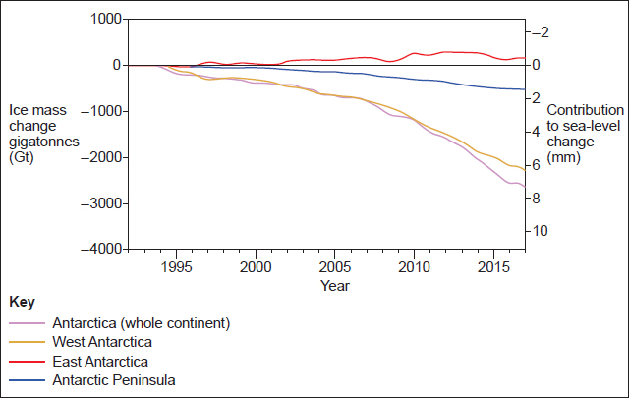

**Figure b**   
**The distribution of the changing ice extent across Antarctica in 2013**

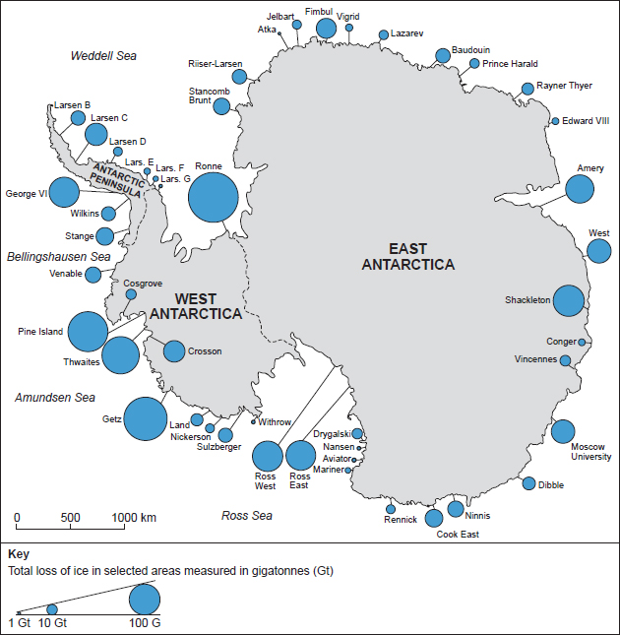

Analyse the data shown in **Figure a** and **Figure b**.

**[6 marks]**

___________________________________________________________________

___________________________________________________________________

___________________________________________________________________

___________________________________________________________________

___________________________________________________________________

___________________________________________________________________

___________________________________________________________________

___________________________________________________________________

___________________________________________________________________

___________________________________________________________________

___________________________________________________________________

___________________________________________________________________

Mark schemes

**Q1.**

**AO1** – Knowledge and understanding of the role of NGOs in enhancing protection of Antarctica. Knowledge and understanding of the role of international government organisations. Knowledge and understanding of the threats to Antarctica.

**AO2** – Application of knowledge and understanding to analyse and evaluate the relative importance of NGOs and International government organisations in enhancing protection of Antarctica.

Notes for answers

The question requires students to assess the relative success of NGOs and International government organisations in protecting Antarctica. This could be in relation to each other or in relation to other strategies or organisations.

**AO1**

•   The concept of the Global Commons in relation to Antarctica and the issues this causes in management of areas that fall outside national jurisdiction and to which all nations have access. There is likely to be increased pressures on such areas as resources become more scarce.

•   Threats to Antarctica at a variety of scales for example fishing and whaling, tourism, mining as well as threats from global climate change such as sea-ice expansion and ocean acidification.

•   An understanding of mitigation, resilience and adaptation with regards to the management of Antarctica. For example, ecosystem resilience includes the ability of species to recover from damage. This is important when considering how to manage Antarctica.

•   Knowledge of international government organisations involved in Antarctica – UN, UNEP, International Whaling commission. The International Whaling convention has the responsibility of ensuring the conduct of whaling in the Southern Ocean for example, ensuring no whaling takes place in the whale sanctuaries. CCAMLR involves 24 states and the EU and focuses on marine protection in the Southern Ocean.

•   Knowledge of legislation and treaties in place to protect Antarctica for example The Antarctic Treaty, the IWC whaling moratorium. The Madrid protocol gives extra protection especially in preventing mineral exploration.

•   The role of NGOs involved in monitoring and protecting Antarctica. For example, the Antarctic and Southern Ocean Coalition (ASOC) which includes Greenpeace and WWF. They have worked together to try and protect Antarctica by regulating tourism preventing damage to penguin colonies.

•   Accept reference to International Whaling Commission (IWC) as an NGO.

**AO2**

•   Analysis of the need for international governance of the global commons of Antarctica in light of future pressures from mineral exploration as technology improves and global reserves decline.

•   The link between threats to Antarctica and the need for management. The fragility of the ecosystem and need for protection. For example, overfishing of krill, essential to the Southern Ocean ecosystem, by more than one nation, needs international co-operation.

•   Analysis of the role of international government organisations in protecting Antarctica. The Antarctic Treaty 1959 governs protection for a wide scope of activities from tourism to scientific research. The number of signatories has grown to 52 nations. Extra protection has also been added at later dates such as the Madrid Protocol in 1991, which designates Antarctica as a natural reserve devoted to peace and science.

•   Analysis of the role played by NGOs. Greenpeace has raised awareness of environmental issues via positive action campaigns such as ‘krill-gotten gains to find Antarctic research’. ASOC successfully blocked the Minerals Convention.

•   Alternative futures in terms of the role of international governance and NGOs would also be relevant. For example, the Madrid Protocol only runs until 2048 and new agreements will be needed to ensure the future protection.

•   Evaluation of link between international government organisations and NGOs. ASOC has been granted observer status in the ATS attends annual meetings.

•   The importance of international government organisations relative to NGOs. The ATS is regarded as one of the most successful international agreements but has required the assistance of NGOs to ensure monitoring is effective. NGOs have been instrumental in ensuring the success of international agreements. For example, ASOC worked tirelessly to bring the Madrid Protocol to fruition. CCAMLR agrees conservation measures proposed by NGOs and has been very successful. For example, reducing seabird mortality to practically zero by regulating fishing. This required legislation which could not have been brought about by NGOs.

•   Overall conclusion should seek to consider the relative success or otherwise of both international governance and NGOs in protecting Antarctica. It should support the body of the text and evidence provided.

**Any valid assessment will be credited.**

**Level 4 (16–20 marks)**

•   Detailed evaluative conclusion that is rational and firmly based on knowledge and understanding which is applied to the context of the question (AO2).

•   Detailed, coherent and relevant analysis and evaluation in the application of knowledge and understanding throughout (AO2).

•   Full evidence of links between knowledge and understanding to the application of knowledge and understanding in different contexts (AO2).

•   Detailed, highly relevant and appropriate knowledge and understanding of place(s) and environments used throughout (AO1).

•   Full and accurate knowledge and understanding of key concepts and processes throughout (AO1).

•   Detailed awareness of scale and temporal change which is well integrated where appropriate (AO1).

**Level 3 (11–15 marks)**

•   Clear evaluative conclusion that is based on knowledge and understanding which is applied to the context of the question (AO2).

•   Generally clear, coherent and relevant analysis and evaluation in the application of knowledge and understanding (AO2).

•   Generally clear evidence of links between knowledge and understanding to the application of knowledge and understanding in different contexts (AO2).

•   Generally clear and relevant knowledge and understanding of place(s) and environments (AO1).

•   Generally clear and accurate knowledge and understanding of key concepts and processes (AO1).

•   Generally clear awareness of scale and temporal change which is integrated where appropriate (AO1).

**Level 2 (6–10 marks)**

•   Some sense of an evaluative conclusion partially based upon knowledge and understanding which is applied to the context of the question (AO2).

•   Some partially relevant analysis and evaluation in the application of knowledge and understanding (AO2).

•   Some evidence of links between knowledge and understanding to the application of knowledge and understanding in different contexts (AO2).

•   Some relevant knowledge and understanding of place(s) and environments which is partially relevant (AO1).

•   Some knowledge and understanding of key concepts, processes and interactions and change (AO1).

•   Some awareness of scale and temporal change which is sometimes integrated where appropriate. There may be a few inaccuracies (AO1).

**Level 1 (1–5 marks)**

•   Very limited and / or unsupported evaluative conclusion that is loosely based upon knowledge and understanding which is applied to the context of the question (AO2).

•   Very limited analysis and evaluation in the application of knowledge and understanding. This lacks clarity and coherence (AO2).

•   Very limited and rarely logical evidence of links between knowledge and understanding to the application of knowledge and understanding in different contexts (AO2).

•   Very limited relevant knowledge and understanding of place(s) and environments (AO1).

•   Isolated knowledge and understanding of key concepts and processes (AO1).

•   Very limited awareness of scale and temporal change which is rarely integrated where appropriate. There may be a number of inaccuracies (AO1).

**Level 0 (0 marks)**

•   Nothing worthy of credit.

**AO1 = 10**

**AO2 = 10**

**[Total 20 marks]**

**Q2.**

Point marked

Allow 1 mark per valid point with extra mark(s) for developed points (d).

For example:

Notes for answers

Allow credit for specific knowledge and understanding of the threats to Antarctica from fishing and whaling. Candidates may also consider the extent to which the threats are mitigated. Candidates can gain maximum marks from covering fishing or whaling, there is no requirement to consider both.

•   Antarctica marine waters are highly productive due to the Antarctic Convergence where the upwelling and mixing creates waters rich in oxygen and nutrients (1). This makes them highly lucrative for fishing businesses and over-fishing has occurred (1) (d).

•   Many species of whales have been over-exploited (1). However, the threat is now less due to the establishment of the IWC which banned commercial whaling globally in 1982 (1). However, some nations such as the Japanese still whale under the guise of scientific research (1) (d).

•   Overfishing of krill removes a major supply of food as it is low down in the food chain (1). It is a popular protein food in SE Asia and commands high prices (1) (d). This demand is making fishing of krill in the Southern Ocean unsustainable (1) (d).

•   Illegal fishing is of grave concern in the Southern Ocean as it is difficult to control and manage for organisations such as ASOC (1). The long-line fishing of the Patagonian Toothfish (1) has caused a massive depletion of stocks but also resulted in the deaths of sea-birds due to loss of a food source (1) (d).

•   Fishing ships are also responsible for ocean pollution, often dumping fishing gear and waste into the ocean (1). The cold water temperatures are slow to break down pollutants (1) (d).

•   Fishing and whaling boats have brought in invasive species on the hull of their ships (1) such as the Mytilus bivalve (1) (d).

The notes for answers are not exhaustive. Credit any valid points.

**AO1 = 4**

**[Total 4 marks]**

**Q3.**

**AO3** – Analysis of the line graph, proportional circles and map of Antarctica to consider the changes in the distribution and volume of ice extent across Antarctica.

Mark scheme

**Level 2 (4–6 marks)**

**AO3** – Clear analysis of the quantitative evidence provided which makes appropriate use of data to support. Clear connections between different aspects of the data.

**Level 1 (1–3 marks)**

**AO3** – Basic analysis of the quantitative evidence provided which makes limited use of data to support. Basic or limited connections between different aspects of the data.

Notes for answers

This question requires analysis of the changing ice extent across Antarctica. There should be analysis of the line graph to examine different rates of change and the map to look at the distribution of change. Connections can be made between **Figure a** and **b** and within the data sets, for example by analysing the spatial relationship of the total ice-loss.

**AO3**

•   **Figure a** shows that all areas of Antarctica, except East Antarctica, have shown a negative mass change.

•   As a whole Antarctica has seen a mass change of approximately 2500gt, which has contributed to about 8mm of sea-level rise. The greatest change is seen in West Antarctica with a loss of 2200gt.

•   East Antarctica has seen very little change with a very slight increase between 2008 and 2014.

•   The proportional circles support the graph in **Figure a** as they show that the highest concentration of largest circles are found in the West, for example Getz and Pine Island both have melt rates in excess of 100gt/yr, whereas only Amery and Shackleton in the East have around 100gt/yr melt.

•   The rate is more erratic around the Antarctica Peninsula with some areas such as George V1 having around 100Gt of melt whereas others have very small amounts of melt such as Larsen G having around 1gt/yr.

•   **Figure b** map of East Antarctica shows that in 2013 many stations were showing ice loss in excess of 10Gt, this doesn’t correlate well with 1a as in 2013 there seems to be a positive mass change and ice mass is above 0. Although after 2013 there does seem to be a slight dip which could reflect the data shown in **Figure b**.

Credit any other valid analysis.

**AO3 = 6**

**[Total 6 marks]**

•

Examiner reports

**Q1.**

Some of the responses to this question were simply outstanding. Students often displayed extensive knowledge of Antarctic NGOs and IGOs and were then able to evaluate their specific success in protecting Antarctica. The most successful answers dealt with all aspects of the question, addressing the command to thoroughly evaluate relative importance in enhancing protection. Some of the better answers also considered that NGOs and IGOs are more successful when they work together and a considered view of the future threats and need for enhanced protection, demonstrating the breadth with which students can tackle these 20 mark questions.

Less effective responses frequently relied on knowledge and understanding of the threats to Antarctica or the strategies used to protect it, without marrying the two together. Others relied heavily on the Antarctic Treaty and failed to consider other strategies. Such responses tended to reflect a lack of understanding of the demands of the question. Some responses referred to specific strategies without identifying them as either NGOs or IGOs and therefore did not address the question successfully.

**Q2.**

This question was answered well by a large majority of students. A high proportion reached 3 or 4 marks. Most students focused on the negative changes to food webs/chains and the threat of extinction. Better responses went on to develop these points and add support through specific examples. Weaker responses tended to focus on vague threats eg ‘whaling impacts food chains’, without any qualification as to what the impact was. This was not creditworthy.

**Q3.**

This was the highest performing AO3 question on the paper, with three-quarters of students achieving L2. Most students were able to use Figure a to pick out the main trends, focusing on Antarctica overall, then looking at the breakdown of the different regions. They were able to support the trends with data. Weaker answers often failed to pick up on the reduction in sea-level as a result of an increase in ice-mass in East Antarctica. The better responses went on to look for connections with Figure b and used examples of stations to support the trends seen in Figure b.