**Q1.**

The map below shows the number of days when precipitation is high enough for plant growth across southern Africa in 2000 and that projected for 2050.

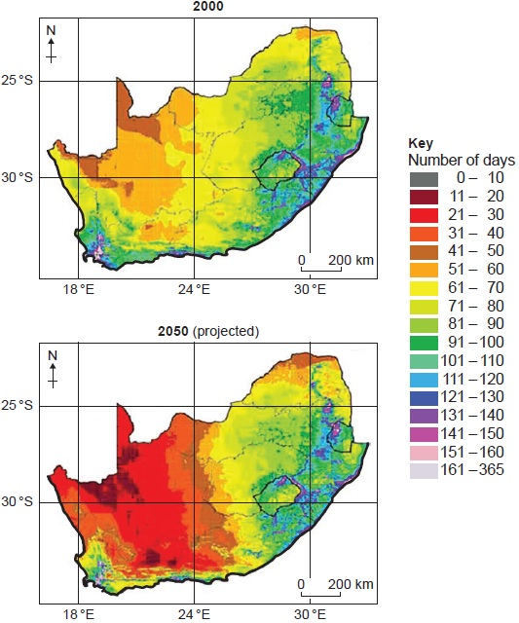

Using the map and your own knowledge, assess the predicted impact of climate change upon life in this region.

**[6 marks]**

_______________________________________________________________________

_______________________________________________________________________

_______________________________________________________________________

_______________________________________________________________________

_______________________________________________________________________

_______________________________________________________________________

_______________________________________________________________________

_______________________________________________________________________

_______________________________________________________________________

_______________________________________________________________________

_______________________________________________________________________

_______________________________________________________________________

**Q2.**

**Figure 1** shows greenhouse gas emissions per capita in selected European countries in 2015.

**Figure 2** shows the % of electricity generated from renewable sources in selected European countries in 2015.

**Figure 3** shows the selected countries.

**Figure 1**

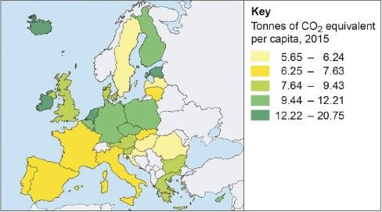

**Figure 2**

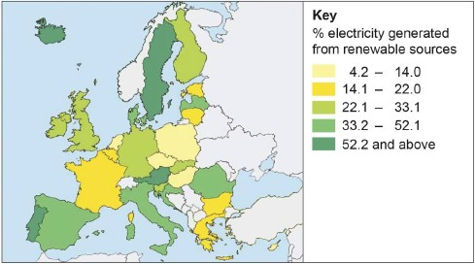

**Figure 3**

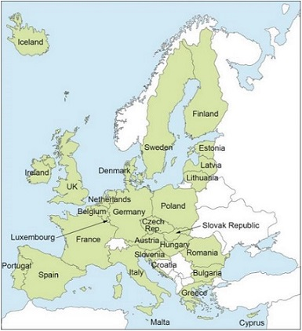

Analyse the data shown in **Figure 1** and **Figure 2**.

**[6 marks]**

_______________________________________________________________________

_______________________________________________________________________

_______________________________________________________________________

_______________________________________________________________________

_______________________________________________________________________

_______________________________________________________________________

_______________________________________________________________________

_______________________________________________________________________

_______________________________________________________________________

_______________________________________________________________________

_______________________________________________________________________

_______________________________________________________________________

**Q3.**

How far do you agree that changes to the carbon cycle will lead to increasingly severe storm events?

**[9 marks]**

_______________________________________________________________________

_______________________________________________________________________

_______________________________________________________________________

_______________________________________________________________________

_______________________________________________________________________

_______________________________________________________________________

_______________________________________________________________________

_______________________________________________________________________

_______________________________________________________________________

_______________________________________________________________________

_______________________________________________________________________

_______________________________________________________________________

**Q4. SECURE MATERIAL**

**Q5.**

Assess the extent to which changes in the carbon cycle can lead to water stress.

**[9 marks]**

___________________________________________________________________

___________________________________________________________________

___________________________________________________________________

___________________________________________________________________

___________________________________________________________________

___________________________________________________________________

___________________________________________________________________

___________________________________________________________________

___________________________________________________________________

___________________________________________________________________

___________________________________________________________________

___________________________________________________________________

**Q6.**

The diagram below represents data from a climate model for Africa. The map shows how rainfall totals are expected to change in Africa by 2099 compared with 1986−2005 averages. The graphs show predictions for rainfall change by month between 2080 and 2099, compared with average rainfall taken from 1986−2005.

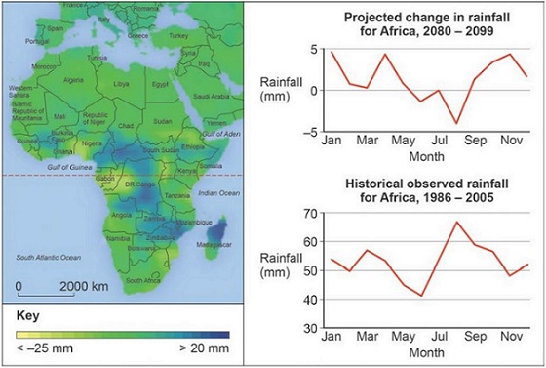

Using the diagram above, analyse projected rainfall change in Africa.

**[6 marks]**

_______________________________________________________________________

_______________________________________________________________________

_______________________________________________________________________

_______________________________________________________________________

_______________________________________________________________________

_______________________________________________________________________

_______________________________________________________________________

_______________________________________________________________________

_______________________________________________________________________

_______________________________________________________________________

_______________________________________________________________________

_______________________________________________________________________

Mark schemes

**Q1.**

**AO1** – Knowledge and understanding of changes of the water cycle and how changes to the water cycle affect the ability of a region to sustain itself.

**AO2** – Application of knowledge to show how the changing rainfall characteristics are likely to affect the ability of the region to sustain life.

**Level 2 (4–6 marks)**

**AO1** – Demonstrates clear knowledge and understanding of concepts, processes, interactions and change.

**AO2** – Applies knowledge and understanding to the novel situation offering clear evaluation and analysis drawn appropriately from the context provided. Connections and relationships between different aspects of study are evident with clear relevance.

**Level 1 (1–3 marks)**

**AO1** – Demonstrates basic knowledge and understanding of concepts, processes, interactions, change.

**AO2** – Applies limited knowledge and understanding to the novel situation offering only basic evaluation and analysis drawn from the context provided. Connections and relationships between different aspects of study are basic with limited relevance.

Notes for answers

**AO1**

•   Changes in the water cycle over time to include natural variation including storm events, seasonal changes and human impact including farming practices, land use change and water abstraction.

•   The key role of water stores and cycles in supporting life on Earth with particular reference to climate. The implications for life on Earth.

**AO2**

•   It is clear from the evidence that the west is set to experience an increase in area where plant growth days are low. Apart from the coastal region there is almost a 50/50 in coverage where there is precipitation facilitating less than 60 days’ plant growth.

•   Responses are likely to connect the reduced plant growth days in the west to increased challenges in farming. A typical growing season is around 3–5 months depending on the crop. With growing days of less than 60 days, this is sure to impact on farming yields, affecting crop growth but also livestock. Expect reference to food shortage and increased reliance on the importation of food supplies.

•   The local environment is also likely to suffer with less natural vegetation growth which supports local habitats.

•   Water supply is also likely to be considered. Whilst this information is not provided it is implicit that there must be less rainfall predicted by 2050. This is likely to impact negatively upon reservoirs and water storage for human consumption. Some may connect this to the rationing of water and the negative impact of this upon quality of life.

Credit any other valid assessment.

**AO1 = 2 AO2 = 4**

**[Total 6 marks]**

**Q2.**

**AO3** − Analysis of map data showing the extent of the relationship between greenhouse gas emissions and use of renewable energy.

Mark scheme

**Level 2 (4−6 marks)**

**AO3** − Clear analysis and interpretation of the quantitative evidence provided, which makes appropriate use of data in support. Clear connection(s) between different aspects of the data and evidence.

**Level 1 (1−3 marks)**

**AO3** − Basic analysis and interpretation of the quantitative evidence provided, which makes limited use of data and evidence in support. Basic connection(s) between different aspects of the data and evidence.

Notes for answers

The question requires analysis of greenhouse gas emissions and renewable use in European countries. Answers should seek connections between and / or within **Figure 1** and **2**.

**AO3**

•   Some evidence that the countries with lower percentages of renewable energy use are also the countries with highest greenhouse gas emissions. For example Belgium has < 14.0% electricity generated by renewables and also has the highest levels of greenhouse gas emissions > 12.22 tonnes of CO2.

•   Romania and Sweden have some of the lowest greenhouse gas emissions in Europe and also have higher levels of renewable energy use.

•   However the pattern is not totally clear as several countries such as Iceland and Ireland have very high levels of greenhouse gas emissions but higher use of renewables. In the case of Iceland is it one of the highest greenhouse gas emitters and one of the highest users of renewable energy.

•   Many of the Mediterranean countries such as Spain, Italy and Portugal have relatively high levels of renewable use > 33.1% and also have lower levels of greenhouse gas emissions.

•   The Central European countries tend to have higher levels of greenhouse gas emissions and some of these also have the lowest use of renewables, for example Poland has 9.44 − 12.21 tonnes of CO2 emissions and less than 14% renewable use.

•   The pattern of renewable use is quite sporadic with no clear spatial pattern. Highest use is spread across Europe − Iceland, Portugal, Sweden and Austria. With the exception of Belgium the lowest amounts are all found in Eastern Europe.

•   The overall pattern of close correlation is apparent but there are several instances where high greenhouse gas emissions are not matched by high renewable use and vice versa.

**AO3 = 6**

**[Total 6 marks]**

**Q3.**

**AO1** − Knowledge and understanding of the carbon cycle and how this links to the water cycle.

**AO2** − Application of knowledge and understanding to evaluate the potential impact of changes to the carbon cycle upon atmospheric patterns.

Mark scheme

**Level 3 (7−9 marks)**

**AO1** − Demonstrates detailed knowledge and understanding of concepts, processes, interactions and change. These underpin the response throughout.

**AO2** − Applies knowledge and understanding appropriately with detail. Connections and relationships between different aspects of study are fully developed with complete relevance. Evaluation is detailed and well supported with appropriate evidence.

**Level 2 (4−6 marks)**

**AO1** − Demonstrates clear knowledge and understanding of concepts, processes, interactions and change. These are mostly relevant though there may be some minor inaccuracy.

**AO2** − Applies clear knowledge and understanding appropriately. Connections and relationships between different aspects of study are evident with some relevance. Evaluation is evident and supported with clear and appropriate evidence.

**Level 1 (1−3 marks)**

**AO1** − Demonstrates basic knowledge and understanding of concepts, processes, interactions and change. This offers limited relevance with inaccuracy.

**AO2** − Applies limited knowledge and understanding. Connections and relationships between different aspects of study are basic with limited relevance. Evaluation is basic and supported with limited appropriate evidence.

Notes for answers

**AO1**

•   Global distribution and size of major stores of water − lithosphere, hydrosphere, cryosphere and atmosphere.

•   Factors driving change in the magnitude of carbon stores over time and space, including flows and transfers at plant, sere and continental scales. Photosynthesis, respiration, decomposition, combustion, carbon sequestration in oceans and sediments, weathering.

•   Changes in the carbon cycle over time, to include natural variation (including wild fires, volcanic activity) and human impact (including hydrocarbon fuel extraction and burning, farming practices, deforestation, land use changes).

•   The key role of the carbon and water stores and cycles in supporting life on Earth with particular reference to climate. The relationship between the water cycle and carbon cycle in the atmosphere. The role of feedbacks within and between cycles and their link to climate change and implications for life on Earth.

•   Human interventions in the carbon cycle designed to influence carbon transfers and mitigate the impacts of climate change.

**AO2**

•   There are any number of storms events to which students can refer. They may consider diverse and / or connected issues such as El Niño or tropical storms.

•   Responses should consider the impact of changes to the carbon cycle through deforestation and the burning of fossil fuels. Some may consider natural variation such as forest fire and volcanic eruptions.

•   Those responses which argue in support of the link to increased storm events are likely to consider the impact of increased temperatures upon sea temperatures and evaporation rates. This combined with the changes to atmospheric circulation (particularly jet streams) is likely to place more water vapour into the atmosphere leading to more intense downpours through storm events.

•   There should be reference to increased levels of carbon dioxide in the atmosphere, leading to a more pronounced greenhouse effect, higher temperatures and therefore greater levels of evaporation

•   Some may argue against the idea of increased storm events. In fact the higher temperatures are also leading to increased evaporation on land. The problem of desertification in continental interiors is set to another extreme challenge affecting places which are already arid. In other words changes to the carbon cycle are also linked with the spread of aridity.

**AO1 = 4, AO2 = 5**

**[Total 9 marks]**

**Q4. SECURE MATERIAL**

**Q5.**

**AO1** – Knowledge and understanding of the concept of water stress and components of demand for water. Knowledge and understanding of carbon cycles.

**AO2** – Application of knowledge and understanding to evaluate the extent to which changes in the carbon cycle can lead to water stress.

Mark scheme

**Level 3 (7–9 marks)**

**AO1** – Demonstrates detailed knowledge and understanding of concepts, processes, interactions and change. These underpin the response throughout.

**AO2** – Applies knowledge and understanding appropriately with detail. Connections and relationships between different aspects of study are fully developed with complete relevance. Analysis and evaluation are detailed and well supported with appropriate evidence.

**Level 2 (4–6 marks)**

**AO1** – Demonstrates clear knowledge and understanding of concepts, processes, interactions and change. These are mostly relevant though there may be some minor inaccuracy.

**AO2** – Applies clear knowledge and understanding appropriately. Connections and relationships between different aspects of study are evident with some relevance. Analysis and evaluation are evident and supported with clear and appropriate evidence.

**Level 1 (1–3 marks)**

**AO1** – Demonstrates basic knowledge and understanding of concepts, processes, interactions and change. This offers limited relevance with inaccuracy.

**AO2** – Applies limited knowledge and understanding. Connections and relationships between different aspects of study are basic with limited relevance. Analysis and evaluation are basic and supported with limited appropriate evidence.

Notes for answers

The question requires links to be made between two different units namely resource security and water and carbon cycles. The question requires evaluation of the roles played by changes in the carbon cycle in causing water stress. They may consider the importance of other factors that cause water stress. Note that the question is about water stress, not water scarcity.

**AO1**

•   Knowledge and understanding of carbon cycles.

•   The key role of the carbon and water stores and cycles in supporting life on Earth with particular reference to climate.

•   The relationship between the water cycle and carbon cycle in the atmosphere.

•   The role of feedbacks within and between cycles and their link to climate change and implications for life on Earth.

•   Knowledge and understanding of global patterns of water availability and demand.

•   Sources of water – components of demand, water stress.

•   Relationship of water supply (volume and quality) to key aspects of physical geography – climate, geology and drainage.

**AO2**

•   Analysis of the link between areas suffering water stress and the changes in the carbon cycle. Increased global temperatures as a result of increased atmospheric carbon, can lead to less plant growth in arid areas which causes lower levels of evapotranspiration, leading to lower levels of cloud formation and less rainfall, therefore leading to water stress.

•   Increased atmospheric carbon may lead to climate change which might make rainfall less predictable meaning that water stress increases, particularly in marginal semi-arid areas.

•   Evaluation of the role of the carbon cycle in causing water stress. Deforestation in the Amazon is causing increased carbon to be released through burning, resulting in increased temperatures but reduced evapotranspiration resulting in less cloud cover and therefore less rainfall, leading to water stress in areas adjacent to the Amazon.

•   Evaluation of other factors that lead to water stress. For example, many areas suffer economic water scarcity, not because there is a physical water scarcity due to lack of rainfall but as a result of rising demand for water from agriculture eg rice cropping in SE Asia.

•   They may consider that water stress leads to changes in the carbon cycle. For example lower rainfall levels in California have increased irrigation demands from major rivers and groundwater stores, reducing water levels, leading to less natural vegetation growth and therefore reduced carbon stores.

•   Alternative futures may also be considered, for example impact of climate change in different areas. Some areas rely on spring snowmelt for water surface supply and without accumulation of winter snow this could lead to water stress.

•   Students should come to a conclusion as to the extent to which changes in the carbon cycle can lead to water stress. Any conclusion is valid as long as it supports the content of the response.

Credit any other valid approach.

**AO1 = 4, AO2 = 5**

**[Total 9 marks]**

**Q6.**

**AO3** − There are a variety of ways of approaching this unseen material. Students are required to analyse rainfall variation and change of over time. Responses should use the resources effectively and appropriately showing understanding of the link between the two graphs. Expect to see analysis of patterns and identification of anomalies on both the graphs and map.

**Level 2 (4−6 marks)**

**AO3** − Clear analysis of the quantitative evidence provided, which makes appropriate use of data in support. Clear connection(s) between different aspects of the data and evidence.

**Level 1 (1−3 marks)**

**AO3** − Basic analysis of the quantitative evidence provided, which makes limited use of data and evidence in support. Basic connection(s) between different aspects of the data and evidence.

Notes for answers

**AO3**

•   Analysis shows that overall Africa is expected to see an increase in the amount of rainfall for most months. The biggest increases appear to be in January, April and November (around 4mm).

•   However, from May to September, this model suggests that rainfall will be lower than the 1986−2005 average by as much as 4mm in August.

•   Some students may calculate this as a reduction from 67 to 63 mm. For many months, February, March, May and September, there is little change expected.

•   The map gives further information about how the changes identified may affect rainfall spatially across Africa. The north of Africa is broadly expected to experience little change.

•   A large group of countries stretching from Chad to Botswana in the south are set to experience an increase in rainfall of up to 20 mm.

•   Some may point to anomalies where rainfall is set to fall such as south-west Nigeria which is expected to experience up to a 25 mm reduction in rainfall.

**AO3 = 6**

**[Total 6 marks]**

Examiner reports

**Q1.**

In this question too many tried to analyse the data presented rather than consider the implications of the expected drier conditions on life in the region.

**Q2.**

This question generally appeared to elicit better responses than the other AO3 questions on the paper. Very few students failed to seek connections between **Figures 1** and **2**. Most students were able to analyse patterns and identify anomalies. Fewer students looked for geographical patterns and variation. It is worth noting that when maps with spatial variation are included, students should be encouraged to engage in spatial analysis.

**Q3.**

This was the first combined AO1 / AO2 based question. This meant that the thrust of the question did not lie explicitly stated in the specification. Students had to make an evidence based assessment as to whether storm events are likely to become more severe because of changes to the carbon cycle. Many argued that this was the case. This was due to increased temperatures caused by global warming, itself caused by increased CO2 emissions. The increased temperatures were argued to lead to increased sea temperatures and increasing likelihood of tropical storms. Others suggest increased evaporation would lead to increased storms due to the increased water vapour in the atmosphere. Although this approach did not deal particularly well with the notion of severity.

The average mark for this question was 4.3 suggesting students need more preparation in the application of knowledge to questions which do not arise explicitly out of one area of specification content.

**Q5.**

Many students seemed unprepared for this cross-specification question. They were asked to apply knowledge of the carbon cycle to causes of water stress. Many students found this very challenging. Many responses were very generic and did not use evidence in support. The best responses used examples of locations suffering water stress and were able to use their knowledge of the location to suggest how changes in the carbon cycle might affect the level of water stress. Teaching concepts through use of examples, certainly provides students more to develop in all exam questions. Weaker responses tended to focus on changes in the carbon cycle with simple links to increased evaporation or more droughts.