**AQA : A LEVEL LAW**

**PAPER 2 – TORT**

**Liability in Negligence**

**ECONOMIC LOSS**

**Liability for pure economic loss**

**caused by negligent acts and negligent misstatements.**

Further Reading and additional learning materials

**Economic Loss**

Year 2 – AQA A Level Law for Year 2 (Hodder); pages 151-154

Tort Law for AQA A Level – Part 2 – Sally Russell pages 17-25

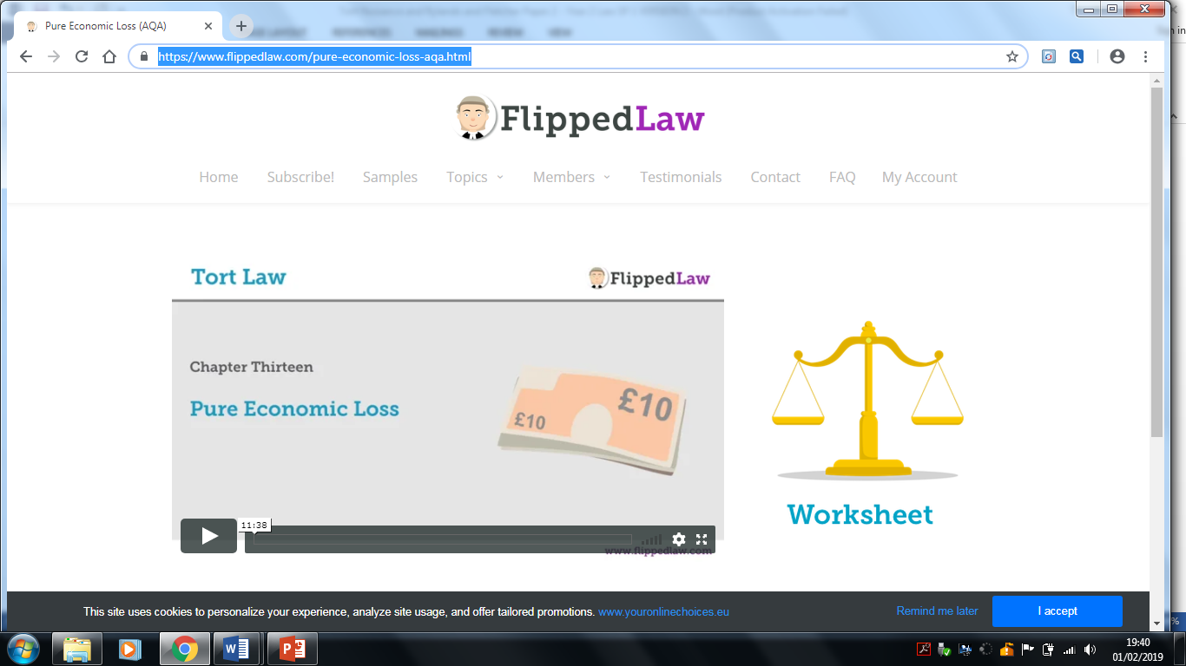

<https://www.flippedlaw.com/pure-economic-loss-aqa.html>

# **Tort Special Duty Situations - Economic Loss**

Law Bank video 37;32

<https://www.youtube.com/watch?v=N9UQ9vykMTc>

**DOES D OWE A DOC FOR ECONOMIC LOSS [IDENTIFY…] SUFFERRED BY V?**

**Was D in BREACH?**

Consider (professional ?) standard

**DOC OWED**

Was there a **special relationship?**

1D had/held out **expertise** in field of advice

2**.** D **assumes responsibility** for statementie aware:

* to **whom** advice being given (directly)
* **purpose** for which advice being given
* advice (highly) **likely to be acted upon** (without further indep inquiry)

3. C (reasonably) **acted/relied** on advice

4. C suffered **detriment**

Was this loss a result of either:

1. **physical** harm to C ?
2. **physical** damage to C’s *own* property?

**= *Consequential* £ Loss**

Established DOC rules apply

**= *Pure £ Loss***

* No physical damage at all or
* Physical damage was to 3rd party property only

What did pure £ loss **result from?....**

**….from negligent act**

…from negligent **misstatement**

**NO DOC**

**NO DAMAGES**

**DAMAGES PAYABLE**

**UNLESS DISCLAIMER**

**DAMAGE tests satisfied? (fact) law**

**Economic loss**

**What is it?**

Economic loss is classed as a financial loss rather than a losses resulting from physical loss such as a personal injury or damage to property.

It is the loss resulting from the defendant’s negligence which has left the claimant less well off than he would have been had the negligence not happened.

An example of this type of loss would be:

* Loss of Profits
* Loss of income
* Loss of financial benefit
* Loss in value of items

Note - The general rule is *consequential* economic loss is recoverable but **pure economic** loss is not.

**Types:**

There are 2 types of economic loss; consequential and pure economic loss.

A claimant can recover for consequential loss but not for pure economic loss;

**Consequential loss**

This occurs when the claimant has suffered a consequential loss as a result of a physical damage.

Examples of this would be:

* Where a worker loses wages because he has been injured by the defendant’s negligence
* Taxi driver loses fares because his taxi has been damaged by the defendant’s negligence.

In both examples the defendant’s negligence has caused the physical loss, i.e. damage to property or personal injury to the claimant, that **consequentially** leads to a money loss for the claimant.

**Pure economic loss**

This is known as a “stand-alone” economic loss: there is no item of physical loss.

An example of this would be if the defendant’s negligence causes a traffic jam that closes the road which prevents any customers getting to the claimant’s shop. The shop owner has suffered a loss of profit as a result.

Here the claimant has **NOT** suffered any Physical loss but instead has lost money which is classed as pure economic loss.

The rule is that consequential loss is always recoverable if it is done by a negligent act, as long as the claimant can prove the normal rules of negligence.

***Network Rail Infrastructure v Conarkin Group (2011)***,

the claimant’s railway line was blocked for 5 days by rubble that had fallen from a bridge because of the negligence on the part of the defendant lorry driver.

had had to pay out compensation to rail companies who were unable to use the line.

This economic loss was recoverable because it was consequential on the physical damage done to the railway line.

**The difference between consequential and pure economic loss**

***Spartan Steel and Alloys Ltd v Martin and Co. Ltd (1972),*** where the defendant was carrying out road works when, negligently, it severed the electricity cable that supplied power to the claimant’s smelting works. At the time the powers was shut off, the claimant was producing a melt. In order to protect its furnace, the claimant had to remove the metal by prematurely cooling it, but this in turn meant that the metal was damaged. The claimant suffered three losses:

1. **Damage to the metal**: this was a physical loss in the form of damage to property
2. **Loss of profit**: because the damaged metal could not be used again and sold. This was a consequence of the physical damage to the metal.
3. **Loss of profit**: on three further melts that were planned for the period that the electricity went off. This was classed as an economic loss not associated with any physical loss (pure economic loss) as the metal that was scheduled to be used was undamaged by the incident.

**Liability for pure economic loss caused by a *negligent act***

**No damages** for pure economic loss even when caused by an act.

***Weller v foot and mouth disease Research Institute ( 1965)***

Ds negligence caused an escape of the foot and moth virus. To prevent the disease from spreading the authorities banned the movement of animals, which in turn damaged the business of the claimants who were livestock auctioneers.

The claim for loss of profit failed as it was a pure economic loss: the claimants had suffered no physical loss.

**Q – Why are the rules on recovery for pure economic loss so strict?**

**Liability for pure economic loss caused by a negligent misstatement**

**D can be liable for consequential AND pure economic loss as a result of a negligent misstatement;**

This is an exception to the general rule that pure economic loss is not recoverable.

A defendant may be liable for economic loss if they make a statement to someone to whom he owes a duty of care to but due to his negligence, the statement is inaccurate and it causes the claimant a reasonably foreseeable pure economic loss.

It can be written or verbal, and can be in any form that conveys information to the claimant. An example of this could be through a report, a reference, professional advice, a survey, a set of accounts and a map.

The leading case on this principle is; **Hedley Bryne v Heller and Partners (1964)**

This case developed the law that; ‘*in principle a claim could be made for a negligent misstatement if* ***a special relationship*** *between the parties could be proved’*.

**What is a Special Relationship?**

The features of a special relationship is ‘the person giving the advice owes a duty of care to the claimant’. The features of this was set out in **Caparo Industries v Dickman (1990)**

A special relationship requires **all** of the following to be proved;

1. **The defendant possesses a skill or expertise:**
2. **The defendant voluntarily assumes responsibility for his statements:** ie aware:
   * to **whom** advice being given (directly)
   * **purpose** for which advice being given
   * advice (highly) **likely to be acted upon** (without further indep inquiry)

3. C (reasonably) **acted/relied** on advice

4. C suffered **detriment:**

**Criteria for assessing liability for negligent misstatement:**

It is clear that for the purposes of negligent misstatement, the claimant must show that the defendant owes a duty of care and that they held a “special relationship”.

The idea behind this is to limit the number of potential claimants there could be if there were no restrictions in place on those who could claim.

Very similar to psychiatric harm, and the “floodgates” that could have opened there if there had been no restrictions in place.

The case law has produced the following criteria in order to identify if there was a special relationship between the individuals:

1. **The defendant possesses a skill or expertise:**
   * The defendant possesses a skill or expertise that the claimant relies upon. E.g. Caparo auditors had financial expertise.

Accountants, surveyors, lawyers, bankers, etc

* + ***Lennon v Metropolitan Police Commissioner (2004)*** C had relied upon information about benefit entitlement from the clerk in the personnel department to give him the right information. As a result of being provided with incorrect information he lost out financially (on housing allowance) and was able to claim for pure economic loss. The skills here was that of the clerk.

See also **Chaudry v Prabhaker (1988) page 154 AQA Law 2 – Textbook**

Why was there a DOC in this case?

1. **The defendant voluntarily assumes responsibility for his statements:**
   * Meaning that the defendant is effectively saying to the claimant that he is prepared for the claimant to rely on any advice and that the defendant will take full responsibility for it.
   * He is accepting a connection/ proximity/ relationship
   * Consider ***Patchett v Swimming Pool and Allied Trades Association (2009)***,

claimant wanted to engage a reputable contractor to build a swimming pool in his garden and consulted a trade association website, where from the drop down menu he picked a firm.

The website stated that any reader should make further enquiries and should obtain the defendants information pack, which would make their position clear.

It was on that basis that the trade website was not liable as they were never intending to take responsibility of their reliability or reputation as a result of posting it on website. It was merely a vehicle for advertising.

**D aware to whom advice being given C :**

* + The defendant will normally only be liable if he knows or should know when making a statement, the identity of the particular person or class of persons who will rely on the statement.
  + This is true in the case of ***Caparo v Dickman*** - can you remember what happened in this case?
  + Were the defendants liable for the negligent misstatements contained in the accounts?

**D aware Purpose for which advice given**

* + The defendant will only be liable if he knows or should know the purpose for which the statement has been made and will be used for.

**What was the known purpose in Caparo?**

* + A further case example is ***Reeman v Department of Transport (1997)***.

The claimant had bought a boat on the strength of the seaworthiness certificate issued by one of the defendant’s inspectors. The certificate had been negligently prepared and the boat was therefore unsafe and of little value.

The claim for negligent misstatement failed because the certificate had been produced for the purpose of complying with the regulations designed to promote safety at sea, not for the purpose of putting commercial value on the boat.

**D (ought to )aware advice likely to be relied on:**

* + Will depend on facts and context

**Chaudry v Prabhaker (1988)** page 154 AQA Law 2 – Textbook

1. **C did (reasonably) rely on the advice**

This will also depend on facts of case and context

* + Would it be reasonable for you to rely on a statement made at a drinks party on a night out when someone may be under the influence as opposed to relying on a statement made in a business meeting, which one would you say would be more reliable?
  + ***Smith v Eric S. Bush (1990)*** HL held it would be reasonable for the claimant to rely on the survey given that the defendant knew that the survey would be passed to the claimant.
  + There was no unknown liability as both the identity of the claimant and the amount of any loss were known in advance.

1. **C suffered loss as a result of that advice**

**Chaudry**

**How to apply Economic Loss within a problem scenario**

Once you have established whether the Duty of Care does exist you would then have to follow the principles established in Breach of Duty of Care and Damage in order to prove the defendant liable for the claimant’s losses, then apply it to the scenario.

**Use the following structure to help you answer the scenario question below;**

1. State the general rule that it is not possible to claim for pure economic loss arising out of a negligent act but it is possible to claim for pure economic loss if they make a negligent misstatement, as an exception to this general rule.
2. Claims for pure economic loss can be made from negligent misstatement following the criteria (known user etc.) and discuss and apply all 5 requirements.

**ACTIVITY**

|  |
| --- |
| **Jenny**  Jenny buys hair straighteners from LoChem. The straighteners are faulty and do not work. Jenny tries to complain to LoChem but they have closed down and gone out of business. She tries instead to sue the manufactures GHD for their negligent manufacture. |
| What type of loss has she suffered?  Does LoChem owe Jenny a DOC? |

|  |
| --- |
| Reconsider if the straighteners caught fire and burned her scalp and damaged the ceiling? As a result of which she loses earnings as a self-employed hairdresser for 6 weeks. What type of loss is this? |
| What type of loss has she suffered?  Does LoChem owe Jenny a DOC? |

|  |
| --- |
| **Jan**  is on her way to the station to catch a train. She is stuck in a large traffic jam caused by a serious road accident. She misses the train and has to purchase another ticket for a later one. This costs Jan an extra charge. The road accident was caused by the negligence of Dan, who crashed into a lorry owned by Charles. |
| What type of loss has she suffered?  Does Charles owe Jan a DOC? |

|  |
| --- |
| **Josh** a senior financial journalist, negligently advises readers in Money Week that shares in Peak plc would be a good investment. Several readers of his paper, including Clem, suffer losses when they invest in Peak. |
| What type of loss has he suffered?  Does Josh owe Clem a DOC? |

|  |
| --- |
| Reconsider your answer where one of Josh’s readers, Kev, gets in touch with Josh and asks for specific advice on investments as is wondering what to do with an inheritance he has received. Josh sends Kev more (inaccurate) information and advises him on how much he should invest in Peak plc he and assures him he can’t lose. |
| What type of loss has he suffered?  Does Josh owe Kev a DOC? |

|  |
| --- |
| Reconsider your answer again where Josh advises Ben, a former colleague and financial journalist at a drinks party to invest in Peak plc. |
| Does Josh owe Ben a DOC? |

An article in the IT pages of the Times newspaper described and recommended Safestore, a security software package. After reading the article, Gordon bought a copy of Safestore and installed it on his computer’s hard disk, hoping to protect his client’s confidential business information. In fact, the article had failed to explain that the version of Safestore on public sale was less comprehensive than the version reviewed. Gordon’s security was breached two months later while he was online. In consequence, he had to pay a total of £30,000 to clients affected by the breach and he stopped receiving orders for his services.

Advise Gordon as to whether he can recover his loss against the Times newspaper. 10 marks

Be sure to state which type he will be able to claim for and why.

**Question 8**

Jack met Layla at a dinner party. She had recently qualified as an accountant. Jack asked Layla how best to invest his money for his children’s university education. On Layla’s advice, Jack bought £20 000 worth of shares in Medico plc. Soon afterwards, Medico became insolvent and Jack’s shares became worthless.

**Advise Jack as to his rights and remedies against Layla regarding the losses on his shares (10 marks)**

Remember marks are awarded for;

* A01 = 3 marks – legal authority/knowledge and understanding of the law in your answer;
* A02 = 4 marks for legal application
* A03 =3 marks for concluding correctly each area/ application of law and providing a clear conclusion to the question set for rights and remedies;
* Timing allocation is 12 minutes to answer the 10 mark question – which includes you reading it carefully – suggest at least 4 times! And spotting the issues and writing up your answer in a format that will enable you to achieve all the marks available.

**Can you answer this question in full within the 12 minutes – time yourself and complete a full answer**.