YOUR LAW SUMMER ASSIGNMENT WORK

Please complete the following 4 Tasks ready for your first law lesson back in September;

TASK 1 – To review an introduction and overview of the Contract Law Topics you will be studying for Paper 3;

Using the additional pack you have been given; THE LAW OF CONTRACT INTRODUCTION STUDY PACK 1 (with the blue front cover) and the PowerPoint on Introduction Topics Studied for Paper 3, (which can be found on LAW Year 2 GOL, - Work through each page in your pack and either identify either your own examples for each topic area or the examples and guidance in the PowerPoint on GOL.

ESTIMATED TIME = 70-90 mins and objectives is for you to know the range of topics studied for Contract law.

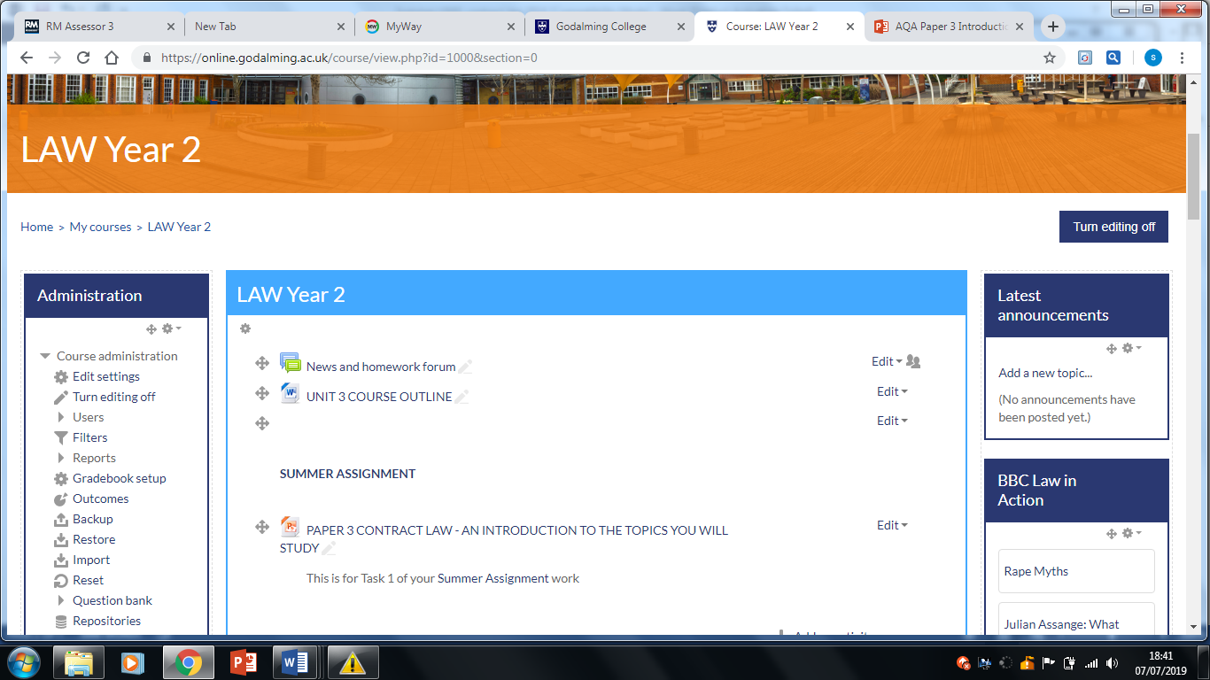

TASK 2; to complete each of the 6 activities to enable you to start the first topic of; FORMATION OF CONTRACT;
AGREEMENT: OFFER AND ACEPTANCE

TO SUBMIT: Quiz on Offers & Acceptance & Topic summary sheets first lesson back.

1. Watch the following video “Introduction to Contract Law” to refresh your memory of our introduction
https://www.youtube.com/watch?v=KFia_uQirNg
2. Read & make notes from the 2nd Year textbook ( which you should either purchase or ensure you are able to access online thorough Godalming online)-Research & make notes on Offers in chapter 18 pages 202- 206.
A Scanned PDF of this chapter is also on GOL – LAW YEAR 2 – Summer Assignment work, underneath the Powerpoint you used for Task 1

3. Complete your answers to the Quiz on OFFERS (on page 3-5) attached to hand in first lesson back.

4. Now create a Topic Summary Sheet [TSS] for Offers. This should be one side of A4 paper, outlining
- characteristics of offers
- the distinction between offers and invitations to treat
- How offers can be terminated
The TSS should identify all the relevant principles, with the relevant case as authority for each principle.

5 Research Acceptance by reading the textbook Pages 206 – 211 & create a Topic Summary sheet outlining the following relevant principles:
A Scanned PDF of this chapter is also on GOL – LAW YEAR 2 – Summer Assignment work;
- method of acceptance
- communication of acceptance:
- acceptance by post – special rules
- methods of communicating acceptance
- acceptance of unilateral offers

6. Answer the attached Quiz on ACCEPTANCE (page 6-7) to hand in first lesson back

Name ………………………………………………… OFFERS: QUIZ
1. What are the 4 legal requirements for a contract to exist?
.....................................................................................................................
.....................................................................................................................
.....................................................................................................................
.....................................................................................................................
2. Give the definition of an invitation to treat (ITT)
...............................................................................................................................................................................................................................................................................................................................................................
3. Give the definition of an offer
..............................................................................................................................................................................................................................................................................................................................................................
4. What principle was established in Guthing v Lynn (1831) ?
..........................................................................................................................................................................................................................................
5. Goods on shop shelves – circle the correct answer
An offer or an ITT ?
6. What case is the authority for your answer to Q5 above?
..........................................................................................................................................................................................................................................
7. What legal principle was established in Partridge v Crittenden (1968)?
..........................................................................................................................................................................................................................................

8. What is the exception to the rule created in Q 6.
Give your case authority for this.
...............................................................................................................................................................................................................................................................................................................................................................
9. “An offer need not be communicated in order to be effective”.
TRUE or FALSE

10. “If an offer is not expressly stated as lasting for a set time, it remains valid for one year”? TRUE OR FALSE

11. Is a shop guilty of offering to sell alcohol to Alan (who is 17) if he attempts to buy cider at the till ? Yes / No
12. Give a reason & a case authority for your answer to Q 12 above
.....................................................................................................................
.....................................................................................................................
.....................................................................................................................
13. Identify where there is a valid offer & acceptance in the following scenario, which together form a contract:-
Alf, an auctioneer offers for sale an antique vase starting price £100
Bert bids £100
Charlie bids £150
Doris bids £200
Edward bids £250
Auctioneer bangs down his Gavel
14. How would your answer change & why if Edward retracts his bid before the Gavel goes down?
.....................................................................................................................
.....................................................................................................................

15. Which case is relevant to the example in Q 13 ?
.....................................................................................................................

SCORE /15

Name: …………………………………………………

ACCEPTANCE QUIZ:

1. When acceptance is communicated to the person making the offer, at what point is an agreement made?

A when acceptance is given by the Offeree : or
B. when it is received by the Offeror

2. Can silence amount to acceptance? Y/N

3. What is the authority for this? ......................................................

4. Acceptance sent by post is effective when?

.................................................................................................................

5. The case authority for the postal rule is

........................................................

6. A Rejection sent by post is effective when?

.................................................................................................................

7. If an acceptance is sent by email , text or telephone when will it be considered to have been communicated ?

……………………………………………………………………………….

8. X says he would like to buy some goods offered but asks whether delivery is included in the price of the offer. Which one of the following do you think is correct:

A-the offer is terminated by this counter offer,
B-the enquiry does not terminate the offer & the contract is made
C-the offer remains open but no agreement is made

9.The case authority for the answer to Q 8 is
.................................................

10. To accept a reward in any offer, the Offeree must communicate his acceptance? True or False?

SCORE /10

TASK 3 = Folder sort out and getting organised for your Second Year;

You will need 3 large folders and all of your current workbooks and law folders.
Using the folder dividers you have been given (which provide a breakdown of each topic you study and need to know for each different law exam Paper 1-3 ), organise and file your workbooks and any other additional handouts, notes, revisions summaries, assignment work, etc under each topic and exam Paper,

It is sensible to have further file dividers to label each topic or at least to divide between the English legal system topics and the substantive law (Crime, Tort) topics.

The topics in bold black font are the ones we have already covered in Year 1 and should all have! and the topics in grey are the Year 2 topics you will cover, so you can see what else will be taught in Year 2; also do label your Folder! Paper 1 – Criminal, Paper 2 – Tort, Paper 3 – Contract. Please note there are topics which are across each exam paper e.g Judges, Nature of Law and A2J, so check you have this and keep in Paper 1 folder).

If you are missing a workbook, please use GOL Year 2 – to print a copy and file in the appropriate folder.

Estimated time – those whom are already organised = 20 minutes, those whom are unorganised it could take up to 90 minutes or more! But this is an important task to complete, it will help you in the long term!

And to be even more organised order the following textbooks ready for your Year 2 Law studies;

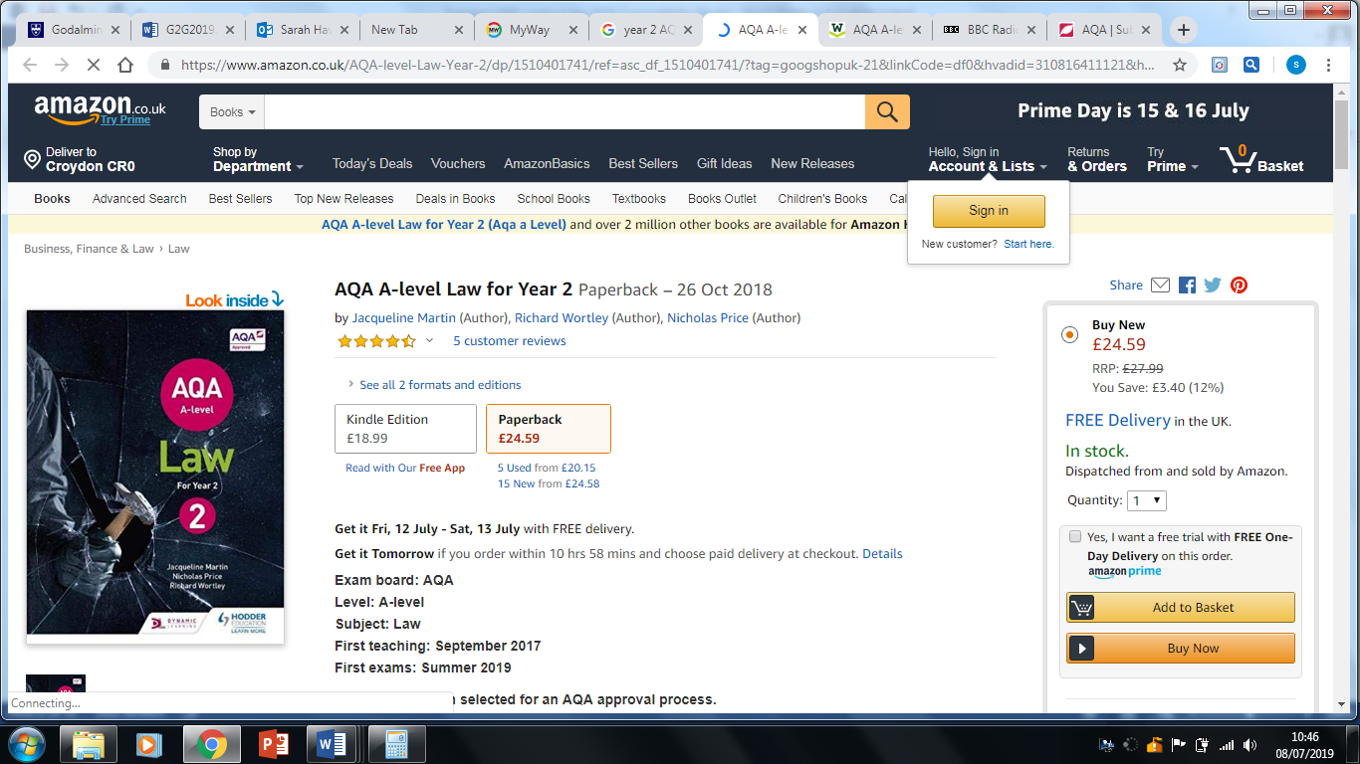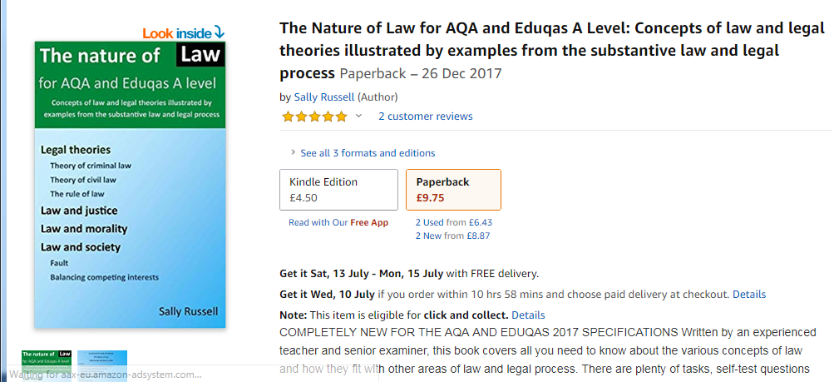
TASK 4 = Bring law to life! Do something extra!

This could be to visit a court, gain some legal work experience, follow a legal case via the news – what’s happened during the trial and the outcome/verdict? Watch a law based film, or series or read a law book beyond your textbook or listen to the Reith (Law Lectures).

Detailed below are some ideas and a guide to visiting the Old Bailey, as this would be a great day out in London for you and you could walk down to the Royal Courts of Justice and the Inns of court (a 10 minute walk from the Old Bailey – via the Strand).

All courts are open to the public – anyone over the age of 14. You can sit in the public gallery [a set of seats reserved for the public at the side of the court]. Courts generally sit between 10.00 and 13.00 and 14.00 and 16.00 – but you should arrive a little before in order to decide which court to watch and to be settled. When you arrive, explain to the court staff that you are a prospective law student, and they will guide you to an appropriate / interesting case.

Our local courts (which are behind the Odeon Cinema in Guildford centre) are:

Guildford Magistrates’ Court: for details go to:
https://courttribunalfinder.service.gov.uk/courts/guildford-magistrates-court-and-family-court

Guildford Crown Court: (please note Guildford CC – welcomes Godalming College students, for details go to:
https://courttribunalfinder.service.gov.uk/courts/guildford-crown-court

Further afield, it would be worth visiting:
The Old Bailey [Central Criminal Court] – in London: for details go to and see below for a guide to visiting:
https://courttribunalfinder.service.gov.uk/courts/central-criminal-court

Winchester Crown Court: for details go to:
https://courttribunalfinder.service.gov.uk/courts/winchester-combined-court-centre

General court information:
For further, general, information about the courts, visit the Judiciary website:
http://www.judiciary.gov.uk/you-and-the-judiciary/going-to-court/

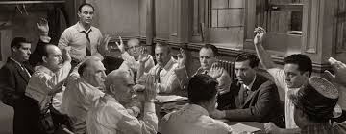
AND! Watch / Browse / Read:

12 Angry Men: - an excellent film about a jury [do not be put off by its age – it is still good and relevant!] [DVD available from Amazon];

The Children Act; in this film a judge must decide a case involving a teenage boy who is refusing a blood transfusion on religious principle (available on you tube/amazon prime).

Eye in the Sky; this film explores the ethical challenges of drone warfare (available on you tube/amazon prime).

Law in Action: http://www.bbc.co.uk/programmes/b006tgy1
- an excellent radio programme covering topical legal news stories;

The Reith Lectures; Law's Expanding Empire
The Reith Lectures 2019: Jonathan Sumption
Jonathan Sumption argues that the law is taking over the space once occupied by politics. Lord Sumption is a former justice of the UK's Supreme Court
https://www.bbc.co.uk/programmes/m00057m8

Watch the news and look out for legal cases on criminal and civil matters
https://www.bbc.co.uk/news

Read;

The Secret Barrister; Stories of the Law and How It's Broken; £6.57 paperback, £3.99 kindle £0 as an audio book on amazon prime

In your Defence – stories of life and law; Sarah Langford (£8.99 Paper back – Kindle £3.99) this book guides you through 11 cases demonstrating the workings of the criminal and family courts. Sarah Langford is a practising criminal and family law barrister.

A Guide to visiting the Old Bailey;

There are a few things you should know before visiting the Old Bailey. There are two parts to the building, old and new. Entrance to the public gallery for the old part is in Newgate Street. This building contains the two most important courts: Court One and Court Two. Court One has witnessed some of the most notorious defendants in British criminal history. The trial of Ian Huntley, who was jailed for the murder of two 10-year-old schoolgirls in Soham, Cambridgeshire, was held in this court. The Kray Twins and The Yorkshire Ripper also appeared in Court One. However because the court is old, has small seats and not much leg room (especially for the Jury) judges often move to the more modern courts in the new building, which are more comfortable. Court Two is the high-security court, and terrorist trials often take place here.The other courts in the old building are Three, Four, 17 and 18. The courts, and therefore the public galleries, are on two floors. Courts One, Two, Three and Four are on the upper floor.
The new building can be accessed from the road called Old Bailey. The public galleries are accessed from Warwick Passage. The new building has three floors and houses 12 courts. On the ground floor are Courts 13, 14, 15 and 16; on the second floor are Courts Five, Six, Seven and Eight, and on the third floor, Courts Nine, 10, 11 and 12. Court 12 is often used for long fraud trials.
Be aware there are strict security measures which make it impossible for visitors to go into the main body of the building. You will only have access to the public galleries to view trials. Admittance to the galleries is free, as the Court is a public building. You may have to queue to gain admittance to a particular case if the public gallery is full. I would suggest that you bring some sort of identification with you – passport or driving licence etc – as these may be required to enter high security-risk trials. You could be denied entry without them.
Cameras, large bags (rucksacks), recording equipment, mobile phones, sharp objects (pen knives and nail scissors), food and drink and writing materials are also banned from the Court. (The x-ray machines will pick up items and you will then be asked to leave the premises. Mobiles, cameras etc are regarded as a security risk.) The Court has no facilities where such items can be left. A nearby travel agents - Capable Travel Agent at a cost of £1 per device will look after property for a small fee, £5 for a bag. As a result, keep what you take with you to a minimum. Visitors to the public galleries are requested to dress appropriately (no vests or shorts for men; no low-cut tops or short skirts for women) or entry to the court building may be refused. Smart casual dress is advised.
The address for the court house is Central Criminal Court, Old Bailey, London EC4M 7EH. The sitting times for the court are 10am to 1pm and 2pm to 4.30pm (approx). The court does not sit on bank holidays and during Easter and Christmas holiday periods. At Christmas the court can be shut for as long as two weeks, depending when Christmas Day falls. At Easter the holiday period is usually around four or five days. The nearest Underground station is St Paul’s, on the Central Line. It is less than five minutes’ walk from the Court. Other nearby Tube stations are Blackfriars, on the District and Circle Lines, and Farringdon, on the Circle and Hammersmith lines. The nearest over-ground station is City Thameslink. There is also a river-bus service from Blackfriars Pier, opposite Blackfriars station.
https://old-bailey.com/category/whats-on-at-the-old-bailey-today/
Close to the Old Bailey;

The Temple Church website details its varied opening times. It’s generally open on weekdays from 10am-4pm. Entry charge is £5 for adults, free for under 16s.

Middle and Inner Temple Gardens are open to the public from 12-3pm on weekdays during the summer. There is no entrance charge.

The Royal Courts of Justice is open on weekdays from 9am-4.30pm. Entry is free.

