AQA A Level Law 7162–
Year 1 Course Handbook




- What topics will I study?
- What exams will I take?
- What is expected of me?
Name: _____________________________________

Law Teacher: _____________________________________

Welcome to A Level Law - This booklet is designed to give you an overview of the A Levell Law course, providing you with details about its structure, exams and content.

Why study A Level Law? This course provides grounding in the main principles and sources of English law and its institutions, which create and administer those laws. It will enable you to develop knowledge, understanding, and critical awareness of the structure, professionals involved in and functions of the legal system and how liability arises in criminal, tort and contract law.

How is the course taught? You will use core textbooks and our study packs to support your learning. In addition, as law is a ‘living subject’ you will be expected, without being directed to do so, to keep abreast of legal developments in the news.

In class you will be guided through our study packs and expected to make notes and to contribute to class discussions and complete activities.
Why not follow (and contribute) to bitesize law account established by one of our former students with the help of some current students to keep you up to date with the profession and topical developments in law.

Independent work
You will be expected to do 50:50 independent learning every week. Work set may be split into midweek and end of week work. Tasks will range from reading text books or watching videos in advance of studying a topic or afterwards to consolidate class work. You may be directed to carry out research tasks, prepare exam style answers and produce revision materials on an on-going basis. This work will be reviewed and you will gain regular feedback on your progress and guidance about how to improve your understanding of the subject and exam technique.

WHAT WE EXPECT FROM YOU;
Homework/Assignment work - This must be completed in full and on time as a matter of routine. If you do not understand the task set then it is your responsibility to speak to your teacher for clarification before the deadline date, so that you can complete it. Producing half- hearted, unfinished work is not acceptable. Use your homework diary/planner to record and plan homework tasks. Work may be required to be uploaded on Teams but even where this is the case you must still have that available in hard copy for the lesson in which it was due . Please also bear in mind we are under no obligation to mark or give feedback on work submitted late.

- Use the library Your understanding of this subject will improve dramatically if you read around the topics. The library has a vast array of legal texts, journals and newspapers. The A Level Law Review is particularly worth reading. Law is a challenging subject and you cannot expect time spent in class will give you a sufficient grasp of its complexities but if you layer your knowledge through reading around the subject you will enrich and secure your grasp of the subject and enjoy it so much more.

- Full attendance to lessons - It is important that you attend all lessons to enable continuity in this subject. Lessons will move quickly, so if you miss one or two lessons you may find you have missed an entire topic area. The consequence of this is that you may not be able to complete the exam paper and be prepared for the A Level exam.

- Absence - If you have missed a lesson for any reason then it is your responsibility to always catch up on the work that you have missed. It is not the teacher’s responsibility to organise missed work for you. Do not wait until the next lesson to catch up on any work that you have missed. Do so as soon as you are back in College and ask classmates for the work covered and if possible to send photos of notes and work covered, so you can be up to speed for the next lesson, otherwise you will very easily fall behind. If you know you will be away, then inform your teacher in advance. Homework set in a lesson you were absent for, must still be produced.

- Punctuality - Please arrive promptly to your lessons. Late comers may be refused admission. Staggered starts are a distraction to not only your teacher, but also other students. If you know you will be arriving late due to an appointment, please email/ Teams message your teacher in advance.

- Come fully prepared and organised to the lessons
This means bringing the following:
  - Folder containing all the current topic work
  - Homework./Assignment work due
  - Paper to write on (this is not supplied by the department)
  - Pens, highlighters,
  - Homework diary/planner

- Attitude to learning;
It goes without saying that in lessons you will be expected to focus and contribute, this benefits you and your fellow class mates, you gain in confidence and others learn from sharing opinions and knowledge. This means you need to participate in activities such as group tasks, class discussions and ask questions in lessons.
- When we are discussing issues as a class respect and listen to other people’s opinions. All opinions are valid as long as you can justify your reasons.

- Be enthusiastic about the subject. The more you enjoy and the more interested you are, the more likely you will achieve a higher grade. Let us know about issues you have seen on the news or in a recent programme, this helps bring law to life within the lesson.

- Mobile phones must be switched to silent and kept in your bag on the floor. They are a distraction in class and should not be used unless the teacher allows them for a specific reason i.e.: recording of assignment/homework. If you have them out on the desk, they will be put in a box until the end of the lesson.

- Communication Your teacher may send you emails and messages via Teams containing essential information or instructions. It is therefore important that you get into the habit of checking these twice a day as a bare minimum. Add your college email to your phone shortcut. You have limited storage in your college email inbox and once this is full you will not be able to receive further messages. It is essential that you manage your emails and do not allow this to occur. You need to not only delete emails, but also to empty your ‘trash’ to maintain capacity. It is not acceptance to miss or ignore an email from us.

SUPPORT AND GUIDANCE; If you are finding an element of your course difficult or are unsure on what you are required to do for an assignment/homework task – please see/email your law teacher and it is important to then check for your teachers reply!

It is a good idea to ask your teacher either within the lesson or arrive early/stay at the end of your lesson, if you need some guidance as often it is easier to explain and clarify in person than over email.

The Law Department operates an ‘Open door’ policy and there are 3 Law teachers within the Department, whom may be able to help you if you have a subject query.

LAW WORKSHOPS;
Further Support is also available through weekly Law Workshops in room 931 or 910. You will be told the precise timings of these sessions by your teacher.

The Law workshops will be varied from offering a ‘drop in time’ for 121 support, to compulsory attendance for non-completion of work and missing benchmark exams and for revision sessions on set law topics.

CORE TEXTBOOK

Year 1 Linear and Year 1 Law | Year 2 Linear – A Level Law
“AQA A-level Law for Year 1”  Jacqueline Martin, Nicholas Price | You will need to purchase the additional Law 2 book at May half term for those on the A Level 2 Year law course; your teacher will remind you of this. “AQA A-level Law for Year 2” Jacqueline Martin, Richard Wortley, Nicholas Price.
ISBN: 9781510401648  Publisher = Hodder
  ISBN:9781510401747
  Publisher = Hodder
Price = £25.00 | Price = £25.00
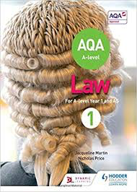 | 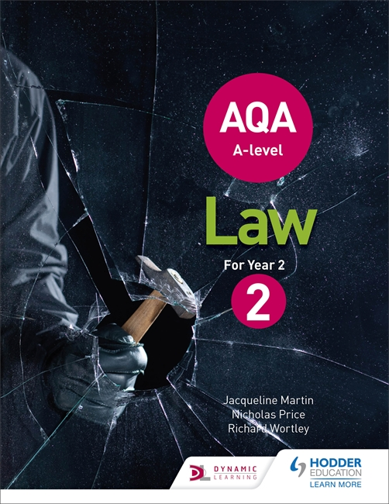

STRUCTURE OF THE COURSE AND EXAMINATIONS;

A Level https://www.aqa.org.uk/subjects/law/as-and-a-level/law-7162/specification-at-a-glance

Spend time to take a look at the specifications and the sample papers to give you a feel for what you will be working towards.

Break down of topics and order of teaching study packs for Year 1 A Level Law teaching.

Paper 1 – Crime and non-substantive Topics | Paper 2 – Tort and non-substantive Topics | Paper 3– Contract and non-substantive Topics
Nature of Law – Criminal | Nature of Law – Civil | Nature of Law – Civil
Rule of Law | Law Making; Parliamentary Law Making | Rule of Law
Criminal Courts and Lay People | Law Making; Law Reform/Law Commission | Law Making – Delegated Legislation
Judiciary – Types and role of Judges (Criminal) |  | Types and role of Judges Civil–
Access to Justice and Civil Funding | Civil Courts and ADR – | Independence of Judiciary
Criminal Liability – Actus Reus and Mens Rea | Tort – Damages in Negligence | Law Making – European Union
Criminal Liability – Non Fatal Offences Against the Person – Assault, Battery, S.47 ABH, S.18 GBH and S.20 GBH - | Tort – Liability in Negligence | Revisit Access to Justice and Civil Funding –
Law Making – Judicial Precedent | Tort – Occupiers Liability in Negligence | Introduction to Contract Law
Legal Personnel – Legal Executive, Barristers and Solicitors | Defences
Statutory Interpretation – | Revisit Access to Justice and Civil Funding
Self defence
Murder & Voluntary Manslaughter
Involuntary Manslaughter

BENCHMARKS (BM’s) in LAW –
Please see the department assessment policy for more detail.

In all your subjecst you will sit BM’s throughout the academic year to monitor your progress.
In Law you will receive 2-3 weeks advance notice of when your BM will be, the topics to revise and the structure of the BM.

Here is an indication of approximate timings of the Year 1 BM’s

Benchmark 1 early autumn term
Benchmark 2 late autumn term

Benchmark 3 late spring term

Benchmark 4 (Mid- Course Exam) early summer term

In Year 2 you will have BMs 5-7

Suggested Law Revision techniques
Revision Summaries | Reduce a topic to key elements, using (abbreviated?) technical terms and terms eg, SC for Supreme Court. There is an art to such summaries: they need to be detailed enough to contain all the necessary key elements and brief enough to be called a ‘summary’! You might then produce a skeleton version of this summary with prompts/ blanks for you to use to test yourself after using the more full version
Flash cards | Make and use for cases, Acts of Parliament, Key facts – topic summaries; one side – key fact / other side – explanation. Key word flashcards for a topic are also a helpful revision aid.
Gap fill exercises | Make gap fills from teacher hand-outs /set reading/suggested answers, to enable you to learn key words for Law.
Podcasts/recording of a topic | Create your own podcast of law topics, which you can listen to on your journey into and back from College.
Mind map, flow/spider diagrams. | Condense your notes and essay answers into a different format.  Use different text and colour to differentiate the content between factual detail and evaluation. For example cases in one colour, statute, facts and evaluation in another colour.
Exam writing | Practice writing exam answers (with notes)  Practice writing exam answers (no notes)  Practice writing exam answers (no notes in timed conditions)
Exam questions | Use the past Benchmark and Exam questions set as assignment/homework to understand the different styles of questioning and practise these.  Do not simply learn content (facts). You must test your ability to utilise your knowledge in exam questions.
Reading | Read your core-text book again with a specific focus:  Conduct wider reading – A Level Law review articles (other text books, journals, news articles) for a revision summary of a topic, often reading a further source of a topic helps you to consolidate and review what you understand and where you might have gaps.
Law Revision websites | https://www.youtube.com/user/TheLawBank  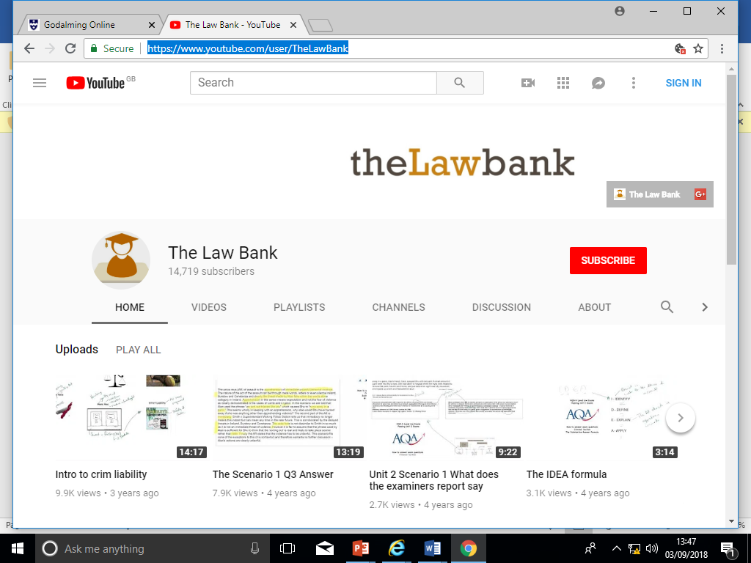  https://www.flippedlaw.com/  Log in Address = law@godalming.ac.uk  Password = GCOLLEGE2021    www.getrevising.com = general guidance on how to structure revision and reach your target grades.
Glossaries | Build up legal key terms – Acts of Parliament, Cases, difficult terminology.
Testing | Write 10 quick test questions – put it away for a week and then answer it.
Matching activities | Create key term cards/case cards and separate definitions – mix and match together.
Exam questions | Plan an exam answer and check it against your notes.
PEEL – make shorthand, evaluation summaries. | Practise your ability to made well-developed discussion on the topics areas you are required discuss. Point, Explain – with examples, Evaluate, Link to question
Work/study buddies | Make use of students studying the same subject as you. Create activities – separately and together then test each other.
A-level Law Department Assessment Policy 2021-2022

The Importance of Feedback and independent work; 50:50’
Learning rarely happens instantly and it takes time; attending lessons is not enough, you also need to be working outside of class to learn research new areas of the course to be able to gain a basic understanding prior to studying a topic as well as consolidate your learning after it has been explored in class. This process is vital for success in law, the course is heavy in content and in topic areas. ‘Exploring’ a new topic and an area of law outside of the lesson helps you to learn more and develop an informed and explorative approach to studying law.
In the process of learning and in studying law you will make mistakes but hopefully your effort in persevering, reviewing and checking your work, recapping assignment work in class and reflecting on feedback, will enhance your understanding of a new subject and enable you to learn more and identify mistakes or misunderstandings. This is why your effort in trying and gaining confidence in your own independent learning and from feedback is essential for your development on the course. This will consist of whole class assignment work review by the teacher, written feedback and grading from your teacher and peer review (where you feedback on each other’s work in the class) and, very importantly, self-reflection and review (where you assess yourself)

There are around 66 weeks of teaching weeks in total at College to help you to learn and prepare for your final assessments. In your first year studying law, you have 1 sole teacher. In Year 2 the classes are shared equally between two teachers for 2.25 hours a week, with one teacher delivering the remaining Crime and Tort topics for Paper 1 and 2 and your second law teacher will cover the whole of Contract law (Paper 3) topics with you. In your second year, one of your law teachers will be the Lead Subject Tutor, who will be responsible for formalised 1-2-1s, writing your Student Reviews, seeing your parents at parents evening and for writing Action Plans.

In line with the College’s ’50-50’ requirement homework will be set each week and could take between 4.5 to 6 hours in total. In Year 1 your teacher will set you the equivalent of 4.5 to 6 hours of work, which will organised/split over the week.
In Year 2 – both law teachers will set work weekly and each teacher therefore could set you up to 2.25 to 3 hours homework per week and you will need to be organised to complete in advance of your lessons for each teacher.

Types of Assessment
- Assignment work – (Homework)): Homework does not necessarily need to be completed at home! You should use non timetabled periods during the day to complete your law assignment tasks outside of lessons. To keep a good work/life balance, you might like to treat College as a 0845 to 1615 day and use your study periods in the library for completing tasks. This will minimise the work you need to complete at home and might make you more productive. We advise students to break down each assignment tasks to complete over manageable windows of independent study, rather than trying to complete it all in one period of time. Each teacher will have a different approach and make her expectation of you clear.

- Assignment Work Tasks will range from reading text books or watching videos (flipped law and law bank) in advance of studying a topic or afterwards to consolidate class work. You may also be directed to carry out research tasks, prepare exam style answers and produce revision materials on an on-going basis at the end of each law topic. This work will be reviewed and will be used to gain regular feedback on progress and guidance about how to improve your understanding of the subject and with exam technique.

- Benchmark Checkpoints After a period of teaching, there will be the opportunity to sit short exam style assessments under timed conditions. They are an indicator of how well you have understood the course content and in how you can apply the content to questions you will meet in the final exams at the end of the two years. BMs are extremely important and should be taken seriously in terms of preparation. They are an ideal point to see how you are progressing and to get valuable feedback. You will make mistakes in these assessments and so the follow up work is to test whether you have learned from those mistakes to improve your study and exam techniques and to develop exam readiness and resilience. Law is 100% exam based and timed exam practise is an essential element of the course. We will provide you with a minimum of two weeks advance notice of a benchmark, confirm the topics to revise and the format of exam questions for you to practise in readiness for your benchmark.

- Tracking your Progress: Student Reviews, Action Plans and Parents Evenings
The College’s policy is to advise you directly of concerns but we also report to your parents at regular intervals to let them know how you are progressing and to inform them of what our expectations are through four Student Reviews (Reports) spread throughout the two years at College and also four parents evenings.

If your tutor feels you are under-performing based on evidence such as benchmark grades and your approach to learning in between these periods (such as in your commitment to assignment work or behaviour in class) then your teacher may place you onto a Formal Department Action Plan and we will formally write to your parents after a 1-2-1 with yourself and to try and get you back on track in a supportive and productive manner.

- Student Review 2, the ARG and Predicted Grades
At the end of the first year your Lead Tutor will have a 1-2-1 to discuss your Annual Review Grade or ARG and also finalise your Predicted Grade which might be used for UCAS applications for University and other destinations.

The ARG is determined by your teacher and will rely on the following evidence base:
- Benchmark Checkpoints Performance Grades (1 to 4.
- Approach to Learning: How you are engaging in your learning, evidenced by attendance, punctuality, ability to meet weekly deadlines with quality work, how you have sought out extra support via workshops and your overall communication with your teachers.

The ARG plays a key part in determining the context in which you progress to the second year. Students who receive an A*-D grade (A-level) are encouraged to continue with their studies into the 2nd year. However, for students who receive a U or E Grade (A-level) as their ARG, it suggests that for whatever reason they have struggled with the transition from Level 2 Courses (GCSE) to Level 3 Courses (A-level/BTEC). This will be evidenced by poor performances throughout their benchmarks and an inconsistent or poor approach to learning in their student reviews and via formal Action Plans. Students who receive a U Grade we would not recommend to continue with the course and they would need to speak to a Senior Tutor about alternative pathways.

The College adopts a consistent and optimistic approach to predicting grades to ensure that they are both aspirational and achievable and are reflective of your effort levels and potential during the current challenges to learning. A predicted grade is what we believe a student is likely to achieve by the conclusion of their course in positive circumstances and the predicted grade provides universities and colleges with some understanding of a student’s academic potential alongside their Personal Statement and a written Reference from their Personal Tutor.

The ARG is important in forming the basis for the predicted grade as well but the predicted grade will also be aspirational for the students’ ambitions although it must remain realistic and cannot be based on hope/ promise that only now will the student start to work harder in the second year!

- LATE WORK POLICY: In line with the ‘College Assessment Policy’, the department are under no obligation to provide feedback to a student who does not meet the internal deadlines for weekly independent tasks, benchmark assessments or coursework drafts. Students who fail to prepare adequately for the lesson as requested, maybe excluded for part of the lesson and asked to work independently at the back of the classroom. A continued failure to meet assignment work requirements will result in a reference to the pastoral team and a phone call home to parents.

- RETURNING ASSESSED WORK: Work will be assessed and returned within 10 working days of it being submitted.

- PLAGIARISIM: Plagiarism is submitting another person’s written work as one’s own original work or using someone else’s idea without referencing the source or using pictorial work without permission or referencing the source. If there is a suspicion of plagiarism, the Head of Department and Senior Tutor will be informed and a meeting will take place. If a student is found to have done this, they will be subject to disciplinary action by the College and the awarding body will be informed. Students should be aware that the College is subscribed to software designed to detect plagiarism.
It can be helpful to support each other when carrying out weekly homework but this does not mean you can submit work which has been done by another student. You might be surprised how easy it is for your teacher to know when this is happening !

The Final Assessment
At the end of the two years, you will complete three, two hour, exams worth 100% of their final grade – each paper has the same exam format as detailed below and is equally worth 33.3% of your overall examination grade;

PAPER 1: Crime | PAPER 2:Tort | PAPER 3:Contract
- Q1 - 5 Multiple Choice Questions (5)  - Q6 – 5 mark explain question  - Q7 – 5 mark suggest question  - Q8 – 10 mark – advise question  - Q9 – 15 mark essay question – examine & discuss  - Q10 – 30 mark problem scenario question – consider  - Q11 – 30 mark scenario question 23- consider (problem scenario) - 7 mark assess (non-substantive). | - Q1 - 5 Multiple Choice Questions (5)  - Q6 – 5 mark explain question  - Q7 – 5 mark suggest question  - Q8 – 10 mark – advise question  - Q9 – 15 mark essay question – examine & discuss  - Q10 – 30 mark problem scenario question – consider  Q11 – 30 mark scenario question 23- consider (problem scenario) - 7 mark assess (non-substantive). | - Q1 - 5 Multiple Choice Questions (5)  - Q6 – 5 mark explain question  - Q7 – 5 mark suggest question  - Q8 – 10 mark – advise question  - Q9 – 15 mark essay question – examine & discuss  - Q10 – 30 mark problem scenario question – consider  Q11 – 30 mark scenario question 23- consider (problem scenario) - 7 mark assess (non-substantive).

