## Properties of Stationary Waves on a Taut String – Part 1

### Apparatus

Signal generator Mass hanger and masses Metre rules String

Vibration generator Large sheets of white paper Pulley clamp Balance

### Diagram

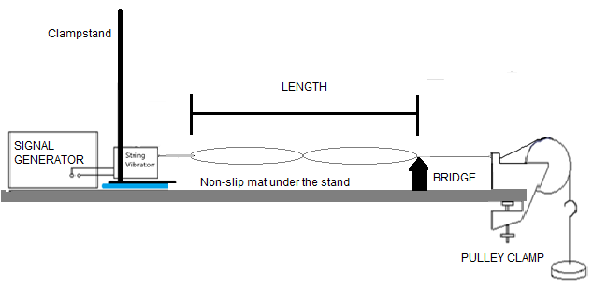

### Theory

For a stationary wave, each ‘loop’ is a half wavelength. Let the length of the string be ***l*** and the number of ‘loops’ be n, then if the wavelength is λ,

***l*** *= nλ/2*

Now, if the velocity of the wave is c, then c = fλ, where f is the frequency. Hence

The speed of waves on a taut string is given by: where *T* is the tension in the string (*mg*, where *m* is mass of load) and *µ* is the mass per unit length of the string.

Hence the frequency is given by:

### Method

Set up the apparatus as indicated in the diagram using the red string. Firstly, use a mass of about 200/300 g to supply the tension. Arrange the paper under the string so you can see the string more clearly. Set the length to be at least 1.5 m.

**For this first part** of the investigation, you should keep the number of loops constant at 2 throughout. Adjust the frequency of the signal generator until a clear 2 loop pattern is seen on the string. Then reducing the length (at fixed tension) record the corresponding frequencies. Adjustment of the length is by moving the position of the bridge.

**For the second part** of the investigation, find the frequency of the first 8 harmonics for the red string. Create a suitable table to record your results.

### Results

You should record the results for each of the 2 main parts of the investigation in a separate table.

For the investigation with length, you will need to calculate and record a column of 1/***l*** values.

### Analysis

**Frequency and length of string**

* What is the dependant, independent and control variables?
* Plot a graph of frequency on the y axis against 1/***l*** on the x axis.
* Determine the gradient of the graph.
* The gradient has units – what are they?

The equation is or for n = 2

This can be written as

* Match this equation to that for a straight line (y = mx + c).

What corresponds to y?

What corresponds to x?

What corresponds to m?

What is the intercept on the y axis?

* State what shape you expected the graph to be.
* Is your graph the shape you expected?
* Is the intercept the expected value?

(If you used a false origin then calculate the intercept as follows:

c = y – mx

Select a point ON THE LINE NOT IN THE TABLE.

Substitute in the values of y, m and x in the equation).

* If the shape is not as expected can you suggest why?
* Is random error very evident in your table and on your graph?

HINT: are the points very close to the line of best fit?

If you repeated the readings are they identical?

* Is a systematic error evident in your graph?

HINT: is the intercept the one expected?

* Calculate the mass per unit length of the string and use this with the fixed tension value to calculate a theoretical gradient.
* Calculate the percentage difference between your measured gradient and the expected value.
* Compare this with the percentage uncertainties in your readings of frequency and length (use a middle value in the table)

**Frequency and number of loops**

* What is the dependant, independent and control variables?
* Plot a graph of frequency on the y axis against n on the x axis.
* Determine the gradient of the graph.
* The gradient has units – what are they?

The equation is

This can be written as

* Match this equation to that for a straight line (y = mx + c).

What corresponds to y?

What corresponds to x?

What corresponds to m?

What is the intercept on the y axis?

* State what shape you expected the graph to be.
* Is your graph the shape you expected?
* Is the intercept the expected value?

(If you used a false origin then calculate the intercept as follows:

c = y – mx

*Select a point ON THE LINE NOT IN THE TABLE.*

*Substitute in the values of y, m and x in the equation).*

* If the shape is not as expected can you suggest why?
* Is random error very evident in your table and on your graph?

HINT: *are the points very close to the line of best fit?*

*If you repeated the readings are they identical?*

* Is a systematic error evident in your graph?

HINT: is the intercept the one expected?

### Planning (CPAC2)

There are 2 other variables that effect the frequency in the equation is

Plan an investigation to show this relationship.

* What equipment do you need?
* What procedure will you follow?
* What are the dependant, independent and control variables?

### Conclusion

State the relationships found between frequency and length of string and between frequency and number of loops.