Godalming College Physics Department
The investigation of loading a cell.
Aim

To investigate the loading of a dry cell with different resistor networks and to measure the e.m.f. and internal resistance of the cell.

Apparatus

Dry cell (1.5V battery)
4.7 Ω resistor
6.8 Ω resistor
10 Ω resistor
Digital multimeters (DMM)
Connecting wires

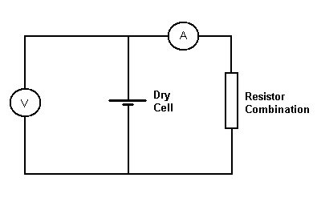

Theory

The potential difference, V measured across the terminals of a cell of e.m.f., ε and internal resistance, r when it is delivering a current, I is given by:
V = ε - Ir
By varying the resistive load in the circuit above it is possible to change the current drawn from the cell, and hence the potential difference across it.

If we simply rearrange the order of the terms on the right hand side
V = - Ir + ε
we can see that it is in the straight line form
y = m x + c
What are y, x, m and c in this case?

As you might now realise, if a graph is plotted of V against I a straight line of negative gradient will be produced.
The intercept on the V axis is ε, the e.m.f. of the cell.
The gradient of this graph is - r, the internal resistance of the cell.
Method
Set up the circuit taking careful note of how you use each digital multimeter as either an ammeter or a voltmeter. You will need to connect the input marked ‘COM’ for common on each meter nearest to the negative or black terminal of the cell. The other input depends on whether you are measuring voltage or current. Use a 2V range for the voltmeter and a 2 A range on the ammeter (available on ‘black in yellow case’ model only).
Ask your teacher to check your circuit before proceeding – do not fully connect the cell until checked.
Use the resistors provided to create a range of load resistances. By connecting pairs of resistors in both series and parallel, and using the resistors singly, you should be able to produce a total of 9 different resistance values. This will give an adequate range and number of values to plot a graph – there is no need to make combinations with all three resistors. There is also no need to calculate the total effective resistance of the combination, however you can if you know how to.
Connect each resistance combination into the circuit and measure the resulting current and potential difference. When you have finished, disconnect the cell immediately to avoid overloading it.

Results

Record the current and corresponding voltage for each resistance arrangement in a table. There is no need to calaculate and record the resistance of the combination.

Calculations and Graph

Plot a graph of V against I. You will probably want to use a false origin for graph. Look at the range of V values produced in the experiment and think about what the graph would like like if the Y axis started at the origin.

Measure the intercept on the Y axis, which gives the value of ε.

Measure the gradient of the graph, which gives the value of (-) r.

Don’t forget that these quantities have units.

Discussion and errors

If possible you should compare your experimental values for ‘ε’ and ‘r’ with the accepted values. The nominal e.m.f. of a dry cell is 1.5 V and the internal resistance will probably be something less than an ohm.

Using the ideas from the introductory practical work, discuss whether the uncertainties in your experimental measurements could account for any error in your result.

Conclusion

State how the voltage of the cell behaves as a current is drawn from it, and quote your values of e.m.f. and internal resistance.

