# Practical handbook for A-level Physics

Version 1.1

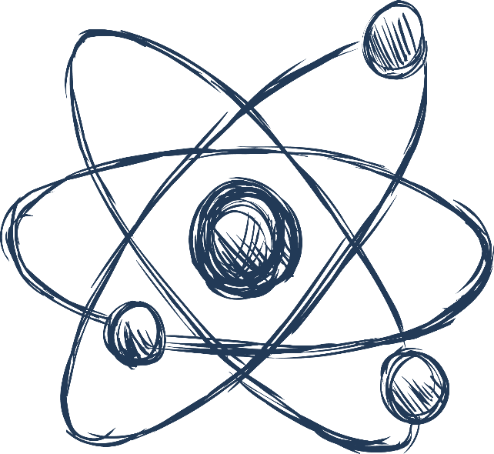

This is the **Physics** version of this Practical handbook.

**Sections I to M are particularly useful for students and could be printed as a student booklet by schools.**

The information in this document is correct, to the best of our knowledge as of August 2015. This document is expected to be revisited throughout the lifetime of the specification. Please check you have the latest version by visiting our website.

Thank you to all the teachers and associates who have commented on previous versions of this document. We’re grateful for all the feedback and hope that your comments have been acted on.

**Changes for version 1.1**

|  |  |  |
| --- | --- | --- |
| **Section** | **Change** | **Notes** |
| Front page | Version 1.0 to 1.1 |  |
| F. Cross-board statement on CPAC | Extensive updates. | CPAC criteria will also be updated in the specifications in September 2015. |
| H. Cross-board apparatus and techniques and AQA required practical activities | Addition of clarification around “or” statements in the apparatus and techniques list. | For the endorsement all students must have experienced use of each of the alternatives in the apparatus and techniques list. For written exams, we suggest that teachers treat “or” statements as “and” statements. |
| J. Significant figures | Added paragraph on equipment measuring to half a unit. | Values should be quoted as .0 or .5, with uncertainty of ±0.3 |
| K. Uncertainties | Clarification added to “measuring length” section.  Stopwatch example slightly changed.  Added section on error bars. | Initial value uncertainty applies to instruments where the user can set the zero.  Previously implied reaction time ~1 s  No need to understand confidence limits.   * Plot the data point at the mean value * Calculate the range of the data, ignoring any anomalies   Add error bars with lengths equal to half the range on either side of the data point. |

|  |  |  |
| --- | --- | --- |
| L. Graphing | Graph axes titles in “Manipulated data and graph” section changed. | Square root / squared / cubed shown on wrong axis. |
| L. Graphing | More complex relationships section small additions and typo corrected. | Final rearrangement of g calculation added in example 1.  log(n) now log(x) in example 2.  log(A), as log(y)  = n(log(x)) + log(A) added. |
| N. Practical ladders and exemplar experiments: Physics  Exemplar practical 2, diffraction experiment | White light source removed from Materials and equipment list. | Not required. |
| N. Practical ladders and exemplar experiments: Physics  Exemplar practical 9 | Typo corrected in method. | lnV was missing ln and brackets added. |

**Contents**

|  |  |  |
| --- | --- | --- |
| **Section** |  | **Page** |
| A | Introduction | 5 |
|  | **Information about practical work for teachers** |  |
| B | Practical work in reformed A-level Biology, Chemistry and Physics | 8 |
| C | Practical skills assessment in question papers |  |
| D | Guidelines for supporting students in practical work | 19 |
| E | Use of lab books | 21 |
| F | Cross-board statement on CPAC |  |
| G | Evidence for the endorsement | 31 |
| H | Cross-board apparatus and techniques and AQA required practical activities | 33 |
|  | **Guidelines for teachers and students** |  |
| I | Tabulating data |  |
| J | Significant figures | 37 |
| K | Uncertainties | 38 |
| L | Graphing | 43 |
| M | Glossary of terms | 53 |
|  | **Guidance on the required practical activities** |  |
| N | Practical ladders and exemplar experiments: Physics | 57 |

**Key**

There have been a number of changes to how practical work will be assessed in the new A-levels. Some of these have been AQA specific, but many are by common agreement between all the exam boards and Ofqual.



The symbol signifies that **all boards** have agreed to this.



The symbol is used where the information relates to **AQA only**.

## 

## Introduction

Practical work brings science to life, helping students make sense of the universe around them. That’s why we’ve put practical work at the heart of our Biology, Chemistry and Physics A-levels. Practical science allows scientific theory to transform into deep knowledge and understanding – scientific thinking. Through investigation, students uncover the important links between their personal observations and scientific ideas.

“In the best schools visited, teachers ensured that pupils understood the ‘big ideas’ of science. They made sure that pupils mastered the investigative and practical skills that underpin the development of scientific knowledge and could discover for themselves the relevance and usefulness of those ideas.”

Ofsted report

Maintaining curiosity in science

November 2013, No. 130135

**The purpose of this Practical handbook**

This handbook has been developed to support you in advancing your students to fluency in science.

Over the years, there have been many rules developed for practical work in Biology, Chemistry and Physics. Some have been prescriptive, some have been intended as guidance. Although we have always attempted to be consistent within subjects, differences have emerged over time. Worse, a student taking Biology may also be taking Physics and find themselves confronted with contradictory rules and guidance.

This practical handbook is an attempt to harmonise the rules and guidance for Biology, Chemistry and Physics. There are occasions where these will necessarily be different, but we will try to explain why on the occasions where that happens.

The new A-level specifications accredited for first teaching in September 2015 bring with them a complete change in the way practical work is assessed. No longer will teachers have to force their students to jump through hoops set up by exam boards or worry about how much help they are giving students and whether it’s allowed or not.

We have worked with teachers and examiners to produce this handbook. This is an evolving document, but one that we hope you will be able to use with your students, whether they’re doing A-level Biology, Chemistry or Physics, or a combination of subjects, to improve their practical skills: in the classroom, in the laboratory, in exams, for the endorsement and on to university or the workplace. The latest version will always be on our website.

Unless specified, all guidance is common to Biology, Chemistry and Physics at both AS and A-level and subject specific examples are for illustration only. However, the extent to which a particular aspect is assessed will differ. Teachers should refer to the specifications and specimen materials on our website for more information.

**The purpose of practical work**

There are three interconnected, but separate reasons for doing practical work in schools. They are:

|  |
| --- |
| 1. To support and consolidate **scientific concepts** (knowledge and understanding).  This is done by applying and developing what is known and understood of abstract ideas and models. Through practical work we are able to make sense of new information and observations, and provide insights into the development of scientific thinking. |
| 2. To develop **investigative skills.** These transferable skills include:   1. devising and investigating testable questions 2. identifying and controlling variables 3. analysing, interpreting and evaluating data. |
| 3. To build and master **practical skills** such as:   1. using specialist equipment to take measurements 2. handling and manipulating equipment with confidence and fluency 3. recognising hazards and planning how to minimise risk. |

By focusing on the reasons for carrying out a particular practical, teachers will help their students understand the subject better, to develop the skills of a scientist and to master the manipulative skills required for further study or jobs in STEM subjects.

The reformed A-levels in Biology, Chemistry and Physics separate the ways in which practical work is assessed. This is discussed in the next section.

**Fluency in science practical work**

At the beginning of a year 12 course, students will need support and guidance to build their confidence. This could involve, for example, breaking down practicals into discrete sections or being more explicit in instructions. Alternatively, a demonstration of a key technique followed by students copying may support students’ development. This could be a better starting point than ‘setting students loose’ to do it for themselves.

Progression in the mastery of practical skills and techniques shows increasing independence and confidence

Phase 1:

**Demonstrate**

“Teacher shows me and I copy”

Phase 2:

**Practise with support**

“I do it myself but I may need to ask teacher every now and again and if it goes wrong I’m stuck.”

Phase 3:

**Practise without support**

“I can have a go and get quite a way without any support or guidance but there are times when I might need to check a few details.”

Phase 4:

**Fluent**

“No problem!

I can help my friends if necessary.”

Note: Safety is always the responsibility of the teacher. No student should be expected to assess risks and then carry out their science practical without the support and guidance of their teacher.

## Practical work in reformed A-level Biology, Chemistry and Physics

**Statement on practical work by Glenys Stacey, Chief Regulator at Ofqual, April 2014**

Practical work and experimentation is at the heart of science. It matters to science students, their teachers and their future universities and employers. But A-level students do not always have the chance to do enough of it.

Practical work counts for up to 30 per cent of the final grades and the vast majority of students get excellent marks for it, but still many enter university without good practical skills.

It is possible to do well in science A-levels without doing sufficient or stretching hands-on science, and other pressures on schools can make it difficult for science teachers to carve out enough time and resource to do it if students can get good A-level grades in any event. That is not right – so why is it so?

Students are assessed and marked on their performance in set tasks, but these are generally experiments that are relatively easy to administer and not particularly stretching. It has proved extremely difficult to get sufficient variety and challenge in these experiments, and so students do well even if they have not had the opportunity to do enough varied and stretching experimentation, and learn and demonstrate a variety of lab skills. What to do?

In future, science A-level exams will test students’ understanding of experimentation more so than now. Those who have not had the chance to design, conduct and evaluate the results from a good range of experiments will struggle to get top grades in those exams. They will also be required to carry out a minimum of twelve practical activities across the two year course – practical activities specific to their particular science, and that are particularly valued in higher education. Students will receive a separate grade for their practical skills (a pass/fail grade).

These reforms should place experimentation and practical skills at the heart of science teaching, where they should be, and students going to university to study a science are more likely to go well prepared. They will also change the game for science teachers, enabling them to teach science in a more integrated and stimulating way with more hands on science and to say with justification that without sufficient time and effort put into lab work, their students will struggle to get the grades they deserve.

Glenys Stacey, Chief Regulator

The reformed AS and A-level specifications will have **no** direct assessment of practical work that contributes to the AS or A-level grades.

There are **two** elements to the practical work that students must carry out in their study of A-level Biology, Chemistry and Physics:



**Apparatus and techniques (see section G)**

These have been agreed by all exam boards, so all students will have experienced similar practical work after following a science A-level course.

Examples:

Use of light microscope at high power and low power, including use of a graticule

Purify a solid product by recrystallization

Use laser or light source to investigate characteristics of light

**12 required practical activities (see section G)**

These have been specified by AQA. They cover the apparatus and techniques for each subject – so teachers do not have to worry about whether they are all covered.

Examples:

Use of aseptic techniques to investigate the effect of antimicrobial substances on microbial growth

Carry out simple test-tube reactions to identify cations and anions in aqueous solution

Determination of g by a free-fall method.



These will be assessed in two ways:

1. Questions in the written papers, assessed by AQA (see section C)

********

Questions in exam papers

12 required practicals

Cross-board agreement on required apparatus and techniques

1. The practical endorsement, directly assessed by teachers (see section F)

Teachers will assess their students’ competence at carrying out practical work. They will assess each student on at least 12 different occasions. These could be the 12 required practicals, or could be during other practical work.

At the end of the course, teachers will decide whether or not to award a pass in the endorsement of practical skills. The teacher must be confident that the student has shown a level of mastery of practical work good enough for the student to go on to study science subjects at university.

**Students who miss a required practical activity**

Students’ practical skills in at least 12 practicals

12 required practical activities

Teacher devised practical experiences

5 competencies:

1. Follows written instructions

2. Applies investigative approaches and methods when using instruments and equipment

3. Safely uses a range of practical equipment and materials

4. Makes and records observations

5. Researches, references and reports

Endorsement of practical skills

**1. Written exam papers**

The required practical activities are part of the specification. As such, exam papers could contain questions about the activities and assume that students understand those activities. A student who misses a particular practical activity may be at a disadvantage when answering questions in the exams.

It will often be difficult to set up a practical a second time for students to catch up. Teachers will need to decide on a case by case basis whether they feel it is important for the student to carry out that particular practical. This is no different from when teachers make decisions about whether to re-teach a particular topic if a student is away from class when it is first taught.

**2. Endorsement**

To fulfil the requirements of the endorsement, every student must carry out 12 practicals. A student who misses one of the required practicals must carry out another practical to be able to gain the endorsement.

In most cases, this can be any experiment of A-level standard. However, students must have experienced use of each of the apparatus and techniques. In some cases, a particular apparatus and technique is only covered in one required practical activity. If a student misses that activity, the teacher will need to provide an opportunity for the student to carry out a practical that includes that activity. The list below shows the apparatus and techniques that are covered by one activity only and alternatives to the required practical.

Note: there is a possibility that the student could be asked questions about the required activity in written papers that would not be fully understood by carrying out the alternative. This should be considered when deciding whether to repeat the required activity.

**Physics **

|  |  |  |
| --- | --- | --- |
| **If a student misses this required practical activity…** | **…they won’t have covered this apparatus and technique.** | **Other practicals within an  A-level Physics course involving this skill** |
| 2. Investigation of interference effects to include the Young’s slit experiment and interference by a diffraction grating | j. use laser or light source to investigate characteristics of light, including interference and diffraction. | Use diffraction (interference) grating mounted at end of rulers arranged in T-shape to view and take measurements of pattern produced when viewing monochromatic light source  OR  <http://tap.iop.org/vibration/superpostion/322/page_46765.html> |
| 3. determination of *g* by free-fall method | d. use stopwatch or light gates for timing. | Using dynamics trolley, ramp and light gates to verify the suvat equations. |
| 12. investigation of the inverse-square law for gamma radiation | l. use ionising radiation, including detectors. | Absorption of alpha, beta and/or gamma radiation by different thicknesses of material.  (Note: activity 12 was chosen to illustrate an example of an inverse square law relationship. Students would need to have experience of this as well, perhaps in a computer simulation or in an experiment involving an LDR and lamp). |

## Practical skills assessment in question papers

The AS and A-level papers will contain the following types of questions which relate to practical work:

1. **Questions set in a practical context, where the question centres on the science, not the practical work.**

**Example (A-level Biology Specimen Paper 1)**

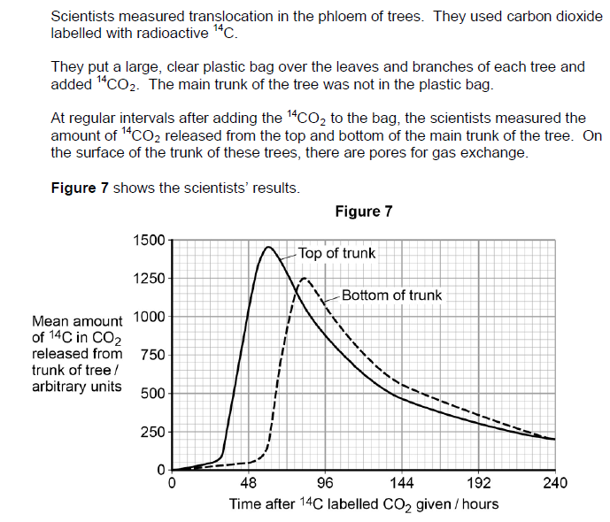

These questions are set in the context of practical work that has been carried out.

However, the questions relate more to the basic Biology behind the situation, or mathematical skills.

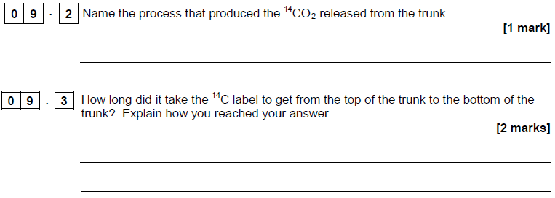

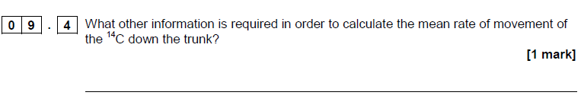

**Example (AS Chemistry Specimen Paper 1)**

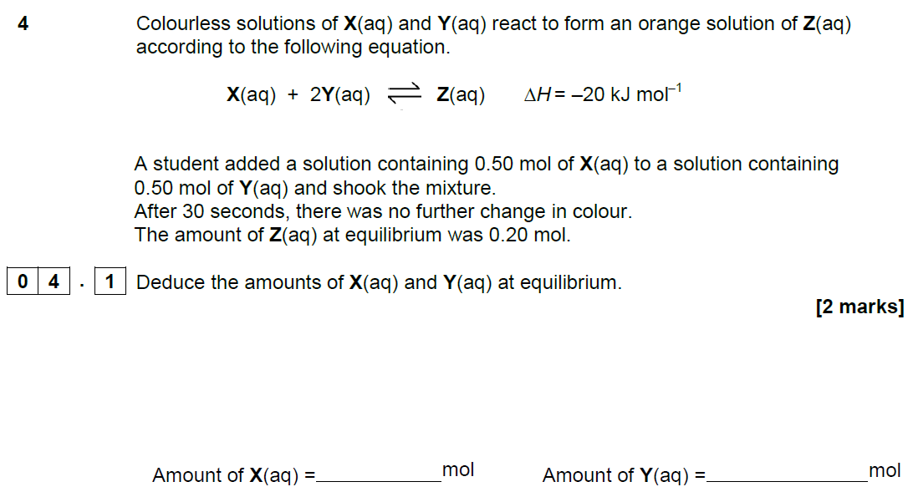

This question requires an understanding of the underlying chemistry, not the practical procedure undertaken.

**Example (A-level Physics Specimen Paper 3)**

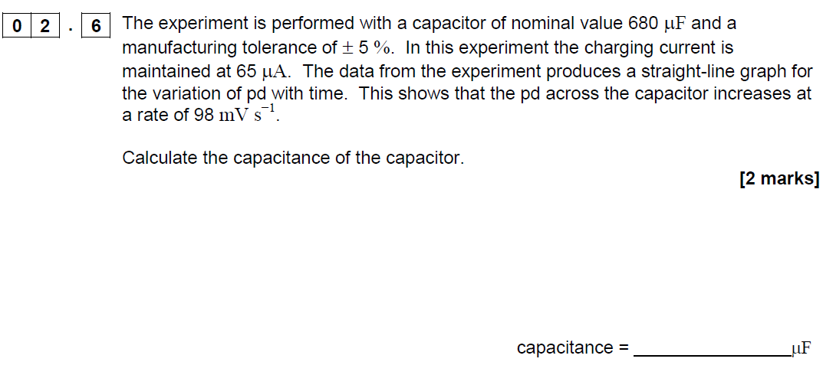

This question is set in a practical context, and particular readings need to be used to calculate the answer, but the specific practical set-up is not important.

1. **Questions that require specific aspects of a practical procedure to be understood in order to answer a question about the underlying science.**

**Example (A-level Biology Specimen Paper 2)**

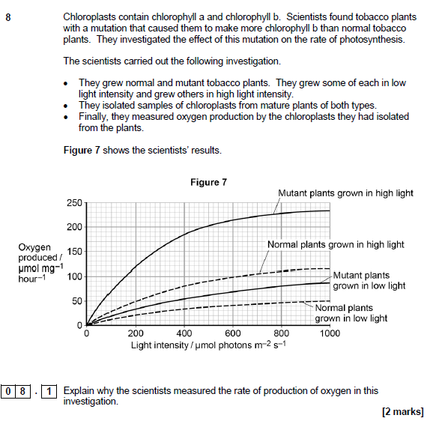

This question requires the students to understand how oxygen production can be used as a proxy measure for photosynthesis, but no other details of the practical procedure are important.

**Example (AS Chemistry Specimen Paper 2)**

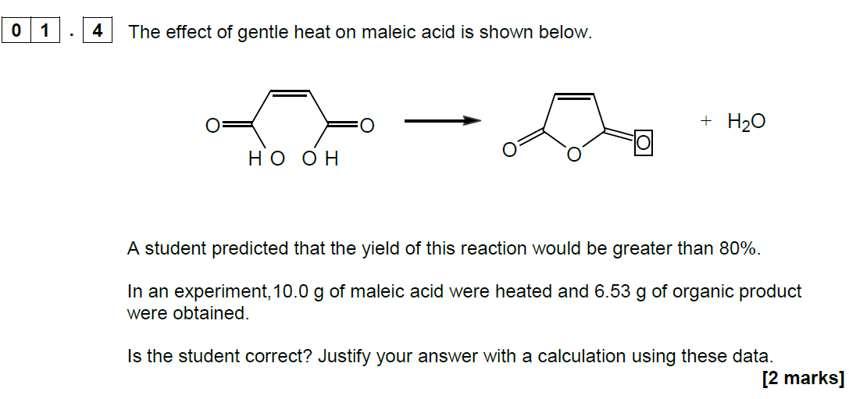

To answer this question, the student must understand the process of yield calculation (which will have been gained through practical work), but again the details of the practical procedure are unimportant.

1. **Questions directly on the required practical procedures.**

**Example (AS Biology Specimen Paper 1)**

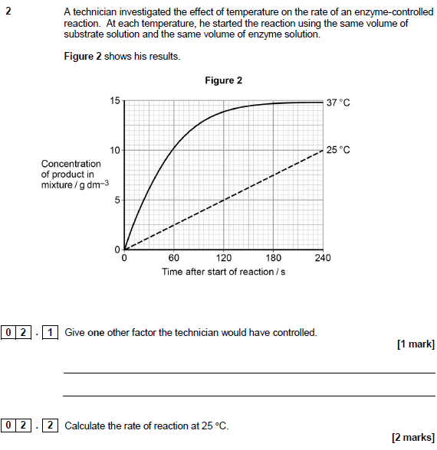

Similarly, in this example, the students should have done a very similar experiment.

The first question is simple recall of the factors involved in the rate of enzyme controlled reactions.

The second requires the calculation of a gradient, which is a skill students will have learned through their practical and other work.

**Example (A-level Chemistry Specimen Paper 3)**

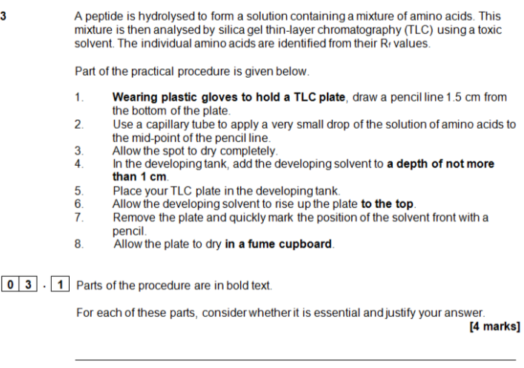

Students who have completed the related required practical will have a greater understanding of each of the steps in the procedure and will be able to explain each in turn.

This type of question is likely to be fairly rare, to avoid predictable assessments.

1. **Questions applying the skills from the required practical procedures and the apparatus and techniques list.**

**Example (A-level Chemistry Specimen Paper 3)**

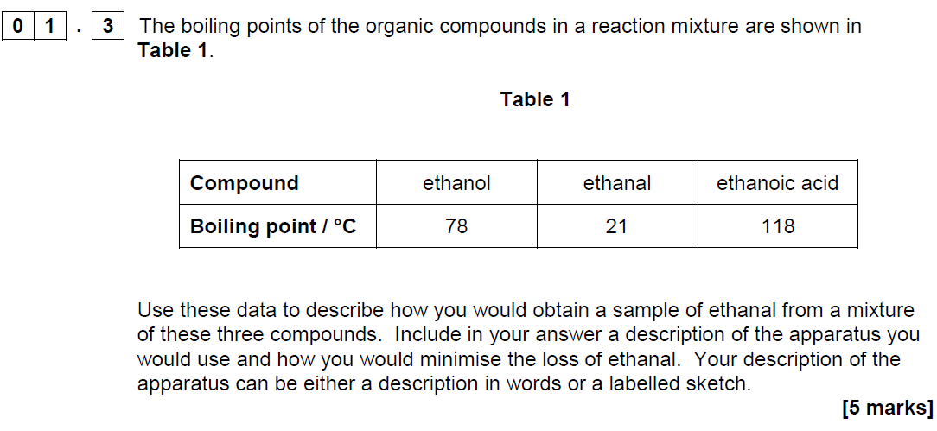

This question expects students to understand distillation which is one of the required practicals. It is not necessary for students to have carried out this precise experiment to understand the requirements.

**Example (AS Physics Specimen Paper 2)**

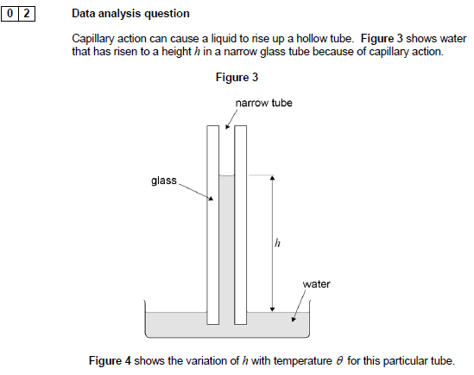

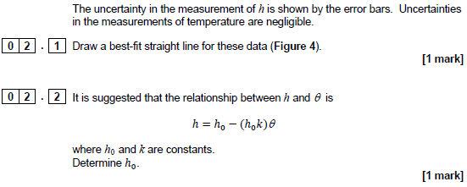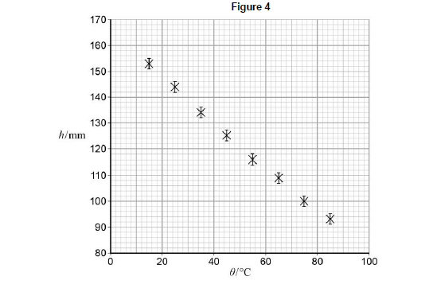

This question requires students to apply the skills of data analysis that they will have gained through their practical work in the required practicals and apply it to an unusual situation.

## Guidelines to supporting students in practical work

Developed in collaboration with NFER and CLEAPSS

**Clarify the importance of keeping a lab book or other records of practical work**

Explain that students need a record of their achievements to guide their learning. Lab books also can be an opportunity to develop a skill used both by scientists and in business. They allow students to accurately and clearly record information, ideas and thoughts for future reference which is a very useful life skill.

**Warn students against plagiarism and copying**

Explain that the use of acknowledged sources is an encouraged and acceptable practice, but trying to pass off other people’s work as their own is not, and will not help them learn.

**Explain the learning criteria for each skill**

This will help students learn and allow them to know when they have met the criteria. The student lab book contains the criteria, but they own the process and have the responsibility for collecting appropriate evidence of success.

**Use clearly defined learning outcomes**

For example, if you are running a practical session to teach students how to use a microscope and staining techniques safely and efficiently, then make sure they know why they are learning this. This will also make it much easier for them to know when they have met the criteria.

**Start with simple tasks initially**

Students need to become confident with the apparatus and concepts of practical work before they can proceed to more complicated experiments. It may be more effective to start with simple manipulation skills and progress to the higher order skills.

**Teach practical work in your preferred order**

Teach the skills as you see fit and suit your circumstances – the assessment process is aimed to be flexible and help you teach practical work, not to dictate how it should be done.

**Use feedback**

Research shows that feedback is the best tool for learning in practical skills. Students who normally only receive marks as feedback for work will need to be trained in both giving and receiving comment-based feedback. Provided it is objective, focused on the task and meets learning outcomes, students will quickly value this feedback.

Feedback is essential to help students develop skills effectively. Allowing self and peer review will allow time for quality feedback as well as provide powerful learning tools. However, this is a decision for teachers. The scheme is designed to be flexible while promoting best practice.

**Don’t give marks**

We have deliberately moved away from banded criteria and marks to concentrate on the mastery of key practical competencies. The purpose of marking should be changed to emphasise learning. Students should find it easier to understand and track their progress, and focus their work. We would expect most students, with practice and the explicit teaching of skills and techniques, to succeed in most competencies by the end of the course.

**Give feedback promptly**

Feedback does not need to be lengthy, but it does need to be done while the task is fresh in the students’ mind. Not everything needs written feedback but could be discussed with students, either individually or as a class. For example, if a teacher finds that many students cannot calculate percentage change, the start of the next lesson could be used for a group discussion about this.

**Use peer assessment**

The direct assessment of practical work is designed to allow teachers to integrate student-centred learning (including peer review), into day-to-day teaching and learning. This encourages critical skills. Research indicates these are powerful tools for learning. For example, teachers could ask students to evaluate each other’s data objectively. The students could identify why some data may be useful and some not. This can be a very good way of getting students to understand why some conventions are used, and what improves the quality of results. This also frees up marking time to concentrate on teaching.

**Use group work**

This is a very useful skill, allowing students to build on each other’s ideas. For example, planning an experiment can be done as a class discussion. Alternatively, techniques such as snowballing can be used, in which students produce their own plan then sit down in a small group to discuss which are the best collective ideas. From this, they revise their plan which is then discussed to produce a new ‘best’ plan.

## Use of lab books

Students do **not** need to write up every practical that they do in detail. However, it is good practice to have a record of all they do. A lab book could contain this record. It is a student’s personal book and may contain a range of notes, tables, jottings, reminders of what went wrong, errors identified and other findings. It is a live document that can function as a learning journal.

Lab books are **not** a requirement of the CPAC endorsement or the AQA AS and A-level specifications in Biology, Chemistry or Physics. They are highly valued by colleagues in higher education and are an easy way for students to demonstrate their mastery of Competence 5 “Researches, references and reports”.

Each institution has its own rules on lab book usage. The following guidelines are an amalgam of guidelines from a selection of companies and universities that use lab books. They are designed to help students and teachers in preparing to use lab books for university but do not represent the only way that books could be used for A-level sciences. Teachers will wish to vary or ignore the following points to suit their purposes.

**The purpose of a lab book**

A lab book is a complete record of everything that has been done in the laboratory. As such it becomes important both to track progress of experiments, but also, in industry and universities, to prove who developed an idea or discovered something first.

A lab book is a:

* source of data that can be used later by the experimenter or others
* complete record of what has been done so that experiments could be understood or repeated by a competent scientist at some point in the future
* tool that supports sound thinking and helps experimenters to question their results to ensure that their interpretation is the same one that others would come to
* record of why experiments were done.

**Type of book**

A lab book is often a hard-backed book with bound pages. Spiral bound notebooks are not recommended as it is too easy to rip a page out and start again. It is generally advisable that a lab book has a cover that won’t disintegrate the moment it gets slightly wet.

**Style**

Notes should be recorded as experiments are taking place. They should not be a “neat” record written at a later date from scraps of paper. However, they should be written clearly, in legible writing and in language which can be understood by others.

Many lab books are used in industry as a source of data, and so should be written in indelible ink.

To ensure that an observer can be confident that all data are included when a lab book is examined, there should be no blank spaces. Mistakes should be crossed out and re-written. Numbers should not be overwritten, erased, nor should Tippex be used. Pencil should not be used for anything other than graphs and diagrams.

**Each page should be dated**

Worksheets, graphs, printed information, photographs and even flat “data” such as chromatograms or TLC plates can all be stuck into a lab book. They should not cover up any information so that photocopying the page shows all information in one go. Anything glued in should lie flat and not be folded.

**Content**

Generally, lab books will contain:

* title and date of experiment
* notes on what the objectives of the experiment
* notes on the method, including all details (eg temperatures, volumes, settings of pieces of equipment) with justification where necessary
* sketches of how equipment has been set up can be helpful. Photographs pasted in are also acceptable
* data and observations input to tables (or similar) while carrying out the experiment
* calculations – annotated to show thinking
* graphs and charts
* summary, discussions and conclusions
* cross-references to earlier data and references to external information.

This list and its order are not prescriptive. Many experiments change as they are set up and trials run. Often a method will be given, then some data, then a brief mention of changes that were necessary, then more data and so on.

## Cross-board statement on CPAC



**Common Practical Assessment Criteria (CPAC)**

The assessment of practical skills is a compulsory requirement of the course of study for A-level qualifications in biology, chemistry and physics. It will appear on all students’ certificates as a separately reported result, alongside the overall grade for the qualification. The arrangements for the assessment of practical skills are common to all awarding organisations. These arrangements include:

* A minimum of 12 practical activities to be carried out by each student which, together, meet the requirements of Appendices 5b (Practical skills identified for direct assessment and developed through teaching and learning) and 5c (Use of apparatus and techniques) from the prescribed subject content, published by the Department for Education. The required practical activities will be defined by each awarding organisation in their specification;
* Teachers will assess students using Common Practical Assessment Criteria (CPAC) issued jointly by the awarding organisations. The CPAC are based on the requirements of Appendices 5b and 5c of the subject content requirements published by the Department for Education, and define the minimum standard required for the achievement of a pass;
* Each student will keep an appropriate record of their practical work, including their assessed practical activities;
* Students who demonstrate the required standard across all the requirements of the CPAC will receive a ‘pass’ grade;
* There will be no separate assessment of practical skills for AS qualifications;
* Students will answer questions in the AS and A level examination papers that assess the requirements of Appendix 5a (Practical skills identified for indirect assessment and developed through teaching and learning) from the prescribed subject content, published by the. Department for Education. These questions may draw on, or range beyond, the practical activities included in the specification.



|  |  |
| --- | --- |
| Competency | Practical mastery |
|  | In order to be awarded a Pass a student must, by the end of the practical science assessment, consistently and routinely meet the criteria in respect of each competency listed below. A student may demonstrate the competencies in any practical activity undertaken as part of that assessment throughout the course of study.  Student may undertake practical activities in groups. However, the evidence generated by each student must demonstrate that he or she independently meets the criteria outlined below in respect of each competency. Such evidence:  a. will comprise both the student’s performance during each practical activity and his or her contemporaneous record of the work that he or she has undertaken during that activity, and  b. must include evidence of independent application of investigative approaches and methods to practical work. |
| 1. Follows written procedures | a. Correctly follows written instructions to carry out experimental techniques or procedures. |
| 2. Applies investigative approaches and methods when using instruments and equipment | a. Correctly uses appropriate instrumentation, apparatus and materials (including ICT) to carry out investigative activities, experimental techniques and procedures with minimal assistance or prompting.  b. Carries out techniques or procedures methodically, in sequence and in combination, identifying practical issues and making adjustments when necessary.  c. Identifies and controls significant quantitative variables where applicable, and plans approaches to take account of variables that cannot readily be controlled.  d. Selects appropriate equipment and measurement strategies in order to ensure suitably accurate results. |
| 3. Safely uses a range of practical equipment and materials | a. Identifies hazards and assesses risks associated with these hazards, making safety adjustments as necessary, when carrying out experimental techniques and procedures in the lab or field.  b. Uses appropriate safety equipment and approaches to minimise risks with minimal prompting. |

|  |  |
| --- | --- |
| 4. Makes and records observations | a. Makes accurate observations relevant to the experimental or investigative procedure.  b. Obtains accurate, precise and sufficient data for experimental and investigative procedures and records this methodically using appropriate units and conventions. |
| 5. Researches, references and reports | a. Uses appropriate software and/or tools to process data, carry out research and report findings.  b. Cites sources of information demonstrating that research has taken place, supporting planning and conclusions. |

## Extra information on the endorsement

The information below is based on the cross-board agreements, but is not a cross-board agreed wording.

**‘Consistently and routinely’**

Teachers should be confident that their students can demonstrate a particular competence going forwards. This means that demonstrating a competence once is unlikely to be enough, but there is no stipulated number of times that each competence must be demonstrated. The teacher should use professional judgement when holistically assessing their students at the end of the course.

**Observing differences in standard over time**

There is an expectation that students will increase in their skills and abilities in practical work throughout a two – year course. A monitor attending a school in the earlier part of the course would expect to see students working at a lower level than the same students would be working at by the end of the course.

There are many different ways of tracking students’ skills development towards competence. Monitors will not expect to see any particular method of tracking or showing this development during visits. Monitors will discuss tracking with teachers in order to become confident that the teachers understand the standard expected at the end of the course and that their planning supports students’ skills progression.

**Demonstrations**

Demonstrations cannot be substituted for any of the required practical activities. Teachers can demonstrate experiments before students carry out the experiment. However, if CPAC 1 is being assessed, the instructions must not simply repeat what was shown in the demonstration.

**The link between the apparatus and techniques and CPAC**

All students should have experienced use of each of the apparatus and techniques. Their competence in practical work will be developed through the use of these apparatus and techniques. However, students are not being assessed on their abilities to use a particular piece of equipment, but on their general level of practical competence.

**Simulations**

Simulations are not acceptable for use in the place of the apparatus and techniques.

**Helping students during practical work**

Teachers can help students during practical work, but the amount of guidance will be dependent on the criteria being assessed. For example, if a student was being assessed on CPAC 4, and needed to be reminded on the basics of safety, they could not be assessed as passing.

It may be appropriate to help students if the equipment or the technique is new or unusual.

The amount of help would depend on when in the course the practical work was taking place. For example, at the beginning of year 12 the teacher would be likely to be giving a lot of guidance, and tasks would include a lot of scaffolding. By the end of year 13, there is likely to be minor prompting to help students as they become more confident and competent.

**Language used by students**

In written exams, students are expected to use scientific language that corresponds to the glossary of terms in this handbook. Whilst doing practical work, students should be encouraged to use the correct terms (such as discussing if results are ‘accurate’, ‘precise’, ‘repeatable’ etc), but should not be penalised for using incorrect vocabulary verbally. This is because the assessment is about the students’ abilities in practical work, not their use of terms.

**Certificates**

Students will either have ‘Pass’ or ‘Not classified’ recorded on their certificate for the endorsement.

**Carry forward and retakes**

Students may carry forward the outcome of practical assessments if they resit their exams. They cannot retake the practical science assessment without retaking exams. This is because practical skills should be developed as part of teaching and learning of the whole subject and the assessment is designed to assess students demonstrating the skills over a period, not just as a one-off.

**Reasonable adjustments**

The JCQ document Access Arrangements and Reasonable Adjustments sets out arrangements for access arrangements for all assessments.

The arrangements applicable to the endorsement must not compromise the objectives of the assessment. So, for example, it is likely to be reasonable for a student to have a reader or extra time while being assessed against CPAC 1. Students would be demonstrating their ability to follow instructions in the form the students were used to receiving them in.

CPAC 2 and 3 make reference to the use of instruments, equipment and materials. The use of a practical assistant for a student with very poor motor coordination or a severe visual impairment could potentially compromise the purpose of the assessment (to develop manipulative skills).

Teachers should work with the special educational needs coordinator to determine which arrangements are appropriate and reasonable.

The AQA website will be updated as further guidance becomes available.

## Monitoring visits

AQA are committed to making the monitoring process a supportive one. One teacher from the cross board trial stated: “I felt like I should have felt a bit more nervous… but I realised it wasn’t an Ofsted. It was an opportunity for my students to show off their learning and the teachers to show their teaching. It wasn’t a big stick. It could be positive and be helpful for the teachers in putting pressure on their SLTs to make resources available.”

All schools will be monitored for one subject by one of the boards in the first two years of the course. For example, if a school is taking Biology with AQA, while Chemistry and Physics with other boards, AQA would only visit the Biology department, or another board may visit Chemistry or Physics. Larger schools and colleges (who tend to have separate departments) will be visited three times. AQA’s first visits will be between January and April 2016 or September 2016 and January 2017, leaving enough time for repeat visits if there is an issue identified.

Monitors will be looking to confirm two things:

* that schools are **compliant** with the **rules**
* that teachers are **assessing** students at the correct **standard**.

Training on the standard will be available from September 2015 and will be online and free.

Cross-board agreed process and code of conduct

**Process**

**Training**

The Lead teacher must undertake training and disseminate information as directed by their exam board.

**Notice of monitoring**

Each exam board is expected to give centres at least 2 weeks’ notice of monitoring visits.

Where possible, exam boards may take into account centres’ timetables, but on some occasions it will be necessary for centres to make arrangements to allow the monitor to observe a practical lesson.

Materials required by the monitor on the day of the visit:

1. Documented plans to carry out sufficient practical activities which meet the requirements of CPAC, incorporating skills and techniques detailed in appendix 5, over the course of the A level;
2. a record of each practical activity undertaken and the date when this was completed;
3. a record of the criteria being assessed in that practical activity;
4. a record of student attendance;
5. a record of which student met the criteria and which did not;
6. student work showing evidence required for the particular task with date;
7. any associated materials provided for the practical activity eg written instructions given.

A timetable for the day and lists of people who the monitor will meet will also be required.

Notes on evidence

Evidence 1. Although there is an expectation that planning to cover the full requirements of the endorsement should take place, these plans may be in outline form if viewed in the first year of the course.

Evidence 2 – 6. Will only be available after particular activities have taken place. The monitor should take a proportionate view on whether sufficient practical activities have taken place.

Evidence 7. A similarly proportionate view should be taken on this requirement.

**Before the day of monitoring**

Exam board / monitor will communicate expectations with the centre, explaining the process, evidence required, the staff and students who will be observed or spoken to, and making arrangements for the day.

**On the day of monitoring**

The timings of the monitoring visit will be discussed with the centre and will be dependent on the number of students.

Monitors will be expected to:

* meet the Lead teacher for the endorsement of practical work for the subject being visited
* observe a lesson including a practical activity (which may or may not be one of the required practicals) during which students are assessed against the competencies
* discuss the teacher’s assessment of the students in the class
* meet students and discuss the practical work that students have been doing (this may take place during the lesson if appropriate)
* view the work of students from lesson and other classes as per cross-board agreement
* view teachers’ records of assessment of practical work.
* follow all rules and procedures as required by the school

Monitors may undertake formal or informal monitoring for an A-level subject where teachers are using the monitor’s exam board and have requested or agreed to such monitoring.

Monitors will under no circumstances:

* attempt to persuade teachers who are not currently teaching for the monitors’ exam board to change exam boards
* attempt to persuade teachers to change exam boards for GCSE or other courses
* collect information about teachers’ names and exam boards for subjects not taking exams with the monitor’s board
* meet teachers for A-level subjects where the board used is not the monitor’s board except where training is on another qualification where the teacher uses the monitor’s board (for example, when a teacher uses different boards for GCSE and A-level)
* accept any sort of gifts from the school or teachers
* make notes that could be constituted as a “lesson observation”, or feedback any judgement on teaching to the teacher or school
* make audio, video or photographic records of students without prior explicit permission being granted by the senior leadership of the school and the parents of the students involved
* remove any original students’ work from the centre at the end of the visit
* expect teachers to be using a particular method of planning, teaching or assessment.

**Feedback**

The monitor will not give a formal judgement during the visit. Feedback will be received by the centre following review by the exam board’s Lead monitor within two weeks of the visit.

**Follow up actions**

On occasion, the monitor may require supplementary evidence. These will generally be any actions that can take place remotely (for example, emailing or sending evidence or documents to the monitor).

**Non-compliant centres**

Centres that have not met the required standard will be reported to JCQ for follow up, which may include a follow up visit for the subject and/or monitoring for the other subjects.

**Safety**

At all times the monitor should comply with health and safety regulations and the instructions of the teacher unless they would put the monitor at risk. The safety of students is the responsibility of the teacher. In particular, monitors should not be left alone with classes, especially where practical work is taking place.

**Quality of teaching**

The monitor is **not** monitoring the quality of teaching.

**Working with students**

Monitors must be accompanied at all times whilst in schools and working with students.

## Evidence for the endorsement



Centres will be visited by a monitor who will agree with teachers a date for their visit. They are likely to watch practical work taking place, and discuss with the teacher present their views of the competencies exhibited by the students. There should be no need to coach students for this visit, as it is the teachers’ abilities to assess practical work that are being monitored, not the students’ performance.

The following minimum documentation requirements have been agreed by the awarding bodies, and would be expected to be available to the monitor to view. There is currently no requirement for any of the following to be sent into the exam board.

1. Documented plans to carry out sufficient practical activities which meet the requirements of CPAC, incorporating skills and techniques detailed in appendix 5, over the course of the A level;
2. a record of each practical activity undertaken and the date when this was completed;
3. a record of the criteria being assessed in that practical activity;
4. a record of student attendance;
5. a record of which student met the criteria and which did not;
6. student work showing evidence required for the particular task with date;
7. any associated materials provided for the practical activity eg written instructions given.



There are many ways of fulfilling these requirements. AQA believe that teachers should have the ability to choose the methods they use to collect this documentation. Different schools and colleges will find different ways to track this information depending on local needs. AQA will be providing exemplar methods of tracking this information, but will not be requiring teachers to use specific forms. Monitors will be trained by AQA and will accept the following methods, or alternatives which contain the required information.

1. documented plans to carry out sufficient practical activities which meet the requirements of CPAC, incorporating skills and techniques detailed in appendix 5, over the course of the A level;

Note: Appendix 5 here refers to the DfE subject criteria. The apparatus and techniques are listed in appendices 7 and 8 of the combined specifications on the AQA website, and the next section in this handbook.

Teachers may wish to keep this information in the following ways:

* Long-term schemes of work which include the required practicals (and any other practicals where teachers will be assessing students’ competencies)
* Timetables or lists of dates of each of the practicals
* Sheets stuck in the front of students’ lab books.

1. a record of each practical activity undertaken and the date when this was completed;
2. a record of the criteria being assessed in that practical activity;

These records could be kept:

* In long-term scheme of work, there may be bullet points after each practical identifying the competencies to be completed
* On student sheets, the competences that the teacher will be assessing could be detailed
* On tracking spread sheets.

1. a record of student attendance;

This could be done via normal school systems if teachers feel that cross-referencing between SIMS or similar and their schemes of work allows them to be confident that all students have done each experiment.

Alternative methods could include:

* Tracking spread sheets
* Teacher mark books
* On sheets stuck at the front of students’ lab books.

1. a record of which student met the criteria and which did not;

Examples of how this could be recorded:

* Tracking spread sheets
* On individual pieces of work / lab book pages
* A overview page per student at the front of lab books.

1. student work showing evidence required for the particular task with date;

Teachers must be confident that they are able to assess the quality of students’ work in accordance with the relevant CPAC criteria. For example:

* In lab books (allowing all practical work to be kept in one place)
* In students’ folders, interspersed with their theory work (allowing the link between practical and theory to be highlighted)
* In computer-based systems
* On individual sheets collected at the end of practical sessions
* In pre-printed workbooks.

In each case, teachers must be able to locate students’ work if a monitor visits the centre and asks to see the work.

1. any associated materials provided for the practical activity eg written instructions given.

This could include:

* Notes in lesson plans or schemes of work
* Worksheets or workbooks
* Notes made on tracking sheets.

These materials should allow a monitor to understand how much guidance students were given. For example, they could show that teachers gave students full details of an experiment, which would limit the ability of the students from demonstrating the ability to apply investigative approaches.

## Cross-board apparatus and techniques and AQA required practical activities

The apparatus and techniques lists for Biology, Chemistry and Physics are common to all boards. Students taking any specification in these subjects are expected to have had opportunities to use the apparatus and develop and demonstrate the techniques.

The required practical activities in each subject are specific to AQA. We have written our specifications so that AS is co-teachable with the A-level specification. Therefore the first six required practicals are included in both specifications and the second six are A-level only.

Carrying out the 12 required practicals in the full A-level will mean that students will have experienced the use of each of the expected apparatus and techniques. Teachers are encouraged to develop students’ abilities by inclusion of other opportunities for skills development, as exemplified in the right-hand column of the content section of the specification.

Teachers are encouraged to vary their approach to the required practical activities. Some are more suitable for highly structured approaches that develop key techniques. Others allow opportunities for students to develop investigative approaches.

This list is not designed to limit the practical activities carried out by students. A rich practical experience for students will include more than the 12 required practical activities. The explicit teaching of practical skills builds students’ competence. Many teachers will also use practical approaches to the introduction of content knowledge in the course of their normal teaching. Students’ work in these activities can also contribute towards the endorsement of practical skills.

For the endorsement all students must have experienced use of each of the alternatives in the apparatus and techniques list. **For written exams, we suggest that teachers treat “or” statements as “and” statements.**

So, for example, in physics, students can pass the **endorsement** if they have used digital or vernier scales.

To best prepare students for **exams**, teachers should ensure that all students understand each of the alternatives so they can answer questions on practical work that involve any of these. Therefore, all “or” statements in the apparatus and techniques list should be viewed as “and” statements for the exams.

**Physics apparatus and techniques **

|  |  |
| --- | --- |
|  | apparatus and techniques |
| ATa | use appropriate analogue apparatus to record a range of measurements (to include length/distance, temperature, pressure, force, angles, volume) and to interpolate between scale markings |
| ATb | use appropriate digital instruments, including electrical multimeters, to obtain a range of measurements (to include time, current, voltage, resistance, mass) |
| ATc | use methods to increase accuracy of measurements, such as timing over multiple oscillations, or use of fiduciary marker, set square or plumb line |
| ATd | use stopwatch or light gates for timing |
| ATe | use calipers and micrometers for small distances, using digital or vernier scales |
| ATf | correctly construct circuits from circuit diagrams using DC power supplies, cells, and a range of circuit components, including those where polarity is important |
| ATg | design, construct and check circuits using DC power supplies, cells, and a range of circuit components |
| ATh | use signal generator and oscilloscope, including volts/division and time-base |
| ATi | generate and measure waves, using microphone and loudspeaker, or ripple tank, or vibration transducer, or microwave/radio wave source |
| ATj | use laser or light source to investigate characteristics of light, including interference and diffraction |
| ATk | use ICT such as computer modelling, or data logger with a variety of sensors to collect data, or use of software to process data |
| ATl | use ionising radiation, including detectors |

**Physics required activities (1-6 AS), (1-12 A-level) **



|  |  |
| --- | --- |
| Required activity | Apparatus and technique reference |
| 1 Investigation into the variation of the frequency of stationary waves on a string with length, tension and mass per unit length of the string | a, b, c, i |
| 2 Investigation of interference effects to include the Young’s slit experiment and interference by a diffraction grating | a, j |
| 3 Determination of *g* by a free-fall method | a, c, d, k |
| 4 Determination of the Young modulus by a simple method | a, c, e |
| 5 Determination of resistivity of a wire using a micrometer, ammeter and voltmeter | a, b, e, f |
| 6 Investigation of the emf and internal resistance of electric cells and batteries by measuring the variation of the terminal pd of the cell with current in it | b, f, g |
| 7 Investigation into simple harmonic motion using a mass-spring system and a simple pendulum | a, b, c, h, i |
| 8 Investigation of Boyle’s (constant temperature) law and Charles’s  (constant pressure) law for a gas | a |
| 9 Investigation of the charge and discharge of capacitors. Analysis techniques should include log-linear plotting leading to a determination of the time constant *RC* | b, f, g, h, k |
| 10 Investigate how the force on a wire varies with flux density, current and length of wire using a top pan balance | a, b, f |
| 11 Investigate, using a search coil and oscilloscope, the effect on magnetic flux linkage of varying the angle between a search coil and magnetic field direction | a, b, f, h |
| 12 Investigation of the inverse-square law for gamma radiation | a, b, k, l |

## Tabulating data



It is important to keep a record of data whilst carrying out practical work. Tables should have clear headings with units indicated using a forward slash before the unit.

|  |  |
| --- | --- |
| **pd**  **/ V** | **Current**  **/ A** |
| 2.0 | 0.15 |
| 4.0 | 0.31 |
| 6.0 | 0.45 |

Although using a forward slash is the standard format, other formats are generally acceptable. For example:

|  |  |  |  |  |
| --- | --- | --- | --- | --- |
| **Length**  **in m** | **Time for 10 oscillations in s** |  | **Distance**  **(cm)** | **Count rate**  **(s-1)** |
| 0.600 | 15.52 |  | 10.0 | 53 |
| 0.700 | 16.85 |  | 15.0 | 25 |
| 0.800 | 17.91 |  | 20.0 | 12 |

It is good practice to draw a table before an experiment commences and then enter data straight into the table. This can sometimes lead to data points being in the wrong order. For example, when investigating the electrical characteristics of a component by plotting an I – V curve, a student may initially decide to take current readings at pd values of 0.5, 1.0, 1.5, 2.0, 2.5, 3.0 V . On discovering a more significant change in current between 1.5 and 2.0 V, the student might decide to take further readings at 1.6, 1.7, 1.8, 1.9 V to investigate this part of the characteristics in more detail. Whilst this is perfectly acceptable, it is generally a good idea to make a fair copy of the table in ascending order of pd to enable patterns to be spotted more easily. Reordered tables should follow the original data if using a lab book, data should not be noted down in rough before it is written up.

It is also expected that the independent variable is the left hand column in a table, with the following columns showing the dependent variables. These should be headed in similar ways to measured variables. The body of the table should not contain units.

**Tabulating logarithmic values**

When the logarithm is taken of a physical quantity, the resulting value has no unit. However, it is important to be clear about which unit the quantity had to start with. The logarithm of a distance in km will be very different from the logarithm of the same distance in mm.

These should be included in tables in the following way:

|  |  |  |
| --- | --- | --- |
| **Reading number** | **time / s** | **log (time / s)** |
| 1 | 2.3 | 0.36 |
| 2 | 3.5 | 0.54 |
| 3 | 5.6 | 0.75 |

## Significant figures

Data should be written in tables to the same number of significant figures. This number should be determined by the resolution of the device being used to measure the data or the uncertainty in measurement. For example, a length of string measured to be 60 cm using a ruler with mm graduations should be recorded as 600 mm, 60.0 cm or 0.600m, and NOT just 60 cm. Similarly a resistor value quoted by the manufacturer as 56 kΩ, 5% tolerance should NOT be recorded as 56.0 kΩ.

There is sometimes confusion over the number of significant figures when readings cross multiples of 10. Changing the number of decimal places across a power of ten retains the number of significant figures **but changes the accuracy.** The same number of decimal places should therefore generally be used, as illustrated below.

|  |  |  |
| --- | --- | --- |
| 0.97 |  | 99.7 |
| 0.98 |  | 99.8 |
| 0.99 |  | 99.9 |
| 1.00 |  | 100.0 |
| 1.10 |  | 101.0 |

It is good practice to write down all digits showing on a digital meter.

Calculated quantities should be shown to the number of significant figures of the data with the least number of significant figures.

Example:

Calculate the size of an object if the magnification of a photo is ×25 and it is measured to be 24.6 mm on the photo.

$size of real object= \frac{size of image}{magnification}$

$size of real object= \frac{24.6 ×{10}^{-3}}{25}$

$size of real object= 9.8 × {10}^{-4}$

Note that the size of the real object can only be quoted to two significant figures as the magnification is only quoted to two significant figures.

Equipment measuring to half a unit (eg a thermometer measuring to 0.5 °C) should have measurements recorded to one decimal place (eg 1.0 °C, 2.5 °C). The uncertainty in these measurements would be ±0.25, but this would be rounded to the same number of decimal places (giving measurements quoted with uncertainty of (1.0 ± 0.3) °C etc).

## Uncertainties

Students should know that every measurement has some inherent uncertainty.

The uncertainty in a measurement using a particular instrument is no smaller than plus or minus half of the smallest division or greater. For example, a temperature measured with a thermometer is likely to have an uncertainty of ±0.5 °C if the graduations are 1 °C apart.

Students should be aware that measurements are often written with the uncertainty. An example of this would be to write a voltage was (2.40 ± 0.005) V.

**Measuring length**

When measuring length, **two** uncertainties must be included: the uncertainty of the placement of the zero of the ruler and the uncertainty of the point the measurement is taken from.

As both ends of the ruler have a ±0.5 scale division uncertainty, the measurement will have an uncertainty of ±1 division.

area of uncertainty

object

|  |  |  |  |  |  |  |  |  |  |  |  |
| --- | --- | --- | --- | --- | --- | --- | --- | --- | --- | --- | --- |
|  |  |  |  |  |  |  |  |  |  |  |  |
|  |  |  |  |  |  |  |  |  |  |  |  |
|  |  |  |  | ruler | | |  |  |  |  |  |

For most rulers, this will mean that the uncertainty in a measurement of length will be ±1 mm.

This “initial value uncertainty” will apply to any instrument where the user can set the zero (incorrectly), but would not apply to equipment such as balances or thermometers where the zero is set at the point of manufacture.

**Other factors**

There are some occasions where the resolution of the instrument is not the limiting factor in the uncertainty in a measurement.

Best practice is to write down the full reading and then to write to fewer significant figures when the uncertainty has been estimated.

Examples:

A stopwatch has a resolution of hundredths of a second, but the uncertainty in the measurement is more likely to be due to the reaction time of the experimenter. Here, the student should write the full reading on the stopwatch (eg 12.20 s) and reduce this to a more appropriate number of significant figures later.

If a student measures the length of a piece of wire, it is very difficult to hold the wire completely straight against the ruler. The uncertainty in the measurement is likely to be higher than the ±1 mm uncertainty of the ruler. Depending on the number of “kinks” in the wire, the uncertainty could be reasonably judged to be nearer ± 2 or 3 mm.

**Multiple instances of readings**

Some methods of measuring involve the use of multiple instances in order to reduce the uncertainty. For example measuring the thickness of several sheets of paper together rather than one sheet, or timing several swings of a pendulum. The uncertainty of each measurement will be the uncertainty of the whole measurement divided by the number of sheets or swings. This method works because the percentage uncertainty on the time for a single swing is the same as the percentage uncertainty for the time taken for multiple swings.

For example:

Time taken for a pendulum to swing 10 times: (5.1 ± 0.1) s

Mean time taken for one swing: (0.51 ± 0.01) s

**Repeated measurements**

If measurements are repeated, the uncertainty can be calculated by finding half the range of the measured values.

For example:

|  |  |  |  |  |
| --- | --- | --- | --- | --- |
| **Repeat** | 1 | 2 | 3 | 4 |
| **Distance/m** | 1.23 | 1.32 | 1.27 | 1.22 |

1.32 – 1.22 = 0.10 therefore

Mean distance: (1.26 ± 0.05) m

**Percentage uncertainties**

The percentage uncertainty in a measurement can be calculated using:

$percentage uncertainty= \frac{uncertainty }{value} x 100\%$

The percentage uncertainty in a repeated measurement can be calculated using:

$percentage uncertainty= \frac{uncertainty }{mean value} x 100\%$

**Uncertainties from gradients**

To find the uncertainty in a gradient, two lines should be drawn on the graph. One should be the “best” line of best fit. The second line should be the steepest or shallowest gradient line of best fit possible from the data. The gradient of each line should then be found.

The uncertainty in the gradient is found by:

$percentage uncertainty= \frac{\left|best gradient-worst gradient\right|}{best gradient}$ × $100\%$

Note the modulus bars meaning that this percentage will always be positive.

Best gradient

Worst gradient could be either:

Steepest gradient possible

or

Shallowest gradient possible

In the same way, the percentage uncertainty in the y-intercept can be found:

$$percentage uncertainty= \frac{\left|best y intercept-worst y intercept\right|}{best y intercept} × 100\%$$

**Error bars in Physics**

There are a number of ways to draw error bars. Students are not expected to have a formal understanding of confidence limits in Physics (unlike in Biology). The following simple method of plotting error bars would therefore be acceptable.

* Plot the data point at the mean value
* Calculate the range of the data, ignoring any anomalies
* Add error bars with lengths equal to half the range on either side of the data point

**Combining uncertainties**

Percentage uncertainties should be combined using the following rules:

|  |  |  |
| --- | --- | --- |
| **Combination** | **Operation** | **Example** |
| **Adding or subtracting values $a= b+c$** | Add the absolute uncertainties  Δa = Δb + Δc | Object distance, *u* = (5.0 ± 0.1) cm  Image distance, *v* = (7.2 ± 0.1) cm  Difference (*v* – *u*) = (2.2 ± 0.2) cm |
| **Multiplying values $a= b ×c$** | Add the percentage uncertainties  εa = εb + εc | Voltage = (15.20 ± 0.1) V  Current = (0.51 ± 0.01) A  Percentage uncertainty in voltage = 0.7%  Percentage uncertainty in current = 1.96%  Power = Voltage x current = 7.75 W  Percentage uncertainty in power = 2.66%  Absolute uncertainty in power = ± 0.21 W |
| **Dividing values $a= \frac{b}{c}$** | Add the percentage uncertainties  εa = εb + εc | Mass of object = (30.2 ± 0.1) g  Volume of object = (18.0 ± 0.5) cm3  Percentage uncertainty in mass of object = 0.3 %  Percentage uncertainty in volume = 2.8%  Density = 30.2 = 1.68 gcm-3  18.0  Percentage uncertainty in density = 3.1%  Absolute uncertainty in density = + 0.05 g cm–3 |
| **Power rules $a= b^{c}$** | Multiply the percentage uncertainty by the power  εa = c × εb | Radius of circle = (6.0 ± 0.1) cm  Percentage uncertainty in radius = 1.6%  Area of circle = πr2 = 20.7 cm2  Percentage uncertainty in area = 3.2%  Absolute uncertainty = ± 0.7 cm2  (Note – the uncertainty in π is taken to be zero) |

Note: Absolute uncertainties (denoted by Δ) have the same units as the quantity.

Percentage uncertainties (denoted by ε) have no units.

Uncertainties in trigonometric and logarithmic functions will not be tested in A-level exams.

## Graphing

Graphing skills can be assessed both in written papers for the A-level grade and by the teacher during the assessment of the endorsement. Students should recognise that the type of graph that they draw should be based on an understanding of the data they are using and the intended analysis of the data. The rules below are guidelines which will vary according to the specific circumstances.

**Labelling axes**

Axes should always be labelled with the quantity being measured and the units. These should be separated with a forward slash mark:

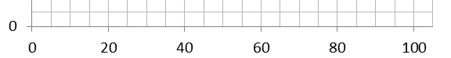

time / seconds



length / mm

Axes should not be labelled with the units on each scale marking.

**Data points**

Data points should be marked with a cross. Both 🞪 and 🞣 marks are acceptable, but care should be taken that data points can be seen against the grid.

Error bars can take the place of data points where appropriate.

**Scales and origins**

Students should attempt to spread the data points on a graph as far as possible without resorting to scales that are difficult to deal with. Students should consider:

* the maximum and minimum values of each variable
* the size of the graph paper
* whether 0.0 should be included as a data point
* whether they will be attempting to calculate the equation of a line, therefore needing the y intercept (Physics only)
* how to draw the axes without using difficult scale markings (eg multiples of 3, 7, 11 etc)
* In exams, the plots should cover **at least half** of the grid supplied for the graph.

This graph has well-spaced marking points and the data fills the paper.

Each point is marked with a cross (so points can be seen even when a line of best fit is drawn).

This graph is on the limit of acceptability. The points do not quite fill the page, but to spread them further would result in the use of awkward scales.

At first glance, this graph is well drawn and has spread the data out sensibly.

However, if the graph were to later be used to calculate the equation of the line, the lack of a y-intercept could cause problems. Increasing the axes to ensure all points are spread out but the y-intercept is also included is a skill that requires practice and may take a couple of attempts.

**Lines of best fit**

Lines of best fit should be drawn when appropriate. Students should consider the following when deciding where to draw a line of best fit:

* Are the data likely to have an underlying equation that it is following (for example, a relationship governed by a physical law)? This will help decide if the line should be straight or curved.
* Are there any anomalous results?
* Are there uncertainties in the measurements? The line of best fit should fall within error bars if drawn.

There is no definitive way of determining where a line of best fit should be drawn. A good rule of thumb is to make sure that there are as many points on one side of the line as the other. Often the line should pass through, or very close to, the majority of plotted points. Graphing programs can sometimes help, but tend to use algorithms that make assumptions about the data that may not be appropriate.

Lines of best fit should be continuous and drawn with a thin pencil that does not obscure the points below and does not add uncertainty to the measurement of gradient of the line.

Not all lines of best fit go through the origin. Students should ask themselves whether a 0 in the independent variable is likely to produce a 0 in the dependent variable. This can provide an extra and more certain point through which a line must pass. A line of best fit that is expected to pass through (0,0), but does not, would imply some systematic error in the experiment. This would be a good source of discussion in an evaluation.

**Dealing with anomalous results**

At GCSE, students are often taught to automatically ignore anomalous results. At A-level students should think carefully about what could have caused the unexpected result. For example, if a different experimenter carried out the experiment. Similarly, if a different solution was used or a different measuring device. Alternatively, the student should ask if the conditions the experiment took place under had changed (for example at a different temperature). Finally, whether the anomalous result was the result of an accident or experimental error. In the case where the reason for an anomalous result occurring can be identified, the result should be ignored. In presenting results graphically, anomalous points should be plotted but ignored when the line of best fit is being decided.

Anomalous results should also be ignored where results are expected to be the same.

Where there is no obvious error and no expectation that results should be the same, anomalous results should be included. This will reduce the possibility that a key point is being overlooked.

Please note: when recording results it is important that all data are included. Anomalous results should only be ignored at the data analysis stage.

It is best practice whenever an anomalous result is identified for the experiment to be repeated. This highlights the need to tabulate and even graph results as an experiment is carried out.

**Measuring gradients**

When finding the gradient of a line of best fit, students should show their working by drawing a triangle on the line. The hypotenuse of the triangle should be at least half as big as the line of best fit.

The line of best fit here has an equal number of points on both sides. It is not too wide so points can be seen under it.

The gradient triangle has been drawn so the hypotenuse includes more than half of the line.

In addition, it starts and ends on points where the line of best fit crosses grid lines so the points can be read easily (this is not always possible).

Δx

$$gradient= \frac{∆y}{∆x}$$

**The equation of a straight line**

Students should be able to translate graphical data into the equation of a straight line.

$$y=mx+c$$

Where y is the dependent variable, m is the gradient, x is the independent variable and c is the y-intercept.

Δy

Δx

Δy

Δx

y-intercept

Δy = 28 – 9 = 19

Δx = 90 – 10 = 80

gradient = 19 / 80 = 0.24 (2 sf)

y-intercept = 7.0

equation of line:

y = 0.24 x + 7.0

**Testing relationships**

Sometimes it is not clear what the relationship between two variables is. A quick way to find a possible relationship is to manipulate the data to form a straight line graph from the data by changing the variable plotted on each axis.

For example:

* **Raw data and graph**

|  |  |
| --- | --- |
| x | y |
| 0 | 0.00 |
| 10 | 3.16 |
| 20 | 4.47 |
| 30 | 5.48 |
| 40 | 6.32 |
| 50 | 7.07 |
| 60 | 7.75 |
| 70 | 8.37 |
| 80 | 8.94 |
| 90 | 9.49 |
| 100 | 10.00 |

This is clearly not a straight line graph. The relationship between x and y is not clear.

* **Manipulated data and graphs**

|  |  |  |  |  |
| --- | --- | --- | --- | --- |
| x | y | √y | y2 | y3 |
| 0 | 0.00 | 0.00 | 0.00 | 0.00 |
| 10 | 3.16 | 1.78 | 10.00 | 32 |
| 20 | 4.47 | 2.11 | 20.00 | 89 |
| 30 | 5.48 | 2.34 | 30.00 | 160 |
| 40 | 6.32 | 2.51 | 40.00 | 250 |
| 50 | 7.07 | 2.66 | 50.00 | 350 |
| 60 | 7.75 | 2.78 | 60.00 | 470 |
| 70 | 8.37 | 2.89 | 70.00 | 590 |
| 80 | 8.94 | 2.99 | 80.00 | 720 |
| 90 | 9.49 | 3.08 | 90.00 | 850 |
| 100 | 10.00 | 3.16 | 100.00 | 1000 |

A series of different graphs can be drawn from these data. The one that is closest to a straight line is a good candidate for the relationship between x and y.

This is an idealised set of data to illustrate the point.

The straightest graph is y2 against x, suggesting that the relationship between x and y is

$$y^{2}∝x$$

This is an idealised set of data to illustrate the point.

The straightest graph is y against x2, suggesting that the relationship between x and y is

$$y∝x^{2}$$

**More complex relationships**

Graphs can be used to analyse more complex relationships by rearranging the equation into a form similar to y=mx+c.

**Example one**

When water is displaced by an amount *l* in a U tube, the time period, T, varies with the following relationship:

$T=2π\sqrt{\frac{l}{2g}}$

This could be used to find g, the acceleration due to gravity.

* Take measurements of *T* and *l*.
* Rearrange the equation to become linear:

$T^{2}=4π^{2}\frac{l}{2g}$

* Calculate *T*2 for each value of *l*.
* By re-writing the equation as:

$T^{2}=\frac{4π^{2}}{2g}l$

it becomes clear that a graph of *T*2 against *l* will be linear with a gradient of $\frac{4π^{2}}{2g}$.

* Calculate the gradient (*m*) by drawing a triangle on the graph.
* Find g by rearranging the equation $m= \frac{4π^{2}}{2g}$ into $g= \frac{4π^{2}}{2}m=2π^{2}m$

**Example two**: testing power laws

A relationship is known to be of the form y=Axn, but n is unknown.

Measurements of y and x are taken.

A graph is plotted with log(y) plotted against log(x).

The gradient of this graph will be n, with the y intercept log(A), as log(y) = n(log(x)) + log(A)

**Example three**

The equation that relates the pd, *V*, across a capacitor, *C*, as it discharges through a resistor, *R*, over a period of time, *t*.

$$V=V_{0}e^{-\frac{t}{RC}}$$

Where *V*o = pd across capacitor at *t* = 0

This can be rearranged into

$$\ln{V= -\frac{t}{RC}+lnVo}$$

So a graph of $lnV$ against *t* should be a straight line, with a gradient of $-\frac{1}{RC}$ and a

y-intercept of $lnVo$



## Glossary of terms

The following subject specific vocabulary provides definitions of key terms used in AQA's AS and A-level Biology, Chemistry and Physics specifications.

#### Accuracy

A measurement result is considered accurate if it is judged to be close to the true value.

#### Calibration

Marking a scale on a measuring instrument.

This involves establishing the relationship between indications of a measuring instrument and standard or reference quantity values, which must be applied.

For example, placing a thermometer in melting ice to see whether it reads 0 °C, in order to check if it has been calibrated correctly.

#### Data

Information, either qualitative or quantitative, that have been collected.

#### Errors

See also uncertainties.

#### measurement error

The difference between a measured value and the true value.

#### anomalies

These are values in a set of results which are judged not to be part of the variation caused by random uncertainty.

#### random error

These cause readings to be spread about the true value, due to results varying in an unpredictable way from one measurement to the next.

Random errors are present when any measurement is made, and cannot be corrected. The effect of random errors can be reduced by making more measurements and calculating a new mean.

#### systematic error

These cause readings to differ from the true value by a consistent amount each time a measurement is made.

Sources of systematic error can include the environment, methods of observation or instruments used.

Systematic errors cannot be dealt with by simple repeats. If a systematic error is suspected, the data collection should be repeated using a different technique or a different set of equipment, and the results compared.

#### zero error

Any indication that a measuring system gives a false reading when the true value of a measured quantity is zero, eg the needle on an ammeter failing to return to zero when no current flows.

A zero error may result in a systematic uncertainty.

#### Evidence

Data that have been shown to be valid.

#### Fair test

A fair test is one in which only the independent variable has been allowed to affect the dependent variable.

#### Hypothesis

A proposal intended to explain certain facts or observations.

#### Interval

The quantity between readings eg a set of 11 readings equally spaced over a distance of 1 metre would give an interval of 10 centimetres.

#### Precision

Precise measurements are ones in which there is very little spread about the mean value.

Precision depends only on the extent of random errors – it gives no indication of how close results are to the true value.

#### Prediction

A prediction is a statement suggesting what will happen in the future, based on observation, experience or a hypothesis.

#### Range

The maximum and minimum values of the independent or dependent variables;

For example a range of distances may be quoted as either:

'From 10cm to 50 cm' or

'From 50 cm to 10 cm'

#### Repeatable

A measurement is repeatable if the original experimenter repeats the investigation using same method and equipment and obtains the same results.

#### Reproducible

A measurement is reproducible if the investigation is repeated by another person, or by using different equipment or techniques, and the same results are obtained.

#### Resolution

This is the smallest change in the quantity being measured (input) of a measuring instrument that gives a perceptible change in the reading.

#### Sketch graph

A line graph, not necessarily on a grid, that shows the general shape of the relationship between two variables. It will not have any points plotted and although the axes should be labelled they may not be scaled.

#### True value

This is the value that would be obtained in an ideal measurement.

#### Uncertainty

The interval within which the true value can be expected to lie, with a given level of confidence or probability eg “the temperature is 20 °C ± 2 °C, at a level of confidence of 95%”.

#### Validity

Suitability of the investigative procedure to answer the question being asked. For example, an investigation to find out if the rate of a chemical reaction depended upon the concentration of one of the reactants would not be a valid procedure if the temperature of the reactants was not controlled.

#### Valid conclusion

A conclusion supported by valid data, obtained from an appropriate experimental design and based on sound reasoning.

#### Variables

These are physical, chemical or biological quantities or characteristics.

#### categoric variables

Categoric variables have values that are labels eg names of plants or types of material or reading at week 1, reading at week 2 etc.

#### continuous variables

Continuous variables can have values (called a quantity) that can be given a magnitude either by counting (as in the case of the number of shrimp) or by measurement (eg light intensity, flow rate etc).

#### control variables

A control variable is one which may, in addition to the independent variable, affect the outcome of the investigation and therefore has to be kept constant or at least monitored.

#### dependent variables

The dependent variable is the variable of which the value is measured for each and every change in the independent variable.

#### independent variables

The independent variable is the variable for which values are changed or selected by the investigator.

#### nominal variables

A nominal variable is a type of categoric variable where there is no ordering of categories (eg red flowers, pink flowers, blue flowers).

## Practical ladders and exemplar experiments: Physics

During the development of our A-levels in Biology, Chemistry and Physics, we spoke to hundreds of teachers. Teachers helped us to develop every part of the specification and assessments including the content and layout of the specification, what is examined on which paper, and question types. Teachers also helped us to decide which practical activities to include in our 12 required practicals for each subject.

Both in development, and in our launch meetings, teachers asked us for full, comprehensive instructions on how to carry out each of the 12 required practicals. In response, we have included a **sample** method for each practical on the next few pages. These have been prepared so that a reasonably equipped school can cover the required activity with their students. It gives **one possible version** of the experiment that teachers could use. They will help inform planning the time required and ensuring schools have the right equipment. Many are based on existing ISA and EMPA tasks as we know that they work well and schools have been using them for a number of years in the current specifications.

This document should **only** be seen as a starting point. We do not intend to stifle innovation and would encourage teachers to try different methods. Students will not be examined on the specific practical work exemplified within this section but on the skills and understanding they build up through their practical work. Teachers can vary all experiments to suit their and their students’ needs.

**Using set methods to assess students’ competence for the endorsement**

Students who are given a method which is fully developed, with full, clear instructions, will be able to demonstrate some competencies (eg following written instructions), but not others (eg researching and reporting).

We have developed ‘ladders’ which will help you to modify each of the given practicals to allow your students greater freedom to develop and demonstrate these wider practical skills. Each ladder identifies how slight modifications to the way the experiment is presented can change the focus of the experiment and allow students to demonstrate more independence. In turn they will allow you to be more confident in your judgement of the students’ abilities for the endorsement of practical skills.

**Investigation**

Students do **not** need to carry out a full investigation. To achieve the endorsement, teachers must be confident that students can carry out practicals using ‘investigative approaches’. In some practicals, teachers will wish to give full instructions for every stage in the activity. In other activities, teachers will give students some choice over how they carry out the activity, for example choosing the apparatus or the conditions for the experiment. On other occasions, teachers will wish to give students choice over how they analyse the data.

This approach means that students will be able to demonstrate all aspects of investigation over the A-level course without the practical problems associated with a full investigation.

**Safety**

At all times, the teacher is responsible for safety in the classroom. Teachers should intervene whenever they see unsafe working. Risk assessments should be carried out before working, and advice from CLEAPSS and other organisations should be followed.

It is appropriate to give students at A-level more independence when making decisions about safety. They should be taught how to assess risks and how to write risk assessments when appropriate. They should also understand the appropriate use of safety equipment and how to put measures in place to reduce the risks.

**It is important that any ‘student version’ of these worksheets takes due account of any relevant safety issues.**

**PRACTICAL 1**

|  |  |  |  |  |  |  |
| --- | --- | --- | --- | --- | --- | --- |
| **Required practical** | | **Investigation into the variation of the frequency of stationary waves on a string (or wire) with length, tension, and mass per unit length of string** | | | | |
| **Apparatus and techniques covered**  (Relevant apparatus only, not full statements) | | a. use appropriate analogue apparatus to record a range of measurements (to include length/distance)  b. use appropriate digital instruments to obtain a range of measurements (to include mass)  c. use methods to increase accuracy of measurements  i. generate and measure waves using vibration transducer | | | | |
| **Indicative apparatus** | | For waves on a steel wire: Sonometer or ‘soundbox’ with steel wire(s) stretched over fixed and moveable bridges and pulley, set of 0.5 kg masses, metre ruler, balance, set of standard tuning forks with paper rider/resonance technique to measure frequency (or alternative electronic sensor for frequency measurement).  Alternative method with strings or wires and suitable transducer (eg vibrator) for producing waves and measuring frequency,  100 g masses, balance, metre ruler. | | | | |
|  | **Amount of choice**  **Increasing independence** | | | | | |
|  | Least choice | | Some choice | Many choices | | Full investigation |
| Teacher gives students a full method with clear instructions as to how to set up the apparatus. All instruments and measurements are specified and students are instructed on the exact procedure and safety precautions. | | Teacher allows students limited choice in identification and control of variables and range of readings. Otherwise all procedural techniques are specified. | Teacher indicates general method but student decides on measurement techniques and methodology, eg measurement of frequency. | | Teacher indicates general line of enquiry at the end of a piece of work in which all separate techniques were seen and used by the student.  Student decides on methodology and appropriate equipment and materials. All choices are justified with reference to experimental errors and safety. |
| **Opportunities for observation and assessment of competencies** | | | | | | |
| Follow written procedures | **🗸🗸🗸** Students follow written method. | | **🗸🗸🗸** Students follow written method. | | **🗸🗸🗸** Students follow a method they have chosen. | **🗸🗸🗸** Students follow a method they have researched. |

|  |  |  |  |  |
| --- | --- | --- | --- | --- |
| Applies investigative approaches and methods when using instruments and equipment | **🗸** Students correctly use the equipment and materials with minimum assistance and prompting. | **🗸🗸**Students correctly use the equipment, carry out procedures methodically and make adjustments when necessary. | **🗸🗸🗸** Students select and correctly use the equipment, carry out procedures methodically and identify and control quantitative variables. | **🗸🗸🗸** Student must choose an appropriate approach, equipment and techniques, identify quantitative variables for measurement and control. |
| Safely uses a range of practical equipment and materials | **🗸** Students must safely use the equipment following advice given. | **🗸🗸** Students must safely use the equipment with minimal prompting. | **🗸🗸🗸** Students minimise risks in all aspects of the investigation with no prompting. | **🗸🗸🗸** Students must carry out a full risk assessment and minimise risks. |
| Makes and records observations | **🗸🗸** Students record observations as specified in the method, and record in a methodical way using appropriate units and conventions. | **🗸🗸🗸** Students obtain accurate, precise and sufficient data and records this methodically using appropriate units and conventions. | **🗸🗸🗸** Students obtain accurate, precise and sufficient data and records this methodically using appropriate units and conventions. | **🗸🗸🗸** Students obtain accurate, precise and sufficient data and records this methodically using appropriate units and conventions. |
| Researches, references and reports | **🗸** Students process data in prescribed way and compare results with expected relationships. | **🗸🗸**Students process data in prescribed way and compare results with expected relationships identifying potential discrepancies and errors. | **🗸🗸** Students identify appropriate methods/tools to process data and compare with expected relationships, identifying potential errors and limitations. | **🗸🗸🗸** Students identify appropriate methods to process data, carry out research and report findings. Sources of information are cited together with supporting planning and conclusions. |

🗸🗸🗸: Very good opportunity 🗸🗸: Good opportunity 🗸: Slight opportunity 🗶: No opportunity

**A-level Physics required practical No 1**

**Investigation into the variation of the frequency of stationary waves on a string with length, tension and mass per unit length of the string**

NB This worksheet gives full details of the experiment, primarily for use by teachers and technicians who may be unfamiliar with the experiment. The worksheet would normally be adapted for student use to provide opportunity for students to make procedural decisions.

**Materials and equipment**

* signal generator
* vibration generator
* stand
* 2 kg mass
* 1.5 m length of string (eg 1.5 mm thick)
* pulley which can be clamped to the bench
* wooden bridge slightly higher than the pulley
* 100 g masses on a holder
* metre ruler
* an electronic top pan balance with precision 0.1 g or better.

**Technical information**

* The signal generator should be operated for about 20 minutes in order for the frequency to stabilise.
* The power output (eg 20 V peak-to-peak) should be used. The output level should be turned up to a value which gives steady vibrations of the vibration generator.
* The string should be tied to the stand and passed through the hole in the vibration generator.
* The bridge should be at the same height as the hole.
* The 2 kg mass is used as a counterweight to ensure the stand does not topple over (an alternative would be to clamp the stand to the bench using a G-clamp).

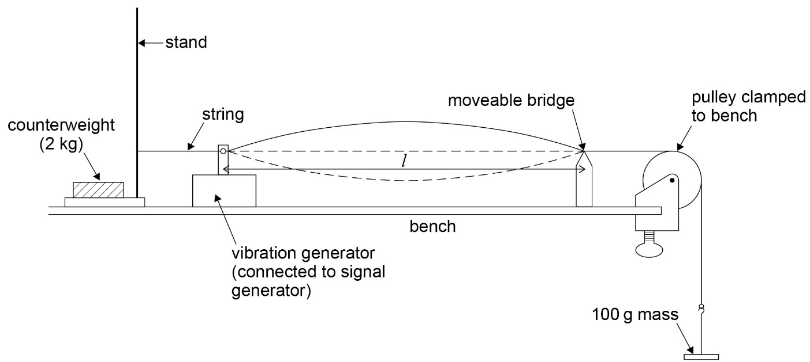

**Method**

* Set up the apparatus as shown in the diagram.
* Adjust the position of the bridge so that *l* is 1.000 m measured using the metre ruler.
* Increase the frequency of the signal generator from zero until the string resonates at its fundamental frequency (as indicated in the diagram with a node at each end and a central antinode).
* Read the frequency *f*, on the signal generator dial.
* Repeat the procedure with *l* = 0.900, 0.800, 0.700, 0.600 and 0.500 m.
* Obtain a second set of results by repeating the experiment and find the mean value of *f* for each value of *l*.
* Plot a graph of mean 1/*f* against *l*.
* Draw the best straight line of fit though the points and find the gradient (the graph should be a straight line through the origin).
* The speed of the travelling waves on the string is *c* = *fλ* where *λ* is the wavelength. When the string is vibrating in its fundamental mode, *λ* = 2*l*. Hence *c* = 2*fl*. The gradient is 1/ *fl* so *c* is given by 2/gradient in *ms–1*.
* The speed is also given by *c* = √(*T*/*m*) where *T* is the tension in the string in N and *m* is the mass per unit length of the string in kg m–1
* With a 100 g mass hanging from the string, *T* = 0.981 N. *m* can be found by weighing the

1.5 m length of string on an electronic balance, converting this into kg, and dividing by 1.5. These values can then be substituted into the above equation to find another value for *c*, which can be compared to the value obtained from the graph.

* The experiment can be repeated with different masses hanging from the string, and different thicknesses of string to investigate the effect of changing *T* and *m*.
* Doubling the fundamental frequency while keeping *l*, *T* and *m* constant will cause the string to resonate in its second harmonic (or first overtone, with nodes at either end, a central node, and two antinodes). Tripling the frequency will give the third harmonic, and so on.

**PRACTICAL 2**

|  |  |  |  |  |  |
| --- | --- | --- | --- | --- | --- |
| **Required practical** | | **Investigation of interference in Young’s slit experiment and diffraction by a diffraction grating.** | | | |
| **Apparatus and techniques covered**  (Relevant apparatus only, not full statements) | | a. use appropriate analogue apparatus to record a range of measurements (to include length/distance, angle)  j. use a laser or light source to investigate characteristics of light, including interference and diffraction | | | |
| **Indicative apparatus** | | **Young’s slits ‘double slit’ interference experiment:**  Laser (eg helium-neon laser), slide with ‘double slit’ (approximately 1 mm spacing), metre ruler, white screen (eg white paper attached to wall), stand with clamp/holder for ‘double slit’  (Alternative light source with single slit/double slit arrangement to produce coherent sources can be used instead of the laser, but this will usually require use of a dark room).  **Diffraction grating:**  Laser, plane transmission diffraction grating, stand with clamp/holder for diffraction grating, metre ruler, screen,  (If available, the use of spectrometer with variety of different light sources, together with the diffraction grating is ideal). | | | |
|  | **Amount of choice**  **Increasing independence** | | | | |
|  | Least choice | | Some choice | Many choices | Full investigation |
| Teacher gives students a full method with clear instructions as to how to set up the apparatus. All instruments and measurements are specified and students are instructed on the exact procedure and safety precautions. | | Teacher allows students limited choice in the measurement of fringe width and angular position of the ‘orders’ of the diffraction pattern. Otherwise all procedural techniques are specified. | Teacher indicates general method for each experiment but student decides on range of readings, control of variables and measurement techniques for fringe width and angular position of the ‘orders’ of the diffraction pattern. | Teacher suggests general line of enquiry – to investigate interference and diffraction of light, including a double slit system and a diffraction grating.  Student decides on methodology and appropriate equipment and materials. All choices are justified with reference to experimental errors and safety. |

|  |  |  |  |  |
| --- | --- | --- | --- | --- |
| **Opportunities for observation and assessment of competencies** | | | | |
| Follow written procedures | **🗸🗸🗸** Students follow written method. | **🗸🗸🗸** Students follow written method. | **🗸🗸🗸** Students follow a method they have chosen. | **🗸🗸🗸** Students follow a method they have researched. |
| Applies investigative approaches and methods when using instruments and equipment | **🗸** Students correctly use the equipment and materials with minimum assistance and prompting. | **🗸🗸** Students correctly use the equipment, carry out procedures methodically and make adjustments when necessary. | **🗸🗸** Students correctly use the equipment, carry out procedures methodically and identify and control quantitative variables. | **🗸🗸🗸** Student must choose an appropriate approach, equipment and techniques, identify quantitative variables for measurement and control. |
| Safely uses a range of practical equipment and materials | **🗸** Students must safely use the equipment following advice given. | **🗸🗸** Students must safely use the equipment with minimal prompting. | **🗸🗸🗸** Students minimise risks in all aspects of the investigation with no prompting. | **🗸🗸🗸** Students must carry out a full risk assessment and minimise risks. |
| Makes and records observations | **🗸🗸** Students record observations as specified in the method, and record in a methodical way using appropriate units and conventions. | **🗸🗸🗸** Students obtain accurate, precise and sufficient data and records this methodically using appropriate units and conventions. | **🗸🗸🗸** Students obtain accurate, precise and sufficient data and records this methodically using appropriate units and conventions. | **🗸🗸🗸** Students obtain accurate, precise and sufficient data and records this methodically using appropriate units and conventions. |
| Researches, references and reports | **🗸** Students process data in prescribed way and compare results with expected relationships. | **🗸🗸**Students process data in prescribed way and compare results with expected relationships identifying potential discrepancies and errors. | **🗸🗸🗸** Students identify appropriate methods/tools to process data and compare with expected relationships, identifying potential errors and limitations. | **🗸🗸🗸** Students identify appropriate methods to process data, carry out research and report findings. Sources of information are cited together with supporting planning and conclusions. |

🗸🗸🗸: Very good opportunity 🗸🗸: Good opportunity 🗸: Slight opportunity 🗶: No opportunity

**A-level Physics required practical No 2**

**Investigation of the interference effects by Young’s slit and diffraction by a diffraction grating**

NB This worksheet gives full details of the experiment, primarily for use by teachers and technicians who may be unfamiliar with the experiment. The worksheet would normally be adapted for student use to provide opportunity for students to make procedural decisions.

**Young’s slit experiment**

**Materials and equipment**

* laser – class II optical laser with output 1 mW or less
* darkened slight with double slit ‘rulings’ (usually 1 mm slit separation)
* vernier callipers to measure slit separation
* adjustable single slit (might be unnecessary with the laser)
* white screen (wall covered with white paper may be suitable but paper must be matt finish or non-reflective to reduce chances of reflected beams)
* metre ruler.

**Technical information**

Using a laser for this this experiment makes it possible to produce visible interference fringes in a partially darkened laboratory. Ensure lasers are used safely and set up so they are not pointed directly into anyone’s eyes.

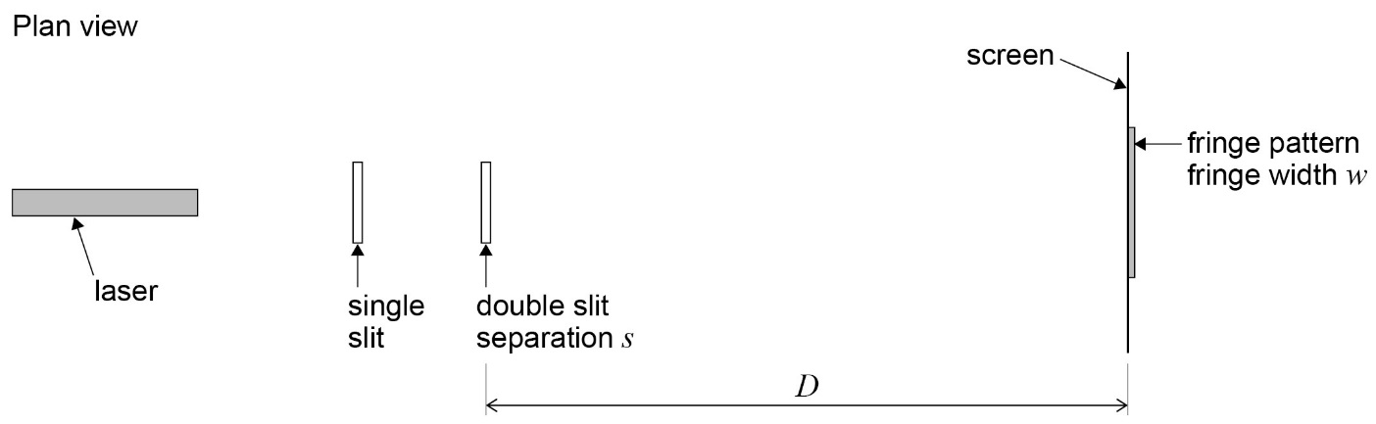

**Method**

* A partially darkened laboratory is required ensuring lasers are used safely.
* Set up the apparatus as shown in the diagram, with the laser illuminating the double slit and the screen a distance *D* of initially about 1 metre. (With the laser the single slit might not be required, provided the laser beam is wide enough to illuminate across the double slit).
* Carefully adjust the position of the laser until the light spreads evenly over the two slits. An interference pattern should be visible on the screen.
* The fringe width (or fringe spacing), *w*, can be measured by measuring across a large number of visible fringes. (Take care when counting – counting from the first bright fringe to the tenth bright fringe would represent nine fringe widths!).
* Use the metre ruler to measure *D*.
* A measurement of the slit separation, *s*, is required. The value could be measured with vernier callipers or travelling microscope. If a travelling microscope is used it must only be used to measure slit separation and **not the fringe width**. Alternatively the manufacture may quote the value on the slide.
* Use the equation $\text{λ = }\frac{\text{w s}}{\text{D}}$
* Alternatively, the value of *D* could be changed from approximately 0.5 m to 1.5 m and the fringe width, *w*, measured for each value of *D*.
* A graph of *w* on the *y*-axis against *D* should be a straight line through the origin, with gradient = *λ* /*s* .

**Diffraction with a plane transmission diffraction grating at normal incidence**

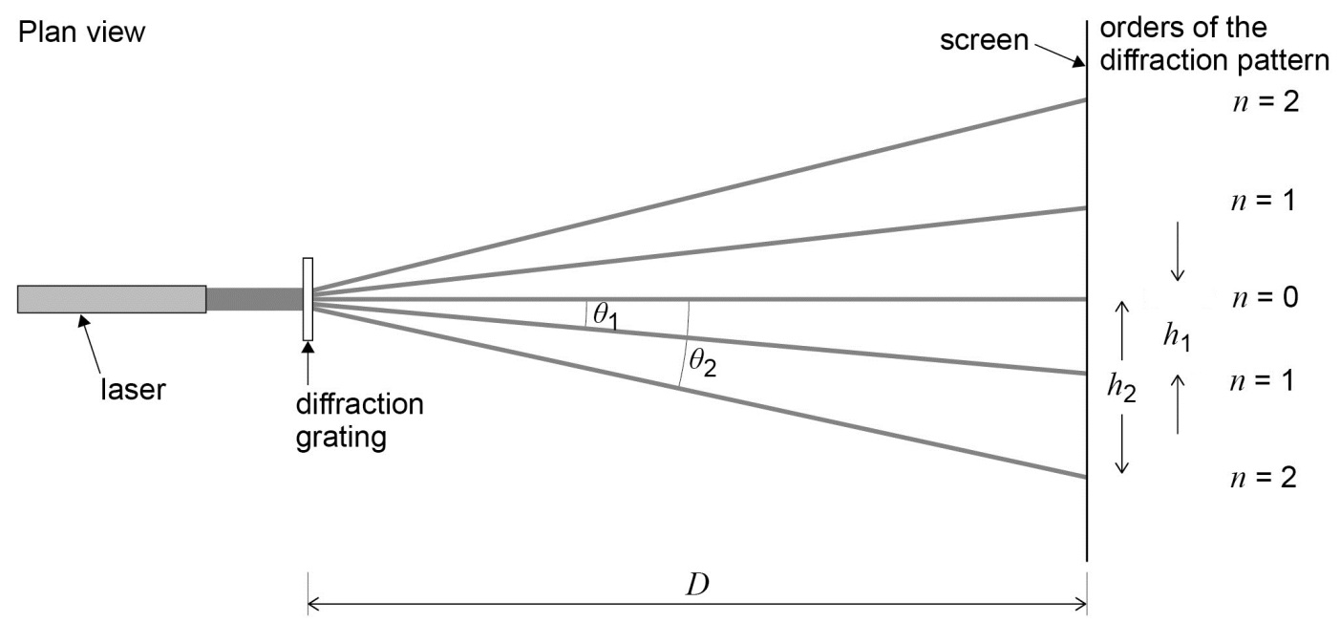

**Materials and equipment**

* laser – class II optical laser with output 1 mW or less
* plane transmission diffraction grating
* white screen (wall covered with white paper may be suitable but paper must be matt finish or non-reflective to reduce chances of reflected beams)
* metre ruler.

**Method**

* A partially darkened laboratory is required. Please ensure lasers are used safely.
* Set up the apparatus as shown in the diagram, with the laser illuminating the diffraction grating and the screen a distance *D* of initially about 1 metre.
* Carefully adjust the position of the diffraction grating so that the diffraction grating is perpendicular to the beam of light from the laser. (A large set square might be useful).
* The diffraction pattern should be visible on the screen. The number of orders shown will depend on the line spacing of the diffraction grating.
* The angles *Ɵ*1 and *Ɵ*2 can be determined by measuring the distances *h*1 , *h*2 and *D*. (This gives the tangent of the angles, and hence the angles can be calculated).
* The formula *nλ* = *d* sin*Ɵ* can be used to determine the wavelength of the laser light.

*n* is the order of the diffraction pattern

*d* is the grating spacing = 1/number of lines per metre

*λ* is the wavelength of light

* The values of *Ɵ* for each order, both above and below the zero order, should be measured. A mean value for *λ* can be calculated from the data.

**Single slit diffraction**

* This arrangement can also be used to illustrate diffraction at a single slit. The diffraction grating is replaced by an adjustable single slit. The effect of ‘slit width’ can easily be observed.

**PRACTICAL 3**

|  |  |  |  |  |  |  |
| --- | --- | --- | --- | --- | --- | --- |
| **Required practical** | | **Determination of *g* by a free-fall method** | | | | |
| **Apparatus and techniques covered**  (Relevant apparatus only, not full statements) | | a. use appropriate analogue apparatus to record a range of measurements (to include length/distance)  c. use methods to increase accuracy of measurements  d. use of light gates for timing  k. use of ICT – Data logger with light gates and data processing software (capable of measurement of time, velocity and/or acceleration directly) | | | | |
| **Indicative apparatus** | | Light gates, data logger, computer, stand boss and clamp for light gates, rectangular laminar (or other suitable object to drop through the light gates, metre ruler.  (Alternative method using centi-second timer, steel ball bearing, electromagnet and impact switch is also acceptable). | | | | |
|  | **Amount of choice**  **Increasing independence** | | | | | |
|  | Least choice | | Some choice | Many choices | | Full investigation |
| Teacher gives students a full method with clear instructions as to how to set up the apparatus. All instruments and measurements are specified and students are instructed on the exact procedure and safety precautions. | | Teacher allows students limited choice in use of light gates and range of heights. Otherwise all procedural techniques are specified. | Teacher suggests outline method, using light gates, to measure *g* by a free-fall method. Student decides range of readings and suitable ‘freefall object’ based on preliminary experiment. Student also makes decisions on the processing of data together with the use of the data processing software. | | At the end of a piece of work on dynamics, where the student has had experience using all relevant practical techniques, teacher sets the problem of devising an accurate method to measure *g*.  Student makes full decision about methodology, equipment and materials. All choices are fully justified with reference to experimental errors and safety. |
| **Opportunities for observation and assessment of competencies** | | | | | | |
| Follow written procedures | **🗸🗸🗸** Students follow written method. | | **🗸🗸🗸** Students follow written method. | | **🗸🗸🗸** Students follow a method they have chosen. | **🗸🗸🗸** Students follow a method they have researched. |

|  |  |  |  |  |
| --- | --- | --- | --- | --- |
| Applies investigative approaches and methods when using instruments and equipment | **🗸** Students correctly use the equipment and materials with minimum assistance and prompting. | **🗸🗸**Students correctly use the equipment, carry out procedures methodically and make adjustments when necessary. | **🗸🗸**. Students select and correctly use the equipment, carry out procedures methodically and identify and control quantitative variables. | **🗸🗸🗸** Student must choose an appropriate approach, equipment and techniques, identify quantitative variables for measurement and control. |
| Safely uses a range of practical equipment and materials | **🗸** Students must safely use the equipment following advice given. | **🗸🗸** Students must safely use the equipment with minimal prompting. | **🗸🗸🗸** Students minimise risks in all aspects of the investigation with no prompting. | **🗸🗸🗸** Students must carry out a full risk assessment and minimise risks. |
| Makes and records observations | **🗸🗸** Students record observations as specified in the method, and record in a methodical way using appropriate units and conventions. | **🗸🗸🗸** Students obtain accurate, precise and sufficient data and records this methodically using appropriate units and conventions. | **🗸🗸🗸** Students obtain accurate, precise and sufficient data and records this methodically using appropriate units and conventions. | **🗸🗸🗸** Students obtain accurate, precise and sufficient data and records this methodically using appropriate units and conventions. |
| Researches, references and reports | **🗸** Students process data in prescribed way and compare results with expected relationships. | **🗸🗸**Students process data in prescribed way and compare results with expected relationships identifying potential discrepancies and errors. | **🗸🗸** Students identify appropriate methods/tools to process data and compare with expected relationships, identifying potential errors and limitations. | **🗸🗸🗸** Students identify appropriate methods to process data, carry out research and report findings. Sources of information are cited together with supporting planning and conclusions. |

🗸🗸🗸: Very good opportunity 🗸🗸: Good opportunity 🗸: Slight opportunity 🗶: No opportunity

**A-level Physics required practical No 3**

**Determination of *g* by a free-fall method**

NB This worksheet gives full details of the experiment, primarily for use by teachers and technicians who may be unfamiliar with the experiment. The worksheet would normally be adapted for student use to provide opportunity for students to make procedural decisions.

**Materials and equipment**

* stand and clamp
* electromagnet
* low voltage variable DC supply (to power the electromagnet)
* 2 kg mass
* steel ballbearing
* two light gates with bosses to attach them to the stand
* an electronic clock or data logger with precision 1 ms or better.
* a pad (eg of felt) to protect the bench when the ballbearing lands.
* metre ruler.

**Technical information**

* The electromagnet is a convenient way of releasing the ballbearing.
* The low voltage supply should be set at the voltage specified by the manufacturer for the electromagnet.
* The supply is switched on and the ballbearing hung from the electromagnet. It will then be released when the supply is switched off.
* Several trials and adjustments will be required to ensure the ballbearing falls directly through the light gates.
* A mechanical release mechanism could be used (eg holding the ballbearing in the clamp which is opened to release the ball bearing, but this is not as quick to reset, and won’t give as clean a release).
* The upper light gate should be connected to the clock or data logger to start the timing.

The lower gate should be connected to stop the timing.

* The 2 kg mass is used as a counterweight to ensure the stand does not topple over (an alternative would be to clamp the stand to the bench using a G-clamp).

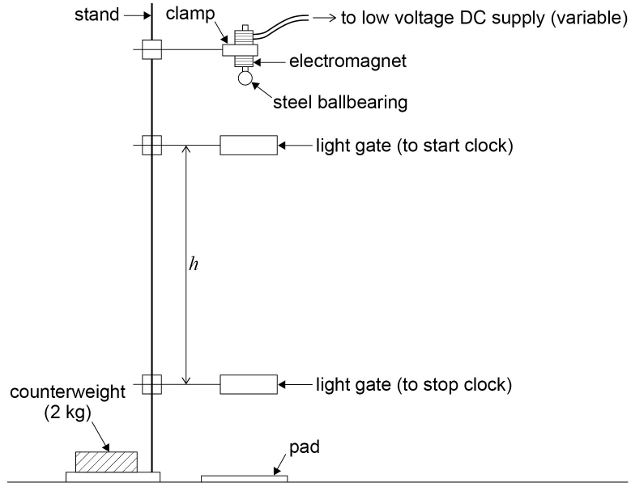

**Method**

* Set up the apparatus as shown in the diagram. The height between the starting position of the ballbearing and the upper light gate should be kept constant, so that the velocity, *u*, with which the ballbearing reaches this light gate is also constant.
* Adjust the position of the lower light gate so that *h* is 0.500 m measured using the metre ruler. (If a taller stand is available, *h* could be set at a higher starting value.)
* Switch on the supply to the electromagnet, and hang the ballbearing from it (or fit the ballbearing into the clamp if a mechanical release mechanism is being used).
* Reset the clock or data logger to zero and switch off the electromagnet (or open the clamp).
* Read the time on the clock or data logger once the ballbearing has passed through the light gates.
* Take repeat readings to find the mean time, *t*.
* Reduce *h* by 0.050 m and repeat the procedure down to a value of 0.250 m (lower values than this make it difficult to obtain accurate timings).
* Plot a graph of 2*h*/t against *t*.
* Draw the best straight line of fit though the points and find the gradient (the graph should be a straight line with intercept 2*u*).

*h* = ut + gt2/2

Re-arranging

2*h*/*t* = *gt* + 2*u*

Hence the gradient of the graph gives *g* in ms–2

The intercept will be 2*u*.

**PRACTICAL 4**

|  |  |  |  |  |  |
| --- | --- | --- | --- | --- | --- |
| **Required practical** | | **Determination of the Young Modulus by a simple method** | | | |
| **Apparatus and techniques covered**  (Relevant apparatus only, not full statements) | | a. use appropriate analogue apparatus to record a range of measurements (to include length/distance)  c. use methods to increase accuracy of measurements  e. use of micrometers for small distances, using digital or vernier scales | | | |
| **Indicative apparatus** | | **For a steel wire suspended vertically:** Suitable (ceiling) suspension point or beam from which loaded test wire can be suspended, clamps to attach wires to supporting beam, suitable test wire (eg steel wire approximately 0–5 mm diameter) and identical ‘comparison’ wire, mm scale with sliding vernier scale (scale with vernier is specially designed for this experiment - with clamps for the main scale to attach to the comparison wire and similar clamps on the vernier which attach to the test wire), set of 0.5 kg or 1 kg slotted masses and mass hanger for test wire, mass hanger and one 0.5 kg mass for comparison wire, metre ruler, micrometer screw gauge.  **Alternative method with test wire stretched horizontally across a bench:** G – clamp and wooden blocks to clamp the test wire, metre ruler, test wire (eg copper wire diameter approximately 0.5 mm), set of 100 g slotted masses and mass hanger, bench pulley (which has clamp to attach to work bench), micrometer screw gauge, set square/marker to attach to wire/vernier scale to measure extension of wire. | | | |
|  | **Amount of choice**  **Increasing independence** | | | | |
|  | Least choice | | Some choice | Many choices | Full investigation |
| Teacher gives students a full method with clear instructions as to how to set up the apparatus. All instruments and measurements are specified and students are instructed on the exact procedure and safety precautions. | | Teacher allows students limited choice of method to measure the diameter of the wire and the extension of the loaded wire. Otherwise all procedural techniques are specified. | Teacher suggests outline method to determine the Young Modulus by measuring the extension of a loaded wire. Students decide on in most appropriate measuring instruments and suitable range of masses after preliminary experiment. | Teacher suggests link between the extension of a loaded stretched metal wire and the dimensions of the wire.  Student makes full decision about methodology, equipment and materials. All choices are fully justified with reference to experimental errors and safety. |

|  |  |  |  |  |
| --- | --- | --- | --- | --- |
| **Opportunities for observation and assessment of competencies** | | | | |
| Follow written procedures | **🗸🗸🗸** Students follow written method. | **🗸🗸🗸** Students follow written method. | **🗸🗸🗸** Students follow a method they have chosen. | **🗸🗸🗸** Students follow a method they have researched. |
| Applies investigative approaches and methods when using instruments and equipment | **🗸** Students correctly use the equipment and materials with minimum assistance and prompting. | **🗸🗸**Students correctly use the equipment, carry out procedures methodically and make adjustments when necessary. | **🗸🗸🗸**. Students select and correctly use the equipment, carry out procedures methodically and identify and control quantitative variables. | **🗸🗸🗸** Student must choose an appropriate approach, equipment and techniques, identify quantitative variables for measurement and control. |
| Safely uses a range of practical equipment and materials | **🗸** Students must safely use the equipment following advice given. | **🗸🗸** Students must safely use the equipment with minimal prompting. | **🗸🗸🗸** Students minimise risks in all aspects of the investigation with no prompting. | **🗸🗸🗸** Students must carry out a full risk assessment and minimise risks. |
| Makes and records observations | **🗸🗸** Students record observations as specified in the method, and record in a methodical way using appropriate units and conventions. | **🗸🗸🗸** Students obtain accurate, precise and sufficient data and records this methodically using appropriate units and conventions. | **🗸🗸🗸** Students obtain accurate, precise and sufficient data and records this methodically using appropriate units and conventions. | **🗸🗸🗸** Students obtain accurate, precise and sufficient data and records this methodically using appropriate units and conventions. |
| Researches, references and reports | **🗸** Students process data in prescribed way and compare results with expected relationships. | **🗸🗸**Students process data in prescribed way and compare results with expected relationships identifying potential discrepancies and errors. | **🗸🗸** Students identify appropriate methods/tools to process data and compare with expected relationships, identifying potential errors and limitations. | **🗸🗸🗸** Students identify appropriate methods to process data, carry out research and report findings. Sources of information are cited together with supporting planning and conclusions. |

🗸🗸🗸: Very good opportunity 🗸🗸: Good opportunity 🗸: Slight opportunity 🗶: No opportunity

**A-level Physics required practical No 4**

**Determination of the Young Modulus by a simple method**

NB This worksheet gives full details of the experiment, primarily for use by teachers and technicians who may be unfamiliar with the experiment. The worksheet would normally be adapted for student use to provide opportunity for students to make procedural decisions.

**Materials and equipment**

* ceiling beam or suitably strong fixing to attach loaded wires
* 2 × 1.5 m lengths of steel wire (eg 0.45 mm diameter mild steel wire)
* scale and vernier arrangement with integral clamps for the wires
* micrometer screw gauge
* metre ruler
* 2 × slotted kg mass holders
* selection of 0.5 kg and 1 kg slotted masses
* safety goggles (in case wire breaks)
* sand tray (to catch masses if wire breaks).

**Technical information**

* It is important that the steel wire used is completely free from kinks – otherwise any measured ‘extension’ will partly be due to the straightening out of the kinks. Scientific equipment suppliers produce suitable wires for this experiment. They also supply suitable clamps to attach the wires to the ceiling beam, vernier-scale arrangement and mass holder.
* A 1 kg mass will produce an extension of 0.47 mm for a 1.5 m steel wire of diameter 0.45 mm. Consequently an accurate measurement of extension requires specialised apparatus. The mm scale and vernier arrangement is one designed specifically for this experiment – the vernier is attached to, and slides alongside the main scale. The main mm scale is usually clamped to the comparison wire and the vernier section clamped to the test wire.
* The main safety consideration is the possibility of the wire breaking. Goggles should be worn and a sand tray placed underneath the arrangement to catch the falling masses.
* The comparison wire compensates for sagging of the beam and thermal expansion effects, and provides a reference point against which to measure the extension of the loaded test wire.

Details of wire clamps **not** shown on this diagram

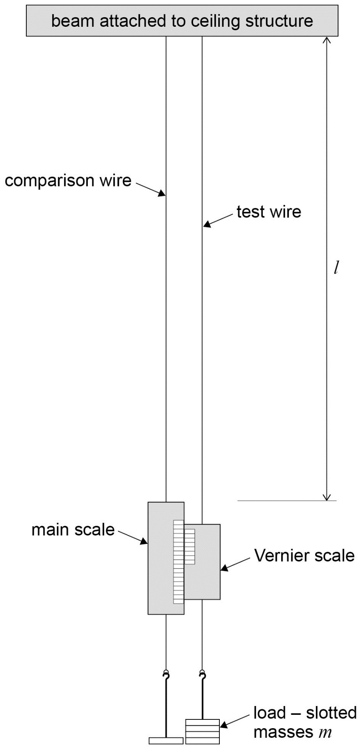

**Method**

* Set up the apparatus as shown in the diagram. Ensure all the wire clamps are fully tightened.
* Measure the initial length of the test wire, *l*, with the metre ruler.
* A 1 kg mass hanger is initially attached to each wire, to ensure both wires are initially stretched taught.
* Take the initial scale reading, using the vernier scale to read to 0.1 mm.
* Add an additional 1 kg (or 0.5 kg) mass to the test wire and take the new scale reading using the vernier. The extension of the wire can be calculated by subtracting the two scale readings.
* Repeat the process, adding an extra 1 kg mass (or 0.5 kg) mass each time, take the new scale reading and calculate the corresponding extension. A total mass of up to 8 kg should be adequate.
* With the wire full loaded remove a 1 kg mass and take the scale reading.
* Continue to unload the wire, 1 kg at a time, taking the scale reading each time.
* The extension of the wire for each mass during the unloading process can then be calculated. If the extension during unloading is greater than during loading, the elastic limit for the wire might have been exceeded. If the extension values are similar a mean extension for loading /unloading can be calculated for each mass.
* Measure the diameter of the wire at several places using a micrometer screw gauge.
* Plot a graph of mean extension, e, on the y-axis against load, mg. (where g = 9.81 N/kg)
* The Young Modulus for the material of the wire (steel) can be calculated using the gradient of the graph.
* Estimate the uncertainty in your values of *l, A, e* and *m*. Use the values to estimate the overall uncertainty in the value obtained for Youngs Modulus.

*Young modulus E* = $\frac{\text{tensile stress}}{\text{tensile strain}}$ = $\frac{\text{mg/A}}{\text{e/L}}\text{= }\frac{\text{ mgL}}{\text{Ae}}\text{= }\frac{\text{L}}{\text{A x gradient}}$

***A* = cross sectional area of wire**

***L* = initial length of wire**

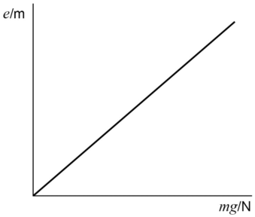

**PRACTICAL 5**

|  |  |  |  |  |  |  |  |
| --- | --- | --- | --- | --- | --- | --- | --- |
| **Required practical** | | **Determination of the resistivity of a wire using a micrometer screw gauge, ammeter and voltmeter.** | | | | | |
| **Apparatus and techniques covered**  (Relevant apparatus only, not full statements) | | a. use appropriate analogue apparatus to record a range of measurements (to include length/distance)  b. use appropriate digital instruments, including electrical multimeters, to obtain a range of measurements (to include current, voltage, resistance)  e. use micrometers for small distances, using digital or vernier scales  f. correctly construct circuits from circuit diagrams using DC power supplies, cells, and a range of circuit components  g. design, construct and check circuits using DC power supplies, cells, and a range of circuit components | | | | | |
| **Indicative apparatus** | | DC power supply or cells, rheostat/potential divider (or other means of adjusting current/pd), connecting leads, micrometer screw gauge, metre ruler, ammeter, voltmeter, selection of different swg resistance wire (eg constantan wire). | | | | | |
|  | **Amount of choice**  **Increasing independence** | | | | | | |
|  | Least choice | | Some choice | | Many choices | Full investigation | |
| Teacher gives students a full method with clear instructions/circuit diagram as to how to set up the circuit. All instruments, including ranges, are specified and students are instructed as to suitable lengths/gauges of resistance wire to use. | | Teacher allows a limited choice of lengths/gauges of resistance wire to use, and also allows students to choose an appropriate instrument to measure the diameter of the wire(s). Other details of experiment fully specified. | | Teacher suggests outline method to determine resistivity by measuring resistance of wire but does not provide a circuit diagram. Students decide on instruments (and ranges), and the gauge and length of resistance wire used after preliminary experiment. | Teacher suggests link between resistance and dimensions of a metal.  Student makes full decision about methodology, equipment and materials. All choices are fully justified with reference to experimental errors and safety. | |
| **Opportunities for observation and assessment of competencies** | | | | | | | |
| Follow written procedures | **🗸🗸🗸** Students follow written method. | | | **🗸🗸🗸** Students follow written method. | **🗸🗸🗸** Students follow a method they have chosen. | | **🗸🗸🗸** Students follow a method they have researched. |

|  |  |  |  |  |
| --- | --- | --- | --- | --- |
| Applies investigative approaches and methods when using instruments and equipment | **🗸** Students correctly use the equipment and materials with minimum assistance and prompting. | **🗸🗸**Students correctly use the equipment, carry out procedures methodically and make adjustments when necessary. | **🗸🗸🗸** Students select and correctly use the equipment, carry out procedures methodically and identify and control quantitative variables. | **🗸🗸🗸** Student must choose an appropriate approach, equipment and techniques, identify quantitative variables for measurement and control. |
| Safely uses a range of practical equipment and materials | **🗸** Students must safely use the equipment following advice given. | **🗸🗸** Students must safely use the equipment with minimal prompting. | **🗸🗸🗸**Students minimise risks in all aspects of the experiment with no prompting. | **🗸🗸🗸** Students must carry out a full risk assessment and minimise risks. |
| Makes and records observations | **🗸🗸** Students record observations as specified in the method, and record in a methodical way using appropriate units and conventions. | **🗸🗸🗸** Students obtain accurate, precise and sufficient data and records this methodically using appropriate units and conventions. | **🗸🗸🗸** Students obtain accurate, precise and sufficient data and records this methodically using appropriate units and conventions. | **🗸🗸🗸** Students obtain accurate, precise and sufficient data and records this methodically using appropriate units and conventions. |
| Researches, references and reports | **🗸** Students process data in prescribed way and compare results with expected values. | **🗸🗸**Students process data in prescribed way and compare results with expected values identifying potential discrepancies and errors. | **🗸🗸** Students identify appropriate methods/tools to process data and compare with expected values, identifying potential discrepancies and errors. | **🗸🗸🗸** Students identify appropriate methods to process data, carry out research and report findings. Sources of information are cited together with supporting planning and conclusions. |

🗸🗸🗸: Very good opportunity 🗸🗸: Good opportunity 🗸: Slight opportunity 🗶: No opportunity

**A-level Physics required practical No 5**

**Determination of resistivity of a wire using a micrometer, ammeter and voltmeter**

NB This worksheet gives full details of the experiment, primarily for use by teachers and technicians who may be unfamiliar with the experiment. The worksheet would normally be adapted for student use to provide opportunity for students to make procedural decisions.

**Materials and equipment**

* 1 metre length of constantan wire of thickness 0.25 mm, for example
* low voltage variable DC supply (eg 0–6 V)
* ammeter (eg 0–1 A with 0.02 A precision or better)
* voltmeter (eg 0–5 V with 0.1 V precision or better)
* two crocodile clips
* five connecting leads
* metre ruler
* micrometer.

**Technical information**

* The constantan wire should be free from kinks and held as straight as possible when measuring the length.
* The thickness of 0.25 mm has been suggested as this is sufficiently large to measure accurately with the micrometer.
* A 10 cm length of it will have a resistance of around 1 Ω, which will allow a reasonably accurate determination of its resistance.

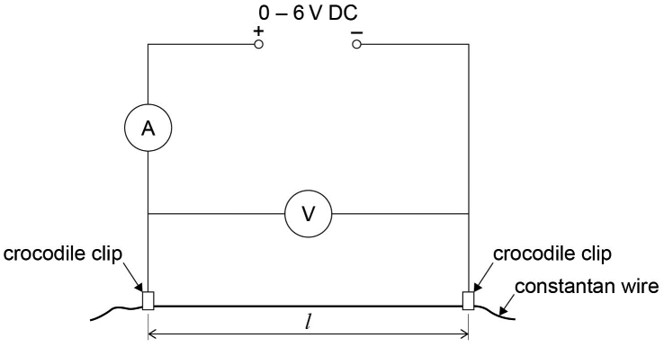

**Method**

* Measure the thickness of the constantan wire using the micrometer in at least 3 places and find the mean diameter *d*. Convert this to metres.
* Set up the apparatus as shown in the diagram.
* Attach the crocodile clips so that *l* = 0.100 m measured on the meter ruler.
* Set the voltage, *V*, to 0.5 V and measure the current, *I* in A.
* Calculate the resistance *R* = *V*/*I* in Ω
* Repeat the procedure for *l* = 0.200, 0.300, 0.400, 0.500, 0.600, 0.700 and 0.800 m, increasing *V* by *0.5 V* each time to maintain the current at about 0.5 A. (This will allow a reasonably accurate measurement of the current, without it being so large that the wire is warmed, which may change its resistance. Switching off the power supply between readings will also keep any heating to a minimum.)
* Obtain a second set of results by repeating the experiment and find the mean value of *R* for each value of *l*.
* Plot a graph of the mean *R* against *l*.
* Draw the best straight line of fit though the points and find the gradient (the graph should be a straight line through the origin).
* Calculate the cross-sectional area of the wire *A* = π*d*2/4 in m2.

The resistivity of constantan is then

$$\text{ρ= }\frac{\text{RA}}{\text{L}}$$

The gradient of the graph gives *R*/*l* so

*ρ* = gradient × *A* in Ωm (the accepted value is 4.9 × 10–7 Ωm).

**PRACTICAL 6**

|  |  |  |  |  |  |
| --- | --- | --- | --- | --- | --- |
| **Required practical** | | **Investigation of emf and internal resistance of electric cells and batteries by measuring the variation of the terminal pd of the cell with current in it** | | | |
| **Apparatus and techniques covered**  (Relevant apparatus only, not full statements) | | b. use of digital instruments, including ammeters, voltmeters and/or electrical multimeters  f. correctly construct circuits from circuit diagrams using DC power supplies, cells and a range of circuit components, including those where polarity is important  g. design, construct and check circuits using DC power supplies, cells, and a range of circuit components | | | |
| **Indicative apparatus** | | Selection of cells with cell holders, variable resistor (or selection of fixed resistors), digital ammeter, digital voltmeter (or digital multimeter for measurement of current and/or pd), connecting leads, switch (or alternative method of disconnecting the circuit). | | | |
|  | **Amount of choice**  **Increasing independence** | | | | |
|  | Least choice | | Some choice | Many choices | Full investigation |
| Teacher gives students a full method with circuit diagram and clear instructions as to how to set up the apparatus. All instruments and measurements are specified and students are instructed on the exact procedure and safety precautions. | | Teacher allows students limited choice of range of current/pd readings.  Otherwise circuit diagram is provided and all procedural techniques are specified. | Teacher suggests outline method, by investigating variation of pd across a cell/battery with current through it, but does not provide a circuit diagram.  Students decide on most appropriate measuring instruments, ranges and resistor values, after preliminary experiment. | Teacher suggests general line of enquiry at the end of a piece of work where the student has had the opportunity to investigate, design and make measurements in a variety of other dc circuits.  Student makes full decision about methodology, equipment and materials. All choices are fully justified with reference to experimental errors and safety. |
| **Opportunities for observation and assessment of competencies** | | | | | |
| Follow written procedures | **🗸🗸🗸** Students follow written method. | | **🗸🗸🗸** Students follow written method. | **🗸🗸🗸** Students follow a method they have chosen. | **🗸🗸🗸** Students follow a method they have researched. |

|  |  |  |  |  |
| --- | --- | --- | --- | --- |
| Applies investigative approaches and methods when using instruments and equipment | **🗸** Students correctly use the equipment and materials with minimum assistance and prompting. | **🗸🗸** Students correctly use the equipment, carry out procedures methodically and make adjustments when necessary. | **🗸🗸🗸** Students select and correctly use the equipment, carry out procedures methodically and identify and control quantitative variables. | **🗸🗸🗸** Student must choose an appropriate approach, equipment and techniques, identify quantitative variables for measurement and control. |
| Safely uses a range of practical equipment and materials | **🗸** Students must safely use the equipment following advice given. | **🗸🗸** Students must safely use the equipment with minimal prompting. | **🗸🗸🗸** Students minimise risks in all aspects of the investigation with no prompting. | **🗸🗸🗸** Students must carry out a full risk assessment and minimise risks. |
| Makes and records observations | **🗸🗸** Students record observations as specified in the method, and record in a methodical way using appropriate units and conventions. | **🗸🗸🗸** Students obtain accurate, precise and sufficient data and records this methodically using appropriate units and conventions. | **🗸🗸🗸** Students obtain accurate, precise and sufficient data and records this methodically using appropriate units and conventions. | **🗸🗸🗸** Students obtain accurate, precise and sufficient data and records this methodically using appropriate units and conventions. |
| Researches, references and reports | **🗸** Students process data in prescribed way and compare results with expected relationships. | **🗸🗸**Students process data in prescribed way and compare results with expected relationships identifying potential discrepancies and errors. | **🗸🗸** Students identify appropriate methods/tools to process data and compare with expected relationships, identifying potential errors and limitations. | **🗸🗸🗸** Students identify appropriate methods to process data, carry out research and report findings. Sources of information are cited together with supporting planning and conclusions. |

🗸🗸🗸: Very good opportunity 🗸🗸: Good opportunity 🗸: Slight opportunity 🗶: No opportunity

**A-level Physics required practical No 6**

**Investigation of the emf and internal resistance of electric cells and batteries**

NB This worksheet gives full details of the experiment, primarily for use by teachers and technicians who may be unfamiliar with the experiment. The worksheet would normally be adapted for student use to provide opportunity for students to make procedural decisions.

**Materials and equipment**

* cell or battery whose internal emf and internal resistance is being investigated. Avoid using rechargeable cells or batteries as these have a very low internal resistance, making it difficult to measure and they can deliver high currents on short circuit
* Cell holder (or suitable connectors for cell/battery used)
* variable resistor (eg a large wire wound rheostat is suitable)
* digital voltmeter (eg 0–10 V)
* digital ammeter (eg 0–1 A)
* switch
* connecting leads.

**Technical information**

* Ideally the cells and/or batteries used should be fairly new. The emf and internal resistance of older, ‘run down’, cells will vary during the experiment. It is advisable to switch off the circuit between readings to avoid the cells/batteries running down.
* Ensure that the power rating of the variable resistor is adequate for the maximum current used.

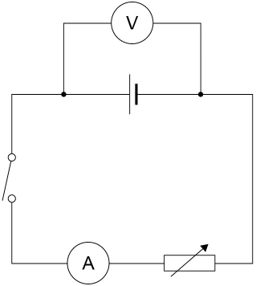

**Method**

* Set up the circuit as shown in the diagram. Set the variable resistor at its maximum value.
* With the switch open record the reading, V, on the voltmeter.
* Close the switch and take the readings of pd, V, on the voltmeter and current, I, on the ammeter.
* Adjust the variable resistor to obtain pairs of readings of V and I, over the widest possible range.
* Open the switch after each pair of readings. Only close it for sufficient time to take each pair of readings.
* Plot a graph of *V* on the y-axis against *I.*

Using *ε = I (R+r)* and *V = I R*

Gives *ε = V+I r*

Rearranging *V = ε–I r*

A graph of *V* against *I* will have a gradient = - *r* and an intercept *ε* on the *y*-axis

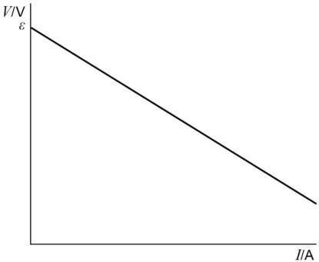

**PRACTICAL 7**

|  |  |  |  |  |  |
| --- | --- | --- | --- | --- | --- |
| **Required practical** | | **Investigation into simple harmonic motion using a mass-spring system and a simple pendulum** | | | |
| **Apparatus and techniques covered**  (Relevant apparatus only, not full statements) | | a. use appropriate analogue apparatus to record a range of measurements (to include length/distance)  b. use appropriate digital instruments to obtain a range of measurements (to include time, mass)  c. use methods to increase accuracy of measurements, such as timing over multiple oscillations and use of fiduciary marker  d. use stopwatch for timing | | | |
| **Indicative apparatus** | | **Simple pendulum:**  Pendulum bob, string/thread, stopclock, pin & Blu-Tack (as fiduciary marker), retort stand, boss, clamp, small wooden blocks (to trap the string), metre ruler.  **Mass-spring system:**  Helical spring, slotted masses and hanger, (balance to check masses), stopclock, metre ruler, set square, pin and Blu-Tack, retort stand, boss, clamp. | | | |
|  | **Amount of choice**  **Increasing independence** | | | | |
|  | Least choice | | Some choice | Many choices | Full investigation |
| Teacher gives students a full method with clear instructions as to how to set up the apparatus. All instruments and measurements are specified and students are instructed on the exact procedure and safety precautions. | | Teacher allows students choice in method of timing oscillations. All procedural techniques are specified. | Teacher suggests outline investigation- to include relationship between time period and mass for a mass-spring system, and time period and length for a simple pendulum.  Student decides on most appropriate measuring instruments and timing techniques to reduce uncertainty. | Teacher suggests general line of enquiry – to investigate factors affecting the time period of oscillations for a mass-spring system and simple pendulum.  Student makes full decision about methodology, equipment and materials. All choices are fully justified with reference to experimental errors and safety. |

|  |  |  |  |  |
| --- | --- | --- | --- | --- |
| **Opportunities for observation and assessment of competencies** | | | | |
| Follow written procedures | **🗸🗸🗸** Students follow written method. | **🗸🗸🗸** Students follow written method. | **🗸🗸🗸** Students follow a method they have chosen. | **🗸🗸🗸** Students follow a method they have researched. |
| Applies investigative approaches and methods when using instruments and equipment | **🗸** Students correctly use the equipment and materials with minimum assistance and prompting. | **🗸🗸** Students correctly use the equipment, carry out procedures methodically and make adjustments when necessary. | **🗸🗸🗸** Students select and correctly use the equipment, carry out procedures methodically and identify and control quantitative variables. | **🗸🗸🗸** Student must choose an appropriate approach, equipment and techniques, identify quantitative variables for measurement and control. |
| Safely uses a range of practical equipment and materials | **🗸** Students must safely use the equipment following advice given. | **🗸🗸** Students must safely use the equipment with minimal prompting. | **🗸🗸🗸** Students minimise risks in all aspects of the investigation with no prompting. | **🗸🗸🗸** Students must carry out a full risk assessment and minimise risks. |
| Makes and records observations | **🗸🗸** Students record observations as specified in the method, and record in a methodical way using appropriate units and conventions. | **🗸🗸🗸** Students obtain accurate, precise and sufficient data and records this methodically using appropriate units and conventions. | **🗸🗸🗸** Students obtain accurate, precise and sufficient data and records this methodically using appropriate units and conventions. | **🗸🗸🗸** Students obtain accurate, precise and sufficient data and records this methodically using appropriate units and conventions. |
| Researches, references and reports | **🗸** Students process data in prescribed way and compare results with expected relationships. | **🗸🗸** Students process data in prescribed way and compare results with expected relationships identifying potential discrepancies and errors. | **🗸🗸🗸** Students identify appropriate methods/tools to process data and compare with expected relationships, identifying potential errors | **🗸🗸🗸** Students identify appropriate methods to process data, carry out research and report findings. Sources of information are cited together with supporting planning and conclusions. |

🗸🗸🗸: Very good opportunity 🗸🗸: Good opportunity 🗸: Slight opportunity 🗶: No opportunity

**A-level Physics required practical No 7**

**Investigation into simple harmonic motion using a mass-spring system and a simple pendulum**

NB This worksheet gives full details of the experiment, primarily for use by teachers and technicians who may be unfamiliar with the experiment. The worksheet would normally be adapted for student use to provide opportunity for students to make procedural decisions.

**Simple pendulum to investigate how the time period varies with length and to measure *g***

**Materials and equipment**

* pendulum bob
* approximately 1.5 m string or thread
* two small wooden blocks to clamp the string
* stand, boss and clamp
* pin and Blu-Tack to use as fiducial mark
* metre ruler
* stopclock (reading to 0,01 s)

**Technical information**

This is a standard laboratory experiment which can be used to give an accurate value for the acceleration due to gravity. For accurate results it is important the pendulum oscillates with small amplitude and in a straight line.

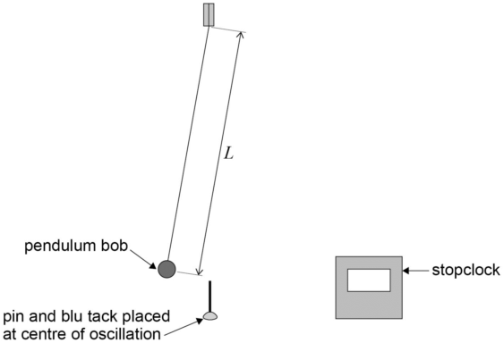

**Method**

* Attach the pendulum bob to the string and clamp it between two small wooden blocks.
* Measure the length, *L*, of the pendulum from the point of suspension to the centre of mass of the pendulum bob. (It might be easier to measure to the top of the pendulum bob and then add on the radius of the bob to give *L.*)
* The pendulum should be suspended from the stand as shown, with a pin and Blu-Tack acting as a fiducial marker, placed immediately below the pendulum bob. This will be at the centre of the oscillation when the pendulum oscillates.
* Carefully pull the pendulum bob to the side and release it. The pendulum should oscillate with **small amplitude and in a straight line**. Check that it continues in a straight line by viewing the oscillation from the side – if not stop it and start the oscillation again.
* Determine the time period of the simple pendulum by timing 10 complete oscillations.
* Take repeat readings of the time for 10 oscillations, *T*10.
* Change the length of the pendulum and repeat the process to determine the time period.
* Determine the time period of the pendulum for at least seven different lengths, *L.*
* Tabulate your data, including columns for *L*, *T*10, repeat values of *T*10, mean value of *T*10, time period for one oscillation *T*, and an additional column for *T*2.
* Plot a graph of *T*2 on the *y*-axis against *L*. A straight line through the origin verifies that *T*2 is proportional to *L*.
* Measure the gradient of the graph and use it to determine a value for the acceleration due to gravity, *g*.
* Estimate the uncertainty in your values of *L* and *T*. Hence estimate the uncertainty in the value of *g*.

Simple Pendulum

$$\text{T = 2π }\sqrt{\frac{\text{l}}{\text{g}}}$$

gives $T^{2}= \frac{4π2L}{G}$ hence $\text{g}\text{ = }\frac{\text{4}{\text{π}}^{\text{2}} }{\text{gradient}}$

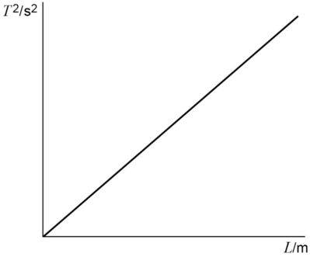

**Mass-spring system**

**Materials and equipment**

* helical spring
* 100 g slotted mass hanger
* 100 g slotted masses
* stand, boss and clamp
* pin and Blu-Tack to use as fiducial mark
* metre ruler
* stopclock (reading to 0,01 s)

**Technical information**

Expendable springs (with *k* approximately 25 Nm–1) are suitable for this experiment, together with a range of slotted masses from 0–800 g.

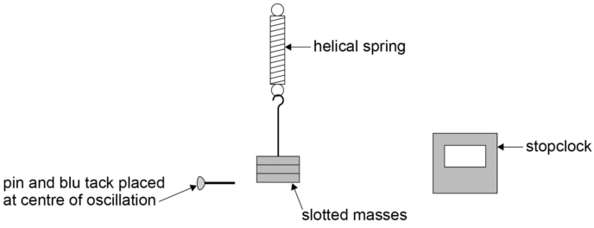

**Method**

* Hang the spring from a clamp and attach the 100 g mass hanger. Ensure the spring is securely attached from its support.
* Position the Blu-Tack and pin, acting as a fiducial marker, at the bottom of the mass as a reference point. This will represent the centre of the subsequent oscillations.
* Pull the mass hanger vertically downwards a few centimetres and release. The spring should oscillate vertically up and down.
* Determine the time period of the mass-spring system by timing 10 complete oscillations.
* Take repeat readings of the time for 10 oscillations, *T*10. Use the values of *T*10 to find the time period for one oscillation, *T*.
* Add a 100 g mass to the mass hanger and repeat the timing process to enable the time period of the oscillations to be found.
* Repeat the experiment with a range of different masses, *m*, and for each mass determine the corresponding time period, *T*.
* Plot a graph of *T*2 on the *y*-axis against *m.*
* A straight line through the origin will confirm the relationship between *T* and *m* predicted by SHM theory ie $T^{2}\text{= }\frac{4π^{2 }m}{k}$ where *k* is the spring constant or stiffness of the spring.
* The gradient of the graph can be used to determine *k*

${\text{T}}^{\text{2}}\text{= }\frac{\text{4}{\text{π}}^{\text{2 }}\text{m}}{\text{k}}$ hence $\text{k}\text{= }\frac{\text{4}{\text{π}}^{\text{2}} }{\text{gradient}}$

* Estimate the uncertainty in *T* and *m*. Hence find the uncertainty in *k*.

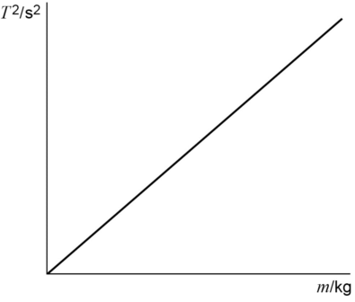

**PRACTICAL 8**

|  |  |  |  |  |  |  |
| --- | --- | --- | --- | --- | --- | --- |
| **Required practical** | | | **Investigation of Boyle’s (constant temperature) law and Charles’s (constant pressure) law for a gas** | | | |
| Apparatus and techniques covered (Relevant apparatus only, not full statements) | | | a. use appropriate analogue apparatus to record a range of measurements (to include length/distance, temperature, pressure) | | | |
| Indicative apparatus | | | **Boyle’s law:**  ‘Boyle’s law apparatus’ (wide bore glass tube, sealed at one end with air trapped by coloured oil. Scale mounted at the side of the tube and integral bourdon gauge), bicycle pump or foot pump.  **Charles’s law:**  Capillary tube approximately 200 mm long, sealed at one end and containing air trapped by a small ‘thread/length’ of concentrated sulfuric acid. The capillary tube is attached to a mm scale. Thermometer, stirrer, beaker, method of heating water in the beaker (eg Bunsen burner, tripod and gauze). | | | |
|  | Amount of choice  Increasing independence | | | | | |
|  | Least choice | | | Some choice | Many choices | Full investigation |
| Teacher gives students a full method with clear instructions as to how to set up the apparatus. All instruments and measurements are specified and students are instructed on the exact procedure and safety precautions. | | | Teacher allows students limited choice in identification and control of variables and range of readings. Otherwise all procedural techniques are specified. | Teacher indicates general method of investigating relationship between pressure and volume for a fixed mass of gas at constant temperature **and** between volume and temperature for a fixed mass of gas at constant pressure.  Student decides on measurement techniques with guidance from teacher on suitable apparatus. | Teacher suggests general line of enquiry – to investigate the relationship between volume, pressure and temperature for a gas. Student decides on methodology and appropriate equipment and materials, with some guidance as to available apparatus. All choices are justified with reference to experimental errors and safety. |
| Opportunities for observation and assessment of competencies | | | | | | |
| Follow written procedures | | **🗸🗸🗸** Students follow written method. | | **🗸🗸🗸** Students follow written method. | **🗸🗸🗸** Students follow a method they have chosen. | **🗸🗸🗸** Students follow a method they have researched. |
| Applies investigative approaches and methods when using instruments and equipment | | **🗸** Students correctly use the equipment and materials with minimum assistance and prompting. | | **🗸🗸** Students correctly use the equipment, carry out procedures methodically and make adjustments when necessary. | **🗸🗸** Students correctly use the equipment, carry out procedures methodically and identify and control quantitative variables. | **🗸🗸🗸** Student must choose an appropriate approach, equipment and techniques, identify quantitative variables for measurement and control. |
| Safely uses a range of practical equipment and materials | | **🗸** Students must safely use the equipment following advice given. | | **🗸🗸** Students must safely use the equipment with minimal prompting. | **🗸🗸🗸** Students minimise risks in all aspects of the investigation with no prompting. | **🗸🗸🗸** Students must carry out a full risk assessment and minimise risks. |
| Makes and records observations | | **🗸🗸** Students record observations as specified in the method, and record in a methodical way using appropriate units and conventions. | | **🗸🗸🗸** Students obtain accurate, precise and sufficient data and records this methodically using appropriate units and conventions. | **🗸🗸🗸** Students obtain accurate, precise and sufficient data and records this methodically using appropriate units and conventions. | **🗸🗸🗸** Students obtain accurate, precise and sufficient data and records this methodically using appropriate units and conventions. |
| Researches, references and reports | | **🗸** Students process data in prescribed way and compare results with expected relationships. | | **🗸🗸**Students process data in prescribed way and compare results with expected relationships identifying potential discrepancies and errors. | **🗸🗸🗸** Students identify appropriate methods/tools to process data and compare with expected relationships, identifying potential errors and limitations. | **🗸🗸🗸** Students identify appropriate methods to process data, carry out research and report findings. Sources of information are cited together with supporting planning and conclusions. |

🗸🗸🗸: Very good opportunity 🗸🗸: Good opportunity 🗸: Slight opportunity 🗶: No opportunity

**A-level Physics required practical No 8**

**Investigation of Boyle’s (constant temperature) law and Charles’s (constant pressure) law for a gas**

NB This worksheet gives full details of the experiments, primarily for use by teachers and technicians who may be unfamiliar with the experiment. The worksheet would normally be adapted for student use to provide opportunity for students to make procedural decisions.

**Boyle’s law**

**Materials and equipment**

* stand and clamp
* 10 ml syringe with 0.5 ml divisions
* 5 cm length of thin-walled rubber or silicone tubing to fit nozzle of syringe
* pinch clip
* 2 kg mass
* loop of string
* 9 × 100 g masses on a 100 g mass holder
* micrometer.

**Technical information**

* The syringe should be the type with a rubber seal on the plunger which is less likely to stick. The type with an O ring seal on the end of the plunger are better, and tend to stick less than the type where the end of the piston is made of solid rubber.
* The rubber tubing should fit tightly onto the nozzle of the syringe. It can then be folded over and clamped with the pinch clip to produce an airtight seal.
* The clip should be as close as possible to the nozzle. There will be a little air in the nozzle, but this has negligible volume compared to the volume of air in the barrel of the syringe.
* A loop of string should be tied to the end of the plunger so that the mass holder can be hung on it.
* The 2 kg mass is used as a counterweight to ensure the stand does not topple over (an alternative would be to clamp the stand to the bench using a G-clamp).

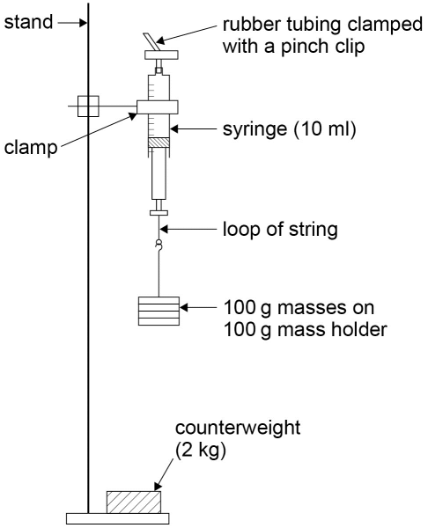

**Method**

* Remove the plunger from the syringe and measure the diameter of the rubber seal, *d*, using the micrometer. Convert this into metres.
* Calculate the cross-sectional area of the seal *A* = π*d*2/4 in m2.
* Replace the plunger and draw in 4.0 ml of air.
* Fit the rubber tubing over the nozzle, fold the tubing over and clamp it with the pinch clip as close to the nozzle as possible.
* Set up the apparatus as shown in the diagram initially with the 100 g mass holder carrying one 100 g mass. Ensure that the string is securely attached to the plunger handle. The clamp should be above the plunger so that the scale can be read. Clamping the syringe barrel can distort it, making it more difficult for the plunger to move freely. Consequently ensure the clamp is high enough on the barrel above the position where the plunger moves. There should be sufficient room below the masses so that the plunger can move down as masses are added.
* Gently move the plunger up and down a few millimetres to ensure it is not sticking.
* Read the new volume on the syringe scale (fractions of a division should be estimated).
* Repeat the procedure with an extra two 100 g masses added to the holder each time, up to a total mass of 1000 g.
* The whole experiment should then be repeated to obtain a second set of results, and the mean volumes found.
* The force exerted by the masses can be calculated using $\text{F = mg}$ where *m* is the mass in kg and *g*, the gravitational field strength, is 9.81 Nkg–1.
* The pressure exerted by this force on the air sample is then *F*/*A* in Pascals (Pa). Convert this into kPa.
* This should be subtracted from standard atmospheric pressure, 101 kPa, to obtain the pressure of the air sample, *P*. (Note: the initial volume of the air with no masses hung on the loop will be at standard atmospheric pressure).
* A graph of 1/*V* against *P* should then be plotted (where *V* is the mean volume of the air sample for each value of *P*).
* Provided care has been taken to ensure the plunger does not stick, a reasonable straight line through the origin should be obtained. (Any slight sticking could result in a graph which curves slightly and/or does not pass through the origin.)

**Charles’s law**

**Materials and equipment**

* 25 cm length of glass capillary tubing (eg outer diameter 5 mm and bore 1 mm, but other sizes will work perfectly well)
* 5 cm length of thin-walled rubber tubing to fit over the end of the capillary tubing
* contact adhesive
* concentrated sulfuric acid
* 30 cm ruler
* 2 elastic bands
* thermometer (eg –10 to 110 °C)
* 2 litre beaker
* 250 ml glass beaker
* paper towels
* kettle.

**Technical information**

As concentrated sulfuric acid is being used, safety spectacles or goggles must be worn. Lab coats and gloves could also be worn. The technician should prepare the capillary tubing with a small drop of concentrated sulfuric acid about half way down its length, with the lower end sealed using contact adhesive. This can be achieved as follows:

* Pour a little concentrated sulfuric acid into a 250 ml glass beaker.
* Attach the length of rubber tubing to one end of the capillary tubing.
* Place the other end into the acid.
* Pinch the rubber tubing, then place a finger over the end and release the tubing to draw a drop of acid into the capillary tube.
* Remove the capillary tube from the acid, and use the same pinch and release technique to move the drop of acid to about half way along the tube.
* Holding the capillary tube horizontally, remove the rubber tubing from the end, and apply a small amount of adhesive to this end of the capillary tubing (see diagram below).
* Using a paper towel, wipe off any surplus acid from the other end of the capillary tubing.
* Leave the tube for the contact adhesive to dry.
* Attach the capillary tubing to a 30 cm ruler using the elastic bands, with the end sealed with contact adhesive at the zero mark.
* The drop of concentrated sulfuric acid will dry the air as well as trap the sample of air in the capillary tubing.

The method suggests adding hot water to the beaker and allowing it to cool to produce the required variation in temperature. This is safer than heating a large beaker of water using a Bunsen and tripod. If a plastic 30 cm ruler is used, the boiled water should be allowed to cool a little before pouring it into the beaker in order to avoid the plastic softening. Students must be told that the apparatus contains concentrated sulfuric acid, and to treat it with care. If dropped or broken it should be reported immediately, and cleared up by someone wearing safety goggles.

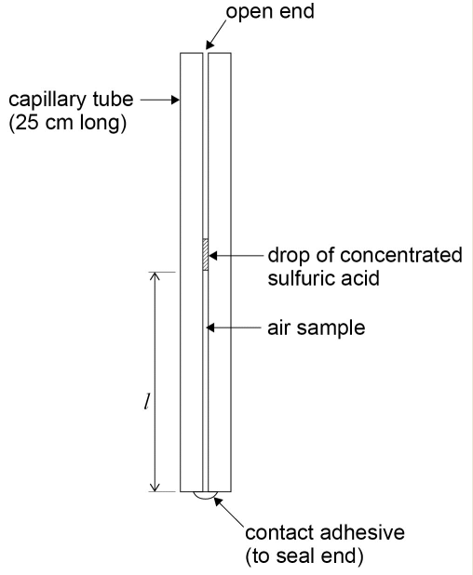

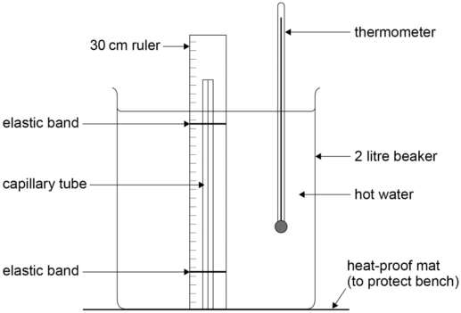

**Method**

* Set up the apparatus as shown in the diagram on page 99 with the open end of the capillary tube at the top. Allow the boiled water from the kettle to cool a little before pouring it into the beaker. The hot water should cover the air sample.
* Stir the water well using the thermometer, read the value of its temperature, *θ*, and the length of the air sample, *l*, on the 30 cm ruler (see diagram above).
* Allow the water to cool by 5 °C and repeat the procedure until room temperature has been reached. (The cooling process can be speeded up by pouring a little water out of the beaker and topping it up with cold water.)
* Plot a graph of *l* against *θ*. Start the axes at a convenient value, and use a scale which will give a spread of points over at least half the graph paper in both directions.
* Draw the best straight line of fit though the points and find the gradient, *m*.
* The form of the graph is *l* = *mθ* + *c*, where *c* is the value of *l* when *θ* = 0°C.
* The value of *c* can be found by reading a pair of values for length and temperature for a point on the straight line (*l*1 and *θ*1, say). Then *c* = *l*1 - *mθ*1.
* An estimate of the value of absolute zero, *θ*0, can then be found by substituting *l* = 0 into the equation for the form of the graph: 0 = *mθ*0 + *c* so *θ*0 = -*c*/*m*.

**PRACTICAL 9**

|  |  |  |  |  |  |  |  |
| --- | --- | --- | --- | --- | --- | --- | --- |
| **Required practical** | | **Investigation of the charge and discharge of capacitors** | | | | | |
| **Apparatus and techniques covered**  (Relevant apparatus only, not full statements) | | b. use appropriate digital instruments, including electrical multimeters, to obtain a range of measurements (to include time, voltage)  d. use stopwatch for timing  f. correctly construct circuits from circuit diagrams using DC power supplies, cells, and a range of circuit components, including those where polarity is important  g. design, construct and check circuits using DC power supplies, cells, and a range of circuit components | | | | | |
| **Indicative apparatus** | | DC power supply or cells, selection of electrolytic capacitors, selection of fixed resistors, digital voltmeter or multimeter, stopclock, connecting leads. | | | | | |
|  | **Amount of choice**  **Increasing independence** | | | | | | |
|  | Least choice | | Some choice | | Many choices | Full investigation | |
| Teacher gives students a full method with clear instructions/circuit diagram as to how to set up the circuit. All instruments including ranges, are given and all details of the experiment are fully specified. | | Student has limited choice in instruments and range of readings - eg voltage readings and time intervals. Resistor and Capacitor values are suggested, and all other aspects of the investigation are fully specified. | | Teacher suggests outline method to investigate charging and discharging of capacitors.  Students decide on control of variables instruments, ranges and component values after preliminary experiments. | Teacher poses problem - to investigate how the time taken in charging and discharging a capacitor through a resistor is related to capacitance and resistance.  Student makes full decision about methodology, equipment and materials. All choices are fully justified with reference to experimental errors and safety. | |
| **Opportunities for observation and assessment of competencies** | | | | | | | |
| Follow written procedures | **🗸🗸🗸** Students follow written method. | | | **🗸🗸🗸** Students follow written method. | **🗸🗸🗸** Students follow a method they have chosen. | | **🗸🗸🗸** Students follow a method they have researched. |

|  |  |  |  |  |
| --- | --- | --- | --- | --- |
| Applies investigative approaches and methods when using instruments and equipment | **🗸** Students correctly use the equipment and materials with minimum assistance and prompting. | **🗸🗸** Students correctly use the equipment, carry out procedures methodically and make adjustments when necessary. | **🗸🗸** Students select and correctly use the equipment, carry out procedures methodically and identify and control quantitative variables. | **🗸🗸🗸** Student must choose an appropriate approach, equipment and techniques, identify quantitative variables for measurement and control. |
| Safely uses a range of practical equipment and materials | **🗸** Students must safely use the equipment following advice given. | **🗸🗸** Students must safely use the equipment with minimal prompting. | **🗸🗸🗸**Students minimise risks in all aspects of the experiment with no prompting. | **🗸🗸🗸** Students must carry out a full risk assessment and minimise risks. |
| Makes and records observations | **🗸🗸** Students record observations as specified in the method, and record in a methodical way using appropriate units and conventions. | **🗸🗸🗸** Students obtain accurate, precise and sufficient data and records this methodically using appropriate units and conventions. | **🗸🗸🗸** Students obtain accurate, precise and sufficient data and records this methodically using appropriate units and conventions. | **🗸🗸🗸** Students obtain accurate, precise and sufficient data and records this methodically using appropriate units and conventions. |
| Researches, references and reports | **🗸** Students process data in prescribed way and compare results with expected values. | **🗸🗸**Students process data in prescribed way and compare results with expected values identifying potential discrepancies and errors. | **🗸🗸🗸**Students identify appropriate methods/tools to process data and compare with expected values, identifying potential discrepancies and errors. | **🗸🗸🗸** Students identify appropriate methods to process data, carry out research and report findings. Sources of information are cited together with supporting planning and conclusions. |

🗸🗸🗸: Very good opportunity 🗸🗸: Good opportunity 🗸: Slight opportunity 🗶: No opportunity

**A-level Physics required practical No 9**

**Investigation of the charge and discharge of capacitors**

NB This worksheet gives full details of the experiment, primarily for use by teachers and technicians who may be unfamiliar with the experiment. The worksheet would normally be adapted for student use to provide opportunity for students to make procedural decisions.

**Materials and equipment**

* stopclock
* electrolytic capacitors (suitable values: 1000 µF, 2200 µF, 4700 µF)
* resistors (0.25 W carbon film, values in the range 10 kΩ to 100 kΩ)
* battery 3 V, 6 V or 9 V
* digital voltmeter, range 0–10 V
* SPDT (single pole double throw) switch
* connecting leads.

**Technical information**

* It is essential that the electrolytic capacitors are connected into the circuit with **correct polarity,** as indicated on the capacitor body. The voltage rating of the capacitor should also be greater than the dc supply used.
* Resistor and capacitor values, indicated above, have been chosen to give a time constant *RC* in the range 10 s to 500 s.

**Discharging a capacitor through a resistor**

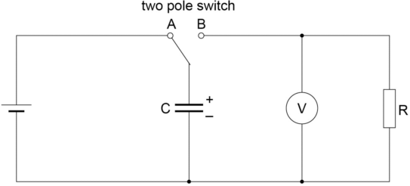

**Method**

* Set up the circuit as shown in the diagram (taking care to ensure the polarity of the capacitor is correct).
* With the two pole switch in position A the capacitor will charge. The internal resistance of the battery is usually enough to limit the charging current to a safe value, but allowing the capacitor to charge up almost instantly.
* The switch should now be moved to position B so that the capacitor, C, will discharge through the resistor, R. (It is well worth doing a ‘trial discharge’ at this point, to see how quick the discharge is so that a suitable time interval can be decided when taking voltage readings during the discharge process).
* After the ‘trial discharge’ move the switch to position A to charge up the capacitor.
* Switch to position B, start the stopclock, and observe and record the voltage reading at time

t = 0. Continue to take voltage readings at 5 s intervals as the capacitor discharges. (For a slower discharge, voltage readings at 10 s intervals will be sufficient).

* Repeat the process with the same capacitor and different resistors.
* The process can also be repeated with different capacitors.
* Plot a graph of pd across the capacitor, *V*, on the *y*-axis against time, *t*. This should give an exponential decay curve, as given by the equation $\text{V = }{\text{V}}_{\text{0}}{\text{e}}^{\text{–t/RC}}$
* To confirm that this is an exponential, plot a graph of Ln(*V*/V) on the *y*-axis against *t*.

This will give a straight line graph with a negative gradient according to the ‘log form’ of the equation (*V)* = ln(*V*0)- *t*/*RC*

This graph will have a gradient of $\frac{\text{- 1}}{\text{RC}}$

Hence the time constant *RC* can be determined from the gradient of the graph. If *R* is known, the value of *C* can also be found.

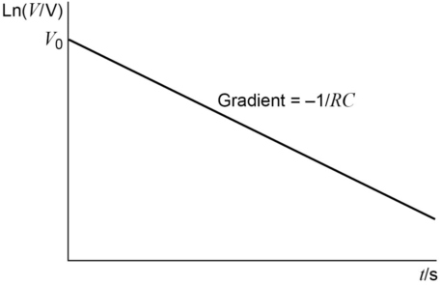

**Charging a capacitor through a resistor**

**Materials and equipment**

* stopclock
* electrolytic capacitors ( suitable values: 1000 µF, 2200 µF, 4700 µF)
* resistors (0.25 W carbon film, values in the range 10 kΩ to 100 kΩ)
* battery 3 V, 6 V or 9 V
* digital voltmeter, range 0–10 V
* SPST (single pole single throw) switch
* connecting leads.

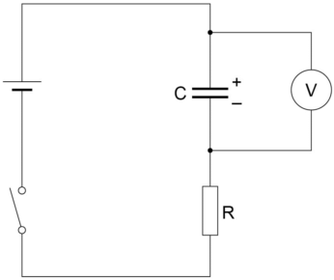

**Method**

* Set up the circuit as shown in the diagram. (Ensure the capacitor is connected with correct polarity). With the switch open and the capacitor initially uncharged, the voltmeter should read zero.
* Close the switch to start the charging process and observe and record the voltage across the capacitor at 5 s intervals (or longer time intervals if the charging process is ‘slow’).
* Repeat with different combinations of C and R. Ensure the capacitor is completely discharged before starting each new charging process
* Plot graphs of pd, *V*, on the *y*-axis against time, *t.* The graph will show an ‘exponential growth’ of pd across the capacitor as it charges as given by the equation

$$\text{V = }{\text{V}}_{\text{0}}\text{(1-}{\text{e}}^{\text{–t/RC}}\text{)}$$

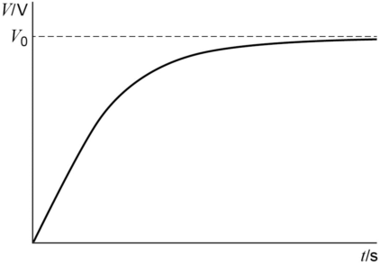

**PRACTICAL 10**

|  |  |  |  |  |  |  |  |  |  |
| --- | --- | --- | --- | --- | --- | --- | --- | --- | --- |
| **Required practical** | | | **Investigation of the relationship between the force, magnetic flux density, current and length of wire using a top pan balance** | | | | | | |
| **Apparatus and techniques covered**  (Relevant apparatus only, not full statements) | | | a. use appropriate analogue apparatus to record a range of measurements (to include length/distance)  b. use appropriate digital instruments to obtain a range of measurements (to include current, mass)  f. correctly construct circuits from circuit diagrams using DC power supplies, cells, and a range of components | | | | | | |
| **Indicative apparatus** | | | Top pan electronic balance, U-shaped mild steel yoke, 4 or 6 magnadur ‘slab’ magnets (to fit in yoke), dc power supply or battery, rheostat, ammeter, range of different length U-shaped copper wires (to place different lengths of wire in the magnetic field), connecting leads, length of wood or ruler (to attach-shaped wires), retort stand, boss and clamps. | | | | | | |
|  | | **Amount of choice**  **Increasing independence** | | | | | | | |
|  | | Least choice | | | Some choice | Many choices | | Full investigation | |
| Teacher gives students a full method with clear instructions as to how to set up the apparatus. All instruments and measurements are specified and students are instructed on the exact procedure and safety precautions. | | | Teacher specifies each aspect of the investigation but gives student some element of choice in devising a suitable circuit to produce a variable current. Otherwise all procedural techniques are specified. | Teacher indicates general method for the experiment but student decides on range of readings, control of variables and measurement techniques following a preliminary experiment. | | After an introductory piece of work where student has had experience of the ‘motor’ effect and associated techniques, teacher sets task: to investigate how the force on a current carrying conductor in a magnetic field varies with current, magnetic flux density and length of wire.  Student decides on methodology and appropriate equipment and materials. All choices are justified with reference to experimental errors and safety. | |
| **Opportunities for observation and assessment of competencies** | | | | | | | | | |
| Follow written procedures | **🗸🗸🗸** Students follow written method. | | | **🗸🗸🗸** Students follow written method. | | | **🗸🗸🗸** Students follow a method they have chosen. | | **🗸🗸🗸** Students follow a method they have researched. |
| Applies investigative approaches and methods when using instruments and equipment | **🗸** Students correctly use the equipment and materials with minimum assistance and prompting. | | | **🗸🗸** Students correctly use the equipment, carry out procedures methodically and make adjustments when necessary. | | | **🗸🗸** Students correctly use the equipment, carry out procedures methodically and identify and control quantitative variables. | | **🗸🗸🗸** Student must choose an appropriate approach, equipment and techniques, identify quantitative variables for measurement and control. |
| Safely uses a range of practical equipment and materials | **🗸** Students must safely use the equipment following advice given. | | | **🗸🗸** Students must safely use the equipment with minimal prompting. | | | **🗸🗸🗸** Students minimise risks in all aspects of the investigation with no prompting. | | **🗸🗸🗸** Students must carry out a full risk assessment and minimise risks. |
| Makes and records observations | **🗸🗸** Students record observations as specified in the method, and record in a methodical way using appropriate units and conventions. | | | **🗸🗸🗸** Students obtain accurate, precise and sufficient data and records this methodically using appropriate units and conventions. | | | **🗸🗸🗸** Students obtain accurate, precise and sufficient data and records this methodically using appropriate units and conventions. | | **🗸🗸🗸** Students obtain accurate, precise and sufficient data and records this methodically using appropriate units and conventions. |
| Researches, references and reports | **🗸** Students process data in prescribed way and compare results with expected relationships. | | | **🗸🗸**Students process data in prescribed way and compare results with expected relationships identifying potential discrepancies and errors. | | | **🗸🗸🗸** Students identify appropriate methods/tools to process data and compare with expected relationships, identifying potential errors and limitations. | | **🗸🗸🗸** Students identify appropriate methods to process data, carry out research and report findings. Sources of information are cited together with supporting planning and conclusions. |

🗸🗸🗸: Very good opportunity 🗸🗸: Good opportunity 🗸: Slight opportunity 🗶: No opportunity

**A-level Physics required practical No 10**

**Investigation of the relationship between magnetic flux density, current and length of wire using a top pan balance**

NB This worksheet gives full details of the experiment, primarily for use by teachers and technicians who may be unfamiliar with the experiment. The worksheet would normally be adapted for student use to provide opportunity for students to make procedural decisions.

**Materials and equipment**

* a 25 cm length of straight bare copper wire of thickness 1.5 mm, for example
* low voltage variable DC supply (eg 0­–6 V)
* ammeter (eg 0–10 A with 0.1 A precision or better)
* two crocodile clips
* two clamps on stands
* three connecting leads
* four magnadur magnets with a metal cradle
* an electronic top pan balance with precision 0.1 g or better
* 30 cm ruler.

**Technical information**

* High currents (up to 6 A) will flow through the wire, so care must be taken as it will get warm.
* The current and field directions shown in the diagrams will give an upward force on the wire according to Fleming’s left hand rule. However, because the wire is clamped and cannot move, there will be a downward force acting on the magnets and cradle which will cause the reading on the electronic balance to increase.

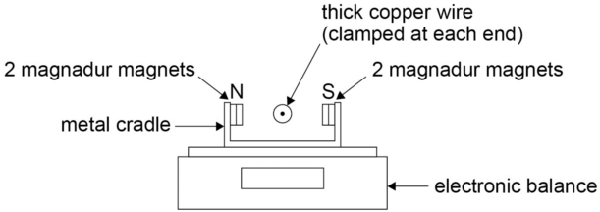

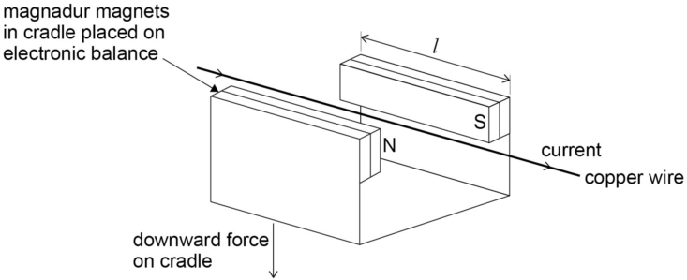

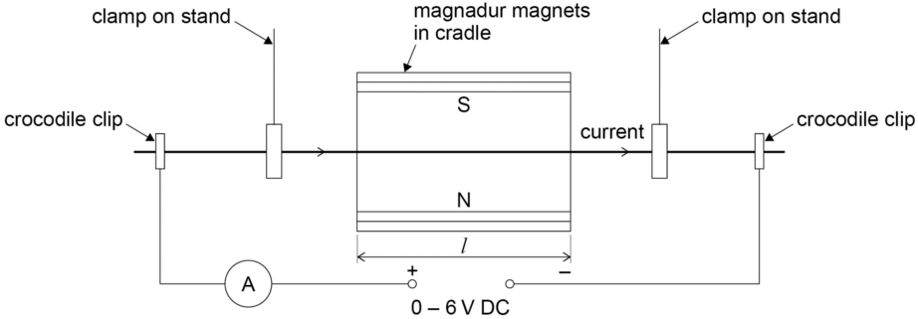

**Method**

* Set up the apparatus as shown in the diagrams (3 views of the apparatus have been given to make the arrangement clear).
* With no current flowing through the wire, the electronic balance should be set to zero.
* Adjust the voltage of the supply so that the current, *I*, flowing through the wire is 6.0 A as measured on the ammeter.
* Read the top pan balance display, *m*, in grams.
* Repeat the procedure for *I* = 5.0, 4.0, 3.0, 2.0 and 1.0 A.
* Obtain a second set of results by repeating the experiment and find the mean value of *m* for each value of *I*.
* Plot a graph of the mean *m* against *I*.
* Draw the best straight line of fit though the points and find the gradient (the graph should be a straight line through the origin).
* Measure the length of the magnadur magnets, *L,* in metres. (This will be the length of wire in the magnetic field, ignoring edge effects.)

The force on the wire is

*F* = *BIL* (where *B* is the magnetic flux density in Tesla).

*F* = *mg*/1000 (converting *m* into kg and with *g = 9.81 Nkg–1*).

Equating

*BIL* = *mg*/1000

Re-arranging

*B* = *mg*/(*I* × *L* × 1000)

The gradient of the graph gives *m*/*I*

Hence *B* = gradient × *g*/(*L* ×1000)

The value obtained for *B* is typically around *5 × 10–2 Tesla*.

**PRACTICAL 11**

|  |  |  |  |  |  |
| --- | --- | --- | --- | --- | --- |
| **Required practical** | | Investigate the effect on magnetic flux linkage by varying the angle using a search coil and oscilloscope | | | |
| **Apparatus and techniques covered**  (Relevant apparatus only, not full statements) | | a. use appropriate analogue apparatus to record a range of measurements (to include angles)  b. use appropriate digital instruments  f. correctly construct circuits from circuit diagrams using dc power supplies, cells, and a range of circuit components  h. use of oscilloscope, including volts/division | | | |
| **Indicative apparatus** | | Circular coil 15–20 cm diameter, stand or ‘holder’ for circular coil, axial or lateral search coil (to position in the centre of the circular coil), protractor, retort stand, boss and clamp (for search coil), oscilloscope, low voltage 50 Hz AC supply or AF signal generator, connecting leads. | | | |
|  | **Amount of choice**  **Increasing independence** | | | | |
|  | Least choice | | Some choice | Many choices | Full investigation |
| Teacher gives students a full method with circuit diagram and clear instructions as to how to set up the apparatus. All instruments and measurements are specified and students are instructed on the exact procedure and safety precautions. | | Teacher allows students to decide how to use the oscilloscope to measure the induced emf from the search coil, including selection of the most appropriate voltage sensitivity setting and time base.  Otherwise all other procedural techniques are specified. | Teacher suggests outline investigation - using a search coil to investigate the effect on magnetic flux linkage of varying the angle.  Student conducts preliminary experiment to decide on range of readings and refinement of techniques to vary the angle of the coil in the magnetic field and how to produce and measure the induced emf. | Teacher suggests general line of enquiry at the end of a piece of work where the student has had experience in the measurement of magnetic flux density.  Student makes full decision about methodology, equipment and materials. All choices are fully justified with reference to experimental errors and safety. |
| **Opportunities for observation and assessment of competencies** | | | | | |
| Follow written procedures | **🗸🗸🗸** Students follow written method. | | **🗸🗸🗸** Students follow written method. | **🗸🗸🗸** Students follow a method they have chosen. | **🗸🗸🗸** Students follow a method they have researched. |

|  |  |  |  |  |
| --- | --- | --- | --- | --- |
| Applies investigative approaches and methods when using instruments and equipment | **🗸** Students correctly use the equipment and materials with minimum assistance and prompting. | **🗸🗸** Students correctly use the equipment, carry out procedures methodically and make adjustments when necessary. | **🗸🗸🗸** Students select and correctly use the equipment, carry out procedures methodically and identify and control quantitative variables. | **🗸🗸🗸** Student must choose an appropriate approach, equipment and techniques, identify quantitative variables for measurement and control. |
| Safely uses a range of practical equipment and materials | **🗸** Students must safely use the equipment following advice given. | **🗸🗸** Students must safely use the equipment with minimal prompting. | **🗸🗸🗸** Students minimise risks in all aspects of the investigation with no prompting. | **🗸🗸🗸** Students must carry out a full risk assessment and minimise risks. |
| Makes and records observations | **🗸🗸** Students record observations as specified in the method, and record in a methodical way using appropriate units and conventions. | **🗸🗸🗸** Students obtain accurate, precise and sufficient data and records this methodically using appropriate units and conventions. | **🗸🗸🗸** Students obtain accurate, precise and sufficient data and records this methodically using appropriate units and conventions. | **🗸🗸🗸** Students obtain accurate, precise and sufficient data and records this methodically using appropriate units and conventions. |
| Researches, references and reports | **🗸** Students process data in prescribed way and compare results with expected relationships. | **🗸🗸**Students process data in prescribed way and compare results with expected relationships identifying potential discrepancies and errors. | **🗸🗸** Students identify appropriate methods/tools to process data and compare with expected relationships, identifying potential discrepancies and errors. | **🗸🗸🗸** Students identify appropriate methods to process data, carry out research and report findings. Sources of information are cited together with supporting planning and conclusions. |

🗸🗸🗸: Very good opportunity 🗸🗸: Good opportunity 🗸: Slight opportunity 🗶: No opportunity

**A-level Physics required practical No 11**

**Investigation of the effect on magnetic flux linkage of varying the angle using a search coil and oscilloscope**

NB This worksheet gives full details of the experiment, primarily for use by teachers and technicians who may be unfamiliar with the experiment. The worksheet would normally be adapted for student use to provide opportunity for students to make procedural decisions.

**Materials and equipment**

* oscilloscope
* large circular coil
* stand (or support) for circular coil
* low voltage 50 Hz AC supply (or AF signal generator)
* connecting leads
* protractor
* axial or lateral search coil
* stand, boss and clamp to support search coil.

**Technical information**

* The exact set up for this experiment will depend on the circular coils and search coils available in your laboratory. A large circular coil of approximately 15–20 cm diameter is connected to an AC supply. The search coil can be positioned to investigate the magnetic field at the centre of the circular coil.
* An oscilloscope connected to the search coil can be used to measure the induced emf, which is proportional to the magnetic field strength and flux linkage in the search coil. By tilting the search coil at different angles to the field, the variation of flux linkage with angle can be investigated.
* The circular coil can be placed flat (horizontal) on a suitable surface or mounted vertically with a stand. If you have a pair of circular coils used as Helmholtz coils, one of these could be used together with the dedicated stand which supports the coils vertically. Do not exceed the specified current rating for the coil or damage will result.
* Alternatively a circular coil can be made by wrapping about 10 turns of 0.45 mm PVC covered copper wire into a coil of about 15 cm diameter. This can be placed flat on the bench. A 50 Hz AC current of about 5 A will usually provide a sufficiently strong field at the centre of this coil. (This is similar to the arrangement suggested in the Nuffield Advanced physics course.)
* Either an axially or laterally mounted search coil can be used. The search coil can be clamped at the centre of the large circular coil. The induced emf in the search coil can be measured on the oscilloscope.
* If the induced voltage is not large enough to measure on the oscilloscope, an AF signal generator can be used with the circular coil instead of the 50 Hz AC supply. The higher frequency will give a greater induced emf in the search coil. (Typically a frequency of 5–10 kHz might be used, but some preliminary experimentation is required to find what works best with your circular coil and search coil).

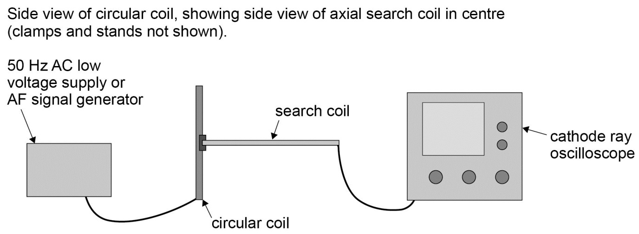

**Method**

* The search coil is clamped so that the plane of the coil is initially parallel to the plane of the large circular coil, and therefore perpendicular to the B-field lines produced by the circular coil, as shown in the diagram. This position will produce maximum flux linkage and maximum induced emf in the search coil.
* A preliminary experiment will be necessary to determine the appropriate voltage (and frequency) to use on the circular coil. (An ammeter might be required to ensure the current through the circular coil does not exceed the manufacturer’s specifications.) Select suitable voltage sensitivity and time base settings on the oscilloscope, to establish that the induced emf produced in the search coil is large enough to be easily measured.
* With the search coil in the initial position, as shown, record the induced emf in the search coil from the CRO display – eg by measuring peak to peak value of the induced AC voltage.
* Tilt the angle of the search coil and use a protractor to measure the angle between the plane of the circular coil and the plane of the search coil. (It might be possible to clamp a large protractor behind the search coil support rod, although students could be set the task of devising a suitable method to measure this angle). Measure the corresponding induced emf in the search coil from the CRO display.
* Repeat for a range of angles from 0° to 90° between the search coil and the circular coil, and in each case measure the corresponding induced emf in the search coil.
* Plot a graph to show the variation of induced emf against the angle of the search coil in the field. This should be maximum for the position shown in the diagram, where the angle between the plane of the circular coil and the plane of the search coil is 0°. The induced emf should be zero when the plane of the search coil is at an angle of 90° to the plane of the circular coil.

**Alternative method using a Hall probe**

The variation of magnetic flux linkage with angle can easily be investigated with a hall probe. This has the advantage that the magnetic field around a permanent magnet can be investigated.

In the above experiment with the circular coil, the search coil and oscilloscope can be replaced by a hall probe and voltmeter. The hall voltage is proportional to the magnetic field strength. There is no requirement for a varying field to produce an induced emf, so a low voltage DC supply is connected to the circular coil instead of the AC supply. The probe can be placed at various angles in the ‘steady’ field at the centre of the circular coil, and the corresponding hall voltage measured.

The hall probe could also be used to investigate the variation in flux linkage with angle, using the magnetic field from a permanent magnet, as shown below. The hall probe can be rotated at varying angles in the field, and the corresponding hall voltage recorded.

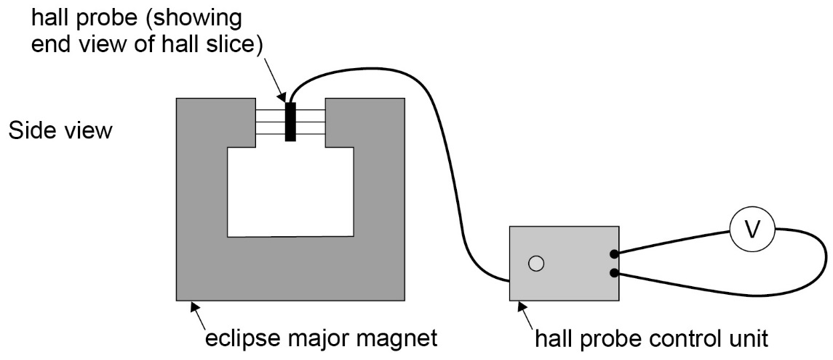

**PRACTICAL 12**

|  |  |  |  |  |  |
| --- | --- | --- | --- | --- | --- |
| **Required practical** | | **Investigation of the inverse-square law for gamma rays** | | | |
| **Apparatus and techniques covered**  (Relevant apparatus only, not full statements) | | a. use appropriate analogue apparatus to record a range of measurements (to include length/distance)  b. use appropriate digital instruments (scaler and stopclock)  k. use ICT such as computer modelling, or data logger with a variety of sensors to collect data, or use of software to process data  l. use ionising radiation, including detectors | | | |
| **Indicative apparatus** | | Gamma source (eg 5μCi sealed cobalt 60), tongs to handle the sealed source, source holder, retort stand, boss and clamp, GM Tube suitable for gamma detection, scaler, stopclock, metre ruler. | | | |
|  | **Amount of choice**  **Increasing independence** | | | | |
|  | Least choice | | Some choice | Many choices | Full investigation |
| Teacher gives students a full method with clear instructions as to how to set up the apparatus. All instruments and measurements are specified and students are instructed on the exact procedure and safety precautions. | | Teacher allows students limited choice of distances to use. All procedural techniques, including requirement for a background count, are specified. | Teacher suggests outline investigation - by measuring intensity of gamma radiation at varying distances from the source. Student decides on most appropriate measuring instruments, counting times and range of distances from source. Student decides how to reduce uncertainty due to background radiation. | Teacher suggests general line of enquiry at the end of a piece of work where the student has had some experience in the use of ionising radiation and detectors.  Student makes full decision about methodology, equipment and materials. All choices are fully justified with reference to experimental errors and safety. |
| **Opportunities for observation and assessment of competencies** | | | | | |
| Follow written procedures | **🗸🗸🗸** Students follow written method. | | **🗸🗸🗸** Students follow written method. | **🗸🗸🗸** Students follow a method they have chosen. | **🗸🗸🗸** Students follow a method they have researched. |

|  |  |  |  |  |
| --- | --- | --- | --- | --- |
| Applies investigative approaches and methods when using instruments and equipment | **🗸** Students correctly use the equipment and materials with minimum assistance and prompting. | **🗸🗸** Students correctly use the equipment, carry out procedures methodically and make adjustments when necessary. | **🗸🗸🗸** Students select and correctly use the equipment, carry out procedures methodically and identify and control quantitative variables. | **🗸🗸🗸** Student must choose an appropriate approach, equipment and techniques, identify variables for measurement and control. |
| Safely uses a range of practical equipment and materials | **🗸** Students must safely use the equipment following advice given, with particular reference to handling the gamma source. | **🗸🗸** Students must safely use the equipment with minimal prompting, but following the specific advice given on handling the gamma source. | **🗸🗸** Students minimise risks in all aspects of the investigation with no prompting, but following the advice given re: handling of the gamma source | **🗸🗸🗸** Students must carry out a full risk assessment and minimise risks. (Risk assessment details re: handling of the gamma source, to be approved in advance). |
| Makes and records observations | **🗸🗸** Students record observations as specified in the method, and record in a methodical way using appropriate units and conventions. | **🗸🗸🗸** Students obtain accurate, precise and sufficient data and records this methodically using appropriate units and conventions. | **🗸🗸🗸** Students obtain accurate, precise and sufficient data and records this methodically using appropriate units and conventions. | **🗸🗸🗸** Students obtain accurate, precise and sufficient data and records this methodically using appropriate units and conventions. |
| Researches, references and reports | **🗸** Students process data in prescribed way and compare results with expected relationships. | **🗸🗸** Students process data in prescribed way and compare results with expected relationships identifying potential discrepancies and errors, (and making appropriate correction for background radiation). | **🗸🗸🗸** Students identify appropriate methods/tools to process data and compare with expected relationships, identifying potential errors (eg due to background radiation and possible systematic errors in source-detector distance measurement). | **🗸🗸🗸** Students identify appropriate methods to process data, carry out research and report findings. Sources of information are cited together with supporting planning and conclusions. |

🗸🗸🗸: Very good opportunity 🗸🗸: Good opportunity 🗸: Slight opportunity 🗶: No opportunity

**A-level Physics required practical No 12**

**Investigation of the inverse-square law for gamma radiation**

NB This worksheet gives full details of the experiment, primarily for use by teachers and technicians who may be unfamiliar with the experiment. The worksheet would normally be adapted for student use to provide opportunity for students to make procedural decisions.

It is important that any ‘student version’ of this worksheet takes due account of any relevant safety issues. **It is the responsibility of the centre to ensure that the apparatus they provide is used safely.**

**Materials and equipment**

* gamma source (eg 185 kBq (5 µCi) Cobalt 60 ‘closed’ source)
* source holder or retort stand, boss and clamp
* scaler with integral power supply for GM tube
* geiger muller tube suitable for gamma detection
* metre ruler
* stopclock.

**Technical information**

* **Teachers, technicians and students must be familiar with the regulations for the use and handling of radioactive materials.** [Document L93](http://www.cleapss.org.uk/secondary/radiation-advice), “Managing Ionisation radiations and radioactive substances in schools and colleges” is publically available on the CLEAPSS website. (You do not have to be a member to download this document).This gives details of every aspect in the use of radioactive sources in schools, and we strongly recommend you refer to it for advice before doing this or other similar experiments.
* The most commonly used closed/sealed gamma source is Cobalt 60. This has a half-life of approximately 5 years. A (nominally) 185 Bq (5µCi) source kept in school for 15 years would only have an activity of around 23 kBq (0.6µCi), which may be too low to obtain satisfactory results.
* The scaler must be compatible with the GM tube used – ie it has the appropriate socket and voltage supply for the GM tube.
* When taking count readings the longer the count, the lower the uncertainty. It can be shown that the uncertainty in a total count of N is + √N. A total count of 400 will have an uncertainty of + 20 or + 5%.

Clamps and source holder not shown. (Some stands with integral source hold, GM tube holder and mm scale are available.)

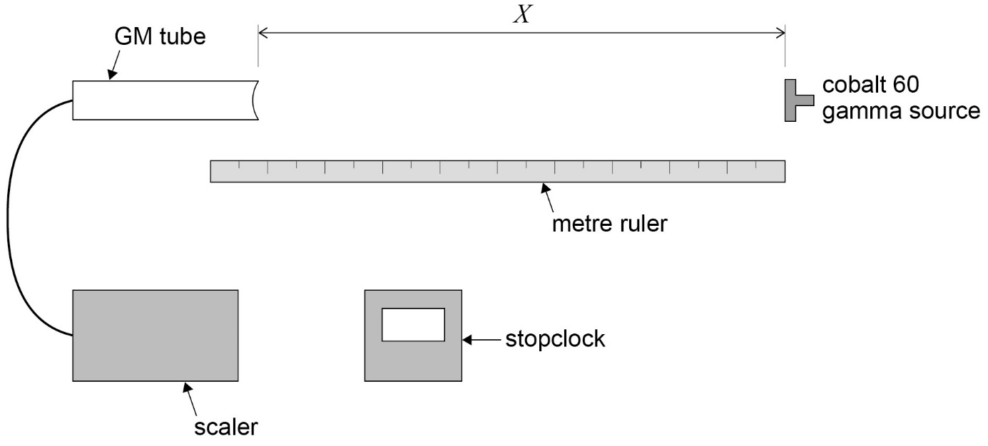

**Method**

* Plug the GM tube into the scaler and set at the appropriate voltage (according to manufacturer’s instructions). Start the scaler to check it is counting - there will be sufficient background radiation to register a count.
* **Before bringing the source into the laboratory**, a background count must be taken. Simultaneously start the scaler and stopclock. Stop the scaler after 20 minutes. Record the time, *t*, and the total count, *N*, on the scaler.
* Set up the arrangement as shown in the diagram.
* Put the source in its holder (observing safety procedures).
* A few preliminary readings would be advantageous at this point, to establish the maximum distance at which a meaningful count can be taken – a count significantly above background is required to give useful data. Additionally, a count rate taken near to the source will enable counting times to be decided for smaller source-detector distances.
* Set the distance from the front of the source to the front of the GM tube window, *x*, to 600 mm. (Assuming this distance gives a satisfactory count rate.)
* Simultaneously start the timer and scaler, and take the count, *N*, after *t* = 5 minutes

(or 10 minutes if the total count is below 400).

* Re-set the source position so that *X* = 500 mm from the GM tube and take the new total count after *t* = 5 minutes.
* Repeat for source - GM tube distances *X* of 400 mm, 300 mm, 200 mm, 100 mm. (As the source is placed closer to the detector, a shorter timed counts will be satisfactory).
* Record *N*, *t*, *X* in a suitable table, allowing columns for count rate *C* = *N*/*t* and corrected count rate *C’* (obtained by subtracting background count rate from *C*) and a final column for 1/√*C’.*
* Plot a graph with 1/√*C’* on the *y*-axis and *X* on the *x-*axis.

A straight line graph would verify the inverse square law relationship for gamma rays. The data is plotted this way around (rather that plotting *C’* against 1/*x*2), to eliminate the systematic error in distance measurement. The exact position of the gamma material inside the sealed source and the position inside the GM tube where ionisation takes place is not known. Actual distance between source and detector, *d*, is given by *d* = *x* + *e* , where *e*  is the systematic error in the distance measurement. This distance *e* can be found from the intercept on the *x-*axis of the graph.

