Santa’s Christmas Vector Challenge

1. This year Santa harnesses 2 reindeer to his sleigh. If each reindeer pulls with a force of 600 N at an angle of 20º as shown below, calculate the resultant force on the sleigh.
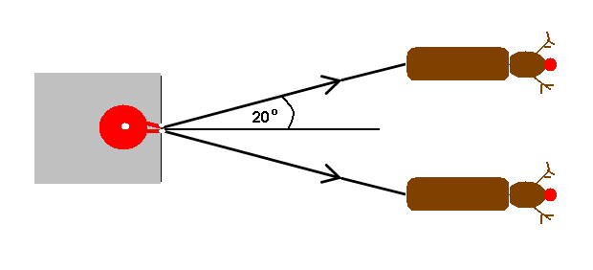
Santa thinks that the reindeer’s exhausts are a bit smelly! He finds some 20 m long chains, so he doesn’t have to sit so close. If the centres of the 2 reindeer are 3 m apart, what does the resultant force now become.

2. A child on a sledge slides down a steep hill at an angle of 25º to the horizontal. The combined mass of the child and sledge is 51 Kg.
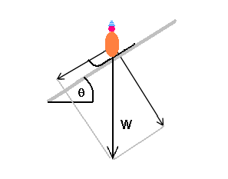
a) If the acceleration due to gravity is 9.8 m s⁻², calculate the weight, W of the child and sledge.
- Calculate the component of this weight down the slope.
- If the frictional force of the ice can be neglected, calculate the acceleration of the child down the slope.
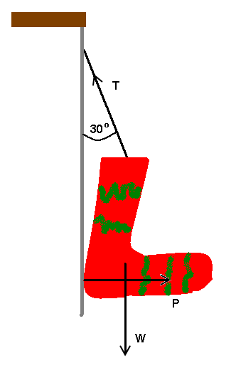
- A bigger child boasts he will go faster down the slope as he is heavier. Is he correct?

3. A greedy Physics teacher hangs his stocking against the fireplace at an angle of 30º as shown in the diagram, so that Santa can fill it with lots of goodies. If the maximum tension in the string he uses is 100 N, What mass of presents will fit in the stocking before it breaks. Ignore the mass of the stocking and use 9.8 m s⁻² as the value for g.

4. This year Santa has so many presents to deliver, he does not have time to go down all of the chimneys. Instead he decides to drop the presents off his sleigh so that they will fall down the chimneys.
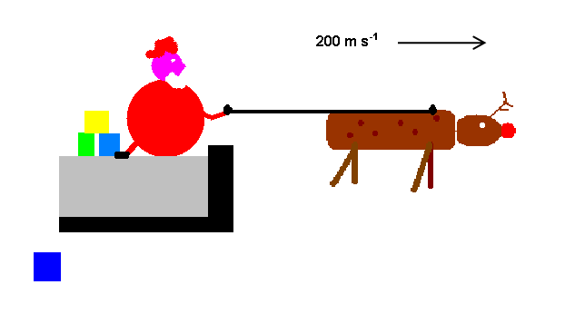

He flies over the rooftops at a horizontal speed of 200 m s⁻¹, and a height of 500 m. At what horizontal distance before each chimney does he need to release the present? Assume that g = 9.8 m s⁻² and that the effects of air resistance are negligible.

In order to fall down the chimneys, the presents need to hit the opening at an angle of less than 25º to the vertical. Will his cunning plan work?

5. After a heavy snowfall the children of Godalming decide to build a giant snowman on Holloway hill to welcome the students as they climb up to College.

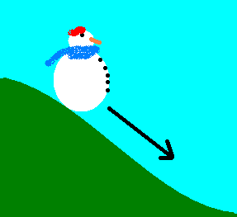

If the snowman has a mass of 100 kg and the maximum frictional force between the base of the snowman and the ground is 350 N, what is the steepest angle to the horizontal at which they can build the snowman without him sliding down the slope? Assume, as always g = 9.8 m s⁻².

