**The Young Modulus of Steel**

In this experiment a steel wire is stretched with 0.5 kg masses and the small extension produced is measured with a Vernier scale.

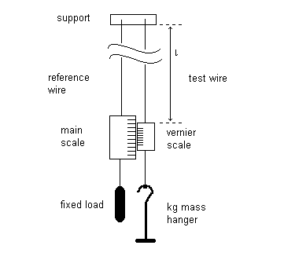The theory uses the following equation: 

Where E is the Young Modulus of the material

*F* is the Force applied to stretch the wire

*Δl* isthe extension produced

*l* is the original length of the wire

and A is the cross-sectional area of the wire

The equation can be re-arranged into straight line form as follows:



If a graph of F is plotted on the y-axis against *Δl* on the x-axis, a straight line of gradient EA/*l* is produced.

The following results were produced with a SWG 26 steel wire of length 1.82 m.

|  |  |  |  |
| --- | --- | --- | --- |
| *M* / kg | F / N | *Δl* / mm | *Δl* / m |
| 0.5 |  | 0.2 |  |
| 1.0 |  | 0.4 |  |
| 1.5 |  | 0.7 |  |
| 2.0 |  | 0.9 |  |
| 2.5 |  | 1.1 |  |
| 3.0 |  | 1.4 |  |
| 3.5 |  | 1.6 |  |
| 4.0 |  | 1.8 |  |
| 4.5 |  | 2.0 |  |

Complete the table by converting the mass of the load, *M* into a corresponding force in newton using F = M g, where g = 9.81 m s-2. The extension was measured with a Vernier scale that read to the nearest 0.1 mm. Convert these values to SI units.

Now plot a graph of F on the y-axis against *Δl* on the x-axis and measure the gradient.

Three measurements of the diameter of the wire were taken with a micrometer in different places on the wire. The readings were 0.46 mm, 0.46 mm and 0.46 mm. Use the formula A = π r2 to calculate the average cross sectional area of the wire in m2.

Now use the formula  to calculate the Young Modulus E. The final result should be recorded in SI units (N m-2 or Pa).

**Error analysis**

Why do you think the diameter of the wire was measured in 3 different places?

What is the uncertainty in these micrometer measurements and the corresponding % uncertainty?

What is the percentage uncertainty in the Area of the wire (Hint: formula has r squared)

The wire length was measured with a tape measure to the nearest cm. Why is it not necessary to use a precision instrument for this length?

What is the percentage uncertainty in the length measurement?

The extension was measured to the nearest mm. Take the middle row of your table and calculate the percentage uncertainty for this extension value.

Assuming that the mass values given are exact, calculate the total uncertainty in the value for the Young Modulus of Steel.