Q1. A pirate ship is a type of amusement park pendulum ride in which a gondola carrying passengers is made to oscillate. The ride can be modelled using a simple pendulum consisting of a mass on a string.
The figure below shows how the displacement x of the mass varies with time t.
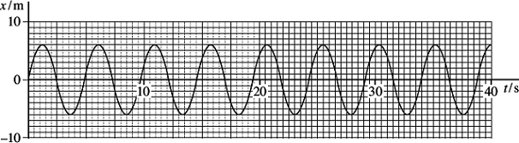
- (i) Define amplitude.
...............................................................................................................
...............................................................................................................
(1)
(ii) Determine the amplitude of the oscillations of the mass.

amplitude ................................................ m
(1)
(iii) Calculate the period of the pendulum.

period ................................................ s
(2)
(b) Another model was constructed using a pendulum of frequency 0.25 Hz with the mass having an initial amplitude of 4.5 m.
(i) Calculate the maximum velocity of the mass.

maximum velocity ................................................ ms^{–1}
(2)
(ii) Calculate the maximum acceleration of the mass.

maximum acceleration ................................................ ms^{–2}
(2)
(iii) Calculate the length of the simple pendulum that has a frequency of 0.25 Hz.

length ................................................ m
(2)
(c) To simplify the driving mechanism of the actual ride it is suggested that the gondola should be pushed each time it reaches the centre moving in one direction.
Explain why this would lead to large amplitude oscillations.
........................................................................................................................
........................................................................................................................
........................................................................................................................
........................................................................................................................
........................................................................................................................
........................................................................................................................
(2)
(d) When the force is no longer applied the gondola will naturally come to rest. The time for this to happen will usually be too long to satisfy the ride operators. External dampers are used to reduce the time taken to stop the gondola.
Explain why the gondola would come to rest naturally and what feature of an energy efficient ride design would make this a lengthy process.
........................................................................................................................
........................................................................................................................
........................................................................................................................
........................................................................................................................
........................................................................................................................
........................................................................................................................
........................................................................................................................
(3)
(Total 15 marks)
Q2. Within certain limits, the bob of a simple pendulum of length l may be considered to move with simple harmonic motion of period T, where
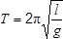
(a) State one limitation that applies to the pendulum when this equation is used.
.............................................................................................................................
.............................................................................................................................
(1)
(b) Describe an experiment to determine the value of the Earth’s gravitational field strength g using a simple pendulum and any other appropriate apparatus.
In your answer you should:
- describe how you would arrange the apparatus
- indicate how you would make the measurements
- explain how you would calculate the value of g by a graphical method
- state the experimental procedures you would use to ensure that your result was accurate.
You may draw a diagram to help you with your answer.
The quality of your written communication will be assessed in your answer.

........................................................................................................................
........................................................................................................................
........................................................................................................................
........................................................................................................................
........................................................................................................................
........................................................................................................................
........................................................................................................................
(6)
(c) When carrying out the experiment in part (b), a student measures the time period incorrectly. Mistakenly, the student thinks that the time period is the time taken for half of an oscillation instead of a full oscillation, as illustrated in the diagram.
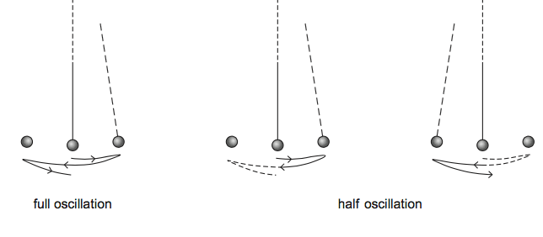
Deduce the effect this will have on the value of g obtained from the experiment, explaining how you arrive at your answer.
.............................................................................................................................
.............................................................................................................................
.............................................................................................................................
.............................................................................................................................
.............................................................................................................................
.............................................................................................................................
.............................................................................................................................
.............................................................................................................................
(3)
(Total 10 marks)
Q3. Figure 1 shows a seismometer used for detecting the horizontal movement of the ground caused by an earthquake.
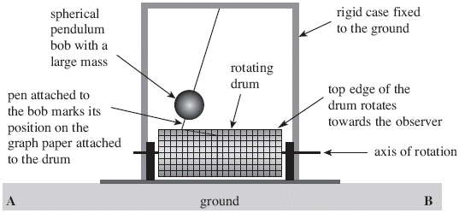
Figure 1

The rigid case is fixed to the ground. When an earthquake occurs, the ground moves horizontally so the rigid case also moves horizontally. Initially, the heavy pendulum bob remains in its original position due to its high inertia. Figure 1 shows the pendulum immediately after an earthquake is detected.

The rotating drum moves at a steady speed. Figure 2 shows the trace produced on the graph paper that is attached to the rotating drum following the earthquake.
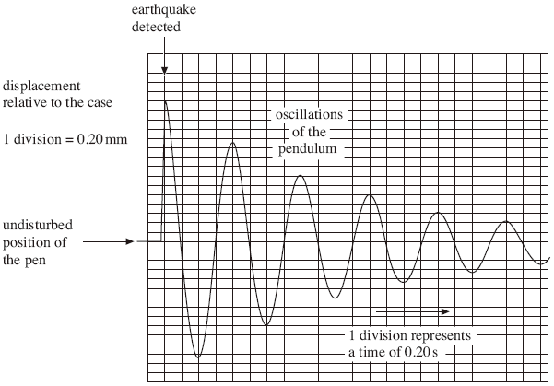
Figure 2
(a) (i) State whether the ground has moved towards A or B to produce the situation shown in Figure 1.
.............................................................................................................
(1)
(ii) Determine the magnitude of the initial displacement of the ground that caused the trace in Figure 2.
.............................................................................................................
(1)
(b) (i) Use data from Figure 2 to calculate the distance between the point of suspension of the pendulum and the centre of mass of the bob. Assume that the arrangement is a simple pendulum.
.............................................................................................................
.............................................................................................................
.............................................................................................................
.............................................................................................................
.............................................................................................................
distance ................................................................... m
(3)
(ii) State and explain the effect of using a bob of the same radius but smaller mass on the initial displacement of the bob,
.............................................................................................................
.............................................................................................................
the period of oscillation of the bob.
.............................................................................................................
.............................................................................................................
(4)
(c) (i) Determine whether the amplitude of the oscillations shown in Figure 2 decreases exponentially.
.............................................................................................................
.............................................................................................................
.............................................................................................................
.............................................................................................................
.............................................................................................................
.............................................................................................................
(3)
(ii) Explain why the amplitude of the oscillations of the bob decreases following the initial displacement.
.............................................................................................................
.............................................................................................................
.............................................................................................................
.............................................................................................................
(2)
(iii) State and explain the effect of using a bob with the same radius but smaller mass on the time taken for the bob to come to rest following the initial disturbance.
.............................................................................................................
.............................................................................................................
.............................................................................................................
.............................................................................................................
(2)
(Total 16 marks)

Q4. Figure 1 shows an acrobat swinging on a trapeze.
Figure 1
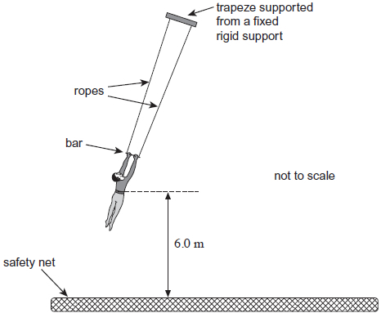
(a) (i) State and explain how the tension in the ropes of the trapeze varies as the acrobat swings on the trapeze.
...................................................................................................................
...................................................................................................................
...................................................................................................................
...................................................................................................................
...................................................................................................................
...................................................................................................................
...................................................................................................................
(3)
(ii) The period of the oscillation of the acrobat on the trapeze is 3.8 s.
Calculate the distance between the point of suspension of the trapeze and the centre of mass of the acrobat. Assume that the acrobat is a point mass and that the system behaves as a simple pendulum.
distance ........................... m
(2)

(b) At one instant the amplitude of the swing is 1.8 m. The acrobat lets go of the bar of the trapeze at the lowest point of the swing. He lands in a safety net when his centre of mass has fallen 6.0 m.
(i) Calculate the speed of the acrobat when he lets go of the bar.
speed ........................... ms⁻¹
(3)
(ii) Calculate the horizontal distance between the point of suspension of the trapeze and the point at which the acrobat lands on the safety net.
horizontal distance ........................... m
(3)
(c) Figure 2 shows the displacement−time (s–t) graph for the bar of the trapeze after the acrobat has let go of the bar.
Figure 2
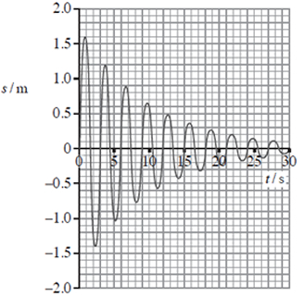
Show that the amplitude of the oscillations decreases exponentially.

(3)
(ii) Explain why the period of the trapeze changes when the acrobat lets go of the bar.
...................................................................................................................
...................................................................................................................
...................................................................................................................
...................................................................................................................
(2)
(Total 16 marks)
Q5. A trolley of mass 0.80 kg rests on a horizontal surface attached to two identical stretched springs, as shown in Figure 1. Each spring has a spring constant of 30 Nm^{–1}, can be assumed to obey Hooke’s law, and to remain in tension as the trolley moves.
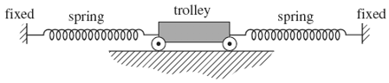
Figure 1
(a) (i) The trolley is displaced to the left by 60 mm and then released. Show that the magnitude of the resultant force on it at the moment of release is 3.6 N.

(2)
(ii) Calculate the acceleration of the trolley at the moment of release and state its direction.

answer = ............................ms^{–2}
direction ...................................................
(2)

(b) (i) The oscillating trolley performs simple harmonic motion. State the two conditions which have to be satisfied to show that a body performs simple harmonic motion.
.............................................................................................................
.............................................................................................................
.............................................................................................................
.............................................................................................................
(2)
(ii) The frequency f of oscillation of the trolley is given by
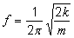
where m = mass of the trolley
k = spring constant of one spring.

Calculate the period of oscillation of the trolley, stating an appropriate unit.

answer = ....................................
(3)
(c) Copper ions in a crystal lattice vibrate in a similar way to the trolley, because the inter-atomic forces act in a similar way to the forces exerted by the springs. Figure 2 shows how this model of a vibrating ion can be represented.
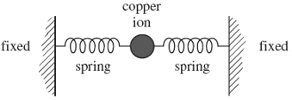
Figure 2
(i) The spring constant of each inter-atomic ‘spring’ is about 200Nm^{–1}. The mass of the copper ion is 1.0 × 10^{–25} kg. Show that the frequency of vibration of the copper ion is about 10¹³ Hz.

(1)
(ii) If the amplitude of vibration of the copper ion is 10^{–11}m, estimate its maximum speed.

answer = ............................m s^{–1}
(1)
(iii) Estimate the maximum kinetic energy of the copper ion.

answer = ...................................J
(1)
(Total 12 marks)
Q6. (a) A mass is attached to one end of a spring and the other end of the spring is suspended from a support rod, as shown in Figure 1.
Figure 1
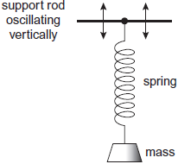
The support rod oscillates vertically, causing the mass to perform forced vibrations.
Under certain conditions, the system may demonstrate resonance.
Explain in your answer what is meant by forced vibrations and resonance. You should refer to the frequency, amplitude and phase of the vibrations.
forced vibrations ............................................................................................
........................................................................................................................
........................................................................................................................
........................................................................................................................
........................................................................................................................
............................................................................................ (contined on next page)

resonance ......................................................................................................
........................................................................................................................
........................................................................................................................
........................................................................................................................
........................................................................................................................
........................................................................................................................
(4)
(b) A simple pendulum is set up by suspending a light paper cone (acting as the pendulum bob) on the end of a length of thin thread. A metal ring may be placed over the cone to increase the mass of the bob, as shown in Figure 2.
Figure 2
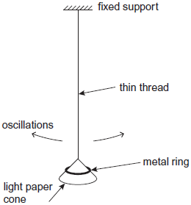
The bob is displaced and released so that it oscillates in a vertical plane. The oscillations are subject to damping.
(i) Are the oscillations of the pendulum more heavily damped when the cone oscillates with the metal ring on it, when it oscillates without the ring, or does the presence of the ring have no effect on the damping of the oscillations? Tick (✓) the correct answer.

cone oscillates with ring
cone oscillates without ring
ring has no effect

(1)
(ii) Explain your answer to part (i).
...............................................................................................................
..................................................................................................... (contined on next page)
...............................................................................................................
...............................................................................................................
...............................................................................................................
...............................................................................................................
...............................................................................................................
(3)
(Total 8 marks)
Q7. Figure 1 shows a parcel on the floor of a delivery van that is passing over a hump-backed bridge on a straight section of road. The radius of curvature of the path of the parcel is r and the van is travelling at a constant speed v. The mass of the parcel is m.
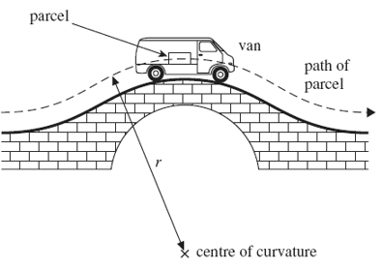
Figure 1

(a) (i) Draw arrows on Figure 2 below to show the forces that act on the parcel as it passes over the highest point of the bridge. Label these forces.
Figure 2
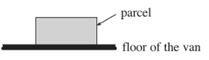

(1)
(ii) Write down an equation that relates the contact force, R, between the parcel and the floor of the van to m, v, r and the gravitational field strength, g.
.............................................................................................................
.............................................................................................................
(1)
(iii) Calculate R if m = 12 kg, r = 23 m, and v = 11 ms^{–1}.

answer = .................................N
(2)
(b) Explain what would happen to the magnitude of R if the van passed over the bridge at a higher speed. What would be the significance of any van speed greater than 15ms^{–1}? Support your answer with a calculation.
......................................................................................................................
......................................................................................................................
......................................................................................................................
......................................................................................................................
......................................................................................................................
......................................................................................................................
......................................................................................................................
(3)
(Total 7 marks)
Q8. In the research into nuclear fusion one of the most promising reactions is between deuterons $\left({}_{1}^{2}H\right)$ and tritium nuclei $\left({}_{1}^{3}H\right)$ in a gaseous plasma. Although deuterons can be relatively easily extracted from sea water, tritium is difficult to produce. It can, however, be produced by bombarding lithium-6 $\left({}_{3}^{6}{Li}\right)$ with neutrons. The two reactions are summarised as:
$${}_{1}^{2}{H+{}_{1}^{3}{H→{}_{2}^{4}{He+{}_{0}^{1}{n+energy}}}}$$

$${}_{3}^{6}{Li+{}_{0}^{1}{n→{}_{1}^{3}{H+{}_{2}^{4}{He+energy}}}}$$
Masses of reactants:
${}_{0}^{1}n$ = 1.008665u
${}_{1}^{2}H$ = 2.013553u
${}_{1}^{3}H$ = 3.016049u
${}_{2}^{4}{He}$ = 4.002603u
${}_{3}^{6}{Li}$ = 6.015122u
1u is equivalent to 1.66 × 10^{–27} kg or 931 MeV

(a) (i) Explain why the atomic mass unit, u, may be quoted in kg or MeV.
.............................................................................................................
.............................................................................................................
.............................................................................................................
.............................................................................................................
(2)
(ii) Calculate the maximum amount of energy, in MeV, released when 1.0 kg of lithium-6 is bombarded by neutrons.
.............................................................................................................
.............................................................................................................
.............................................................................................................
.............................................................................................................
.............................................................................................................
.............................................................................................................
.............................................................................................................
energy released ...................................... MeV
(5)
(iii) Suggest why the lithium-6 reaction could be thought to be self-sustaining once the deuteron-tritium reaction is underway.
.............................................................................................................
.............................................................................................................
.............................................................................................................
(1)
(b) (i) In order to fuse, a deuteron and a tritium nucleus must approach one another to within approximately 1.5 × 10^{–15} m.
Calculate the minimum total initial kinetic energy that these nuclei must have.
.............................................................................................................
.............................................................................................................
.............................................................................................................
.............................................................................................................
.............................................................................................................
minimum total kinetic energy of nuclei ............................................. J
(3)

(ii) Show that a temperature of approximately 4 × 10⁹ K would be sufficient to enable this fusion to occur in a gaseous plasma.
.............................................................................................................
.............................................................................................................
.............................................................................................................
.............................................................................................................
.............................................................................................................
.............................................................................................................
(3)
(iii) Explain in terms of the forces acting on nuclei why the deuteron-tritium mixture must be so hot in order to achieve the fusion reaction.
.............................................................................................................
.............................................................................................................
.............................................................................................................
.............................................................................................................
.............................................................................................................
(4)
(Total 18 marks)
Q9. In stars, helium-3 and helium-4 are formed by the fusion of hydrogen nuclei. As the temperature rises, a helium-3 nucleus and a helium-4 nucleus can fuse to produce beryllium-7 with the release of energy in the form of gamma radiation.
The table below shows the masses of these nuclei.

Nucleus | Mass / u
Helium-3 | 3.01493
Helium-4 | 4.00151
Beryllium-7 | 7.01473
(a) (i) Calculate the energy released, in J, when a helium-3 nucleus fuses with a helium-4 nucleus.

energy released ................................................... J
(4)

(ii) Assume that in each interaction the energy is released as a single gamma-ray photon.
Calculate the wavelength of the gamma radiation.

wavelength ................................................. m
(3)
(b) For a helium-3 nucleus and a helium-4 nucleus to fuse they need to be separated by no more than 3.5 × 10^{–15} m.
(i) Calculate the minimum total kinetic energy of the nuclei required for them to reach a separation of 3.5 × 10^{–15} m.

total kinetic energy ................................................... J
(3)
(ii) Calculate the temperature at which two nuclei with the average kinetic energy for that temperature would be able to fuse.
Assume that the two nuclei have equal kinetic energy.

temperature .................................................. K
(3)
(c) Scientists continue to try to produce a viable fusion reactor to generate energy on Earth using reactors like the Joint European Torus (JET). The method requires a plasma that has to be raised to a suitable temperature for fusion to take place.
(i) State two nuclei that are most likely to be used to form the plasma of a fusion reactor.
1 .............................................................................................................
2 .............................................................................................................
(2)
(ii) State one method which can be used to raise the temperature of the plasma to a suitable temperature.
...............................................................................................................
...............................................................................................................
(1)
(Total 16 marks)
Q10. In a nuclear reactor the mean energy produced by each uranium-235 nucleus that undergoes induced fission is 3.0 × 10^{–11} J. In one pressurised water reactor, PWR, the fuel rods in the reactor contain 2.0 × 10⁴ kg of uranium-235 and 40% of the energy produced per second is converted to 500 MW of electrical output power. It is assumed that all the energy produced in the reactor core is removed by pressurised water in the coolant system. The pressure of the water is approximately 150 times greater than normal atmospheric pressure. The water enters the reactor at a temperature of 275 °C ad leaves at a temperature of 315 °C. Under the operational conditions of the reactor the mean density of water in the coolant circuit is
730 kgm^{–3} and the specific heat capacity of water is approximately 5000 J kg^{–1} K^{–1}.
normal atmospheric pressure = 1.0 × 10⁵ Pa
molar mass of uranium-235 = 0.235 kg
(a) The equation below gives one induced fission reaction that takes place in a reactor.
$${}_{92}^{235}{U+{}_{0}^{1}{X→{}_{56}^{n}{Br+{}_{p}^{90}{Kr+2{}_{0}^{1}X}}}}$$
(i) State the name of the particle represented by X.
...............................................................................................................
(1)
(ii) State the proton and nucleon numbers represented by p and n.
p ..........................................................
n ..........................................................
(2)
(b) (i) Calculate the number of fission reactions that occur in the reactor each second.

number of fission reactions per second ............................................ (2)
(ii) The reactor fuel rods contain 2.0 × 10⁴ kg of uranium-235. Assume that all this uranium-235 could be used.
Calculate the maximum time, in years, for which the reactor could operate.

time .........................................years
(4)
(iii) Suggest why it is not possible to use all the uranium-235 in the reactor fuel rods.
...............................................................................................................
...............................................................................................................
...............................................................................................................
...............................................................................................................
(2)
c) Calculate the force exerted by the pressurised water on each square centimetre of the wall of the reactor.

force .........................................................N
(2)
(d) Calculate, in m³ s^{–1}, the flow rate of the water through the PWR reactor.
You will need to use data from the passage at the beginning of the question.

flow rate ......................................................... m³ s^{–1}
(4)

(e) In a PWR the cooling water also acts as the moderator in the reactor and boron rods are used to control the power output. Describe the physical processes that take place in the moderator and control rods.
........................................................................................................................
........................................................................................................................
........................................................................................................................
........................................................................................................................
........................................................................................................................
........................................................................................................................
........................................................................................................................
........................................................................................................................
........................................................................................................................
........................................................................................................................
........................................................................................................................
........................................................................................................................
........................................................................................................................
(4)
(Total 21 marks)
Q11. Figure 1 shows a fairground ride called a Rotor. Riders stand on a wooden floor and lean against the cylindrical wall.
Figure 1
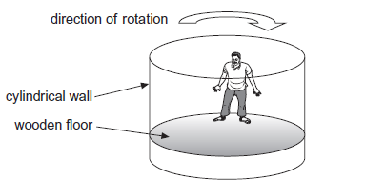
The fairground ride is then rotated. When the ride is rotating sufficiently quickly the wooden floor is lowered. The riders remain pinned to the wall by the effects of the motion. When the speed of rotation is reduced, the riders slide down the wall and land on the floor.

(a) (i) At the instant shown in Figure 2 the ride is rotating quickly enough to hold a rider at a constant height when the floor has been lowered.
Figure 2
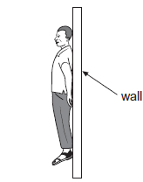

Draw onto Figure 2 arrows representing all the forces on the rider when held in this position relative to the wall.
Label the arrows clearly to identify all of the forces.
(3)
(ii) Explain why the riders slide down the wall as the ride slows down.
...............................................................................................................
...............................................................................................................
...............................................................................................................
(2)
A Rotor has a diameter of 4.5 m. It accelerates uniformly from rest to maximum angular velocity in 20 s.
The total moment of inertia of the Rotor and the riders is 2.1 × 10⁵ kg m².
(b) (i) At the maximum speed the centripetal acceleration is 29 m s^{–2}.
Show that the maximum angular velocity of a rider is 3.6 rad s^{–1}.

(2)
(ii) Calculate the torque exerted on the Rotor so that it accelerates uniformly to its maximum angular velocity in 20 s. State the appropriate SI unit for torque.

torque ................................................. SI unit for torque ........................(3)
(iii) Calculate the centripetal force acting on a rider of mass 75 kg when the ride is moving at its maximum angular velocity.
Give your answer to an appropriate number of significant figures.

centripetal force .................................................. N
(1)
(c) Figure 3 shows the final section of a roller coaster which ends in a vertical loop. The roller coaster is designed to give the occupants a maximum acceleration of 3g. Cars on the roller coaster descend to the start of the loop and then travel around it, as shown.
Figure 3
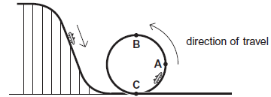
(i) At which one of the positions marked A, B and C on Figure 3 would the passengers experience the maximum reaction force exerted by their seat?
Circle your answer below.

A B C

(1)
(iii) Explain why the maximum acceleration is experienced at the position you have chosen.
...............................................................................................................
...............................................................................................................
...............................................................................................................
...............................................................................................................
(2)
(Total 14 marks)

Q12. (a) (i) Name the two types of potential energy involved when a mass–spring system performs vertical simple harmonic oscillations.
...............................................................................................................
...............................................................................................................
(1)
(ii) Describe the energy changes which take place during one complete oscillation of a vertical mass-spring system, starting when the mass is at its lowest point.
...............................................................................................................
...............................................................................................................
...............................................................................................................
...............................................................................................................
...............................................................................................................
...............................................................................................................
(2)
(b) Figure 1 shows how the total potential energy due to the simple harmonic motion varies with time when a mass-spring system oscillates vertically.
Figure 1
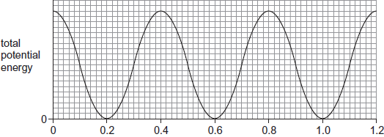
time / s
(i) State the time period of the simple harmonic oscillations that produces the energy–time graph shown in Figure 1, explaining how you arrive at your answer.
...............................................................................................................
...............................................................................................................
...............................................................................................................
...............................................................................................................
(2)

(ii) Sketch a graph on Figure 2 to show how the acceleration of the mass varies with time over a period of 1.2 s, starting with the mass at the highest point of its oscillations. On your graph, upwards acceleration should be shown as positive and downwards acceleration as negative. Values are not required on the acceleration axis.
Figure 2
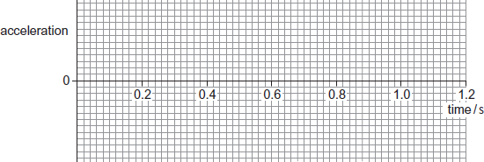
(2)
(c) (i) The mass of the object suspended from the spring in part (b) is 0.35 kg. Calculate the spring constant of the spring used to obtain Figure 1. State an appropriate unit for your answer.

spring constant ...................................... unit ....................................
(3)
(ii) The maximum kinetic energy of the oscillating object is 2.0 × 10^{–2} J. Show that the amplitude of the oscillations of the object is about 40 mm.

(4)
(Total 14 marks)
Q13. (a) The concept of an absolute zero of temperature may be explained by reference to the behaviour of a gas.
Discuss one experiment that can be performed using a gas which would enable you to explain absolute zero and determine its value.
It is not necessary to give full details of the apparatus. Your answer should:
    - include the quantities that are kept constant
    - identify the measurements to be taken
    - explain how the results may be used to find absolute zero
    - justify why the value obtained is absolute zero.
The quality of your written communication will be assessed in your answer.

...............................................................................................................
...............................................................................................................
...............................................................................................................
...............................................................................................................
...............................................................................................................
...............................................................................................................
...............................................................................................................
...............................................................................................................
...............................................................................................................
...............................................................................................................
...............................................................................................................
...............................................................................................................
(6)
(b) (i) State two assumptions about the movement of molecules that are used when deriving the equation of state, pV = $\frac{1}{3}$ N m (c_{rms})² for an ideal gas.
1 ............................................................................................................
...............................................................................................................
2 ............................................................................................................
...............................................................................................................
(2)
(ii) Three molecules move at the speeds shown in the table below.

molecule | speed / m s⁻¹
1 | 2000
2 | 3000
3 | 7000

Calculate their mean square speed.

mean square speed ........................................... m² s^{–2}
(1)
(c) The average molecular kinetic energy of an ideal gas is 6.6 × 10^{–21} J.
Calculate the temperature of the gas.

temperature................................................. ^{K}
(2)
(Total 11 marks)
Q14. An electrical heater is placed in an insulated container holding 100 g of ice at a temperature of –14 °C. The heater supplies energy at a rate of 98 joules per second.
(a) After an interval of 30 s, all the ice has reached a temperature of 0 °C. Calculate the specific heat capacity of ice.

answer = ............................J kg^{–1}K^{–1}
(2)
(b) Show that the final temperature of the water formed when the heater is left on for a further 500 s is about 40 °C.
specific heat capacity of water = 4200 J kg^{–1}K^{–1}
specific latent heat of fusion of water = 3.3 × 10⁵ J kg^{–1}

(3)

(c) The whole procedure is repeated in an uninsulated container in a room at a temperature of 25 °C.
State and explain whether the final temperature of the water formed would be higher or lower than that calculated in part (b).
................................................................................................................................
................................................................................................................................
................................................................................................................................
................................................................................................................................
(2)
(Total 7 marks)
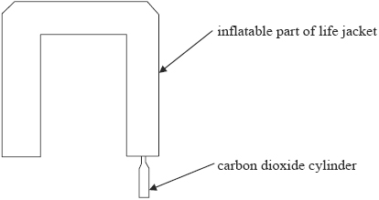
Q15. A life jacket inflates using gas released from a small carbon dioxide cylinder. The arrangement is shown in the following figure.
(a) The cylinder initially contains 1.7 × 10²³ molecules of carbon dioxide at a temperature of 12 °C and occupying a volume of 3.0 × 10⁻⁵ m³.
(i) Calculate the initial pressure, in Pa, in the carbon dioxide cylinder.

(ii) When the life jacket inflates, the pressure falls to 1.9 × 10⁵ Pa and the final temperature is the same as the initial temperature. Calculate the new volume of the gas.

(iii) Calculate the mean molecular kinetic energy, in J, of the carbon dioxide in the cylinder.

(6)
(b) (i) Explain, in terms of the kinetic theory model, why the pressure drops when the carbon dioxide is released into the life jacket.
.............................................................................................................
.............................................................................................................
.............................................................................................................
.............................................................................................................
.............................................................................................................
(ii) Explain why the kinetic theory model would apply more accurately to the gas in the inflated life jacket compared with the gas in the small cylinder.
.............................................................................................................
.............................................................................................................
.............................................................................................................
.............................................................................................................
.............................................................................................................
(6)
(c) Explain, in terms of the first law of thermodynamics, how the temperature of the gas in the system can be the same at the beginning and the end of the process.
......................................................................................................................
......................................................................................................................
......................................................................................................................
......................................................................................................................
......................................................................................................................
......................................................................................................................
(4)
(Total 16 marks)
Q16. (a) Calculate the energy released when 1.5 kg of water at 18 °C cools to 0 °C and then freezes to form ice, also at 0 °C.
specific heat capacity of water = 4200 J kg^{–1} K^{–1}
specific latent heat of fusion of ice = 3.4 × 10⁵ J kg^{–1}
......................................................................................................................
......................................................................................................................
......................................................................................................................
......................................................................................................................
(4)
(b) Explain why it is more effective to cool cans of drinks by placing them in a bucket full of melting ice rather than in a bucket of water at an initial temperature of 0 °C.
......................................................................................................................
......................................................................................................................
......................................................................................................................
......................................................................................................................
(2)
(Total 6 marks)
Q17. (a) Define the Avogadro constant.
........................................................................................................................
........................................................................................................................
........................................................................................................................
(1)
(b) (i) Calculate the mean kinetic energy of krypton atoms in a sample of gas at a temperature of 22 °C.

mean kinetic energy ........................................... J
(1)
(ii) Calculate the mean-square speed, (c_{rms})², of krypton atoms in a sample of gas at a temperature of 22 °C.
State an appropriate unit for your answer.
mass of 1 mole of krypton = 0.084 kg

mean-square speed..................................... unit ..........................
(3)

(c) A sample of gas consists of a mixture of krypton and argon atoms.
The mass of a krypton atom is greater than that of an argon atom.
State and explain how the mean-square speed of krypton atoms in the gas compares with that of the argon atoms at the same temperature.
........................................................................................................................
........................................................................................................................
........................................................................................................................
........................................................................................................................
(2)
(Total 7 marks)
Q18. The Hubble space telescope was launched in 1990 into a circular orbit near to the Earth.
It travels around the Earth once every 97 minutes.
(a) Calculate the angular speed of the Hubble telescope, stating an appropriate unit.

answer = .....................................
(3)
(b) (i) Calculate the radius of the orbit of the Hubble telescope.

answer = ................................ m
(3)
(ii) The mass of the Hubble telescope is 1.1 × 10⁴ kg. Calculate the magnitude of the centripetal force that acts on it.

answer = ................................ N
(2)
(Total 8 marks)
Q19. In a reverse bungee experience a ‘rider’ is catapulted high into the air.
A designer creates a less extreme version for more timid participants, as shown in the figure below.
The rider is strapped into a rigid harness attached to one end of an elastic rope PR. The rider and the rope behave in the same way as a mass-spring system.
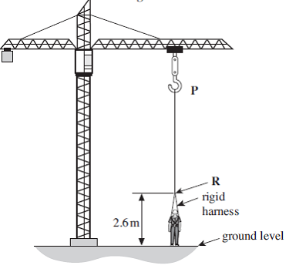
The rider is initially held at rest at ground level. The top end of the rope, P, is raised to stretch the rope. The rider is then released and moves upwards, reaching a maximum height when the rope is at its unstretched (natural) length. The rider then oscillates vertically until eventually coming to rest, suspended above the ground.
The rope has an unstretched length of 20 m. When stretched, the rope obeys Hooke’s law and has a stiffness of 92 Nm^{–1}. In the following questions ignore the mass of the rope.
(a) (i) The rider and harness have a total mass of 55 kg.
Calculate the overall length of the rope when the rider comes to rest, suspended above the ground, at the end of the ride.
.............................................................................................................
.............................................................................................................
.............................................................................................................
.............................................................................................................
.............................................................................................................
overall length .............................................. m
(3)

(ii) At the start of the ride, the lower end of the rope R is attached to the rigid harness at a point which is 2.6 m above the ground.
The top end of the rope, P, has to be adjusted so that the rope just becomes unstretched when the rider is at the highest point of the ride.
Determine the height of P above the ground.
Neglect air resistance in this part of the question.
.............................................................................................................
.............................................................................................................
.............................................................................................................
height of point P ......................................... m
(1)
(b) (i) Show that the frequency of oscillation of the rider on the end of the rope
is about 0.2 Hz.
.............................................................................................................
.............................................................................................................
.............................................................................................................
.............................................................................................................
.............................................................................................................
.............................................................................................................
(3)
(ii) Calculate the maximum speed reached by the rider when the amplitude of the oscillation is 4.2 m.
.............................................................................................................
.............................................................................................................
.............................................................................................................
.............................................................................................................
.............................................................................................................
maximum speed ..................................... ms^{–1}
(2)

(iii) In practice, air resistance has an effect. Sketch below, a graph showing how you would expect the velocity to vary with time over the first two complete oscillations, from the instant the rider was released from ground level. Take an upward velocity as being positive.

Label the time axis with a suitable scale. No scale is required on the velocity axis.

(3)
(c) (i) A rider of greater mass now uses the ride. Explain how the height of P has to be changed to produce the same initial amplitude of oscillations as that for the previous rider.
.............................................................................................................
.............................................................................................................
.............................................................................................................
.............................................................................................................
(3)
(ii) A safety officer examines the design of the ride and thinks that, if the end P of the rope is raised too high so that the rope is stretched too much at the start, there is a risk that the rider could hit the ground after the first oscillation and suffer an injury.
Describe what would happen to the rider during the ride in this case and explain why, even if air resistance is negligible, the safety officer’s concerns are unfounded.
.............................................................................................................
.............................................................................................................
.............................................................................................................
.............................................................................................................
.............................................................................................................
.............................................................................................................
.............................................................................................................
(3)
(Total 18 marks)
Q20. A lead ball of mass 0.25 kg is swung round on the end of a string so that the ball moves in a horizontal circle of radius 1.5 m. The ball travels at a constant speed of 8.6 m s^{–1}.
(a) (i) Calculate the angle, in degrees, through which the string turns in 0.40 s.

angle ......................................... degree
(3)
(ii) Calculate the tension in the string.
You may assume that the string is horizontal.

tension ................................................. N
(2)
(b) The string will break when the tension exceeds 60 N.
Calculate the number of revolutions that the ball makes in one second when the tension is 60 N.

number of revolutions .....................................................
(2)

(c) Discuss the motion of the ball in terms of the forces that act on it. In your answer you should:
    - explain how Newton’s three laws of motion apply to its motion in a circle
    - explain why, in practice, the string will not be horizontal.
You may wish to draw a diagram to clarify your answer.
The quality of your written communication will be assessed in your answer.

...............................................................................................................
...............................................................................................................
...............................................................................................................
...............................................................................................................
...............................................................................................................
...............................................................................................................
...............................................................................................................
...............................................................................................................
...............................................................................................................
...............................................................................................................
...............................................................................................................
...............................................................................................................
(6)
(Total 13 marks)

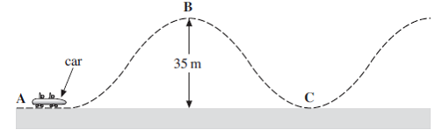
Q21. The figure below shows a car on a rollercoaster track. The car is initially at rest at A and is lifted to the highest point of the track, B, 35 m above A.

The car with its passengers has a total mass of 550 kg. It takes 25 s to lift the car from A to B. It then starts off with negligible velocity and moves unpowered along the track.
(a) Calculate the power used in lifting the car and its passengers from A to B.
Include an appropriate unit in your answer.
......................................................................................................................
......................................................................................................................
......................................................................................................................
......................................................................................................................
power.................................unit................................
(3)
(b) The speed reached by the car at C, the bottom of the first dip, is 22 ms^{–1}. The length of the track from B to the bottom of the first dip C is 63 m.
Calculate the average resistive force acting on the car during the descent.
Give your answer to a number of significant figures consistent with the data.
......................................................................................................................
......................................................................................................................
......................................................................................................................
......................................................................................................................
......................................................................................................................
......................................................................................................................
resistive force .............................................. N
(4)

(c) Explain why the resistive force is unlikely to remain constant as the car descends
from B to C.
......................................................................................................................
......................................................................................................................
......................................................................................................................
......................................................................................................................
......................................................................................................................
......................................................................................................................
(3)
(d) At C, a passenger of mass 55 kg experiences an upward reaction force of 2160 N when the speed is 22 ms^{–1}.
Calculate the radius of curvature of the track at C. Assume that the track is a circular arc at this point.
......................................................................................................................
......................................................................................................................
......................................................................................................................
......................................................................................................................
......................................................................................................................
......................................................................................................................
radius of curvature of the track ..................................... m
(3)
(Total 13 marks)
Q22. A roundabout in a fairground requires an input power of 2.5 kW when operating at a constant angular velocity of 0.47 rad s^{–1}.
(a) Show that the frictional torque in the system is about 5 kN m.
(3)

(b) When the power is switched off, the roundabout decelerates uniformly because the frictional torque remains constant. The roundabout takes a time of 34 s to come to rest.
(i) Calculate the moment of inertia of the roundabout.
Give an appropriate unit for your answer.
moment of inertia ........................... unit ...............
(3)
(ii) Calculate the number of revolutions that are made before the roundabout comes to rest.
number of revolutions ...........................
(3)
(c) An operator of mass 65 kg is standing on the roundabout when the roundabout is rotating at an angular velocity of 0.47 rad s^{–1}. His centre of mass is 2.2 m from the axis of rotation. The diagram shows that his body leans towards the centre of the path.
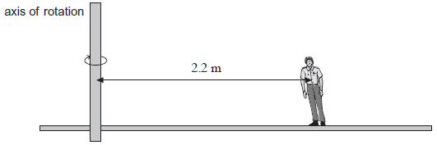
(i) Calculate the centripetal force needed for the operator to remain at this radius on the roundabout.
centripetal force ........................... N
(2)

(ii) State the origin of this centripetal force and suggest why the operator has to incline his body towards the centre of rotation to avoid falling over.
You may draw the forces that act on the operator in the diagram to help your answer.
...................................................................................................................
...................................................................................................................
...................................................................................................................
...................................................................................................................
...................................................................................................................
(2)
(iii) While the roundabout is moving, the operator drops a coin.
Which statement correctly describes and explains what happens to the coin?
Tick (✔) the correct answer in the right-hand column.

Tick (✔)
There is no longer a centripetal force acting, so the coin falls vertically downwards and lands on the roundabout directly below the point at which it was dropped.
The centripetal force causes the coin to have a horizontal component of velocity towards the centre of the roundabout, so that it follows a trajectory towards the centre of the roundabout.
There is no longer a centripetal force acting, so there is a horizontal component of the coin’s velocity directed away from the centre of the roundabout and it follows a trajectory directly away from the centre.
There is no longer a centripetal force acting, so the coin has a horizontal component of its velocity tangential to its original path on the roundabout and it follows a trajectory along this tangent.

(1)
(Total 14 marks)
Q23.(a) Outline what is meant by an ideal gas.
........................................................................................................................
........................................................................................................................
........................................................................................................................
........................................................................................................................
(2)

(b) An ideal gas at a temperature of 22 °C is trapped in a metal cylinder of volume 0.20 m³ at a pressure of 1.6 × 10⁶ Pa.
(i) Calculate the number of moles of gas contained in the cylinder.

number of moles ....................................... mol
(2)
(ii) The gas has a molar mass of 4.3 × 10^{–2} kg mol^{–1}.
Calculate the density of the gas in the cylinder.
State an appropriate unit for your answer.

density ......................... unit ..............
(3)
(iii) The cylinder is taken to high altitude where the temperature is −50 °C and the pressure is 3.6 × 10⁴ Pa. A valve on the cylinder is opened to allow gas to escape.
Calculate the mass of gas remaining in the cylinder when it reaches equilibrium with its surroundings.
Give your answer to an appropriate number of significant figures.

mass .......................................... kg
(3)
(Total 10 marks)

Q24. A cola drink of mass 0.200 kg at a temperature of 3.0 °C is poured into a glass beaker. The beaker has a mass of 0.250 kg and is initially at a temperature of 30.0 °C.
specific heat capacity of glass = 840 J kg^{–1}K^{–1}
specific heat capacity of cola = 4190 J kg^{–1}K^{–1}
(i) Show that the final temperature, T_{f}, of the cola drink is about 8 °C when it reaches thermal equilibrium with the beaker.
Assume no heat is gained from or lost to the surroundings.

(2)
(ii) The cola drink and beaker are cooled from T_{f} to a temperature of 3.0 °C by adding ice at a temperature of 0 °C.
Calculate the mass of ice added.
Assume no heat is gained from or lost to the surroundings.
specific heat capacity of water = 4190 J kg^{–1} K^{–1}
specific latent heat of fusion of ice = 3.34 × 10⁵ J kg^{–1}

mass .......................................... kg
(3)
(Total 5 marks)

Q25. Molten lead at its melting temperature of 327°C is poured into an iron mould where it solidifies. The temperature of the iron mould rises from 27°C to 84°C, at which the mould is in thermal equilibrium with the now solid lead.
mass of lead = 1.20 kg
specific latent heat of fusion of lead = 2.5 × 10⁴ J kg^{–1}
mass of iron mould = 3.00 kg
specific heat capacity of iron = 440 J kg^{–1}K^{–1}
(a) Calculate the heat energy absorbed by the iron mould.

answer = ..................................... J
(2)
(b) Calculate the heat energy given out by the lead while it is changing state.

answer = ...................................... J
(1)
(c) Calculate the specific heat capacity of lead.

answer = ...................................... J kg^{–1} K^{–1}
(3)
(d) State one reason why the answer to part (c) is only an approximation.
......................................................................................................................
......................................................................................................................
......................................................................................................................
(1)
(Total 7 marks)

Q26. (a) Define the specific latent heat of vaporisation of water.
........................................................................................................................
........................................................................................................................
........................................................................................................................
........................................................................................................................
(2)
(b) An insulated copper can of mass 20 g contains 50 g of water both at a temperature of 84 °C. A block of copper of mass 47 g at a temperature of 990 °C is lowered into the water as shown in the figure below. As a result, the temperature of the can and its contents reaches 100 °C and some of the water turns to steam.
specific heat capacity of copper = 390 J kg⁻¹
specific heat capacity of water = 4200 J kg^{–1}
specific latent heat of vaporisation of water = 2.3 × 10⁶ Jkg⁻¹
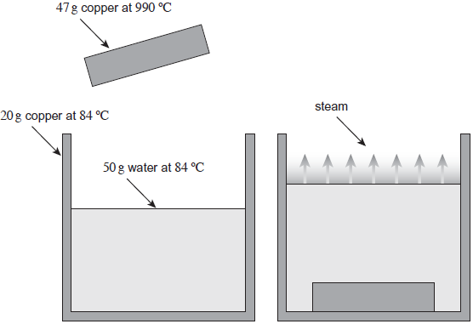
Before placement After placement
(i) Calculate how much thermal energy is transferred from the copper block as it cools to 100 °C.
Give your answer to an appropriate number of significant figures.

thermal energy transferred ........................................... J
(2)
(ii) Calculate how much of this thermal energy is available to make steam.
Assume no heat is lost to the surroundings.

available thermal energy ........................................... J
(2)
(iii) Calculate the maximum mass of steam that may be produced.

mass ......................................... kg
(1)
(Total 7 marks)
Q27.(a) ‘The pressure of an ideal gas is inversely proportional to its volume’, is an incomplete statement of Boyle’s law.
State two conditions necessary to complete the statement.
1 ..........................................................................................................................
2 ..........................................................................................................................
(2)
(b) A volume of 0.0016 m³ of air at a pressure of 1.0 × 10⁵ Pa and a temperature of 290 K is trapped in a cylinder. Under these conditions the volume of air occupied by 1.0 mol is 0.024 m³. The air in the cylinder is heated and at the same time compressed slowly by a piston. The initial condition and final condition of the trapped air are shown in the diagram.
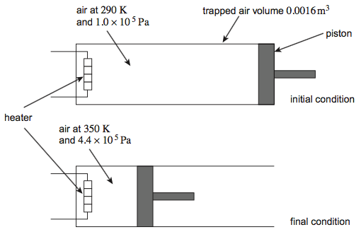
In the following calculations treat air as an ideal gas having a molar mass of 0.029 kg mol^{–1}.
(i) Calculate the final volume of the air trapped in the cylinder.
volume of air = ............................ m³
(2)
(ii) Calculate the number of moles of air in the cylinder.
number of moles = ............................
(1)
(iii) Calculate the initial density of air trapped in the cylinder.
density = ............................ kg m^{–3}
(2)
(c) State and explain what happens to the speed of molecules in a gas as the temperature increases.
.............................................................................................................................
.............................................................................................................................
.............................................................................................................................
.............................................................................................................................
.............................................................................................................................
.............................................................................................................................
.............................................................................................................................
(2)
(Total 9 marks)

Q28.(a) Which statement explains why energy is needed to melt ice at 0°C to water at 0°C?
Place a tick (✔) in the right-hand column to show the correct answer.

✔ if correct
It provides the water with energy for its molecules to move faster.
It breaks all the intermolecular bonds.
It allows the molecules to vibrate with more kinetic energy.
It breaks some intermolecular bonds.

(1)
(b) The diagram shows an experiment to measure the specific heat capacity of ice.
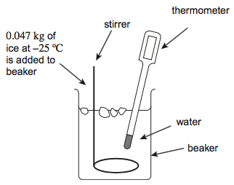
A student adds ice at a temperature of –25°C to water. The water is stirred continuously. Ice is added slowly until all the ice has melted and the temperature of the water decreases to 0°C. The mass of ice added during the experiment is 0.047 kg.
(i) Calculate the energy required to melt the ice at a temperature of 0°C.
The specific latent heat of fusion of water is 3.3 × 10⁵ J kg^{–1}.

energy = ............................ J
(1)
(ii)The water loses 1.8 × 10⁴ J of energy to the ice during the experiment.
Calculate the energy given to the ice to raise its temperature to 0°C. Assume that no energy is transferred to or from the surroundings and beaker.
energy
= ............................ J
(1)
(iii) Calculate the specific heat capacity of the ice.
State an appropriate unit for your answer.
specific heat capacity = ............................ unit = ............................
(2)
(Total 5 marks)
Q29. Figure 1 shows the cross-section of a bicycle pump with a cylindrical barrel. The piston has been pulled to the position marked X and the outlet of the pump sealed.
Figure 1
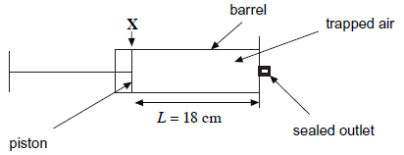
The length L of the column of trapped air is 18 cm and the volume of the gas is 1.7 × 10⁻⁴m³ when the piston is at position X. Under these conditions the trapped air is at a pressure p of 1.01 × 10⁵ Pa and its temperature is 19°C.
Assume the trapped air consists of identical molecules and behaves like an ideal gas in this question.
(a) (i) Calculate the internal diameter of the barrel.
diameter ........................... m
(2)
(ii) Show that the number of air molecules in the column of trapped air is approximately 4 × 10²¹.

(3)

(iii) The ratio $\frac{totalvolumeoftheairmolecules}{volumeoccupiedbythecolumnoftrappedair}$ equals 7.0 × 10⁻⁴.
Calculate the volume of one air molecule.
volume ........................... m³
(2)
(iv)he ratio in part (a)(iii) is important in supporting assumptions made in the kinetic theory of ideal gases.
Explain how the value of the ratio supports two of the assumptions made in the kinetic theory of ideal gases.
...................................................................................................................
...................................................................................................................
...................................................................................................................
...................................................................................................................
...................................................................................................................
...................................................................................................................
(3)
(b) The mass of each air molecule is 4.7 × 10⁻²⁶ kg.
Calculate the mean square speed of the molecules of trapped air when the length of the column of trapped air is 18.0 cm.
Give an appropriate unit for your answer.
mean square speed ........................... unit .........
(4)

(c) The piston is pushed slowly inwards until the length L of the column of trapped air is 4.5 cm.
Figure 2 shows how the pressure p of the trapped air varies as L is changed during this process.
Figure 2
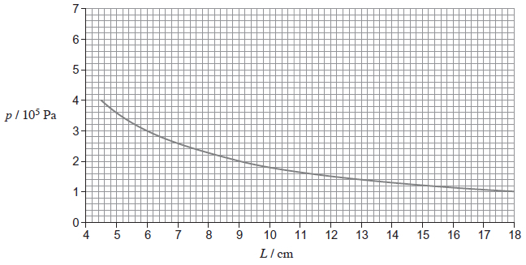
(i) Use data from Figure 2 to show that p is inversely proportional to L.
(3)
(ii) Name the physical property of the gas which must remain constant for p to be inversely proportional to L.
...................................................................................................................
(1)
(d) Explain how the relationship between p and L shown in Figure 2 can be predicted using the kinetic theory for an ideal gas.
.............................................................................................................................
.............................................................................................................................
.............................................................................................................................
.............................................................................................................................
.............................................................................................................................
.................................................................................................. (contined on next page)
.............................................................................................................................
.............................................................................................................................
(4)
(Total 22 marks)
Q30.(a) State two assumptions made about the motion of the molecules in a gas in the derivation of the kinetic theory of gases equation.
........................................................................................................................
........................................................................................................................
........................................................................................................................
........................................................................................................................
(2)
(b) Use the kinetic theory of gases to explain why the pressure inside a football increases when the temperature of the air inside it rises. Assume that the volume of the ball remains constant.
........................................................................................................................
........................................................................................................................
........................................................................................................................
........................................................................................................................
(3)
(c) The ‘laws of football’ require the ball to have a circumference between 680 mm and 700 mm. The pressure of the air in the ball is required to be between 0.60 × 10⁵ Pa and 1.10 × 10⁵ Pa above atmospheric pressure.
A ball is inflated when the atmospheric pressure is 1.00 × 10⁵ Pa and the temperature is 17 °C. When inflated the mass of air inside the ball is 11.4 g and the circumference of the ball is 690 mm.
Assume that air behaves as an ideal gas and that the thickness of the material used for the ball is negligible.
Deduce if the inflated ball satisfies the law of football about the pressure.
molar mass of air = 29 g mol^{–1}

(6)
(Total 11 marks)

Q31.(a) (i) State two situations in which a charged particle will experience no magnetic force when placed in a magnetic field.
first situation...........................................................................................
...............................................................................................................
...............................................................................................................
second situation.....................................................................................
...............................................................................................................
...............................................................................................................
(2)
(ii) A charged particle moves in a circular path when travelling perpendicular to a uniform magnetic field. By considering the force acting on the charged particle, show that the radius of the path is proportional to the momentum of the particle.

(2)
(b) In a cyclotron designed to produce high energy protons, the protons pass repeatedly between two hollow D-shaped containers called ‘dees’. The protons are acted on by a uniform magnetic field over the whole area of the dees. Each proton therefore moves in a semi-circular path at constant speed when inside a dee. Every time a proton crosses the gap between the dees it is accelerated by an alternating electric field applied between the dees. The diagram below shows a plan view of this arrangement.
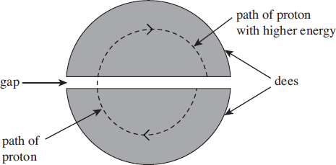
(i) State the direction in which the magnetic field should be applied in order for the protons to travel along the semicircular paths inside each of the dees as shown in the diagram above.
...............................................................................................................
(1)
(ii) In a particular cyclotron the flux density of the uniform magnetic field is 0.48 T. Calculate the speed of a proton when the radius of its path inside the dee is 190 mm.

speed .................................... ms^{–1}
(2)
(iii) Calculate the time taken for this proton to travel at constant speed in a semicircular path of radius 190 mm inside the dee.

time .......................................... s
(2)
(iv) As the protons gain energy, the radius of the path they follow increases steadily, as shown in the diagram above. Show that your answer to part (b)(iii) does not depend on the radius of the proton’s path.
...............................................................................................................
...............................................................................................................
...............................................................................................................
...............................................................................................................
...............................................................................................................
...............................................................................................................
(2)
(c) The protons leave the cyclotron when the radius of their path is equal to the outer radius of the dees. Calculate the maximum kinetic energy, in MeV, of the protons accelerated by the cyclotron if the outer radius of the dees is 470 mm.

maximum kinetic energy .................................... MeV
(3)
(Total 14 marks)
Q32. The diagram below shows the main parts of a geophone.
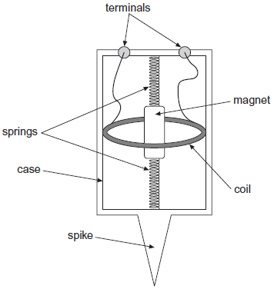
The spike attaches the geophone firmly to the ground. At the instant an earthquake occurs, the case and coil move upwards due to the Earth’s movement. The magnet remains stationary due to its inertia. In 3.5 ms, the coil moves from a position where the flux density is 9.0 mT to a position where the flux density is 23.0 mT.
(a) The geophone coil has 250 turns and an area of 12 cm².
Calculate the average emf induced in the coil during the first 3.5 ms after the start of the earthquake.

emf ................................................. V
(3)
(b) Explain how the initial emf induced in the coil of the geophone would be affected:
if the stiffness of the springs were to be increased
........................................................................................................................
........................................................................................................................
if the number of turns on the coil were to be increased.
........................................................................................................................
........................................................................................................................
(2)

(c) (i) The geophone’s magnet has a mass of 8.0 × 10^{–3} kg and the spring stiffness of the system is 2.6 N m^{–1}.
Show that the natural period of oscillation of the mass−spring system is approximately 0.35 s.

(2)
(ii) At the instant that the Earth stops moving after one earthquake, the emf in the coil is at its maximum value of +8 V. The magnet continues to oscillate.
On the grid below, sketch a graph showing the variation of emf with time as the magnet’s oscillation decays.
Show at least three oscillations.



(3)
(Total 10 marks)
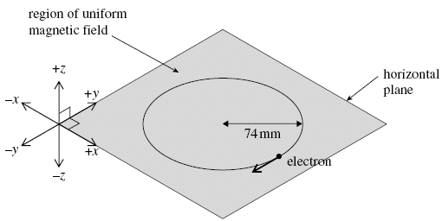
Q33. When travelling in a vacuum through a uniform magnetic field of flux density 0.43 m T, an electron moves at constant speed in a horizontal circle of radius 74 mm, as shown in the figure below.
(a) When viewed from vertically above, the electron moves clockwise around the
horizontal circle. In which one of the six directions shown on the figure above,
+x, –x, +y, –y, +z or –z, is the magnetic field directed?
direction of magnetic field ......................................
(1)
(b) Explain why the electron is accelerating even though it is travelling at constant speed.
......................................................................................................................
......................................................................................................................
......................................................................................................................
......................................................................................................................
......................................................................................................................
......................................................................................................................
(2)
(c) (i) By considering the centripetal force acting on the electron, show that its speed is
5.6 × 10⁶ m s^{–1}.

(2)

(ii) Calculate the angular speed of the electron, giving an appropriate unit.

answer = ......................................
(2)
(iii) How many times does the electron travel around the circle in one minute?

answer = ......................................
(2)
(Total 9 marks)
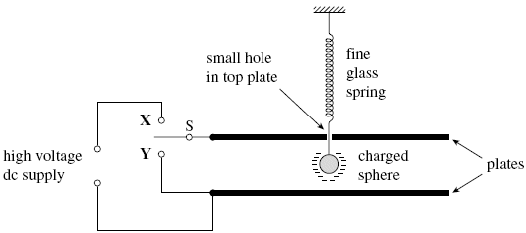
Q34. A small negatively charged sphere is suspended from a fine glass spring between parallel horizontal metal plates, as shown in the figure below.
(a) Initially the plates are uncharged. When switch S is set to position X, a high voltage dc supply is connected across the plates. This causes the sphere to move vertically upwards so that eventually it comes to rest 18 mm higher than its original position.
(i) State the direction of the electric field between the plates.
.............................................................................................................
(1)
(ii) The spring constant of the glass spring is 0.24 N m^{–1}. Show that the force exerted on the sphere by the electric field is 4.3 × 10^{–3} N.

(1)
(iii) The pd applied across the plates is 5.0 kV. If the charge on the sphere is –4.1 × 10^{–8} C, determine the separation of the plates.

answer = ..................................... m
(3)
(b) Switch S is now moved to position Y.
(i) State and explain the effect of this on the electric field between the plates.
.............................................................................................................
.............................................................................................................
.............................................................................................................
(2)
(ii) With reference to the forces acting on the sphere, explain why it starts to move with simple harmonic motion.
.............................................................................................................
.............................................................................................................
.............................................................................................................
.............................................................................................................
.............................................................................................................
(3)
(Total 10 marks)
Q35. (a) Figure 1 shows how the kinetic energy, E_{k}, of an oscillating mass varies with time when it moves with simple harmonic motion.
Figure 1
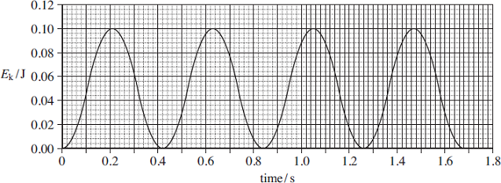

(i) Determine the frequency of the oscillations of the mass.

frequency of oscillation .............................................. Hz
(2)
(ii) Sketch, on Figure 1, a graph showing how the potential energy of the mass varies with time during the first second.
(2)
(b) Figure 2 shows a ride called a ‘jungle swing’.
Figure 2
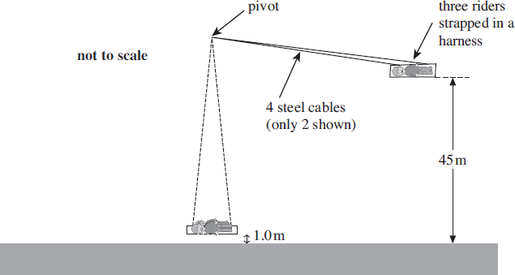
The harness in which three riders are strapped is supported by 4 steel cables. An advert for the ride states that the riders will be released from a height of 45 m above the ground and will then swing with a period of 14.0 s. It states that they will be 1.0 m above the ground at the lowest point and that they will travel at speeds of ‘up to 120 km per hour’.
(i) Treating the ride as a simple pendulum, show that the distance between the pivot and the centre of mass of the riders is about 49 m.

(2)
(ii) The riders and their harness have a total mass of 280 kg.
Calculate the tension in each cable at the lowest point of the ride, assuming that the riders pass through this point at a speed of 120 km h^{–1}. Assume that the cables have negligible mass and are vertical at this point in the ride.

tension in each cable ................................................ N
(4)
(iii) Show that the maximum speed stated in the advert is an exaggerated claim.
Assume that the riders are released from rest and neglect any effects of air resistance.

(4)
(iv) The riders lose 50% of the energy of the oscillation during each half oscillation. After one swing, the speed of the riders as they pass the lowest point is 20 m s^{–1}.
Calculate the speed of the riders when they pass the lowest point, travelling in the same direction after two further complete oscillations.

speed of riders .......................................... ms^{–1}
(3)
(Total 17 marks)

Q36. In a geothermal power station, water is pumped through pipes into an underground region of hot rocks. The thermal energy of the rocks heats the water and turns it to steam at high pressure. The steam then drives a turbine at the surface to produce electricity.
(a) Water at 21°C is pumped into the hot rocks and steam at 100°C is produced at a rate of 190 kg s^{–1}.
(i) Show that the energy per second transferred from the hot rocks to the power station in this process is at least 500 MW.
specific heat capacity of water = 4200 J kg^{–1} K^{–1}
specific latent heat of steam = 2.3 × 10⁶ J kg^{–1}
.............................................................................................................
.............................................................................................................
.............................................................................................................
.............................................................................................................
(ii) The hot rocks are estimated to have a volume of 4.0 × 10⁶ m³. Estimate the fall of temperature of these rocks in one day if thermal energy is removed from them at the rate calculated in part (i) without any thermal energy gain from deeper underground.
specific heat capacity of the rocks = 850 J kg^{–1} K^{–1}
density of the rocks = 3200 kg m^{–3}
.............................................................................................................
.............................................................................................................
.............................................................................................................
.............................................................................................................
.............................................................................................................
.............................................................................................................
(7)
(b) Geothermal energy originates as energy released in the radioactive decay of the
uranium isotope ${}_{92}^{238}U$ deep inside the Earth. Each nucleus that decays releases 4.2 MeV.
Calculate the mass of U that would release energy at a rate of 500 MW.
half-life of ${}_{92}^{238}U$ = 4.5 × 10⁹ years
molar mass of ${}_{92}^{238}U$ = 0.238 kg mol^{–1}
......................................................................................................................
......................................................................................................................
......................................................................................................................
......................................................................................................................
......................................................................................................................
......................................................................................................................
......................................................................................................................
......................................................................................................................
......................................................................................................................
......................................................................................................................
(5)
(Total 12 marks)
Q37.
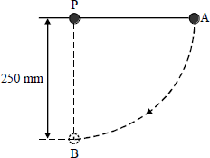
A 150 g mass is attached to one end of a light inextensible string and the other end of the string is fixed at a point P as shown in the diagram above. The mass is held at point A so that the string is taut and horizontal. The mass is released so that it moves freely along a circular arc of 250 mm radius.
When the string moves through the vertical position, the mass is at point B. Neglecting the effect of air resistance, calculate
(a) the kinetic energy of the mass,
........................................................................................................................
........................................................................................................................
........................................................................................................................
........................................................................................................................
(b) the velocity of the mass,
........................................................................................................................
........................................................................................................................
(c) the centripetal force acting on the mass,
........................................................................................................................
........................................................................................................................

(d) the tension in the string.
........................................................................................................................
........................................................................................................................
(Total 6 marks)
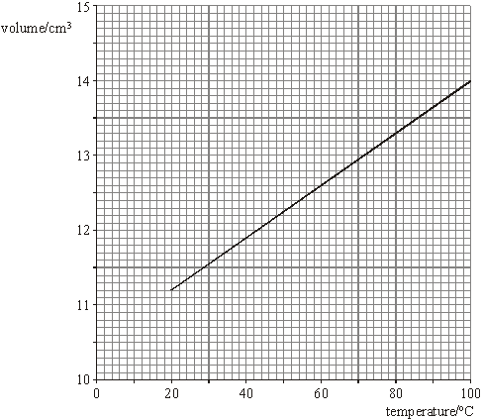
Q38. The graph in the figure below shows the best fit line for the results of an experiment in which the volume of a fixed mass of gas was measured over a temperature range from 20°C to 100°C. The pressure of the gas remained constant throughout the experiment.
(a) Use the graph in the figure to calculate a value for the absolute zero of temperature in °C. Show clearly your method of working.

(4)

(b) Use data from the graph in the figure to calculate the mass of gas used in the experiment. You may assume that the gas behaved like an ideal gas throughout the experiment.
gas pressure throughout the experiment = 1.0 × 10⁵ Pa
molar gas constant = 8.3 J mol^{–1} K^{–1}
molar mass of the gas used = 0.044 kg mol^{–1}

(5)
(Total 9 marks)
Q39. (a) A 500 µF capacitor and a 1000 µF capacitor are connected in series. Calculate the total capacitance of the combination.

(2)
(b) The figure below shows a diagram of an arrangement used to investigate the energy stored by a capacitor.
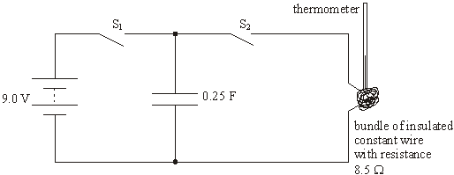
The bundle of constantan wire has a resistance of 8.5 Ω. The capacitor is initially charged to a potential difference of 9.0 V by closing S₁.

(i) Calculate the charge stored by the 0.25 F capacitor.

(ii) Calculate the energy stored by the capacitor.

(iii) Switch S₁ is now opened and S₂ is closed so that the capacitor discharges through the constantan wire. Calculate the time taken for the potential difference across the capacitor to fall to 0.10 V.

(7)
(c) The volume of constantan wire in the bundle in the figure above is 2.2 × 10^{–7} m³.
density of constantan = 8900 kg m^{–3}
specific heat capacity of constantan = 420 J kg^{–1} K^{–1}
(i) Assume that all the energy stored by the capacitor is used to raise the temperature of the wire. Use your answer to part (b)(ii) to calculate the expected temperature rise when the capacitor is discharged through the constantan wire.

(ii) Give two reasons why, in practice, the final temperature will be lower than that calculated in part (c)(i).
...............................................................................................................
...............................................................................................................
...............................................................................................................
(5)
(Total 14 marks)

Q40. The International Space Station (ISS) moves in a circular orbit around the Earth at a speed of 7.68 km s^{–1} and at a height of 380 km above the Earth‘s surface.
- Calculate the centripetal acceleration of the ISS, given that the radius of the Earth is
6380 km.

(3)
(b) Explain why a scientist working on board the ISS experiences “apparent weightlessness”.
........................................................................................................................
........................................................................................................................
........................................................................................................................
........................................................................................................................
(2)
This state of apparent weightlessness makes the space station an ideal laboratory for experiments in “zero gravity” conditions. Examples are the study of lattice vibrations in solids and Brownian Motion in fluids.
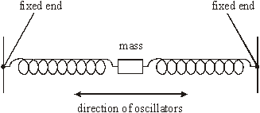
(c) The figure below shows a mass-spring system which, in zero gravity, provides a good model of forces acting on an atom in a solid lattice.
When the mass is displaced and released it oscillates as shown. The motion is very similar to the motion in one dimension of an atom in a crystalline solid. The springs behave like the bonds between adjacent atoms.
(i) The mass in the model system is 2.0 kg and it oscillates with a period of 1.2 s. Show that the stiffness of the spring system is about 55 N m^{–1}.

(2)

(ii) The bonds between the atoms in a particular solid have the same stiffness as the model system and the mass of the oscillating atom is 4.7 ×10^{–26} kg. Calculate the frequency of oscillation of the atom.

(2)
(Total 9 marks)
Q41. The Bohr model of a hydrogen atom assumes that an electron e is in a circular orbit around a proton P. The model is shown schematically in Figure 1.
Figure 1
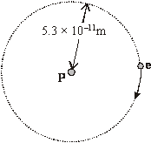
In the ground state the orbit has a radius of 5.3 × 10^{–11} m. At this separation the electron is attracted to the proton by a force of 8.1 × 10^{–8} N.
(a) State what is meant by the ground state.
........................................................................................................................
........................................................................................................................
(1)
(b) (i) Show that the speed of the electron in this orbit is about 2.2 × 10⁶ m s^{–1}.
mass of an electron = 9.1 × 10^{–31} k g

(ii) Calculate the de Broglie wavelength of an electron travelling at this speed.
Planck constant = 6.6 × 10^{–34} J s

(iii) How many waves of this wavelength fit the circumference of the electron orbit? Show your reasoning.

(7)
(c) The quantum theory suggests that the electron in a hydrogen atom can only exist in certain well-defined energy states. Some of these are shown in Figure 2.
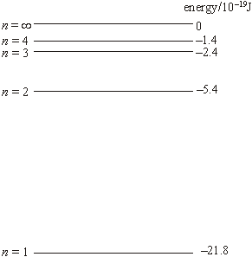
Figure 2

An electron E of energy 2.5 × 10^{–18} J collides with a hydrogen atom that is in its ground state and excites the electron in the hydrogen atom to the n = 3 level.
Calculate
(i) the energy that is needed to excite an electron in the hydrogen atom from the ground state to the n = 3 level,

(ii) the kinetic energy of the incident electron E after the collision,

(iii) the wavelength of the lowest energy photon that could be emitted as the excited electron returns to the ground state.
speed of electromagnetic radiation = 3.0 × 10⁸ m s^{–1}

(5)
(Total 13 marks)
Q42.Helium is a monatomic gas for which all the internal energy of the molecules may be considered to be translational kinetic energy.
molar mass of helium = 4.0 × 10^{–3} kg
the Boltzmann constant = 1.38 × 10^{–23} J K^{–1}
the Avogadro constant = 6.02 × 10²³ mol^{–1}
(a) Calculate the kinetic energy of a tennis ball of mass 60 g travelling at 50 m s^{–1}.
........................................................................................................................
........................................................................................................................
........................................................................................................................
(1)
(b) Calculate the internal energy of 1.0 g of helium gas at a temperature of 48K.
........................................................................................................................
........................................................................................................................
........................................................................................................................
........................................................................................................................
........................................................................................................................
........................................................................................................................
(3)
(c) At what temperature would the internal energy of 1.0 g of helium gas be equal to the kinetic energy of the ball in part (a).
........................................................................................................................
........................................................................................................................
(1)
(Total 5 marks)

Q43. A simple pendulum was made by attaching a small mass to a 1.20 m length of thin string. The pendulum was displaced 10.0 cm sideways and released to swing in a vertical plane. The amplitude of the motion was then observed and recorded after each oscillation. Figure 1 shows some of the results from the experiment.
Figure 1

Oscillation | 0 | 1 | 2 | 3 | 4 | 5 | 6
Amplitude/cm | 10.0 | 8.4 | 7.1 | 5.9 | 5.0 | 4.2 | 3.5

(a) The time for 6 oscillations was 13.2 s. Calculate the periodic time of the oscillations.

periodic time .................................
(1)
(b) On the axes in Figure 2, carefully sketch a graph of displacement against time for the first two oscillations of the pendulum. Mark the scale on each axis.
Figure 2
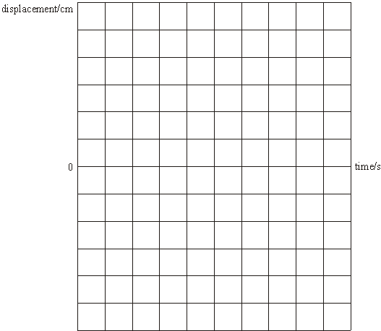
(4)
(c) State the effect on the motion of the pendulum when
(i) a shorter string is used,
...............................................................................................................
(ii) a greater mass of the same size is used.
...............................................................................................................
(2)
(Total 7 marks)
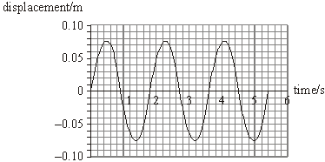
Q44. The figure below shows how the displacement of the bob of a simple pendulum varies with time.
(a) (i) Calculate the frequency of the oscillation.

(ii) State the magnitude of the amplitude of the oscillation.
...............................................................................................................
(iii) State how the frequency and amplitude of a simple pendulum are affected by increased damping.
...............................................................................................................
...............................................................................................................
(5)
(b) Draw on the figure above the displacement-time graph for a pendulum that has the same period and amplitude but oscillates 90° (π/2 radian) out of phase with the one shown.
(2)
(c) The pendulum bob has a mass of 8.0 × 10^{–3} kg. Calculate
(i) the maximum acceleration of the bob during the oscillation,

(ii) the total energy of the oscillations.

(5)
(Total 12 marks)
Q45. (a) (i) Explain what is meant by the specific latent heat of vaporisation of a liquid.
...............................................................................................................
...............................................................................................................
...............................................................................................................
(ii) Suggest why the specific latent heat of vaporisation of water is much greater than the specific latent heat of fusion of water.
...............................................................................................................
...............................................................................................................
...............................................................................................................
(3)
(b) A cup contains 0.25 kg of water at a temperature of 15 °C. The water is heated by passing steam at 100 °C into it.
specific heat capacity of water = 4200 J kg^{–1} K^{–1}
specific latent heat of vaporisation of water = 2.3 × 10⁶ J kg^{–1}
boiling point of water = 100 °C
(i) Use the above data to calculate the minimum mass of water that is in the cup when the temperature of the water reaches its boiling point.

(ii) Explain why there is likely to be a greater mass of water in the cup than you have calculated in part (b)(i).
...............................................................................................................
...............................................................................................................
...............................................................................................................
(4)
(Total 7 marks)

Q46. When a deuterium nucleus and a tritium nucleus overcome their Coulomb barrier and fuse together they may be considered as charged spheres in contact. The constant r_{o} which relates the nuclear radius, R, to the cube root of the mass number A may be assumed to be 1.3 fm.
(a) (i) Calculate the radius of the deuterium nucleus and, R, the radius of the tritium nucleus before fusion.
R_{D} ......................................................................................................
............................................................................................................
R_{T} .......................................................................................................
............................................................................................................
(ii) Calculate the minimum energy, in MeV, which must be supplied to the deuterium nucleus and the tritium nucleus when they fuse together.
...............................................................................................................
...............................................................................................................
...............................................................................................................
...............................................................................................................
(5)
(b) Estimate the temperature at which deuterium and tritium nuclei would have enough kinetic energy to undergo fusion.
........................................................................................................................
........................................................................................................................
........................................................................................................................
........................................................................................................................
(3)
(Total 8 marks)
Q47. (a) State what is meant by
(i) a free vibration,
...............................................................................................................
...............................................................................................................
(ii) a forced vibration.
...............................................................................................................
...............................................................................................................
(2)

(b) A car and its suspension can be treated as a simple mass-spring system. When four people of total weight 3000 N get into a car of weight 6000 N, the springs of the car are compressed by an extra 50 mm.
(i) Calculate the spring constant, k, of the system.
...............................................................................................................
...............................................................................................................
(ii) Show that, when the system is displaced vertically and released, the time period of the oscillations is 0.78 s.
...............................................................................................................
...............................................................................................................
...............................................................................................................
(3)
(c) The loaded car in part (b) travels at 20 m s^{–1} along a road with humps spaced 16 m apart.
(i) Calculate the time of travel between the humps.
...............................................................................................................
...............................................................................................................
(ii) Hence, state and explain the effect the road will have on the oscillation of the car.
...............................................................................................................
...............................................................................................................
...............................................................................................................
(3)
(Total 8 marks)
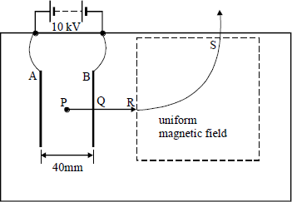
Q48.

A positive ion with a mass of 3.4 × 10^{–26} kg and a charge of 3.2 × 10^{–19} C is initially at rest at a point P, midway between two parallel conducting plates, A and B which are separated by 40 mm. The ion is accelerated and passes through a hole Q in plate B. It enters a magnetic field of uniform flux density 0.10 T at R. After following a circular path the ion leaves the field at S. Assume that the magnetic field is uniform everywhere within the dotted rectangle and that the space within the solid rectangle is evacuated.
(a) (i) Calculate the electric field strength between the plates AB.
...............................................................................................................
...............................................................................................................
...............................................................................................................
(ii) Calculate the force on the ion due to the electric field.
...............................................................................................................
...............................................................................................................
(iii) Show that the speed of the ion just after it has passed through the hole at Q is 3.1 × 10⁵ m s^{–1}.
...............................................................................................................
...............................................................................................................
...............................................................................................................
...............................................................................................................
(5)
(b) (i) State the direction of the magnetic field.
...............................................................................................................
(ii) Explain why the ion follows a circular path in the magnetic field.
...............................................................................................................
...............................................................................................................
...............................................................................................................
(iii) Show that the radius of the circular path is proportional to the momentum of the ion and calculate the value of the radius.
...............................................................................................................
...............................................................................................................
...............................................................................................................
...............................................................................................................
...............................................................................................................
(6)

(c) Explain how, if at all, the trajectory would be different for an ion with a slightly greater mass but carrying the same charge.
........................................................................................................................
........................................................................................................................
........................................................................................................................
........................................................................................................................
(2)
(Total 13 marks)
Q49. (a) (i) State what is meant by thermal equilibrium.
...............................................................................................................
...............................................................................................................
...............................................................................................................
(ii) Explain thermal equilibrium by reference to the behaviour of the molecules when a sample of hot gas is mixed with a sample of cooler gas and thermal equilibrium is reached.
...............................................................................................................
...............................................................................................................
...............................................................................................................
(3)
(b) A sealed container holds a mixture of nitrogen molecules and helium molecules at a temperature of 290 K. The total pressure exerted by the gas on the container is 120 kPa.
molar mass of helium = 4.00 × 10^{–3} kg mol^{–1}
molar gas constant R= 8.31 J K^{–1} mol^{–1}
the Avogadro constant N_{A} = 6.02 × 10²³ mol^{–1}
(i) Calculate the root mean square speed of the helium molecules.
...............................................................................................................
...............................................................................................................
...............................................................................................................
...............................................................................................................
(ii) Calculate the average kinetic energy of a nitrogen molecule.
...............................................................................................................
...............................................................................................................
...............................................................................................................
(iii) If there are twice as many helium molecules as nitrogen molecules in the container, calculate the pressure exerted on the container by the helium molecules.
...............................................................................................................
...............................................................................................................
...............................................................................................................
(6)
(Total 9 marks)
Q50. (a) Use the kinetic theory of gases to explain why
(i) the pressure exerted by an ideal gas increases when it is heated at constant volume.
...............................................................................................................
...............................................................................................................
...............................................................................................................
...............................................................................................................
(ii) the volume occupied by an ideal gas increases when it is heated at constant pressure.
...............................................................................................................
...............................................................................................................
...............................................................................................................
...............................................................................................................
(4)
(b) A quantity of 0.25 mol of air enters a diesel engine at a pressure of 1.05 × 10⁵ Pa and a temperature of 27°C. Assume the gas to be ideal.
(i) Calculate the volume occupied by the gas.
...............................................................................................................
...............................................................................................................
...............................................................................................................
...............................................................................................................
(ii) When the gas is compressed to one twentieth of its original volume the pressure rises to 7.0 × 10⁶ Pa. Calculate the temperature of the gas immediately after the compression.
...............................................................................................................
...............................................................................................................
...............................................................................................................
...............................................................................................................
...............................................................................................................
...............................................................................................................
(4)
(Total 8 marks)
Q51. (a) A 2.0 kW heater is used to heat a room from 5 °C to 20 °C. The mass of air in the room is
30 kg. Under these conditions the specific heat capacity of air = 1000 J kg^{–1} K^{–1}.
Calculate
(i) the gain in thermal energy of the air,
.............................................................................................................
.............................................................................................................
(ii) the minimum time required to heat the room.
.............................................................................................................
.............................................................................................................
.............................................................................................................
(4)
(b) State and explain one reason why the actual time taken to heat the room is longer than the value calculated in part (a)(ii).
......................................................................................................................
......................................................................................................................
......................................................................................................................
......................................................................................................................
(2)
(Total 6 marks)
Q52. (a) The air in a room of volume 27.0 m³ is at a temperature of 22 °C and a pressure of 105 kPa.
Calculate
(i) the temperature, in K, of the air,
.............................................................................................................
(ii) the number of moles of air in the room,
.............................................................................................................
.............................................................................................................
.............................................................................................................

(iii) the number of gas molecules in the room.
.............................................................................................................
.............................................................................................................
(5)
(b) The temperature of an ideal gas in a sealed container falls. State, with a reason, what happens to the
(i) mean square speed of the gas molecules,
.............................................................................................................
.............................................................................................................
.............................................................................................................
(ii) pressure of the gas.
.............................................................................................................
.............................................................................................................
.............................................................................................................
.............................................................................................................
.............................................................................................................
.............................................................................................................
(4)
(Total 9 marks)
Q53. (a) Explain what is meant by
(i) the specific heat capacity of water,
...............................................................................................................
...............................................................................................................
...............................................................................................................
...............................................................................................................
(ii) the specific latent heat of fusion of ice.
...............................................................................................................
...............................................................................................................
...............................................................................................................
...............................................................................................................
(4)

(b) A sample of solid material, which has a mass of 0.15 kg, is supplied with energy at a constant rate. The specific heat capacity of the material is 1200 J kg^{–1} K^{–1} when in the solid state. During heating, its temperature is recorded at various times and the following graph is plotted.
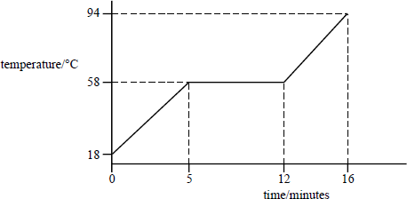
Assume there is no heat exchange with the surroundings.
(i) Show that energy is supplied to the material at a rate of 24 W.
...............................................................................................................
...............................................................................................................
...............................................................................................................
...............................................................................................................
(ii) Calculate the specific latent heat of fusion of the material.
...............................................................................................................
...............................................................................................................
...............................................................................................................
...............................................................................................................
(iii) Calculate the specific heat capacity of the material when in the liquid state.
...............................................................................................................
...............................................................................................................
...............................................................................................................
...............................................................................................................
(6)
(Total 10 marks)

Q54. The pressure exerted by an ideal gas in a container of volume 1.2 × 10^{–5} m³ is 1.5 × 10⁵ Pa at a temperature of 50°C.
- Calculate the number of molecules of gas in the container.
........................................................................................................................
........................................................................................................................
........................................................................................................................
(3)
(b) The pressure of the gas is measured at different temperatures whilst the volume of the container and the mass of the gas remain constant. Draw a graph on the grid to show how the pressure varies with the temperature.
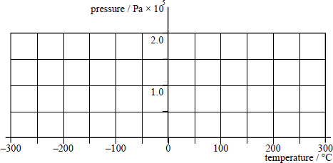
(3)
(c) The container described in part (a) has a release valve that allows gas to escape when the pressure exceeds 2.0 × 10⁵ Pa. Calculate the number of gas molecules that escape when the temperature of the gas is raised to 300°C.
........................................................................................................................
........................................................................................................................
........................................................................................................................
........................................................................................................................
........................................................................................................................
........................................................................................................................
(3)
(Total 9 marks)

Q55.An electrical heater is used to heat a 1.0 kg block of metal, which is well lagged. The table shows how the temperature of the block increased with time.

temp / °C | 20.1 | 23.0 | 26.9 | 30.0 | 33.1 | 36.9
time / s | 0 | 60 | 120 | 180 | 240 | 300

(a) Plot a graph of temperature against time on the grid provided.

(3)
(b) Determine the gradient of the graph.
........................................................................................................................
........................................................................................................................
(2)
(c) The heater provides thermal energy at the rate of 48 W. Use your value for the gradient of the graph to determine a value for the specific heat capacity of the metal in the block.
........................................................................................................................
........................................................................................................................
........................................................................................................................
(2)
(d) The heater in part (c) is placed in some crushed ice that has been placed in a funnel as shown.
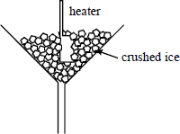
The heater is switched on for 200 s and 32 g of ice are found to have melted during this time. Use this information to calculate a value for the specific latent heat of fusion for water, stating one assumption made.
........................................................................................................................
........................................................................................................................
........................................................................................................................
........................................................................................................................
........................................................................................................................
(3)
(Total 10 marks)
Q56. The table gives the average kinetic energy of gas molecules at certain temperatures.

E_{k}/J × 10^{–21} | 6.21 6.62 7.04 7.45 7.87 8.28
T/K | 300 320 340 360 380 400

(a) On the grid provided below plot a graph of E_{k} against T.
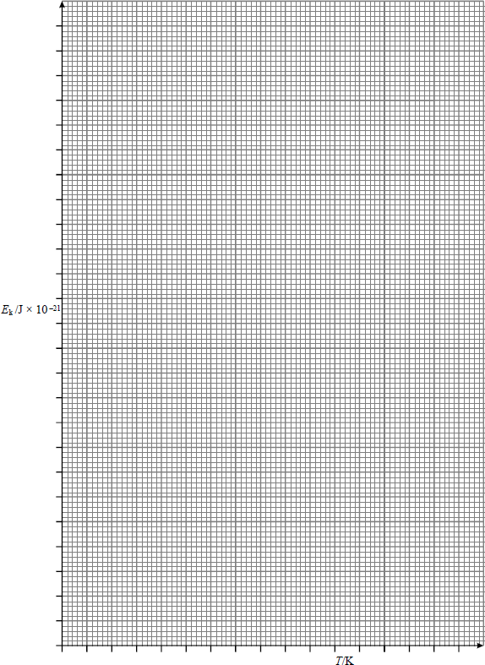
(i) Use your graph to determine the average kinetic energy of gas molecules at 350K.
...............................................................................................................

(ii) Determine the gradient of your graph and hence calculate a value for the Boltzmann constant. Show all your working.
...............................................................................................................
...............................................................................................................
...............................................................................................................
...............................................................................................................
...............................................................................................................
(8)
(b) One of the assumptions of the kinetic theory is that collisions of gas molecules are elastic.
(i) State what is meant by an elastic collision.
...............................................................................................................
...............................................................................................................
...............................................................................................................
(ii) State another assumption of the kinetic theory.
...............................................................................................................
...............................................................................................................
(iii) Explain how the data in the table leads to the concept of absolute zero.
...............................................................................................................
...............................................................................................................
...............................................................................................................
...............................................................................................................
(4)
(Total 12 marks)
Q57. (a) The molecular theory model of an ideal gas leads to the derivation of the equation
$$pV=\frac{1}{3}Nmc^{2}$$
Explain what each symbol in the equation represents.
p ....................................................................................................................
V ....................................................................................................................
N ....................................................................................................................
........................................................................................................................

m ....................................................................................................................
..................................................................................................................
........................................................................................................................
(4)
(b) One assumption used in the derivation of the equation stated in part (a) is that molecules are in state of random motion.
(i) Explain what is meant by random motion.
...............................................................................................................
...............................................................................................................
...............................................................................................................
(ii) State two more assumptions used in this derivation.
...............................................................................................................
...............................................................................................................
...............................................................................................................
(3)
(c) Describe how the motion of gas molecules can be used to explain the pressure exerted by a gas on the walls of its container.
........................................................................................................................
........................................................................................................................
........................................................................................................................
........................................................................................................................
........................................................................................................................
(4)
(Total 11 marks)
Q58. (a) An electric shower heats water from 15°C to 47°C when water flows through it at a rate of 0.045 kg s^{–1}.
(i) Calculate the energy supplied to the water each second by the heating element in the shower.
specific heat capacity of water = 4200 J kg^{–1} K^{–1}
...............................................................................................................
...............................................................................................................
...............................................................................................................
...............................................................................................................
(ii) Show that the power of the heating element is 6.0 kW. Assume there is no heat loss to the surroundings.
...............................................................................................................
...............................................................................................................
(3)
(b) (i) The heating element in part (a) is connected to an alternating supply at 230 V rms. Calculate the rms current passing through the heating element in normal operation.
...............................................................................................................
...............................................................................................................
(ii) The live wire and the neutral wire in the connecting cable are insulated copper wires of diameter 2.4 mm. Calculate the resistance per metre length of copper wire of this diameter.
resistivity of copper = 1.7 × 10⁻⁸ Ωm
...............................................................................................................
...............................................................................................................
...............................................................................................................
...............................................................................................................
...............................................................................................................
...............................................................................................................
(iii) Show that in normal operation, the potential drop per metre along the cable is 0.20 V m^{–1}.
...............................................................................................................
...............................................................................................................
...............................................................................................................
...............................................................................................................
(iv) Electrical safety regulations require the potential drop along the cable to be less than 6.0 V.
Calculate the maximum safe distance along the cable from the distribution board to the heating element.
...............................................................................................................
...............................................................................................................
...............................................................................................................
(9)
(Total 12 marks)

Q59. (a) A cylinder of fixed volume contains 15 mol of an ideal gas at a pressure of 500 kPa and a temperature of 290 K.
(i) Show that the volume of the cylinder is 7.2 × 10^{–2} m³.
.............................................................................................................
.............................................................................................................
(ii) Calculate the average kinetic energy of a gas molecule in the cylinder.
.............................................................................................................
.............................................................................................................
(4)
(b) A quantity of gas is removed from the cylinder and the pressure of the remaining gas falls to 420 kPa. If the temperature of the gas is unchanged, calculate the amount, in mol, of gas remaining in the cylinder.
......................................................................................................................
......................................................................................................................
......................................................................................................................
(2)
(c) Explain in terms of the kinetic theory why the pressure of the gas in the cylinder falls when gas is removed from the cylinder.
......................................................................................................................
......................................................................................................................
......................................................................................................................
......................................................................................................................
......................................................................................................................
(4)
(Total 10 marks)
Q60. A tray containing 0.20 kg of water at 20 °C is placed in a freezer.
(a) The temperature of the water drops to 0 °C in 10 minutes.
specific heat capacity of water = 4200 J kg^{–1} K^{–1}
Calculate
(i) the energy lost by the water as it cools to 0 °C,
.............................................................................................................
.............................................................................................................

(ii) the average rate at which the water is losing energy, in J s^{–1}.
.............................................................................................................
.............................................................................................................
(3)
(b) (i) Estimate the time taken for the water at 0 °C to turn completely into ice.
specific latent heat of fusion of water = 3.3 × 10⁵ J kg^{–1}
.............................................................................................................
.............................................................................................................
.............................................................................................................
(ii) State any assumptions you make.
.............................................................................................................
.............................................................................................................
.............................................................................................................
.............................................................................................................
(3)
(Total 6 marks)
Q61. (a) (i) Write down the equation of state for n moles of an ideal gas.
.............................................................................................................
(ii) The molecular kinetic theory leads to the derivation of the equation
$$pV=\frac{1}{3}Nmc^{2}$$
where the symbols have their usual meaning.
State three assumptions that are made in this derivation.
.............................................................................................................
.............................................................................................................
.............................................................................................................
.............................................................................................................
.............................................................................................................
(4)

(b) Calculate the average kinetic energy of a gas molecule of an ideal gas at a temperature
of 20 °C.
......................................................................................................................
......................................................................................................................
......................................................................................................................
(3)
(c) Two different gases at the same temperature have molecules with different mean square speeds.
Explain why this is possible.
......................................................................................................................
......................................................................................................................
......................................................................................................................
......................................................................................................................
(2)
(Total 9 marks)
Q62. (a) A 3.0 kW electric kettle heats 2.4 kg of water from 16°C to 100°C in 320 seconds.
- Calculate the electrical energy supplied to the kettle.
...............................................................................................................
...............................................................................................................
(ii) Calculate the heat energy supplied to the water.
specific heat capacity of water = 4200 J kg^{–1} K^{–1}
...............................................................................................................
...............................................................................................................
...............................................................................................................
(iii) Give one reason why not all the electrical energy supplied to the kettle is transferred to the water.
...............................................................................................................
...............................................................................................................
(4)
(b) The potential difference supplied to the kettle in part (a) is 230 V.
(i) Calculate the resistance of the heating element of the kettle.
...............................................................................................................
...............................................................................................................
...............................................................................................................
(ii) The heating element consists of an insulated conductor of length 0.25 m and diameter 0.65 mm. Calculate the resistivity of the conductor.
...............................................................................................................
...............................................................................................................
...............................................................................................................
...............................................................................................................
(5)
(Total 9 marks)
Q63. A bicycle and its rider have a total mass of 95 kg. The bicycle is travelling along a horizontal road at a constant speed of 8.0 m s^{–1}.
(a) Calculate the kinetic energy of the bicycle and rider.
......................................................................................................................
......................................................................................................................
(2)
(b) The brakes are applied until the bicycle and rider come to rest. During braking, 60% of the kinetic energy of the bicycle and rider is converted to thermal energy in the brake blocks. The brake blocks have a total mass of 0.12 kg and the material from which they are made has a specific heat capacity of 1200 J kg^{–1} K^{–1}.
(i) Calculate the maximum rise in temperature of the brake blocks.
.............................................................................................................
.............................................................................................................
.............................................................................................................
.............................................................................................................
- State an assumption you have made in part (b)(i).
.............................................................................................................
.............................................................................................................
(4)
(Total 6 marks)
Q64. The number of molecules in one cubic metre of air decreases as altitude increases. The table shows how the pressure and temperature of air compare at sea-level and at an altitude of 10 000 m.

altitude | pressure/Pa | temperature/K
sea-level | 1.0 × 10⁵ | 300
10 000 m | 2.2 × 10⁴ | 270

(a) Calculate the number of moles of air in a cubic metre of air at
(i) sea-level,
.............................................................................................................
.............................................................................................................
(ii) 10 000 m.
.............................................................................................................
.............................................................................................................
(3)
(b) In air, 23% of the molecules are oxygen molecules. Calculate the number of extra oxygen molecules there are per cubic metre at sea-level compared with a cubic metre of air at an altitude of 10 000 m.
......................................................................................................................
......................................................................................................................
......................................................................................................................
(2)
(Total 5 marks)
Q65. The graph shows how the pressure of an ideal gas varies with its volume when the mass and temperature of the gas are constant.
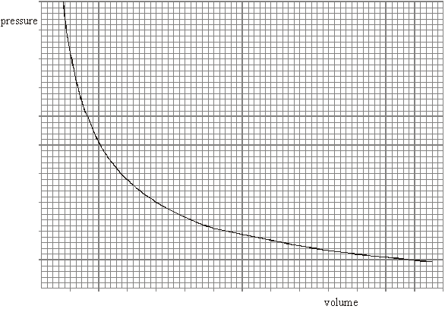

(a) On the same axes, sketch two additional curves A and B, if the following changes are made.
(i) The same mass of gas at a lower constant temperature (label this A).
(ii) A greater mass of gas at the original constant temperature (label this B).
(2)
(b) A cylinder of volume 0.20 m³ contains an ideal gas at a pressure of 130 kPa and a temperature of 290 K. Calculate
(i) the amount of gas, in moles, in the cylinder,
.............................................................................................................
.............................................................................................................
.............................................................................................................
(ii) the average kinetic energy of a molecule of gas in the cylinder,
.............................................................................................................
(iii) the average kinetic energy of the molecules in the cylinder.
.............................................................................................................
.............................................................................................................
.............................................................................................................
(5)
(Total 7 marks)
Q66. (a) State, in words, Newton’s law of gravitation.
......................................................................................................................
......................................................................................................................
......................................................................................................................
......................................................................................................................
(3)
(b) By considering the centripetal force which acts on a planet in a circular orbit,
show that T² R³, where T is the time taken for one orbit around the Sun and R is the radius of the orbit.
......................................................................................................................
......................................................................................................................
......................................................................................................................
......................................................................................................................
......................................................................................................................
(3)

(c) The Earth’s orbit is of mean radius 1.50 × 10¹¹ m and the Earth’s year is 365 days long.
(i) The mean radius of the orbit of Mercury is 5.79 × 10¹⁰ m. Calculate the length of Mercury’s year.
.............................................................................................................
.............................................................................................................
.............................................................................................................
.............................................................................................................
.............................................................................................................
.............................................................................................................
.............................................................................................................
(ii) Neptune orbits the Sun once every 165 Earth years.
Calculate the ratio $distanceSunNeptune\frac{}{distance}SunEarth$.
.............................................................................................................
.............................................................................................................
.............................................................................................................
.............................................................................................................
.............................................................................................................
.............................................................................................................
.............................................................................................................
(4)
(Total 10 marks)
Q67. (a) Suggest two reasons why an α particle causes more ionisation than a β particle of the same initial kinetic energy.
You may be awarded marks for the quality of written communication in your answer.
......................................................................................................................
......................................................................................................................
......................................................................................................................
......................................................................................................................
......................................................................................................................
......................................................................................................................
(2)

(b) A radioactive source has an activity of 3.2 × 10⁹ Bq and emits α particles, each with kinetic energy of 5.2 Me V. The source is enclosed in a small aluminium container of mass 2.0 × 10^{–4} kg which absorbs the radiation completely.
(i) Calculate the energy, in J, absorbed from the source each second by the aluminium container.
.............................................................................................................
.............................................................................................................
.............................................................................................................
.............................................................................................................
(ii) Estimate the temperature rise of the aluminium container in 1 minute, assuming no energy is lost from the aluminium.
specific heat capacity of aluminium = 900 J kg^{–1} K^{–1}
..............................................................................................................
.............................................................................................................
.............................................................................................................
.............................................................................................................
(5)
(Total 7 marks)
Q68. In a football match, a player kicks a stationary football of mass 0.44 kg and gives it a speed of 32 m s^{–1}.
(a) (i) Calculate the change of momentum of the football.
.............................................................................................................
(ii) The contact time between the football and the footballer’s boot was 9.2 m s. Calculate the average force of impact on the football.
.............................................................................................................
.............................................................................................................
.............................................................................................................
(3)

(b) A video recording showed that the toe of the boot was moving on a circular arc of radius 0.62 m centred on the knee joint when the football was struck. The force of the impact slowed the boot down from a speed of 24 m s^{–1} to a speed of 15 m s^{–1}.
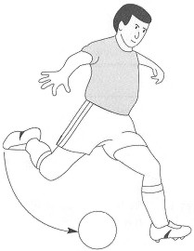
Figure 1
(i) Calculate the deceleration of the boot along the line of the impact force when it struck the football.
.............................................................................................................
.............................................................................................................
.............................................................................................................
(ii) Calculate the centripetal acceleration of the boot just before impact.
.............................................................................................................
.............................................................................................................
.............................................................................................................
(iii) Discuss briefly the radial force on the knee joint before impact and during the impact.
.............................................................................................................
.............................................................................................................
.............................................................................................................
.............................................................................................................
.............................................................................................................
.............................................................................................................
.............................................................................................................
.............................................................................................................
(4)
(Total 7 marks)

Q69. (a) (i) One of the assumptions of the kinetic theory of gases is that molecules make elastic collisions. State what is meant by an elastic collision.
.............................................................................................................
.............................................................................................................
(ii) State two more assumptions that are made in the kinetic theory of gases.
.............................................................................................................
.............................................................................................................
.............................................................................................................
.............................................................................................................
(3)
(b) One mole of hydrogen at a temperature of 420 K is mixed with one mole of oxygen at 320 K. After a short period of time the mixture is in thermal equilibrium.
(i) Explain what happens as the two gases approach and then reach thermal equilibrium.
.............................................................................................................
.............................................................................................................
.............................................................................................................
.............................................................................................................
(ii) Calculate the average kinetic energy of the hydrogen molecules before they are mixed with the oxygen molecules.
.............................................................................................................
.............................................................................................................
.............................................................................................................
(4)
(Total 7 marks)
Q70. (a) A body is moving with simple harmonic motion. State two conditions that must be satisfied concerning the acceleration of the body.
condition 1 ....................................................................................................
......................................................................................................................
condition 2 …..........................……...............................................................
......................................................................................................................
(2)

(b) A mass is suspended from a vertical spring and the system is allowed to come to rest.
When the mass is now pulled down a distance of 76 mm and released, the time taken for 25 oscillations is 23 s.
Calculate
(i) the frequency of the oscillations,
.............................................................................................................
.............................................................................................................
(ii) the maximum acceleration of the mass,
.............................................................................................................
.............................................................................................................
(iii) the displacement of the mass from its rest position 0.60 s after being released.
State the direction of this displacement.
.............................................................................................................
.............................................................................................................
.............................................................................................................
.............................................................................................................
(6)
(c) Figure 1
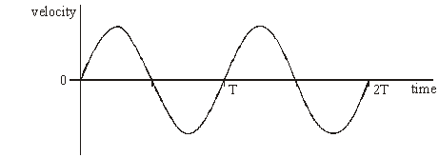
Figure 1 shows qualitatively how the velocity of the mass varies with time over the first two cycles after release.
(i) Using the axes in Figure 2, sketch a graph to show qualitatively how the displacement of the mass varies with time during the same time interval.
Figure 2
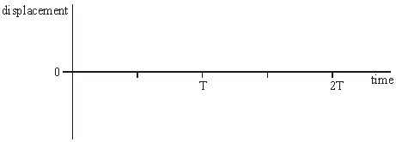
(ii) Using the axes in Figure 3, sketch a graph to show qualitatively how the potential energy of the mass-spring system varies with time during the same time interval.
Figure 3
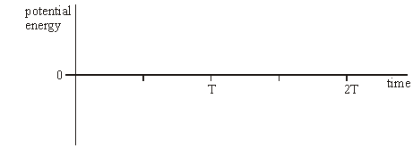
(4)
(Total 12 marks)
Q71. Figure 1 shows a spring loaded with a mass of 0.15 kg. When the mass is displaced vertically it oscillates up and down. A and C show the extreme positions of the mass and B is its equilibrium position.
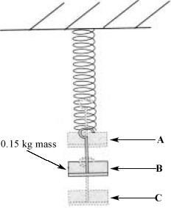
Figure 1
(a) The 0.15 kg mass extends the spring by 0.040 m. Calculate the elastic potential energy stored in the spring when it is extended by this amount.
gravitational field strength, g = 9.8 N kg^{–1}

Elastic potential energy = ..................................
(2)

(b) (i) Mark and label on the diagram the amplitude of the motion.
(1)
(ii) Describe the energy changes that occur during one cycle when the mass is pulled down to position C and then released. You should consider the motion to be undamped during this cycle.
...............................................................................................................
...............................................................................................................
...............................................................................................................
...............................................................................................................
...............................................................................................................
(2)
(Total 5 marks)
Q72. (a) The equation that describes simple harmonic motion is
a = –ω²x.
State the meaning of the symbol ω in this equation and go on to explain the significance of the negative sign.
........................................................................................................................
........................................................................................................................
........................................................................................................................
........................................................................................................................
(2)

(b) Figure 1a shows a demonstration used in teaching simple harmonic motion. A sphere rotates in a horizontal plane on a turntable. A lamp produces a shadow of the sphere. This shadow moves with approximate simple harmonic motion on the vertical screen.
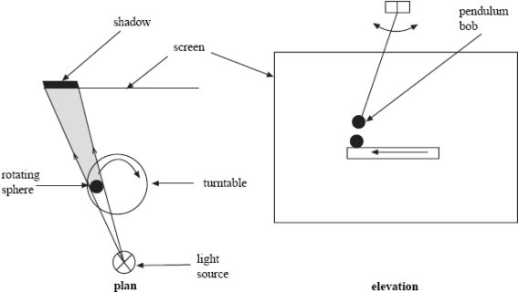
Figure 1a Figure 1b

(i) The turntable has a radius of 0.13 m and the teacher wishes the time taken for one cycle of the motion to be 2.2 s. The mass of the sphere is 0.050 kg.
Calculate the magnitude of the horizontal force acting on the sphere.

(2)

(ii) State the direction in which the force acts.
...............................................................................................................
(1)

(c) Figure 1b shows how the demonstration might be extended. A simple pendulum is mounted above the turntable so that the shadows of the sphere and the pendulum bob can be seen to move in a similar way and with the same period.
(i) Calculate the required length of the pendulum.
acceleration due to gravity = 9.8 m s^{–2}

(1)
(ii) Calculate the maximum acceleration of the pendulum bob when its motion has an amplitude of 0.13 m.

(2)

(d) Figure 2 includes a graph of displacement against time for the pendulum. Sketch, on the axes below, graphs of
(i) acceleration against time for the bob, and
(ii) kinetic energy against time for the bob.
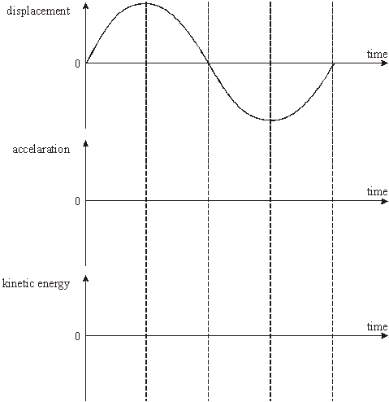
Figure 2
(4)
(Total 12 marks)

Q73. Figure 1 shows a p–V graph that you are to use to illustrate the process of a gas undergoing two changes.
In its initial state, the gas has a pressure of 50 kPa and a volume of 1.5 m³; this is plotted on the graph. First, the gas undergoes an isothermal change from an initial volume of 1.5 m³ to 0.85 m³ followed by a compression at constant pressure to a volume of 0.35 m³.
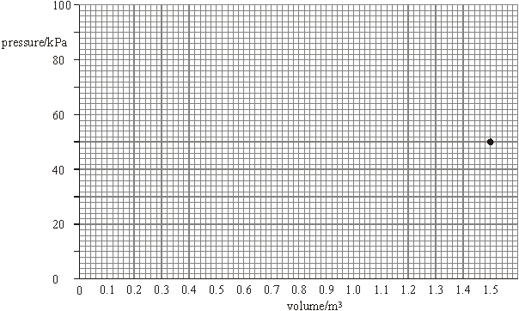
Figure 1
(a) Show that the final pressure of the gas is about 90 kPa.

(2)
(b) Complete the graph in Figure 1 to show both changes.

(2)
(c) (i) Use your graph to estimate the work done during the whole process.

(3)
(ii) State and explain whether the work in part (c)(i) is done on or by the gas.
...............................................................................................................
...............................................................................................................
(1)
(Total 8 marks)
Q74.The diagram below shows how the kinetic energy of a simple pendulum varies with displacement.
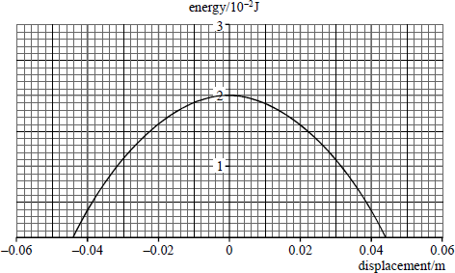
(a) Sketch on the diagram above a graph to show how the potential energy of the pendulum varies with displacement.
(2)
(b) (i) State the amplitude of the oscillation.
...............................................................................................................
(1)
(ii) The frequency of vibration of the pendulum is 3.5 Hz. Write down the equation that models the variation of position with time for the simple harmonic motion of this pendulum.
...............................................................................................................
(1)
(iii) Calculate the maximum acceleration of the simple pendulum.
(2)
(Total 6 marks)

Q75. The diagram below shows a diagram of a mass spectrometer.
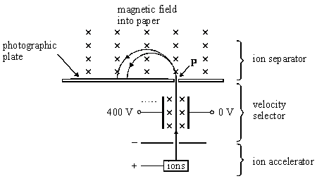
(a) The magnetic field strength in the velocity selector is 0.14 T and the electric field strength is 20 000 V m^{–1}.
(i) Define the unit for magnetic flux density, the tesla.
...............................................................................................................
...............................................................................................................
(2)
(ii) Show that the velocity selected is independent of the charge on an ion.

(2)
(iii) Show that the velocity selected is about 140 km s^{–1}.

(1)

(b) A sample of nickel is analysed in the spectrometer. The two most abundant isotopes of nickel are ${}_{28}^{58}{}$ and ${}_{28}^{60}{}$. Each ion carries a single charge of +1.6 × 10^{–19} C.
mass of a proton or neutron = 1.7 × 10^{–27} kg
The ${}_{28}^{58}{}$ ion strikes the photographic plate 0.28 m from the point P at which the ion beam enters the ion separator.
Calculate:
(i) the magnetic flux density of the field in the ion separator;

(3)
(ii) the separation of the positions where the two isotopes hit the photographic plate.

(2)
(Total 10 marks)
Q76. (a) Explain the meaning of the statement the specific heat capacity of ice is 2100 J kg ^{–1}K^{–1}.
........................................................................................................................
........................................................................................................................
........................................................................................................................
........................................................................................................................
(2)

(b) An engineer is designing an ice-making machine. Water will enter the device at 18°C and the ice cubes are to be cooled to –5°C before release.
(i) Show that about 0.4 MJ of energy must be removed from 1.0 kg of water at 18°C to change it into ice at –5°C.
Set out the stages in your answer clearly.
specific heat capacity of water = 4.2 ×10³ J kg^{–1} K^{–1}
specific heat capacity of ice = 2.1 ×10³ J kg^{–1} K^{–1}
specific latent heat of fusion of ice = 3.3 ×10⁵ J kg^{–1}

(3)
(ii) The design brief requires that 1.5 kg of water is frozen in 300 s. Calculate the rate at which energy must be removed by the machine.

(2)
(Total 7 marks)

Q77. Figure 1 shows a mass suspended on a spring.
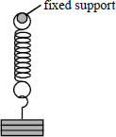
Figure 1
The mass is pulled down by a distance A below the equilibrium position and then released at time t = 0. It undergoes simple harmonic motion.
(a) Taking upward displacements as being positive, draw graphs on Figure 2 to show the variation of displacement, velocity and the acceleration with time. Use the same time scale for each of the three graphs.
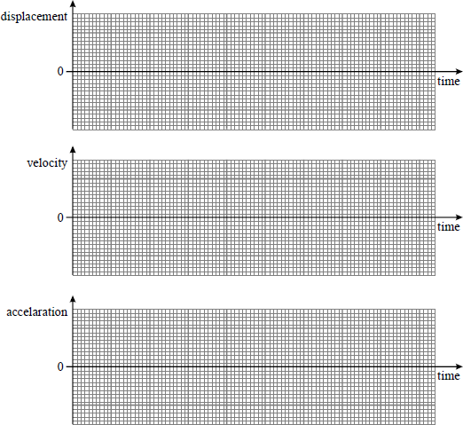
Figure 2
(4)

(b) The spring stiffness, k, is 32 N m^{–1}. The spring is loaded with a mass of 0.45 kg.
Calculate the frequency of the oscillation.

(3)
(Total 7 marks)
Q78. The diagram below shows a simple accelerometer designed to measure the centripetal acceleration of a car going round a bend following a circular path.
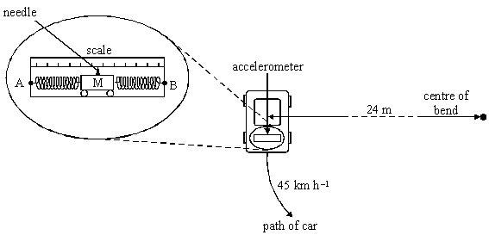
The two ends A and B are fixed to the car. The mass M is free to move between the two springs.
The needle attached to the mass moves along a scale to indicate the acceleration.
In one instant a car travels round a bend of radius 24 m in the direction shown in the diagram above. The speed of the car is 45 km h^{–1}.
(a) State and explain the direction in which the pointer moves from its equilibrium position.
........................................................................................................................
........................................................................................................................
........................................................................................................................
........................................................................................................................
(3)

(b) (i) Calculate the acceleration that would be recorded by the accelerometer.

(2)
(ii) The mass M between the springs in the accelerometer is 0.35 kg. A test shows that a force of 0.75 N moves the pointer 27 mm.
Calculate the displacement of the needle from the equilibrium position when the car is travelling with the acceleration in part (i).

(2)
(c) When the car leaves the bend the accelerometer eventually returns to its zero reading after a few cycles of damped simple harmonic motion.
(i) Calculate the period of the oscillation of the mass M.

(3)

(ii) Sketch, on the axes below, a graph showing how the displacement of the mass varies with time from the instant the car leaves the bend. Include appropriate values on the axes of your graph.
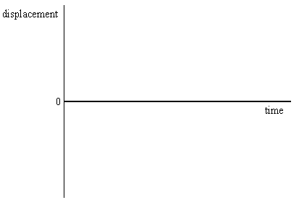
(2)
Total 12 marks)
Q79. The diagram below shows a number of smoke particles suspended in air. The arrows indicate the directions in which the particles are moving at a particular time.
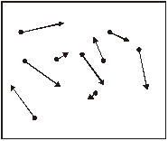
(a) (i) Explain why the smoke particles are observed to move.
...............................................................................................................
...............................................................................................................
(1)
(ii) Smoke particles are observed to move in a random way. State two conclusions about air molecules and their motion resulting from this observation.
...............................................................................................................
...............................................................................................................
...............................................................................................................
...............................................................................................................
(2)
(b) A sample of air has a density of 1.24 kg m^{–3} at a pressure of 1.01 × 10⁵ Pa and a temperature of 300 K.
the Boltzmann constant = 1.38 × 10^{–23} J K^{–1}
(i) Calculate the mean kinetic energy of an air molecule under these conditions.

(2)
(ii) Calculate the mean square speed for the air molecules.

(3)
(iii) Explain why, when the temperature of the air is increased to 320 K, some of the molecules will have speeds much less than that suggested by the value you calculated in part (b)(ii).
...............................................................................................................
...............................................................................................................
...............................................................................................................
...............................................................................................................
(2)
(Total 10 marks)
Q80. The diagram below shows a way to measure the mass of a lorry. The vehicle and its contents are driven onto a platform mounted on a spring. The platform is then made to oscillate vertically and the mass is found from a measurement of the natural frequency of oscillation.
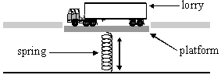
(a) (i) State whether the period of oscillation increases, decreases or remains unchanged when the amplitude of oscillation of the platform is reduced.
...............................................................................................................
(1)
(ii) The spring constant k of the supporting spring is increased to four times its original value.
State the value of the ratio. $\frac{newoscillationperiod}{oldoscillationperiod}$
...............................................................................................................
(1)
(iii) The time period of oscillation is T when a lorry is on the platform. The spring constant of the spring is k. Show that the total mass M of lorry and platform is given by $M=\frac{kT^{2}}{4π^{2}}$

(2)
(iv) A lorry and its contents have a total mass of 5300 kg. The spring constant of the supporting spring k is 1.9 × 10⁵ N m^{–1}. The frequency of oscillation of the platform with the lorry resting on it is 0.91 Hz.
Calculate the mass of the platform.

(3)

(b) The graph below shows how the displacement of the platform varies with time over one cycle. Sketch on the axes provided graphs of velocity against time and kinetic energy against time for the motion of the platform.
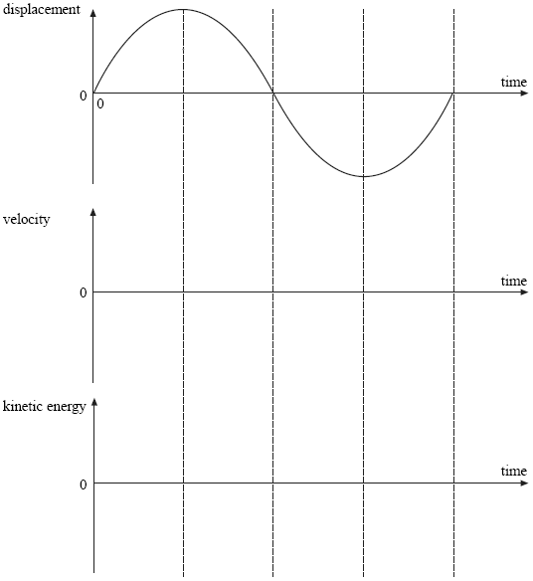
(5)

(c) The driver is required to turn off the vehicle engine whilst the measurement is taking place.
The driver of the lorry in part (a)(iv) fails to do this and slowly increases the frequency of vibration of his vehicle from 0.5 Hz to about 4 Hz whilst the measurement is in progress and the platform is free to move. Describe and explain how the amplitude and frequency of the platform vary as this frequency increase occurs. You should use a sketch graph to support your answer.

........................................................................................................................
........................................................................................................................
........................................................................................................................
........................................................................................................................
........................................................................................................................
........................................................................................................................
(4)
(Total 16 marks)
Q81. (a) State the conditions necessary for a mass to undergo simple harmonic motion.
........................................................................................................................
........................................................................................................................
(2)

(b) A child on a swing oscillates with simple harmonic motion of period 3.2 s.
acceleration of free fall = 9.8 m s^{–2}
(i) Calculate the distance between the point of support and the centre of mass of the system.

(2)
(ii) The total energy of the oscillations is 40 J when the amplitude of the oscillations is 0.50 m. Sketch a graph showing how the total energy of the child varies with the amplitude of the oscillations for amplitudes between 0 and 1.00 m. Include a suitable scale on the total energy axis.
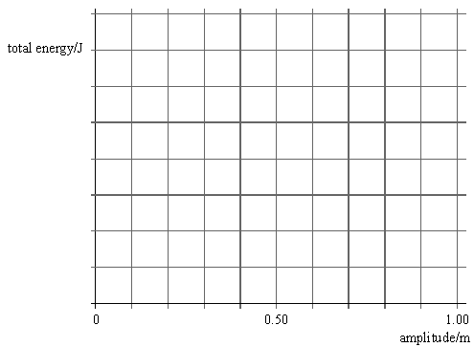
(2)
(Total 6 marks)

Q82.The diagram below shows the rotor-blade arrangement used in a model helicopter. Each of the blades is 0.55 m long with a uniform cross-sectional area of 3.5 × 10⁻⁴ m² and negligible mass. An end-cap of mass 1.5 kg is attached to the end of each blade.
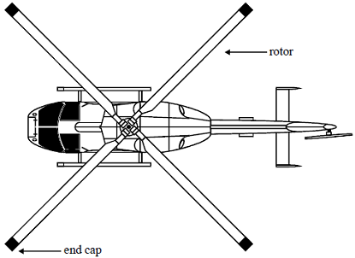
(a) (i) Show that there is a force of about 7 kN acting on each end-cap when the blades rotate at 15 revolutions per second.

(3)
(ii) State the direction in which the force acts on the end-cap.
...............................................................................................................
(1)
(iii) Show that this force leads to a longitudinal stress in the blade of about 20 MPa.

(2)
(iv) Calculate the change in length of the blade as a result of its rotation.
Young modulus of the blade material = 6.0 × 10¹⁰ Pa

(2)

(v) Calculate the total strain energy stored in one of the blades due to its extension.

(2)
(b) The model helicopter can be made to hover above a point on the ground by directing the air from the rotors vertically downwards at speed v.
(i) Show that the change in momentum of the air each second is Aρv², where A is the area swept out by the blades in one revolution and ρ is the density of air.

(2)
(ii) The model helicopter has a weight of 900 N. Calculate the speed of the air downwards when the helicopter has no vertical motion.
Density of air = 1.3 kg m⁻³

(3)
(Total 15 marks)

Q83. The diagram below shows a simple pendulum that consists of a large mass at the end of a long string. A, B and C are positions of the pendulum as it oscillates in the air. A and C are the extreme positions of the motion and B is the centre of the motion.
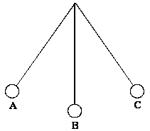
(a) State clearly in terms of the positions shown on the diagram what is meant by the period of oscillation of the pendulum.
........................................................................................................................
........................................................................................................................
........................................................................................................................
........................................................................................................................
(2)
(b) The diagram shows positions of the bob during an oscillation. State at which position the damping is greatest. Explain why the damping is greatest in the position you have quoted.
........................................................................................................................
........................................................................................................................
........................................................................................................................
........................................................................................................................
(3)
(Total 5 marks)
Q84. (a) Simple harmonic motion may be represented by the equation
a = – (2πf)²x
(i) Explain the significance of the minus sign in this equation.
...............................................................................................................
...............................................................................................................
(1)

(ii) In Figure 1 sketch the corresponding v-t graph to show how the phase of velocity v relates to that of the acceleration a.
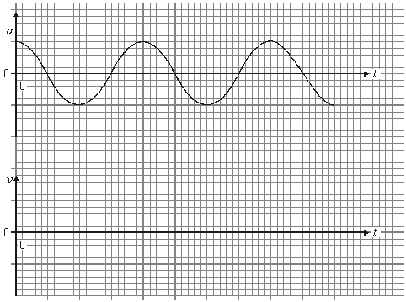
(1)
(b) (i) A mass of 24 kg is attached to the end of a spring of spring constant 60 N m^{–1}. The mass is displaced 0.035 m vertically from its equilibrium position and released. Show that the maximum kinetic energy of the mass is about 40 mJ.

(5)
(ii) When the mass on the spring is quite heavily damped its amplitude halves by the end of each complete cycle. On the grid of Figure 2 sketch a graph to show how the kinetic energy, E_{k}, of the mass on the spring varies with time over a single period. Start at time, t = 0, with your maximum kinetic energy. You should include suitable values on each of your scales.
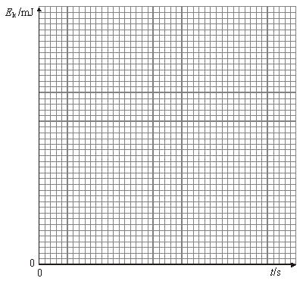
(3)
(Total 10 marks)
Q85. An electric oven is connected to a 230 V root mean square (rms) mains supply using a cable of negligible resistance.
(a) (i) Calculate the peak-to-peak voltage of the mains supply.
peak-to-peak voltage = ......................... V
(2)
(ii) The resistance of the heating element in the oven at its working temperature is 12 Ω.
Calculate the power dissipated by the heating element in the oven.
Give your answer to an appropriate number of significant figures.
power = ......................... W
(3)
(b) In practice the resistance of the cable connecting the oven to the mains supply is not negligible. Each of the two wires connecting the heating element to the mains electricity supply has a length of 3.15 m. Each metre of wire has a resistance of 0.0150 Ω.

(i) Explain why the rms voltage across the heating element in the oven will be less than
230 V.
...................................................................................................................
...................................................................................................................
...................................................................................................................
...................................................................................................................
(2)
(ii) Calculate the rms voltage across the heating element in the oven when it is at its working temperature.
r.m.s. voltage = ......................... V
(3)
(iii) Calculate the average power wasted in the cable due to the heating effect of the electric current.
average power = ......................... W
(2)
(iv) State two reasons why it is important that the cable has a low resistance.
1 ................................................................................................................
...................................................................................................................
...................................................................................................................
2 ................................................................................................................
...................................................................................................................
...................................................................................................................
(2)
(Total 14 marks)

Q86. The table shows the binding energy per nucleon for two nuclei.

nucleus | binding energy per  nucleon/10^{–12}J
helium-4 | 1.1332417
beryllium-8 | 1.1314027

(a) (i) Explain what is meant by the total binding energy of a nucleus.
...............................................................................................................
...............................................................................................................
(1)
(ii) It is more usual to quote binding energies of nucleons in MeV rather than J.
Calculate the total binding energy, in MeV, of a beryllium-8 nucleus.

binding energy .........................................................MeV
(3)
(b) (i) Calculate the change in mass that occurs when two helium-4 nuclei fuse to form a beryllium-8 nucleus.

mass change .........................................................kg
(2)
(ii) Two helium-4 nuclei are initially separated by a large distance and are travelling toward one another. The helium nuclei become influenced by the strong force when their centres are separated by a distance of 3.82 × 10^{–15} m.
Calculate the total initial kinetic energy of the nuclei needed for them to reach this separation.

kinetic energy ..........................................................J
(3)

(iii) Explain why the kinetic energy calculated in part (b)(ii) will not enable the helium nuclei to fuse and produce a beryllium-8 nucleus.
...............................................................................................................
...............................................................................................................
...............................................................................................................
...............................................................................................................
(3)
(Total 12 marks)
Q87. (a) (i) Define gravitational field strength and state whether it is a scalar or vector quantity.
...............................................................................................................
...............................................................................................................
...............................................................................................................
...............................................................................................................
(2)
(ii) A mass m is at a height h above the surface of a planet of mass M and radius R.
The gravitational field strength at height h is g. By considering the gravitational force acting on mass m, derive an equation from Newton’s law of gravitation to express g in terms of M, R, h and the gravitational constant G.

(2)
(b) (i) A satellite of mass 2520 kg is at a height of 1.39 × 10⁷ m above the surface of the Earth. Calculate the gravitational force of the Earth attracting the satellite.
Give your answer to an appropriate number of significant figures.

force attracting satellite ........................................ N
(3)
(ii) The satellite in part (i) is in a circular polar orbit. Show that the satellite would travel around the Earth three times every 24 hours.

(5)
(c) State and explain one possible use for the satellite travelling in the orbit in part (ii).
........................................................................................................................
........................................................................................................................
........................................................................................................................
........................................................................................................................
........................................................................................................................
........................................................................................................................
(2)
(Total 14 marks)
Q88. (a) Define the electric potential at a point in an electric field.
........................................................................................................................
........................................................................................................................
........................................................................................................................
........................................................................................................................
........................................................................................................................
........................................................................................................................
(3)
(b) Figure 1 shows part of the region around a small positive charge.
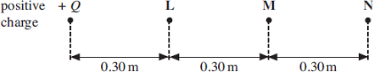
Figure 1

(b) (i) The electric potential at point L due to this charge is + 3.0 V. Calculate the magnitude Q of the charge. Express your answer to an appropriate number of significant figures.

answer = ................................. C
(3)

(ii) Show that the electric potential at point N, due to the charge, is +1.0 V.

(1)
(iii) Show that the electric field strength at point M, which is mid-way between L and N, is
2.5 Vm^{–1}.

(1)
(c) R and S are two charged parallel plates, 0.60 m apart, as shown in Figure 2.
They are at potentials of + 3.0 V and + 1.0 V respectively.
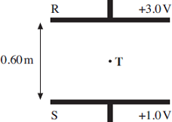
Figure 2
(i) On Figure 2, sketch the electric field between R and S, showing its direction.
(2)
(ii) Point T is mid-way between R and S.
Calculate the electric field strength at T.

answer = .......................... Vm^{–1}
(1)
(iii) Parts (b)(iii) and (c)(ii) both involve the electric field strength at a point mid-way between potentials of + 1.0 V and + 3.0 V. Explain why the magnitudes of these electric field strengths are different.
...............................................................................................................
...............................................................................................................
...............................................................................................................
(1)
(Total 12 marks)

Q89. The figure below shows part of the discharge curve for a capacitor that a manufacturer tested for use in a heart pacemaker.
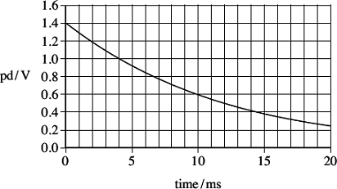
The capacitor was initially charged to a potential difference (pd) of 1.4 V and then discharged through a 150 Ω resistor.
(a) Show that the capacitance of the capacitor used is about 80 μF.
........................................................................................................................
........................................................................................................................
........................................................................................................................
........................................................................................................................
........................................................................................................................
(3)
(b) Explain why the rate of change of the potential difference decreases as the capacitor discharges.
........................................................................................................................
........................................................................................................................
........................................................................................................................
........................................................................................................................
........................................................................................................................
(3)
(c) Calculate the percentage of the initial energy stored by the capacitor that is lost by the capacitor in the first 0.015 s of the discharge.

energy lost .........................................................%
(3)
(d) The charge leaving the capacitor in 0.015 s is the charge used by the pacemaker to provide a single pulse to stimulate the heart.
(i) Calculate the charge delivered to the heart in a single pulse.

charge .........................................................C
(1)
(ii) The manufacturer of the pacemaker wants it to operate for a minimum of 5 years working at a constant pulse rate of 60 per minute.
Calculate the minimum charge capacity of the power supply that the manufacturer should specify so that it will operate for this time.
Give your answer in amp-hours (Ah).

minimum capacity .........................................................Ah
(2)
(Total 12 marks)
Q90. The figure below shows the variation of gravitational potential, V, with distance from the centre of the Earth, r. The radius of the Earth is 6.4 × 10⁶ m.
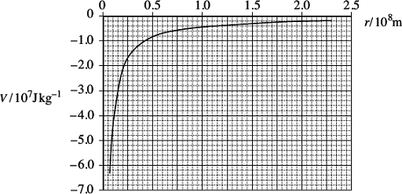
(a) Explain why the V values are negative.
........................................................................................................................
........................................................................................................................
........................................................................................................................
........................................................................................................................
........................................................................................................................
........................................................................................................................
(3)
(b) Use data from the graph to show that the mass of the Earth is approximately 6 × 10²⁴ kg.

(3)
(c) (i) Calculate the work done in raising a satellite of mass 2100 kg from the surface of the Earth to a height of 850 km above the surface of the Earth.

work done ......................................................... J
(3)
(ii) Calculate the change in the kinetic energy of the satellite when it moves from its
850 km orbit to one at a height of 700 km above the Earth’s surface. Make it clear whether the change in kinetic energy is an increase or decrease.

kinetic energy change ......................................................... J
(4)

(iii) Without performing any further calculations explain how the change in kinetic energy relates to the change of the potential energy when the satellite’s orbit alters as in part (c)(ii).
...............................................................................................................
...............................................................................................................
...............................................................................................................
...............................................................................................................
...............................................................................................................
(2)
(Total 15 marks)
Q91. (a) Define the capacitance of a capacitor.
........................................................................................................................
........................................................................................................................
........................................................................................................................
........................................................................................................................
(2)
(b) The circuit shown in the figure below contains a battery, a resistor, a capacitor and a switch.
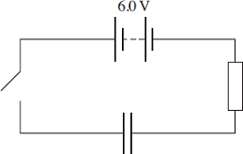
The switch in the circuit is closed at time t = 0. The graph shows how the charge Q stored by the capacitor varies with t.
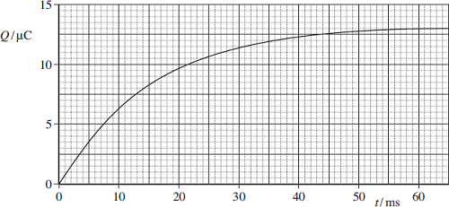
(b) (i) When the capacitor is fully charged, the charge stored is 13.2 μC. The electromotive force (emf) of the battery is 6.0 V. Determine the capacitance of the capacitor.

answer = ................................. F
(2)
(ii) The time constant for this circuit is the time taken for the charge stored to increase from 0 to 63% of its final value. Use the graph to find the time constant in milliseconds.

answer = ................................. ms
(2)
(iii) Hence calculate the resistance of the resistor.

answer = ................................. Ω
(1)
(iv) What physical quantity is represented by the gradient of the graph?
...............................................................................................................
...............................................................................................................
(1)
(c) (i) Calculate the maximum value of the current, in mA, in this circuit during the charging process.

answer = ................................. mA
(1)
(ii) Sketch a graph on the outline axes to show how the current varies with time as the capacitor is charged. Mark the maximum value of the current on your graph.
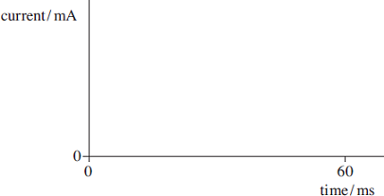
(2)
(Total 11 marks)
Q92. The Large Hadron Collider (LHC) uses magnetic fields to confine fast-moving charged particles travelling repeatedly around a circular path. The LHC is installed in an underground circular tunnel of circumference 27 km.
(a) In the presence of a suitably directed uniform magnetic field, charged particles move at constant speed in a circular path of constant radius. By reference to the force acting on the particles, explain how this is achieved and why it happens.
........................................................................................................................
........................................................................................................................
........................................................................................................................
........................................................................................................................
........................................................................................................................
........................................................................................................................
........................................................................................................................
........................................................................................................................
........................................................................................................................
(4)
(b) (i) The charged particles travelling around the LHC may be protons. Calculate the centripetal force acting on a proton when travelling in a circular path of circumference 27 km at one-tenth of the speed of light. Ignore relativistic effects.

answer = ................................ N
(3)
(ii) Calculate the flux density of the uniform magnetic field that would be required to produce this force. State an appropriate unit.

answer = ...................................... unit ........................
(3)

(c) The speed of the protons gradually increases as their energy is increased by the LHC.
State and explain how the magnetic field in the LHC must change as the speed of the protons is increased.
........................................................................................................................
........................................................................................................................
........................................................................................................................
........................................................................................................................
........................................................................................................................
(2)
(Total 12 marks)
Q93. (a) Figure 1 shows an electron at a point in a uniform electric field at an instant when it is stationary.
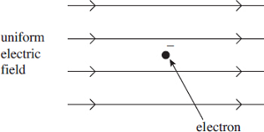
Figure 1

(i) Draw an arrow on Figure 1 to show the direction of the electrostatic force that acts on the stationary electron.
(1)
(ii) State and explain what, if anything, will happen to the magnitude of the electrostatic force acting on the electron as it starts to move in this field.
...............................................................................................................
...............................................................................................................
...............................................................................................................
...............................................................................................................
...............................................................................................................
(2)

(b) Figure 2a shows a stationary electron in a non-uniform electric field. Figure 2b shows a stationary proton, placed in exactly the same position in the same electric field as the electron in Figure 2a.

Figure 2a | Figure 2b
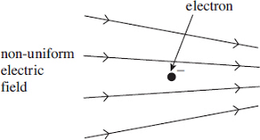 | 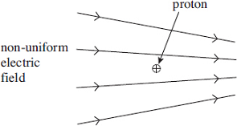
(i) State and explain how the electrostatic force on the proton in Figure 2b compares with that on the electron in Figure 2a.
...............................................................................................................
...............................................................................................................
...............................................................................................................
...............................................................................................................
...............................................................................................................
(2)
(ii) Each of the particles starts to move from the positions shown in Figure 2a and Figure 2b. State and explain how the magnitude of the initial acceleration of the proton compares with that of the electron.
...............................................................................................................
...............................................................................................................
...............................................................................................................
...............................................................................................................
...............................................................................................................
...............................................................................................................
(2)
(iii) Describe and explain what will happen to the acceleration of each of these particles as they continue to move in the electric field.
...............................................................................................................
...............................................................................................................
...............................................................................................................
...............................................................................................................
...............................................................................................................
...............................................................................................................
(2)
(c) The line spectrum of neon gas contains a prominent red line of wavelength 650 nm.
(i) Show that the energy required to excite neon atoms so that they emit light of this wavelength is about 2 eV.

(3)
(ii) An illuminated shop sign includes a neon discharge tube, as shown in Figure 3.
A pd of 4500 V is applied across the electrodes, which are 180 mm apart.
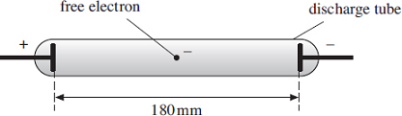
Figure 3

Assuming that the electric field inside the tube is uniform, calculate the minimum distance that a free electron would have to move from rest in order to excite the red spectral line in part (c).

answer = ................................ m
(3)
(Total 15 marks)
Q94. (a) State, in words, Coulomb’s law.
........................................................................................................................
........................................................................................................................
........................................................................................................................
........................................................................................................................
(2)
(b) The diagram below shows two point charges of +4.0 nC and +6.0 nC which are 68 mm apart.

(i) Sketch on the diagram above the pattern of the electric field surrounding the charges.
(3)
(ii) Calculate the magnitude of the electrostatic force acting on the +4.0 nC charge.

magnitude of force ................................ N
(2)
(c) (i) Calculate the magnitude of the resultant electric field strength at the mid-point of the line joining the two charges in the diagram above.
State an appropriate unit for your answer.

electric field strength ................................ unit ...............
(4)
(ii) State the direction of the resultant electric field at the mid-point of the line joining the charges.
...............................................................................................................
(1)
(Total 12 marks)

Q95. The graph below shows how the gravitational potential energy, E_{p}, of a 1.0 kg mass varies with distance, r, from the centre of Mars. The graph is plotted for positions above the surface of Mars.
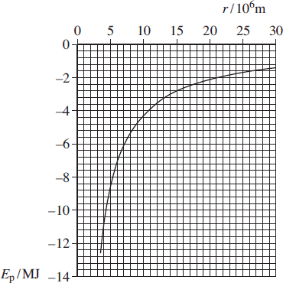
(a) Explain why the values of E_{p} are negative.
........................................................................................................................
........................................................................................................................
........................................................................................................................
........................................................................................................................
........................................................................................................................
(2)
(b) Use data from the graph to determine the mass of Mars.

mass of Mars .......................................... kg
(3)

(c) Calculate the escape velocity for an object on the surface of Mars.

escape velocity .................................... m s^{–1}
(3)
(d) Show that the graph data agree with E_{p} ∝ $\frac{1}{r}$

(3)
(Total 11 marks)
Q96. (a) State Lenz’s law.
........................................................................................................................
........................................................................................................................
........................................................................................................................
........................................................................................................................
(2)
(b) Figure 1 shows two small, solid metal cylinders, P and Q. P is made from aluminium. Q is made from a steel alloy.
Figure 1
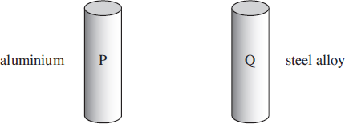

(i) The dimensions of P and Q are identical but Q has a greater mass than P. Explain what material property is responsible for this difference.
...............................................................................................................
...............................................................................................................
...............................................................................................................
(1)
(ii) When P and Q are released from rest and allowed to fall freely through a vertical distance of 1.0 m, they each take 0.45 s to do so. Justify this time value and explain why the times are the same.
...............................................................................................................
...............................................................................................................
...............................................................................................................
...............................................................................................................
...............................................................................................................
...............................................................................................................
(2)
(c) The steel cylinder Q is a strong permanent magnet. P and Q are released separately from the top of a long, vertical copper tube so that they pass down the centre of the tube, as shown in Figure 2.
Figure 2
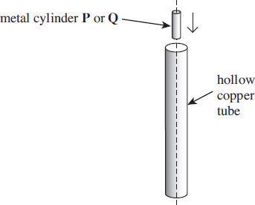
The time taken for Q to pass through the tube is much longer than that taken by P.

(i) Explain why you would expect an emf to be induced in the tube as Q passes through it.
...............................................................................................................
...............................................................................................................
...............................................................................................................
...............................................................................................................
(2)
(ii) State the consequences of this induced emf, and hence explain why Q takes longer than P to pass through the tube.
...............................................................................................................
...............................................................................................................
...............................................................................................................
...............................................................................................................
...............................................................................................................
...............................................................................................................
...............................................................................................................
...............................................................................................................
(3)
(d) The copper tube is replaced by a tube of the same dimensions made from brass. The resistivity of brass is much greater than that of copper. Describe and explain how, if at all, the times taken by P and Q to pass through the tube would be affected.
P: ...................................................................................................................
........................................................................................................................
........................................................................................................................
........................................................................................................................
Q: ...................................................................................................................
........................................................................................................................
........................................................................................................................
........................................................................................................................
(3)
(Total 13 marks)

Q97. (a) Describe how a beam of fast moving electrons is produced in the cathode ray tube of an oscilloscope.
........................................................................................................................
........................................................................................................................
........................................................................................................................
........................................................................................................................
........................................................................................................................
........................................................................................................................
(3)
(b) The figure below shows the cathode ray tube of an oscilloscope. The details of how the beam of electrons is produced are not shown.
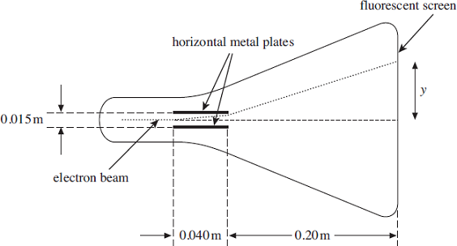
The electron beam passes between two horizontal metal plates and goes on to strike a fluorescent screen at the end of the tube. The plates are 0.040 m long and are separated by a gap of 0.015 m. A potential difference of 270 V is maintained between the plates.An individual electron takes 1.5 × 10^{–9} s to pass between the plates.The distance between the right-hand edge of the plates and the fluorescent screen is 0.20 m.
(i) Show that the vertical acceleration of an electron as it passes between the horizontal metal plates is approximately 3.2 × 10¹⁵ ms^{–2}.

(3)
(ii) Show that the vertical distance travelled by an electron as it passes between the horizontal metal plates is approximately 3.6 mm.

(2)
(iii) Show that the vertical component of velocity achieved by an electron in the beam by the time it reaches the end of the plates is approximately 4.7 × 10⁶ m s^{–1}.

(2)
(iv) Calculate the vertical displacement, y, of the electron beam from the centre of the screen. Give your answer in m.

vertical displacement ................................................ m
(3)
(Total 13 marks)
Q98.A rectangular coil is rotating anticlockwise at constant angular speed with its axle at right angles to a uniform magnetic field. Figure 1 shows an end-on view of the coil at a particular instant.
Figure 1
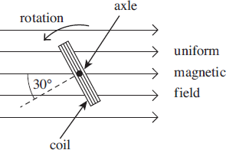
(a) At the instant shown in Figure 1, the angle between the normal to the plane of the coil and the direction of the magnetic field is 30°.
(i) State the minimum angle, in degrees, through which the coil must rotate from its position in Figure 1 for the emf to reach its maximum value.
angle ................................. degrees
(1)
(ii) Calculate the minimum angle, in radians, through which the coil must rotate from its position in Figure 1 for the flux linkage to reach its maximum value.

angle ................................. radians
(2)
(b) Figure 2 shows how, starting in a different position, the flux linkage through the coil varies with time.
(i) What physical quantity is represented by the gradient of the graph shown in Figure 2?
...............................................................................................................
(1)
(ii) Calculate the number of revolutions per minute made by the coil.

revolutions per minute ..............................................
(2)
Figure 2
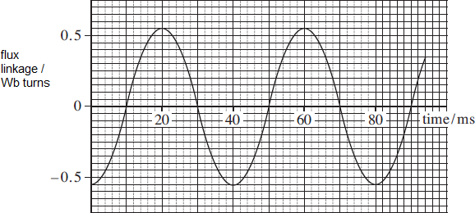

Figure 3
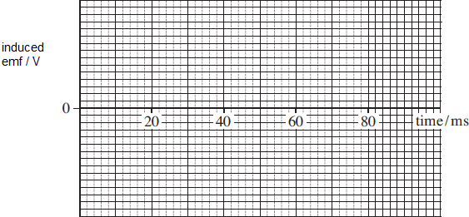
(iii) Calculate the peak value of the emf generated.

peak emf ......................................... V
(3)
(c) Sketch a graph on the axes shown in Figure 3 above to show how the induced emf varies with time over the time interval shown in Figure 2.
(2)
(d) The coil has 550 turns and a cross-sectional area of 4.0 × 10^{–3}m².
Calculate the flux density of the uniform magnetic field.

flux density .......................................... T
(2)
(Total 13 marks)

Q99. (a) (i) State two situations in which a charged particle will experience no magnetic force when placed in a magnetic field.
first situation...........................................................................................
...............................................................................................................
...............................................................................................................
second situation.....................................................................................
...............................................................................................................
...............................................................................................................
(2)
(ii) A charged particle moves in a circular path when travelling perpendicular to a uniform magnetic field. By considering the force acting on the charged particle, show that the radius of the path is proportional to the momentum of the particle.

(2)
(b) In a cyclotron designed to produce high energy protons, the protons pass repeatedly between two hollow D-shaped containers called ‘dees’. The protons are acted on by a uniform magnetic field over the whole area of the dees. Each proton therefore moves in a semi-circular path at constant speed when inside a dee. Every time a proton crosses the gap between the dees it is accelerated by an alternating electric field applied between the dees. The diagram below shows a plan view of this arrangement.
(i) State the direction in which the magnetic field should be applied in order for the protons to travel along the semicircular paths inside each of the dees as shown in the diagram above.
...............................................................................................................
(1)

(ii) In a particular cyclotron the flux density of the uniform magnetic field is 0.48 T. Calculate the speed of a proton when the radius of its path inside the dee is 190 mm.

speed .................................... ms^{–1}
(2)
(iii) Calculate the time taken for this proton to travel at constant speed in a semicircular path of radius 190 mm inside the dee.

time .......................................... s
(2)
(iv) As the protons gain energy, the radius of the path they follow increases steadily, as shown in the diagram above. Show that your answer to part (b)(iii) does not depend on the radius of the proton’s path.
...............................................................................................................
...............................................................................................................
...............................................................................................................
...............................................................................................................
...............................................................................................................
...............................................................................................................
(2)
(c) The protons leave the cyclotron when the radius of their path is equal to the outer radius of the dees. Calculate the maximum kinetic energy, in Me V, of the protons accelerated by the cyclotron if the outer radius of the dees is 470 mm.

maximum kinetic energy .................................... Me V
(3)
(Total 14 marks)
Q100. The graph below shows how a sinusoidal alternating voltage varies with time when connected across a resistor, R.
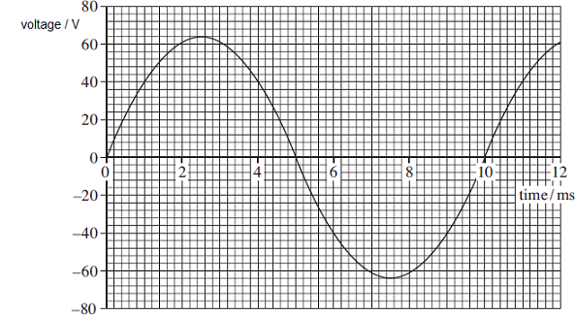
(a) (i) State the peak-to-peak voltage.

peak-to-peak voltage...........................................V
(1)
(ii) State the peak voltage.

peak voltage...........................................V
(1)
(iii) Calculate the root mean square (rms) value of the alternating voltage.

rms voltage...........................................V
(2)
(iv) Calculate the frequency of the alternating voltage. State an appropriate unit.

frequency.........................................unit ...............
(3)

(b) On the graph above draw a line to show the dc voltage that gives the same rate of energy dissipation in R as produced by the alternating waveform.
(2)
(c) An oscilloscope has a screen of eight vertical and ten horizontal divisions.
Describe how you would use the oscilloscope to display the alternating waveform in the graph above so that two complete cycles are visible.
........................................................................................................................
........................................................................................................................
........................................................................................................................
........................................................................................................................
........................................................................................................................
........................................................................................................................
........................................................................................................................
........................................................................................................................
(3)
(Total 12 marks)
Q101. (a) When an uncharged capacitor is charged by a constant current of 4.5 μA for 60 s the pd across it becomes 4.4 V.
(i) Calculate the capacitance of the capacitor.

capacitance ......................................... F
(3)
(ii) The capacitor is charged using the circuit shown in Figure 1. The battery emf is 6.0 V and its internal resistance is negligible. In order to keep the current constant at 4.5 μA, the resistance of the variable resistor R is decreased steadily as the charge on the capacitor increases.
Figure 1
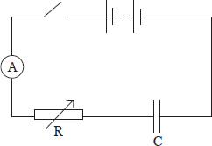

Calculate the resistance of R when the uncharged capacitor has been charging for 30 s.

resistance ........................................ Ω
(3)
(b) The circuit in Figure 2 contains a cell, an uncharged capacitor, a fixed resistor and a two-way switch.
Figure 2
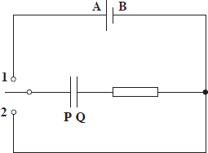
The switch is moved to position 1 until the capacitor is fully charged. The switch is then moved to position 2.
Describe what happens in this circuit after the switch is moved to position 1, and after it has been moved to position 2. In your answer you should refer to:
- the direction in which electrons flow in the circuit, and how the flow of electrons changes with time,
- how the potential differences across the resistor and the capacitor change with time,
- the energy changes which take place in the circuit.
The terminals of the cell are labelled A and B and the capacitor plates are labelled P and Q so that you can refer to them in your answer.
The quality of your written communication will be assessed in your answer.
........................................................................................................................
........................................................................................................................
........................................................................................................................
........................................................................................................................
........................................................................................................................
........................................................................................................................
............................................................................................ (contined on next page)
........................................................................................................................
........................................................................................................................
........................................................................................................................
........................................................................................................................
........................................................................................................................
(6)
(Total 12 marks)
Q102. (a) Figure 1 shows a negative ion which has a charge of –3e and is free to move in a uniform electric field. When the ion is accelerated by the field through a distance of 63 mm parallel to the field lines its kinetic energy increases by 4.0 × 10^{–16} J.
Figure 1
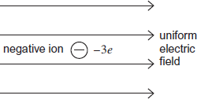
(i) State and explain the direction of the electrostatic force on the ion.
...............................................................................................................
...............................................................................................................
...............................................................................................................
...............................................................................................................
(2)
(ii) Calculate the magnitude of the electrostatic force acting on the ion.

magnitude of electrostatic force ........................................ N
(2)
(iii) Calculate the electric field strength.

electric field strength .................................. NC^{–1}
(1)
(b) Figure 2 shows a section of a horizontal copper wire carrying a current of 0.38 A.
A horizontal uniform magnetic field of flux density B is applied at right angles to the wire in the direction shown in the figure.
Figure 2
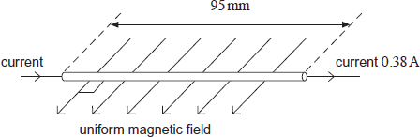
(i) State the direction of the magnetic force that acts on the moving electrons in the wire as a consequence of the current and explain how you arrive at your answer.
...............................................................................................................
...............................................................................................................
...............................................................................................................
...............................................................................................................
...............................................................................................................
(2)
(ii) Copper contains 8.4 × 10²⁸ free electrons per cubic metre. The section of wire in Figure 2 is 95 mm long and its cross-sectional area is 5.1 × 10^{–6} m².
Show that there are about 4 × 10²² free electrons in this section of wire.

(1)
(iii) With a current of 0.38 A, the average velocity of an electron in the wire is5.5 × 10^{–6} m s^{–1} and the average magnetic force on one electron is 1.4 × 10^{–25} N.
Calculate the flux density B of the magnetic field.

flux density ......................................... T
(2)
(Total 10 marks)

Q103. The graph shows how the charge Q stored by a capacitor varies with the potential difference (pd) V across it as V is increased from 9.0 V to 12.0 V.
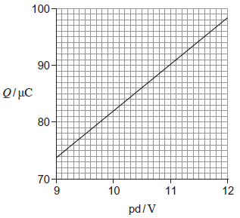
(a) (i) Use the graph to determine an accurate value for the capacitance of the capacitor.
capacitance = ......................... μF
(2)
(ii) Calculate the additional energy stored by the capacitor when V is increased from 9.0 V to 12.0 V.
additional energy = ......................... J
(3)
(b) When a 470 μF capacitor is discharged through a fixed resistor R, the pd across it decreases by 80% in 45 s.
(i) Calculate the time constant of the capacitor–resistor circuit.
time constant= ......................... s
(3)
(ii) Determine the resistance of R.
resistance = ......................... Ω
(2)
(iii) At which point during the discharging process is the capacitor losing charge at the smallest rate? Tick (✔) the correct answer.

✔ if correct
when the charge on the capacitor is greatest
when energy is dissipated at the greatest rate
when the current in the resistor is greatest
when the pd across R is least
(1)
(Total 11 marks)
Q104. The specification for a pacemaker requires a suitable charge to be delivered in 1.4 ms. A designer uses a circuit with a capacitor of capacitance 3.0 μF and a 2.5 V power supply to deliver the charge. The designer calculates that a suitable charge will be delivered to the heart as the capacitor discharges from a potential difference (pd) of 2.5 V to a pd of 1.2 V in 1.4 ms.
(a) (i) Calculate the charge on the capacitor when it is charged to a pd of 2.5 V.

charge .................................................. C
(1)

(ii) Draw a graph showing how the charge, Q, on the capacitor varies with the pd, V, as it discharges through the heart.
Include an appropriate scale on the charge axis.

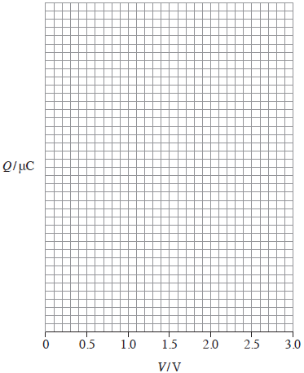
(3)
(b) Calculate the energy delivered to the heart in a single pulse from the pacemaker when the capacitor discharges to 1.2 V from 2.5 V.

energy ................................................... J
(3)
(c) (i) Calculate the resistance of the heart that has been assumed in the design.

resistance ................................................. Ω
(3)
(ii) Explain why the rate of change of pd between the capacitor plates decreases as the capacitor discharges.
...............................................................................................................
...............................................................................................................
...............................................................................................................
...............................................................................................................
...............................................................................................................
(2)
(Total 12 marks)
Q105. In stars, helium-3 and helium-4 are formed by the fusion of hydrogen nuclei. As the temperature rises, a helium-3 nucleus and a helium-4 nucleus can fuse to produce beryllium-7 with the release of energy in the form of gamma radiation.
The table below shows the masses of these nuclei.

Nucleus | Mass / u
Helium-3 | 3.01493
Helium-4 | 4.00151
Beryllium-7 | 7.01473
(a) (i) Calculate the energy released, in J, when a helium-3 nucleus fuses with a helium-4 nucleus.

energy released ................................................... J
(4)
(ii) Assume that in each interaction the energy is released as a single gamma-ray photon.
Calculate the wavelength of the gamma radiation.

More space on next page)

wavelength ................................................. m
(3)
(b) For a helium-3 nucleus and a helium-4 nucleus to fuse they need to be separated by no more than 3.5 × 10^{–15} m.
(i) Calculate the minimum total kinetic energy of the nuclei required for them to reach a separation of 3.5 × 10^{–15} m.

total kinetic energy ................................................... J
(3)
(ii) Calculate the temperature at which two nuclei with the average kinetic energy for that temperature would be able to fuse.
Assume that the two nuclei have equal kinetic energy.

temperature .................................................. K
(3)
(c) Scientists continue to try to produce a viable fusion reactor to generate energy on Earth using reactors like the Joint European Torus (JET). The method requires a plasma that has to be raised to a suitable temperature for fusion to take place.
(i) State two nuclei that are most likely to be used to form the plasma of a fusion reactor.
1 .............................................................................................................
2 .............................................................................................................
(2)

(ii) State one method which can be used to raise the temperature of the plasma to a suitable temperature.
...............................................................................................................
...............................................................................................................
(1)
(Total 16 marks)
Q106. The diagram below shows the main parts of a geophone.
The spike attaches the geophone firmly to the ground. At the instant an earthquake occurs, the case and coil move upwards due to the Earth’s movement. The magnet remains stationary due to its inertia. In 3.5 ms, the coil moves from a position where the flux density is 9.0 mT to a position where the flux density is 23.0 mT.
(a) The geophone coil has 250 turns and an area of 12 cm².
Calculate the average emf induced in the coil during the first 3.5 ms after the start of the earthquake.

emf ................................................. V
(3)

(b) Explain how the initial emf induced in the coil of the geophone would be affected:
if the stiffness of the springs were to be increased
........................................................................................................................
........................................................................................................................
if the number of turns on the coil were to be increased.
........................................................................................................................
........................................................................................................................
(2)
(c) (i) The geophone’s magnet has a mass of 8.0 × 10^{–3} kg and the spring stiffness of the system is 2.6 N m^{–1}.
Show that the natural period of oscillation of the mass−spring system is approximately 0.35 s.

(2)
(ii) At the instant that the Earth stops moving after one earthquake, the emf in the coil is at its maximum value of +8 V. The magnet continues to oscillate.
On the grid below, sketch a graph showing the variation of emf with time as the magnet’s oscillation decays.
Show at least three oscillations.
(3)
(Total 10 marks)
Q107. The planet Venus may be considered to be a sphere of uniform density 5.24 × 10³ kg m⁻³.
The gravitational field strength at the surface of Venus is 8.87 N kg⁻¹.
(a) (i) Show that the gravitational field strength g_{s} at the surface of a planet is related to the the density ρ and the radius R of the planet by the expression
$$g_{s}=\frac{4}{3}πGrρ$$
where G is the gravitational constant.

(2)

(ii) Calculate the radius of Venus.
Give your answer to an appropriate number of significant figures.
radius = ......................... m
(3)
(b) At a certain time, the positions of Earth and Venus are aligned so that the distance between them is a minimum.
Sketch a graph on the axes below to show how the magnitude of the gravitational field strength g varies with distance along the shortest straight line between their surfaces.
Consider only the contributions to the field produced by Earth and Venus.
Mark values on the vertical axis of your graph.
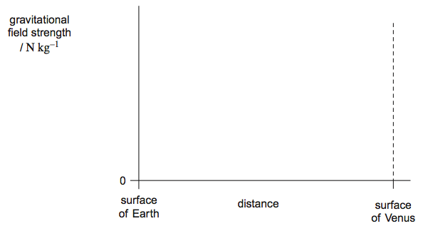
(3)
(Total 8 marks)
Q108. (a) (i) State what is meant by the term escape velocity.
...............................................................................................................
...............................................................................................................
(1)

(ii) Show that the escape velocity, v, at the Earth’s surface is given by v = $\sqrt{\frac{2GM}{R}}$
where M is the mass of the Earth
and R is the radius of the Earth.

(2)
(iii) The escape velocity at the Moon’s surface is 2.37 × 10³ m s^{–1} and the radius of the Moon is 1.74 × 10⁶ m.
Determine the mean density of the Moon.

mean density ......................................... kg m^{–3}
(2)
(b) State two reasons why rockets launched from the Earth’s surface do not need to achieve escape velocity to reach their orbit.
........................................................................................................................
........................................................................................................................
........................................................................................................................
........................................................................................................................
(2)
(Total 7 marks)
Q109. (a) Explain why astronauts in an orbiting space vehicle experience the sensation of weightlessness.
........................................................................................................................
........................................................................................................................
........................................................................................................................
........................................................................................................................
(2)

(b) A space vehicle has a mass of 16 800 kg and is in orbit 900 km above the surface of the Earth.
mass of the Earth = 5.97 × 10²⁴ kg
radius of the Earth = 6.38 × 10⁶ m
- Show that the orbital speed of the vehicle is approximately 7400 m s^{–1}.

(4)
(ii) The space vehicle moves from the orbit 900 km above the Earth’s surface to an orbit 400 km above the Earth’s surface where the orbital speed is 7700 m s^{–1}.
Calculate the total change that occurs in the energy of the space vehicle.
Assume that the vehicle remains outside the atmosphere after the change of orbit.
Use the value of 7400 m s^{–1} for the speed in the initial orbit.

change in energy ................................................... J
(4)
(Total 10 marks)

Q110. (a) Figure 1 shows two coils, P and Q, linked by an iron bar. Coil P is connected to a battery through a variable resistor and a switch S. Coil Q is connected to a centre-zero ammeter.
Figure 1
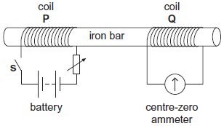
(i) Initially the variable resistor is set to its minimum resistance and S is open.
Describe and explain what is observed on the ammeter when S is closed.
...............................................................................................................
...............................................................................................................
...............................................................................................................
...............................................................................................................
...............................................................................................................
...............................................................................................................
(3)
(ii) With S still closed, the resistance of the variable resistor is suddenly increased.
Compare what is now observed on the ammeter with what was observed in part (i).
Explain why this differs from what was observed in part (i).
...............................................................................................................
...............................................................................................................
...............................................................................................................
...............................................................................................................
...............................................................................................................
(2)

(b) Figure 2 shows a 40-turn coil of cross-sectional area 3.6 × 10^{–3} m² with its plane set at right angles to a uniform magnetic field of flux density 0.42 T.
Figure 2
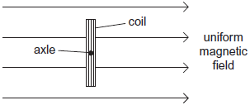
(i) Calculate the magnitude of the magnetic flux linkage for the coil.
State an appropriate unit for your answer.

flux linkage ....................................................... unit .....................
(2)
(ii) The coil is rotated through 90° in a time of 0.50 s.
Determine the mean emf in the coil.

mean emf ................................................. V
(2)
(Total 9 marks)

Q111. (a) The graph shows how the current varies with time as a capacitor is discharged through a
150 Ω resistor.
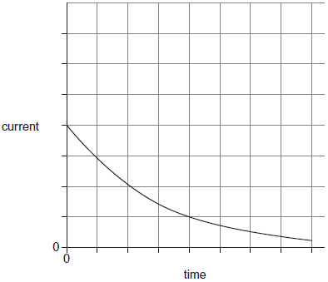
(i) Explain how the initial charge on the capacitor could be determined from a graph of current against time.
...............................................................................................................
...............................................................................................................
...............................................................................................................
...............................................................................................................
(1)
(ii) The same capacitor is charged to the same initial potential difference (pd) and then discharged through a 300 kΩ resistor. Sketch a second graph on the same axes above to show how the current varies with time in this case.
(3)
(b) In an experiment to show that a capacitor stores energy, a student charges a capacitor from a battery and then discharges it through a small electric motor. The motor is used to lift a mass vertically.
(i) The capacitance of the capacitor is 0.12 F and it is charged to a pd of 9.0 V.
The weight of the mass raised is 3.5 N.
Calculate the maximum height to which the mass could be raised.
Give your answer to an appropriate number of significant figures.

More space on next page

maximum height ................................................. m
(4)
(ii) Give two reasons why the value you have calculated in part (i) would not be achieved in practice.
1 ............................................................................................................
...............................................................................................................
...............................................................................................................
...............................................................................................................
2 ............................................................................................................
...............................................................................................................
...............................................................................................................
...............................................................................................................
(2)
(Total 10 marks)
Q112. (a) State, in words, Coulomb’s law.
........................................................................................................................
........................................................................................................................
........................................................................................................................
........................................................................................................................
........................................................................................................................
........................................................................................................................
(2)

(b) The graph shows how the electric potential, V, varies with $\frac{1}{r}$, where r is the distance from a point charge Q.
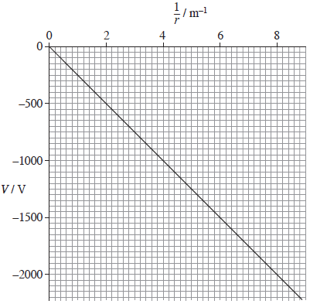
State what can be deduced from the graph about how V depends on r and explain why all the values of V on the graph are negative.
........................................................................................................................
........................................................................................................................
........................................................................................................................
........................................................................................................................
(2)
(c) (i) Use data from the graph to show that the magnitude of Q is about 30 nC.

(2)

(ii) A +60 nC charge is moved from a point where r = 0.20 m to a point where r = 0.50 m. Calculate the work done.

(2)
work done ................................................... J
(iii) Calculate the electric field strength at the point where r = 0.40 m.

electric field strength .......................................... V m⁻¹
(2)
(Total 10 marks)
Q113. (a) State, in words, the two laws of electromagnetic induction.
Law 1 .....................................................................................................................
.............................................................................................................................
.............................................................................................................................
.............................................................................................................................
Law 2 .....................................................................................................................
.............................................................................................................................
.............................................................................................................................
.............................................................................................................................
(3)

(b) The diagram below illustrates the main components of one type of electromagnetic braking system. A metal disc is attached to the rotating axle of a vehicle. An electromagnet is mounted with its pole pieces placed either side of the rotating disc, but not touching it. When the brakes are applied, a direct current is passed through the coil of the electromagnet and the disc slows down.
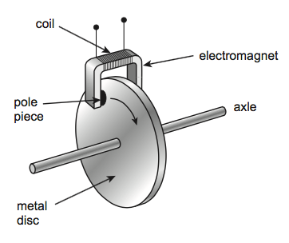
(i) Explain, using the laws of electromagnetic induction, how the device in the diagram acts as an electromagnetic brake.
...................................................................................................................
...................................................................................................................
...................................................................................................................
...................................................................................................................
...................................................................................................................
...................................................................................................................
...................................................................................................................
...................................................................................................................
...................................................................................................................
...................................................................................................................
(3)

(ii) A conventional braking system has friction pads that are brought into contact with a moving metal surface when the vehicle is to be slowed down.
State one advantage and one disadvantage of an electromagnetic brake compared to a conventional brake.
Advantage ..................................................................................................
...................................................................................................................
...................................................................................................................
Disadvantage .............................................................................................
...................................................................................................................
...................................................................................................................
(2)
(Total 8 marks)
Q114. Read the following passage and answer the questions that follow

Satellites used for telecommunications are usually in geostationary orbits. Using suitable dishes to transmit the signals, communication over most of the Earth’s surface is possible at all times using only 3 satellites.
Satellites used for meteorological observations and observations of the Earth’s surface are usually in low Earth orbits. Polar orbits, in which the satellite passes over the North and South Poles of the Earth, are often used.
One such satellite orbits at a height of about 12 000 km above the Earth’s surface circling the Earth at an angular speed of 2.5 × 10^{–4} rad s^{–1}. The microwave signals from the satellite are transmitted using a dish and can only be received within a limited area, as shown in the image below.
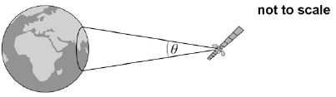
The signal of wavelength λ is transmitted in a cone of angular width θ, in radian, given by
where d is the diameter of the dish.
The satellite transmits a signal at a frequency of 1100 MHz using a 1.7 m diameter dish. As this satellite orbits the Earth, the area over which a signal can be received moves. There is a maximum time for which a signal can be picked up by a receiving station on Earth.
(a) Describe two essential features of the orbit needed for the satellite to appear geostationary.
........................................................................................................................
........................................................................................................................
(2)
(b) Calculate the time taken, in s, for the satellite mentioned in line 7 in the passage to complete one orbit around the Earth.

time taken = _____________s
(1)
(c) Show that at a distance of 12 000 km from the satellite the beam has a width of 1900 km.

(3)
(d) The satellite is in a polar orbit and passes directly over a stationary receiver at the South Pole.
Show that the receiver can remain in contact with the satellite for no more than about 20 minutes each orbit.
radius of the Earth = 6400 km

maximum time = ___________________________ minute
(3)
(e) The same satellite is moved into a higher orbit.
Discuss, with reasons, how this affects the signal strength and contact time for the receiver at the South Pole.
........................................................................................................................
........................................................................................................................
........................................................................................................................
........................................................................................................................
........................................................................................................................
........................................................................................................................
........................................................................................................................
........................................................................................................................
(4)
(Total 13 marks)
Q115. The Rosetta space mission placed a robotic probe on Comet 67P in 2014.
(a) The total mass of the Rosetta spacecraft was 3050 kg. This included the robotic probe of mass 108 kg and 1720 kg of propellant. The propellant was used for changing velocity while travelling in deep space where the gravitational field strength is negligible.
Calculate the change in gravitational potential energy of the Rosetta spacecraft from launch until it was in deep space.
Give your answer to an appropriate number of significant figures.
Mass of the Earth = 6.0 × 10²⁴ kg
Radius of the Earth = 6400 km
change in gravitational potential energy ........................... J
(4)
(b) As it approached the comet, the speed of the Rosetta spacecraft was reduced to match that of the comet. This was done in stages using four ‘thrusters’. These were fired simultaneously in the same direction.
Explain how the propellant produces the thrust.
.............................................................................................................................
.............................................................................................................................
.............................................................................................................................
.............................................................................................................................
.............................................................................................................................
.............................................................................................................................
.............................................................................................................................
(3)
(c) Each thruster provided a constant thrust of 11 N.
Calculate the deceleration of the Rosetta spacecraft produced by the four thrusters when its mass was 1400 kg.
decleration ........................... m s^{–2}
(1)

(d) Calculate the maximum change in speed that could be produced using the 1720 kg of propellants.
Assume that the speed of the exhaust gases produced by the propellant was 1200 m s^{–1}
maximum change in speed ........................... m s^{–1}
(3)
(e) When the robotic probe landed, it had to be anchored to the comet due to the low gravitational force. Comet 67P has a mass of about 1.1 × 10¹³ kg. A possible landing site was about 2.0 km from the centre of mass.
(i) Calculate the gravitational force acting on the robotic probe when at a distance of 2.0 km from the centre of mass of the comet.
gravitational force ........................... N
(3)
(ii) Calculate the escape velocity for an object 2.0 km from the centre of mass of the comet.
escape velocity ........................... m s^{–1}
(3)
(iii) A scientist suggests using a drill to make a vertical hole in a rock on the surface of the comet. The anchoring would be removed from the robotic probe before the drill was used. The drill would exert a force of 25 N for 4.8 s.
Explain, with the aid of a calculation, whether this process would cause the robotic probe to escape from the comet.

More space on next page
...................................................................................................................
...................................................................................................................
...................................................................................................................
...................................................................................................................
...................................................................................................................
...................................................................................................................
...................................................................................................................
...................................................................................................................
...................................................................................................................
(3)
(Total 20 marks)
Q116. A metal detector is moved horizontally at a constant speed just above the Earth’s surface to search for buried metal objects
Figure 1 shows the coil C of a metal detector moving over a circular bracelet made from a single band of metal. The planes of the coil and the bracelet are both horizontal.
Figure 1
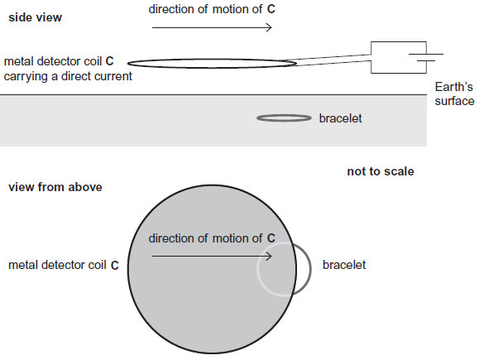
In this metal detector, C carries a direct current so that the magnetic flux produced by C does not vary. The bracelet is just below the surface, so the flux is perpendicular to the plane of the bracelet. The field is negligible outside the shaded region of C.
Figure 2 shows how the magnetic flux through the bracelet varies with time when C is moving at a constant velocity.
Figure 2
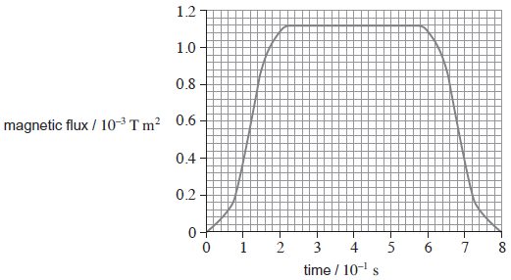
(a) (i) Sketch a graph on the grid to show how the emf induced in the bracelet varies with time as C moves across the bracelet. Use the same scale on the time axis as in Figure 2.

(3)
(ii) Use the laws of Faraday and Lenz to explain the shape of your graph.
...................................................................................................................
...................................................................................................................
...................................................................................................................
...................................................................................................................
...................................................................................................................
............................................................................................ (contined on next page)
...................................................................................................................
...................................................................................................................
...................................................................................................................
...................................................................................................................
(4)
(b) The velocity at which C is moved is 0.28 m s⁻¹.
Show that the diameter of the bracelet is about 6 cm.
(1)
(c) Determine the magnetic flux density of the field produced by C at the position of the bracelet.
magnetic flux density ........................... T
(2)
(d) Determine the maximum emf induced in the bracelet.
maximum emf ........................... V
(3)
(Total 13 marks)
Q117. The figure below shows a capacitor of capacitance 370 pF. It consists of two parallel metal plates of area 250 cm². A sheet of polythene that has a relative permittivity 2.3 completely fills the gap between the plates.
not to scale
(a) Calculate the thickness of the polythene sheet.

thickness = _____________m
(2)

(b) The capacitor is charged so that there is a potential difference of 35 V between the plates. The charge on the capacitor is then 13 nC and the energy stored is 0.23 µJ.
The supply is now disconnected and the polythene sheet is pulled out from between the plates without discharging or altering the separation of the plates.
Show that the potential difference between the plates increases to about 80 V.

(2)
(c) Calculate the energy that is now stored by the capacitor.

energy stored = _____________µJ
(2)
(d) Explain why there is an increase in the energy stored by the capacitor when the polythene sheet is pulled out from between the plates.
........................................................................................................................
........................................................................................................................
........................................................................................................................
........................................................................................................................
(2)
(Total 8 marks)

Q118. Figure 1 shows an arrangement for investigating electromagnetic induction.
Figure 1
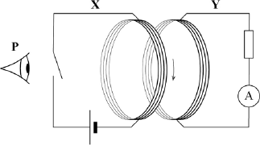
When the switch is closed there is a current in the coil in circuit X. The current is in a clockwise direction as viewed from position P.
Circuit Y is viewed from position P.
(a) Explain how Lenz’s law predicts the direction of the induced current when the switch is opened and again when it is closed.
........................................................................................................................
........................................................................................................................
........................................................................................................................
........................................................................................................................
........................................................................................................................
........................................................................................................................
........................................................................................................................
........................................................................................................................
........................................................................................................................
........................................................................................................................
........................................................................................................................
........................................................................................................................
(4)

An ‘Earth inductor’ consists of a 500 turn coil. Figure 2 and Figure 3 shows it set up to measure the horizontal component of the Earth’s magnetic field. When the coil is rotated an induced emf is produced.

Figure 2 |  | Figure 3
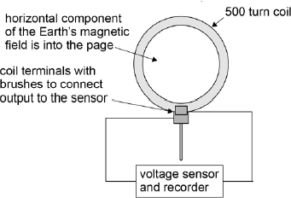 |  | 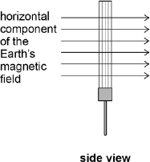
The mean diameter of the turns on the coil is 35 cm. Figure 4 shows the output recorded for the variation of potential difference V with time t when the coil is rotated at 1.5 revolutions per second.
Figure 4
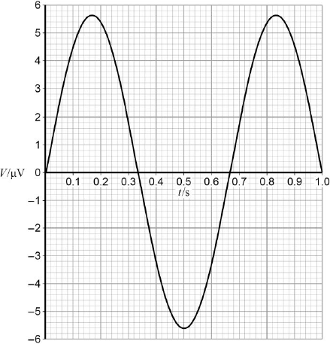

(b) Determine the flux density, B_{H}, of the horizontal component of the Earth’s magnetic field.

horizontal component of flux density = _____________T
(3)
(Total 7 marks)
Q119. The figure below shows a system that separates two minerals from the ore containing them using an electric field.
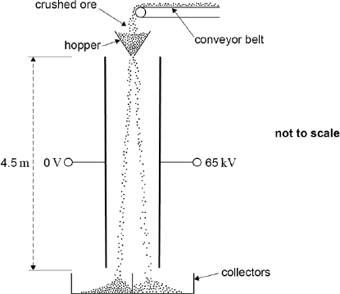
The crushed particles of the two different minerals gain opposite charges due to friction as they travel along the conveyor belt and through the hopper. When they leave the hopper they fall 4.5 metres between two parallel plates that are separated by 0.35 m.
(a) Assume that a particle has zero velocity when it leaves the hopper and enters the region between the plates.
Calculate the time taken for this particle to fall between the plates.

time taken = _____________s
(2)
(b A potential difference (pd) of 65 kV is applied between the plates.
Show that when a particle of specific charge 1.2 × 10^{–6} C kg^{–1} is between the plates its horizontal acceleration is about 0.2 m s^{–2}.

(3)
(c) Calculate the total horizontal deflection of the particle that occurs when falling between the plates.

horizontal deflection = _____________m
(1)
(d) Explain why the time to fall vertically between the plates is independent of the mass of a particle.
........................................................................................................................
........................................................................................................................
........................................................................................................................
........................................................................................................................
(2)
(e) State and explain two reasons, why the horizontal acceleration of a particle is different for each particle.
........................................................................................................................
........................................................................................................................
........................................................................................................................
........................................................................................................................
........................................................................................................................
........................................................................................................................
........................................................................................................................
........................................................................................................................
(4)
(Total 12 marks)
Q120. An oscilloscope is used to investigate various voltage sources. In order to do this a voltage source is connected to the y-input and the time base is switched off. Figure 1 below shows the screen of the oscilloscope when the y-input is not connected to a voltage source.
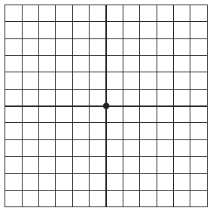
Figure 1
Figure 2 shows the screen when a 1.5V cell is connected to the y-input.
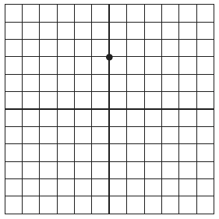
Figure 2

(a) On the grid below show the appearance of the screen if the y-input is connected to a 2.5V dc supply.

(1)
(b) The y-input is now connected to a sinusoidal ac voltage supply and the screen is shown in Figure 3.
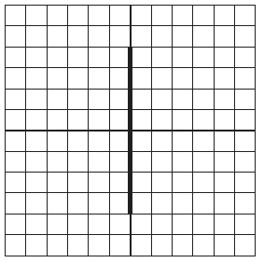
Figure 3
(i) Explain why a vertical line is now seen on the screen.
.............................................................................................................
.............................................................................................................
.............................................................................................................
.............................................................................................................
.............................................................................................................
(2)
(ii) Calculate the peak-to-peak voltage of the ac supply.

answer = ..................................... V
(2)
(iii) Calculate the root mean square voltage of the supply.

answer = ..................................... V
(2)
(Total 7 marks)
Q121. A 680 µF capacitor is charged fully from a 12 V battery. At time t = 0 the capacitor begins to discharge through a resistor. When t = 25 s the energy remaining in the capacitor is one quarter of the energy it stored at 12 V.
(a) Determine the pd across the capacitor when t = 25s.
......................................................................................................................
......................................................................................................................
......................................................................................................................
......................................................................................................................
(2)
(b) (i) Show that the time constant of the discharge circuit is 36 s.
.............................................................................................................
.............................................................................................................
.............................................................................................................
.............................................................................................................
.............................................................................................................

(ii) Calculate the resistance of the resistor.
.............................................................................................................
.............................................................................................................
(4)
(Total 6 marks)
Q122. (a)
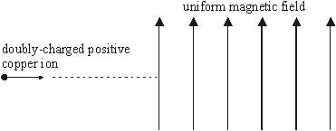
The diagram above shows a doubly-charged positive ion of the copper isotope ${}_{29}^{63}{Cu}$that is projected into a vertical magnetic field of flux density 0.28 T, with the field directed upwards. The ion enters the field at a speed of 7.8 × 10⁵ m s^{–1}.
(i) State the initial direction of the magnetic force that acts on the ion.
.............................................................................................................
(ii) Describe the subsequent path of the ion as fully as you can.
Your answer should include both a qualitative description and a calculation.
mass of ${}_{29}^{63}{Cu}$ ion = 1.05 × 10^{–25} kg
.............................................................................................................
.............................................................................................................
.............................................................................................................
.............................................................................................................
.............................................................................................................
.............................................................................................................
.............................................................................................................
.............................................................................................................
(5)
(b) State the effect on the path in part (a) if the following changes are made separately.
(i) The strength of the magnetic field is doubled.
.............................................................................................................
.............................................................................................................
(ii) A singly-charged positive ${}_{29}^{63}{Cu}$ ion replaces the original one.
.............................................................................................................
.............................................................................................................
(3)
(Total 8 marks)
Q123. (a) Complete the table of quantities related to fields. In the second column, write an SI unit for each quantity. In the third column indicate whether the quantity is a scalar or a vector.

quantity | SI unit | scalar or vector
gravitational potential
electric field strength
magnetic flux density

(3)
(b) (i) A charged particle is held in equilibrium by the force resulting from a vertical electric field. The mass of the particle is 4.3 × 10^{–9} kg and it carries a charge of magnitude
3.2 × 10^{–12} C. Calculate the strength of the electric field.
.............................................................................................................
.............................................................................................................
.............................................................................................................
.............................................................................................................
(ii) If the electric field acts upwards, state the sign of the charge carried by the particle
.............................................................................................................
(3)
(Total 6 marks)
Q124. A coil is connected to a centre zero ammeter, as shown. A student drops a magnet so that it falls vertically and completely through the coil.
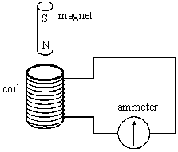

(a) Describe what the student would observe on the ammeter as the magnet falls through the coil.
......................................................................................................................
......................................................................................................................
......................................................................................................................
......................................................................................................................
(2)
(b) If the coil were not present the magnet would accelerate downwards at the acceleration due to gravity. State and explain how its acceleration in the student’s experiment would be affected, if at all,
(i) as it entered the coil,
.............................................................................................................
.............................................................................................................
.............................................................................................................
(ii) as it left the coil.
.............................................................................................................
.............................................................................................................
.............................................................................................................
(4)
(c) Suppose the student forgot to connect the ammeter to the coil, therefore leaving the circuit incomplete, before carrying out the experiment. Describe and explain what difference this would make to your conclusions in part (b).
You may be awarded marks for the quality of written communication provided in your answer.
......................................................................................................................
......................................................................................................................
......................................................................................................................
......................................................................................................................
......................................................................................................................
(3)
(Total 9 marks)

Q125. An oscilloscope is connected to a sinusoidal ac source as shown in Figure 1.
The frequency and the voltage output of the ac source can be varied.
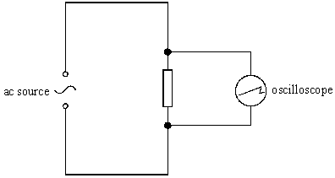
Figure 1
At a certain frequency the ac signal has an rms output of 7.1 V. Figure 2 shows the trace obtained on the screen of the oscilloscope when one horizontal division corresponded to a time of 5.0 ms.
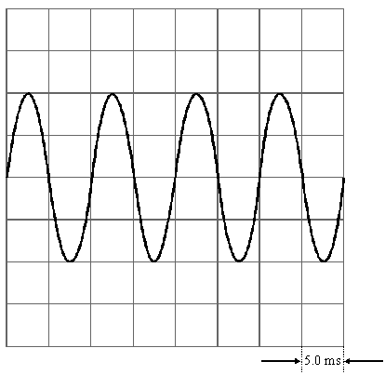
Figure 2
(a) Calculate, for the signal shown in Figure 2,
(i) the peak voltage,
.............................................................................................................

(ii) the frequency.
.............................................................................................................
.............................................................................................................
(3)
(b) The voltage output and frequency of the signal are now changed so that the peak voltage is 80 V and the frequency is 200 Hz.
State which two controls on the oscilloscope have to be altered so that four full cycles again appear on the screen but the peak to peak distance occupies the full screen.
Determine the values at which these two controls have to be set.
control 1: …...................................................................................................
value of the setting: ......................................................................................
......................................................................................................................
control 2: …...................................................................................................
value of setting: ............................................................................................
......................................................................................................................
(5)
(Total 8 marks)
Q126. The Global Positioning System (GPS) is a system of satellites that transmit radio signals which can be used to locate the position of a receiver anywhere on Earth.
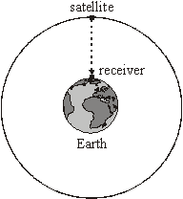
(a) A receiver at sea level detects a signal from a satellite in a circular orbit when it is passing directly overhead as shown in the diagram above.
(i) The microwave signal is received 68 ms after it was transmitted from the satellite. Calculate the height of the satellite.
.............................................................................................................
.............................................................................................................

(ii) Show that the gravitational field strength of the Earth at the position of the satellite is
0.56 N kg^{–1}.
mass of the Earth =6.0 × 10²⁴ kg
mean radius of the Earth = 6400 km
.............................................................................................................
.............................................................................................................
.............................................................................................................
.............................................................................................................
.............................................................................................................
.............................................................................................................
.............................................................................................................
(4)
(b) For the satellite in this orbit, calculate
(i) its speed,
.............................................................................................................
.............................................................................................................
.............................................................................................................
.............................................................................................................
.............................................................................................................
(ii) its time period.
.............................................................................................................
.............................................................................................................
.............................................................................................................
.............................................................................................................
.............................................................................................................
(5)
(Total 9 marks)

Q127. A sinusoidal alternating voltage source of frequency 500 Hz is connected to a resistor of resistance 2.0 kΩ and an oscilloscope, as shown in Figure 1.
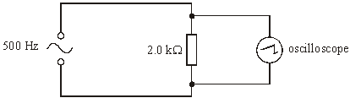
Figure 1
(a) The rms current through the resistor is 5.3 mA. Calculate the peak voltage across the resistor.
......................................................................................................................
......................................................................................................................
......................................................................................................................
(2)
(b) The settings on the oscilloscope are
timebase: 250 µs per division,
voltage sensitivity: 5.0 V per division.
Draw on the grid, which represents the screen of the oscilloscope, the trace that would be seen.
......................................................................................................................
......................................................................................................................

(4)
(Total 6 marks)
Q128.
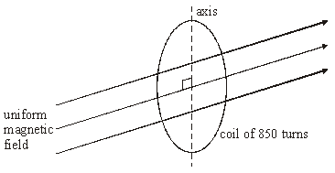
Figure 1
A circular coil of diameter 140 mm has 850 turns. It is placed so that its plane is perpendicular to a horizontal magnetic field of uniform flux density 45 mT, as shown in Figure 1.
(a) Calculate the magnetic flux passing through the coil when in this position.
......................................................................................................................
......................................................................................................................
(2)
(b The coil is rotated through 90° about a vertical axis in a time of 120 ms.
Calculate
(i) the change of magnetic flux linkage produced by this rotation,
.............................................................................................................
.............................................................................................................
(ii) the average emf induced in the coil when it is rotated.
.............................................................................................................
.............................................................................................................
.............................................................................................................
(4)
(Total 6 marks)
Q129. (a) Explain what is meant by the gravitational potential at a point in a gravitational field.
......................................................................................................................
......................................................................................................................
......................................................................................................................
......................................................................................................................
(2)
(b) Use the following data to calculate the gravitational potential at the surface of the Moon.
mass of Earth = 81 × mass of Moon
radius of Earth = 3.7 × radius of Moon
gravitational potential at surface of the Earth = –63 MJ kg^{–1}
......................................................................................................................
......................................................................................................................
......................................................................................................................
......................................................................................................................
......................................................................................................................
......................................................................................................................
(3)
(c) Sketch a graph on the axes below to indicate how the gravitational potential varies with distance along a line outwards from the surface of the Earth to the surface of the Moon.
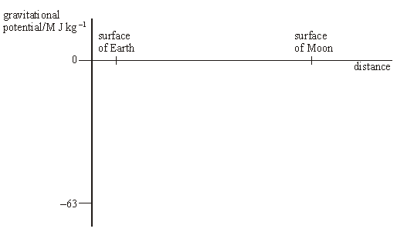
(3)
(Total 8 marks)
Q130. (a) State, in words, Newton’s law of gravitation.
......................................................................................................................
......................................................................................................................
......................................................................................................................
......................................................................................................................
......................................................................................................................
(3)

(b) By considering the centripetal force which acts on a planet in a circular orbit, show that
T² ∝ R³, where T is the time taken for one orbit around the Sun and R is the radius of the orbit.
......................................................................................................................
......................................................................................................................
......................................................................................................................
......................................................................................................................
......................................................................................................................
(3)
(c) The Earth’s orbit is of mean radius 1.50 × 10¹¹ m and the Earth’s year is 365 days long.
(i) The mean radius of the orbit of Mercury is 5.79 × 10¹⁰ m. Calculate the length of Mercury’s year.
.............................................................................................................
.............................................................................................................
.............................................................................................................
.............................................................................................................
.............................................................................................................
.............................................................................................................
.............................................................................................................
(ii) Neptune orbits the Sun once every 165 Earth years.
Calculate the ratio $distancefronSunNeptune\frac{}{distance}SunEarth$.
.............................................................................................................
.............................................................................................................
.............................................................................................................
.............................................................................................................
.............................................................................................................
.............................................................................................................
.............................................................................................................
.............................................................................................................
(4)
(Total 10 marks)
Q131. (a) The equation F = BQv may be used to calculate magnetic forces.
(i) State the condition under which this equation applies.
.............................................................................................................
.............................................................................................................
(1)
(ii) Identify the physical quantities that are represented by the four symbols in the equation.
F .........................................................................................................
B .........................................................................................................
Q..........................................................................................................
v...........................................................................................................
(1)
(b) The figure below shows the path followed by a stream of identical positively charged ions, of the same kinetic energy, as they pass through the region between two charged plates. Initially the ions are travelling horizontally and they are then deflected downwards by the electric field between the plates.
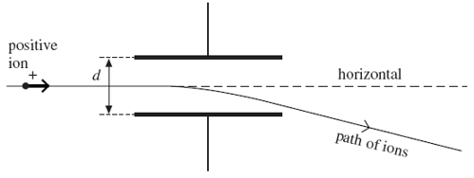
While the electric field is still applied, the path of the ions may be restored to the horizontal, so that they have no overall deflection, by applying a magnetic field over the same region as the electric field. The magnetic field must be of suitable strength and has to be applied in a particular direction.
(i) State the direction in which the magnetic field should be applied.
.............................................................................................................
(1)
(ii) Explain why the ions have no overall deflection when a magnetic field of the required strength has been applied.
.............................................................................................................
.............................................................................................................
.............................................................................................................
.............................................................................................................
(2)
(iii) A stream of ions passes between the plates at a velocity of 1.7 x 10⁵ms^{–1}. The separation d of the plates is 65 mm and the pd across them is 48 V. Calculate the value of B required so that there is no overall deflection of the ions, stating an appropriate unit.

answer = ....................................
(4)
(c) Explain what would happen to ions with a velocity higher than 1.7 x 10⁵ms^{–1} when they pass between the plates at a time when the conditions in part (b)(iii) have been established.
.....................................................................................................................
.....................................................................................................................
.....................................................................................................................
.....................................................................................................................
.....................................................................................................................
(2)
(Total 11 marks)
Q132. (a) As a capacitor was charged from a 12 V supply, a student used a coulomb meter and a voltmeter to record the charge stored by the capacitor at a series of values of potential difference across the capacitor. The student then plotted a graph of pd (on the y-axis) against charge (on the x-axis).
(i) Sketch the graph obtained.
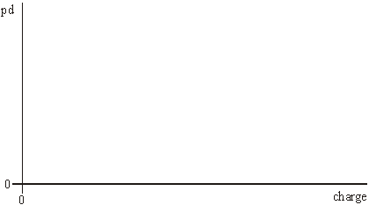
(ii) State what is represented by the gradient of the line.
.............................................................................................................
(iii) State what is represented by the area enclosed by the line and the x-axis of the graph.
.............................................................................................................
(3)
(b) The student then connected the capacitor as shown in the diagram below to carry out an investigation into the discharge of the capacitor.
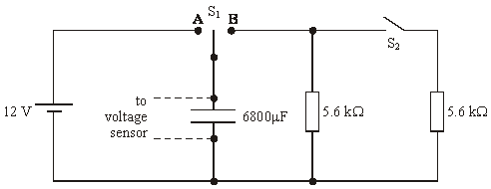
The student used a voltage sensor, datalogger and computer to obtain values for the pd across the capacitor at various times during the discharge.
(i) At time t = 0, with switch S₂ open, switch S₁was moved from position A to position B. Calculate the pd across the capacitor when t = 26 s.
.............................................................................................................
.............................................................................................................
.............................................................................................................
.............................................................................................................
(ii) At time t = 26 s, as the discharge continued, the student closed switch S₂. Calculate the pd across the capacitor 40 s after switch S₁ was moved from position A to position B.
.............................................................................................................
.............................................................................................................
.............................................................................................................
.............................................................................................................

(iii) Sketch a graph of pd against time for the student’s experiment described in parts (b)(i) and (b)(ii).
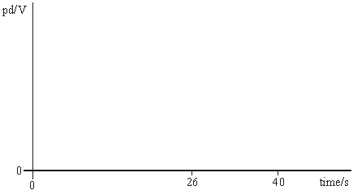
(7)
(Total 10 marks)
Q133. The first artificially produced isotope, phosphorus ${}_{15}^{30}P$, was formed by bombarding an
aluminium isotope,${}_{13}^{27}{Al}$ , with an α particle.
(a) Complete the following nuclear equation by identifying the missing particle.
$${}_{13}^{27}{Al}+α→{}_{15}^{30}P+……….$$
(1)
(b) For the reaction to take place the α particle must come within a distance, d, from the centre of the aluminium nucleus. Calculate d if the nuclear reaction occurs when the α particle is given an initial kinetic energy of at least 2.18 × 10^{–12} J.
The electrostatic potential energy between two point charges Q₁ and Q₂ is equal
to $\frac{Q_{1}Q_{2}}{4πε_{0}r}$
where r is the separation of the charges and ε₀ is the permittivity of free space.

answer = .......................................m
(3)
(Total 4 marks)

Q134. (a) (i) State the relationship between the gravitational potential energy, E_{p}, and the gravitational potential, V, for a body of mass m placed in a gravitational field.
.............................................................................................................
.............................................................................................................
(1)
(ii) What is the effect, if any, on the values of E_{p} and V if the mass m is doubled?
value of E_{p} ...........................................................................................
value of V ……….................................................................................
(2)
(b)
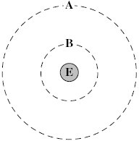
The diagram above shows two of the orbits, A and B, that could be occupied by a satellite in circular orbit around the Earth, E.
The gravitational potential due to the Earth of each of these orbits is:
orbit A – 12.0 MJ kg^{–1}
orbit B – 36.0 MJ kg^{–1}.
(i) Calculate the radius, from the centre of the Earth, of orbit A.

answer = .......................... m
(2)
(ii) Show that the radius of orbit B is approximately 1.1 × 10⁴ km.

(1)

(iii) Calculate the centripetal acceleration of a satellite in orbit B.

answer = ..................... m s^{–2}
(2)
(iv) Show that the gravitational potential energy of a 330 kg satellite decreases by about 8 GJ when it moves from orbit A to orbit B.

(1)
(c) Explain why it is not possible to use the equation ∆E_{p} = mg∆h when determining the change in the gravitational potential energy of a satellite as it moves between these orbits.
......................................................................................................................
......................................................................................................................
......................................................................................................................
......................................................................................................................
(1)
(Total 10 marks)
Q135. The circuit in Figure 1 shows a sinusoidal ac source connected to two resistors, R₁ and R₂, which form a potential divider. Oscilloscope 1 is connected across the source and oscilloscope 2 is connected across R₂.
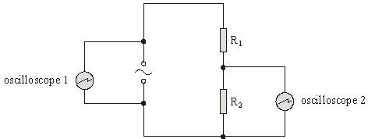
Figure 1

(a) Figure 2 shows the trace obtained on the screen of oscilloscope 1. The time base of the oscilloscope is set at 10 m/s per division and the voltage sensitivity at 15 V per division.
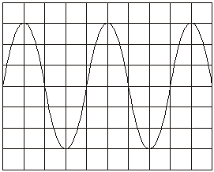
Figure 2
For the ac source, calculate
(i) the frequency,
.............................................................................................................
.............................................................................................................
(ii) the rms voltage.
.............................................................................................................
.............................................................................................................
.............................................................................................................
(4)
(b) The resistors have the following values: R₁ = 450 Ω and R₂ = 90 Ω.
Calculate
(i) the rms current in the circuit,
.............................................................................................................
(ii) the rms voltage across R₂.
.............................................................................................................
(2)
(c) Oscilloscope 2 is used to check the calculated value of the voltage across R₂. The screen of oscilloscope 2 is identical to that of oscilloscope 1 and both are set to the same time base. Oscilloscope 2 has the following range for voltage sensitivity: 1 V per div., 5 V per div., 10 V per div. and 15 V per div.
State which voltage sensitivity would give the most suitable trace. Explain the reasons for your choice.
......................................................................................................................
......................................................................................................................
............................................................................................ (contined on next page)
......................................................................................................................
......................................................................................................................
......................................................................................................................
(3)
(Total 9 marks)
Q136. (a) (i) Define the capacitance of a capacitor.
.............................................................................................................
.............................................................................................................
(ii) Calculate the charge, in C, stored on a 470 μF capacitor which has a potential difference of 2.3 × 10² V across it.
(2)
(b) A 470 μF capacitor is connected in a circuit which enables it to charge when the switch is in position S₁ and discharged when the switch is in position S₂. The arrangement is shown in Figure 1.
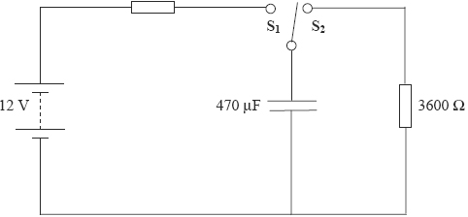
Figure 1
(i) Calculate the time constant of the discharge circuit when the switch is in position S₂. Give your answer in s.

(ii) The capacitor is fully charged and then discharged. On the axes below, mark appropriate scales and draw a graph to show the variation of the potential difference across the capacitor with time for the discharge of the capacitor.

(4)
(c) Figure 2 shows the variation of charge with time for the charging of the capacitor.
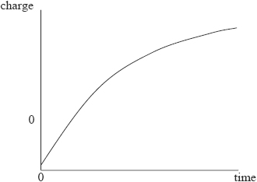
Figure 2
Explain why the charge across the capacitor changes in the way shown by the graph.
......................................................................................................................
......................................................................................................................
......................................................................................................................
......................................................................................................................
......................................................................................................................
......................................................................................................................
(3)
(Total 9 marks)
Q137. (a) Give two examples of the techniques used by geologists to obtain values of the strength of the local gravitational field of the Earth.
In each of your quoted examples, describe the information that the geologists can derive from their measurements.
......................................................................................................................
......................................................................................................................
......................................................................................................................
......................................................................................................................
......................................................................................................................
......................................................................................................................
......................................................................................................................
......................................................................................................................
(4)
In 1774, Nevil Maskelyne carried out an experiment near the mountain of Schiehallion in
Scotland to determine the density of the Earth.
Figure 1 shows two positions of a pendulum hung near to, but on opposite sides of, the mountain. The centre of mass of the mountain is at the same height as the pendulum.
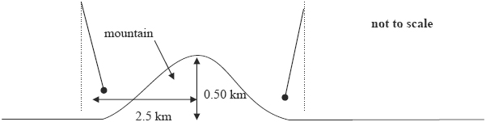
Figure 1
(b) (i) Explain why the pendulums do not point towards the centre of the Earth.
.............................................................................................................
.............................................................................................................
.............................................................................................................
.............................................................................................................

(ii) Suggest why Maskelyne carried out the experiment on both sides of the mountain.
.............................................................................................................
.............................................................................................................
.............................................................................................................
.............................................................................................................
(3)
(c) Figure 2 shows measurements made with the left-hand pendulum in Figure 1.
Figure 2
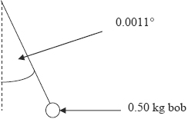
(i) The mountain is in the appropriate shape of a cone 0.50 km high and 1.3 km base radius; it rises from a locally flat plain.
Show that the mass of the mountain is about 2 × 10¹² kg.
Volume of a cone = $\frac{1}{3}πr^{2}h$
density of rock = 2.5 × 10³ kg m⁻³

(ii) Figure 2 shows the left-hand pendulum bob lying on a horizontal line that also passes through the centre of mass of the mountain. The bob is 1.4 km from the centre of the mountain and it hangs at an angle of 0.0011° to the vertical.
Calculate the mass of the Earth.

(iii) The answer Maskelyne obtained for the mass of the Earth was lower than today’s accepted value even though he had an accurate value for the Earth’s radius.
Suggest one reason why this should be so.
.............................................................................................................
.............................................................................................................
.............................................................................................................
.............................................................................................................
(7)
(Total 14 marks)
Q138. The diagram below shows an ac waveform that is displayed on an oscilloscope screen.
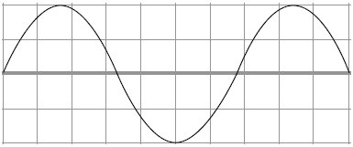
The time base of the oscilloscope is set at 1.5 ms per division and the y-gain at 1.5 V per division.
(a) For the ac waveform shown,
(i) Calculate the frequency
.............................................................................................................
.............................................................................................................
.............................................................................................................
.............................................................................................................
answer ............................................ Hz
(3)
(ii) Calculate the peak voltage
.............................................................................................................
.............................................................................................................
.............................................................................................................
.............................................................................................................
answer ........................................... V
(2)
(iii) the rms voltage
.............................................................................................................
.............................................................................................................
.............................................................................................................
.............................................................................................................
answer ............................................ V
(2)
(b) State and explain the effect on the oscilloscope trace if the time base is switched off.
......................................................................................................................
......................................................................................................................
......................................................................................................................
......................................................................................................................
......................................................................................................................
......................................................................................................................
(2)
(Total 9 marks)
Q139. (a) (i) Outline the essential features of a step-down transformer when in operation.
.............................................................................................................
.............................................................................................................
.............................................................................................................
.............................................................................................................
.............................................................................................................
(2)
(ii) Describe two causes of the energy losses in a transformer and discuss how these energy losses may be reduced by suitable design and choice of materials.
The quality of your written communication will be assessed in this question.
.............................................................................................................
.............................................................................................................
.............................................................................................................
.............................................................................................................
............................................................................................ (contined on next page)

.............................................................................................................
.............................................................................................................
.............................................................................................................
.............................................................................................................
.............................................................................................................
.............................................................................................................
.............................................................................................................
.............................................................................................................
.............................................................................................................
.............................................................................................................
.............................................................................................................
.............................................................................................................
.............................................................................................................
.............................................................................................................
.............................................................................................................
(6)
(b) Electronic equipment, such as a TV set, may usually be left in ‘standby’ mode so that it is available for instant use when needed. Equipment left in standby mode continues to consume a small amount of power. The internal circuits operate at low voltage, supplied from a transformer. The transformer is disconnected from the mains supply only when the power switch on the equipment is turned off. This arrangement is outlined in the diagram below.
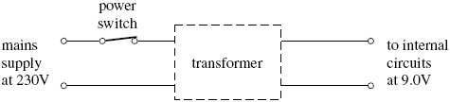
When in standby mode, the transformer supplies an output current of 300 mA at 9.0V to the internal circuits of the TV set.
(i) Calculate the power wasted in the internal circuits when the TV set is left in standby mode.

answer = .......................... W
(1)
(ii) If the efficiency of the transformer is 0.90, show that the current supplied by the 230 V mains supply under these conditions is 13 mA.

(2)
(iii) The TV set is left in standby mode for 80% of the time. Calculate the amount of energy, in J, that is wasted in one year through the use of the standby mode.
1 year = 3.15 × 10⁷ s

answer = ............................ J
(1)
(iv) Show that the cost of this wasted energy will be about £4, if electrical energy is charged at 20 p per kWh.

(2)
(c) The power consumption of an inactive desktop computer is typically double that of a TV set in standby mode. This waste of energy may be avoided by switching off the computer every time it is not in use. Discuss one advantage and one disadvantage of doing this.
......................................................................................................................
......................................................................................................................
......................................................................................................................
......................................................................................................................
......................................................................................................................
......................................................................................................................
(2)
(Total 16 marks)

Q140. (a) A capacitor, initially charged to a pd of 6.0V, was discharged through a 100 kΩ resistor.
A datalogger was used to record the pd across the capacitor at frequent intervals. The graph shows how the pd varied with time during the first 40 s of discharge.
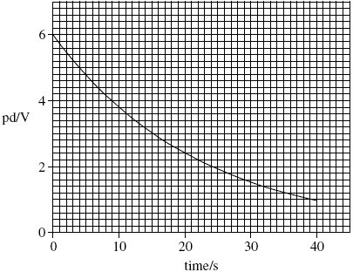
- Calculate the initial discharge current.

answer = ........................... A
(1)
(ii) Use the graph to determine the time constant of the circuit, giving an appropriate unit.

answer = ...............................
(4)
(iii) Hence calculate the capacitance of the capacitor.

answer = .................................. µF
(1)

(iv) Show that the capacitor lost 90% of the energy it stored originally after about 25 s.

(3)
(b) In order to produce a time delay, an intruder alarm contains a capacitor identical to the capacitor used in the experiment in part (a). This capacitor is charged from a 12 V supply and then discharges through a 100 kΩ resistor, similar to the one used in the experiment.
(i) State and explain the effect of this higher initial pd on the energy stored by this capacitor initially.
.............................................................................................................
.............................................................................................................
.............................................................................................................
(2)
(ii) State and explain the effect of this higher initial pd on the time taken for this capacitor to lose 90% of its original energy.
.............................................................................................................
.............................................................................................................
.............................................................................................................
(1)
(Total 12 marks)
Q141. (a) Explain why the mass of an object is constant but its weight may change.
......................................................................................................................
......................................................................................................................
......................................................................................................................
......................................................................................................................
......................................................................................................................
......................................................................................................................
......................................................................................................................
(3)
(b) The table gives the gravitational potentials, V, at three different distances, r, from the centre of the Earth.

distance from centre of Earth  r / km | gravitational potential  V / 10⁷ J kg^{–1}
7500 | –5.36
12500 | –3.22
22500 | –1.79
(i) Explain why the gravitational potential at a point in a gravitational field is negative.
.............................................................................................................
.............................................................................................................
.............................................................................................................
.............................................................................................................
.............................................................................................................
(2)
(ii) Show that the data in the table are consistent with V ∝ r ^{–1}.
.............................................................................................................
.............................................................................................................
.............................................................................................................
.............................................................................................................
.............................................................................................................
.............................................................................................................
.............................................................................................................
.............................................................................................................
(3)
(iii) A satellite of mass 450 kg is moved from an orbit of radius 7500 km around the Earth to an orbit of radius 12 500 km.
Use data from the table to show that the potential energy of the satellite increases,
by about 10 GJ.
.............................................................................................................
.............................................................................................................
............................................................................................ (contined on next page)
.............................................................................................................
.............................................................................................................
.............................................................................................................
.............................................................................................................
.............................................................................................................
(2)
(c) The kinetic energy of a 450 kg satellite orbiting the Earth with a radius of 7500 km is 12 GJ.
(i) Calculate the kinetic energy of the 450 kg satellite when it is in an orbit of radius 12 500 km.
mass of the Earth = 6.0 × 10²⁴ kg
.............................................................................................................
.............................................................................................................
.............................................................................................................
.............................................................................................................
.............................................................................................................
.............................................................................................................
kinetic energy ............................................ GJ
(4)
(ii) Calculate the change in kinetic energy of the satellite when it moves into the higher orbit.
.............................................................................................................
.............................................................................................................
.............................................................................................................
change in kinetic energy ............................................ GJ
(1)
(iii) Calculate the total energy that has to be supplied to move the 450 kg satellite from an orbit of radius 7500 km to an orbit of radius 12 500 km.
.............................................................................................................
.............................................................................................................
total energy ............................................ GJ
(1)
(Total 16 marks)

Q142. The figure below shows an end view of a simple electrical generator. A rectangular coil is rotated in a uniform magnetic field with the axle at right angles to the field direction. When in the position shown in the figure below the angle between the direction of the magnetic field and the normal to the plane of the coil is θ.
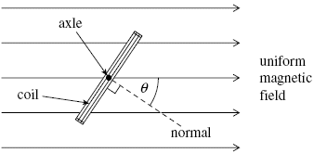
(a) The coil has 50 turns and an area of 1.9 × 10^{–3} m². The flux density of the magnetic field is 2.8 × 10^{–2} T. Calculate the flux linkage for the coil when θ is 35°, expressing your answer to an appropriate number of significant figures.

answer = ...................................... Wb turns
(3)
(b) The coil is rotated at constant speed, causing an emf to be induced.
(i) Sketch a graph on the outline axes to show how the induced emf varies with angle θ during one complete rotation of the coil, starting when θ = 0. Values are not required on the emf axis of the graph.
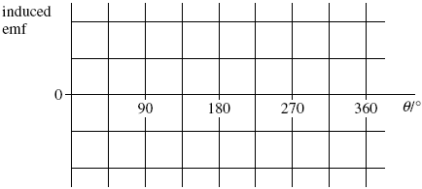
(1)
(ii) Give the value of the flux linkage for the coil at the positions where the emf has its greatest values.
answer = ...................................... Wb turns
(1)

(iii) Explain why the magnitude of the emf is greatest at the values of θ shown in your answer to part (b)(i).
.............................................................................................................
.............................................................................................................
.............................................................................................................
.............................................................................................................
.............................................................................................................
.............................................................................................................
.............................................................................................................
.............................................................................................................
(3)
(Total 8 marks)
Q143. (a) The weight w of an object on the Earth can be represented either as w = mg or $w=\frac{GMm}{r^{2}}$
(i) Explain the meaning of g and G in these equations.
.............................................................................................................
.............................................................................................................
.............................................................................................................
.............................................................................................................
.............................................................................................................
.............................................................................................................
(3)
(ii) Use the equations above to show that $M=\frac{gr^{2}}{G}$
.............................................................................................................
.............................................................................................................
.............................................................................................................
(1)

(iii) Calculate the mass of the Earth to a precision consistent with the data below.
mean radius of the Earth, = 6.4 × 10⁶ m
G = 6.7 × 10^{–11} N m² kg^{–2}
g = 9.8 N kg^{–1}
.............................................................................................................
.............................................................................................................
.............................................................................................................
.............................................................................................................
.............................................................................................................
.............................................................................................................
.............................................................................................................
.............................................................................................................
.............................................................................................................
mass of the Earth ...................................... kg
(3)
(b) The figure below shows a satellite in a geostationary orbit around the Earth.
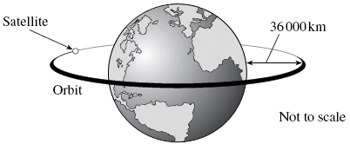
(i) State the time period for a geostationary satellite.
.............................................................................................................
(1)
(ii) The height of a geostationary satellite in orbit is approximately 36 000 km above the surface of the Earth.
Calculate the radius of a geostationary orbit.
...............................................................................................................
.............................................................................................................
radius ...................................... m
(1)

(iii) Calculate the speed, in km s^{–1}, of a satellite in a geostationary orbit.
.............................................................................................................
.............................................................................................................
.............................................................................................................
.............................................................................................................
.............................................................................................................
.............................................................................................................
speed ...................................... km s^{–1}
(3)
(iv) State a common use for a geostationary satellite.
.............................................................................................................
(1)
(v) Explain why a geostationary orbit is necessary for this use.
.............................................................................................................
.............................................................................................................
.............................................................................................................
(1)
(Total 14 marks)
Q144. An alternating current (ac) source is connected to a resistor to form a complete circuit. The trace obtained on an oscilloscope connected across the resistor is shown in the diagram below.
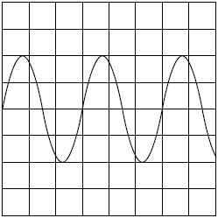
The oscilloscope settings are: Y gain 5.0 V per division
time base 2.0 ms per division.

(i) Calculate the peak voltage of the ac source.

answer = ....................................... V
(1)
(ii) Calculate the rms voltage.

answer = ....................................... V
(1)
(iii) Calculate the time period of the ac signal.

answer = ..................................... ms
(1)
(iv) Calculate the frequency of the ac signal.

answer = ...................................... Hz
(2)
(Total 5 marks)

Q145. Figure 1 shows a circuit that is used in a defibrillator in which a short pulse of charge is used to revive a patient who suffers a cardiac arrest in which their heart stops beating.
Figure 2 shows how the charge on the capacitor varies with time when the capacitor is charging.
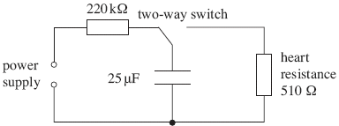
Figure 1
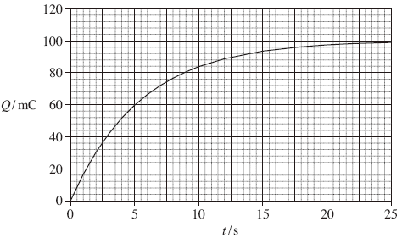
Figure 2
(a) (i) Use Figure 2 to determine the initial charging current.
.............................................................................................................
.............................................................................................................
.............................................................................................................
.............................................................................................................
.............................................................................................................
.............................................................................................................
.............................................................................................................
initial charging current ....................... A
(2)

(ii) Calculate the emf of the supply used to charge the capacitor.
Assume that the supply has negligible internal resistance.
.............................................................................................................
.............................................................................................................
.............................................................................................................
.............................................................................................................
emf of the supply ...................................... V
(2)
(iii) Explain why the current that charges the capacitor falls as the capacitor charges.
.............................................................................................................
.............................................................................................................
.............................................................................................................
.............................................................................................................
.............................................................................................................
.............................................................................................................
(3)
(b) For the system to work successfully, the capacitor has to deliver 140 J of energy to the heart in a pulse that lasts for 10 ms.
(i) Show that the charge on the capacitor when it is storing this much energy is about 85 mC.
.............................................................................................................
.............................................................................................................
.............................................................................................................
.............................................................................................................
.............................................................................................................
(2)
(ii) Calculate the average power supplied during the pulse.
.............................................................................................................
.............................................................................................................
.............................................................................................................
average power ....................................... W
(1)

(c) The circuit designer suggests that the capacitor can be used successfully after a charging time equal to 1.5 time constants of the charging circuit shown in Figure 1.
Explain with a calculation whether or not the designer’s suggestion is valid.
......................................................................................................................
......................................................................................................................
......................................................................................................................
......................................................................................................................
......................................................................................................................
......................................................................................................................
......................................................................................................................
......................................................................................................................
......................................................................................................................
......................................................................................................................
(3)
(Total 13 marks)
Q146. When travelling in a vacuum through a uniform magnetic field of flux density 0.43 m T, an electron moves at constant speed in a horizontal circle of radius 74 mm, as shown in the figure below.
(a) When viewed from vertically above, the electron moves clockwise around the
horizontal circle. In which one of the six directions shown on the figure above,
+x, –x, +y, –y, +z or –z, is the magnetic field directed?
direction of magnetic field ......................................
(1)

(b) Explain why the electron is accelerating even though it is travelling at constant speed.
......................................................................................................................
......................................................................................................................
......................................................................................................................
......................................................................................................................
......................................................................................................................
......................................................................................................................
(2)
(c) (i) By considering the centripetal force acting on the electron, show that its speed is
5.6 × 10⁶ m s^{–1}.

(2)
(ii) Calculate the angular speed of the electron, giving an appropriate unit.

answer = ......................................
(2)
(iii) How many times does the electron travel around the circle in one minute?

answer = ......................................
(2)
(Total 9 marks)

Q147. A small negatively charged sphere is suspended from a fine glass spring between parallel horizontal metal plates, as shown in the figure below.
(a) Initially the plates are uncharged. When switch S is set to position X, a high voltage dc supply is connected across the plates. This causes the sphere to move vertically upwards so that eventually it comes to rest 18 mm higher than its original position.
(i) State the direction of the electric field between the plates.
.............................................................................................................
(1)
(ii) The spring constant of the glass spring is 0.24 N m^{–1}. Show that the force exerted on the sphere by the electric field is 4.3 × 10^{–3} N.

(1)
(iii) The pd applied across the plates is 5.0 kV. If the charge on the sphere is
–4.1 × 10^{–8} C, determine the separation of the plates.

answer = ..................................... m
(3)

(b) Switch S is now moved to position Y.
(i) State and explain the effect of this on the electric field between the plates.
.............................................................................................................
.............................................................................................................
.............................................................................................................
.............................................................................................................
(2)
(ii) With reference to the forces acting on the sphere, explain why it starts to move with simple harmonic motion.
.............................................................................................................
.............................................................................................................
.............................................................................................................
.............................................................................................................
.............................................................................................................
.............................................................................................................
(3)
(Total 10 marks)
Q148. Domestic users in the United Kingdom are supplied with mains electricity at a root mean square voltage of 230V.
(a) State what is meant by root mean square voltage.
......................................................................................................................
......................................................................................................................
......................................................................................................................
(1)
(b) (i) Calculate the peak value of the supply voltage.

answer = ...................................... V
(2)
(ii) Calculate the average power dissipated in a lamp connected to the mains supply when the rms current is 0.26 A.

answer = ..................................... W
(1)
(c) The frequency of the voltage supply is 50 Hz. On the axes below draw the waveform of the supplied voltage labelling the axes with appropriate values.
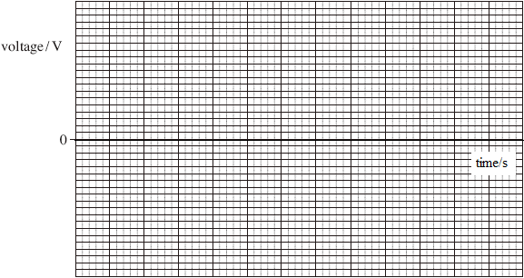
(4)
(Total 8 marks)
Q149. (a) State Newton’s law of gravitation.
......................................................................................................................
......................................................................................................................
......................................................................................................................
......................................................................................................................
(2)

(b) In 1798 Cavendish investigated Newton’s law by measuring the gravitational force between two unequal uniform lead spheres. The radius of the larger sphere was 100 mm and that of the smaller sphere was 25 mm.
(i) The mass of the smaller sphere was 0.74 kg. Show that the mass of the larger sphere was about 47 kg.
density of lead = 11.3 × 10³ kg m^{–3}

(2)
(ii) Calculate the gravitational force between the spheres when their surfaces were in contact.

answer = ..................................... N
(2)
(c) Modifications, such as increasing the size of each sphere to produce a greater force between them, were considered in order to improve the accuracy of Cavendish’s experiment. Describe and explain the effect on the calculations in part (b) of doubling the radius of both spheres.
......................................................................................................................
......................................................................................................................
......................................................................................................................
......................................................................................................................
......................................................................................................................
......................................................................................................................
......................................................................................................................
......................................................................................................................
......................................................................................................................
(4)
(Total 10 marks)

Q150. In the research into nuclear fusion one of the most promising reactions is between deuterons ${}_{1}^{2}H$
and tritium nuclei ${}_{1}^{3}H$ in a gaseous plasma. Although deuterons can be relatively easily
extracted from sea water, tritium is difficult to produce. It can, however, be produced by
bombarding lithium-6 ${}_{3}^{6}{Li}$with neutrons. The two reactions are summarised as:

${}_{1}^{2}H+{}_{1}^{3}{H→{}_{2}^{4}He+{}_{0}^{1}n+energy}$
${}_{3}^{6}{Li}+{}_{0}^{1}n→{}_{1}^{3}{H→{}_{2}^{4}He}++energy$
Masses of reactants:
${}_{0}^{1}n$ = 1.008665u
${}_{1}^{2}H$ = 2.013553u
${}_{1}^{3}H$= 3.016049u
${}_{2}^{4}He$ = 4.002603u
${}_{3}^{6}{Li}$= 6.015122u
1u is equivalent to 1.66 × 10^{–27} kg or 931 MeV
(a) (i) Explain why the atomic mass unit, u, may be quoted in kg or MeV.
.............................................................................................................
.............................................................................................................
.............................................................................................................
.............................................................................................................
(2)
(ii) Calculate the maximum amount of energy, in MeV, released when 1.0 kg of lithium-6 is bombarded by neutrons.
.............................................................................................................
.............................................................................................................
.............................................................................................................
.............................................................................................................
.............................................................................................................
.............................................................................................................
.............................................................................................................
energy released ...................................... MeV
(5)
(iii) Suggest why the lithium-6 reaction could be thought to be self-sustaining once the deuteron-tritium reaction is underway.
.............................................................................................................
.............................................................................................................
.............................................................................................................
(1)
(b) (i) In order to fuse, a deuteron and a tritium nucleus must approach one another to within approximately 1.5 × 10^{–15} m.
Calculate the minimum total initial kinetic energy that these nuclei must have.
.............................................................................................................
.............................................................................................................
.............................................................................................................
.............................................................................................................
.............................................................................................................
.............................................................................................................
minimum total kinetic energy of nuclei ............................................. J
(3)
(ii) Show that a temperature of approximately 4 × 10⁹ K would be sufficient to enable this fusion to occur in a gaseous plasma.
.............................................................................................................
.............................................................................................................
.............................................................................................................
.............................................................................................................
.............................................................................................................
.............................................................................................................
(3)
(iii) Explain in terms of the forces acting on nuclei why the deuteron-tritium mixture must be so hot in order to achieve the fusion reaction.
.............................................................................................................
.............................................................................................................
.............................................................................................................
.............................................................................................................
.............................................................................................................
(4)
(Total 18 marks)
Q151. (a) A particular heart pacemaker uses a capacitor which has a capacitance of 4.2 μF.
Explain what is meant by a capacitance of 4.2 μF.
......................................................................................................................
......................................................................................................................
......................................................................................................................
......................................................................................................................
(2)
(b) Capacitor A, of capacitance 4.2 μF, is charged to 4.0 V and then discharged through a sample of heart tissue. This capacitor is replaced by capacitor B and the charge and discharge process repeated through the same sample of tissue.
The discharge curves are shown in the figure below.
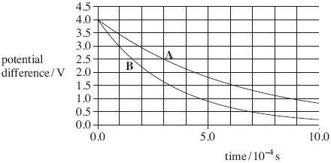
(i) By considering the discharge curve for capacitor A, show that the resistance of the sample of heart tissue through which the discharge occurs is approximately 150 Ω.
.............................................................................................................
.............................................................................................................
.............................................................................................................
.............................................................................................................
.............................................................................................................
(4)
(ii) State and explain whether capacitor B has a larger or smaller capacitance than that of capacitor A.
.............................................................................................................
.............................................................................................................
.............................................................................................................
.............................................................................................................
(2)

(c) Capacitor A was charged to a potential difference of 4.0V before discharging through the sample of heart tissue.
Determine how much energy it passed to the sample of heart tissue in the first 0.90 m s of the discharge.
......................................................................................................................
......................................................................................................................
......................................................................................................................
......................................................................................................................
......................................................................................................................
......................................................................................................................
......................................................................................................................
......................................................................................................................
energy ...................................... J
(3)
(Total 11 marks)
Q152. The figure below shows a horizontal wire, held in tension between fixed points at P and Q. A short section of the wire is positioned between the pole pieces of a permanent magnet, which applies a uniform horizontal magnetic field at right angles to the wire. Wires connected to a circuit at P and Q allow an electric current to be passed through the wire.
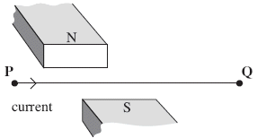
(a) (i) State the direction of the force on the wire when there is a direct current from P to Q, as shown in the figure above.
.............................................................................................................
(1)
(ii) In a second experiment, an alternating current is passed through the wire. Explain why the wire will vibrate vertically.
.............................................................................................................
.............................................................................................................
.............................................................................................................
.............................................................................................................
.............................................................................................................
.............................................................................................................
(3)
(b) The permanent magnet produces a uniform magnetic field of flux density 220 mT over a 55 mm length of the wire. Show that the maximum force on the wire is about 40 mN when there is an alternating current of rms value 2.4 A in it.

(3)
(c) The length of PQ is 0.40 m. When the wire is vibrating, transverse waves are propagated along the wire at a speed of 64 m s^{–1}. Explain why the wire is set into large amplitude vibration when the frequency of the a.c. supply is 80 Hz.
......................................................................................................................
......................................................................................................................
......................................................................................................................
......................................................................................................................
......................................................................................................................
......................................................................................................................
......................................................................................................................
......................................................................................................................
(3)
(Total 10 marks)
Q153. The Hubble space telescope was launched in 1990 into a circular orbit near to the Earth.
It travels around the Earth once every 97 minutes.
(a) Calculate the angular speed of the Hubble telescope, stating an appropriate unit.

answer = .....................................
(3)

(b) (i) Calculate the radius of the orbit of the Hubble telescope.

answer = ................................ m
(3)
(ii) The mass of the Hubble telescope is 1.1 × 10⁴ kg. Calculate the magnitude of the centripetal force that acts on it.

answer = ................................ N
(2)
(Total 8 marks)
Q154. Figure 1 shows a small polystyrene ball which is suspended between two vertical metal plates, P₁ and P₂, 80 mm apart, that are initially uncharged. The ball carries a charge of –0.17 μC.
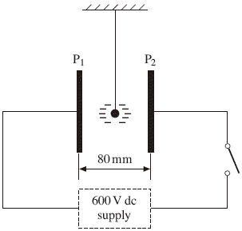
Figure 1

(a) (i) A pd of 600 V is applied between P₁ and P₂ when the switch is closed. Calculate the magnitude of the electric field strength between the plates, assuming it is uniform.

answer = ...........................V m^{–1}
(2)
(ii) Show that the magnitude of the electrostatic force that acts on the ball under these conditions is 1.3 mN.

(1)

(b) Because of the electrostatic force acting on it, the ball is displaced from its original position. It comes to rest when the suspended thread makes an angle θ with the vertical, as shown in Figure 2.
Figure 2
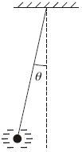
(i) On Figure 2, mark and label the forces that act on the ball when in this position.
(2)
(ii) The mass of the ball is 4.8 × 10^{–4} kg. By considering the equilibrium of the ball, determine the value of θ.

More space on next page

answer = ........................ degrees
(3)
(Total 8 marks)
Q155. A capacitor of capacitance 330 µF is charged to a potential difference of 9.0 V. It is then discharged through a resistor of resistance 470 kΩ.
Calculate
(a) the energy stored by the capacitor when it is fully charged,
......................................................................................................................
......................................................................................................................
......................................................................................................................
(2)
(b) the time constant of the discharging circuit,
......................................................................................................................
......................................................................................................................
(1)
(c) the p.d. across the capacitor 60 s after the discharge has begun.
......................................................................................................................
......................................................................................................................
......................................................................................................................
......................................................................................................................
......................................................................................................................
(3)
(Total 6 marks)
Q156. Communications satellites are usually placed in a geo-synchronous orbit.
(a) State two features of a geo-synchronous orbit.
......................................................................................................................
......................................................................................................................
......................................................................................................................
......................................................................................................................
(2)

(b) Given that the mass of the Earth is 6.00 × 10²⁴ kg and its mean radius is 6.40 × 10⁶ m,
(i) show that the radius of a geo-synchronous orbit must be 4.23 × 10⁷ m,
.............................................................................................................
.............................................................................................................
.............................................................................................................
.............................................................................................................
.............................................................................................................
(ii) calculate the increase in potential energy of a satellite of mass 750 kg when it is raised from the Earth’s surface into a geo-synchronous orbit.
.............................................................................................................
.............................................................................................................
.............................................................................................................
.............................................................................................................
(6)
(Total 8 marks)
Q157. (a) The equation F = BIl, where the symbols have their usual meanings, gives the magnetic force that acts on a conductor in a magnetic field.
Given the unit of each of the quantities in the equation.
F .............................. B ..............................
I .............................. l ...............................
State the condition under which the equation applies.
......................................................................................................................
......................................................................................................................
(2)

(b) The diagram shows a horizontal copper bar of 25 mm × 25 mm square cross-section and length l carrying a current of 65 A.
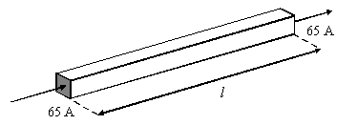
(i) Calculate the minimum value of the flux density of the magnetic field in which it should be placed if its weight is to be supported by the magnetic force that acts upon it.
density of copper = 8.9 × 10³ kg m^{–3}
.............................................................................................................
.............................................................................................................
.............................................................................................................
.............................................................................................................
.............................................................................................................
(ii) Draw an arrow on the diagram above to show the direction in which the magnetic field should be applied if your calculation in part (i) is to be valid. Label this arrow M.
(5)
(Total 7 marks)
Q158. A small charged sphere of mass 2.1 × 10^{–4} kg, suspended from a thread of insulating material, was placed between two vertical parallel plates 60 mm apart. When a potential difference of 4200 V was applied to the plates, the sphere moved until the thread made an angle of 6.0° to the vertical, as shown in the diagram below.
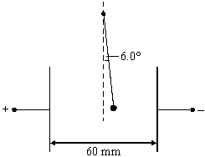

(a) Show that the electrostatic force F on the sphere is given by
F = mg tan 6.0°
where m is the mass of the sphere.
......................................................................................................................
......................................................................................................................
......................................................................................................................
......................................................................................................................
......................................................................................................................
(3)
(b) Calculate
(i) the electric field strength between the plates,
.............................................................................................................
.............................................................................................................
(ii) the charge on the sphere.
.............................................................................................................
.............................................................................................................
.............................................................................................................
.............................................................................................................
(3)
(Total 6 marks)
Q159. (a) State the three factors upon which the capacitance of a parallel plate capacitor depends.
........................................................................................................................
........................................................................................................................
........................................................................................................................
(2)

(b) The figure below shows a circuit for measuring the capacitance of a capacitor.
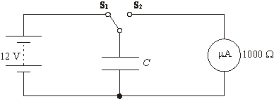
The switch is driven by a signal generator and oscillates between S₁ and S₂ with frequency f.
When the switch is in position S₁ the capacitor charges until the potential difference across it is equal to the supply emf. When the switch moves to position S₂ the capacitor discharges through the microammeter which has a resistance of 1000 Ω.
In one experiment a 0.047 µF capacitor is used with a 12 V supply.
(i) Calculate the charge stored by the capacitor when the switch is in position S₁.

(ii) Calculate the time for which the switch must remain in contact with S₂ in order for the charge on the capacitor to fall to 1% of its initial charge.

(iii) Assuming that the capacitor discharges all the stored charge through the microammeter, calculate the reading on the meter when the switch oscillates at 400 Hz.

(6)
(Total 8 marks)
Q160. (a) State the law that governs the magnitude of the force between two point masses.
........................................................................................................................
........................................................................................................................
........................................................................................................................
........................................................................................................................
(2)

(b) The table shows how the gravitational potential varies for three points above the centre of the Sun.

distance from centre of Sun/10⁸ m | gravitational potential/10¹⁰ J kg^{–1}
7.0 (surface of Sun) | –19
16 | –8.3
35 | –3.8

(i) Show that the data suggest that the potential is inversely proportional to the distance from the centre of the Sun.

(2)
(ii) Use the data to determine the gravitational field strength near the surface of the Sun.

(3)

(iii) Calculate the change in gravitational potential energy needed for the Earth to escape from the gravitational attraction of the Sun.
mass of the Earth = 6.0 × 10²⁴ kg
distance of Earth from centre of Sun = 1.5 × 10¹¹ m

(3)
(iv) Calculate the kinetic energy of the Earth due to its orbital speed around the Sun and hence find the minimum energy that would be needed for the Earth to escape from its orbit. Assume that the Earth moves in a circular orbit.

(3)
(Total 13 marks)

Q161. (a) Figure 1 shows the electron gun that accelerates electrons in an electron microscope.
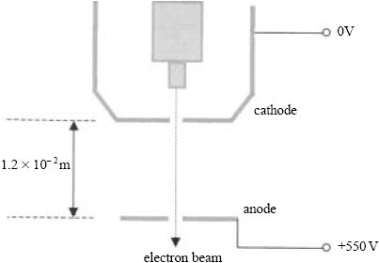
Figure 1
(i) Draw, on Figure 1, electric field lines and lines of equipotential in the region between the anode and cathode. Assume that there are no edge effects and that the holes in the plates do not affect the field.
Clearly label your diagram.
(3)
(ii) Calculate the kinetic energy, speed and momentum of an electron as it passes through the hole in the anode.
mass of an electron = 9.1 × 10^{–31} kg
charge of an electron = –1.6 × 10^{–19} C

(4)
(b) By calculating the de Broglie wavelength of electrons coming through the anode of this device, state and explain whether or not they will be suitable for the investigation of the crystal structure of a metal.
Planck constant = 6.6 × 10^{–34} J s
........................................................................................................................
........................................................................................................................
........................................................................................................................
........................................................................................................................
(4)
(Total 11 marks)
Q162. (a) (i) Explain what is meant by the gravitational field strength at a point in a gravitational field.
...............................................................................................................
...............................................................................................................
...............................................................................................................
(ii) State the SI unit of gravitational field strength.
...............................................................................................................
(2)
(b) Planet P has mass M and radius R. Planet Q has a radius 3R. The values of the gravitational field strengths at the surfaces of P and Q are the same.
(i) Determine the mass of Q in terms of M.

(ii) The figure below shows how the gravitational field strength above the surface of planet P varies with distance from its centre. Draw on the diagram the variation of the gravitational field strength above the surface of Q over the range shown.
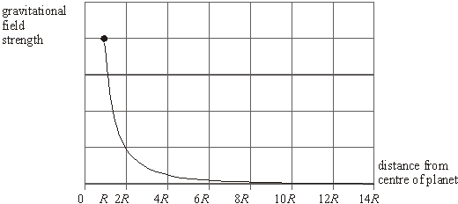
(6)
(Total 8 marks)
Q163.The gravitational field strength at the surface of a planet, X, is 19 N kg^{–1}.
(a) (i) Calculate the gravitational potential difference between the surface of X and a point 10 m above the surface, if the gravitational field can be considered to be uniform over such a small distance.
...............................................................................................................
...............................................................................................................

(ii) Calculate the minimum amount of energy required to lift a 9.0 kg rock a vertical distance of 10 m from the surface of X.
...............................................................................................................
...............................................................................................................
(iii) State whether the minimum amount of energy you have found in part (ii) would be different if the 9.0 kg mass were lifted a vertical distance of 10 m from a point near the top of the highest mountain of planet X. Explain your answer.
...............................................................................................................
...............................................................................................................
...............................................................................................................
(3)
(b) Calculate the gravitational field strength at the surface of another planet, Y, that has the same mass as planet X, but twice the diameter of X.
........................................................................................................................
........................................................................................................................
........................................................................................................................
........................................................................................................................
(2)
(Total 5 marks)
Q164. The gravitational field associated with a planet is radial, as shown in Figure 1, but near the surface it is effectively uniform, as shown in Figure 2.
Alongside each figure, sketch a graph to show how the gravitational potential V associated with the planet varies with distance r (measured outwards from the surface of the planet) in each of these cases.
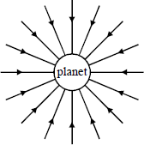
Figure 1

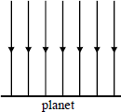
Figure 2
(Total 4 marks)
Q165. (a) Show that the kinetic energy of an α particle travelling at 2.00 × 10⁷ m s^{–1} is 1.33 × 10^{–12} J when relativistic effects are ignored.
........................................................................................................................
........................................................................................................................
........................................................................................................................
(2)
(b) Calculate the closest distance of approach for a head-on collision between the α particle referred to in part (a) and a gold nucleus for which the proton number is 79. Assume that the gold nucleus remains stationary during the collision.
........................................................................................................................
........................................................................................................................
........................................................................................................................
........................................................................................................................
........................................................................................................................
........................................................................................................................
........................................................................................................................
(4)
(c) State one reason why methods other than α particle scattering are used to determine nuclear radii.
........................................................................................................................
........................................................................................................................
(1)
(Total 7 marks)

Q166. When a deuterium nucleus and a tritium nucleus overcome their Coulomb barrier and fuse together they may be considered as charged spheres in contact. The constant r_{o} which relates the nuclear radius, R, to the cube root of the mass number A may be assumed to be 1.3 fm.
(a) (i) Calculate the radius of the deuterium nucleus and, R, the radius of the tritium nucleus before fusion.
R_{D} ......................................................................................................
............................................................................................................
R_{T} .......................................................................................................
............................................................................................................
(ii) Calculate the minimum energy, in MeV, which must be supplied to the deuterium nucleus and the tritium nucleus when they fuse together.
...............................................................................................................
...............................................................................................................
...............................................................................................................
...............................................................................................................
(5)
(b) Estimate the temperature at which deuterium and tritium nuclei would have enough kinetic energy to undergo fusion.
........................................................................................................................
........................................................................................................................
........................................................................................................................
........................................................................................................................
(3)
(Total 8 marks)
Q167. (a) State, in words, Newton’s law of gravitation.
........................................................................................................................
........................................................................................................................
........................................................................................................................
........................................................................................................................
........................................................................................................................
........................................................................................................................
(2)

(b) Some of the earliest attempts to determine the gravitational constant, G, were regarded as experiments to “weigh” the Earth. By considering the gravitational force acting on a mass at the surface of the Earth, regarded as a sphere of radius R, show that the mass of the Earth is given by
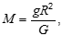
where g is the value of the gravitational field strength at the Earth’s surface.
........................................................................................................................
........................................................................................................................
........................................................................................................................
........................................................................................................................
(2)
(c) In the following calculation use these data.
radius of the Moon = 1.74 × 10⁶ m
gravitational field strength at Moon’s surface = 1.62 N kg^{–1}
mass of the Earth M = 6.00 × 10²⁴ kg
gravitational constant G = 6.67 × 10^{–11} N m² kg^{–2}
Calculate the mass of the Moon and express its mass as a percentage of the mass of the Earth.
........................................................................................................................
........................................................................................................................
........................................................................................................................
........................................................................................................................
........................................................................................................................
(3)
(Total 7 marks)

Q168.
A positive ion with a mass of 3.4 × 10^{–26} kg and a charge of 3.2 × 10^{–19} C is initially at rest at a point P, midway between two parallel conducting plates, A and B which are separated by 40 mm. The ion is accelerated and passes through a hole Q in plate B. It enters a magnetic field of uniform flux density 0.10 T at R. After following a circular path the ion leaves the field at S. Assume that the magnetic field is uniform everywhere within the dotted rectangle and that the space within the solid rectangle is evacuated.
(a) (i) Calculate the electric field strength between the plates AB.
...............................................................................................................
...............................................................................................................
...............................................................................................................
(ii) Calculate the force on the ion due to the electric field.
...............................................................................................................
...............................................................................................................
...............................................................................................................
(iii) Show that the speed of the ion just after it has passed through the hole at Q is 3.1 × 10⁵ m s^{–1}.
...............................................................................................................
...............................................................................................................
...............................................................................................................
...............................................................................................................
(5)

(b) (i) State the direction of the magnetic field.
...............................................................................................................
(ii) Explain why the ion follows a circular path in the magnetic field.
...............................................................................................................
...............................................................................................................
...............................................................................................................
(iii) Show that the radius of the circular path is proportional to the momentum of the ion and calculate the value of the radius.
...............................................................................................................
...............................................................................................................
...............................................................................................................
...............................................................................................................
...............................................................................................................
(6)
(c) Explain how, if at all, the trajectory would be different for an ion with a slightly greater mass but carrying the same charge.
........................................................................................................................
........................................................................................................................
........................................................................................................................
........................................................................................................................
(2)
(Total 13 marks)

Q169. A narrow beam of electrons is directed into a uniform electric field created by two oppositely-charged parallel metal plates at right angles to the field lines. A fluorescent screen is used to make the beam give a visible trace.
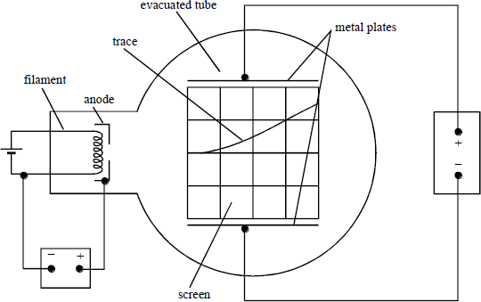
(a) (i) Explain why the beam curves towards the positive plate.
...............................................................................................................
...............................................................................................................
(ii) How does the trace show that, on entry to the electric field, all the electrons have the same speed?
...............................................................................................................
...............................................................................................................
...............................................................................................................
(3)
(b) The beam is produced as a result of accelerating electrons between the filament and a metal anode.
(i) Explain why the wire filament must be hot.
...............................................................................................................
...............................................................................................................
...............................................................................................................

(ii) Write down an equation relating the speed of the electrons, υ, to the potential difference, V_{A}, between the anode and the filament.
...............................................................................................................
...............................................................................................................
(2)
(c) The deflection of the beam due to the electric field can be cancelled by applying a suitable uniform magnetic field in the same region as the electric field.
(i) What direction should the magnetic field be in to do this?
...............................................................................................................
...............................................................................................................
(ii) Write down an equation relating the speed of the electrons υ to the plate voltage V_{p}, the plate separation d, and the magnetic flux density B necessary to make the beam pass undeflected between the plates.
...............................................................................................................
...............................................................................................................
(iii) The following measurements were made when the beam was undeflected.
V_{A} = 3700 V V_{p} = 4500 V d = 50 mm B = 2.5 mT
Use the two equations you have written down and the given data to calculate the specific charge, e/m, of the electron.
...............................................................................................................
...............................................................................................................
...............................................................................................................
...............................................................................................................
...............................................................................................................
...............................................................................................................
...............................................................................................................
...............................................................................................................
...............................................................................................................
...............................................................................................................
...............................................................................................................
(5)
(Total 10 marks)

Q170. (a) (i) Define electric field strength, and state whether it is a scalar quantity or a vector quantity.
...............................................................................................................
...............................................................................................................
...............................................................................................................
...............................................................................................................
(ii) Complete the diagram below to show the electric field lines in the region around two equal positive point charges. Mark with a letter N the position of any point where the field strength is zero.

(6)
(b) Point charges A, of +2.0 nC, and B, of –3.0 nC, are 200 mm apart in a vacuum, as shown by the figure. The point P is 120 mm from A and 160 mm from B.
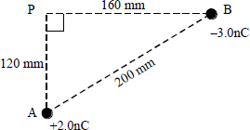
(i) Calculate the component of the electric field at P in the direction AP.
...............................................................................................................
...............................................................................................................
...............................................................................................................

(ii) Calculate the component of the electric field at P in the direction PB.
...............................................................................................................
...............................................................................................................
...............................................................................................................
(iii) Hence calculate the magnitude and direction of the resultant field at P.
...............................................................................................................
...............................................................................................................
...............................................................................................................
...............................................................................................................
(6)
(c) (i) Explain why there is a point X on the line AB in part (b) at which the electric potential is zero.
...............................................................................................................
...............................................................................................................
...............................................................................................................
...............................................................................................................
(ii) Calculate the distance of the point X from A.
...............................................................................................................
...............................................................................................................
...............................................................................................................
...............................................................................................................
(4)
(Total 16 marks)
Q171. (a) (i) State two differences between a proton and a positron.
difference 1 ...........................................................................................
...............................................................................................................
difference 2 ...........................................................................................
...............................................................................................................

(ii) A narrow beam of protons and positrons travelling at the same speed enters a uniform magnetic field. The path of the positrons through the field is shown in Figure 1.
Sketch on Figure 1 the path you would expect the protons to take.
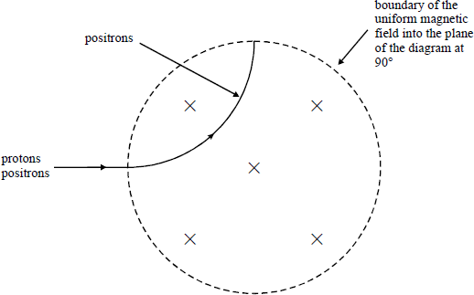
Figure 1
(iii) Explain why protons take a different path to that of the positrons.
...............................................................................................................
...............................................................................................................
...............................................................................................................
...............................................................................................................
...............................................................................................................
...............................................................................................................
(5)

(b) Figure 2 shows five isotopes of carbon plotted on a grid in which the vertical axis represents the neutron number N and the horizontal axis represents the proton number Z.
Two of the isotopes are stable, one is a beta minus emitter and two are positron emitters.
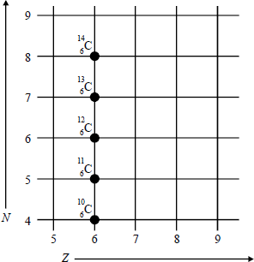
Figure 2
(i) Which isotope is a beta minus emitter?
...............................................................................................................
(ii) Which of the two positron emitters has the shorter half-life? Give a reason for your choice.
...............................................................................................................
...............................................................................................................
...............................................................................................................
(3)
(c) A positron with kinetic energy 2.2 MeV and an electron at rest annihilate each other. Calculate the average energy of each of the two gamma photons produced as a result of this annihilation.
........................................................................................................................
........................................................................................................................
........................................................................................................................
........................................................................................................................
(2)
(Total 10 marks)

Q172. The diagram shows an arrangement in a vacuum to deflect protons into a detector using a magnetic field, which can be assumed to be uniform within the square shown and zero outside it.
The motion of the protons is in the plane of the paper.
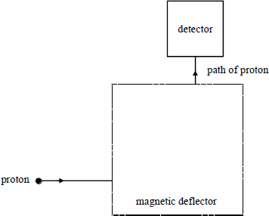
(a) Sketch the path of a proton through the magnetic deflector. At any point on this path draw an arrow to represent the magnetic force on the proton. Label this arrow F.
(2)
(b) State the direction of the uniform magnetic field causing this motion.
........................................................................................................................
(1)
(c) The speed of a proton as it enters the deflector is 5.0 × 10⁶ m s^{–1}. If the flux density of the magnetic field is 0.50 T, calculate the magnitude of the magnetic force on the proton.
........................................................................................................................
........................................................................................................................
........................................................................................................................
(2)
(d) If the path were that of an electron with the same velocity, what two changes would need to be made to the magnetic field for the electron to enter the detector along the same path?
........................................................................................................................
........................................................................................................................
(2)
(Total 7 marks)

Q173. A 10μF capacitor is connected across the terminals of a 100 V d.c. power supply and allowed to charge fully.
(a) Calculate
(i) the charge on the capacitor,
...............................................................................................................
...............................................................................................................
(ii) the energy stored by the capacitor.
...............................................................................................................
...............................................................................................................
(2)
(b) The fully-charged capacitor is disconnected from the power supply and connected via two wires across the terminals of an uncharged 10 μF capacitor as shown.
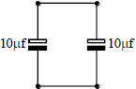
The charge on the original 10 μF capacitor is shared equally between the capacitors in the parallel combination.
(i) Calculate the potential difference across the terminals of each capacitor.
...............................................................................................................
...............................................................................................................
(ii) Calculate the total energy stored by the two capacitors.
...............................................................................................................
...............................................................................................................
(iii) Account for the difference between the energy stored by the two capacitors in parallel and that stored by the original single 10 μF capacitor.
...............................................................................................................
...............................................................................................................
...............................................................................................................
...............................................................................................................
(4)
(Total 6 marks)

Q174. (a) An electron moves parallel to, but in the opposite direction to, a uniform electric field, as shown in Figure 1.
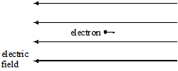
Figure 1
(i) State the direction of the force that acts on the electron due to the electric field.
...............................................................................................................
(ii) What is the effect of this force on the motion of the electron?
...............................................................................................................
...............................................................................................................
(2)
(b) An electron, which is travelling in a horizontal path at constant speed, enters a uniform vertical electric field as shown in Figure 2.
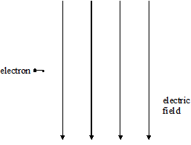
Figure 2
(i) Sketch on Figure 2 the path followed by the electron.
(ii) Explain the motion of the electron whilst in this field.
...............................................................................................................
...............................................................................................................
...............................................................................................................
...............................................................................................................
...............................................................................................................
(3)
(Total 5 marks)

Q175. (a) For a capacitor of capacitance C, sketch graphs of charge, Q, and energy stored, E, against potential difference, V.
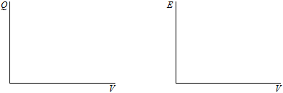
graph A graph B
What is represented by the slope of graph A?
........................................................................................................................
(3)
(b) A capacitor of capacitance 0.68 F is charged to 6.0 V. Calculate
(i) the charge stored by the capacitor,
...............................................................................................................
...............................................................................................................
(ii) the energy stored by the capacitor.
...............................................................................................................
...............................................................................................................
(2)
(Total 5 marks)
Q176. Both gravitational and electric field strengths can be described by similar equations written in the form
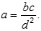
(a) Complete the following table by writing down the names of the corresponding quantities, together with their SI units, for the two types of field.

symbol | gravitational field  quantity SI unit |  | electrical field  quantity SI unit
a | gravitational  field strength
b |  |  | 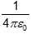 | m F^{–1}
c
d
(4)

(b) Two isolated charged objects, A and B, are arranged so that the gravitational force between them is equal and opposite to the electric force between them.
(i) The separation of A and B is doubled without changing their charges or masses. State and explain the effect, if any, that this will have on the resultant force between them.
...............................................................................................................
...............................................................................................................
(ii) At the original separation, the mass of A is doubled, whilst the charge on A and the mass of B remain as they were initially. What would have to happen to the charge on B to keep the resultant force zero?
...............................................................................................................
...............................................................................................................
(3)
(Total 7 marks)
Q177. (a) The graph shows how the gravitational potential varies with distance in the region above the surface of the Earth. R is the radius of the Earth, which is 6400 km. At the surface of the Earth, the gravitational potential is −62.5 MJ kg^{–1}.
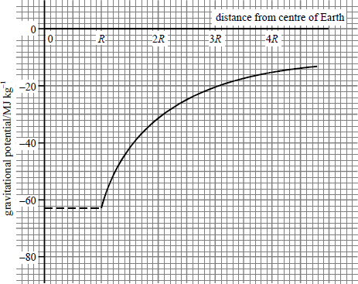
Use the graph to calculate
(i) the gravitational potential at a distance 2R from the centre of the Earth,
...............................................................................................................

(ii) the increase in the potential energy of a 1200 kg satellite when it is raised from the surface of the Earth into a circular orbit of radius 3R.
...............................................................................................................
...............................................................................................................
...............................................................................................................
...............................................................................................................
...............................................................................................................
...............................................................................................................
...............................................................................................................
(4)
(b) (i) Write down an equation which relates gravitational field strength and gravitational potential.
...............................................................................................................
(ii) By use of the graph in part (a), calculate the gravitational field strength at a distance 2R from the centre of the Earth.
...............................................................................................................
...............................................................................................................
...............................................................................................................
...............................................................................................................
(iii) Show that your result for part (b)(ii) is consistent with the fact that the surface gravitational field strength is about 10 N kg^{–1}.
...............................................................................................................
...............................................................................................................
...............................................................................................................
...............................................................................................................
(5)
(Total 9 marks)

Q178. An alternating current (a.c.) source is connected to a resistor to form a complete circuit. The trace obtained on an oscilloscope connected across the resistor is shown.
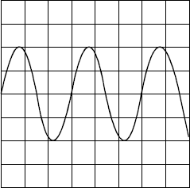
The oscilloscope settings are: Y sensitivity 4.0 V per division,
time base 1.0 m s per division.
(a) Determine the peak voltage of the a.c. source.
........................................................................................................................
........................................................................................................................
(b) Hence calculate the r.m.s. voltage.
........................................................................................................................
........................................................................................................................
(c) Determine the time period of the a.c. signal.
........................................................................................................................
........................................................................................................................
(d) Hence calculate the frequency of the a.c. signal.
........................................................................................................................
........................................................................................................................
(Total 4 marks)

Q179. The diagram shows a magnet placed on a top-pan balance. A fixed horizontal wire, through which a current can flow, passes centrally through the magnetic field parallel to the pole-pieces. With no current flowing, the balance records a mass of 201.32 g. When a current of 5.0 A flows, the reading on the balance is 202.86 g.
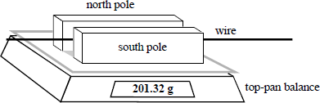
(a) (i) Explain why the reading on the balance increased when the current was switched on.
...............................................................................................................
...............................................................................................................
...............................................................................................................
(ii) State the direction of current flow and explain your answer.
...............................................................................................................
...............................................................................................................
...............................................................................................................
(iii) If the length of the wire in the magnetic field is 60 mm, estimate the flux density of the magnetic field.
...............................................................................................................
...............................................................................................................
...............................................................................................................
(6)
(b) Sketch a graph to show how you would expect the balance reading to change if the current through the wire was changed.
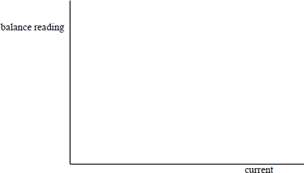
(2)
(Total 8 marks)

Q180. (a) The circuit shown in Figure 1 may be used to determine the internal resistance of a battery. An oscilloscope is connected across the battery as shown. Figure 2 represents the screen of the oscilloscope.
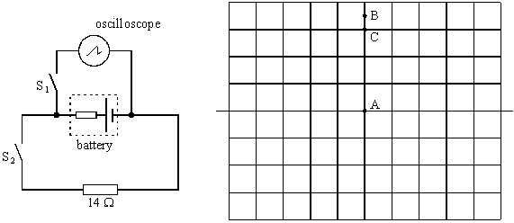
Figure 1 Figure 2
The time base of the oscilloscope is switched off throughout the experiment. Initially the switches S₁ and S₂ are both open. Under these conditions the spot on the oscilloscope screen is at A.
(i) Switch S₁ is now closed, with S₂ remaining open. The spot moves to B. State what the deflection AB represents.
.............................................................................................................
(ii) Switch S₁ is kept closed and S₂ is also closed. The spot moves to C. State what the deflection AC represents.
.............................................................................................................
(iii) The vertical sensitivity of the oscilloscope is 0.50 V div^{–1}. Calculate the current through the 14 Ω resistor with both switches closed.
.............................................................................................................
.............................................................................................................
.............................................................................................................
(iv) Hence, calculate the internal resistance of the battery.
.............................................................................................................
.............................................................................................................
.............................................................................................................
(6)

(b) The oscilloscope is now connected to an alternating voltage source of rms value 3.5 V.
(i) Calculate the peak value of the alternating voltage.
..............................................................................................................
.............................................................................................................
(ii) Draw on Figure 3 what you would expect to see on the oscilloscope screen, if the time base is still switched off and the voltage sensitivity is altered to 2.0 V div^{–1}.

Figure 3
(3)
(Total 9 marks)
Q181. (a) A 2.0 μF capacitor is charged through a resistor from a battery of emf 4.5 V. Sketch a graph on the axes below to show how the charge stored, Q, varies with the potential difference, V, across the capacitor during the charging process. Mark appropriate values on the axes of the graph.
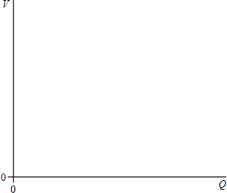
(2)

(b) (i) Show that the energy stored by a charged capacitor is given by E = $\frac{1}{2}$QV.
...............................................................................................................
...............................................................................................................
...............................................................................................................
...............................................................................................................
...............................................................................................................
...............................................................................................................
(ii) Calculate the energy stored by the capacitor in part (a) when the potential difference across it is 1.5 V.
...............................................................................................................
...............................................................................................................
...............................................................................................................
...............................................................................................................
(5)
(Total 7 marks)
Q182. A student used a voltage sensor connected to a datalogger to plot the discharge curve for a 4.7 μF capacitor. She obtained the following graph.
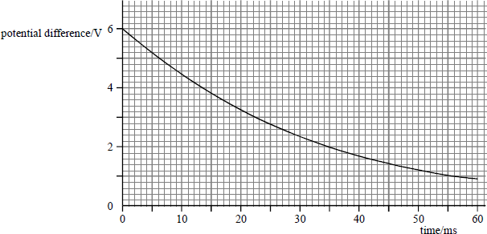
Use data from the graph to calculate
(a) the initial charge stored,
........................................................................................................................
(2)

(b) the energy stored when the capacitor had been discharging for 35 ms,
........................................................................................................................
........................................................................................................................
(3)
(c) the time constant for the circuit,
........................................................................................................................
........................................................................................................................
........................................................................................................................
........................................................................................................................
(3)
(d) the resistance of the circuit through which the capacitor was discharging.
........................................................................................................................
........................................................................................................................
........................................................................................................................
(2)
(Total 10 marks)
Q183. (a) A satellite moves in a circular orbit at constant speed. Explain why its speed does not change even though it is acted on by a force.
........................................................................................................................
........................................................................................................................
........................................................................................................................
........................................................................................................................
........................................................................................................................
........................................................................................................................
(3)
(b) At a certain point along the orbit of a satellite in uniform circular motion, the Earth’s magnetic flux density has a component of 56 μT towards the centre of the Earth and a component of 17 μT in a direction perpendicular to the plane of the orbit.
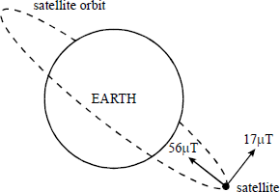
(i) Calculate the magnitude of the resultant magnetic flux density at this point.
...............................................................................................................
...............................................................................................................
(ii) The satellite has an external metal rod pointing towards the centre of the Earth.
Calculate the angle between the direction of the resultant magnetic field and the rod.
...............................................................................................................
...............................................................................................................
...............................................................................................................
...............................................................................................................
...............................................................................................................
(iii) Explain why an emf is induced in the rod in this position.
...............................................................................................................
...............................................................................................................
(4)
(Total 7 marks)
Q184. Protons and pions are produced in a beam from a target in an accelerator. The two types of particles can be separated using a magnetic field.
(a) State the quark composition of
(i) a proton,
...............................................................................................................
(ii) a positive pion, π⁺
...............................................................................................................
(2)
(b) A narrow beam consisting of protons and positive pions, all travelling at a speed of.
1.5 × 10⁷ m s^{–1} , is directed into a uniform magnetic field of flux density 0.16 T, as shown in the diagram.
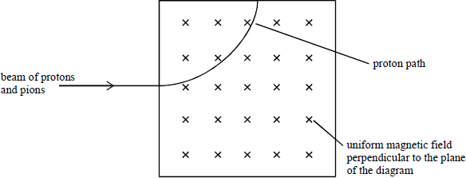

(i) Calculate the radius of curvature of the path of the protons in the field.
...............................................................................................................
...............................................................................................................
...............................................................................................................
...............................................................................................................
...............................................................................................................
...............................................................................................................
...............................................................................................................
(ii) Sketch, on the diagram above, the path of the pions from the point of entry into the field to the point of exit from the field.
(iii) If the magnetic field were increased, how would this affect the paths of the particles?
...............................................................................................................
...............................................................................................................
...............................................................................................................
(7)
(Total 9 marks)
Q185. A rectangular coil measuring 20 mm by 35 mm and having 650 turns is rotating about a horizontal axis which is at right angles to a uniform magnetic field of flux density 2.5 × 10^{–3} T.
The plane of the coil makes an angle θ with the vertical, as shown in the diagrams.
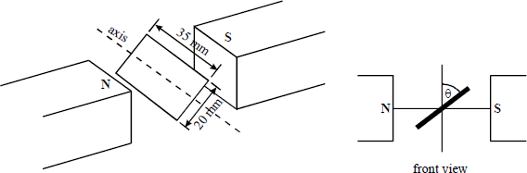
(a) State the value of θ when the magnetic flux through the coil is a minimum.
........................................................................................................................
(1)
(b) Calculate the magnetic flux passing through the coil when θ is 30°.
........................................................................................................................
........................................................................................................................
(2)
(c) What is the maximum flux linkage through the coil as it rotates?
........................................................................................................................
........................................................................................................................
........................................................................................................................
(2)
(Total 5 marks)
Q186. The mass of the nucleus of an isolated copper atom is 63 u and it carries a charge of +29 e. The diameter of the atom is 2.3 × 10^{–10} m.
P is a point at the outer edge of the atom.
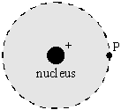
(a) Calculate
(i) the electric field strength at P due to the nucleus,
.............................................................................................................
.............................................................................................................
.............................................................................................................
(ii) the gravitational potential at P due to the nucleus.
.............................................................................................................
.............................................................................................................
.............................................................................................................
(5)
(b) Draw an arrow on the above diagram to show the direction of the electric field at the point P.
(1)
(Total 6 marks)

Q187 A hydroelectric power station has a power output of 2.0 MW when water passes through its turbines at a rate of 1.4 m³ s^{–1}. The water is supplied from a reservoir which is 750 m above the power station turbines, as shown in the diagram below.
density of water = 1000 kg m^{–3}
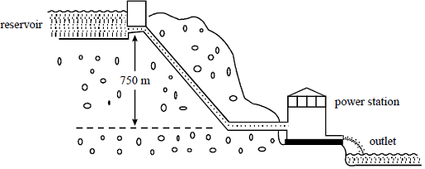
(a) Calculate
(i) the mass of water passing through the turbines each second,
...............................................................................................................
...............................................................................................................
...............................................................................................................
...............................................................................................................
(ii) the loss of potential energy per second of the water flowing between the reservoir and the power station turbines,
...............................................................................................................
...............................................................................................................
...............................................................................................................
(iii) the efficiency of the power station.
...............................................................................................................
...............................................................................................................
...............................................................................................................
...............................................................................................................
(6)
(b) The turbines drive generators that produce alternating current at an rms potential difference of 25 kV which is then stepped up to an rms potential difference of 275 kV by means of a transformer.

(i) Calculate the rms current supplied by the generators to the transformer when the power output of the generators is 2.0 MW.
...............................................................................................................
...............................................................................................................
...............................................................................................................
...............................................................................................................
(ii) The transformer has an efficiency of 95%. Calculate the output current of the transformer.
...............................................................................................................
...............................................................................................................
...............................................................................................................
...............................................................................................................
(4)
(Total 10 marks)
Q188. (a) The diagram shows the apparatus required for a simple experiment to measure the speed of sound.
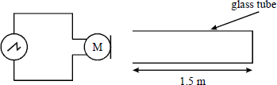
A pulse of sound is sent down a hollow glass tube and is reflected at the sealed end of the tube. A microphone, M, placed at the open end detects the initial pulse and, at a later time, the reflected pulse. The microphone is connected to an oscilloscope which gives a signal when the microphone detects a pulse of sound.
The signal displayed on the oscilloscope screen is shown below.
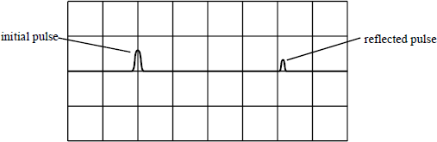
If the time base of the oscilloscope is set to 2.0 ms per division, estimate the speed of sound in air.
........................................................................................................................
............................................................................................ (contined on next page)

........................................................................................................................
........................................................................................................................
........................................................................................................................
(3)
(b) Describe how the frequency of a sinusoidal alternating (ac) voltage source is measured using an oscilloscope.
Your answer should include a sketch of the trace seen on the oscilloscope screen and explain how the frequency is obtained from this trace.

........................................................................................................................
........................................................................................................................
........................................................................................................................
........................................................................................................................
........................................................................................................................
........................................................................................................................
........................................................................................................................
........................................................................................................................
........................................................................................................................
(5)
(Total 8 marks)
Q189. (a) This part of the question is about protons.
(i) Calculate the electrostatic potential energy, in J, of two protons at a distance apart of
1.0 × 10^{–15} m.
...............................................................................................................
...............................................................................................................
...............................................................................................................
...............................................................................................................
...............................................................................................................

(ii) Two protons moving in opposite directions at the same initial speed collide head-on with each other. The least distance apart of the two protons is 1.0 × 10¹⁵ m. By considering conservation of energy, estimate the initial kinetic energy, in MeV, of each proton.
...............................................................................................................
...............................................................................................................
...............................................................................................................
...............................................................................................................
...............................................................................................................
...............................................................................................................
...............................................................................................................
(5)
(b) State the quark composition of
(i) a proton,
...............................................................................................................
(ii) a positive pion, π⁺.
...............................................................................................................
(2)
(c) A proton collides with another proton moving in the opposite direction at the same speed, creating a positive pion and a further particle X in the process. This process is represented by the equation
p + p → p + p + π⁺ + X.
(i) State the charge, Q, and baryon number, B, of X.
Q ...........................................................................................................
B ...........................................................................................................
(ii) State the identity and quark composition of X.
...............................................................................................................
...............................................................................................................
(iii) Explain why two protons with initial kinetic energies as in part (a)(ii) could not produce the reaction in part (c).
...............................................................................................................
...............................................................................................................
...............................................................................................................
...............................................................................................................
(5)
(Total 12 marks)

Q190. (a) Calculate the length of copper wire that has a diameter of 1.6 × 10^{–3} m and a resistance
of 25 Ω.
resistivity of copper = 1.7 × 10^{–8} Ω m

Length of wire .......................................................
(3)
(b) The resistance of copper wire is not zero. Explain why this fact leads to the use of alternating current rather than direct current when transmitting electrical energy.
........................................................................................................................
........................................................................................................................
........................................................................................................................
........................................................................................................................
........................................................................................................................
........................................................................................................................
........................................................................................................................
(3)
(Total 6 marks)
Q191. The Earth’s surface and the base of a charged cloud can be considered to be two plates of a parallel-plate capacitor.
(a) Calculate the capacitance of an Earth-cloud system when the base of the cloud has an area of 1.4 × 10⁶ m² and is 800 m above the Earth’s surface.
$ε_{0}$ = 8.9 × 10^{–12} F m^{–1}
$ε_{r}$ for air = 1.0

(2)

(b) A potential difference of 3.0 × 10⁶ V across each metre of air will cause the air to break down and allow the cloud to discharge to the Earth.
(i) Show that the average breakdown p.d. for the 800 m layer of air between the Earth and the base of the cloud is about 2.5 × 10⁹ V.

(1)
(ii) Calculate the maximum energy that the charged Earth – cloud system can store.

(2)
(iii) Calculate the maximum charge stored by the system before breakdown commences.

(1)
(c) By considering the cloud discharge to be modelled by a resistor connected across a capacitor, calculate the resistance that would allow a cloud to discharge 99% of its charge to Earth in a time of 0.25 s.

(3)
(Total 9 marks)

Q192. (a) The diagram below shows part of a precipitation system used to collect dust particles in a chimney. It consists of two large parallel vertical plates maintained at potentials of +25 kV and –25 kV.
The diagram below also shows the electric field lines between the plates.
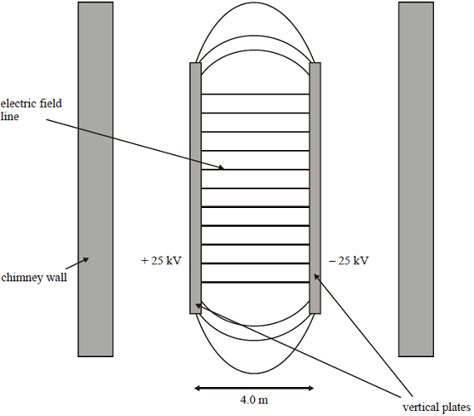
(i) Add arrows to the diagram to show the direction of the electric field.
(1)
(ii) Explain what is meant by an equipotential surface.
...............................................................................................................
...............................................................................................................
...............................................................................................................
(1)
(iii) Draw and label on the diagram equipotentials that correspond to potentials
of –12.5 kV, 0 V, and +12.5 kV.
(2)
(b) A small dust particle moves vertically up the centre of the chimney, midway between the plates.
(i) The charge on the dust particle is +5.5 nC. Show that there is an electrostatic force on the particle of about 0.07 mN.

(2)
(ii) The mass of the dust particle is 1.2 × 10^{–4} kg and it moves up the centre of the chimney at a constant vertical speed of 0.80 m s^{–1}.
Calculate the minimum length of the plates necessary for this particle to strike one of them. Ignore air resistance.

(4)
(Total 10 marks)
Q193. (a) Explain what is meant by the term magnetic flux linkage. State its unit.
........................................................................................................................
........................................................................................................................
........................................................................................................................
........................................................................................................................
(2)
(b) Explain, in terms of electromagnetic induction, how a transformer may be used to step down voltage.
........................................................................................................................
........................................................................................................................
........................................................................................................................
........................................................................................................................
........................................................................................................................
........................................................................................................................
(4)
(c) A minidisc player is provided with a mains adapter. The adapter uses a transformer with a turns ratio of 15:1 to step down the mains voltage from 230 V.
(i) Calculate the output voltage of the transformer.
(2)
(ii) State two reasons why the transformer may be less than 100% efficient.
...............................................................................................................
...............................................................................................................
...............................................................................................................
(2)
(Total 10 marks)

Q194. For an object, such as a space rocket, to escape from the gravitational attraction of the Earth it must be given an amount of energy equal to the gravitational potential energy that it has on the Earth’s surface. The minimum initial vertical velocity at the surface of the Earth that it requires to achieve this is known as the escape velocity.
(a) (i) Write down the equation for the gravitational potential energy of a rocket when it is on the Earth’s surface. Take the mass of the Earth to be M, that of the rocket to be m and the radius of the Earth to be R.

(1)
(ii) Show that the escape velocity, v, of the rocket is given by the equation v =$\sqrt{\frac{2GM}{R}}$

(2)
(b) The nominal escape velocity from the Earth is 11.2 km s^{–1}. Calculate a value for the escape velocity from a planet of mass four times that of the Earth and radius twice that of the Earth.

(2)
(c) Explain why the actual escape velocity from the Earth would be greater than the nominal value calculated from the equation given in part (a)(ii).
........................................................................................................................
........................................................................................................................
........................................................................................................................
(2)
(Total 7 marks)

Q195. In the cathode ray tube illustrated below, electrons are accelerated by a potential difference of 1.8 kV between the cathode (C) and the anode (A).
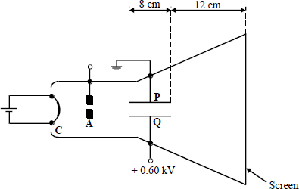
(a) (i) Calculate the kinetic energy, in J, of the electrons after they have passed the anode.
charge on an electron, e = –1.6 × 10^{–19} C

(2)
(ii) Calculate the velocity of the electrons after they have passed the anode.
Mass of an electron = 9.1 × 10^{–31} kg

(2)
(b) The plates P and Q are 8.0 cm long and are separated by a gap of 4.0 cm.
(i) Define electric field strength.
...............................................................................................................
...............................................................................................................
(1)
(ii) Calculate the force acting on an electron when it is between P and Q and state the direction of the force.

Direction ..............................................................................................................
(3)
(iii) Calculate the time taken for an electron to pass between the plates.

(1)
(iv) Calculate the vertical component of velocity at the time the electron leaves the electric field between P and Q.

(2)
(v) Calculate the additional vertical displacement of the electron between the time it leaves the electric field between P and Q and when it reaches the screen.

(1)
(Total 12 marks)
Q196. (a) Explain why a particle is accelerating even when it is moving with a uniform speed in a circular path.
........................................................................................................................
........................................................................................................................
........................................................................................................................
(2)
(b) Figure 1 shows a schematic diagram of a proton synchrotron. This is a device for accelerating protons to high speeds in a horizontal circular path.
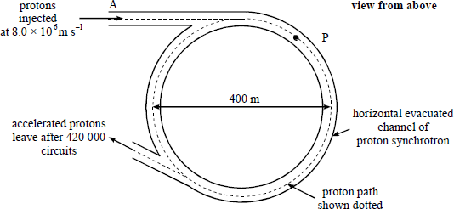
Figure 1
In the synchrotron the protons of mass 1.7 × 10^{–27} kg are injected at point A at a speed of
8.0 × 10⁶ m s^{–1}. The diameter of the path taken by the protons is 400 m.
(i) Show on Figure 1 the direction of the force required to make a proton move in the circular path when the proton is at the position marked P.
(1)
(ii) Calculate the force that has to be provided to produce the circular path when the speed of a proton is 8.0 × 10⁶ m s^{–1}.
(2)
(iii) Sketch on Figure 2 a graph to show how this force will have to change as the speed of the proton increases over the range shown on the x-axis. Insert an appropriate scale on the force axis.
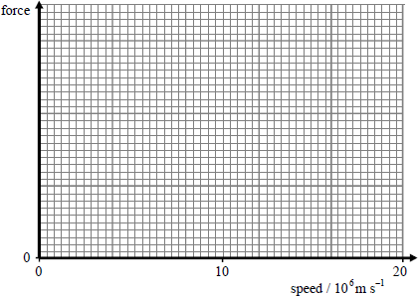
Figure 2
(c) Before reaching their final energy the protons in the synchrotron in part (b) travel around the accelerator 420 000 times in 2.0 s.
acceleration of free fall, g = 9.8 m s^{–2}
(i) Calculate the total distance travelled by a proton in the 2.0 s time interval.

(2)
(ii) Unless a vertical force is applied the protons wold fall as they move through the horizontal channel.
Calculate the distance a proton would fall in two seconds.

(2)

(iii) Determine the force necessary to prevent the vertical movement.

(1)
(Total 12 marks)
Q197. (a) (i) A label on a capacitor shows it to have a capacitance of 0.020 F. Explain what this tells you about the capacitor.
...............................................................................................................
...............................................................................................................
(1)
(ii) Sketch on Figure 1 the graph that shows how the charge on the 0.020 F capacitor varies with the potential difference across it over the voltage range given. Insert an appropriate scale on the charge axis.
(2)
(iii) Explain how your graph could be used to obtain the energy stored for a given potential difference.
...............................................................................................................
...............................................................................................................
...............................................................................................................
(2)
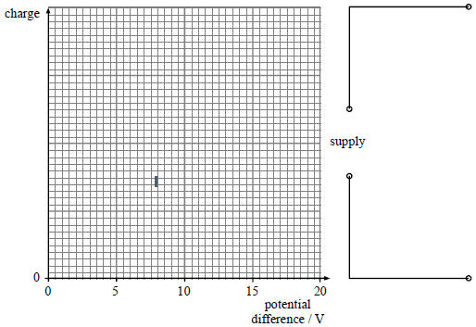
Figure 1 Figure 2

(iv) Show on Figure 2 how two similar capacitors could be connected to a supply to store more energy for the same potential difference.
(1)
(b) Figure 3 shows one 0.020 F capacitor connected to a 20 V supply. By means of the changeover switch S, the capacitor is disconnected from the supply and connected to a small motor. The motor lifts an object of mass 0.15 kg through a height of 0.80 m, after which the energy left in the capacitor is negligible.
acceleration of free fall, g = 9.8 m s^{–2}
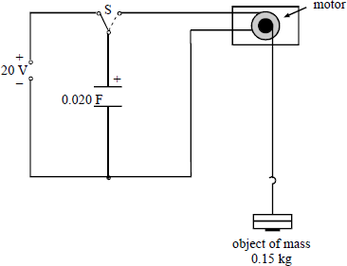
Figure 3
Calculate:
(i) the initial energy stored by the capacitor;

(2)
(ii) the efficiency of the energy conversion.

(3)
(Total 11 marks)

Q198. A transformer is required to produce an r.m.s. output of 2.0 × 10³ V when it is connected to the 230 V r.m.s. mains supply. The primary coil has 800 turns.
(a) Calculate the number of turns required on the secondary coil, assuming the transformer is ideal.

(2)
(b) The transformer suffers from eddy current losses.
(i) Explain how eddy currents arise.
...............................................................................................................
...............................................................................................................
...............................................................................................................
...............................................................................................................
...............................................................................................................
...............................................................................................................
(4)
(ii) State the feature of transformers designed to minimise eddy currents.
...............................................................................................................
(1)
(Total 7 marks)
Q199. The diagram below (not to scale) shows the planet Neptune (N) with its two largest moons, Triton (T) and Proteus (P). Triton has an orbital radius of 3.55 × 10⁸ m and that of Proteus is 1.18 × 10⁸ m. The orbits are assumed to be circular.
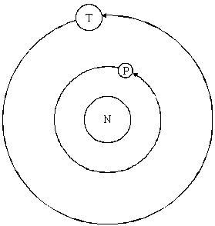

(a) Explain why the velocity of each moon varies whilst its orbital speed remains constant.
........................................................................................................................
........................................................................................................................
(1)
(b) Write down an equation that shows how Neptune’s gravitational attraction provides the centripetal force required to hold Triton in its orbit. Hence show that it is unnecessary to know the mass of Triton in order to find its angular speed.

(3)
(c) Show that $\frac{theorbitalperiodofTriton}{theorbitalperiodofProteus}$ is approximately 5.2.

(4)
(Total 8 marks)

Q200. (a) A capacitor is marked ‘2200 μF 15 V’.
(i) Explain what is meant by a capacitance of 2200 μF.
...............................................................................................................
...............................................................................................................
(2)
(ii) What is the significance of the 15 V marking?
...............................................................................................................
...............................................................................................................
(1)
(b) An egg-timer is designed to produce a sound when an egg has been boiled for a sufficient time. The time which elapses before the alarm sounds is controlled by the circuit shown below. The circuit is operated from a 6.0 V cell of negligible internal resistance.
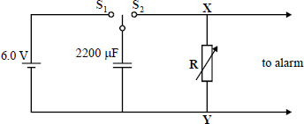
The time is set by means of the variable resistor R.
The capacitor is charged by moving the two-way switch to position S₁ for a short time. The timing is then started automatically when the two-way switch is moved to position S₂. An alarm rings when the potential difference between terminals XY reaches 2.0 V.
(i) In one setting the time constant of the circuit when the capacitor is discharging is 3.0 minutes. Sketch a graph to show how the potential difference between the terminals X and Y varies with time for the first 6.0 minutes after the switch moves to the position S₂.
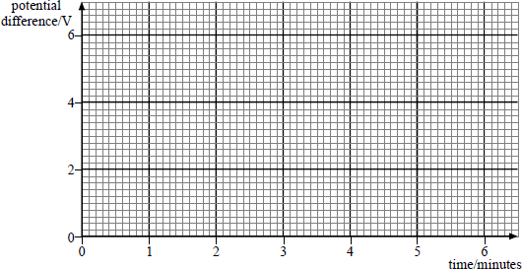
(2)

(ii) How long after timing commences will the alarm sound for the setting in part (i)?
...............................................................................................................
(1)
(iii) Calculate the resistance of the variable resistor when the time constant is 3.0 minutes.

(2)
(iv) The system is designed to measure cooking times up to 5.0 minutes. Determine the maximum value of the resistance R that is needed.

(2)
(v) State how a suitable capacitor would be connected to increase the measurable cooking time.
...............................................................................................................
...............................................................................................................
(1)
(Total 11 marks)
Q201. A lunar landing module and its parent craft are orbiting the Moon at a height above the surface of 6.0 × 10⁵ m. The mass of the lunar module is 2.7 × 10³ kg. The graph below shows the variation of the gravitational force on the module with height above the surface of the Moon.
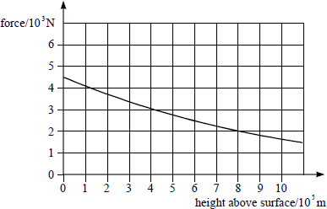

(a) (i) Using data from the graph, find the gravitational force on the lunar module and hence find its speed when its orbital height is 6.0 × 10⁵ m.

(3)
(ii) Using data from the graph, find the change in gravitational potential energy of the lunar module as it descends from its orbit to the surface of the Moon.

(3)
(b) The descent of the lunar module is controlled by a set of rockets. Describe how you would use the data which you have already calculated to determine the minimum fuel load which would enable the lunar module to land on the surface of the Moon and subsequently to rejoin its parent craft in orbit. State what additional information you would need to know.
........................................................................................................................
........................................................................................................................
........................................................................................................................
........................................................................................................................
........................................................................................................................
........................................................................................................................
(3)
(Total 9 marks)
Q202. (a) (i) Explain what is meant by gravitational field strength.
...............................................................................................................
...............................................................................................................
...............................................................................................................
(1)

(ii) Describe how you would measure the gravitational field strength close to the surface of the Earth. Draw a diagram of the apparatus that you would use.

(6)

(b) (i) The Earth’s gravitational field strength (g) at a distance (r) of 2.0 × 10⁷ m from its centre is 1.0 N kg^{–1}. Complete the table with the 3 further values of g.

g/N kg^{–1} | 1.0
r/10⁷ m | 2.0 | 4.0 | 6.0 | 8.0

(2)
(ii) Below is a grid marked with g and r values on its axes. Draw a graph showing the variation of g with r for values of r between 2.0 × 10⁷ m and 10.0 × 10⁷ m.
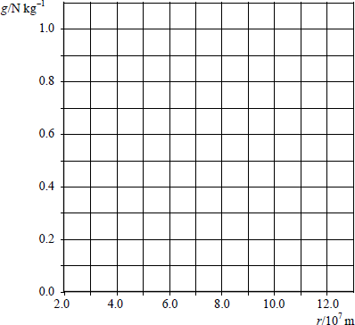
(2)
(iii) Estimate the energy required to raise a satellite of mass 800 kg from an orbit of radius 4.0 × 10⁷ m to one of radius 10.0 × 10⁷ m.

(3)
(Total 14 marks)

Q203. Figure 1 shows the plan view of a cyclotron in which protons are emitted in between the dees. The protons are deflected into a circular path by the application of a magnetic field. Figure 2 shows a view from in front of the cyclotron.
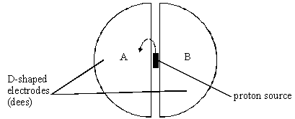
Figure 1
Figure 2
(a) (i) Mark on Figure 2 the direction of the magnetic field in the region of the dees such that it will deflect the proton beam in the direction shown in Figure 1.
(2)
(ii) Show that the velocity of the proton, v, at some instant is given by:
v = $\frac{Ber}{m}$
where m is the proton mass, r the radius of its circular path, B the magnetic flux density acting on the proton and +e the proton charge.

(2)
(iii) Write down an equation for the time T for a proton to make a complete circular path in this magnetic field.

(2)

(iv) Explain how your equation leads to the conclusion that T is independent of the speed with which the proton is moving.
...............................................................................................................
...............................................................................................................
...............................................................................................................
(1)
(b) In addition to this magnetic field there is an electric field provided between the dees. This accelerates the proton towards whichever dee is negatively charged. An alternating potential difference causes each dee to become alternately negative and then positive. This causes the proton to accelerate each time it crosses the gap between the dees.
(i) Describe and explain the effect the acceleration has on the path in which the proton moves.
...............................................................................................................
...............................................................................................................
...............................................................................................................
(2)
(ii) In terms of T, write down the frequency with which the p.d. must alternate to match the period of motion of the proton.

(1)
(c) (i) Calculate the velocity of a proton of energy 0.12 keV.
the proton mass, m = 1.7 × 10^{–27} kg
the magnitude of the electronic charge, e = 1.6 × 10^{–19} C

(3)

(ii) Calculate the de Broglie wavelength of the 0.12 keV proton.
the Planck constant, h = 6.6 × 10^{–34} J s

(3)
(iii) Name the region of the electromagnetic spectrum which has an equivalent wavelength to that of the proton.
...............................................................................................................
(1)
(Total 17 marks)
Q204. A physicist wants to design an experiment in which two free protons collide to produce two delta-plus (∆⁺) particles. This is an allowed reaction and is fully represented by the equation
p⁺ + p⁺ → ∆⁺ + ∆⁺
Two options are available that are shown as A and B in the diagram below.

A | accelerated proton | stationary proton
B | accelerated proton | accelerated proton
In A an accelerated proton collides with a stationary proton and in B two accelerated protons, each with the same energy, collide head on.
the charge on a proton = +1.6 × 10⁻¹⁹ C
the rest mass of a proton = 1.7 × 10⁻²⁷ kg
the permittivity of free space ε₀ = 8.9 × 10⁻¹² F m⁻¹
(a) State the baryon number of a ∆⁺ particle.
........................................................................................................................
(1)
(b) The radius of a proton is 1.5 × 10⁻¹⁵ m.
(i) Calculate the minimum total kinetic energy that the accelerated protons need so that they will touch each other.

(3)

(ii) State what happens in situation A when the energy is less than your answer to part (i).
...............................................................................................................
...............................................................................................................
(1)
(iii) State and explain what happens in situation B when the energy is less than your answer to part (i).
...............................................................................................................
...............................................................................................................
...............................................................................................................
...............................................................................................................
(3)
(iv) Explain why the protons can undergo fusion if this energy is exceeded.
...............................................................................................................
...............................................................................................................
...............................................................................................................
(2)
(c) Calculate the minimum total kinetic energy, in J, of the protons that will allow the two protons to collide and produce the two ∆⁺ particles.
speed of electromagnetic radiation in free space = 3.0 × 10⁸ m s⁻¹
rest mass of a ∆⁺ particle = 2.2 × 10⁻²⁷ kg

(3)
(Total 13 marks)
Q205.The Earth has an electric charge. The electric field strength outside the Earth varies in the same way as if this charge were concentrated at the centre of the Earth. The axes in the diagram below represent the electric field strength E and the distance from the centre of the Earth r. The electric field strength at A has been plotted.
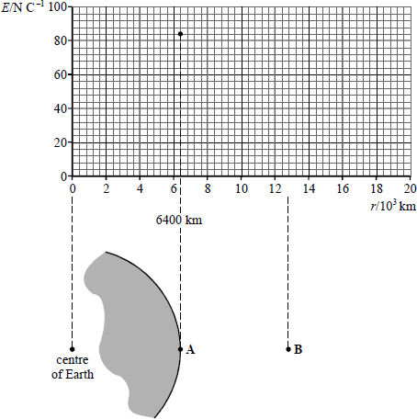
(a) (i) Determine the electric field strength at B and then complete the graph to show how the electric field strength varies with distance from the centre of the Earth for distances greater than 6400 km.

(3)
(ii) State how you would use the graph to find the electric potential difference between the points A and B.
...............................................................................................................
...............................................................................................................
(1)
(b) The permittivity of free space ε₀ is 8.9 × 10^{–12} F m^{–1} .
(i) Calculate the total charge on the Earth.

(2)

(ii) The charge is distributed uniformly over the Earth's surface. Calculate the charge per square metre on the Earth's surface.

(2)
(Total 8 marks)
Q206. (a) Explain what is meant by a capacitance of 1 farad (F).
........................................................................................................................
........................................................................................................................
(1)
(b) A parallel plate capacitor was made from two circular metal plates with air between them.
The distance between the plates was 1.8 mm. The capacitance of this capacitor was found to be 2.3 × 10^{–11} F.
The permittivity of free space ε₀ = 8.9 ×10^{–12} F m^{–1}
The relative permittivity of air = 1.0
Calculate:
(i) the radius of the plates used in the capacitor;

(3)
(ii) the energy stored when the potential difference between the capacitor plates is 6.0 V.

(2)

(c) A student charged the capacitor and then tried to measure the potential difference between the plates using an oscilloscope. The student observed the trace shown in the diagram below and concluded that the capacitor was discharging through the oscilloscope.
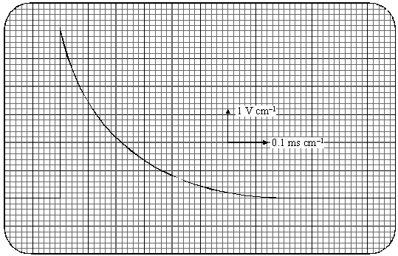
Calculate the resistance of the oscilloscope.

(3)
(Total 9 marks)
Q207. (a) State the factors that affect the gravitational field strength at the surface of a planet.
........................................................................................................................
........................................................................................................................
(2)

(b) The diagram below shows the variation, called an anomaly, of gravitational field strength at the Earth’s surface in a region where there is a large spherical granite rock buried in the Earth’s crust.
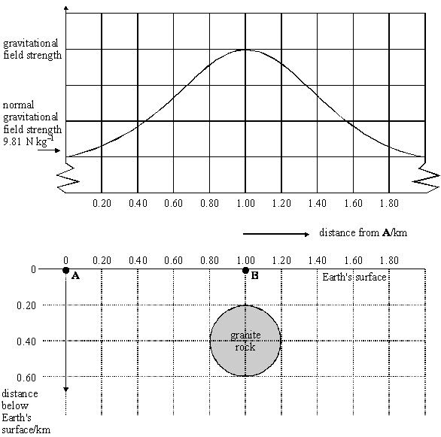
The density of the granite rock is 3700 kg m^{–3} and the mean density of the surrounding material is 2200 kg m^{–3}.
(i) Show that the difference between the mass of the granite rock and the mass of an equivalent volume of the surrounding material is 5.0 × 10¹⁰ kg.

(4)

(ii) The universal gravitational constant G = 6.7 × 10^{–11} N m² kg^{–2}. Calculate the difference between the gravitational field strength at B and that at point A on the Earth’s surface that is a long way from the granite rock.

(4)
(iii) Add to the diagram above a graph to show how the variation in gravitational field strength would change if the granite rock were buried deeper in the Earth’s crust.
(1)
(Total 11 marks)
Q208. The diagram below shows a diagram of a mass spectrometer.
(a) The magnetic field strength in the velocity selector is 0.14 T and the electric field strength is 20 000 V m^{–1}.
(i) Define the unit for magnetic flux density, the tesla.
...............................................................................................................
...............................................................................................................
(2)
(ii) Show that the velocity selected is independent of the charge on an ion.

(2)

(iii) Show that the velocity selected is about 140 km s^{–1}.

(1)
(b) A sample of nickel is analysed in the spectrometer. The two most abundant isotopes of nickel are ${}_{28}^{58}{}$ and ${}_{28}^{60}{}$. Each ion carries a single charge of +1.6 × 10^{–19} C.
mass of a proton or neutron = 1.7 × 10^{–27} kg
The ${}_{28}^{58}{}$ ion strikes the photographic plate 0.28 m from the point P at which the ion beam enters the ion separator.
Calculate:
(i) the magnetic flux density of the field in the ion separator;

(3)
(ii) the separation of the positions where the two isotopes hit the photographic plate.

(2)
(Total 10 marks)

