**Induction work for Politics Students: September 2022**

**Task 1**

In July, PM Boris Johnson was forced to resign as party leader.

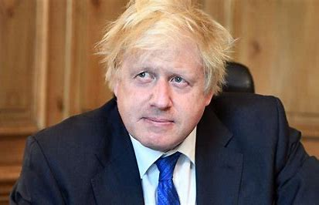

Find out, using this article: <https://uk.movies.yahoo.com/boris-johnson-resignation-prime-ministers-110457689.html>

1. What scandal proved to be the final straw for Johnson?
2. Who were the two most high profile resignations and how many more resignations followed?
3. Who urged him to step aside? What difficulties did Johnson face with all of the resignations?
4. What were Johnson’s claims in his resignation speech?

Over the summer, Conservative party members (who represent 0.3% of the population of the UK) are voting to decide who will be the next leader of their party and in effect, who becomes the next Prime Minister of the UK. The results will be announced on 5th September.

1. Who are the two remaining candidates? Look at this article and draw up a quick, bullet point profile of each of the two contenders: <https://www.theguardian.com/politics/ng-interactive/2022/aug/15/liz-truss-v-rishi-sunak-a-timeline-of-their-roads-to-tory-final-two>
2. Watch this short video and describe 2 differences in policy between the two: <https://www.independent.co.uk/news/uk/politics/truss-sunak-opinium-poll-conservatives-b2140059.html>



1. Who, according to polls, is most likely to win?
2. Who would you prefer to win if you had the choice to vote? Do you think it is right that such a small percentage of the population get to choose who our next PM is? Why?

**Pressure Groups in action: Sewage on the beaches…**

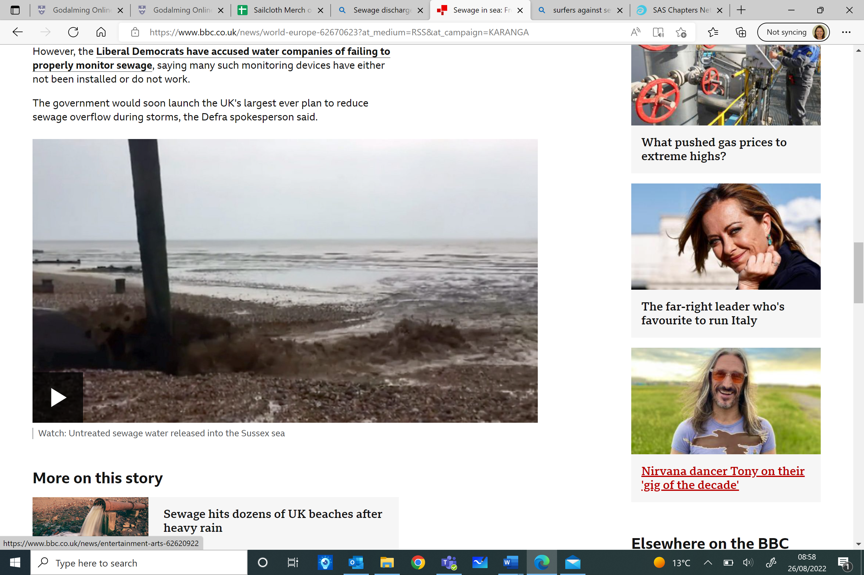



One part of our course is to study how pressure groups affect the political system. These are organisations who try to influence government policy without running for office. Here is an example of them in action.

Go to [Water firms face growing criticism over beach sewage - BBC News](https://www.bbc.co.uk/news/uk-62633559) answer the following questions:

1. How many beaches in the UK had warnings?
2. What has former pop star & campaigner Feargal Sharkey said about the issue?
3. How has the government responded?
4. Look at this article [Campaigners to hold protest in Sussex over sewage discharges by into the sea by Southern Water | ITV News Meridian](https://www.itv.com/news/meridian/2022-08-26/campaigners-to-protest-over-sewage-discharges-into-the-sea)– what are local people doing in Bexhill to show their unhappiness about the situation?
5. ***Extra*** – find out what the French think about sewage in the English Channel & research another pressure group – Surfers Against Sewage. Look at their website ([SAS Chapters Network • Surfers Against Sewage](https://www.sas.org.uk/sas-chapters-network/)) and find out what they do to campaign for cleaner waters.

**Parliament’s summer break**

Go to <http://www.parliament.uk/about/faqs/house-of-commons-faqs/business-faq-page/recess-dates/> and answer the following questions

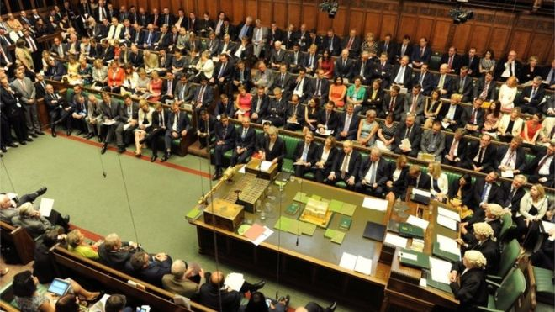1) When did the House of Commons break up for their summer recess?

2) When do they return properly?

3) Do you think they deserve this long of a break?

**Task 2**

|  |  |
| --- | --- |
| **POLITICAL CONCEPTS MATCHING EXERCISE** |  |
| Possible answers are: *MP, Conservatives, constitution, left wing, capitalism, Coalition, A body that represents workers, Liberal Democrats, Parliament, Cabinet, the Greens, minister, democracy, right wing, Labour, government, ideology, sovereignty, socialism, the State, Constituency.* |  |
| 1. Which party traditionally favoured trade unions. |  |
| 1. What is a trade union? |  |
| 1. The smaller party in the 2010-2015 coalition government. |  |
| 1. The party which stands for free enterprise and traditional values. |  |
| 1. The legislature (supreme law making body). |  |
| 1. The group of senior politicians who decide policy and rule the country. |  |
| 1. The institution at the centre of the above which meets once a week to advise the Prime Minister on policy. |  |
| 1. A politician who runs all or part of a government department like the Department of Education. |  |
| 1. A member of the legislature. |  |
| 1. The area represented by a member of the legislature. |  |
| 1. Which party cares most about the environment? |  |
| 1. Someone is called this if they believe in a more equal society and a more liberal approach to issues like immigration. |  |
| 1. The economic system based on private ownership and free enterprise with minimum state interference. |  |
| 1. The economic system in which the government intervenes to make society more equal. |  |
| 1. A system or document which defines the relationship between government institutions and between them and the individual citizen. |  |
| 1. Supreme political authority and a country’s right to determine its own affairs. |  |
| 1. A set of political ideas like conservatism or liberalism. |  |
| 1. The political system in which the government is elected by and accountable to the people. |  |
| 1. The area controlled by a national government; also the word for government authority as opposed to privately owned businesses or individual citizens. |  |
| 1. When two or more parties combine to govern |  |

**Task 3 – Get involved with social media!**

Politics is a fast-moving, dynamic subject which lends itself really well to social media.

i) The department runs an Instagram site where you can follow our posts on current affairs and discuss them, if you wish, with other politics students at college. If you are on Instagram, you can follow ‘**godcolpol**’ on Instagram. The links to each news story are posted in the profile of the page.

|  |
| --- |
| When you follow the page you are deemed to have agreed to these guidelines:   * Please do:   + Maintain the terms and conditions of your Student Contract when using the Godalming College Politics Forum, specifically: *To behave in a courteous, considerate and responsible manner at all times respecting the needs and rights of others whether staff or students at the college or members of the local community****.*** In this instance the community also includes the online community.   + be accurate, fair and transparent when creating or altering online sources of information. * Please don’t:   + engage in activities involving this Forum which might bring Godalming College into disrepute.   + represent your personal views as those of Godalming College on this site.   + discuss personal information about students or staff at Godalming College on this site.   + use this Forum in any way to attack, insult, abuse or defame students, their family members, colleagues, other professionals, other organisations or Godalming College.   **If you contravene any of these principles you risk being removed from the Forum and referred to your Senior Tutor.** |

**ii) Try following news organisations on Instagram:**

bbcnews; guardian; telegraph; the.independent; theeconomist; simplepolitics; daily_politics; channel4news;

**Task 4 – Keeping up with the press!**

Read *one* of these newspapers for 10 minutes each day (or use their website): *The Times; The Independent; The Guardian; The Telegraph*

Have a look at *one* of these magazines (or their website) and read a couple of the articles:

*The Spectator; The Economist; Prospect; The New Statesman; Time*