**Art history induction work**

Welcome to Art History! If you have any queries about any aspect of the course or support, please do not hesitate to contact Dan Greaney: [dlg@godalming.ac.uk](mailto:dlg@godalming.ac.uk)

Introduction

During your first year, you will complete an initial foundation module on Visual Analysis and two further modules on the themes of War and Identities. You will explore both of these themes each week. The initial Visual Analysis module will be delivered during the first half term (September – October). These three modules account for 50% of your final A Level examination, so it is vital that you keep accurate and detailed notes from each of your lessons in the workbooks provided for you. If, for some unavoidable reason, you miss a lesson, it is your responsibility to contact your study buddy and catch up on both the concepts and content you have missed. After the summer half term, you will begin work on your final two Period modules but this will be explained nearer the time.

Initial preparatory work: **Please complete the 2 tasks for each of the two modules, War and Identities as explained below and bring to your first lesson.**

**War**

**Task 1**: Find three portraits/depictions of military leaders from any time in history. These can be paintings and/or sculptures and male or female. They might be individuals you have studied in GCSE History. Copy and paste the images onto a single sheet and bring to your first lesson. Briefly answer the questions below in relation to your choices.  
1. Consider how they have been represented. Are they portrayed in a positive or negative manner?

2. Consider the gender of the subject. Have they been depicted in a stereotypical way for their gender?

3. How has colour been used (if the work is a painting)? Do the colours suggest or imply a feeling in the work?  
4. Does the individual appear benign or intimidating?

5. Are there elements within the work which indicate a battle or historical event which the subject was involved in?

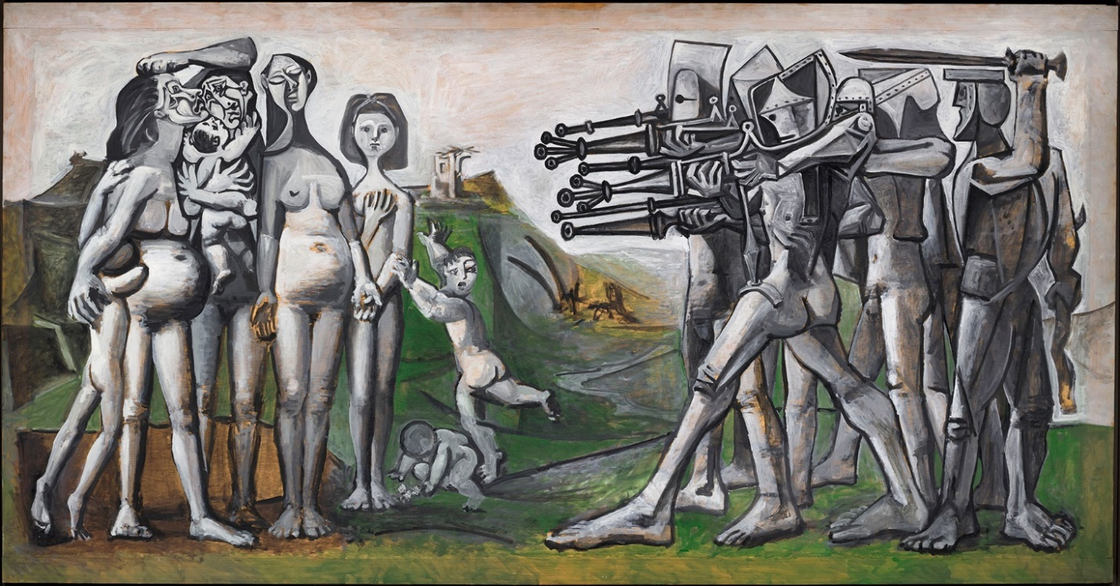**Task 2**: Pablo Picasso’s ‘*Massacre in Korea*’ (painted in 1951, 1.1m x 2.1m, oil on wood, Musée Picasso). This is a painting depicting an event which occurred in 1950 during the Korean War.

Look very carefully at Picasso’s representation of the figures in this work. Can you see a clear narrative between the groups? Can you identify who the victims of the ‘massacre’ are? What does the title of the painting tell you about Picasso’s opinion on this event? How are the soldiers represented? Might their appearance remind you of other eras?

Write a description of this work using the above questions as prompts. Don’t worry about historical context. Instead ‘visually analyse’ the work using your own judgements based on what you can see. Write approximately 300 words on this task.

**Identities**

**Task 1:** Find three painted portraits of individuals. One must date from the 18th century, one from the 19th century, and one from the 20th century. Copy these images onto a single sheet of paper and print them (or email to me), making sure you identify the name of the artist, the sitter and the size of the work.

Then consider and make brief notes on the following:

1. What elements are consistent across all (or the majority) of the works you have selected?
2. What changes over time?
3. What do you think are the key messages of each work?
4. How does the artist’s technique contribute to your understanding of the meaning of each work?
5. How does the scale (size) of each work make a difference?

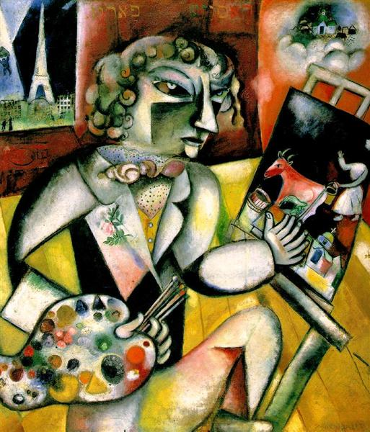**Task 2**: Marc Chagall ‘*Self Portrait with seven fingers’* (1912) oil on canvas, 126 x 107.5cm, (Stedelijk Museum, Amsterdam)

Please do NOT read or research this work, just look at it for yourself. Spend a few minutes just looking at this work. What is happening within this scene? Look at details for clues. The title of the work is also important and will help your understanding of the artist’s message. Now, answer the question below, based on your own ideas and opinions. You should aim to write approximately 300 words.

Q: **Describe the figure and setting in this painting and discuss how the artist conveys *identity*** (identity can encompass a broad spectrum of factors; gender, race, ethnicity, class, status, profession, age, appearance etc- so look out for these in this painting).