Environmental Science Induction Work 2022

You will have to complete these 2 tasks below and bring your work (printed or hand written) to your first lesson in college.

Task 1: Research Biomimetics
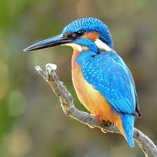
- Research what biomimetics means.
- Select 2 examples of manufactured items that use biomimetics for their design and outline the following:
    - the species
    - the specific feature of species that is being used
    - details of the design of the manufactured item
  - Write a summary of your research.

Some websites that may help you:
https://www.scienceabc.com/innovation/what-is-biomimicry-definition-real-life-examples.html
https://biomimicry.org/what-is-biomimicry/
https://www.youtube.com/watch?v=UHb_XNgIHFY
https://www.bbc.co.uk/programmes/w13xttw7/episodes/downloads

Task 2: Conservation

Select one species (plant or animal) that is being conserved at the moment.
Research why this species needs to be conserved and the different methods that are being taken to conserve the species.
Write a short report outlining these details. (1 A4 page maximum)
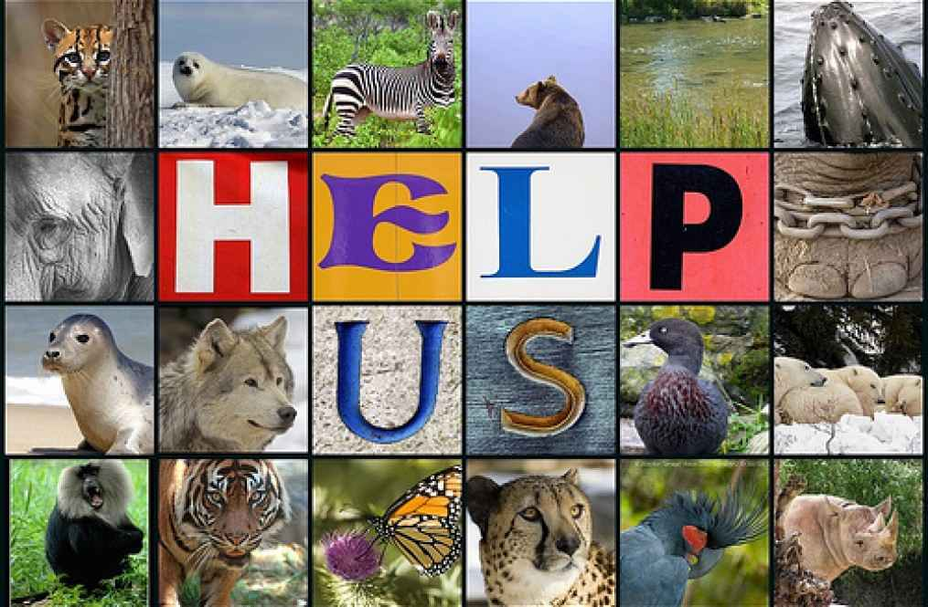
Consider the following:
- What is causing the numbers of this species to decline?
- What are the main conservation methods?
- What organisations and laws are involved in the conservation?
- How is the success of the conservation programmes being measured?

