**Your Enrolment task for August/ September 2022 and helping you to be organised and ready to study Law**;

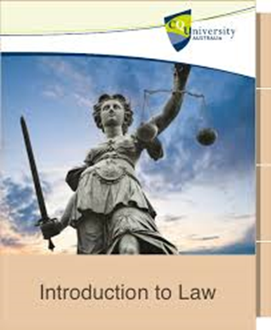Thank you for enrolling to study A Level Law.

Your enrolment task is to complete this online course; **Starting with law: An overview of the law** with the Open University;it is a free course, you will need to set up an account with them to access the course, this then allows you to log back in and complete the course at your own pace. The details required to create an account are your name, email address, date of birth, do remember to save your password for this account.

The course will introduce you to the key players in law making in the UK and provide you with some helpful tips on study techniques, for law and help you to get back into studying by following and working through this short online course.

After studying this short course, you should be able to:

* understand how the legal system in the UK works
* understand how laws are made in the UK
* understand some of the key players in UK law enforcement
* understand different ways of taking notes

The course is a total of 5 hours private study time (which is a general guide to the amount of private study time you should aim to complete for each of your subject choices per week – ) and it will help you to get back into the mind-set and process of studying – students who have completed it, have said it took them on average 3 hours to complete.

Once completed in full, please either save and print your completion certificate or take a screen shot of this and bring/have ready to show/share on MS Teams for your first timetabled law lesson in September 2022, in the week starting from Monday 12th September, so ensure you have completed and printed/screen shot of your certificate prior to this date.

Also whilst you are completing the course; please note down the following;

Any questions on Law and the English Legal System from completing this course

And what you found of most interest when you completed this course;

**Here’s the link to your Law enrolment course**;

[Starting with law: An overview of the law - OpenLearn - Open University](https://www.open.edu/openlearn/society-politics-law/starting-law-an-overview-the-law/content-section-0?active-tab=description-tab)

**Helping you to be organised, ready for your Law Lessons and to help support you in making the transition from school to college learning.**

****You need to be in the habit of being prepared for all of your Law lessons.

To help you to do this, during your first two weeks of the law course (which will be focused on induction and understanding the basics of law, the legal system and the rule of law), you must always do the following ready for every law lesson.

* Bring for every law lesson, your current law studypack (which for the first 2 weeks, this will be your ‘Law Induction and Nature of Law studypack’ and the ‘Rule of Law’ studypack in week 2, pens and a notepad AND have these out ready, on your desk (in front of you) at the start of your law lesson, and with your mobile phone on silent and tucked away in your bag.
* Start to organise and have ready Law Folders – you will need 4 (explained below) in total in your first year, which need to be labelled Law -Paper 1 - Crime and Law Paper 2 – Tort and Law Paper 3 - Contract– Page 4 shows a breakdown of all the topics covered across the A Level – 2 Year law course. It will help you to have 3 large folders (lever arch) to use at home and 1 smaller law folder that you use to bring to college for your law lessons in which you file your current workbook, notes and assignment work.

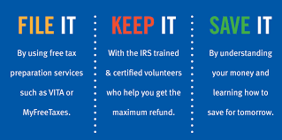

When we progress through the different topics over the academic year, you will need to file each of you workbooks into the correct folder. This will enable you to be organised and prevent you from losing any workbooks (which you will have spent time completing in and outside of the classroom). It also ensures that when you come to revise you have all the topics/workbooks ready and are easily accessible. Please also have dividers to separate out your workbooks within the folders labelled with the names of the topics, e.g. ‘Criminal Courts and Process”.

* Read through page 4, so you are clear on the course content and the exam unit breakdown of the course. It will also be a helpful guide to enable you to check which folder to file your law workbooks into.
* Completing Assignment work (more commonly referred to as Homework) – you will be set regular amounts of Assignment work in Law and must complete them on time and bring them to your next lesson. Once you are aware of your timetable it is helpful to then start to plan allocated time to complete your assignment work for each of your subjects. You will have a range of free/study periods during your college day and these should be used as personal study time to complete assignment work set and to review class notes and content covered in class (doing this will really help you, in studying law, as to all of you it will be a new subject and the terminology and content can take time to adapt to). To be on top of your assignment work across all of your subjects, identify the free periods during your College week that you are going to dedicate to each of your subjects and then plan times outside of college, to achieve the additional time you can and will spend on your studies that fits in with your commitments and interests outside of College.
* Committing to 4.5 to 6 hours of personal study for each of your subjects is the recommended amount and College expectation (50;50 approach to learning) for you to reach your potential and progress. Students who do not do this underperform at A Level, so set yourself up to achieve and stick with dedicating this time every week and you will see the rewards in doing so. Also have the mind-set and attitude that completing assignment work is adding your learning and understanding, so dedicate time to it, rather than rushing to complete as soon as possible.
* Organise your copy of the Year 1 Law Textbook, either by ordering the textbook or getting an Electronic version of the law book – a physical copy is advised. Assignment work will assume you have the textbook to support your learning and it is a vital learning aid, to support your legal studies.

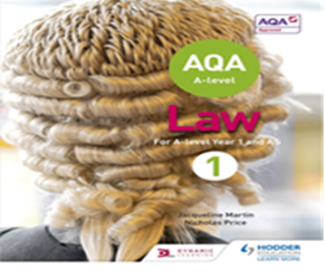“AQA A-level Law for Year 1/AS” - Jacqueline Martin, Nicholas Price

**ISBN: 9781510401648, Publisher = Hodder, Price = £25.99**



By doing all of the above, you will be in the habit of being prepared for your law lessons in the future. This will help you to be organised, proactive and on top of your law studies and assignment work and setting yourself up to make rewarding progress in studying law.

We will expect you to continue with this level of organisation and preparation throughout the academic year and in Year 2.

**What Topics are covered on the A Level Law Course?**

|  |  |  |
| --- | --- | --- |
| **Paper 1 - Crime** | **Paper 2 - Tort** | **Paper 3 - Contract** |
| * Criminal Liability * Non-Fatal Offences * Fatal Offences – Murder, Voluntary Manslaughter and Involuntary Manslaughter. * Property Offences, Theft and Robbery * Criminal Attempts * General Defences; Automatism, Insanity, Intoxication, Self Defence, Duress. | * Negligence * Occupiers Liability * Remedies/Damages * Nuisance and the escape of dangerous things – Private Nuisance and Rylands and Fletcher. * Vicarious Liability * Further Negligence Economic Loss and Psychiatric Injury * Defences | * Nature of Contract Law * Formation of a Contract; Offer and Acceptance, Consideration, Legal Intent, Privity. * Terms; types, express and implied, Consumer Rights Act 2015 and Exclusion Clauses. * Vitiating Factors, Misrepresentation and Duress. * Discharge of Contract; Breach, Performance and Frustration * Remedies |
| * Nature of Law - Criminal * The Criminal Process; criminal courts, appeals, sentencing, role of Juries and Lay Magistrates. * The Legal Profession; Barristers, Solicitors and legal executives. * The Judiciary; criminal role. * Judicial Precedent * Statutory Interpretation * Criminal Access to Justice | * Nature of Law – Civil * Judiciary role in Civil cases. * Parliamentary law making. * Law Commission * The civil courts and other forms of dispute resolution including civil courts and the appeal system. * Access to justice and funding in civil system. | * Nature of Law – Civil and the Rule of Law * Delegated legislation. * The European Union. * The judiciary: types of judge. Role of judges in civil courts and Independence of the Judiciary. * Access to justice and funding in civil system. |
| **Concepts;**   * Law and Justice * Law and Fault * Theory of Criminal Law | **Concepts;**   * Law and Morality * Law and Fault * Theory of Tort Law | **Concepts;**   * Law and Justice * Law and Morality * Balancing Conflicting Interests * Theory of Contract Law |