## 

## 

## **Enrolment Pack**

## **BTEC Health and Social Care Extended Certificate Enrolment work 2022**

Please bring this completed Enrolment Pack to your first Health and Social Care lesson. All tasks need to be completed by **Friday 9th September.**

Pre-reading and research will help you to become more familiar with the topics you are going to study on your BTEC Health and Social Care course. Through completing the tasks below they will help you to become more confident when you start your course.

**What is health and social care?**

Health and Social Care describes the work sectors that provide healthcare and social care services. Health and Social Care as a subject of study is multidisciplinary in nature. It includes concepts and knowledge from natural sciences such as biology and social sciences such as sociology and psychology. This gives Health and Social Care broad appeal and something for everyone to enjoy.

It is a fascinating subject, focused on understanding how people live, grow and develop and the factors that affect this. This provides students with the foundational knowledge required in a large variety of careers.

BTEC Level 3 Extended Certificate in Health and Social Care

The BTEC Level 3 Extended Certificate is designed to provide you with an understanding of key areas of growth and development across the lifespan. You will take part in a mixture of external examinations and internally assessed coursework. This is a useful choice for anyone with an interest in improving their knowledge of human development or with an interest in Healthcare, Social Care or Education.

This qualification consists of 3 mandatory units and 1 optional unit.

In the first year you will be studying Unit 1 ‘Human Lifespan Development’, which will be examined and Unit 5 ‘Meeting Individual Care and Support Needs’ which will be coursework.

### Task 1 link to Unit 1

Outline the main life stages and put them in the following table with the age range which accompanies them:

|  |  |
| --- | --- |
| Life Stage | Age range |
|  |  |
|  |  |
|  |  |
|  |  |
|  |  |
|  |  |

Find definitions to the following terms

**Growth**

...............................................................................................................................

...............................................................................................................................

...............................................................................................................................

...............................................................................................................................

**Development**

...............................................................................................................................

...............................................................................................................................

...............................................................................................................................

...............................................................................................................................

### Task 2 link to Unit 1

Read the paragraph and thing how Sarah has grown and developed in the table after:

Sarah is a 1 year old girl who is developing normally. Her health visitor has come to visit her for a one year check. When she was born, Sarah weighed around 3kg, the health visitor finds that she now weighs 9kg. Sarah’s mother mentions that Sarah has recently begun to use words such as ‘dada’ and ‘moo,’ the health visitor says that this is normal language development and Sarah won’t move on to two-word phrases until around 2 years old. Next, the health visitor measures Sarah and finds that she is 74cm long; the health visitor reassures Sarah’s mother that this is normal for her weight and age. Finally, the health visitor gives Sarah some toys to play with and monitors her abilities; Sarah can build a tower with three blocks, point to a picture of a sheep in a book and can sit herself up after lying down.

How has Sarah…

|  |  |
| --- | --- |
| Grown? | Developed? |
|  |  |

### Task 3 links to Unit 5

The 6Cs are a set of values for all health and social care staff. These 6 values are essential in providing the best care for individuals and their different needs.

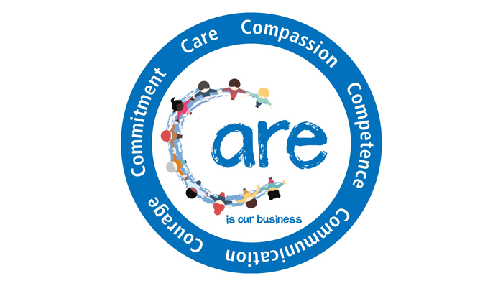

**Using your A3 sheet- Design a Poster about the 6 C’s of Health and Social Care for a team of Nurses starting their new roles at Royal Surrey County Hospital.**

These links will help you to research the 6 C’s and create an eye-catching poster explaining the importance of the 6 C’s for meeting the care and support needs of individuals.

<https://www.england.nhs.uk/6cs/wp-content/uploads/sites/25/2015/03/introducing-the-6cs.pdf>

<https://www.england.nhs.uk/blog/jane-cummings-4/>

### Task 4 links to Unit 2



Research the NHS and what it means to work in the health sector. Then identify some of the different roles offered by the NHS for those looking to start a career working for Britain’s biggest employer.

<https://www.england.nhs.uk/>

<https://www.healthcareers.nhs.uk/explore-roles>

<https://www.healthcareers.nhs.uk/>

…………………………………………………………………………………………………………………………………………………………………………………………………………………………………………………………………………………………………………………………………………………………………………………………………………………………………………………………………………………………………………………………………………………………………………………………………………………………………………………………………………………………………………………………………………………………………………………………………………………………………………………………………………………………………………………………………………………………………………………………………………………………………………………………………………………………………………………………………………..…………………………………………………………………………………………………………………………………………………………..…………………………………………………………………………………………

List in the table below the sector and some of the skills and attributes required for the following health and social care roles:

|  |  |  |
| --- | --- | --- |
| **Job Role:** | **Health or Social Care role:** | **Skills and Attributes required for role:** |
| Paediatric Nurse |  |  |
| Pharmacist |  |  |
| Care Assistant |  |  |
| Psychologist |  |  |
| Occupational Therapist |  |  |
| Youth Worker |  |  |
| Social Worker |  |  |
| General Practitioner |  |  |
| Midwife |  |  |

Task 5 links to Unit 2

Finally, complete the NHS quiz using the link below to find out your ideal health career: <https://www.healthcareers.nhs.uk/findyourcareer>

The quiz should take only 5 minutes to complete. Write down your findings below, what careers have you been signposted to.

………………………………………………………………………………………………………………………………………………………………………………………………………………………………………………………………………………………………………………………………………………………………………………………………………………………………………………………………………………..…………………………………………………………………………………………………………………………………………………………..…………………………………………………………………………………………………………………………………………………………..…………………………………………………………………………………………………………………………………………………………..

Task 6

Note down any questions you might have about Health and Social Care course. Also you could note down some of the things you have done in preparation for the course. For example work experience, books or documentaries you have watched.