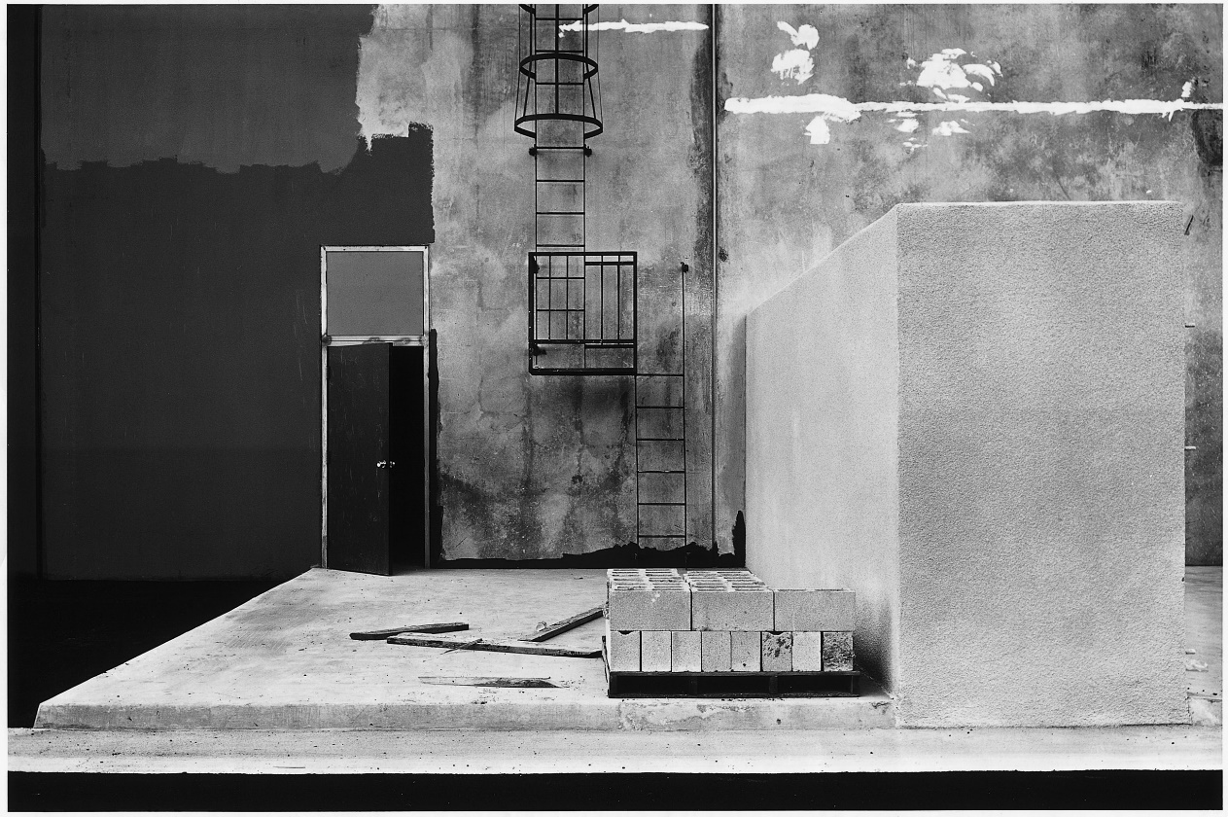****

Photography A-Level

AQA: Art and Design (Photography) 7206  3570

Course Handbook

**NAME:**

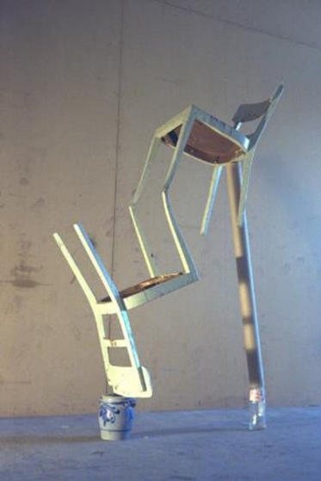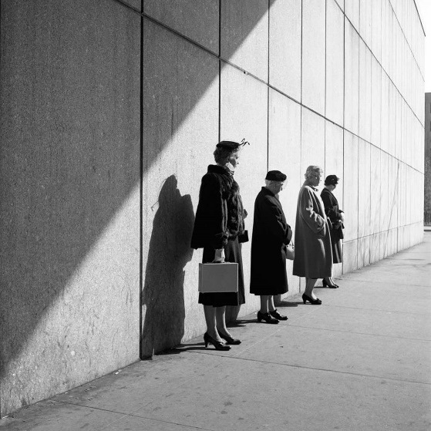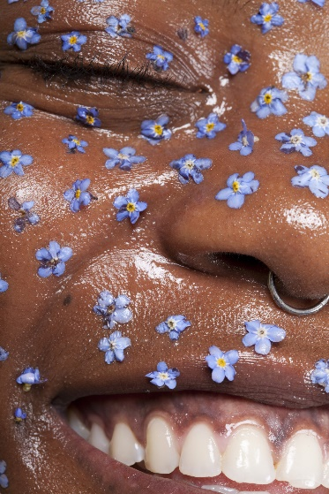

Introduction To The Department

Welcome to Photography, a part of the Art and Design department. We hope that you enjoy your time in our department and find the process of studying the course a challenging and rewarding one.

The purpose if this guide is to provide you with a range of information and advice to help you organise your programme of study and practice, to learn independently, and equip you with important information about the department and how we can support you.

**Ellie Coleman**(Course Leader) [efc@godalming.ac.uk](mailto:efc@godalming.ac.uk)  
**Sarah Markbreiter** (Teacher) smr@godalming.ac.uk  
**Danielle Cook** (Technician) dec@godalming.ac.uk  
**Daniel Fooks** (Head of Art and Design) dxf@godalming.ac.uk  
**Jonathan Sparshott** (Director of Faculty) jss@godalming.ac.uk

* We have two **classrooms** equipped with computers, scanners and three types of printer.
* We have a **technician base** where equipment and facilities can be booked and advice obtained.
* We have a **dedicated** **photographic studio** with various backdrops, continuous and flash lighting.
* We have a **darkroom** for experimental wet processes.

Along with the people and places above, the following departments and places will be useful whilst studying on the course:

**The wider Art and Design Department**- facilities, technicians and staff with a range of knowledge.

**The ILC** – your go-to place to complete research with a large library of photography books and computers with programs such as Photoshop to use outside of lessons. The Silent Study area provides an area to work individually, and the library also contains an excellent selection of relevant wider reading e.g. Film Studies, Media Studies, Art and Design. Make sure that you have familiarised yourself with the ILC when you start the course

**The Exams Office** – for any questions you have about your exam entries, exam timetable or remarks and script requests.

**Learning Support** – for any extra support or advice you need to help you study in general. If you are struggling to organise and manage your workload; need help refining your analysis technique; help with revision; or if you think you might be entitled to any exam concessions, learning support are the people to talk to.

**Careers** – when you start to think about your options after college, whether university or employment based, careers can give you advice on where to apply and help in producing a personal statement.

## What Do I Need In Order To Do The Course?

Whilst we have cameras so that students can successfully complete the course without owning their own (DSLR type) camera, ***it is an advantage to have your own*** (second hand can be the same as new! See MPB site www.mpb.com/en-uk).

Once you have returned an 'Off-Site Use of Equipment' form you can borrow a camera. Borrowed cameras can only be held for a week at a time and must then be checked back into the Technicians Office.

We strongly advise that you have a little kit of tools such as USB SD card reader, your own SD card for cameras, black ball-pen, glue sticks, fine-liner black pen (and white if possible), scissors, ruler. You cannot rely upon there being a supply of these in class.

As the year progresses you will generate lots of digital image files. It is important to keep the essential outcome images at college to work on, but you will run out of storage space at college quite soon if you try to keep everything. Take your work home and have a back-up set of images in case of deletion accidents. We recommend you take advantage of Microsoft 365 (see about me tab) and have a memory stick to do this.

* Once you have returned an 'Off-Site Use of Equipment' form you can borrow a  
  camera for homework. Cameras borrowed from technicians upstairs in 600s building should be returned at agreed time. Invoices for the cost of a replacement will be issued if the camera is not returned after a couple of weeks.

Shopping List:

* Card Reader – You will need one for an SD Card
* Glue sticks
* Scissors
* Black and white pens.
* Ruler

## Subject specific and Transferable skills developed on the A Level Photography course

**ExpecTations**

**What is expected of students?**

1. **Attendance and punctuality** – learning cannot begin if you are not in lessons or if you arrive late to them and miss the essential introduction to what is happening. Students should maintain full attendance and punctuality. Any unavoidable and legitimate absences should be accounted for properly, meaning that students get a parent or a guardian to contact college and then email their teacher(s) and catch up on missed work (see Godalming Online Photography resources).
2. **To maintain a mature and respectful learning environment** – this means behaving in and out of lessons in a way expected of a Sixth-Form student: listening carefully to the views of others and offering constructive contributions in class.
3. **To stay up-to-date** – you are set weekly structured preparation and homework tasks and it is essential that these are completed on time and in the required level of engagement. This includes finishing work begun in class, carrying out research and conducting and processing photo-shoots. If work is incomplete your progress will be impaired and you will under-perform. If you arrive at a lesson having not completed preparation work then your teacher may also ask you to leave and complete this elsewhere.
4. **To stay organised** – managing the demands of a minimum of three subjects is expected to be challenging. You need, therefore, to stay organised. This means allocating sufficient time to the demands of the course every week and being ready for classes.
5. **To meet the 50/50** – students are expected to conduct 4.5 to 6 hours of independent study a week. This will include structured preparation or homework tasks set by your teachers along with proactive tasks you complete yourself to consolidate and extend your understanding. See the advice later in this booklet for more help on doing this.
6. **To make the most of feedback and support** – you will get a lot of feedback during your time on the course. This will come as written feedback on digital online work, verbal feedback on workbook progress, and targets set at formal 1-1s. Feedback needs to be recorded carefully by you and acted upon. When you have had work assessed, for example you will be expected to record your own targets based on this, and may, in addition, be asked to attend a lunchtime workshop to help support your progress.
7. **To be resilient** – any subject will at times be very challenging. At times you will not do as well as you want or will struggle to understand a new topic or idea. You need to be prepared to spend more time on areas such as these and to seek out extra help when needed. You have to be prepared to experiment and take risks rather than only doing the things you already know how to do well. These experiences are what lead to success.

**What can you expect of your teachers?**

1. **To deliver a structured and engaging course** – your teachers will deliver lessons and set work designed to challenge you whilst also helping you to gradually build up your knowledge and skills. These lessons will follow the scheme of work, a version of which you can see in this handbook.
2. **Regular assessment and feedback** – in addition to your benchmark assessments (four in the first year and three in the second) your teachers will regularly discuss your work with you to give help you understand what you need to do to improve.
3. **Structured weekly work** – you should expect to be set a significant amount of work to do by your teachers each week and/or following instructions available online.
4. **Additional support** – your teachers will be happy to provide extra help outside of lessons either informally, by responding to emails, or more formally through departmental workshops. Workshops are a good opportunity to received additional help and there is also the technician to provide support.

**Course Overview**

|  |  |  |  |
| --- | --- | --- | --- |
| **YEAR ONE** | **Technical Skills** | **Including:**   * **Camera controls** * **Lighting** * **Software** * **Aesthetic Technique** | **Skills Development** |
| **Working with Photoshoots to develop projects** | **Including:**   * **Developing ideas** * **Research and Analysis** * **Planning and producing outcomes** | **Skills Development** |
|  |  |  |  |
| **YEAR TWO** | **Component 1:   Personal Investigation** | * **Produced between September and January** * An idea is established and workbook/s developing the project produced with experiments leading to outcome work produced in January * **Mark out of 96** | **A Level = 60%** |
| **Component 2   Externally Set Assignment** | * **Choice of themes (from paper with 8) issued Feb 1st** * Workbook developing the project is produced and submitted at the start of the ‘Period of Sustained Focus’(‘exam’) end April- first half of May 2023 outcome work is produced * **Mark out of 96** | **A Level = 40%** |

**Student scheme of work**

Below is an example summary of how you will be taught the elements of the course and how it fits into the approximately 66 weeks of teaching time over the two years of your A-Level.   
You will also see the key assessment points given below. It is important that you know when these are so that you can organise your work completion and preparation. The specific topics are an illustration and are subject to change, but they give a good sense of the structure and content of the course.   
An important idea to understand when looking at this student scheme of work, is that the course flows consistently over two years. Consider that the May half term in the first year is, in reality, the mid-point of the course not the summer holiday. This time will go quickly so make sure you understand the structure of the course fully and get any help when it is needed.

|  |  |  |
| --- | --- | --- |
| **Week**  **(First Year)** | **Component 1: Portfolio  (leading to Major Project)** | **Assessment** |
| 1-6 | **Autumn First Half** | |
| **Establishing Key Skills – How to Structure Images** | * Oral feedback during lessons * Weekly comments on digital docs |
| Composition, Colour, Texture |
| **Autumn Second Half** | |
| 7-13 | **Understanding The Camera** | * Oral feedback during lessons * Weekly comments on digital docs   **Benchmark 1**  Assessment of all work set and completed in the Digital Sketchbook |
| Exposure Triangle, Aperture, Shutter Speed, White Balance, Focal Length |
| 14-19 | **Spring First Half** | |
| **Exploring Photographic Style, Genres and Concepts** | * Oral feedback during lessons * Post-its in sketchbooks   **Benchmark 2** Assessment of work Assessment of all work set and completed in the Paper Sketchbook  **Student Review 1 Available** |
| The Built Environment, The Human Body, Abstract and Experimental |
| 20-25 | **Spring Second Half** | |
| **How to Structure a Project** | * Oral feedback during lessons * Post-its in sketchbooks   **Benchmark 3**  Assessment of Conceptual Understanding and how successfully he 10 Step Process has been utilised |
| Guided Project: Aesthetic, Conceptual and Technical Developments, The 10 Step Process, Research and Analysis, Outcome Production |
| 26-31 | **Summer First Half** | |
| **Independent Developments** | * Oral feedback during lessons * Post-its in sketchbooks |
| Continuation of Guided Project, but students are required to work more independently, selecting appropriate research topics for development and responding accordingly in their practical work |
| 32-37 | **Summer Second Half** | |
| **Establishing Component 1** | * Oral feedback during lessons * Post-its in sketchbooks   **BM4/ARGs Predicted Grades**  Based on all work completed throughout the year, with most emphasis on how well students have engaged with work set over the summer term |
| **Exploring interests, identifying potential concepts, writing statement of intent, beginning Component 1** |

|  |  |  |
| --- | --- | --- |
| **Week (Second Year)** | **Component 1: Major Project** | **Assessment** |
| 38-43 | **Autumn First Half** | |
| Component 1 | * Oral feedback during lessons * Post-its in sketchbooks   **Benchmark 5**  Assessing summer work and project so far |
| Concept clarification, Artist and theory research. Concept refinement. Project development, development log |
| 44-50 | **Autumn Second Half** | |
| Project development, Research and analysis support, Ideas and techniques for outcome work, Compiling ‘development log’ into essay | * Oral feedback during lessons * Post-its in sketchbooks * Formal written feedback on ‘development log’ essay   **Benchmark 6**  **Student Review 3 Available**  Sketchbooks will be handed in toward the end of term for a ‘hard mark’ and formal feedback before being returned for Xmas |
| 51-56 | **Spring First Half** | |
| Final workbook prep, Outcome prototyping, Component One Outcome production  (serves as a mock exam)**,** submit final version of supporting essay | * Oral feedback during lessons * Post-its in sketchbooks * Formal written feedback on ‘development log’ essay |
| **Component 2**  **Externally Set Assignment** (coursework exam) | | |
| 57-62 | **Spring Second Half** | * **Component One Mark available** |
| Establishing ideas, Concept clarification Artist and theory research, Concept refinement, Outcome prototyping | * Oral feedback during lessons * Post-its in sketchbooks   **Benchmark 7**  Assessing Component 2 work only  **Student Review 4 Available**  Assessing Component 1 work and Component 2 work |
| 63-66 | **Summer First Half** | |
| Final workbook prep | * Oral feedback during lessons * Post-its in sketchbooks |
| 67-68 | **Exams**  15 hours over Two weeks | |
|  | **Internal Marking and Moderation** | **Centre assessed marks available to students** |
| **Summer Second Half**  No Classes | | |
| 6th July | **Exhibition Opening** |  |

**Assessment: How your work is marked**

When starting the course, it is important to know how the course is assessed. All assessed work is marked around what are known as **‘assessment objectives’** (AOs) which have been set by the exam board. You need to understand what each of these is and how many marks it carries for each type of question. If you can do this then you will know what skills to demonstrate and to what extent for each question on the exam.

|  |  |  |
| --- | --- | --- |
| **AO1** | **Develop ideas through sustained and focused investigations informed by contextual and other sources, demonstrating analytical and critical understanding.** | **25%** |
| **AO2** | **Explore and select appropriate resources, media, materials, techniques and processes, reviewing and refining ideas as work develops**. | **25%** |
| **AO3** | **Record ideas, observations and insights relevant to intentions, reflecting critically on work and progress.** | **25%** |
| **AO4** | **Present a personal and meaningful response that realises intentions and, where appropriate, makes connections between visual and other elements.** | **25%** |

***What do these mean?***

***AO1 – How you take a project on a journey… a chain of linking ideas informed by researching other peoples’ work and ideas. Including writing notes and sometimes paragraphs of writing.***

***AO2 – Carrying out a wide range of appropriate technical experimentation and development. Trying things out and evaluating the results to inform how you move forward.***

***AO3- Evaluating your own work as you go along. Including writing notes and sometimes paragraphs of writing. Also, how you present your work visually in a way that aids the understanding of what you are doing to for someone looking at your workbooks.***

***AO4 – Make work that expresses your ideas. Effectively achieving what you set out to do. Communicating ideas and what can be seen in your work.***

**A-Level Mark scheme**

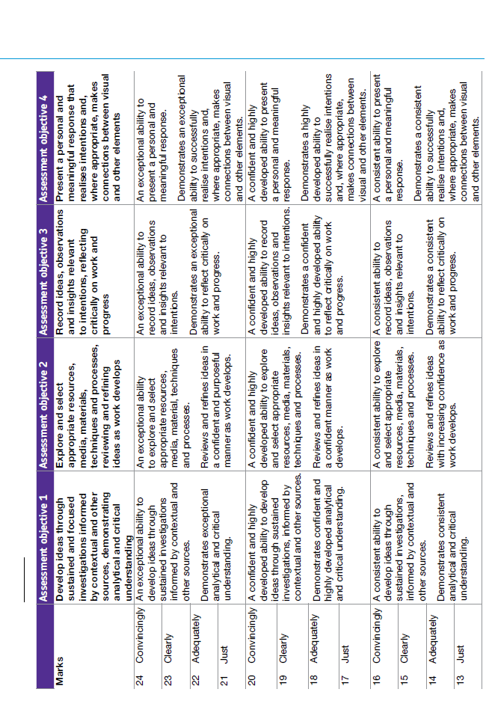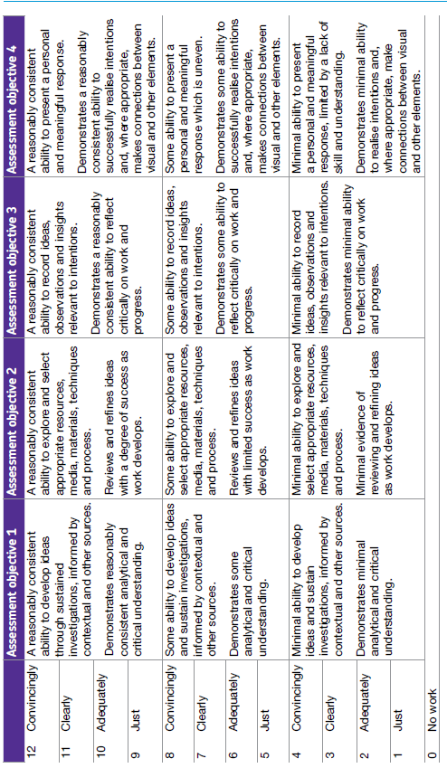

**Example “Exam” Paper**

**“Photography” A-level Course Assessment Policy 2020-2022**

Updated July2020 for Covid-19 Situation

**The Importance of Feedback and Learning Outside the Classroom – ’50:50’**

Learning will not happen instantly and takes time; attending lessons is not enough, you also need to be working outside of class. It is important to take risks with work; self-reflection and teacher feedback will hopefully enable you to learn from these experiments. Feedback is essential for your learning and will consist of ‘self’ (where you assess your own work, usually in your workbook), ‘peer’ (where you discuss other students work in the class) and written published marks from teacher. Essential information about approaches to tasks and techniques for practical and annotated research, analysis, and project development is available on ‘Godalming Online’.

* Written and Verbal feedback: Each benchmark assessment will receive a published grade and will be discussed with student. These benchmark assessments will then feed directly into the student reviews (‘reports’) which get sent home to your parents.
* Reflection: After each assessment, students will be expected to reflect on the written feedback from their teacher and set themselves targets for improvement using ‘feedback sheets’.
* Students who perform particularly badly are given a ‘contract’ with specific targets and a time-scale for improvement.
* ARG (Annual Review Grades and Predicted Grades): At the end of the first year, one teacher from the course will give an end of year grade which will, with adjustment if necessary, become your estimated predicted grade for the second year. This is the grade you will apply to Universities with. Essentially it is based heavily on the benchmarks of the first year in April and June but will also make reference to your total workbook content, and general progress in class (including meeting deadlines and attendance).

**Further notes on Student Review 2, the ARG and Predicted Grades**

At the end of the first year (June 2020), your Lead Tutor will have a 1-2-1 to discuss your Annual Review Grade or ARG and also finalise your Predicted Grade which might be used for UCAS applications for University and other destinations.

**Weekly Independent Tasks (Homework): Philosophy of the Department**

Homework does not necessarily need to be completed at home! You can use free periods during the day to complete these tasks outside of lessons. To keep a good work/life balance, you might like to treat College as an 0845 to 1615 day and use your free periods in the library or Art and Design department studio areas for completing tasks. This will minimise the work you need to complete at home and might make you more productive. The classes are usually shared between two teachers for the 4.5hours, with each teacher delivering parts of the two units and setting homework each week. There is an expectation that 50% of your learning takes place in the classroom and 50% takes place outside of the classroom. Therefore each week, homework will be set and could take 4.5 to 6 hours in total. Each teacher therefore could set you up to 2 to 3 hours homework per week. If the homework only takes you 1 hour for a week, then you will have a further 1 ½ hours to conduct further experimentation and research to develop as an artist/designer. Homework tasks will consist of two types:

* Specific tasks relating to the taught aspects being introduced in class and inspected in your workbooks in class.
* Developmental work where a project is being progressed from week to week following a procedure such as that below.

**Ten stage development of work procedure:**

1.Explaining the Aim of a student’s photographic shoot.  
2.Assessing what achieved by annotating results –using an index/ contact sheet[.](https://online.godalming.ac.uk/mod/resource/view.php?id=34499)   
3.Summing up strengths(where I have achieved my aims)/weaknesses(things about the images that suggest I should have another go)/opportunities of shoot(things I hadn’t expected, but suggest potential future work).   
4.Analysis of some shots in detail.   
5.Adjustment of some shots in Photoshop (levels/ colour etc.) and assessment.   
6.Experiment eg possible cropping of some pictures and assessing the difference it makes.   
7.Comparison of photos achieved to those of photographers/artists studied.   
8.Print experiments with assessment of various media.  
9.Final evaluation of shoot and a plan for your next shoot.   
10.Research and analysis of work of another photographer. Consider subject matter, Photographic and presentational techniques (ideas for each of these aspects could come from different photographers and artists).

**Benchmark Assessments**

Students will have seven benchmark assessments during their two years (36 weeks) in the Art and Design Department. These are important progress checks that are used to gauge the progress students are making, identify any who are under-performing so support can be put in place, and provide students with developed feedback on their work.

Each benchmark assessment will include the following:

* WRITTEN FEEDBACK: Each benchmark assessment will receive written feedback and questions will be posed about how to improve).
* VERBAL FEEDBACK: 1-2-1’s with your teachers will be held throughout the year. These may take the form of brief discussions following the return of benchmarks, or more general discussions in the build-up to student reviews and following end of year exams
* These benchmark assessments will feed directly into the student reviews (‘reports’) which get sent home to your parents.
* REFLECTION AND TARGET SETTING: After each assessment, students will be expected to reflect on the written feedback from their teacher and set themselves targets for improvement in the period in question.

Results in benchmark assessments are important to help you understand how you are performing in a particular area and to receive and apply the feedback that will help you improve. Individual benchmark results are not, however, predictions of how you will perform in either component of the final assessment.

Your teachers and the department as a whole are not allowed to give a ‘grade’ prediction for either the Personal Investigation or the Externally-set Assignment as both are subject to external moderation.

|  |  |  |  |
| --- | --- | --- | --- |
| **First Year** | **Type** | **Mark Uploaded by** | **Deadline** |
| **Benchmark 1** | Sketch books and class work to be assessed | Lead Teacher | **09/11/22** |
| **Benchmark 2** | Sketch books and class work to be assessed | Lead Teacher | **14/01/23** |
| **Benchmark 3** | Sketch books and class work to be assessed | Lead Teacher | **22/03/23** |
| **Benchmark 4** | Sketch books and class work to be assessed | Lead Teacher | **24/06/23** |
| **Second Year** | **Type** | **Uploaded by** | **Deadline** |
| **Benchmark 5** | Sketch books and class work to be assessed | Lead Teacher | **05/10/22** |
| **Benchmark 6** | Sketch books and class work to be assessed | Lead Teacher | **10/12/22** |
| **Benchmark 7** | Sketch books and class work to be assessed (COMP 2 ONLY) | Lead Teacher | **11/03/23** |

**Predicted Grades**

The predicted grade for A-level students moving from their first to their second year, will be based on the combined results of their benchmark assessments, their attitude to learning throughout the first year, and their propensity to learn (i.e. their ability to develop and improve based on the evidence of the first year)

Students will receive an ‘Annual Review Grade’ (ARG) at the end of their first year, which will automatically form the predicted grade. The ARG will communicated to the student via a 1-1 with the student in the summer term of Year 1.

It is essential that predicted grades are accurate reflections of a student’s performance and are based on the evidence of achieved results. It is the college’s policy that a predicted grade can only be one level higher than an ARG.

**Mock Exams**

Art and Design students will sit mock exams before or immediately after the Christmas holiday in their second year. These are designed to help students prepare for the externally-set assignment (Component 2) by giving them an experience of working under exam conditions. Each of the five courses will structure their mocks differently. Some will use existing lesson time whilst others will organise mocks as ‘trips’ to take students off timetable. It is essential for students to have this experience to prepare for the demands of their final C2 assessment

Students will be given developed feedback on their mock exams but this is not a prediction of their final outcome.

**Non-Examined Assessment/Coursework**

Art and Design students need to be aware of the procedures outlined below as these are the standards which are applied to ensure that their work is assessed rigorously and consistently.

Both the Personal Investigation and the Externally-Set Assignment are completed by students internally and are marked by members of the department. Great care is taken to **standardise** marking to ensure that all teachers are marking consistently. Work is also **internally moderated** to check the awarding of marks. Finally student work is then **externally moderated** by the exam board.

Before submitting the final internal marks to AQA students will be informed of their provisional mark (not a grade) in each component (marks will made available on Markbook).

Students have the right to appeal the process by which their non-examined assessment has been internally marked once they have received their provisional mark. Please note that students are not able to contest their *mark*, only the *process* by which their work has been marked.

|  |  |  |  |
| --- | --- | --- | --- |
| **Component 1 – Personal Investigation (60%)** | | **Component 2 – Externally-set assignment (40%)** | |
| ***Stage*** | ***Date*** | ***Stage*** | ***Date*** |
| **First Submission** | **End of January** | **Draft Deadline** | **Draft D.** |
| **Formal Submission** | **End of April (to be confirmed)** | ***Final Deadline*** | **As per exam timetable (end of April or first week of May)** |
| **Internal Moderation** | **May** | **Internal Moderation** | **May** |
| **Marks Uploaded to Markbook for students to view** | **By 21st May 2023** | **Marks Uploaded to Markbook for students to view** | **By 21st May 2023** |
| **Marks sent to AQA for external Moderation** | **By 31st May 2023** | **Marks sent to AQA for external Moderation** | **By 31st May 2023** |
| **Final Result Awarded** | **13th August 2023** | **Final Result Awarded** | **13th August 2023** |

**Tracking your Progress: Student Reviews, Action Plans and Parents Evenings**

The College’s policy is to deal with the student first but we also report to your parents at regular intervals to let them know how you are progressing and to inform them of what our expectations are through four Student Reviews (Reports) spread throughout the two years at College and also four parents evenings.

If the department feel you are under-performing based on evidence such as benchmark grades and your approach to learning in between these periods, then your Lead Subject Tutor may place you onto a Formal Department Action Plan and we will formally write to your parents after a 1-2-1 with yourself and to try and get you back on track in a supportive way

The ARG (Annual Review Grade) plays a key part in determining the context in which you progress to the second year.   Students who receive an A*-D grade (A-level) are encouraged to continue with their studies into the 2nd year.  However for students who receive a U or E Grade (A-level) as their ARG, it suggests that for whatever reason they have struggled with the transition from Level 2 Courses (GCSE) to Level 3 Courses (A-level/BTEC).  This will be evidenced by poor performances throughout their benchmarks and an inconsistent or poor approach to learning in their student reviews and via formal Action Plans.  Students who receive a U Grade we would not recommend to continue with the course and they would need to speak to a Senior Tutor about alternative pathways.

The College adopts a consistent and optimistic approach to predicting grades to ensure that they are both aspirational and achievable.  A predicted grade is what we believe a student is likely to achieve by the conclusion of their course in positive circumstances and the predicted grade provides universities and colleges with some understanding of a student’s academic potential alongside their Personal Statement and a written Reference from their Personal Tutor.

The ARG is important in forming the basis for the predicted grade as well but the predicted grade will also be aspirational for the students’ ambitions although it must remain realistic and cannot be based on the idea that only now will the student start to work harder in the second year!

**Other Considerations**

* *LATE POLICY:* In line with the ‘College Assessment Policy’, the department are under no obligation to provide feedback to a student who does not meet the internal deadlines for weekly independent tasks, benchmark assessments or coursework drafts.  Please be warned that a failure to meet the final coursework deadline is the equivalent to missing the exam and it will be recommended that the student should be removed from the course.  Students who fail to prepare adequately for the lesson as requested, maybe excluded for part of the lesson and asked to work independently at the back of the classroom.  A continued failure to meet ‘PREP’ work requirements will result in a reference to the pastoral team and a phone call home to parents.
* *Assessing WORK:* Workbooks will be assessed in classes, digital work online with written feedback and in a 10 working day cycle when possible. Written assignments will be assessed and returned within 10 days of it being submitted unless it is the final coursework submission. The exam board stipulates that for final coursework submissions, no feedback or formal grade can be released to students by the teacher.  The exam board reserve the right to inform you of the final grade in August with your results.  Please do not ask the teacher for your final mark as they will be unable to provide it.
* *PLAGIARISIM:* Plagiarism is submitting another person’s written, physical or visual work as one’s own original work or using someone else’s idea without referencing the source or using pictures without referencing the source.  If there is a suspicion of plagiarism, the Head of Department and Senior Tutor will be informed and a meeting will take place.  If a student is found guilty, they will be subject to disciplinary action by the College and the awarding body will be informed. Students should be aware that the College is subscribed to software designed to detect plagiarism.

**Photography Course**

**50:50 Help and Advice**

Key to your success whilst studying on the course is the level of effort and work you put into the subject outside of lessons. The college’s expectation is that you match every hour of class time with an hour of independent study – **50:50**. This will include completing **structured homework** tasks set by your teachers but will also require you to **work independently**; finding ways to consolidate and extend your understanding and skill. To help you to do this, the list below gives some ideas or activities to consider each week.

**Consolidate your weekly work**

Go over your lesson materials and Teams instructions or handouts from the week making sure that all activities have been finished in detail. Have you properly completed all the tasks? Can you improve the presentation of ideas and materials produced? Should you have another go at taking photographs or doing something with software?.

**Browse books in the ILC Library**

There are a huge selection of specially selected books about photography, photographers, techniques, history, Art movements, film directors and cinematographers, Artists, designers... There are also magasines in the ILC and links to further material on the Godalming Online Photography pages.

**Watch a documentary**

E-stream has a wide selection of Photography and Art documentaries which support your courses or extend your understanding. You may often find yourself watching part of a documentary in class and can then also finish this off at home. Make sure that you are ‘actively’ watching e.g. create a basic spider-diagram with the issue you are investigating in the middle and then record brief notes around it.

**Are you tthouroughly processing photo-shoots?**

Below is the ’10 step process’ that you should follow each time you undertake a shoot, it works like a cycle that you repeat throughout your project. Step 1 and 10 are somewhat interchangeable.

1. Aim of Shoot – What are you intending to achieve within this shoot? How will it develop and demonstrate your skills?
2. Contact Sheet – Each shoot must have an annotated contact sheet that records your thought process during and after your shoot.
3. Strengths and Weaknesses – An evaluation of your initial thoughts about what went well and what could have been improved in your shoot
4. Experiment and Edit – Engaging with your images to explore them and make them as strong as possible. This may be digital or physical.
5. Cropping – Ensure you consider how alternate framing could strengthen your work
6. Media and Materials – Establishing how printing and manipulating your work may be of benefit
7. Analysis – Using visual and written analytical techniques to explore your images
8. Compare – Identify how the previous research that you have undertaken influenced your work
9. More research? – Evaluate the need for further research, you may not need to complete this step
10. Shoot Plan – Clearly plan your next shoot based on your reflections and conclusions about the previous shoot