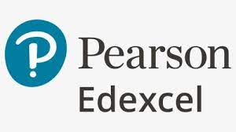****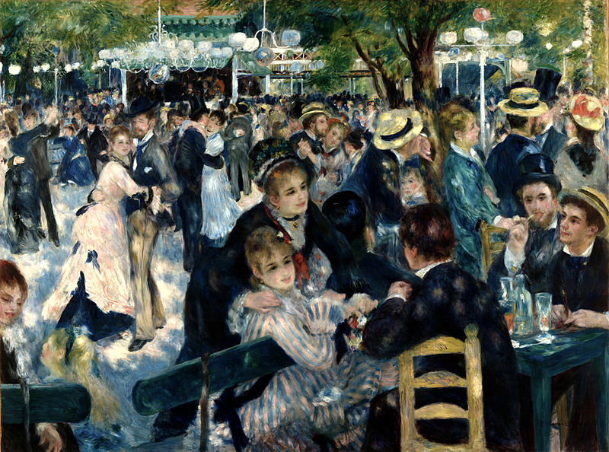

History of Art

**Course Handbook**

**A-Level History of Art (9HT0)**

**NAME:**

**CONTENTS**

|  |  |
| --- | --- |
| 2 | Introduction to the course |
| 3 | Staff and Student Expectation |
| 4 | Overview of A Level History of Art |
| 5-10 | Visual Analysis, Themes and Periods Explained |
| 11 | Assessment Explained |
| 12-16 | Mark Schemes |
| 17-20 | Exam Technique for A Level History of Art |
| 20-26 | Examples of Previously Marked Exam Scripts |
| 27-29 | Assessment Policy |
| 30 | Advice and Recommended Resources |

**Introduction to a level history of art**

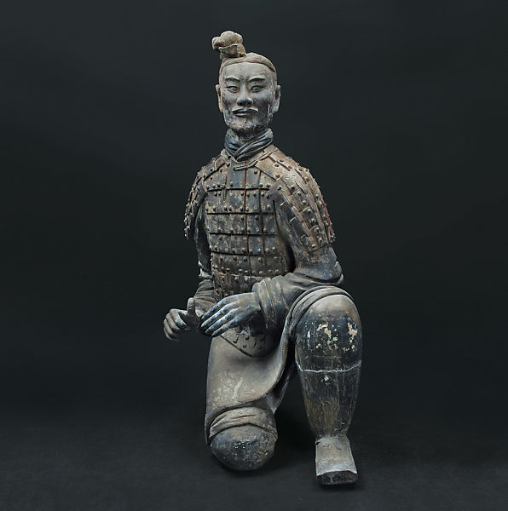Welcome to History of Art A-level. We hope that you enjoy your time in the department and the process of studying paintings, sculptures and buildings from the Classical era to the present day.

The purpose if this guide is to provide you with a range of information and advice to help you organise your programme of study, learn independently outside of the classroom and prepare for the final exams. This guide is split into two sections: the first provides information on the structure and assessment of History of Art, the second study advice and resources. Please place this guide at the start of your folder and keep checking it regularly for help and support.

History of Art at Godalming College is part of the **History and Politics Department** located in the 200s. This is one of the largest department’s in college having over 600 students studying courses within it at any time. The History and Politics office is located in room **214**.

**History of Art Staff:**

* Daniel Greaney

**Head of History and Politics:**

* Laurie Huggett-Wilde

**Director of Faculty (Humanities and Social Sciences):**

* Deborah Haggar

Along with the names above, the following departments and places will be useful during your time in History of Art:

**The ILC** – your go-to place to complete work and independent study outside of lessons. The Silent Study area provides an area to work individually, whilst the library contains an excellent selection of wider reading. Make sure that you have familiarised yourself with the ILC when you start the course

**The Exams Office** – for any questions you have about your exam entries, exam timetable or remarks and script requests.

**Learning Support** – for any extra support or advice you need to help you study in general. If you are struggling to organise and manage your workload; need help refining your essay-writing technique; help with revision; or if you think you might be entitled to any exam concessions, learning support are the people to talk to.

**Careers** – when you start to think about your options after college and possibly applying for an art history-related degree, careers can give you advice on where to apply and help in producing a personal statement.

**Expectations**

**What is expected of students?**

1. **Attendance and punctuality** – learning cannot begin if you are not in lessons or if you arrive late to them and miss important content. Students should maintain full attendance and punctuality. Any unavoidable and legitimate absences should be accounted for properly, meaning that students get a parent or a guardian to contact college and then email their teacher(s) to catch up on missed work.
2. **To maintain a mature and respectful learning environment** – this means behaving in and out of lessons in a way expected of a Sixth-Form student: listening carefully to the views of others and offering constructive contributions in class
3. **To stay up-to-date** – you will be set weekly structured homework tasks and it is essential that these are completed on time and in the required level of detail. We use structured homework to consolidate particular content or to set up lessons to come. If work is incomplete your understanding will be incomplete and you will under-perform. If you arrive at a lesson having not completed preparation work then your teacher may also ask you to leave and complete this elsewhere.
4. **To stay organised** – managing the demands of a minimum of three subjects is challenging. You need, therefore, to stay organised. This means preparing a folder for each of your modules, bringing the correct materials to each lesson and recording homework in the same place every time (whether this is your planner or the homework grids at the back of lesson materials)
5. **To meet the 50/50** – students are expected to conduct 4.5 to 6 hours of independent study a week. This will include structured homework tasks set by your teachers along with proactive tasks you complete yourself to consolidate and extend your understanding. See the advice late in this booklet for more help on doing this.
6. **To make the most of feedback and support** – you will get a lot of feedback during your time on the course. This will come as written feedback on assessed work, verbal feedback on general class or homework, and targets set at formal 1-1s. Feedback needs to be recorded carefully by you and acted upon. When you get back assessed work, for example you will be asked to record two targets of your own and also to update your progress log
7. **To be resilient** – any A-level subject will at times be very challenging. At times you will not do as well as you want, or will struggle to understand a new topic or idea. You need to be prepared to spend more time on areas such as these and to seek out extra help when needed. These experiences of finding areas where you are not doing so well and improving them are what lead to A-Level success.

**What can you expect of your teachers?**

1. **To deliver structured and engaging lessons** – the backbone of your lessons will be the booklets you receive, one for each module. Your teachers will deliver lessons designed to challenge your understanding whilst also helping you to gradually build up your knowledge and skills
2. **Regular assessment and feedback** – in addition to your benchmark assessments (four in the first year and three in the second) your teacher will regularly set you exam-style questions to give you opportunities to practice and improve. Feedback will be given on standardised sheets which include the relevant mark scheme and clear developmental targets
3. **Structured weekly work** – you should expect to be given a significant amount of work to do by your teachers each week. You will be given guidance on how long this should take and completed work will be checked and/or taken in
4. **Additional support** – your teacher will be happy to provide extra help outside of lessons either informally, by responding to emails, or more formally through departmental workshops.

**history of art – Overview**

|  |  |  |  |
| --- | --- | --- | --- |
| **YEAR ONE** | **Visual Analysis of**  **Painting**  **Sculpture**  **Architecture** | * **One 12 mark question on a painting (unseen)** * **One 12 mark question on a sculpture (unseen)** * **One 12 mark question on a building (unseen)** | **A Level = 25%** |
| **Themes:**   * **Identities** in Works of Art and Architecture * **War** in Works of Art and Architecture | **(For each Theme)**   * **One 12 mark question on key works of art/architecture** * **One 25 mark essay question** | **A Level = 25%** |
|  |  |  |  |
| **YEAR TWO** | **Rebellion and Revival:  19th Century British and French Avant-Garde** | * **Two 5 mark questions on key works of art/architecture** * **One 15 mark question on two key works of art/architecture** * **One 30 mark essay using key works of art/architecture** | **A Level = 25%** |
| **Brave New World: Modernism in Europe (1900-39)** | * **Two 5 mark questions on key works of art/architecture** * **One 15 mark question on two key works of art/architecture** * **One 30 mark essay using key works of art/architecture** | **A Level = 25%** |

**The Exams**

At the end of your second year, you will take two exams in History of Art:

**Paper One (3 hours / 110 marks / 50%)**

* **Section A:** Visual Analysis (total marks for this section is 36)
* **Section B:** Themes (total marks for this section is 74)

**Paper Two (3 hours / 110 marks / 50%)**

* Answer questions on two Periods. One Part A, one Part B, one Part C and one Part D question on each of the periods below.

C3 *Rebellion and Revival: the British and French Avant-Garde (1848-99)*

C4 *Brave New World: Modernism in Europe (1900-39)*

**History of art Content – each section**

Section 1. **Visual Analysis**

This section requires you to demonstrate your visual literacy on ‘unseen’ examples of painting, sculpture and architecture. You will begin with a core course in visual literacy so that you have the skills to analyse any painting, sculpture or building. You will develop your vocabulary to articulate what it is you see, in relation to the question asked.

In the final exam, you will be given an image of a painting, sculpture and building with a question on each. You will be expected to answer the question using your art historical vocabulary (see example below from **Summer 2019 Paper)**. This is a test of your looking skills and no historical context or historical knowledge (AO1) is required to answer the ‘unseen’ questions (see **Assessment** below for more details on Assessment Objectives - AOs). You will not receive credit for any AO1 in this part of the paper.

Each question is worth 12 marks. Students are encouraged to spend approximately 60 minutes answering the Visual Analysis question; that is 20 minutes each on the painting, sculpture and building. A hard copy booklet, titled ‘**Module 1: Visual Analysis**’, will be given to each student at the beginning of study. It is your responsibility to retain this for the duration of the course.

|  |  |  |
| --- | --- | --- |
| **Visual Analysis** | | |
| *TOPIC* | | *CONTENT* |
| **1** | **Visual Analysis Painting** | * Colour * Composition * Light & Tone * Space & Depth * Materials & Techniques * Form * Line * Scale |
| **2** | **Visual Analysis Sculpture** | * Colour * Composition * 3-dimensional space * Light & Tone * Line * Scale * Volume/mass |
| **3** | **Visual Analysis Architecture** | * Composition * Structure/Form * Volume/Mass * Site/Location * Scale * Materials * Architectural vocab and specifics of these styles: Classical, Gothic, Modernist |

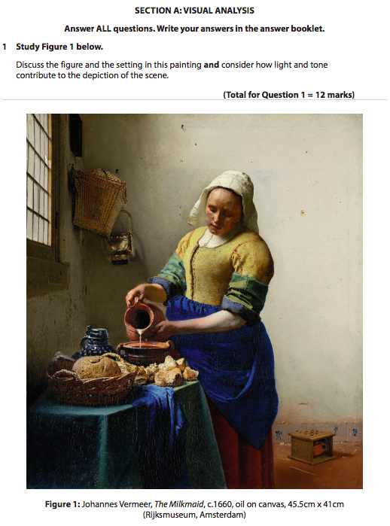**Example of Visual Analysis question. (Summer 2019 Paper)**

Section 2 **Themes**

The Themes you will study are ***Identities in Art and Architecture***, and ***War in Art and Architecture***. These Themes explore developments in art and architecture and students will examine global examples from the Classical era to the present day. To ensure students gain a solid understanding of artistic developments, they will study key works from pre- and post-1850. These key works will be used to answer the Theme questions in Paper 1. Furthermore, students must study at least two examples each by their specified painter, specified sculptor and specified architect (see grid below for **Specified** practitioners).

Each Theme has various scopes of work, and these must include one example from before 1850 and one example from after. The scopes are clearly defined and specify if an example must be 2D or 3D. Students will also be expected to study at least one 2D, 3D and building from beyond the European tradition. he Theme Questions will include one 12 mark and one 25 mark each. For the 25 mark question, students will be expected to include references to critical texts. These texts will be recommended by the subject tutor and from the students own research and study.

A hard copy booklet for each **Theme** and containing images of the key works will be given to each student at the beginning of study. It is your responsibility to retain this for the duration of the course.

|  |  |  |
| --- | --- | --- |
| **Themes** | | |
| *TOPIC* | | *CONTENT* |
| **1** | ***Identities in art and architecture*** | Two key works on each of the below categories, one example must be pre 1850 and one example post.  In addition, students must study at least one painting (2D), one sculpture (3D) and one building from beyond the European tradition.   * The Divine in 2D or 3D works (pre- and post-1850) * Portraits in 2D works (pre- and post-1850) * Portraits in 3D works (pre- and post-1850) * Gender identity in 2D or 3D works (pre- and post-1850) * Ethnic identity in 2D or 3D works (pre- and post-1850) * Identity in architectural works (pre- and post-1850) * **Specified Painter (Jan Van Eyck)** * **Specified Sculptor (Marc Quinn)** * **Specified Architect (Zaha Hadid)** |
| **2** | ***War in art and architecture*** | Two key works on each of the below categories, one example must be pre 1850 and one example post.  In addition, students must study at least one painting (2D), one sculpture (3D) and one building from beyond the European tradition.   * War or revolution in 2D works (pre- and post-1850) * Leaders in 2D or 3D works (pre- and post-1850) * Participants of War in 3D works (pre- and post-1850) * Places affected by war in 2D or 3D works (pre- and post-1850) * Memorials in 2D or 3D works (pre- and post-1850) * Defensive or commemorative architectural works (pre- and post-1850) * **Specified Painter (Eugène Delacroix)** * **Specified Sculptor (Jeremy Deller)** * **Specified Architect (Daniel Libeskind)** |

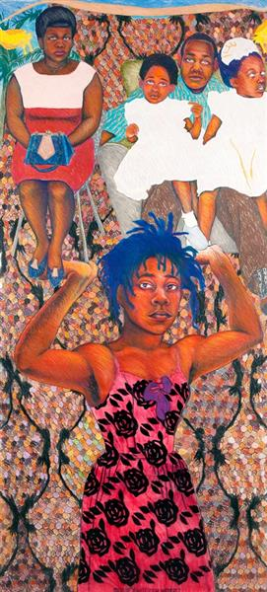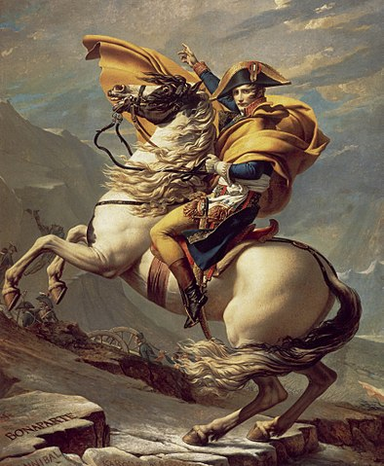

Section 3 **Historical Periods**

Studying a period in-depth allows for a fuller understanding of the key movements, contextual factors and artistic developments within a specific time frame. The two periods students will study are:

* **Rebellion and Revival: the British and French Avant-Garde (1848-99)**
* **Brave New World: Modernism in Europe (1900-39)**

Each period has specific scopes/categories of key works that students must study. These key works will be used to answer exam questions. In addition, both periods have a Specified Painter and Specified Sculptor, each of whom has three key works which must be studied. Specified artists are outlined in the table below. The exam paper for this section consists of a Part A, Part B, Part C and Part D question. The Part D question requires students to include references to critical texts. These texts will be recommended by the subject tutor and from the students own research and study.

A hard copy booklet for each **Period** and containing images of the key works will be given to each student at the beginning of study. It is your responsibility to retain this for the duration of the course.

|  |  |  |
| --- | --- | --- |
| **Historical Periods** | | |
| *TOPIC* | | *CONTENT* |
| **1** | **Rebellion and Revival: the British and French Avant-Garde (1848-99)** | * Painting of working life, one British AND one French example * Painting of leisure, one British AND one French example * Religious painting, one British AND one French example * Mythological/literary works in 2D or 3D, one British AND one French example * The female figure in 2D or 3D, one British AND one French example * Landscape painting, one British AND one French example * Commemorative sculpture, one British AND one French example * Public architecture, one British AND one French example * Domestic architecture, one British AND one French example * Specified Painter: William Holman Hunt * Specified Sculptor: Auguste Rodin   The above scopes/categories of 2D and 3D art must include one key work in each of the following styles: Academic, Realism, Impressionism, Post-Impressionism, Victorian, Pre-Raphaelite.  The architecture works must include at least one example of Art Nouveau, Arts & Crafts |
| **2** | **Brave New World: Modernism in Europe (1900-39)** | * Painting of modern, urban life, one French AND non French example * Painting or sculpture influenced by ‘primitive’ ideas and artefacts, one French AND non French example * The female figure (painting or sculpture), one French AND non French example * Portraits (painting or sculpture), one French AND non French example * Landscape painting, one French AND non French example * Still life painting, one French AND non French example * Human figurative sculpture, one French AND non French example * Public architecture, one French AND non French example * Domestic architecture, one French AND non French example * Specified Painter: Henri Matisse * Specified Sculptor: Constantin Brancusi   The above scopes/categories of 2D and 3D art must include one key work in each of the following styles: Fauvism, Cubism, German Expressionism, Futurism, Dada, Surrealism.  The architecture must include on example of Modernism |

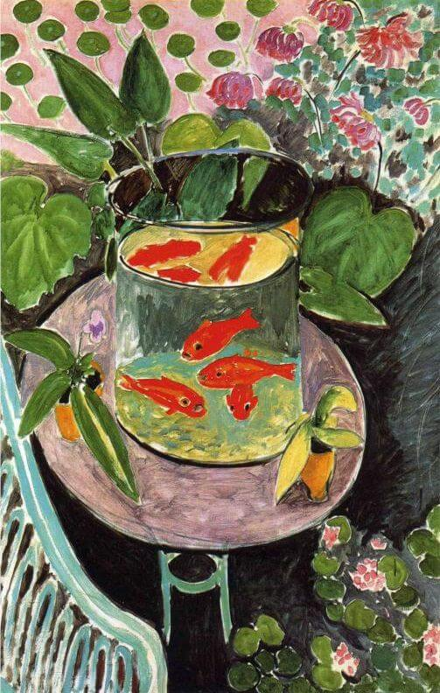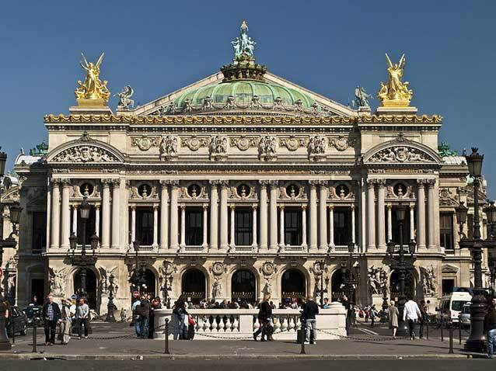

**Assessment**

When starting History of Art it is important to know how the course is assessed. All assessed work is marked around what are known as **‘assessment objectives’** (AOs) which have been set by the exam board. You need to understand what each of these is and how many marks it carries for each type of question. If you can do this then you will know what skills to demonstrate and to what extent for each question on the exam.

|  |  |  |
| --- | --- | --- |
| **AO1** | Demonstrate knowledge and understanding of the contexts of art | **30%** |
| **AO2** | Analyse and interpret artists’ work, demonstrating understanding of visual language. | **36%** |
| **AO3** | Make critical judgements about art through substantiated reasoned argument. | **34%** |

**Visual Analysis** is only assessed with AO2 and AO3. Students are not expected, nor rewarded, for knowledge about the contexts of art in these questions as this is the ‘unseen’ element. All questions on the **Theme** sections are assessed across all three **Assessment Objectives**. The first two short questions on the **Period** sections are assessed only on AO1 and AO2 as critical judgement through substantiated reasoned argument is not expected here. The two longer questions on the Period sections are assessed across all three Assessment Objectives.

***Breakdown of Assessment Objectives***

|  |  |  |  |  |
| --- | --- | --- | --- | --- |
| Paper | **AO1%** | **AO2%** | **AO3%** | Total for all assessment objectives |
| **Paper 1: Visual analysis and themes** | 11 | 5 | 10 | **50%** |
| **Paper 2: Periods** | 19 | 17 | 14 | **50%** |
| **Total for A Level** | 30% | 36% | 34% | 100% |

***Synoptic assessment***

Synoptic assessment requires students to work across different parts of a qualification and to show their accumulated knowledge and understanding of a topic or subject area. Synoptic assessment enables students to show their ability to combine their skills, knowledge and understanding with breadth and depth of the subject. Synopticity will be assessed in the 25-mark questions in Paper 1, Section B and the 30-mark questions in Paper 2. Students will be expected to integrate knowledge and understanding from works they have studied, as well as visual analysis and interpretation skills applied to the different types of art. They will also be expected to use their knowledge of critical texts to support their arguments and judgements

**A-Level Mark schemes**

|  |  |  |
| --- | --- | --- |
| **Paper 1: Visual Analysis.**  **AO targeting: AO2: 6 marks; AO3: 6 marks.** | | |
| **Level** | **Mark** | **Descriptor** |
|  | 0 | No rewardable material. |
| **Level 1** | 1-3 | Analysis and interpretation are limited, showing basic understanding of visual language. [AO2]  Basic critical judgement, with limited reasoned argument and evidence.  [AO3] |
| **Level 2** | 4-6 | Analysis and interpretation are generally competent, showing an adequate understanding of visual language. [AO2]  Adequate critical judgement, supported by generally competent reasoned argument and evidence. [AO3] |
| **Level 3** | 7-9 | Analysis and interpretation are coherent throughout, showing a secure understanding of visual language. [AO2]  Good critical judgement, supported by coherent reasoned argument and evidence throughout. [AO3] |
| **Level 4** | 10-12 | Analysis and interpretation are perceptive throughout, showing excellent understanding of visual language. [AO2]  In-depth critical judgement, supported by excellent reasoned argument and evidence throughout. [AO3] |

|  |  |  |
| --- | --- | --- |
| **Paper 1: Themes QUESTION A**  **AO targeting: AO1: 4 marks; AO2: 4 marks; AO3: 4 marks.**  Candidates who fail to refer to any named works of art will be demonstrating only ‘basic’ knowledge and should be awarded a mark in Level 1 (1–3 marks). Answers that discuss only one valid example should be limited to a maximum of Level 2 (4–6 marks). | | |
| **Level** | **Mark** | **Descriptor** |
|  | 0 | No rewardable material. |
| **Level 1** | 1-3 | Knowledge is basic, selected in a way that demonstrates a limited understanding of contexts of art. [AO1]  Analysis and interpretation are limited, showing basic understanding of visual language. [AO2]  Basic critical judgement, with limited reasoned argument and evidence. [AO3] |
| **Level 2** | 4-6 | Knowledge is adequate, selected in a way that demonstrates generally competent understanding of contexts of art. [AO1]  Analysis and interpretation are generally competent, showing an adequate understanding of visual language. [AO2]  Adequate critical judgement, supported by generally competent reasoned argument and evidence. [AO3] |
| **Level 3** | 7-9 | Knowledge is good, selected in a way that demonstrates secure understanding of contexts of art throughout. [AO1]  Analysis and interpretation are coherent throughout, showing a secure understanding of visual language. [AO2]  Good critical judgement, supported by coherent reasoned argument and evidence throughout. [AO3] |
| **Level 4** | 10-12 | Knowledge is detailed, accurate and in depth, selected in a way that reveals excellent understanding of contexts of art throughout. [AO1]  Analysis and interpretation are perceptive throughout, showing excellent understanding of visual language. [AO2]  In-depth critical judgement, supported by excellent reasoned argument and evidence throughout. [AO3] |

|  |  |  |
| --- | --- | --- |
| **Paper 1: Themes QUESTION B**  **AO targeting AO1: 8 marks; AO2: 8 marks; AO3: 9 marks.**  Candidates who fail to refer to any named works of art will be demonstrating only ‘basic’ knowledge and should be awarded a mark in Level 1 (1–5 marks). Those who refer to only a single work of art will similarly fail to demonstrate an effective argument or knowledge and so should be limited to a maximum of Level 2 (6–10 marks).  *This is a synoptic question. Candidates are therefore expected to integrate knowledge and understanding from works they have studied, as well as the visual analysis and interpretation skills applied to the different types of art. | | |
| **Level** | **Mark** | **Descriptor** |
|  | 0 | No rewardable material. |
| **Level 1** | 1-5 | Knowledge is basic, selected in a way that demonstrates a limited understanding of contexts of art. [AO1]  Analysis and interpretation are limited, showing basic understanding of visual language. [AO2]  Basic critical judgement, with limited reasoned argument and evidence. No relevant reference to critical texts. [AO3] |
| **Level 2** | 6-10 | Knowledge is partially adequate, selected in a way that demonstrates uneven understanding of contexts of art. [AO1]  Analysis and interpretation are uneven, showing a partially-adequate understanding of visual language. [AO2]  Partially-adequate critical judgement supported by uneven reasoned argument and evidence. Some relevant use of view(s) from critical texts. [AO3] |
| **Level 3** | 11-15 | Knowledge is competent, selected in a way that demonstrates competent understanding of contexts of art. [AO1]  Analysis and interpretation are competent, showing a competent understanding of visual language. [AO2]  Competent critical judgement, supported by appropriate reasoned argument and evidence. Competent use of view(s) from critical texts. [AO3] |
| **Level 4** | 16-20 | Knowledge is good, selected in a way that demonstrates secure understanding of contexts of art throughout. [AO1]  Analysis and interpretation are coherent throughout, showing a secure understanding of visual language. [AO2]  Good critical judgement, supported by coherent reasoned argument and evidence throughout. Secure integration of view(s) from critical texts. [AO3] |
| **Level 5** | 21-25 | Knowledge is detailed, accurate and in depth, selected in a way that reveals excellent understanding of contexts of art throughout. [AO1]  Analysis and interpretation are perceptive throughout, showing excellent understanding of visual language. [AO2]  In-depth critical judgement, supported by excellent reasoned argument and evidence throughout. Insightful integration of view(s) from critical texts. [AO3] |

|  |  |  |
| --- | --- | --- |
| **Paper 2: Periods QUESTION A and QUESTION B**  **AO targeting- AO1: 3 marks AO2: 2 marks.**  The first two short questions on the **Period** sections are assessed only on AO1 and AO2 as critical judgement through substantiated reasoned argument is not expected here. | | |
| **Level** | **Mark** | **Descriptor** |
|  | 0 | No rewardable material. |
| **Level 1** | 1 | Knowledge and understanding are basic. [AO1]  No meaningful analysis or interpretation related to selected work. [AO2] |
| **Level 2** | 2-3 | Knowledge and understanding are competent. [AO1]  Competent analytical and interpretative comments, linking to selected work. [AO2] |
| **Level 3** | 4-5 | Knowledge and understanding are excellent, detailed and precise. [AO1]  Excellent analytical and interpretative comments, linking to selected work. [AO2] |

|  |  |  |
| --- | --- | --- |
| **Paper 2: Periods QUESTION C**  **AO targeting- AO1: 5 marks; AO2: 5 marks; AO3: 5 marks.**  Answers must apply the level descriptors on the next page in line with the general marking guidance (pages 3–4). The question clearly asks for named works of art and so candidates must cover at least two named works. Candidates who fail to refer to any named works of art will be demonstrating only ‘basic’ knowledge and should be awarded a mark in Level 1 (1–3 marks). Those who refer to only a single work of art will similarly fail to demonstrate an effective argument or knowledge and so should be limited to a maximum of Level 2 (4–6 marks). | | |
| **Level** | **Mark** | **Descriptor** |
|  | 0 | No rewardable material. |
| **Level 1** | 1-3 | Knowledge is basic, selected in a way that demonstrates a limited understanding of contexts of art. [AO1]  Analysis and interpretation are limited, showing basic understanding of visual language. [AO2]  Basic critical judgement, with limited reasoned argument and evidence. [AO3] |
| **Level 2** | 4-6 | Knowledge is partially adequate, selected in a way that demonstrates uneven understanding of contexts of art. [AO1]  Analysis and interpretation are uneven, showing a partially adequate understanding of visual language. [AO2]  Partially adequate critical judgement supported by uneven reasoned argument and evidence. [AO3] |
| **Level 3** | 7-9 | Knowledge is competent, selected in a way that demonstrates competent understanding of contexts of art. [AO1]  Analysis and interpretation are competent, showing a competent understanding of visual language. [AO2]  Competent critical judgement, supported by appropriate reasoned argument and evidence. [AO3] |
| **Level 4** | 10-12 | Knowledge is good, selected in a way that demonstrates secure understanding of contexts of art throughout. [AO1]  Analysis and interpretation are coherent throughout, showing a secure understanding of visual language. [AO2]  Good critical judgement, supported by coherent reasoned argument and evidence throughout. [AO3] |
| **Level 5** | 13-15 | Knowledge is detailed, accurate and in depth, selected in a way that reveals excellent understanding of contexts of art throughout. [AO1]  Analysis and interpretation are perceptive throughout, showing excellent understanding of visual language. [AO2]  In-depth critical judgement, supported by excellent reasoned argument and evidence throughout. [AO3] |

|  |  |  |
| --- | --- | --- |
| **Paper 2: Periods QUESTION D**  **AO targeting- AO1: 10 marks; AO2: 10 marks; AO3: 10 marks.**  The question clearly asks for named works of art and so candidates must cover at least two named works. Candidates who fail to refer to any named works of art will be demonstrating only ‘basic’ knowledge and should be awarded a mark in Level 1 (1–6 marks). Those who refer to only a single work of art will similarly fail to demonstrate an effective argument or knowledge and so should be limited to a maximum of Level 2 (7–12 marks). This is a synoptic question. Candidates are therefore expected to integrate knowledge and understanding from works they have studied, as well as the visual analysis and interpretation skills applied to the different types of art. | | |
| **Level** | **Mark** | **Descriptor** |
|  | 0 | No rewardable material. |
| **Level 1** | 1-6 | Knowledge is basic, selected in a way that demonstrates a limited understanding of contexts of art. [AO1]  Analysis and interpretation are limited, showing basic understanding of visual language. [AO2]  Basic critical judgement, with limited reasoned argument and evidence. No relevant reference to critical texts. [AO3] |
| **Level 2** | 7-12 | Knowledge is partially adequate, selected in a way that demonstrates uneven understanding of contexts of art. [AO1]  Analysis and interpretation are uneven, showing a partially adequate understanding of visual language. [AO2]  Partially adequate critical judgement supported by uneven reasoned argument and evidence. Some relevant use of view(s) from critical texts. [AO3] |
| **Level 3** | 13-18 | Knowledge is competent, selected in a way that demonstrates competent understanding of contexts of art. [AO1]  Analysis and interpretation are competent, showing a competent understanding of visual language. [AO2]  Competent critical judgement, supported by appropriate reasoned argument and evidence. Competent use of view(s) from critical texts. [AO3] |
| **Level 4** | 19-24 | Knowledge is good, selected in a way that demonstrates secure understanding of contexts of art throughout. [AO1]  Analysis and interpretation are coherent throughout, showing a secure understanding of visual language. [AO2]  Good critical judgement, supported by coherent reasoned argument and evidence throughout. Secure integration of view(s) from critical texts. [AO3] |
| **Level 5** | 25-30 | Knowledge is detailed, accurate and in depth, selected in a way that reveals excellent understanding of contexts of art throughout. [AO1]  Analysis and interpretation are perceptive throughout, showing excellent understanding of visual language. [AO2]  In-depth critical judgement, supported by excellent reasoned argument and evidence throughout. Insightful integration of view(s) from critical texts. [AO3] |

**Exam technique: paper 1 in history of art**

Structuring your exam responses

|  |  |  |  |  |  |  |  |  |
| --- | --- | --- | --- | --- | --- | --- | --- | --- |
| Q1 | Q2 | Q3 | Q4a) | Q4b) | Q5a) | Q5b) | Q6a) | Q6b) |
| 1 hour | | |  |  | 1 hour | | 1 hour | |
| Visual Analysis (unseens) | | |  |  | Themes | | | |
| **Painting** | **Sculpture** | **Architecture** | **Nature** | | **Identities** | | **War** | |
| *20 mins* | *20 mins* | *20 mins* |  |  | *20 mins* | *40 mins* | *20 mins* | *40 mins* |
| 12 marks | 12 marks | 12 marks |  |  | 12 marks | 25 marks | 12 marks | 25 marks |

* **Do NOT answer the questions on Nature in Art and Architecture!**
* **And only use Identities key works for that question and likewise War key works for questions on that Theme.**

**Paper 1: Visual Analysis and Themes: 3 hours total**

**Section A: Visual Analysis**

* 1 x 20 minute response on **each** of Painting, Sculpture and Architecture.
* 12 marks each
* *Suggested technique:*

1. Begin with an overview of the work in the first sentence, including scale, location, genre, symmetry etc as appropriate. (Simply refer to it as the work – don’t waste time writing out the title/artist.)
2. Work your way methodically across the image, commenting specifically on each detail with an interpretative comment about message/effect.
3. Make sure you are always answering the question prompts (underline these with a highlighter, before you begin): there will not be time to cover everything.
4. You will probably write 3 or 4 paragraphs on each work. Order does not matter: detail and relevancy does….You will be writing in an answer booklet. Make sure you put the right answer in the right place.

**Section B: Themes**

* You will answer one question on **Identities** and one question on **War**. The format of the questions will be the same for both and therefore you can also follow the same technique suggested here.
* **Part a) 1 x 20 minute** **response** on 2 works of art.

*Suggested technique:*

1. This is not a comparison, so don’t bother to compare/contrast. Nor is it a full essay so don’t bother with an introduction/conclusion.
2. Aim to write **two** paragraphs (in ten minutes) on your first work. Link specific detail from the work with the interpretation relevant to the question. Make sure you include art historical analysis on composition, colour, space & depth, line, light & tone, scale, patron, location, materials etc as appropriate to the work/question.
3. Aim to follow the same approach with a further **two** paragraphs on your second work.

* **Part b) 1 x 40 minute** **response**, making reference to at least 2 or 3 works **in detail**, with others cited as influence or support in passing as well as your critical texts.
* *Suggested technique:*

1. This is a debate. Use your introduction to clarify the main parts of your argument and define any terms as necessary. (Again, use your highlighter on the question paper to ensure you realise what you are meant to be discussing.)
2. Select your works strategically to make sure they offer you the best opportunity to show off your relevant detail and knowledge. Make sure you name each work you are discussing so that it can be recognised.
3. It does not matter if you agree/disagree with the question in whole or in part. But each paragraph must contain a clear link to the question so that you are demonstrating relevance and debate throughout.
4. You must leave time for a short conclusion, giving your final response to the question. This need only be one or two sentences – but think of it like the final judgement in a courtroom: guilty or not?

**Exam technique: Paper 2 in history of art**

**Paper 2: Periods: 3 hours total**

|  |  |  |  |  |  |  |  |
| --- | --- | --- | --- | --- | --- | --- | --- |
| C3a) | C3b) | C3c) | C3d) | C4a) | C4b) | C4c) | C4d) |
| **C3: Rebellion and Revival: French and British Art and Architecture (1948-99)** | | | | **C4: European Modernism (1900-1939)** | | | |
| 1.5 hours | | | | 1.5 hours | | | |
| *7 mins* | *7 mins* | *21 mins* | *55 mins* | *7 mins* | *7 mins* | *21 mins* | *55 mins* |
| 5 marks | 5 marks | 15 marks | 30 marks | 5 marks | 5 marks | 15 marks | 30 marks |

* **Do NOT answer questions on C1 Renaissance, C2 Baroque or C5 Contemporary Art and Architecture!**
* **Only use Rebellion and Revival: French and British Art and Architecture (1948-99) for that Period and**

**European Modernism (1900-1939) for its Period. (Although you can refer to the Post-Impressionist artists as influencers.)**

* There will be **four compulsory** questions on **each** Period. The format of the questions will be the same for both and therefore you can also follow the same technique suggested here. You will have an answer booklet.
* **Part a) and Part b)** will each be 7 minute responses on **one** work.
* Each worth 5 marks.
* *Suggested technique:*

1. You should look for a more detailed requirement in the part b) question: eg: a French work or a non-French/British work. Be careful to check whether the question is asking for a specific media (painting or sculpture) or genre. (‘Work of art’ allows both painting and sculpture but not architecture.)
2. Aim to write a single paragraph on one work.
3. No introduction or conclusion but be as concise, detailed, specific and relevant as possible.

Examples of Part A & B questions in the Period modules:

a) *Explain how one work from this period has been influenced by social/ cultural/ historical factors. (5 marks)*

a) *Explain the ways in which one work of art is associated with Dada*

a) *Explain the ways in which one painting by your specified painter has been influenced by earlier and/or contemporary artists*.

a) *Explain the ways in which one sculpture by your specified sculptor has created meaning through their choice of materials and techniques*.

Each question will begin with two five mark parts; a) and b). Both these parts will ask you to **Explain** an aspect of **one** specific work of art, so you must make sure you offer detailed and specific evidence along with supporting analysis. You are advised to spend approximately **7 minutes** on your response to each of these parts.

* **Part c)** will be a 21 minute response asking you to explore and evaluate at least **two** works.
* 15 marks.
* *Suggested technique:* Aim to write two paragraphs on each work. Make sure you cover both the exploration (detail, context) and evaluation (significance, effect, impact) as relevant to the question you have been asked. If the question is on a Specified Artist, movement or genre, you might need a very brief introduction setting out the basics of that element, so that you can make your discussions of key works more detailed and specific.
* **Part d)** will be a 55 minute response asking how far you agree with a statement.
* 30 marks.
* Must include critical texts.
* *Suggested technique:*

1. Introduction is essential here: explore the parameters of the question, define any key terms as appropriate. . (Again, use your highlighter on the question paper to ensure you realise what you are meant to be discussing.)
2. Select your works strategically to make sure they offer you the best opportunity to show off your relevant detail and knowledge. Make sure you name each work you are discussing so that it can be recognised.
3. It does not matter if you agree/disagree with the question in whole or in part. But each paragraph **must** contain a clear link to the question so that you are demonstrating relevance and **debate** throughout.
4. Discuss **at least 3 works** in a **high level** of detail (include composition, colour, light & tone, context etc), cite further works as influencers or further support of your position.
5. Integrate critical texts. (Learn at least one for each work and some more general ones to cover the spirit of the age.)
6. You must leave time for a short conclusion, giving your final response to the question. This need only be one or two sentences – but think of it like the final judgement in a courtroom: guilty or not?

The prompt questions are always the same across both ‘*Rebellion and Revival’* and ‘*European Modernism’*:

Explain – tell how

Explore – how with more detail and reflection – include context

Evaluate – why is this important/significant – what does it achieve/effect?

How far do you agree – a debate, question is how far (not do you disagree?) so pick works that fit and then test out in your argument how and why they fit – each selected work will do so in different ways as every artwork is unique and comes from a different artist/style/place/context/date. Use critical texts to reinforce your argument.

**Examples of previously marked exam scripts**

These are included to give you an idea of how to structure and answer questions across both papers in the History of Art exam. Actual marks are included and these scripts were marked by examiners.

**Paper 1 Visual Analysis (Sculpture)**

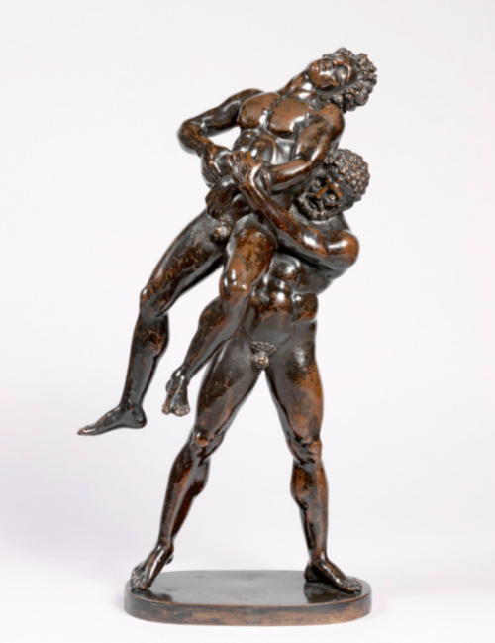*Hercules and Antaeus Wrestling*, Antico, c1500-1510, bronze with silver inlays, 40.8cm high

**Q1: Analyse the artist’s representation of the figures in this sculpture and discuss how he has exploited the qualities of bronze in this work?** (12 marks)

A: This smaller than life-sized sculpture depicts two male figures wrestling. Both figures are nude, this nudity allows the artist to depict the muscles and physiques of both figures in this work. One man is shown lifting the other upwards and showing he is stronger. Hercules is possibly the one who is shown here as the stronger of the two, the heel of his right foot is raised from the ground, this is a contrapposto pose and breaks the symmetry of the figure, it also shows the power of his strength, he is forcing his own body upwards and using his strength to keep the body of Antaeus held aloft. Antaeus’s posture by comparison suggests defeat, his muscles are less tensed and appear less prominent than those of Hercules who appears more vigorous and energetic.

The incline of Antaeus’ head suggests submission. The struggle has left him exhausted and it appears that his strength is slipping away. His eyes are closed and it looks as if he is almost sleeping or dying. This is also echoed in the hand gestures of and positions of Antaeus, he is able to only grip Hercules’ hands, showing he is weaker. Physically Hercules is depicted as having stronger limbs and muscles, he appears more robust. His pose is rigid and more structured unlike Antaeus whose pose is softer and less powerful.

Hercules facial expression suggests determination and concentration, his eyes appear focussed whereas Antaeus eyes are closed and this removes him from the action or event. The facial hair of Hercules makes him appear more masculine and mature, Antaeus appears younger and more youthful which could suggest inexperience but also weakness, Antaeus also appears more feminine by comparison to Hercules. This again shows that Hercules is the stronger figure. The figures are classically proportioned, Hercules’ hairstyle appears as tight curls unlike Antaeus whose hair appears longer and again suggests femininity.

This sculpture would have been cast from a wax model which allows the figures here to be positioned in a way that would be difficult to recreate in a material such as marble due to marble’s lower tensile strength. The limbs of Antaeus stretch outwards without support, showing the high tensile strength of bronze. The legs of Hercules that essentially support the mass and weight of the sculpture are thin and spread far apart, they spread across the base of the sculpture. This negative space again shows the strength of bronze as a material for casting such top heavy forms. The patina of the sculpture is highly polished which successfully mimics the effect of the sweaty or oiled skin of the wrestling figures. Bronze can be coloured, the figures shown here are in a natural bronze colouring and this might suggest their tanned skin. Silver has been set into the figures’ eyes to suggest the whites of the eyes and also to contrast with the dark bronzed colouring of the figures. Parts of the bronze sculpture appear lighter in tone, this allows us to see the shadows and forms of the figures more clearly and also add variety to the tone of the sculpture. The small scale of the work forces the viewer to look more closely at the subject and this allows us to see finely modelled details such as fingers, toes and facial features. The base of the sculpture is round and contains Hercules’ stance. It is the same colour as the figures and unifies the whole subject.

**Student covers both parts of the question equally. (12/12)**

**Paper 1 *War in Art and Architecture***

**Qa: Discuss the representation of military leaders in two works of art. (12 marks)**

A: *Napoleon Crossing the Alps* by David, oil on canvas completed in 1801, is an equestrian portrait of the French leader crossing the Alps to defeat the Austrians and occupy Italy. Napoleon is dressed in the uniform of the First Consul, the government he now rules. He wears a red billowing cape which draws our eye directly to him and suggests power. Napoleon is idealised, his muscular figure evident beneath his fitted uniform. His facial features are symmetrical and based on classical antiquity, linking him with classical leaders and making him appear more physically appealing. He appears bigger than the rearing white horse he sits on, suggesting authority and control. He and the horse fill the composition, giving him prominence and authority. Napoleon is posed with his arm and hand in an ad locutio gesture, linking again to classical antiquity and suggesting that he leads the way to victory. His army in the background also face in that direction, emphasising Napoleons power over them. Names carved in the stone, including Hannibal, Charlemagne and Napoleon’s compares him to these great classical leaders. The gaze of Napoleon is directly towards the viewer suggesting confidence and strength of a leader. The colours of the French flag appear throughout the painting, emphasising Napoleon’s nationality and the power of France at that time.

Italian dictator Mussolini is depicted as an all-seeing, knowledgeable leader in Bertelli’s sculpture *Continuous Mussolini* produced in 1933. The modelled head is life-sized, giving a sense of realism and convincing the viewer they are in the presence of the Italian leader. The stylised work shows a silhouette of Mussolini’s head with its strong masculine facial features constantly turning and looking. Mussolini is shown in profile, wearing a helmet, celebrating his role as a military leader. The 360 degrees effect of the work provides a sense of intimidation, suggesting a sense of constant observation from Mussolini. The form is solid and black, resembling a chess piece and therefore conjures ideas of games and military strategy whilst black is associated with the ‘Black Shirts’ who were the Italian fascist party loyal to Mussolini. The outline of the form also makes it look like a bullet or bomb, devices used by Mussolini to gain and maintain control. The sculpture is made from terracotta which is a natural material, from the earth which could be referencing the idea of the dictator’s ability to take land through military force and also making him integral to the land of Italy. Terracotta is sourced easily and is inexpensive meaning that this sculpture could be reproduced and distributed easily, becoming a piece of propaganda, the work used as promotion, exploited by the leader when he was in power. The Futurist style of the work embodies ideas of speed and power, Mussolini was determined to make Italy a progressive, modern country and used war to achieve this. **(12/12)**

**Paper 1 *Identities in Art and Architecture***

Qb: ’*The understanding of identity in a work of architecture or art is always affected by its original location*.’ (25 marks)

How far do you agree with this statement? To support your answer you must refer to:

■ named works of art from before and after 1850

* your critical text(s).

A: Social, cultural and geographical differences, to name but a few, can contribute to differing interpretations of art and architecture. The original location of a work may also contribute in varying degrees to its status, visibility, audience, reception and in this case identity.  
  
*Alison Lapper Pregnant* (2005) is a 3D portrait (full length) in marble by Mark Quinn. Alison Lapper MBE, the subject of this work was born without arms and with shortened legs. In 2005 Mark Quinn won the prestigious Fourth Plinth competition to display the first piece of work on the new fourth empty plinth in Trafalgar Square, he chose to display Alison Lapper pregnant. Alison Lapper is posed seated, nude and pregnant. The work is very large scale and produced in marble which is an expensive and long-lasting material traditionally associated with heroic male figures. Marble traditionally celebrated the perfection of the figure as seen in works like Prima Porta Augustus and Quinn uses it in this work to depict a disabled person in a style which traditionally idealised the human form. Her skin is smooth and unblemished and her face is idealised. The work sat in a very public location and the monumental scale was one also associated with heroes. Her chiselled features are not those normally associated with the softer, traditional female stereotype. They are more in keeping with Michelangelo’s *David*. Quinn knew the work would sit on top of a plinth in the grand classical tradition and that the other plinths featured 3 historical military heroes alongside Nelson on his column. By placing Lapper in this context Quinn was reinforcing her identity as a hero. By depicting a pregnant, disabled person with no arms and shortened legs in the style of the Greeks and Neo Classicists and alongside historically traditional heroes, Quinn is making sure our attention is drawn to preconceived ideas of beauty, disability, heroism and femininity.

Many critics felt that Lapper was not a hero in the same sense as the other historical figures in Trafalgar Square and her right to be there was questioned. Had this work been displayed elsewhere this connection with heroism may not have been so evident or so contested. I believe the location of this piece of work entirely reinforces Lapper’s identity as a heroic woman who has overcome the difficult circumstances of her birth and early life to become an artist and spokesperson for the disabled. Quinn celebrates her differences and Quinn himself describes the work as ‘*a monument to the future*’. He shows us that the disabled form is as beautiful and relevant as any other and the location of the work in the heart of establishment London gives the work’s meaning even more impact.

A selection of the Benin Plaques displayed in the British Museum are part of a much larger body of work which is spread throughout museums all around the world. The plaques are originally from the ancient African kingdom of Benin or Edo in Nigeria and would have been commissioned by the Oba (King) to decorate the pillars of his palace. I am going to concentrate on a high relief sculpted plaque showing the façade of the Royal Palace which dates from the sixteenth century by an unknown artist. Without knowing the original location of this plaque, it would be impossible to gain a full understanding of the true identity of the work.The plaque is cast in brass which was highly prized by the Benin people for its colour and shine and the use of this material reflected the high status of the Oba. The brass was made from copper traded with the Portuguese and this was symbolic of the Oba’s power and control over trade and enhanced the identity he wanted to portray of himself through the plaque. Brass was not as desirable as bronze in the Western world at this time and its high status is very specific to this item’s original location.

The plaque depicts the façade of the Royal Palace which it would have itself decorated. Two leopards stand on either side of a doorway and reinforce the Oba’s position as King. A Python, the king of snakes sits on the roof and 2 birds’ feet at the top of the plaque refer to the story of how Oba Esigie who commissioned the plaques conquered his enemies. The Oba wants to be seen through this imagery as being more powerful and stronger than the snakes and the leopards. The symbolism here is very relevant to the original location. Four figures stand front on, symmetrically on either side of the entrance. Their facial features are simplified with distinctive noses and lips expressing ethnic Edo identity. The scarification above their eyes makes sense when we know the work was produced in Nigeria. Their coral headdresses are also associated with Benin royalty and wealth. The patterned background and fine detail throughout the work are designed to reinforce the status, prestige and achievements of the King.

Like the Parthenon Marbles, the Benin Plaques were taken by British military forces who besieged and sacked Benin City in 1897 in an effort to control trade routes, in what was known as the ‘Scramble for Africa’. The plaques were removed from the Oba’s palace when it was destroyed. When the plaques were received back in Europe, Westerners couldn’t comprehend how works of such technical accomplishment and detail could have been made by Nigerian craftspeople. David Olusoga described how the Victorians came to realise that they were indeed ‘*true hallmarks of civilisation*’. The plaques challenged western stereotypes about African racial inferiority and by becoming objects of imperial appropriation taken from their original location a whole new layer of identity is added to our understanding of them.

*The Heydar Aliyev Centre* in Baku, Azerbaijan, by architect Zaha Hadid was completed in 2012. It was commissioned by President Ilham Aliyev as a cultural centre, and named after his father. Baku had a very long and rich Islamic cultural history due to its location on The Silk Road which linked East to West. In 1813 Azerbaijan was divided between Russia and Iran. Northern Azerbaijan including its capital Baku were annexed to Russia. In 1991 Azerbaijan declared its independence from Russia and set about promoting its new identity as an independent state. The geographical location of this building impacts hugely on its identity. The building is in the style known as Parametricism and uses curves and folds and sensual lines. The lines of the exterior are fluid, a large parabolic curve houses a window and the roof undulates and flows reminiscent of the country’s mountain ranges and mud volcanoes.

The country’s Islamic heritage and rich ethnic identity is expressed through the soft curves and undulating forms of its construction which connect it to Arabic calligraphy and Islamic architecture. The building could also be likened to a tent symbolic of the caravans of tents and people who travelled the Silk Road and influenced Azerbaijan’s ethnic and national identity. The dynamic plan of the building and use of new expensive materials like GFRC and curtain glazing reflect also Azerbaijan’s new identity as a wealthy and prosperous emerging state. The pure white exterior and asymmetry of form are a direct contrast to the Soviet style geometrical buildings constructed under the Russian era and an attempt to reinforce Azerbaijan’s new national identity and independence from the Soviet Union. Inside the building is open plan, welcoming and full of light reflecting the new democratic, emerging nation. ‘*They wanted to have something unique, something which is looking at the future, somehow showing their soft, romantic side but at the same time their optimistic side*’ (Saffet Kaya Bekiroglu, project architect at Zaha Hadid Architects).The location of the Heydar Aliyev Centre is integral to the understanding of the building’s identity. The topography, history and culture of the location have all hugely influenced the identity this building was commissioned to reinforce.

In my opinion the original location of a work will almost always be significant to its meaning.Quinn’s subject for the Fourth Plinth was specifically chosen, despite being a temporary display and Hadid’s design is integral to the location of the building. The Benin Plaques can still be understood even though they were removed from their place of origin and we have a better understanding now of their function and turbulent history and despite it being from a Western perspective.

Examiner’s comment: Mark 22/25 AO1 was consistently strong across the works discussed and all were more suitably linked to the question. AO2 good, but particularly so in the Zaha Hadid analysis. AO3 was strong across the whole essay. Regarding critical text, choose those which support an argument.

**Paper 2**

**Q3(a) Explain how colour has been used in one British painting of this period. (5)**

A) Millais’s ‘*Ophelia*’ is a Pre-Raphaelite depiction of a scene from Shakespeare’s Hamlet. We see the figure of Ophelia sink beneath a river as she drowns having being rejected by Hamlet. Her pale white complexion contrasts with the dark brown of the river, making her the focal point. Likewise, her pale hands are shown rising above the dark water as she allows herself to drown. Around her flowers are full of Pre-Raphaelite symbolism. Red poppies indicate death, a pink rose symbolises beauty and white daisies represent innocence. These all link to Ophelia’s character. The surrounding landscape is a rich green colour and shows the Pre-Raphaelite’s interest in nature. A tall clump of dark green reeds are shown reflected in the river. Patches of white highlights are dotted across the river to show its surface, showing attention to detail in nature which the Pre-Raphaelites followed. Ophelia wears a silver coloured dress, this mimics the water as Ophelia becomes one with the stream. A red and brown robin which was mentioned in the play is shown singing on a tree above Ophelia. The Pre-Raphaelites achieved these intense details through a use of bright colours applied to a wet white ground.

Examiner’s comment: Mark 5/5

An excellent, detailed and precise response which successfully draws out the relevant points about colour from the student’s wider body of knowledge on this work.

**3(b) Explain the relationship between form and function in one building constructed during this period.**

A) Oxford University Museum was built in the late 19th century and designed by Deane and Woodward. It was commissioned in order to have a location in keep all the natural science artefacts in one place instead of in all the different colleges of the university. This reflects society’s new and increasing desire for education. Deane and Woodward chose to reflect the use of the building in its appearance: the natural aspect is reflected in the façade’s irregularity – irregular fenestration and use of quintefoil and octofoils and its overall asymmetric appearance. John Ruskin was a great admirer of this. The use of a polychromatic Venetian Gothic Revival style in the entrance emphasises again the function of the doorway to welcome those interested in education and achievement. The cloister complex inside provides extensive display opportunities while the large glass roof provides natural light for illumination. Paired colonettes of different stones found in the British Isles serve both a structural function and also work as geological specimens. Decoration and iron pillars that support the roof integrate details of flora and fauna reflecting the museum’s primary purpose as the education about nature.

Examiner’s comment: Mark 5/5

Excellent, precise and detailed response which focuses entirely on the question posed. Confidently covers elements of both the façade and the interior organisation of the building. While this can never be comprehensive in such a short response, this answer sits confidently at the top of Level 3 and is given full marks, despite the unnecessary addition of the sentence about Ruskin.

**3(c) Explore and evaluate the influence of Impressionism on Post-Impressionism. You must refer to named works of art and/or architecture in your response. (15)**

A) Post Impressionism was a reaction against Impressionism, but also relied upon some characteristics of the earlier style. Impressionism was an avant-garde movement which had a scientific approach to colour and light. Renoir’s ‘*Bal du Moulin de la Galette*’, (1876), was painted en plein air which was a new innovation at the time. This is an everyday scene, showing a large group of figures in an open-air dancehall. Such scenes had become popular with the Impressionists as a way of depicting contemporary life. Renoir focuses on natural sunlight, falling on the figures dancing and socialising. Blue shadows are shown on the ground and on the white dress of a female figure in the centre. Patches of light colour, including pink, appear on the dark blue suits of the men in the foreground and represent the sunlight streaming through the leaves above. Renoir adds to the spontaneity of the scene by cropping foreground figures, particularly the seated boy and girl on the left.

However, the French artists who followed, saw this approach as too scientific and lacking in individual artistic expression and also condemned the focus on a transitory or fleeting moment. Gauguin’s ‘*Yellow Christ*’ (1889) is a Post-Impressionist work showing three women kneeling at the foot of a wooden cross on which a figure of Christ is displayed. Gauguin travelled to Brittany, in an attempt to capture a more honest and simple way of life. The women shown are in Breton costume which makes them appear traditional and a contrast to the modern figures of Renoir’s painting. Gauguin uses colour more solidly than Renoir, making it expressive and symbolic rather than light and ephemeral. Thus, the figure of Christ is painted yellow, linking him with the landscape surrounding him. Figures and forms are heavily outlined in black, giving them a flat and simplistic appearance. This technique is known as Cloisonnism and gives the painting a decorative appearance. Orange appears in the trees in the background, the whole season appears autumnal and links to ideas of harvest time.

However, Gauguin is also linking Christ and his resurrection with the yearly cycle and routines of these rural people which shares the Impressionist interest in ordinary people but takes a more symbolic than spontaneous standpoint. The foreground women have been cropped and Christ has been placed asymmetrically, similar to Renoir’s composition. However, in Gauguin’s work, the cropping allows the painting to appear more dynamic and avant-garde. Despite the radical appearance of this painting, Gauguin followed the Impressionists practice of painting outdoors, he did so to capture the essence of spiritual traditions in a Breton community whereas Renoir captures the liveliness and spontaneity of modern life in an

Examiner’s comment: Mark 11/15

This is a good response with a tight and controlled evaluation of the influence of Impressionism on Post-Impressionism. Knowledge of the cited works is good and there is coherent analysis on both, with a great range of points covered than in the previous example. Critical judgement is also clearer and more coherent. This merits a Level 4 mark, but not quite at the top of the level as the AO2 analysis is not entirely consistent.

**4(d) ‘*Few, if any, external influences on the work of modern painters and sculptors have been more important than that of the tribal arts of Africa, Oceania and North America*’.**

**How far do you agree with this statement? To support your answer, you must refer to named works of art and your critical text(s). (30)**

A) Early Modernism was the rejection of a traditional or academic style to create an anti-naturalistic language. Some modern artists, such as Matisse and Epstein and Matisse (in their respective works ‘*Blue Nude*’ and ‘*Female Figure in flenite*’ were very much influenced by the tribal arts of Africa, Oceania and America, with their question for a new means of representation appropriate to the modern world. However, there were also external influences such as philosophical ideas and urbanisation which were influential to many modernist artworks. In Delaunay’s description of the ‘*Red Eiffel Tower*’ and Epstein’s ‘*Torso in Metal from the rock drill’* ideas reflect the technology of the modern world and what evolved from it.

One work where the evidence that there is significant external influence is evident is ‘*Blue Nude*’ by Matisse, painted in oil in 1907. The image presents a reclining female nude depicted within an exotic landscape, which is shown through the flora depicted in the background. Gill Perry mentions that Matisse’s work was directly influenced by the primitive as the subject matter is “*explicitly colonial*” and is set in North Africa which he had visited the year before. Although the work is not symbolic, it could be seen as a reflection of his memories of the journey. The style is influenced by the tribal arts through the rejection of naturalism such as the illogical proportions of the figure and the simplified ‘realism’. Matisse subverts the traditional expectations of beauty by depicting the female form distorted rather than idealised, which is emphasised through the use of anti-naturalistic colour seen through the blue shading across the form. William Ruben referred to the female figure as an ‘*African Venus*’, implying the impact of ‘primitive’ arts on this work and the rejection of traditional subject matter. This painting can also be seen as a form of escapism as Matisse presents a paradise removed from his own contemporary industrialised world which is also seen in earlier works such as ‘Open Window’

Another modern work that features the importance of tribal art as an influence is Epstein’s small scale, 1913 work ‘*Female Figure in Flenite*’, made of serpentine. Epstein was influenced by the modern and worldly ideas of avant-garde artists like Picasso, Brancusi and Modigliani, who were interested in overhauling European sculpture and were influenced by the sense of freedom they found in ‘primitive’ art. The subject matter of a pregnant woman is a primitivizing one, as it is not a traditional Western treatment of a woman. It has a feeling of prehistoric fertility suggesting that the figure “*inhabits a primeval world*” as suggested by art historian Richard Cork. The celebration of nudity also reflects Epstein’s love for the poet, Walt Whitman, who sought a freer approach to the body and uncorrupted sexuality. The work is incredibly anti-naturalistic and stylised, which emphasises the influence of primitive art. Epstein has reduced the figure to basic elements making his approach a conceptual and dehumanised one. This non-mimetic approach and the abstracted, polished quality of the sculpture reflect the overarching Modernist style.

For example, there is a lack of any detailing or psychological realism, which refers to the raw quality of African and Oceanic masks. The huge eyes have an insect-like quality to them, furthering the sense of dehumanisation in the figure. The illogical proportions such as the massive head with small body, draw back to the disregarded naturalism of tribal art. The form has been simplified and reduced to a geometric, simple and compact composition. Direct carving was another approach which was influenced by tribal art and Epstein may have seen through the work of Brancusi.

Although many modernist artists were influenced by the tribal artists, there were other important external influences, such as modernisation and the rise of technology which has a profound impact on both Delaunay’s ‘*Red Eiffel Tower*’ and Epstein’s ‘*Rock Drill’*. In the latter work, finished in 1913, Epstein was clearly influenced by the machine aesthetic. It was completed prior to the outbreak of the first world war and the figure was originally cast in plaster and mounted on top of a ready-made drill. The body is severely simplified, distorted and dehumanised, becoming part of the machine with the rock drill acting as an extension and the use of geometric planes for limbs suggesting the cogs of machines. The sculpture was almost three metres high and experimental through its use of a ready made or found object in the drill. After the outbreak of war, Epstein’s views changed as he understood the horrific and threatening capability of the machine, causing him to break up the work. By removing the legs and the arm that had once been operating the machine, Epstein transformed his sculpture into a victim rather than a destroyer. Therefore, although the primitive was a driving influence, other influences must be considered too: a position backed up by Cork who argues that the “*move of influence of tribal art towards a formal language [is] more directly redolent of technological prowess*”, which is seen through the technology of the new machine aesthetic.

Other significant external influences include Bergson’s idea of the “*world in a constant state of flux*” and the growing sense of a rapidly changing and urbanising world. In Delaunay’s ‘*Red Eiffel Tower*’ (1911-12), depicting the modern symbol of Paris towering over the Parisian skyline, with the abstracted city booming below. The painting celebrates French innovation, progress and nationalism and is a “*prophet of the future*” and “*a fundamental image of modernity*” (Robert Hughes). The Cubist fragmentation across the picture plane creates movement which refers to Bergson’s ideas of the world in flux and the temporality of vision. The anti-naturalistic depiction of the tower and the visible brushstrokes create a sense of vitality and dynamism. Delaunay was influenced by the Cubist idea of simultaneity and multiple viewpoints. The viewer is looking from both above and below the architecture, providing the process of our experience of looking and creating a subjective experience of the modern world. The simultaneity in the painting evokes the modern innovations of media as well as the rapid change in other technologies. Blaise Cendrars said “*Delaunay wanted to show Paris simultaneously, to incorporate the tower into its surroundings.*” The work is part of the Unanisme movement and reflects, primarily, on the modern progress of the new century in Paris.

Ultimately, I could argue that tribal art is a significance in some modernist painters but there is also a clear sense of influence from the contemporary society of the machine aesthetic, urbanisation and industrialisation.

Examiner’s comment: Mark 25/30

This is a strong response with some detailed and in-depth discussion of selected works. The debate is effectively supported by visual analysis which is perceptive at moments. The critical argument is sustained throughout (even when the student is making the opposing case) and references to relevant critical texts have been skilfully integrated, although perhaps not directly used to develop the candidate’s own position. This is a Level 5 response.

**Godalming College, History and Politics Department**

**Assessment and Predicted Grade Policy**

***(This is an abridged version of the assessment policy – see Godalming online for the full version covering History, Politics, Ancient History and History of Art)***

**The Importance of Feedback**

Learning will not happen instantly and takes time; attending lessons is not enough, you also need to be working outside of class, to learn new information and consolidate learning. In the process, you will make mistakes but hopefully feedback will enable you to learn from these mistakes. Better to make a mistake during the year and correct it, than make your first mistake in the actual exam! Feedback is essential for your learning and will consist of written (teacher marking), peer (where you feedback on someone else’s work in the class) and self (where you assess yourself).

**Weekly Independent Tasks (Homework)**

Homework does not necessarily need to be completed at home. You should use free periods during the day to complete these tasks outside of lessons. To keep a good work/life balance, you might like to treat College as an 0845 to 1615 day and use your free periods in the library completing tasks. This will minimise the work you need to complete at home and might make you more productive.

Each week, homework will be set and could take up to 5 hours in total. If the homework only takes you 1 hour for a week, then you will have a further 1 ½ hours to conduct further reading and consolidate learning. Each week, therefore, you should be completing between 4.5 to 6 hours of independent study in History of Art. This will consist of:

* **Structured homework** - tasks set by your teacher to help consolidate work done in class or prepare for future lessons
* **Proactive work** – these are tasks that you complete independently to improve your understanding of a topic, revise material in preparation for an assessment, or to extent your knowledge. See the ‘50/50 Support Sheet’ displayed around the department and available on Godalming online for more ideas.

When work is taken in to be assessed (practice essays, revision sheets, consolidation tasks etc.) it will be returned to students within 10 working days. If work receives a formal mark then it will be accompanied by a departmental feedback sheet outlining the different levels of the appropriate mark scheme.

Students can expect their work to be returned within an appropriate timeframe and with clear developmental targets. In return it is expected that students will meet the deadlines set by teachers and remain up to date. To help students do this they need to record homework carefully in a diary or planner, and organise their study periods each week to spread their workloads out evenly. The department also offers a range of weekly workshops to provide extra support to students. See the posters displayed around the department for more information.

If work is not submitted on time then the student will be spoken to by their subject teacher to find out the reason for this. If appropriate, the student will then be given a warning and a revised deadline set. The department may also place a student on an action plan to give them a 3-5 week window to improve their performance, after which, if they have failed to do so, they will enter the college’s disciplinary system.

The department also reserves the right to not mark any work which is handed in after the set deadline.

**Benchmark Assessments**

Benchmark assessments are substantial, exam-style questions that are set, completed, and assessed during a two-year A level course. The History and Politics department gives students four benchmarks in their first year and three benchmarks in their second.

Benchmark assessments are marked consistently across the department using Edexcel mark schemes and feedback is given on standardised feedback sheets. Results on these assessments are then recorded centrally using the college mark book. The size of each benchmark is set in advance but the specific question may differ depending on what individual teachers think is most appropriate.

|  |  |  |  |
| --- | --- | --- | --- |
|  | **Benchmark** | **Date** | **History of Art** |
| ***Lower Sixth*** | **1** | **08.11.21** | Visual Analysis question on Painting & Architecture (12 marks each) |
| **2** | **13.01.22** | Part A Question on Identities in Art and Architecture (12 marks)  Part A Question on War in Art and Architecture (12 marks) |
| **3** | **21.03.22** | Part B Question on Identities in Art and Architecture (25 marks)  Part B Question on War in Art and Architecture (25 marks) |
| **4** | **23.06.22** | Part A Question on 19th Century British and French Art (5 marks)  Part B Question on 19th Century British and French Art (5 marks)  Part A Question on 20th Century Modernism (5 marks)  Part B Question on 20th Century Modernism (5 marks) |
| ***Upper Sixth*** | **5** | **11.10.22** | Part A Question on 19th Century British and French Art (5 marks) Part B Question on 19th Century British and French Art (5 marks) Part C Question on 19th Century British and French Art (15 marks) Part A Question on 20th Century Modernism (5 marks) Part B Question on 20th Century Modernism (5 marks) Part C Question on 20th Century Modernism (15 marks) |
| **6** | **9.12.22** | Full paper on 19th Century British and French Art (30 marks)  Full paper on 20th Century Modernism (30 marks) |
| **7** | **17.03.23** | Mock Exams |

Benchmarks are extremely important and should be treated like the actual exam. They are an ideal point to see how you are progressing and to get valuable feedback. You will make mistakes in the benchmarks and so the follow up work is to test whether you have learned from those mistakes to become better at the subject and exam technique. When completing benchmarks you will receive some or all of the following:

* WRITTEN FEEDBACK: Each benchmark assessment will receive substantial written feedback in the form of comments on a cover sheet that relate directly to the assessment criteria of the exam board. Alongside this, symbols (representing comments) and questions will be posed about how to improve).
* VERBAL FEEDBACK: 1-2-1’s with your teachers will be held throughout the year. These may take the form of brief discussions following the return of benchmarks, or more general discussions in the build-up to student reviews and following end of year exams
* These benchmark assessments will feed directly into the student reviews (‘reports’) which get sent home to your parents.
* REFLECTION AND TARGET SETTING: After each assessment, students will be expected to reflect on the written feedback from their teacher and set themselves targets for improvement in the period in question.
* FOLLOW UP WORK: After each benchmark, work will be set to consolidate students’ understanding such as revision sheets. The idea is to learn from the mistakes in your written work. Students who perform particularly badly are encouraged to rewrite the assessment and submit to the teacher for another grade.

**Predicted Grades**

* The predicted grade for full A-level students moving from their first to their second year, will be based on the combined result of their two mock exams. These exams are used to produce an Annual Review Grade (ARG) for students.
* Students will have a full mock exam in both their Unit 1 and Unit 2 courses once the content of these courses has been completed.
* It is essential therefore that students approach these mock exams as significant assessments and revise accordingly. Failure to do so will not be seen as a reason to change the predicted grade.
* If a student has underperformed substantially in the mock exams then their benchmark results will be taken into account when deciding on their predicted grade.

Students will have a 1-1 in the summer term of their first year to discuss their predicted grade. It is essential that these grades are accurate reflections of a student’s performance and are based on the evidence of achieved results. It is the college’s policy that a predicted grade can only be one level higher than an ARG.

**Mock Exams**

A level students will sit a full mock exam in each of the units studied in the first year:

These exams will be sat in formal timed conditions and any students entitled to extra time or to word-process will be able to do so. Students will be expected to conduct substantial revision to prepare for these exams and will be supported with revision materials and revision sessions (either during lunchtimes or after college).

Completed mock exams will be marked using the full OCR/Edexcel mark schemes and feedback will be given using standardised feedback sheets.

**Plagiarism**

Plagiarism is submitting another person’s written work as one’s own original work or using someone else’s idea without referencing the source or using pictorial work without permission or referencing the source. If there is a suspicion of plagiarism, the Head of Department and Senior Tutor will be informed and a meeting will take place. If a student is found guilty, they will be subject to disciplinary action by the College and the awarding body will be informed. Students should be aware that the College is subscribed to software designed to detect plagiarism.

**History and Politics Department**

**50:50 Help and Advice**

Key to your success whilst studying in the History and Politics Department is the level of effort and work you put into your subjects outside of lessons. The college’s expectation is that you match every hour of class time with an hour of independent study – **50:50**. This will include completing **structured homework** tasks set by your teachers but will also require you to **work independently**; finding ways to consolidate and extend your understanding. To help you to do this, the list below gives some ideas or activities to consider each week.

**Consolidate your weekly work *(Suggested time = 1.5 hours per week)***

Go over your lesson materials and booklets/handouts from that week, making sure that all activities have been finished in detail. If you have been reading articles or sources, go over these highlighting key points and adding annotations to the margins. When you have looked at a new style, artistic development or movement, produce a simple mind-map to summarise the key information ready for future revision.

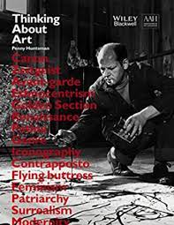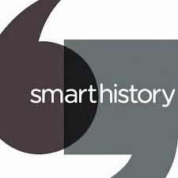

**Revision *(Suggested time = 1 hour per week)***

It is never too early to start the process of revision, particularly if you are on a linear A-Level course. Go back to topics and lesson materials you completed earlier in the year and start to produce revision notes e.g. flashcards, mind-maps, typed notes, glossaries, key-dates timelines etc.. Starting your revision early will make it much easier when you come to revise for your end of year or final exams fully.

**read: thinking about art *(Suggested time = 30 minutes per week)***

Although there is no official course book for this A Level, Thunking About Art by Penny Huntsman is essential reading for any History of Art student. You can download a PDF copy of this book from the homepage of History of Art on GoL <https://online.godalming.ac.uk/course/view.php?id=930>

**Other online libraries *(Suggested time = 30 minutes per week)***

A number of websites have viewing and reading materials specific to your studies. These include Heni Talks <https://henitalks.com/find-talks/>, the Metropolitan Museum of Art, New York, <https://www.metmuseum.org/toah/essays/>, Art History in Schools, <http://www.arthistoryinschools.org.uk/alevelresources>,

**Watch a video/read an article *(Suggested time = 30 minutes per week)***

There are a wealth of resources on Smarthistory, an online library of videos and articles. A large number of these have been produced specifically for use by A Level students. You will find examples of both for many of the key works you will be studying in the Themes and Periods, plus Visual Analysis. <https://smarthistory.org/why-look-at-art-2/> to get feedback.

**Past-Question practice *(Suggested time = 1.5 hours per week)***

Use the selection of past questions from the department’s Godalming Online pages (or straight from the exam board: <https://qualifications.pearson.com/en/qualifications/edexcel-a-levels/history-of-art-2017.coursematerials.html#%2FfilterQuery=category:Pearson-UK:Category%2FExam-materials> You can then bring any completed work to one of the weekly support sessions. to get feedback.