**Godalming Case Study – the essentials**

Godalming is a historic [market town](https://en.wikipedia.org/wiki/Market_town), [civil parish](https://en.wikipedia.org/wiki/Civil_parishes_in_England) and administrative centre of the [Borough of Waverley](https://en.wikipedia.org/wiki/Borough_of_Waverley) in [Surrey](https://en.wikipedia.org/wiki/Surrey), [England](https://en.wikipedia.org/wiki/England), 4 miles (6 km) [SSW](https://en.wikipedia.org/wiki/Boxing_the_compass) of [Guildford](https://en.wikipedia.org/wiki/Guildford). The town traverses the banks of the [River Wey](https://en.wikipedia.org/wiki/River_Wey) in the [Greensand Ridge](https://en.wikipedia.org/wiki/Greensand_Ridge) – a hilly, heavily wooded part of the outer [London commuter belt](https://en.wikipedia.org/wiki/London_commuter_belt) and [Green Belt](https://en.wikipedia.org/wiki/Metropolitan_Green_Belt). In 1881, it became the first place in the world to have a public electricity supply and electric street lighting.[[](https://en.wikipedia.org/wiki/Godalming#cite_note-3)

Read through the information below on both economic change and demographic and social change. On a blank piece of paper write does as much as you can remember about both.

**Economic change**

Godalming was originally a market town and between 1500 and 1800 had a flourishing wool industry making it very prosperous. However, during the 17th century the wool industry declined sharply and the industry shifted to the north of England which brought hardship to the residents. Godalming also had a paper industry, a tanning industry (leather) and was an important stopping point for the stagecoaches travelling from Portsmouth to London.

Changes in transport – the construction of the railway connecting Godalming and London in 1849 and Godalming and Portsmouth in 1859 making it far more accessible and allowed the town to grow rapidly.

In 1872 Charterhouse School moved from London to Godalming and still remains in the town providing job opportunities.

In the 20th Century 2 main factories dominated the town – Alan Paine knitwear and Weyburn Engineering. Both of which have closed down due to foreign competition.

Today the town’s economy is based on service industries with accountancy, insurance, shops and leisure major employers. Many of the inhabitants do not work in Godalming but commute to London or Guildford.

**Demographic and social change**

Godalming’s population has grown rapidly from 3,400 in 1801 to 13,200 today. Godalming is a desirable country town to live in with excellent commuter links resulting in very high average incomes. It attracts wealthier families and retirees who are attracted by the high standard of education, low crime rates and attractive surrounding scenery as it is located in the Wye Valley with surrounding woodlands. In the past, there would have been a more socially and economically diverse population. The building of Ockford Ridge and Aaron’s Hill social housing estates have enabled those on lower incomes to reside in the town still but average house prices are very high.

In the late 1920s the national government set up a job creation scheme with the building of the A3 bypass. Workers from the NW/NE England and South Wales arrived and lodged in the town. In order to provide housing for the new workers money was given to build 200 homes which became the Ockford Ridge and Aaron’s Hill social housing estates.

Post 2nd WW migrants came from Poland, Italy, Germany and Spain. Many of the Poles worked on the by-pass and then when the road was completed got jobs in the manufacturing factories in the town, married locals and moved into the new housing estate which had another 200 homes built. The immigrants from Italy mostly worked in farming and the hospitals and came to the UK on immigration permits. Unlike the Poles, who had found alongside the British in the war, the Italians did not qualify for social housing and instead lived in the centre of Godalming in shared housing, with friends and family who had already arrived in the UK as this was cheap. As a requirement of their permits they needed to work for at least 2 years in farming or in the hospitals but after this could seek alternative work.

Post 2WW also saw the development of the Ockford Ridge Social Club. Residents for a number of years donated money in order to purchase the land and construction started in 1946. The social club consisted of a bar, main hall for dances, darts and card clubs. It developed a sense of community that was organised by the locals.

In Godalming at this time, the main employers were Alan Paine knitwear and Weyburn engineering and Charterhouse College.

Today the population of Godalming is 96% white (which will include the European immigrants) and so is not considered ethnically diverse. It also has a high mean age of 42 years reflecting the desirability of the quieter location for older people, although more wealthy families are also attracted to the town due to its excellent schools. In Waverley 59.9% (round up to 60%) of the population have qualifications level 4 and above, whilst nationally it is 29.7% (round up to 30%). Those on higher professional salaries are those who are most likely to be able to afford the high Godalming house prices.

Despite Godalming being a wealthy market town in the commuter belt there is still social and economic inequality.

You need to know about how there is social and economic inequality in our local area and how it contrasts with our distant place (Stratford). Highlight a couple of the figures that you can learn and use as evidence in an essay question.

Contrast Godalming Holloway and Central and Oxford.

|  |  |  |  |
| --- | --- | --- | --- |
|  | Godalming Holloway | Central and Ockford | Newham (Stratford) |
| % economically active | 81.5% (many more retired 5.8%) | 83.1% (less retired 3.0%) | 77.5% |
| % Unemployment | 3.0% | 4.4% | 11.2% |
| % Long term sick | 0.8% | 4.8% | 4.6% |
| Professional | 33% | 24% | 21% |
| No qualification | 2.4% | 10.9% | 16.5% |

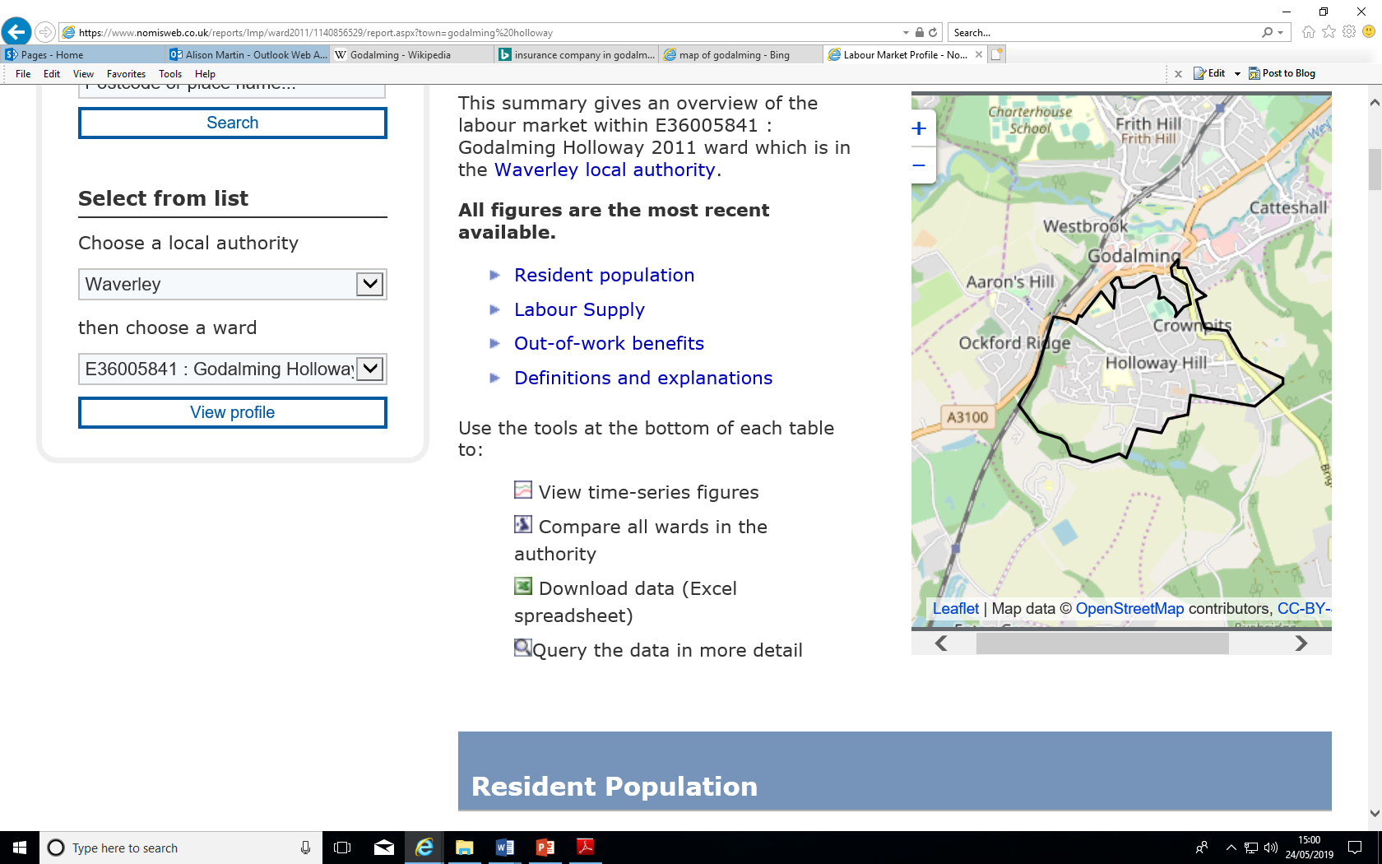 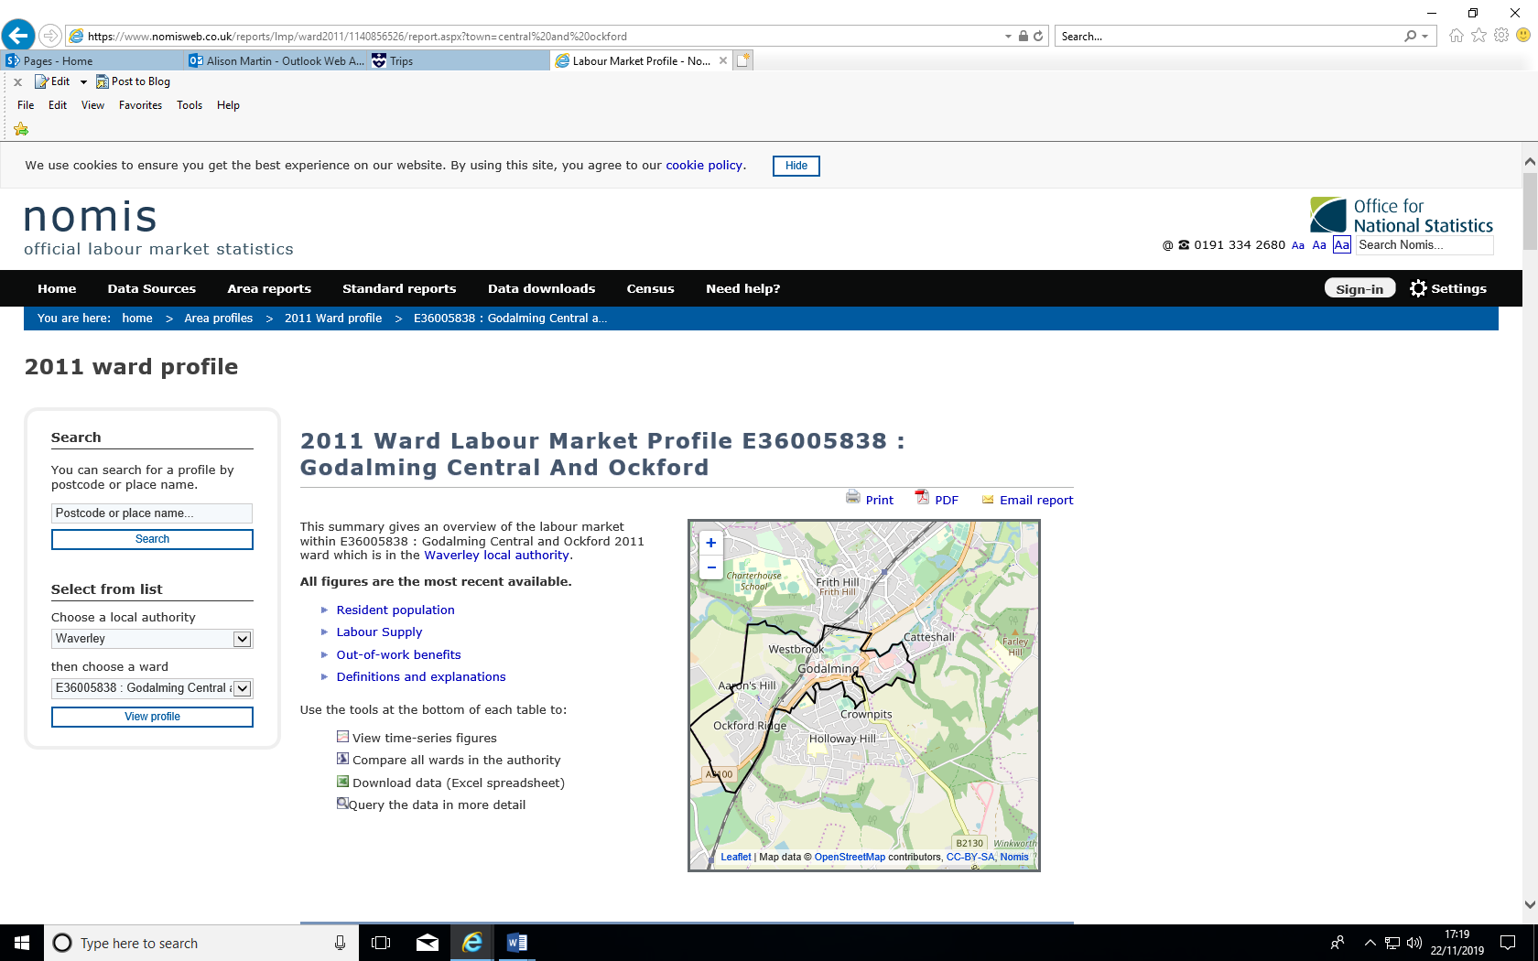

Crime rates:-

March 2019

Do these statistics surprise you?

Godalming 116 crimes 5654 population **Crime rate 2.05**

Stratford 641 crimes 27,243 population **Crime rate 2.35**

Classify the factors into either endogenous or exogenous.

Endogenous or exogenous factors for Godalming?

Good schools ___________________________

Government immigration policies ___________________________

Migration of workers from the NE and NW England and S Wales ______________________

Chain stores ___________________________

The physical landscape – valleys and woodlands ___________________________

High quality housing ___________________________

Foreign competition of manufacturing ___________________________

The local people and community actions ___________________________

Independent shops ___________________________

Government job creation schemes – A3 road ___________________________

Local business ___________________________

Market town selling local produce ___________________________

**Media representations**

Fairly limited for Godalming but you could include:-

Paintings – focusing on the tudor architecture, river scenes and churches portraying an attractive and peaceful town.

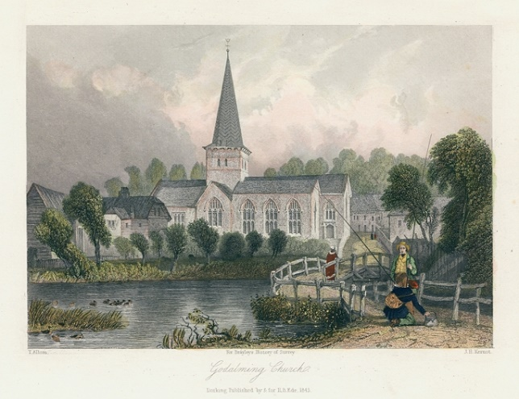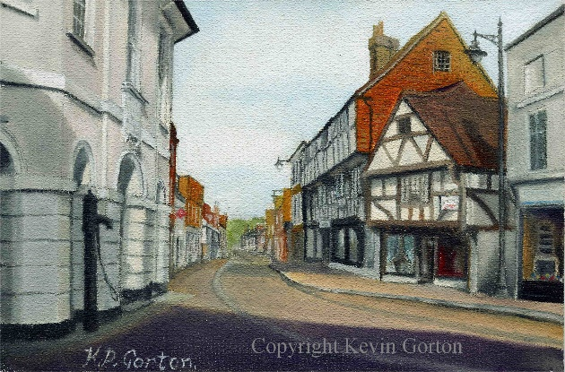

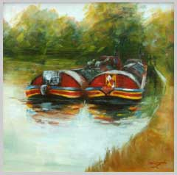

What do these images portray Godalming as being like?

Would you agree?

**Let’s move to Godalming – Guardian newspaper article from the property section**

What's going for it? We'[ve been here before, but](mailto:theguardian.com/letsmoveto) such is its cuteness I can't stop myself from wittering on about Godalming until you all move there. Imagine an archetypal little English town. Sun-dappled, weatherboarded cottages on wooded slopes? Yep. Nice lanes where the trees arch over? Yep. Cricket on the green? Yep. Warm beer in ivy-clad pubs? Indeed. Cycling spinsters? Sorry, getting all [John Major](https://www.theguardian.com/cartoons/stevebell/0,7371,802577,00.html) on you. But you get the picture. Plus it does a nice line in independent stores, such as [Wakeling's](http://www.wakelings.co.uk/dFinity/wakelings) butchers (and uber-foodie farm shop [Secretts](http://www.secretts.co.uk/)). Basically Britain circa 1953. My kinda town.

The case against ZZZzzz. Terrifically middle of the road. Fun culminates in bridge clubs, am dram and Sunday afternoon concerts at the bandstand, though good sporting facilities and gentler pursuits such as messing about on the river Wey. Pricey.