**Local Place Study - Godalming**

* <http://www.localhistories.org/godalming.html>
* <http://www.godalmingmuseum.org.uk/index.php?page=work-and-industry>
* <http://www.godalmingmuseum.org.uk/index.php?page=1881-godalming-and-electricity>
* <http://www.godalmingmuseum.org.uk/index.php?page=timeline>
* <https://www.freeindex.co.uk/south_east/surrey/godalming/> Useful to see what types of businesses are now found in Godalming. Be careful – some are not located in Godalming itself, but the Godalming area.

**Resources to complete the case study**

* Complete the tasks on the PPT on Godalming Online using the information/links on slides. GOL, Geography Y1, Changing Places, Godalming Local Case Study folder. **Integrate the information into your case study content.**
* Use the websites above, and any others you may find to complete case study notes for Godalming.
* Use the data you collected from the NOMIS website (page 2 of the booklet)
* Use the background information on Godalming completed as part of your induction work
* Use the media representation research on Godalming completed for homework
* Use the audio clips listened to in class. **NOTE: THE AUDIO CLIPS ARE AN ESSENTIAL SOURCE OF INFORMATION AND MUST BE INCLUDED.**
* Include images, maps, statistics to support points made

|  |  |
| --- | --- |
| **CONTENT TO INCLUDE** | **TICK WHEN COMPLETE** |
| Describe the location and locale |  |
| Outline a brief history of Godalming |  |
| Describe the demographic characteristics of Godalming. How does Godalming Holloway compare to Central and Ockford? |  |
| Describe the economic characteristics of Godalming? |  |
| Describe the social characteristics and inequalities that exist |  |
| Describe the exogenous factors which have been responsible for its place making  Describe the endogenous factors which have been responsible for its place making |  |
| How have the media portrayed the place? There may be a number of examples you could use here. |  |
| Complete a literature review examining the sources of data used, whether they are quantitative or qualitative, subjective or objective and how useful/reliable the information was. |  |

June 2021 paper

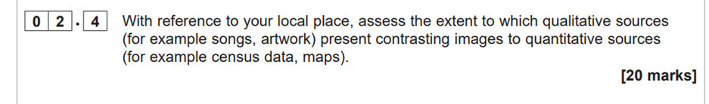

June 2019 paper

