**UPLOADING FILES TO GOL**

N.B. You can’t upload files directly from OneDrive. To upload files from there you need to

* download the file
* upload it as below from your downloads folder
* then delete the file from your downloads

The assignments have icons as shown below:

e.g.



Click on the assignment name next to the icon and you will get:

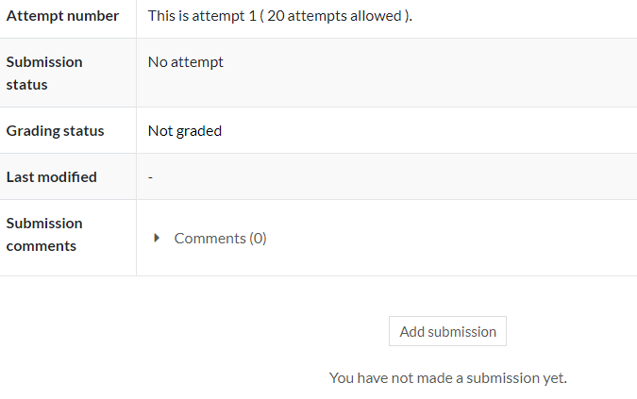

Click on ‘Add submission’

Then drag and drop your file into the box that appears. You don't drag and drop the file when it is open, just the file from File Manager – left click on the file you want, hold and drag to the box then let go.

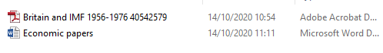

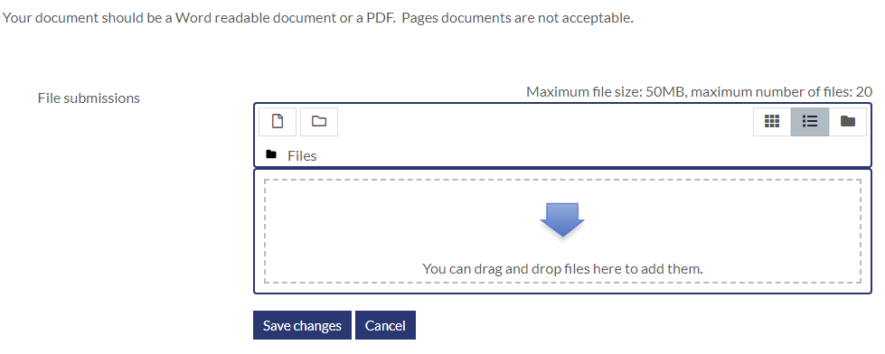

and click on ‘Save Changes’.