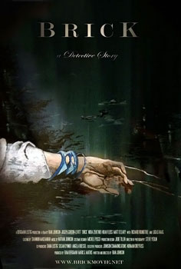**Brick *(2006)***

**Director:** [Rian](http://uk.imdb.com/name/nm0000965/) Johnson

**Writer:** Rian Johnson

**Release Date:** April 7th 2006

**Tagline:** A detective story

**Budget:** $450,000

**Gross Revenue:** $3,919,254

During the screening of this film make notes on the following:

Mise en Scene (pronounced **meez ahn sen**)

|  |  |
| --- | --- |
| 1. Setting/location/Décor |  |
| 1. Lighting |  |
| 1. Props |  |
| 1. Costume & Make-up |  |
| 1. Performance (body language, movement) |  |