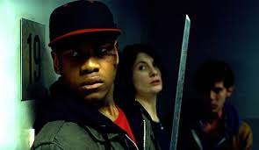**Mise-en-Scène task**

Watch the opening of *Attack the Block (2011)*. What do the following areas of mise-en-Scène tell us about the:

**Genre**

**Characters**

**Narrative**

|  |  |
| --- | --- |
| Setting/Location | Lighting |
| Props | Costume |
| Make up | Performance/body language/movement |