**Week 3 Unit 2 Year 11**

**TRANSITIONS FOR CHILDREN**

**Name: Date:**

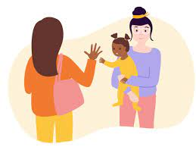 

**Read the attached articles about the role of the key person and transitions, then complete the questions.**

**What is a key person?**

**Why do children need a key person in an early years setting?**

**Describe the role of a key person in 80-100 words-** *include a quote from any book or website.*

**What is a transition for a child?**

**What affect can transitions have on children? List 5**

**1.**

**2.**

**3.**

**4.**

**5.**

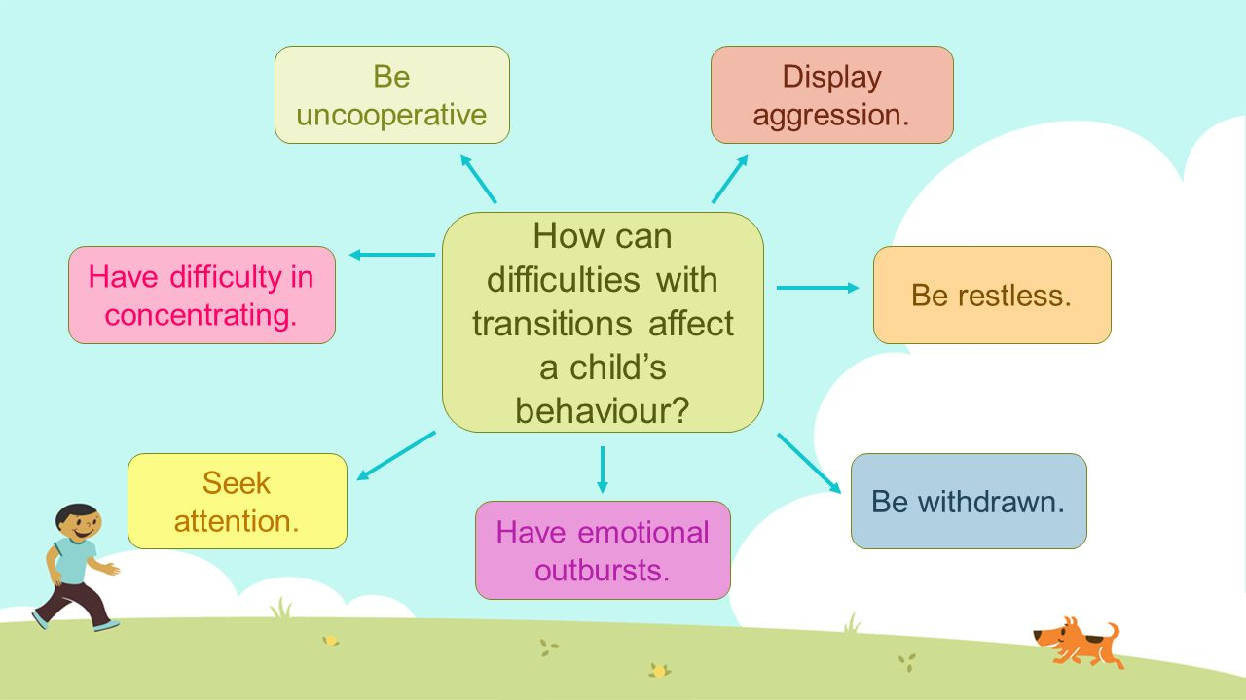

**List 3 activities you could do with a child settling into a new nursery class:**

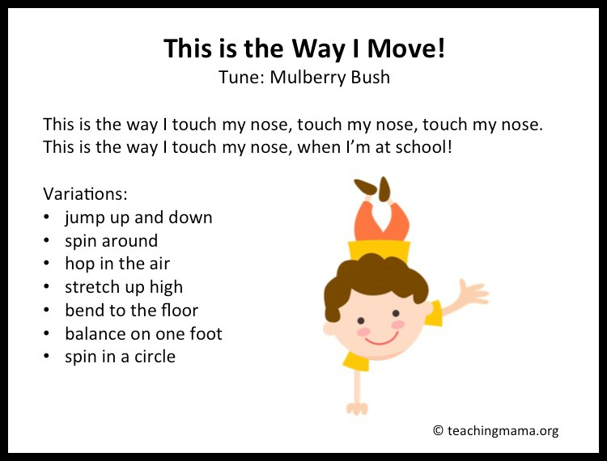 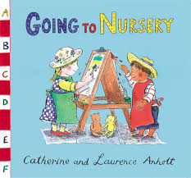

**1.**

**2.**

**3.**

**What does the Early Years Foundation Stage Curriculum (EYFS) say about the key person role?**

Look at page 27 via this link to the EYFS and write what it says below:

<https://assets.publishing.service.gov.uk/government/uploads/system/uploads/attachment_data/file/974907/EYFS_framework_-_March_2021.pdf>

**The EYFS says that the key person is …**

**A key person can support their key children during different transitions that they may be experiencing.**

***Complete the table below by writing out different ways children can be supported, and activities that will help ease the transition:***

|  |  |
| --- | --- |
| **Type of Transition:** | * **How can the key person (early years worker) support a child with during the transition?** * **Name one activity they could do for each transition** |
| Moving home |  |
| Breakdown of parental relationship  (divorce/separation) |  |
| Starting pre-school |  |
| Moving to primary school |  |
| Moving rooms in a nursery |  |
| The birth of a new sibling |  |
| Weaning from milk to solids |  |
| Potty Training |  |

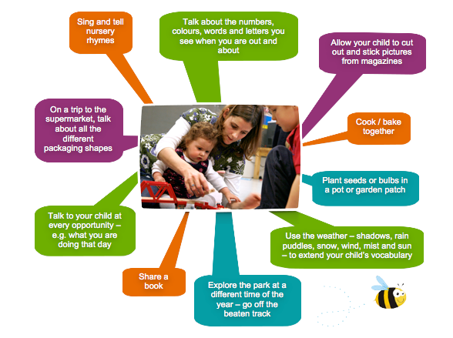

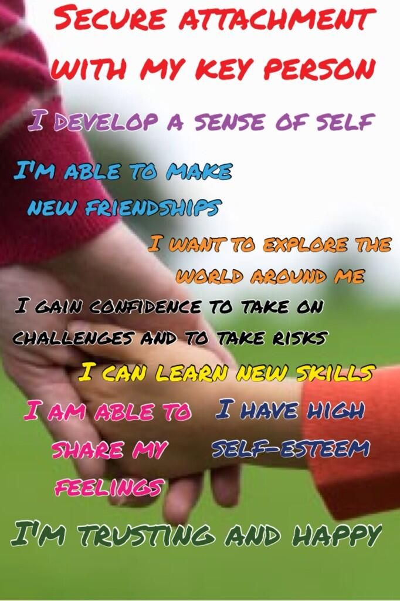

# ARTICLE 1:

# The role of the Key Person

# 7TH JUNE 2015 BY [KELLY](https://www.earlyyearscareers.com/eyc/author/kelly/)

### **The importance of the key person**

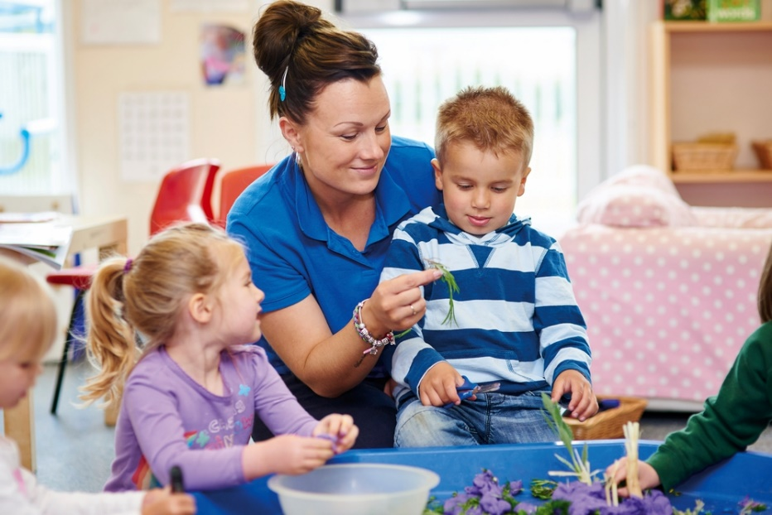

The key person is a named practitioner who has responsibilities for a small group of children, they are there to help the child feel safe and secure. The role is important for both child and parent and it is an approach set out in the EYFS. The key person will respond to children’s needs and help them settle into a new environment, communicate is paramount between parent and key person as these discussions hold key information about the child. A Key person will be a point of contact for parents.

#### **Engaging with parents/carers**

* Participate in and plan ways of getting parents involved e.g. coffee mornings, parents evening, informal occasions; stay and play, themed weeks, trips.
* Promote a positive relationship between nursery and home,  engage in a positive way, create a bond  with the parent/ carer
* Help child to settle at nursery, reassure and comfort parent/carer e.g. take photos in their absence to aid feedback.
* Settling questionnaire sent home after 6 weeks.
* Provide daily verbal feedback to parents, supported by the ‘how much I’ve eaten’ and the ‘what I’ve been doing today’ charts and the planning sheets displayed.
* Messages to parents/ carers (medicine and accident forms) are the responsibility of the key person, but the room team should also support the key person in this.
* Update parent boards daily with information for parents to access about their child.

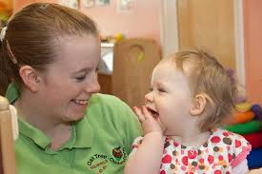 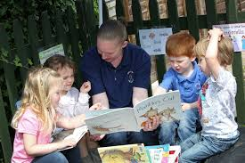

#### **Meeting child’s needs**

* Aim to match key child to practitioner they make attachment to.
* Key person to have an input into the planning, based on what feel their key child would enjoy/ benefit from to progress further.
* Use characteristics of effective learning statements when planning for children’s individual needs
* Key person is inclusive, they are aware of the child’s individual needs, related to their culture, background, any learning disabilities, ability, dietary requirements and sensitivities, to pass the information to the rest of the staff team and ensure they are met.
* Make other room staff and kitchen aware of key child’s allergies and requirements- follow settings red dot system

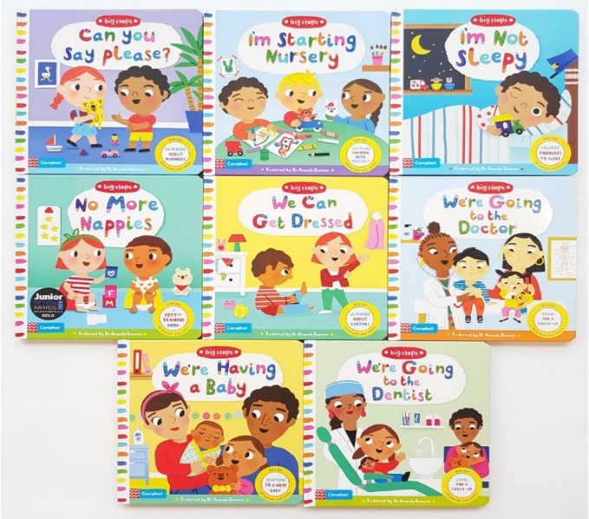

#### **Keeping records of the key child…**

* All room members (including cover staff) to collect evidence of child’s progress if they observe it, this can be photos, written observations eg post it notes or narrative obs, or the child’s work.
* Keep a record of child’s Learning Journey and update regularly
* On trial session Key person to complete all about me form with parents, this starts the beginning of the child learning journey
* Progress summary sheets are completed and shared with child’s other setting if they attend a dual setting.
* Tracking sheets are complete when a child starts the nursery (on Entry assessment) and then completed termly.
* During the end term of Pre School, Practitioners will complete a transfer profile to the reception teacher.

**Source:**  <https://www.earlyyearscareers.com/eyc/latest-news/the-role-of-the-key-person/>

# ARTICLE 2:

# Your child's key person

Let's explore the role of the key person in a setting and how they will support your child and work in partnership with you.

The key person is a named person who has responsibility in a setting for working with you and meeting your child’s individual needs. The importance of the key person is highlighted in childcare policy in England and Wales. In a nursery, one of the childcare staff will be assigned as your child's key person. If you are using a childminder then they are the child’s key person.

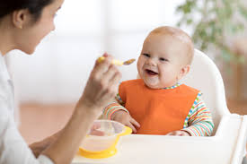 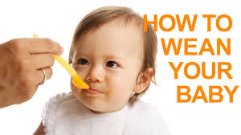

The key person will get to know you and your child really well, finding out about your child’s preferences and routines and will be the person that shares information with you about what your child has done during the session and information about their learning and development.

The key person role is important. Research and evidence show that children thrive when their needs are met by special people that they know, trust and respect. Familiarity, pattern and predictability support children’s personal development and helps them understand who they are and what they can do. Children can concentrate and learn more effectively if they're not under stress or pressure, so having a key person who is attentive and knows the child well will support children in their personal, social and emotional development.

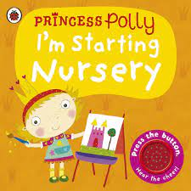 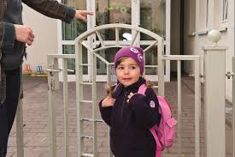

Children learn by observing and being with others. The key person is an important role model for the child who they can relate to and rely on. The key person observes your child to identify how they learn through their play, their next aspect of development, what their interests are and whether there is any cause for concern or need for extra support. They will share this information with you, working with you to formulate a plan of support. The key person supports physical needs too, helping with issues like nappy changing, toileting and dressing.

### **What does this mean for me?**

The key person works alongside parents and carers to ensure that there is continuity of care for the child thus supporting the child’s emotional well-being. The key person will want you to share information about your child - the more you can tell them the better the relationship they will be able to form with your child and plan how to meet their needs.

The key person is someone you can talk to about any concerns, they will know your child well and will be able to provide advice and support with all aspects of learning and development. You should be offered regular times to talk to your child’s key person and look at their child’s learning and development records.

### **What can you do to support your child?**

* Talk to your child about their key person so that they know they can go to them for help. Keep the key person updated with any changes in routines or changes in your child’s home life, for example, if you are moving house or expecting a sibling, as your child’s key person will be able to support your child through transition times.
* Share any new interests your child may have or special experiences they may have taken part in as their key person will be able to follow up on these in the setting.
* Tell your child’s key person about any ‘wow’ moments your child has had at home and when they meet developmental milestones. Together you can celebrate your child’s achievements and plan suitable next steps to support them.

Source: <https://www.pacey.org.uk/parents/resources-for-parents/tips,-factsheets-and-downloads/your-child-s-key-person/>

**Here are some ways to support transitions for children**

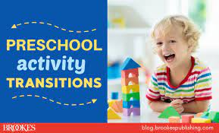 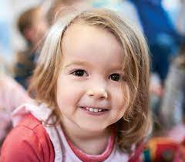

**All children experience transitions throughout the day;**

It is helpful to plan reassuring and flexible routines to help children cope with changes;

Rhymes and songs help to make learning and understanding a bit of fun.

You can support and promote positive experiences when guiding children through different types of transitions – try the following ideas:

● View transition as a process not an event; plan ahead and value the concerns of children and their families. Make transition and the wellbeing of children a priority.

● Request welcome packs from the schools your children will move on to, distributing key dates and information to parents.

● Have an Induction day/week for children and parents to help them settle into a new nursery, play group or any early years setting. Find out activities they like to do and have these ready for children to do.

● Call and arrange a visit if a child is starting a nursery class or Reception class. This makes them familiar with their new teacher / early years worker.

● Transfer assessments, progress reports and learning journeys in good time, and share vital information about a child’s heritage, language and social skills.

● Ensure children develop independent self-care skills to manage in a setting with fewer adults.

● Role play experiences such as dressing up in school uniforms, family home setting, dentist, doctors, airport etc…

● Support and reassure children if they are upset and give them time to choose, rest and make friends.

● Observe and identify what they are interested in or if they need support with learning new skills such as riding a bike, scooter, drawing

● Remember that lunchtime is a quiet time in most settings, but at school the rowdy nature of playtime can be overwhelming and a total shift in routine.

● Focus on core skills, such as reading for pleasure, early phonological awareness and number, that lay the foundations for lifelong learning.

● Ensure areas are made available for parents to meet and interact as they enter your setting.

● Gain all you can from home visits, small group play dates, liaison with the key person and relationships with parents; a baseline assessment will be more accurate if it relies less on the first few stressful weeks in a new setting.

● Ensure ‘a range of books’ are continuously available to families and early years workers to support the range of transitions (see below).

● Build in special time in which small groups of children can be with their key person on a daily basis.

● Encourage children and parents to express themselves throughout the transition process; value their concerns.

● Focus on the language of similarity, not difference – there’s a fine line between exciting and overwhelming.

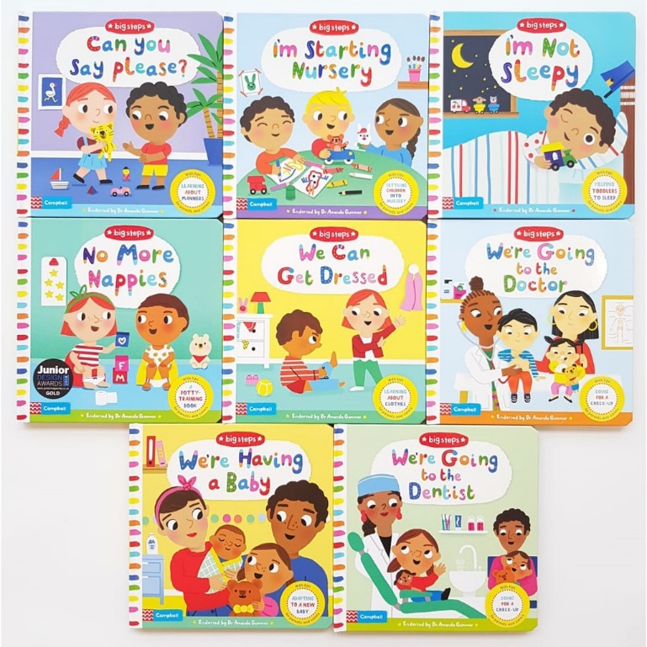

# Attachment and the role of the key person

# <https://birthto5matters.org.uk/attachment-and-the-role-of-the-key-person/#:~:text=The%20key%20person%20helps%20the,with%20the%20child%20and%20family.&text=Babies%20and%20children%20become%20attached,essential%20in%20order%20to%20thrive>.

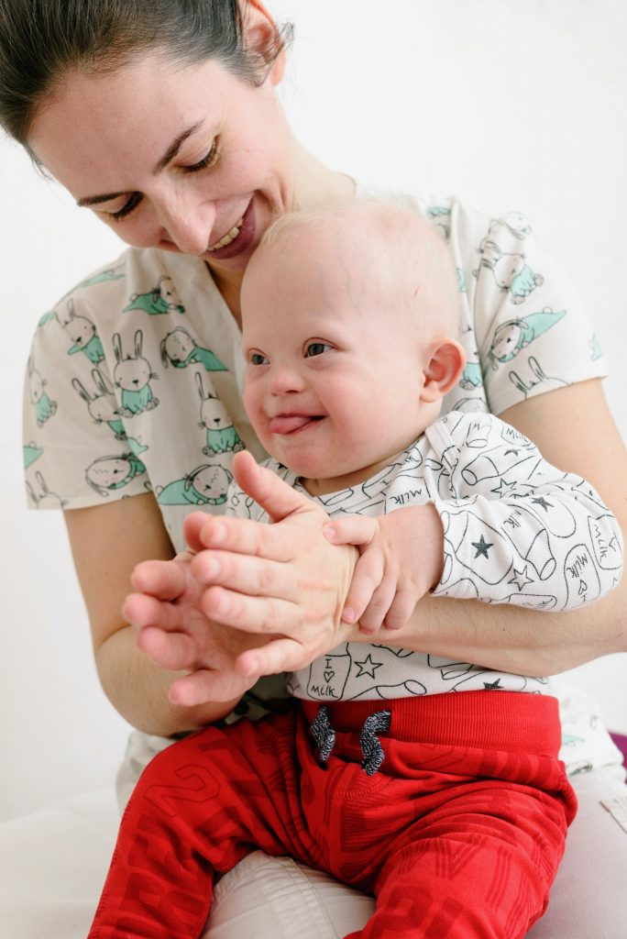

**Key points**

* The key person helps the child to feel known, understood, cared about, and safe.
* The key person role involves a triangle of trust with the child and family.
* An effective key person approach needs strong leadership and committed practice.
* Children benefit most when their key person has special qualities and dispositions.

Babies and children become attached to significant adults within reliable, respectful, warm and loving relationships which are essential in order to thrive. Babies and children experience wellbeing and contentment when their physical and emotional needs are met and their feelings are accepted.  The key person approach, reflecting relationships within families, helps serve to meet these conditions. Early experiences of love and attachment have lifelong benefits.

**The key person helps the child to feel known, understood, cared about, and safe.**The key person helps the baby or child feel confident that they are “held in mind”, thought about and loved. This experience of being cared for by reliable adults who meet their physical needs and remain attentive and playful, affectionate and thoughtful allows children to form secure attachments. Such a grounding provides a “secure base” from which children feel confident to explore the world and form other relationships.

**The key person role involves a “triangle of trust” with the child and family.**A key person approach is a way to ensure that all children and families have one or more persons within the setting with whom they have a special, nurturing relationship. The presence of a key person helps the child to feel emotionally secure when away from home and provides a reassuring point of contact for parents. There are different ways to ensure a key person is always available (e.g. shared and paired caring, or support partner or buddy).

A key person has special responsibilities for supporting a specific group of children and building relationships with them and their families. The role will involve close physical and personal care for a baby or young child. It is therefore important that parents feel able to share vital information about their child’s intimate care preferences, likes and dislikes, motivations and interests, and how they feel about being away from home. Parents might want to talk about their child’s feelings or development.  It is most helpful for a key person to attend the home visit with another colleague. This frees up opportunities for parents to talk while the key person makes playful connection with the child. If a home visit is not possible, adults can meet somewhere comfortable, with resources to encourage relaxed and playful introductions.

The key person’s role includes, but goes far beyond, administrative and operational activities such as keeping records or communicating about the child with parents or other professionals.  It is an emotional, reciprocal relationship. As children grow, the key person may not always be present at the setting. Despite this, the child should still feel “held in mind” when they are apart. The key person approach is statutory throughout the early years phase, including in Reception. The role may look very different in a large class of children with often only two adults, but the principles remain the same. A teacher can retain overall knowledge of the children in their class and benefit from particular knowledge that other people working with them might have. The stronger the relationships are, the more supported the child (and their family) will feel about subsequent transitions, including to Key Stage 1.

**An effective key person approach needs strong leadership and committed practice.**Leaders should have a good working knowledge of the key person approach and be able to implement it to maximise consistency and continuity for the child and family, while offering the best possible support and supervision for practitioners. Although there is legally no minimum qualification to be a key person, leaders can support less experienced staff, including careful thought about the pairing (or mentoring) so that all can benefit from wide expertise. Key persons communicate with a wide range of people involved with the child, including those in other settings the child attends, health visitors, paediatricians, Portage, physiotherapists, social services, Child and Adolescent Mental Health Service, educational psychologists, speech and language therapists, bilingual support, children’s centres, and others such as dinner staff.

The role of the key person involves building a relationship of “professional love”, with specific and potentially heavy demands. It is important to have professional support and supervision in order to share the challenges of the role. It is also a joyful and privileged position to share in the care of a baby or young child, so having opportunities to celebrate and share those joys are equally important.

**Children benefit most when their key person has special qualities and dispositions.** Ideally, a key person:

* has passion for their work and sees the value and rewards in being a key person
* is empathic and understands the different ways of creating a family
* appreciates and respects the cultures, identities and diverse backgrounds of the children and families with whom they work
* is able to draw on their own informal knowledge of childcare practice from within their own experience and reflect on how best to use or build on it
* is able to reflect on and understand the influence of their own attachment experiences on their work with children and families, with the confidence to know when to ask for support and further training
* is willing to research and reflect on the concept of “professional love”, so that they can see its relevance to their work as a key person
* finds effective ways to connect with families, such as developing digital technologies while continuing with as many opportunities for face-to-face connection as possible
* is not judgemental and has the skills to communicate with other agencies and settings involved with the child and their family
* is well qualified, and/or has wider knowledge and understanding of, for example:
  + child development
  + attachment theory, including social and biological factors that might affect a child”s capacity to form attachments
  + co-regulation and self-regulation
  + neuroscience (brain development and how it links with all the Prime areas as well as self-regulation and executive function)
  + pedagogy of effective, relation-based practice
  + bias and prejudice, how it affects the children and families they work with as well as themselves, and strategies to challenge this
  + how to identify and support children in a range of circumstances, including those who are vulnerable, looked after, with visible and invisible special educational needs and disabilities
* recognises that it is a personal as well as a  professional relationship which brings with it much joy, as well as challenge.
* works collaboratively with other practitioners, to ensure consistency for the child, and supports transition as an ongoing process, not just an event.

**The Key Person & Attachment**

**The Key Person**

Children thrive from a base of loving and secure relationships. This is normally provided by a child’s parents but it can also be provided by a key person.

A key person is a named member of staff with responsibilities for a small group of children who helps those children in the group feel safe and cared for. The role is an important one and an approach set out in the EYFS which is working successfully in settings and in Reception classes. It involves the key person in responding sensitively to children’s feelings and behaviours and meeting emotional needs by giving reassurance, such as when they are new to a setting or class, and supporting the child’s well-being. The key person supports physical needs too, helping with issues like nappy changing, toileting and dressing. That person is a familiar figure who is accessible and available as a point of contact for parents and one who builds relationships with the child and parents or carers.

Records of development and care are created and shared by the key person, parents and the child. Small groups foster close bonds between the child and the key person in a way that large groups cannot easily do. These groups allow the key person to better ‘tune into’ children’s play and their conversations to really get to know the children in the group well. Children feel settled and happy and are more confident to explore and as a result become more capable learners.

**Why Attachment Matters**

What is attachment and why is it important for young children? Attachments are the emotional bonds that young children develop with parents and other carers such as their key person. Children with strong early attachments cry less when separated. They engage in more pretend play and sustain attention for longer. They are less aggressive and are popular with other children and with adults. Their sense of who they are is strong. Children need to be safe in the relationship they have with parents or carers. They are vulnerable but will develop resilience when their physical and psychological well-being is protected by an adult. Being emotionally attached to such an adult helps the child feel secure that the person they depend on is there for them.  When children feel safe they are more inclined to try things out and be more independent. They are confident to express their ideas and feelings and feel good about themselves. Attachment influences a child’s immediate all-round development and future relationships.