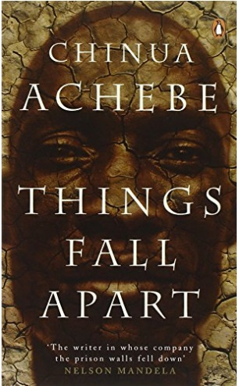********

**NAME:**

English Literature (Pearson Edexcel)

9ET0

English Literature A-Level

**Course Handbook**

**Introduction to the department**

Welcome to English Literature A level. We hope that you enjoy your time in the department and find the process of studying the course a challenging and rewarding one.

The purpose if this guide is to provide you with a range of information and advice to help you organise your programme of study, learn independently, and equip you with important information about the department and how it can support you.

Teaching is carried out in a purpose-built modern building, opened in 2016, by a team of highly-qualified staff, passionate about the subject. There are four full-time and three part-time colleagues, two holding PhDs in English and a number of them examiners, exam authors, and writers of professionally-produced materials for A level English teachers. One member of the team has a two-book fiction deal with Headline Press and supports creative writing EPQs in the department. We see ourselves as a forward-looking department in terms of teaching and learning, always trying new ways to deliver our courses in a manner which embraces the demands of a two-year A level, but also fosters creative thinking and a genuine enjoyment of studying English for its own sake, above and beyond getting successful outcomes.

**Teaching Staff:**

* **David Deeming, Jacqui Dearden, Adam Duce, Juliet Harrison, Jenny Hunter-Phillips, Jenny Kennedy, David Kinder, and delivering specialised workshops, Deana Buchan and Lisa Hart**

**Head of Department:**

* **David Kinder**

**Director of Faculty:**

* **Mark Woodward**

Along with the names above, the following departments and places will be useful whilst studying on the course:

**The ILC** – your go-to place to complete work and independent study outside of lessons. The Silent Study area provides an area to work individually, whilst the library contains an excellent selection of wider reading. Make sure that you have familiarised yourself with the ILC when you start the course

**The Exams Office** – for any questions you have about your exam entries, exam timetable or remarks and script requests.

**Learning Support** – for any extra support or advice you need to help you study in general. If you are struggling to organise and manage your workload; need help refining your essay-writing technique; help with revision; or if you think you might be entitled to any exam concessions, learning support are the people to talk to.

**Careers** – when you start to think about your options after college, whether university or employment based, careers can give you advice on where to apply and help in producing a personal statement.

**ExpecTations**

**What is expected of students?**

1. **Attendance and punctuality** – learning cannot begin if you are not in lessons or if you arrive late to them and miss important content. Students should maintain full attendance and punctuality. Any unavoidable and legitimate absences should be accounted for properly, meaning that students get a parent or a guardian to contact college and then email their teacher(s) to catch up on missed work
2. **To maintain a mature and respectful learning environment** – this means behaving in and out of lessons in a way expected of a Sixth-Form student: listening carefully to the views of others and offering constructive contributions in class
3. **To stay up-to-date** – you will be set weekly structured preparation or homework tasks and it is essential that these are completed on time and in the required level of detail. We use structured homework to consolidate particular content or to set up lessons to come. If work is incomplete your understanding will be incomplete and you will under-perform. If you arrive at a lesson having not completed preparation work then your teacher may also ask you to leave and complete this elsewhere.
4. **To stay organised** – managing the demands of a minimum of three subjects is challenging, especially when you are being taught more than one unit in each. You need, therefore, to stay organised. This means preparing a folder for each of your units, bringing the correct materials to each lesson and recording homework in the same place every time
5. **To meet the 50/50** – students are expected to conduct 4.5 to 6 hours of independent study a week. This will include structured preparation or homework tasks set by your teachers along with proactive tasks you complete yourself to consolidate and extend your understanding. See the advice later in this booklet for more help on doing this.
6. **To make the most of feedback and support** – you will get a lot of feedback during your time on the course. This will come as written feedback on assessed work, verbal feedback on general class or homework, and targets set at formal 1-1s. Feedback needs to be recorded carefully by you and acted upon. When you get back assessed work, for example you will be asked to record your own targets based on this, and may, in addition, be asked to attend a lunchtime workshop to help process feedback.
7. **To be resilient** – any subject will at times be very challenging. At times you will not do as well as you want or will struggle to understand a new topic or idea. You need to be prepared to spend more time on areas such as these and to seek out extra help when needed. These experiences of finding areas where you are not doing so well and improving them are what lead to success.

**What can you expect of your teachers?**

1. **To deliver structured and engaging lessons** – your teachers will deliver lessons designed to challenge your understanding whilst also helping you to gradually build up your knowledge and skills. These lessons will follow the scheme of work, a version of which you can see in this handbook.
2. **Regular assessment and feedback** – in addition to your benchmark assessments (four in the first year and three in the second) your teachers will regularly set you exam-style questions to give you opportunities to practice and improve. Feedback will be given on standardised sheets which include the relevant mark scheme and clear developmental targets
3. **Structured weekly work** – you should expect to be given a significant amount of work to do by your teachers each week. You will be given guidance on how long this should take and completed work will be checked and/or taken in
4. **Additional support** – your teachers will be happy to provide extra help outside of lessons either informally, by responding to emails, or more formally through departmental workshops. Workshops are the best opportunity to received additional help and work best when students come to lunchtime sessions with a specific area of confusion or set of questions to get answered



**Course Overview**

|  |  |  |  |
| --- | --- | --- | --- |
| **YEAR ONE** | **Drama -**  **(Component 1)** | * **One 25 mark question from a choice of two on a studied modern play** | **A Level = 12.5%** |
| **Drama - Shakespeare**  **(Component 1)** | * **One 35 mark question from a choice of two on a studied play** | **A Level = 17.5%** |
| **Prose**  **(Component 2)** | * **One 40 mark question from a choice of two, comparing two studied novels** | **A Level = 20%** |
|  | **Modern Poetry**  **(Component 3)** | * **One 30 mark question from a choice of two, comparing an unseen poem with a studied poem** | **A Level = 15%** |
|  |  |  |  |
| **YEAR TWO** | **Pre-1900 Poetry**  **(Component 3)** | * **One 30 mark question from a choice of two, on two poems from a studied poetry text** | **A Level = 15%** |
| *Coursework*  **(Component 4)** | * **3,000 word essay comparing two texts** | **A Level = 20%** |

**The Exams**

At the end of your second year you will take three exams in:

**Exam 1 – Drama : (2.25 hours / 60 marks / 30%)**

* **Section A:** modern drama (25 marks)
* **Section B:** Shakespeare, incoporating ideas from wider critical reading (35 marks)

**Exam 2 - Prose: (1.25 hours / 40 marks / 20%)**

* **One section only:** comparative essay on two novels on a studied theme (40 marks)

**Exam 3 – Poetry: (2.25 hours / 60 marks / 30%)**

* **Section A:** unseen poem compared with studied contemporary poem (30 marks)
* **Section B:** studied poet or poetic movement (30 marks)

Note: all examinations are **open book.**

**Student scheme of work**

Below is a summary of how you will be taught the different units of the course and how this fits into the approximately 66 weeks of teaching time over the two years of your A-Level. You will also see the key assessment points given below. It is important that you know when these are so that you can organise your revision and preparation. An important idea to understand when looking at this student scheme of work, is that the course flows consistently over two years. The topics you study at the start of your first year are as ‘difficult’ as those you will look at the end of your second year. You need to treat all work in the same way and apply yourself fully throughout. Also consider that the May half term in the first year is, in reality, the mid-point of the course not the summer holiday. This time will go quickly so make sure you understand the structure of the course fully and get any help when it is needed.

[Please note that if a piece of assessment is in an unshaded box, it is a guide only to the work you should be doing. It may or may not be set by the teacher.]

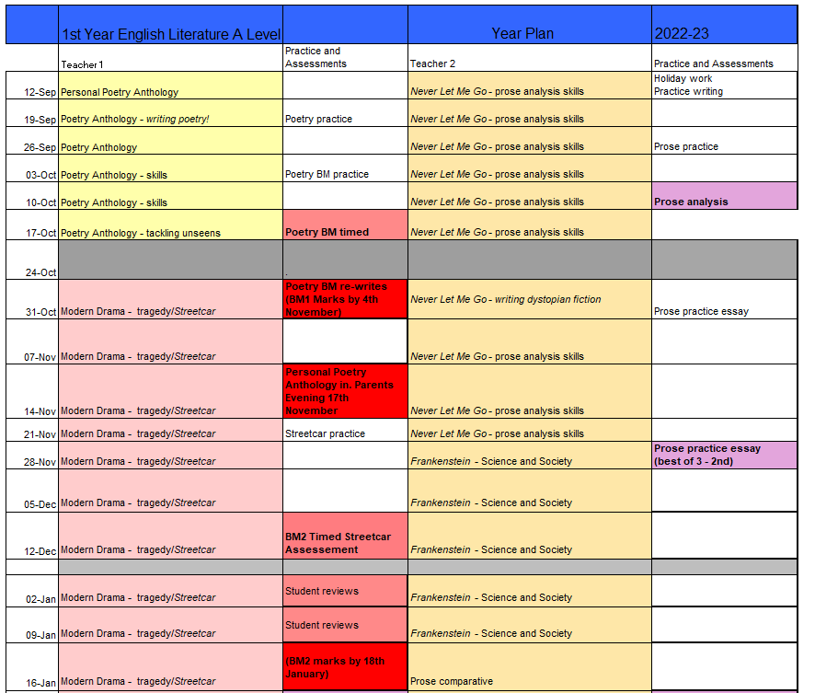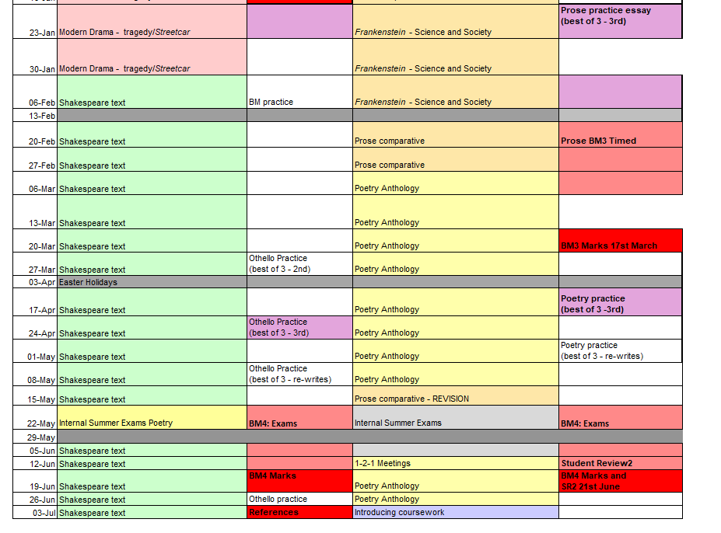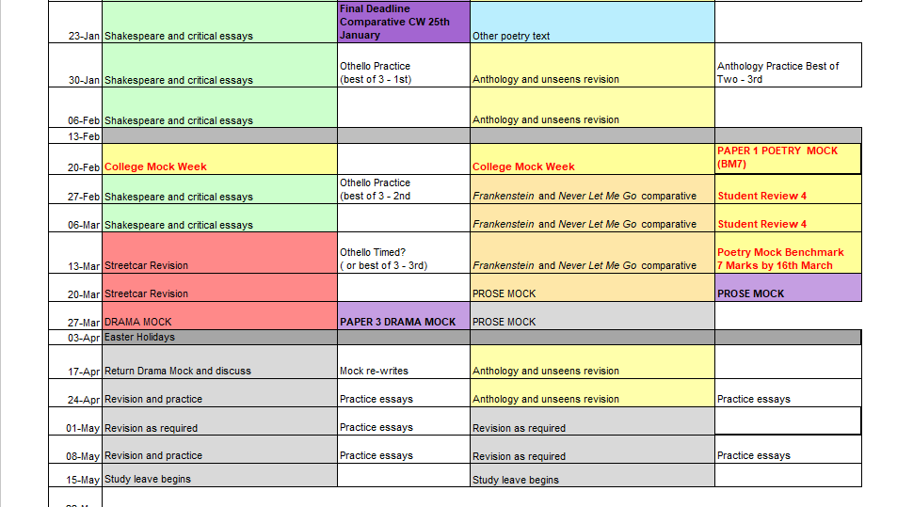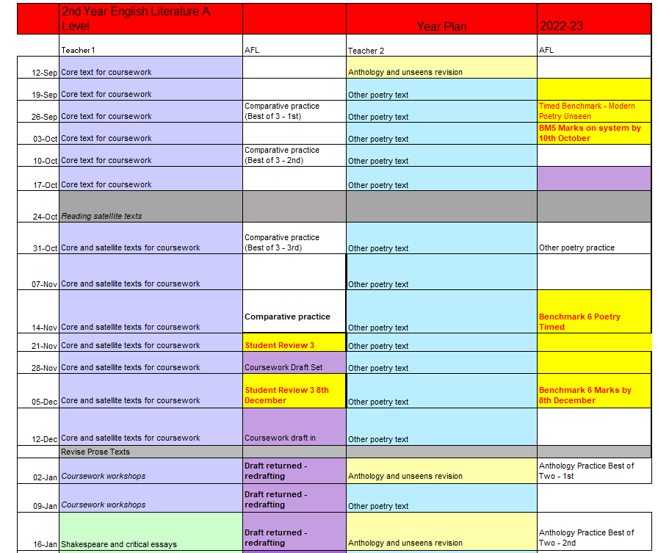

**Assessment**

When starting the course, it is important to know how the course is assessed. All assessed work is marked around what are known as **‘assessment objectives’** (AOs) which have been set by the exam board. You need to understand what each of these is and how many marks it carries for each type of question. If you can do this then you will know what skills to demonstrate and to what extent for each question on the exam. Please note that when scripts are marked, examiners do not use weightings for each AO. They will use skill levels, which often have a combination of AOs in each one.

|  |  |  |
| --- | --- | --- |
| **AO1** | Articulate informed, personal and creative responses to literary texts, using associated concepts and terminology, and coherent, accurate written expression | **26.7** |
| **AO2** | Analyse ways in which meanings are shaped in literary texts | **26.7** |
| **AO3** | Demonstrate understanding of the significance and influence of the contexts in which literary texts are written and received | **21.9** |
| **AO4** | Explore connections across literary texts | **14** |
| **AO5** | Explore literary texts informed by different interpretations | **11** |

***What do these mean?***

***AO1 -*** *Writing well-argued analytical essays, using appropriate literary terms*

***AO2 –*** *Analysing the craft of the writer. For novels this involves exploring how writers tell stories. For poetry it involves the analysis of poetic technique. For drama it involves the analysis of stagecraft.*

***AO3 –*** *Applying your knowledge of contexts to analytical points, drawn from the text itself, or from a knowledge of genres over time, or historical, cultural, biographical contexts*

***AO4 –*** *In three different areas of the course you need to be able to compare texts, using analysis of one text to shed light on the other and develop an argument in relation to an overarching question on a theme*

***AO5 –*** *Applying the writing of critics to texts to inform and develop your argument.*

A Level General EDEXCEL Mark Scheme for **Prose** Comparative question (*Frankenstein* and *Never Let Me Go*)

A Level Mark Schemes

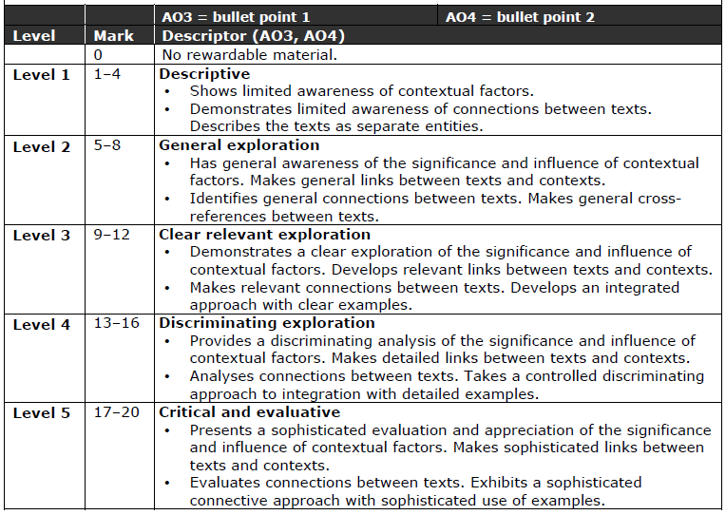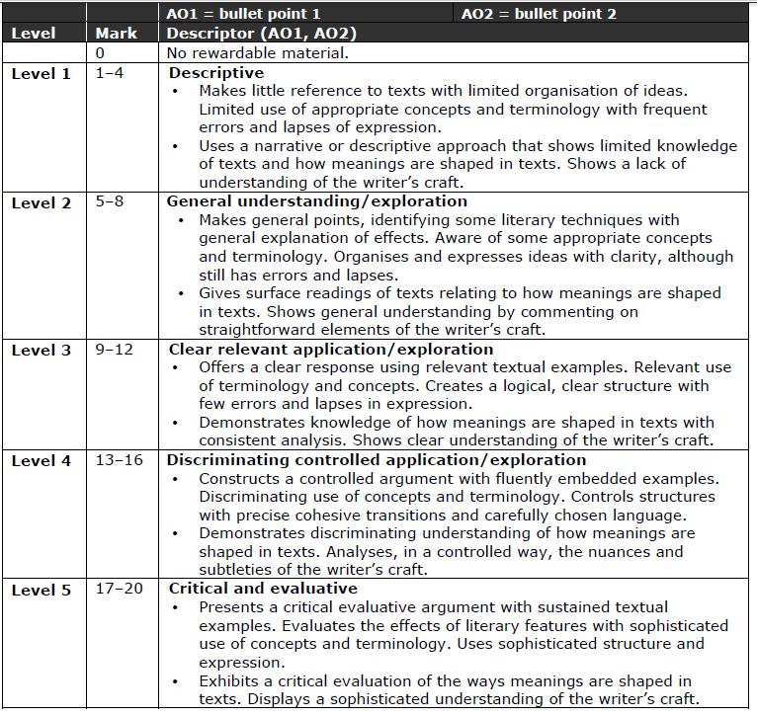

**Shakespeare** Generic Mark Scheme for A level (Edexcel)

**EnGlish**

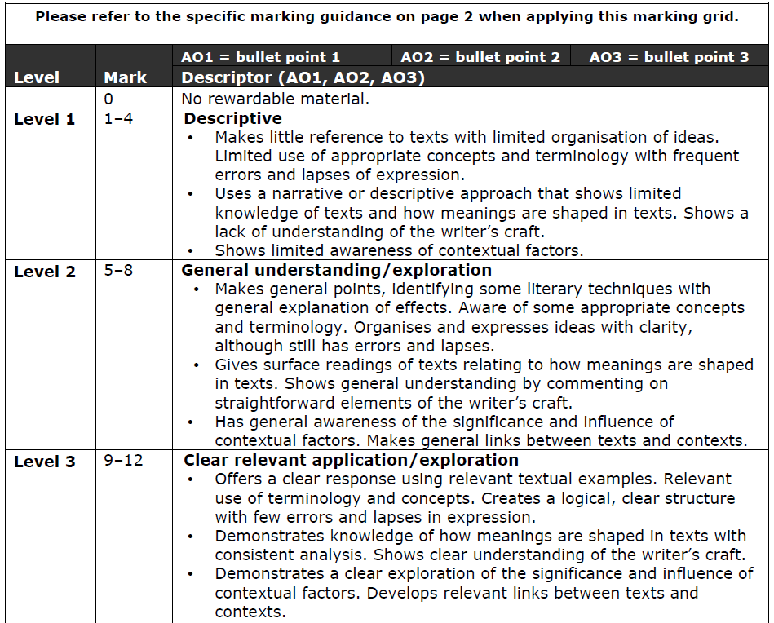

**EnGlish**

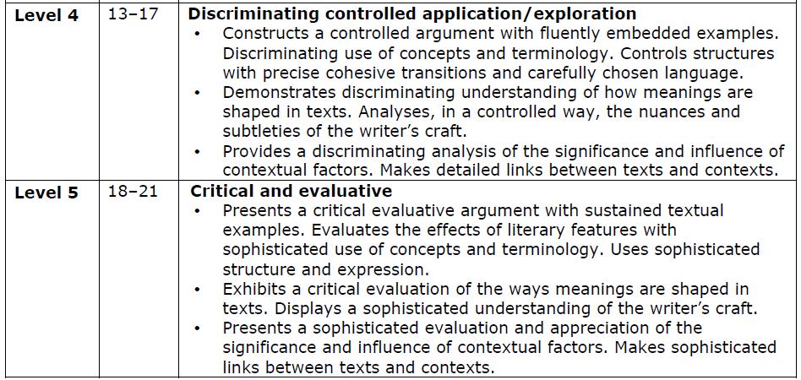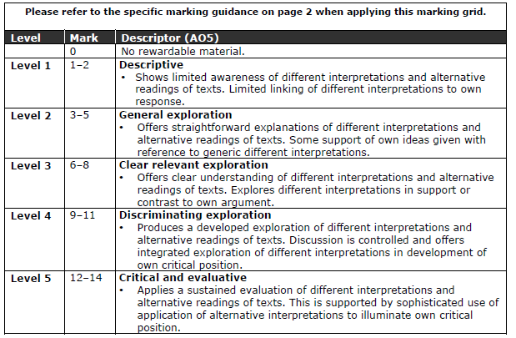

**Other Drama (*Streetcar*…)** Generic Mark Scheme for A level (Edexcel)

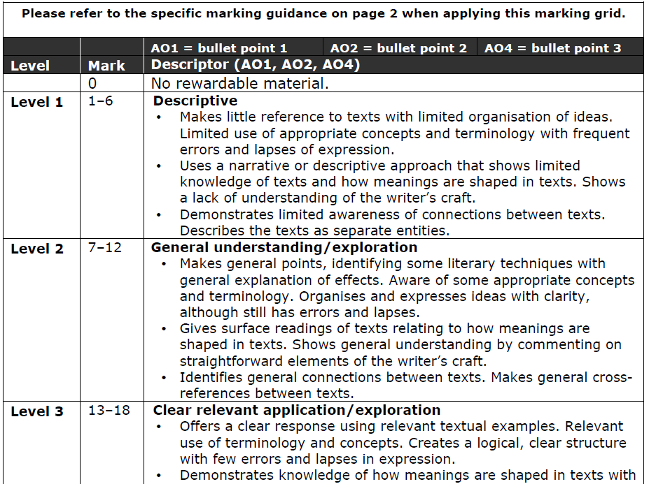**Poetry** – **Unseen/Forward Anthology** A Level English Literature General EDEXCEL Markcheme

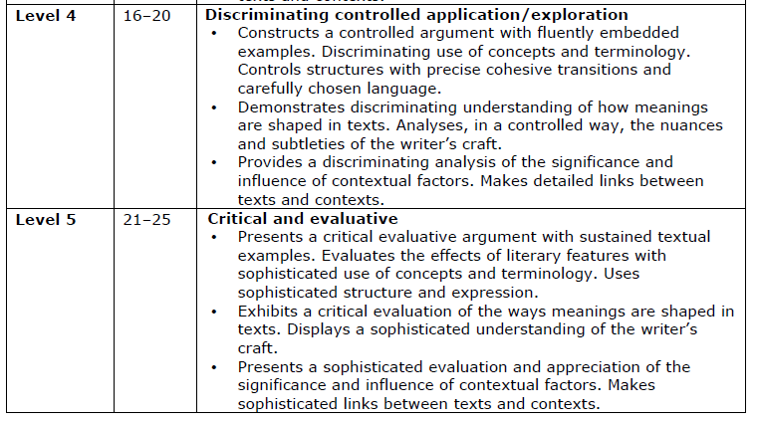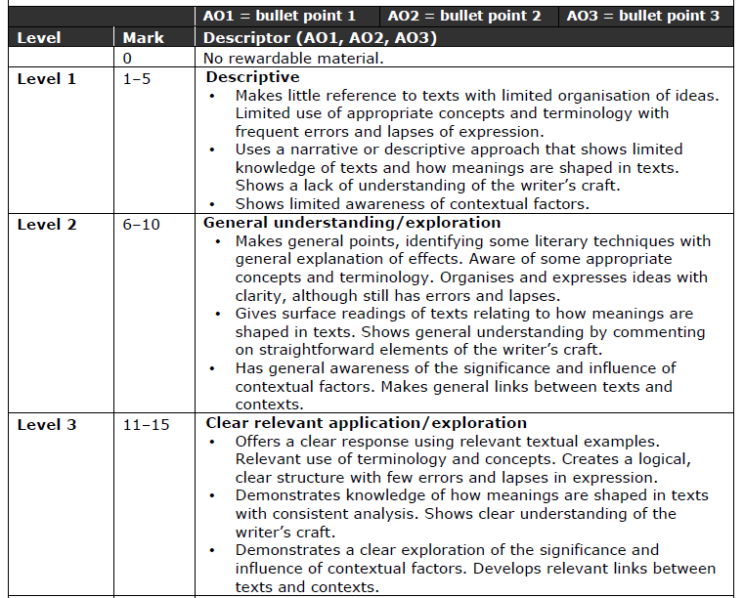

**EnGlish**

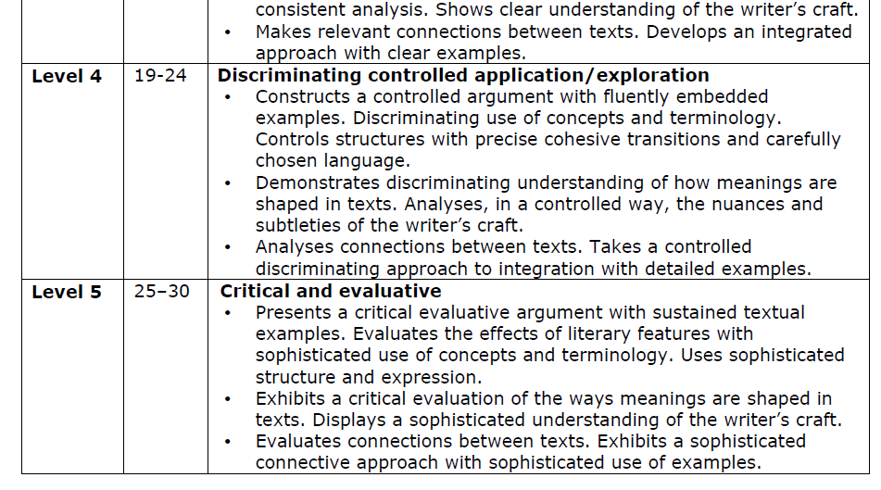

**EnGlish**

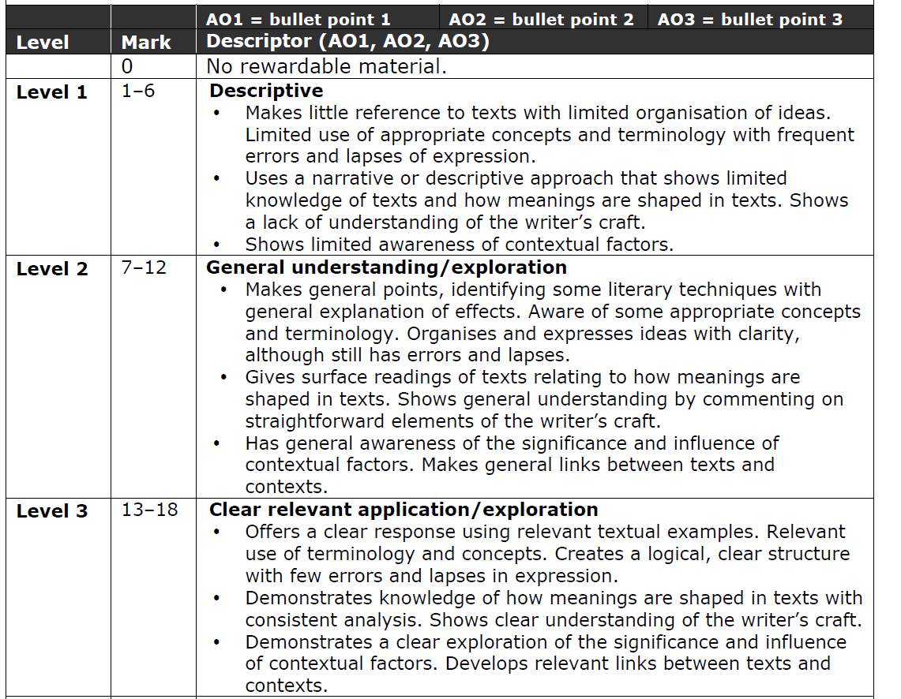**Poetry** – **Poet/Movement**  A Level English Literature General EDEXCEL Mark Scheme

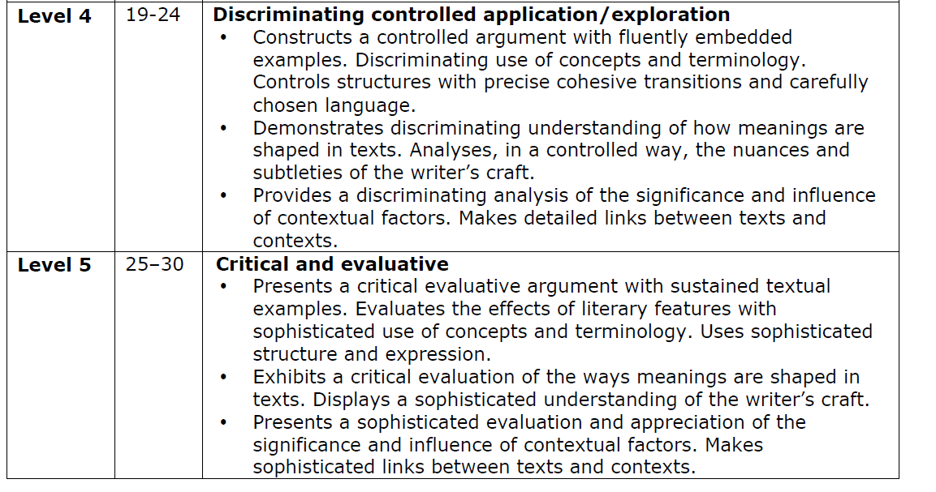

**Example Exam Paper**

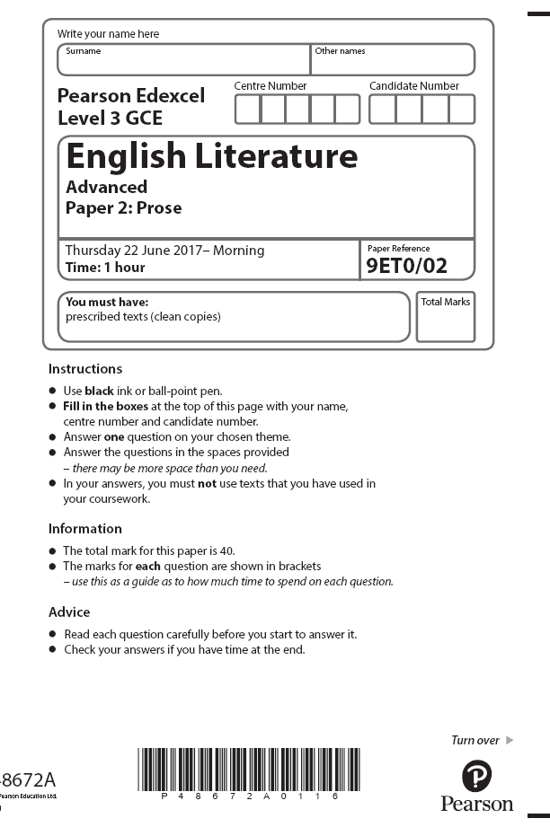

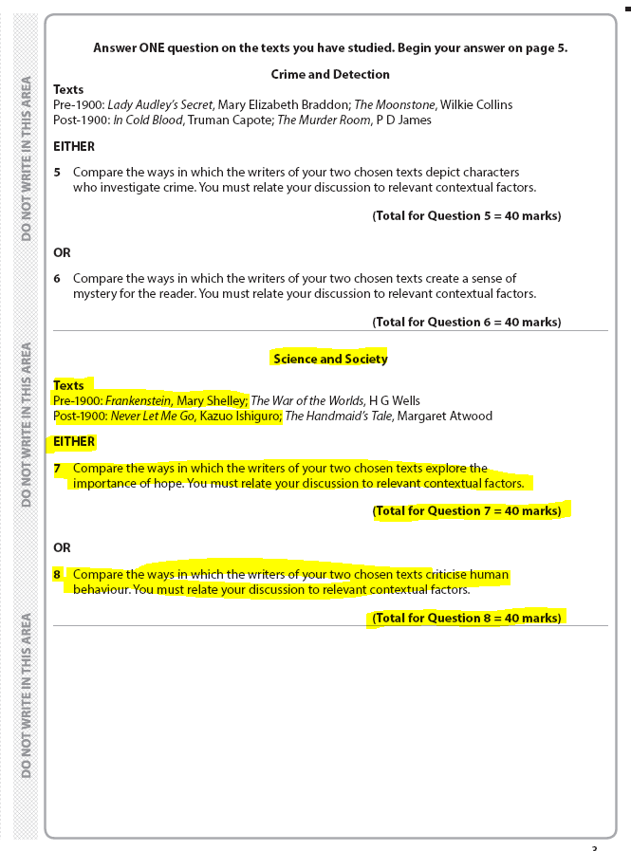

**English Department Assessment Policy 2022-2024**

**English Language, Language and Literature, and Literature A levels**

**The Importance of Feedback and Learning Outside the Classroom – ’50:50’ Mantra….**

Learning will not happen instantly and takes time; attending lessons is not enough (although important!). You also need to be working outside of class, to learn new information and consolidate learning. In the process, you will make mistakes, but hopefully feedback will enable you to learn from these mistakes. Better to make a mistake during the year and correct it, than make your first mistake in the final assessment! Feedback is essential for your learning and will consist of whole class (teacher runs a session in lessons), written (teacher marking), peer (where you feedback on someone else’s work in the class) and self (where you assess yourself) feedback.

There are 66 weeks of teaching weeks in total at College to help you learn and prepare for your final assessments. The classes are shared equally between two teachers for 2.25 hours, with each teacher delivering one of the two units; one of your tutors will be the “Lead Subject Tutor” who is likely to be the teacher responsible for seeing your parents at parents’ evening.

In line with the College’s ’50-50’ initiative, each week, homework will be set and could take between 4.5 to 6 hours in total. Each teacher therefore could set you up to 2.25 to 3 hours homework per week. If, for a particular week, a homework task from one teacher only takes you 1 hour for a week, then you will have a further 1.25 to 2 hours to conduct further reading and consolidate learning. These are just a few of the things we recommend that you do with that time:-

* Read a book! We give out reading lists at the end of Year 11 to nudge students into reading, but it shouldn’t stop when you get to college! For all courses, having a good novel or non-fiction text on the go will help you in many ways, not to mention giving you a potential text to use for coursework (in the case of English Literature in particular). For Language and Language and Literature, it is helpful to be reading newspaper columns, both in the paper and in published collections. A target of 500 words a day (one short article) as a minimum is a helpful starting point
* Using Godalming Online, where for your course there are masses of resources, including videos on the texts and topics you are studing. There are ‘walk-throughs’ of difficult texts and a new Grammar Course which will take you through many aspects of grammar that can then frame part of your analysis in your essays.
* Listen to Podcasts. There is an excellent list of these on our English Language Godalming Online page. For Literature and Lang/Lit we have links to fascinating radio content such as ‘In Our Time’

For many more ideas, please see the top of our Godalming Online page for your course at the section on ‘Wider Reading’.

**‘Practice Makes Perfect’**

**Our approach to developing good writing at A Level**

To do well in English at A level, a lot rests on your ability to write well. You need to be able to structure pieces of writing with a clear argument and you need to be able to develop a piece of analysis which has depth. As a department, we favour what Professor John Dunlosky (Kent State University, 2013) has called ‘high utility practice techniques’ – so, not just re-reading texts and improving your notes, but actually sitting down to write an answer to a question on a text or texts, every week.

**‘An Essay a Week’**

In your first you will get a homework schedule for the first term. We want you to get a decent amount of practice and we think this means that you need to write an essay a week.

What does ‘An Essay a Week’ mean?

1. Every week, you will get a question to answer, usually on a text or texts, although in some cases it could be non-analytical writing (journalistic, creative etc).
2. You should aim to write 500 words a week, but as a minimum the piece should consist of two paragraphs (including introduction where appropriate) and a detailed outline of the rest of the piece.
3. The ‘essay a week’ is addition to other homework tasks, making up 1-2 hours of your 4-5 hours of study out of lessons (2-2.5 per teacher).
4. The assignments will alternate between teachers, week by week
5. *One out of every three pieces*, on average, will be taken in and marked by your teacher. Try to think of this like practising a musical instrument or a sport before you take a grade or play a match. You don’t need a teacher to tell you how you’re doing all the time. Regular feedback, four or five times a term across both sides of the course, should be enough.
6. At certain points in the year, we will let *you* select the piece you would like us to mark. At other points you will write under timed conditions in class. In most cases, though, you will get a chance to build up to these timed pieces.
7. Sometimes we will ask you to ‘peer review’ other students’ pieces. This will not be a grading exercise. You will be getting out the coloured pens and picking out where the main assessment objectives are being met.
8. For all of these approaches, above, we may ask you to upload your responses (either a PDF of a handwritten essay, or a Word typed version) to ‘Godalming Online’, which is our college online virtual learning environment, or to Teams.

We will give you a single-side Year Plan for your course. All teachers in the department will be sticking to this as closely as we can.

**Benchmarks – preparing you gradually for the ‘real thing’**

The college uses the term ‘benchmark’ as a name for key pieces of work done four times in the first year and three times in the second year. The English department observes these, and you will be writing them under timed conditions. If we are operating remotely, you will get two days to complete them and a date and time by which you need to have uploaded your essay.

In the first year, we place more emphasis on ‘Benchmark 4’, which for us is an exam with at least two elements/essay questions, done under full exam conditions. All this goes ‘into the mix’ to help us to work out your Annual Review Grade and predicted grades for 2024.

In essence, we believe that you should have every opportunity during the year to show us what you can do, so all pieces that you do, including essays done at home, paragraphs that you might write in ‘workshop’ style lessons, coursework drafts and so on, *all* count as far as we are concerned.

**How We Mark Your Work**

We don’t issue any formal grading before half term in your first year. We will make sure, though, that you are well aware of examiners’ mark schemes. Just after half term in your first year, and earlier in your second year, we will start putting your work in a band or level on a mark scheme. You will know before you write the piece what the criteria for success are and the piece you hand in may be a ‘best of three’ which you have selected from three practice essays.

It is quite likely that you will not be higher than level 3 out of 5 (Literature) or level 4 out of 6 (Language and Language and Literature) for the first piece in the first year. We believe in being realistic about A level grading from near the start of the course. It is possible to find out, roughly, how a particular band result equates to grades, although we recommend you focus on the assessment criteria for the band and on how to get to the next band with your next piece of work. Obviously the higher you are the better!

**Building a Dialogue**

We are always experimenting with ways to keep the assessment process constructive and part of your learning process. So, when you get a piece of work to do at home, make sure you write an evaluation at the end, so that we can respond to it when we put our comment underneath. The evaluation should consist of a simple comment where you assess for yourself the extent to which you are understanding the assessment criteria, as well as reflecting on what you still need to work on.

When we hand work back, we ask that you write the key successes you achieved, as well as targets for improvement, up on to your Self page on Godalming Online. Your teacher will explain more about how to do this.

We like ‘peer review’ as an approach, where a peer will point out where they think you have met particular assessment objectives.

**Coursework**

We have coursework in all of our A level English courses, worth 20% of the overall marks. We are only allowed to give you one full draft of coursework. However, running up to the draft you can improve your chances of success by handing in a plan with a sample paragraph.

A full coursework policy is available on the course page for your A level on Godalming Online.

**The Final Assessment**

English Literature

At the end of the two years, students will complete three two hour exams worth 80% of their final grade and an NEA (Non-Examined Assessment worth 20%.

|  |  |  |  |
| --- | --- | --- | --- |
| **Exam 1 – Drama** | **Exam 2 - Prose** | **Exam 3 – Poetry** | **Coursework (NEA)** |
| * **Section A:** modern drama (25 marks) * **Section B:** Shakespeare, incoporating ideas from wider critical reading (35 marks) | * **One section only:** comparative essay on two novels on a studied theme (40 marks) | * **Section A:** unseen poem compared with studied contemporary poem (30 marks) | * A single 3000 word analytical comparative essay on two texts chosen by the student |

**N.B. All essays in the exam should be of a similar length, between 3 and 5 sides of A4. The higher marks reflect the complexity of the task**

Note: all examinations are **open book.**

**Tracking your Progress: Student Reviews, Action Plans and Parents’ Evenings**

The College’s policy is to deal with the student first, but we also report to your parents at regular intervals to let them know how you are progressing and to inform them of what our expectations are through four Student Reviews (Reports) spread throughout the two years at College and also four parents evenings. If the department feel you are under-performing based on evidence such as benchmark grades and your approach to learning in between these periods, then your Lead Subject Tutor may place you onto an Action Plan and we will write to your parents after a 1-2-1 with you, to try and get you back on track in a supportive way.

**Student Review 2, the ARG and Predicted Grades**

At the end of the first year (June 2024), your Lead Tutor will have a 1-2-1 to discuss your Annual Review Grade (ARG) and also finalise your predicted grade which might be used for UCAS applications for University and other destinations.

The ARG is determined by your Lead Tutor, in communication with your other teacher and will rely on the following evidence:

1. **Benchmark Checkpoints Performance Grades (1 to 4).** Benchmark 3 and 4 grading will carry more weight to this grade but Benchmark 2 will also have some influence. Benchmark 1 will have a very little weighting as it was the first time you sat a timed assessment.
2. **Approach to Learning.** This is a measurement of how you are engaging in your learning, evidenced by attendance, punctuality, ability to meet weekly deadlines with quality work; we also consider how you have actively sought out extra support via workshops and your overall communication with your teachers (perhaps via email/Teams chat?).

The ARG plays a key part in determining the context in which you progress to the second year. Students who receive an A*-D grade (A-level) are encouraged to continue with their studies into the 2nd year. However, for students who receive a U or E Grade (A-level) as their ARG, it suggests that for whatever reason they have struggled with the transition from Level 2 Courses (GCSE) to Level 3 Courses (A-level/BTEC). This will be evidenced by poor performances throughout their benchmarks and an inconsistent or poor approach to learning in their student reviews and via formal Action Plans. Students who receive an E/U Grade we would be extremely worried about your progress and your ability to pass the course. A comprehensive action plan would be created and we would expect to see improvements over the summer with the work that was set. You would also be required to attend lunchtime workshops for the remainder of the course and we would be in more contact with your parents to ensure that you are staying on track.

The College adopts a consistent and optimistic approach to predicting grades to ensure that they are both aspirational and achievable. A predicted grade is what we believe a student is likely to achieve by the conclusion of their course in positive circumstances and the predicted grade provides universities and colleges with some understanding of a student’s academic potential alongside their Personal Statement and a written Reference from their Personal Tutor. The ARG is important in forming the basis for the predicted grade as well but the predicted grade will also be aspirational for the students’ ambitions although it must remain realistic and cannot be based on the idea that only now will the student start to work harder in the second year! The College policy is that the predicted grade cannot be more than one grade above the ARG.

**Other Considerations**

* *LATE POLICY:* In line with the ‘College Assessment Policy’, the department are under no obligation to provide feedback to a student who does not meet the internal deadlines for weekly independent tasks, benchmark assessments or coursework drafts. Please be warned that a failure to meet the final coursework deadline is the equivalent to missing the exam and it will be recommended that the student should be removed from the course which may mean you have to leave College entirely. Students who fail to prepare adequately for the lesson as requested, maybe excluded for part of the lesson and asked to work independently at the back of the classroom. A failure to meet ‘PREP’ work requirements consistently will result in a reference to the pastoral team and a phone call home to parents.
* *RETURNED WORK:* Work will be assessed and, except at times of exceptionally intense marking loads, such as during mock exam periods, returned within 10 working days of it being submitted, unless it is the final coursework submission. The exam board stipulates that no feedback or formal grade can be released to students by the teacher with regards to coursework. We will issue you with the coursework mark but the exam board reserve the right to inform you of the final grade in August with your results. Please do not ask the teacher for your final grade as they will be unable to provide it.
* *PLAGIARISIM:*  Plagiarism is submitting another person’s written work as one’s own original work or using someone else’s idea without referencing the source or using pictorial work without permission or referencing the source. If there is a suspicion of plagiarism, the Head of Department and Senior Tutor will be informed and a meeting will take place. If a student is found guilty, they will be subject to disciplinary action by the College and the awarding body will be informed. Students should be aware that the College is subscribed to software designed to detect plagiarism.
* *ACCESS ARRANGEMENTS FOR EXAMS:* These are pre-examination adjustments for candidates based on evidence of need and normal way of working which must approved by the Learning Support department. For example, use of a computer or extra time in the exam. Since these arrangements are your ‘normal way of working’, you must practice them in class and with your homeworks – please see the Learning Support department for how you might do this. Homework is always set to take between 4.5 to 6 hours to allow students who have extra time for example, more time to complete the homework compared to their peers. Equally, in timed assessments it is vital that we are accommodating any access arrangements you might have. Your teachers will speak to you individually, and in confidence about how they will best be able to support you through your studies with us.

**Benchmark Checkpoints, Student Reviews (Reports) and Mock Exams 2022-4**

Below is an overview of all the key assessment checkpoints

English Literature

|  |  |  |
| --- | --- | --- |
| **CHECKPOINT** | **DATE** | **DETAILS** |
| **Benchmark 1 Checkpoint** | Oct 2022 | **11/4**  **hour timed poetry comparison essay, comparing an unseen poem with a studied poem.**  **30 Marks (this essay will be ‘scaffolded’)** |
| **Parents Evening (For All)** | Nov 2022 | **Meetings with your parents to discuss how you have settled in and transferred from GCSE to A-level learning based upon:**   1. **Approach to learning** (how you are engaging in your learning, evidenced by attendance, punctuality, ability to meet weekly deadlines with quality work, how you have sought out extra support via workshops and your overall communication with your teachers) 2. **Performance Grade** in Benchmark 1 and from your homework tasks |
| **XMAS BREAK** |  |  |
| **Benchmark 2 Checkpoint** | Dec 2022 | **1**  **hour timed essay on the play *A Streetcar Named Desire***  **25 marks** |
| **Student Review 1** | Jan 2023 | **A review of your progress in the first term (12-13 weeks of teaching) after a 1-2-1 with your Lead Tutor:**   1. **Performance grade (A to U)** (based on benchmark 1 and 2 but also your homework tasks) 2. **Approach to Learning** (how you are engaging in your learning, evidenced by attendance, punctuality, ability to meet weekly deadlines with quality work, how you have sought out extra support via workshops and your overall communication with your teachers). |
| **Parents Evening (Targeted)** | Mar 2023 | **Meetings with your parents primarily where teachers may have a concern about your progress since Student Review 1 in January.** |
| **EASTER BREAK** |  |  |
| **Benchmark 3 Checkpoint** | Mar  2023 | **11/4 hour timed essaycomparing two prose texts** |
| **Benchmark 4 Checkpoint** | July 2023 | **Summer Exams – a one and a quarter hour poetry paper and a 1 and a quarter hour prose paper. (Remote in 2023)** |
| **Student Review 2** | July 2023 | **A review of your progress for the academic year (30-35 weeks of teaching) after a 1-2-1 with your Lead Tutor**   1. Approach to Learning 2. Performance Grade (Annual Review Grade or ‘ARG’ – performance for whole year (see notes above in main doc.) 3. Predicted Grade |
| **SUMMER BREAK** |  |  |
| **Benchmark 5 Checkpoint** | Oct 2024 | **Timed essay on an unseen poem compared with a poem from the studied anthology *The Forward Book of Modern Poetry.* 1 and quarter hours, in class.** |
| **Parents Evening (All)** | Oct 2024 | **Meetings with your parents to discuss how you have settled in to the second phase of learning:**   1. **Approach to learning** (how you have engaged since Student Review 2 including completion of summer homework and the first five weeks of teaching – deadlines met, engagement in class and communication with teacher) 2. **Performance**with reference to your draft coursework mark and to talk about the final deadline for after half-term. 3. **How to support you:**Discuss how parents can further support you and what is coming up in this year |
| **Benchmark 6 Checkpoint** | Nov 2024 | **One hour poetry essay, in response to poetry text studied in second year (e.g. *English Romantic Verse*)** |
| **Student Review 3** | Dec 2024 | **A review of your progress for the academic year since last Student Review (July) after a 1-2-1 with your Lead Tutor**   1. Approach to Learning 2. Performance Grade (based upon benchmark 6 and homework tasks) compared to Predicted Grade |
| **XMAS BREAK** |  |  |
| **Benchmark 7 Checkpoint** | Mar 2024 | **2 and a half hour poetry exam where you write about the modern poetry and the classic poetry text.** |
| **Student Review 4** | Mar 2024 | **A review of your progress for the academic year (30-35 weeks of teaching) after a 1-2-1 with your Lead Tutor (see above)**   1. Approach to Learning 2. Performance Grade (based upon benchmark 7 Mock Exam only) compared to Predicted Grade |
| **Parents Evening (Targeted)** | Apr 2024 | **Meetings with your parents primarily where teachers may have a concern about your progress since Student Review 4.** |
| **EASTER BREAK** |  |  |

**Rationale for Assessment Programme**

We are not obsessed with assessment! We know that students who have developed the skills of unpicking the nuances of texts do best in English. However, since all three English A levels are predominantly assessed under examination timed conditions, we have a responsibility to ensure that you can show these skills in that setting. As detailed above, the key to this is practice.

Therefore, the first few benchmarks will have more in the way of scaffolding to support your answers and then we will gradually remove that support over time. The first experience of assessment that might feel close to the real thing is Benchmark 4, which takes place in the summer of your first year. This is not a be-all-and-end-all assessment. If you have shown us a high degree of skill earlier in the year we will use that to inform our judgements about your ARG and your predicted grade.

**Grade Boundaries**

We do not place stress on grades in the English department, except in the formation of the predicted grade at the end of the first year. We use the examination boards marking grids (see course booklet for each course) when we mark your work and will place your essay or answer at a band or level where the descriptors in the band match the quality of the work you have produced. We use our knowledge of essays that have been placed at a particular level in the past to determine where to place your answer. No grade is put on the work. We think that this is important, because it is the skills, not the number or the grade, that determine your final level of achievement in the subject. Instead you will receive a copy of the mark grid with an indication on there of the skills you have reached and the ones you still need to aim for.

That said, we will give an indication of grade boundaries when asked. When you do a benchmark, we enter a number that corresponds to the place on the grid that you have achieved and that will automatically generate a grade. Students are never left in the dark about where they are and what they need to do to get into a different band.