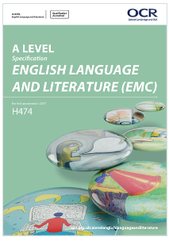****

**NAME:**

Course Code: H474

English Language and Literature

A-Level (OCR/EMC)

**Course Handbook**

**Introduction to the department**

Welcome to English Language and Literature A level. We hope that you enjoy your time in the department and find the process of studying the course a challenging and rewarding one.

The purpose if this guide is to provide you with a range of information and advice to help you organise your programme of study, learn independently, and equip you with important information about the department and how it can support you.

Teaching is carried out in a purpose-built modern building, opened in 2016, by a team of highly-qualified staff, passionate about the subject. There are four full-time and five part-time, two holding PhDs in English and a number of them examiners, exam authors, and writers of professionally-produced materials for A level English teachers. One member of the team has a two-book fiction deal with Headline Press and supports creative writing EPQs in the department. We see ourselves as a forward-looking department in terms of teaching and learning, always trying new ways to deliver our courses in a manner which embraces the demands of a two year A level, but also fosters creative thinking and a genuine enjoyment of studying English for its own sake, above and beyond getting successful outcomes.

**Teaching Staff:**

* **Jacqui Dearden, David Deeming, Juliet Harrison**

**Head of Department:**

* **David Kinder**

**Director of Faculty:**

* **Mark Woodward**

Along with the names above, the following departments and places will be useful whilst studying on the course:

**The ILC** – your go-to place to complete work and independent study outside of lessons. The Silent Study area provides an area to work individually, whilst the library contains an excellent selection of wider reading. Make sure that you have familiarised yourself with the ILC when you start the course

**The Exams Office** – for any questions you have about your exam entries, exam timetable or remarks and script requests.

**Learning Support** – for any extra support or advice you need to help you study in general. If you are struggling to organise and manage your workload; need help refining your essay-writing technique; help with revision; or if you think you might be entitled to any exam concessions, learning support are the people to talk to.

**Careers** – when you start to think about your options after college, whether university or employment based, careers can give you advice on where to apply and help in producing a personal statement.

**ExpecTations**

**What is expected of students?**

1. **Attendance and punctuality** – learning cannot begin if you are not in lessons or if you arrive late to them and miss important content. Students should maintain full attendance and punctuality. Any unavoidable and legitimate absences should be accounted for properly, meaning that students get a parent or a guardian to contact college and then email their teacher(s) to catch up on missed work
2. **To maintain a mature and respectful learning environment** – this means behaving in and out of lessons in a way expected of a Sixth-Form student: listening carefully to the views of others and offering constructive contributions in class
3. **To stay up-to-date** – you will be set weekly structured preparation or homework tasks and it is essential that these are completed on time and in the required level of detail. We use structured homework to consolidate particular content or to set up lessons to come. If work is incomplete your understanding will be incomplete and you will under-perform. If you arrive at a lesson having not completed preparation work then your teacher may also ask you to leave and complete this elsewhere.
4. **To stay organised** – managing the demands of a minimum of three subjects is challenging, especially when you are being taught more than one unit in each. You need, therefore, to stay organised. This means preparing a folder for each of your units, bringing the correct materials to each lesson and recording homework in the same place every time
5. **To meet the 50/50** – students are expected to conduct 4.5 to 6 hours of independent study a week. This will include structured preparation or homework tasks set by your teachers along with proactive tasks you complete yourself to consolidate and extend your understanding. See the advice later in this booklet for more help on doing this.
6. **To make the most of feedback and support** – you will get a lot of feedback during your time on the course. This will come as written feedback on assessed work, verbal feedback on general class or homework, and targets set at formal 1-1s. Feedback needs to be recorded carefully by you and acted upon. When you get back assessed work, for example you will be asked to record your own targets based on this, and may, in addition, be asked to attend a lunchtime workshop to help process feedback.
7. **To be resilient** – any subject will at times be very challenging. At times you will not do as well as you want or will struggle to understand a new topic or idea. You need to be prepared to spend more time on areas such as these and to seek out extra help when needed. These experiences of finding areas where you are not doing so well and improving them are what lead to success.

**What can you expect of your teachers?**

1. **To deliver structured and engaging lessons** – your teachers will deliver lessons designed to challenge your understanding whilst also helping you to gradually build up your knowledge and skills. These lessons will follow the scheme of work, a version of which you can see in this handbook.
2. **Regular assessment and feedback** – in addition to your benchmark assessments (four in the first year and three in the second) your teachers will regularly set you exam-style questions to give you opportunities to practice and improve. Feedback will be given on standardised sheets which include the relevant mark scheme and clear developmental targets
3. **Structured weekly work** – you should expect to be given a significant amount of work to do by your teachers each week. You will be given guidance on how long this should take and completed work will be checked and/or taken in
4. **Additional support** – your teachers will be happy to provide extra help outside of lessons either informally, by responding to emails, or more formally through departmental workshops. Workshops are the best opportunity to received additional help and work best when students come to lunchtime sessions with a specific area of confusion or set of questions to get answered

**Course Overview**

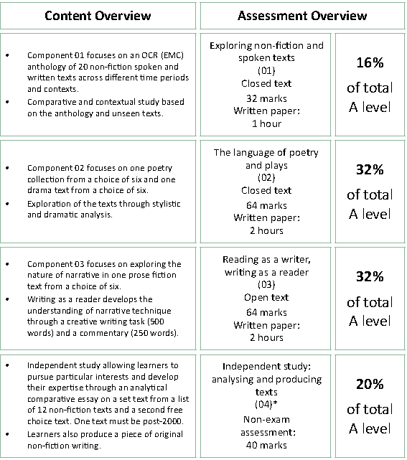

**The Exams**

At the end of your second year you will take three exams in:

**Exam 1: ‘Exploring non-fiction and spoken texts’ (1 hour / 32 marks / 16%)**

* **One question**

**Exam 2: ‘The language of poetry and plays’ (2 hours / 64 marks / 32%)**

* **Section A:** The poetry of William Blake – 1 hour (32 marks)
* **Section B:** *Jerusalem* by Jez Butterworth – 1 hour (32 marks)

**Exam 3: (2 hours / 64 marks / 32%)**

* **Section A:** Reading as a writer – 1 hour (32 marks)
* **Section B:** Writing as a reader- 1 hour (32 marks)

+ **A coursework folder** comprised of (i) a comparative analysis of Jeanette Winterson’s autobiography *Why Be Happy When You Could Be Normal* with a novel (24 marks) and (ii) a piece of your own non-fiction writing (16 marks) Total = 40 marks **(20%)**.

**Student scheme of work**

Below is a summary of how you will be taught the different units of the course and how this fits into the approximately 66 weeks of teaching time over the two years of your A-Level. You will also see the key assessment points given below. It is important that you know when these are so that you can organise your revision and preparation. An important idea to understand when looking at this student scheme of work, is that the course flows consistently over two years. The topics you study at the start of your first year are as ‘difficult’ as those you will look at the end of your second year. You need to treat all work in the same way and apply yourself fully throughout. Also consider that the May half term in the first year is, in reality, the mid-point of the course not the summer holiday. This time will go quickly so make sure you understand the structure of the course fully and get any help when it is needed.

[Please note that if a piece of assessment is in an unshaded box, it is a guide only to the work you should be doing. It may or may not be set by the teacher.]

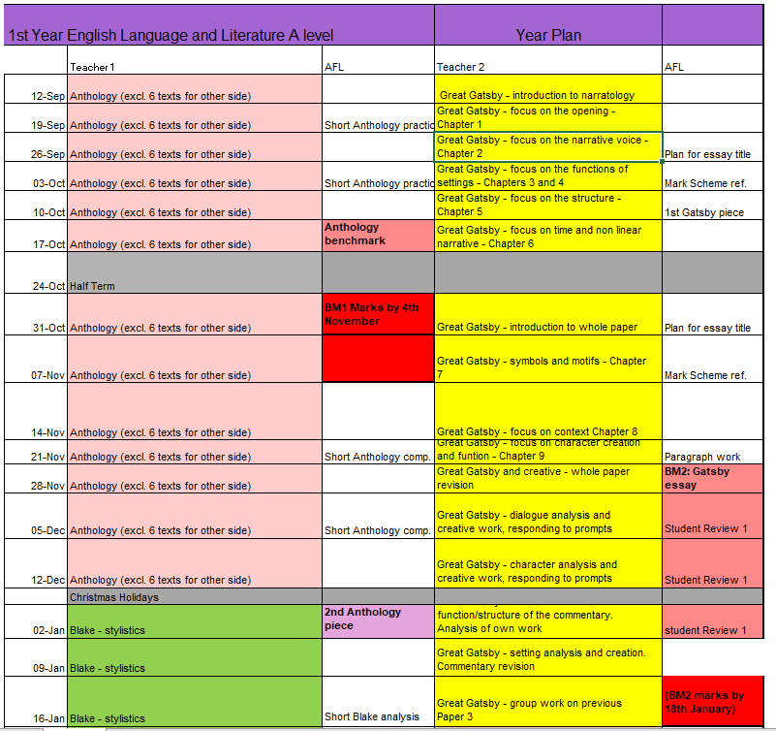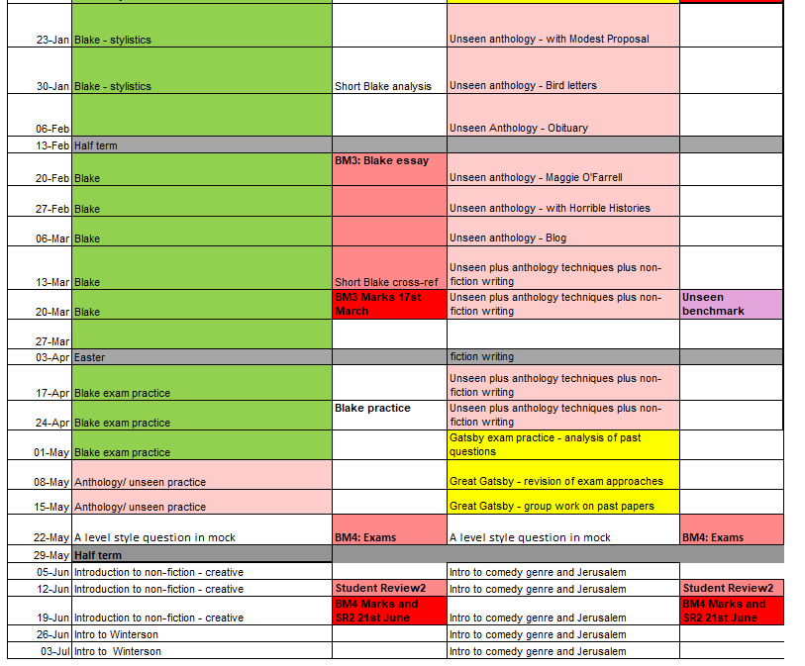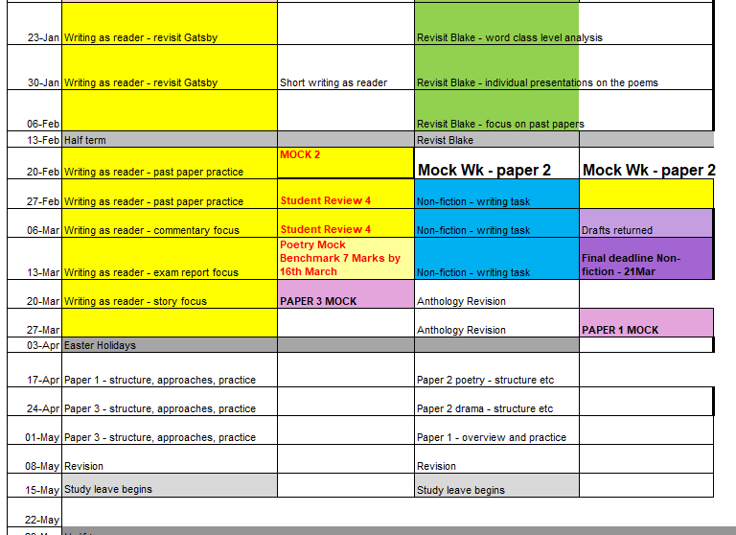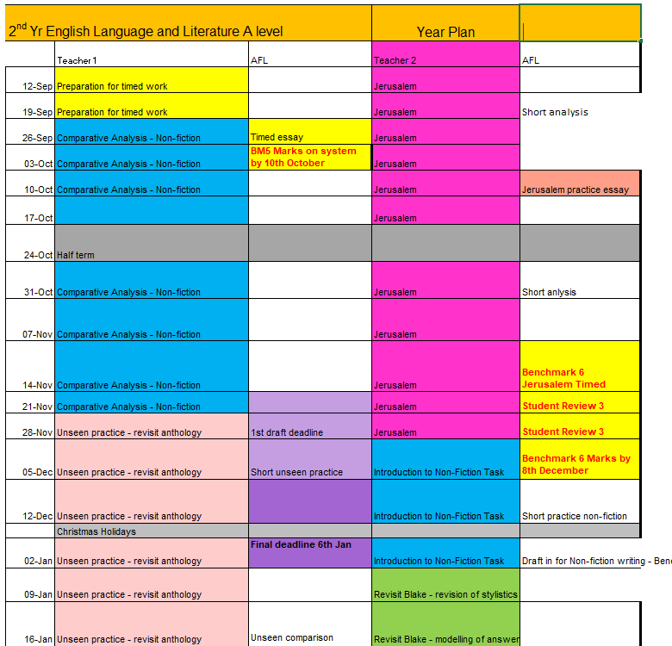

**Assessment**

When starting the course, it is important to know how the course is assessed. All assessed work is marked around what are known as **‘assessment objectives’** (AOs) which have been set by the exam board. You need to understand what each of these is and how many marks it carries for each type of question. If you can do this then you will know what skills to demonstrate and to what extent for each question on the exam.

|  |  |  |  |
| --- | --- | --- | --- |
| **AO1** | |  | | --- | | Apply concepts and methods from integrated linguistic and literary study as  appropriate, using associated terminology and coherent written expression. | | **25%** |
| **AO2** | Analyse ways in which meanings are shaped in texts. | **30%** |
| **AO3** | Demonstrate understanding of the significance and influence of the contexts in which texts are produced and received. | **20%** |
| **AO4** | Explore connections across texts, informed by linguistic and literary concepts and methods. | **12%** |
| **AO5** | Demonstrate expertise and creativity in the use of English to communicate in different ways. | **13%** |

***What do these mean?***

***AO1 –*** you can present you work in a clear, organised and coherent way, using technical terminology appropriately and accurately and making sure your points of analysis are properly exemplified.

***AO2 –*** you understand why a writer is choosing to use a particular technique (connected with, for example, language choice, formal technique such as poetic technique or the way a text is structured) and say how the choice of these techniques increases the effectiveness of what the writer is trying to say.

***AO3 –*** you can make effective links between your linguistic and literary analysis of texts and the contexts in which those texts are produced (for example to do with genre, purpose, audience, mode, social and historical factors). These contextual points help to add to our overall understanding.

***AO4 –*** you are able to structure work effectively so as to produce a productive comparison between texts, when required by the question to do so.

***AO5 –*** you are able to take your knowledge of the styles and techniques used by writers in producing different texts and integrate this knowledge into the produ

**A-Level Mark schemes**

|  |
| --- |
| **Paper 1** |
|  |
|  |
| **Paper 2: Section A** |
| **Paper 2: Section b**          **Paper 3: section A**      **Paper 3: section b (narrative Writing)** |
|  |
| **paper3: section B (commentary)** |
|  |
|  |
| **Coursework**  **analytical and comparative writing**      **Coursework**  **analytical and comparative writing** |

**Example Exam Paper**

|  |  |
| --- | --- |
|  |  |
|  |  |
|  |  |
|  |  |
|  |  |
|  |  |

**Department Assessment Policy 2022-24**

Updated May 2020 for Covid-19 Situation

**The Importance of Feedback and Learning Outside the Classroom – ’50:50’**

Learning will not happen instantly and takes time; attending lessons is not enough, you also need to be working outside of class, to learn new information and consolidate learning.  In the process, you will make mistakes but hopefully feedback will enable you to learn from these mistakes.  Better to make a mistake during the year and correct it, than make your first mistake in the final exam!   Feedback is essential for your learning and will consist of whole class (teacher runs a session in lessons), written (teacher marking), peer (where you feedback on someone else’s work in the class) and self (where you assess yourself).

There are 66 weeks of teaching weeks in total at College to help you learn and prepare for your final assessments.  The classes are shared equally between two teachers for 2.25 hours, with each teacher delivering one of the two units; one of your tutors will be the Lead Subject Tutor who will be responsible for formalised 1-2-1s, writing your Student Reviews, seeing your parents at parents evening and for writing Action Plans.

In line with the College’s ’50-50’ initiative, each week, homework will be set and could take between 4.5 to 6 hours in total.  Each teacher therefore could set you up to 2.25 to 3 hours homework per week.  If a homework from one teacher only takes you 1 hour for a week, then you will have a further 1.25 to 2 hours to conduct further reading and consolidate learning.

**The Final Assessment**

At the end of the two years, students will complete three two hour exams worth 80% of their final grade and an NEA (Non-Examined Assessment worth 20%.

|  |  |  |  |
| --- | --- | --- | --- |
| Exam 1 – Exploring non-fiction and spoken texts | Exam 2 – The language of poetry and plays | Exam 3 – Reading as writer, writing as reader | Coursework (NEA) |
| * One section only: question in response to studied text and an unseen text | * Section A: the poetry of William Blake * Section B: *Jerusalem* by Jez Butterworth | * Section A: Reading as writer, on *The Great Gatsby* * Section B: Writing as reader | * A comparative essay * A piece of non-fiction writing, plus short commentary |

**NB All essays on texts are of a similar length, between 3 and 5 sides. The main source poems or extracts for each question are printed on the paper. Students are required to analyse these closely but need to be able to refer to the rest of the text from memory in Exam 2. Exam 3 is open book.**

**‘Practice Makes Perfect’**

**Our approach to developing good writing at A Level**

To do well in English at A level, a lot rests on your ability to write well. You need to be able to structure pieces of writing with a clear argument and you need to be able to develop a piece of analysis which has depth. As a department, we favour what Professor John Dunlosky (Kent State University, 2013) has called ‘high utility practice techniques’ – so, not just re-reading texts and improving your notes, but actually sitting down to write an answer to a question on a text or texts, every week.

**‘An Essay a Week’**

The scheme of work, also known to us as the Year Plan, is *a guide* (specific non-benchmark tasks will vary from teacher to teacher), indicates the basic intention of the department. We want you to get a decent amount of practice and we think this means that you need to write an essay a week.

What does ‘An Essay a Week’ mean?

1. Once you are in a position to be able to answer them (after the first half term) you will have a supply of questions to answer, on a text or texts
2. You should aim to write 500 words a week, but as a minimum the piece should consist of two paragraphs (including introduction where appropriate) and a detailed outline of the rest of the piece.
3. The ‘essay a week’ is addition to other homework tasks, making up 1-2 hours of your 4-5 hours of study out of lessons (2-2.5 per teacher).
4. The assignments will alternate between teachers, week by week
5. *One out of every three pieces*, on average, will be taken in and marked by your teacher. Try to think of this like practising a musical instrument or a sport before you take a grade or play a match. You don’t need a teacher to tell you how you’re doing all the time. Regular feedback, four or five times a term across both sides of the course, should be enough.
6. At certain points in the year, we will let *you* select the piece you would like us to mark. At other points you will write under timed conditions in class. In most cases, though, you will get a chance to build up to these timed pieces.
7. Sometimes we will ask you to ‘peer review’ other students’ pieces. This will not be a grading exercise. You will be getting out the coloured pens and picking out where the main assessment objectives are being met.

**Benchmarks – preparing you gradually for the ‘real thing’**

The college uses the term ‘benchmark’ as a name for key pieces of work done four times in the first year and three times in the second year. The English department observes these, and you will be writing them under timed conditions. However, in the first year, we place more emphasis on ‘Benchmark 4’, which for us is an exam with at least three elements/essay questions, done as far we can under full exam conditions.

That is not all we do, however. We believe that you should have every opportunity during the year to show us what you can do, so all pieces that you do, including essays done at home, paragraphs that you might write in ‘workshop’ style lessons, coursework drafts and so on, *all* count as far as we are concerned.

**How We Mark Your Work**

You will not receive any formal grading before half term in your first year. You will, however, be well aware of examiners’ mark schemes. Just after half term in your first year, and earlier in your second year, we will start putting your work in a band or level on a mark scheme. You will know before you write the piece what the criteria for success are and the piece you hand in may be a ‘best of three’ which you have selected from three practice essays.

It is quite likely that you will not be higher than level 3 out of 5 (Literature) for the first piece in the first year. We believe in being realistic about A level grading from near the start of the course. It is possible to find out, roughly, how a particular band result equates to grades, although we recommend you focus on the assessment criteria for the band and on how to get to the next band with your next piece of work. Obviously the higher you are the better!

It should be noted that Benchmark 5, at the beginning of the second year, is used more as ‘getting to know you on paper’, and has less impact on the way we gauge the quality of your work.

**Building a Dialogue**

We are always experimenting with ways to keep the assessment process constructive and part of your learning process. So, when you get a piece of work to do at home, make sure you write an evaluation at the end, so that we can respond to it when we put our comment underneath. The evaluation should consist of a simple comment where you assess for yourself the extent to which you are understanding the assessment criteria, as well as reflecting on what you still need to work on.

When we hand work back, we ask that you write the key successes you achieved, as well as targets for improvement, up on to your Self page on Godalming Online. Your teacher will explain more about how to do this.

We like ‘peer review’ as an approach, where a peer will point out where they think you have met particular assessment objectives.

**Coursework**

We have coursework in all of our A level English courses, worth 20% of the overall marks. We are only allowed to give you one full draft of coursework. However, running up to the draft you can improve your chances of success by handing in a plan with a sample paragraph.

A full coursework policy is available at the top of your GoL page for your course.

**Tracking your Progress: Student Reviews, Action Plans and Parents Evenings**

The College’s policy is to deal with the student first but we also report to your parents at regular intervals to let them know how you are progressing and to inform them of what our expectations are through four Student Reviews (Reports) spread throughout the two years at College and also four parents evenings.

If the department feel you are under-performing based on evidence such as benchmark grades and your approach to learning in between these periods, then your Lead Subject Tutor may place you onto a Formal Department Action Plan and we will formally write to your parents after a 1-2-1 with yourself and to try and get you back on track in a supportive way

**Student Review 2, the ARG and Predicted Grades**

At the end of the first year (June 2020), your Lead Tutor will have a 1-2-1 to discuss your Annual Review Grade or ARG and also finalise your Predicted Grade which might be used for UCAS applications for University and other destinations.

The ARG is determined by your Lead Tutor in communication with your other teacher and will rely on the following evidence base:

1. **Benchmark Checkpoints Performance Grades (1 to 4).**  Benchmark 3 and 4 would normally carry more weight than 1 and 2 but since they have been carried out remotely under the current Covid-19 scenario, although still valid, they will be taken into consideration alongside other factors like your ‘Approach to Learning’ before and after lockdown to signal your academic potential.
2. **Approach to Learning (before 20th March 2020):** How you are engaging in your learning, evidenced by attendance, punctuality, ability to meet weekly deadlines with quality work, how you have sought out extra support via workshops and your overall communication with your teachers.
3. **Approach to Learning (after 20th March 2020):** How you were engaging in your learning remotely, evidenced by the ability to meet weekly deadlines with quality work, attendance at any remote lessons (unless previously communicated to state your unavailability) and communication with your teachers via Email and/or Microsoft Teams.

The ARG plays a key part in determining the context in which you progress to the second year.   Students who receive an A*-D grade (A-level) are encouraged to continue with their studies into the 2nd year.  However for students who receive a U or E Grade (A-level) as their ARG, it suggests that for whatever reason they have struggled with the transition from Level 2 Courses (GCSE) to Level 3 Courses (A-level/BTEC).  This will be evidenced by poor performances throughout their benchmarks and an inconsistent or poor approach to learning in their student reviews and via formal Action Plans.  Students who receive a U Grade we would not recommend to continue with the course and they would need to speak to a Senior Tutor about alternative pathways.

The College adopts a consistent and optimistic approach to predicting grades to ensure that they are both aspirational and achievable.  A predicted grade is what we believe a student is likely to achieve by the conclusion of their course in positive circumstances and the predicted grade provides universities and colleges with some understanding of a student’s academic potential alongside their Personal Statement and a written Reference from their Personal Tutor.

The ARG is important in forming the basis for the predicted grade as well but the predicted grade will also be aspirational for the students’ ambitions although it must remain realistic and cannot be based on the idea that only now will the student start to work harder in the second year!

**Other Considerations**

* *LATE POLICY:* In line with the ‘College Assessment Policy’, the department are under no obligation to provide feedback to a student who does not meet the internal deadlines for weekly independent tasks, benchmark assessments or coursework drafts.  Please be warned that a failure to meet the final coursework deadline is the equivalent to missing the exam and it will be recommended that the student should be removed from the course.  Students who fail to prepare adequately for the lesson as requested, maybe excluded for part of the lesson and asked to work independently at the back of the classroom.  A continued failure to meet ‘PREP’ work requirements will result in a reference to the pastoral team and a phone call home to parents.
* *RETURNED WORK:* Work will be assessed and returned within 10 working days of it being submitted unless it is the final coursework submission. The exam board stipulates that no feedback or formal grade can be released to students by the teacher.  The exam board reserve the right to inform you of the final grade in August with your results.  Please do not ask the teacher for your final mark as they will be unable to provide it.
* *PLAGIARISIM:* Plagiarism is submitting another person’s written work as one’s own original work or using someone else’s idea without referencing the source or using pictorial work without permission or referencing the source.  If there is a suspicion of plagiarism, the Head of Department and Senior Tutor will be informed and a meeting will take place.  If a student is found guilty, they will be subject to disciplinary action by the College and the awarding body will be informed. Students should be aware that the College is subscribed to software designed to detect plagiarism.

**Benchmark Checkpoints, Student Reviews (Reports) and Mock Exams 2022-24**

Below is an overview of all the key assessment checkpoints

|  |  |  |
| --- | --- | --- |
| **CHECKPOINT** | **DATE** | **DETAILS** |
| **Benchmark 1 Checkpoint** | Oct 2022 | Question on Anthology (1 hour 32 Marks) – exploring non-fiction and spoken texts |
| **Parents Evening (For All)** | Nov 2022 | **Meetings with your parents to discuss how you have settled in and transferred from GCSE to A-level learning based upon:**   1. **Approach to learning** (how you are engaging in your learning, evidenced by attendance, punctuality, ability to meet weekly deadlines with quality work, how you have sought out extra support via workshops and your overall communication with your teachers) 2. **Performance Grade** in Benchmark 1 and from your homework tasks |
| **XMAS BREAK** |  |  |
| **Benchmark 2 Checkpoint** | Dec 2022 | Reading as a writer – 1 hour (32 marks) question on *The Great Gatsby* |
| **Student Review 1** | Jan 2023 | **A review of your progress in the first term (12-13 weeks of teaching) after a 1-2-1 with your Lead Tutor:**   1. **Performance grade (A to U)** (based on benchmark 1 and 2 but also your homework tasks) 2. **Approach to Learning** (how you are engaging in your learning, evidenced by attendance, punctuality, ability to meet weekly deadlines with quality work, how you have sought out extra support via workshops and your overall communication with your teachers). |
| **Parents Evening (Targeted)** | Mar 2023 | **Meetings with your parents primarily where teachers may have a concern about your progress since Student Review 1 in January.** |
| **EASTER BREAK** |  |  |
| **Benchmark 3 Checkpoint** | May 2023 | The poetry of William Blake – 1 hour (32 marks) single essay question |
| **Benchmark 4 Checkpoint** | July 2023 | Summer Exam – 2 hours (Anthology and Gatsby)  **(Remote Assessment due to Covid-19)** |
| **Student Review 2** | July 2023 | **A review of your progress for the academic year (30-35 weeks of teaching) after a 1-2-1 with your Lead Tutor**   1. Approach to Learning 2. Performance Grade (Annual Review Grade or ‘ARG’ – performance for whole year (see notes above in main doc.) 3. Predicted Grade |
| **SUMMER BREAK** |  |  |
| **Benchmark 5 Checkpoint** | Oct 2023 | **Short comparison assignment** |
| **Parents Evening (All)** | Oct 2023 | **Meetings with your parents to discuss how you have settled in to the second phase of learning:**   1. **Approach to learning** (how you have engaged since Student Review 2 including completion of summer homework and the first five weeks of teaching – deadlines met, engagement in class and communication with teacher) 2. **Performance**with reference to your draft coursework mark and to talk about the final deadline for after half-term. 3. **How to support you:**Discuss how parents can further support you and what is coming up in this year |
| **Benchmark 6 Checkpoint** | Dec 2023 | **One hour timed question on *Jerusalem* by Jez Butterworth** |
| **Student Review 3** | Dec 2023 | **A review of your progress for the academic year since last Student Review (July) after a 1-2-1 with your Lead Tutor**   1. Approach to Learning 2. Performance Grade (based upon benchmark 6 and homework tasks) compared to Predicted Grade |
| **XMAS BREAK** |  |  |
| **Benchmark 7 Checkpoint** | Mar 2024 | **Two hour Mock Exam**  Paper 1 |
| **Student Review 4** | Mar 2024 | **A review of your progress for the academic year (30-35 weeks of teaching) after a 1-2-1 with your Lead Tutor (see above)**   1. Approach to Learning 2. Performance Grade (based upon benchmark 7 Mock Exam only) compared to Predicted Grade |
| **Parents Evening (Targeted)** | Mar 2024 | **Meetings with your parents primarily where teachers may have a concern about your progress since Student Review 4.** |
| **EASTER BREAK** |  |  |

**How are students supported in English Language and Literature and what can parents do to help?**

Sometimes students find that they are not making the kind of progress they are expecting in English Language and Literature. The list below is a guide to the things students should be doing and the support they should be accessing to make the best of their studies.

**English Language and Literature**

1. **The Text.** This is should be the first port of call. When students are struggling in English Language and Literature, it is often because they have not read the text. We recommend that students read all set texts **four times** in total before the summer in which you sit your exam. Before anything else takes place, students must be able to say that they have read the texts right through, from cover to cover, at least twice.
   1. First reading: this is for enjoyment, ideally, and for novels will be done prior to starting to study the text. For plays and poems we will often read them in class and there are often opportunities to see or watch the play in performance. We organise a trip to the theatre archive at the V&A museum every year to watch a screening of Jez Butterworth’s play *Jerusalem* and there is an online resource called *Jerusalem*: a walk-through, created by the department, that allows students to listen and watch a teacher go through the text and annotate so that they really understand the language. We do the same thing for some of the Blake poems.
   2. Second reading: for novels, this should be done both in and out of class as we study the text. It is the point at which the first level of annotation is made and where students start to see patterns across the text.
   3. Third reading: for consolidation, where you take all the notes you have made, any supporting material (handouts, booklets) and see patterns in the text that you might not have had time to discuss in class. It is where you take control of the text yourself.
   4. Fourth reading: for revision, and often very quick, where you are collecting key sequences from the text (some of these will have been suggested by the teacher, but some may be chosen by you, as a student), key quotations etc and using them to plan and write practice answers ready for the exam.
2. **Handouts and booklets.** We have a range of handouts that we give students to support their study and these are increasing, including a new study and revise guide on *Jerusalem*. Many of our presentations are also on Godalming Online.
3. **Audio-Visual Tutorials.** The department now has a substantial number of these, produced by the team. Many of them are revision tutorials, to be found in the ‘Exam Revision’ section of the Godalming Online English Language and Literature page. Increasingly, however, there are study support materials, such as our commentaries on Blake’s poetry where, if students are struggling with the language, they can go back through the entire play and annotate it with the help of a teacher’s recorded commentary.
4. **Revision Guides.** The library is well stocked with these, such as the English and Media Centre course textbook and York Notes Advanced (on *The Great Gatsby* and *The Songs of Innocence and of Experience*).
5. **Practice Papers.** We have past papers online which students can complete and submit for feedback, having marked them against the assessment criteria.
6. **Ask a Teacher.** We are a supportive department. If all the above steps have been taken and students are still struggling, then the message is come and talk to someone. All English teachers teach and work on the top floor of the 400s and we have space outside for students to study and it is easy to catch a teacher to ask for clarification or explanation if you are having difficulty with an aspect of the subject. Teachers are usually happy to mark extra essays if students attempt them and we will go through essays with students if, after feedback work in class, they are still struggling to understand the feedback they have been given.