# Homework 2 Adders and D-type flip-flops

1. (a) What is a **half adder**? [3]

(b) Complete the diagram below to construct a half adder circuit. [2]

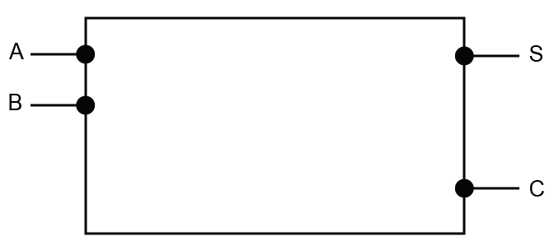

(c) Draw the truth table for the half adder, which has inputs A and B and   
outputs S and C. [2]

|  |  |  |  |  |  |
| --- | --- | --- | --- | --- | --- |
| **A** |  | **B** |  | **S** | **C** |
| 0 | + | 0 | = |  |  |
| 0 | + | 1 | = |  |  |
| 1 | + | 0 | = |  |  |
| 1 | + | 1 | = |  |  |

(d) What are the inputs to a full adder? [2]

(e) Show the outputs S0, S1, S2, S3, C1, C2, C3 from the following 4-bit adder. [4]

|  |  |  |  |  |  |
| --- | --- | --- | --- | --- | --- |
|  | C3 | C2 | C1 | **0** C0 |  |
|  | 1 A3 | 0 A2 | 1 A1 | 1 A0 |  |
| + | 0 B3 | 0 B2 | 1 B1 | 1 B0 |  |
| = | S3 | S2 | S1 | S0 |  |

2. (a) What is an edge-triggered D type flip-flop? [3]

(b) Draw the flip flop’s output Q on the graph. [4]

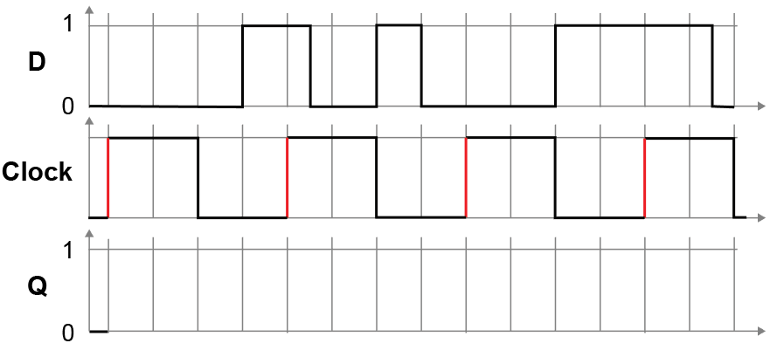

[Total 20 marks]