# Homework 5 Input and output devices Answers

# For each of the situations below, state the most suitable input device. You may only use each device once.

|  |  |  |
| --- | --- | --- |
| **Digital camera** | **Barcode scanner** | **RFID enabled device** |

# (i) Anti-theft detection and identification of small, high-value items RFID [1]

# (ii) Identification and recognition of vehicle number plates at a toll crossing

# Digital camera [1]

# (iii) Validating tickets for admission to an event Barcode scanner [1]

# Describe the principles of operation of a barcode scanner. [4]

# Light/laser/LED/Infra-red light shone at bar code;

# Mirror or prism moves light beam across bar code//user moves reader across bar code;

# Light is reflected back;

# Black/white bands reflect different amounts of light // black reflects less light // white reflects more light;

# Light sensor/photo sensor/photo diode/CCD measures amount of reflected light;

# Light reflected converted into an electrical signal;

# Reflected patterns analysed to determine value encoded in bar code;

# 

# A mail sorting office uses a camera-based scanner and specialist optical character recognition software in order to scan and recognise postcodes in typed addresses on envelopes.

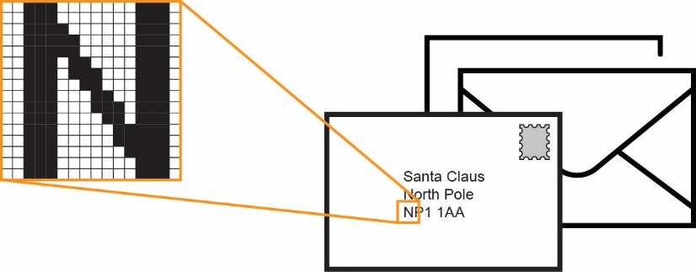

# Describe the principles of operation of a digital camera excluding its ability to determine a character from an image. [3]

Camera/CCD measures (ambient) light reflected from lens/letter;

Camera/CCD converts light into an electrical signal;

Light is reflected back;

Black areas reflect less light than white;

Image data for each pixel transmitted to computer;

# Explain how a digital camera image may be used to determine a character of text. [2]

Character image is split into a grid of pixels;

Pattern of black white pixels is analysed; and compared with patterns installed in the software;

A match is made;

3. A company uses a laser printer to print black and white invoices and customer orders. Describe the stages of operation of the laser printer as it produces an invoice. [6]

# Printing process starts by giving printer drum a negative charge;

# As printer drum rotates a laser beam scans across it removing the negative charge in certain areas; this leaves positively charged areas which match the text or images to be printed;

# Printer drum is coated with negatively charged toner; it only sticks to the positively charged parts of the drum;

# Positively charged sheet of paper is then rolled over the drum;

# Toner on the drum now sticks to the paper producing exact copy of the text and images

# To prevent paper sticking to the drum, the electric charge is removed once the page has been printed;

# Paper goes through a fuser which bonds the ink to the paper making a permanent copy;

# At the very end of the printing process, a discharge lamp removes the electric charge from the drum making it ready for the next page;

[Total 18 Marks]