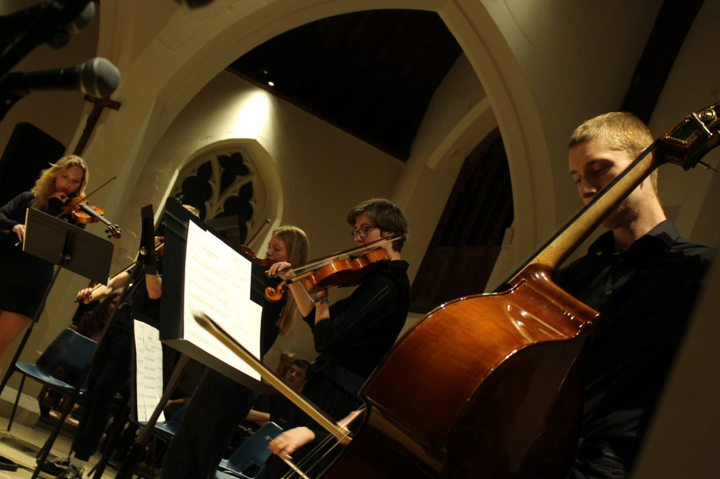

Course Title

Music

Course Code

A-Level

**Course Handbook**

**NAME:**

**Introduction to the department**

Welcome to

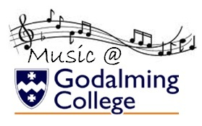

We are looking forward to teaching you!

The purpose if this guide is to provide you with a range of information and advice to help you organise your programme of study, learn independently, and equip you with important information about the department and how it can support you.

**Paul Clifford**

**Head of Music & Music Technology**

*A level Music Technology Course Leader*

**PSC@godalming.ac.uk**



Music Technician: Joe Barnes [JCB@godalming.ac.uk](mailto:JCB@godalming.ac.uk)

Music Technology Teacher: Dean Ormsby [DNO@godalming.ac.uk](mailto:DNO@godalming.ac.uk)

Along with the names above, the following departments and places will be useful whilst studying on the course:

**The ILC** – your go-to place to complete work and independent study outside of lessons. The Silent Study area provides an area to work individually, whilst the library contains an excellent selection of wider reading. Make sure that you have familiarised yourself with the ILC when you start the course

**The Exams Office** – for any questions you have about your exam entries, exam timetable or remarks and script requests.

**Learning Support** – for any extra support or advice you need to help you study in general. If you are struggling to organise and manage your workload; need help refining your essay-writing technique; help with revision; or if you think you might be entitled to any exam concessions, learning support are the people to talk to.

**Careers** – when you start to think about your options after college, whether university or employment based, careers can give you advice on where to apply and help in producing a personal statement.

**ExpecTations**

**What is expected of students?**

1. **Attendance and punctuality** – learning cannot begin if you are not in lessons or if you arrive late to them and miss important content. Students should maintain full attendance and punctuality. Any unavoidable and legitimate absences should be accounted for properly, meaning that students get a parent or a guardian to contact college and then email their teacher(s) to catch up on missed work
2. **To maintain a mature and respectful learning environment** – this means behaving in and out of lessons in a way expected of a Sixth-Form student: listening carefully to the views of others and offering constructive contributions in class
3. **To stay up-to-date** – you will be set weekly structured preparation or homework tasks and it is essential that these are completed on time and in the required level of detail. We use structured homework to consolidate particular content or to set up lessons to come. If work is incomplete your understanding will be incomplete and you will under-perform. If you arrive at a lesson having not completed preparation work then your teacher may also ask you to leave and complete this elsewhere.
4. **To stay organised** – managing the demands of a minimum of three subjects is challenging, especially when you are being taught more than one unit in each. You need, therefore, to stay organised. This means preparing a folder for each of your units, bringing the correct materials to each lesson and recording homework in the same place every time
5. **To meet the 50/50** – students are expected to conduct 4.5 to 6 hours of independent study a week. This will include structured preparation or homework tasks set by your teachers along with proactive tasks you complete yourself to consolidate and extend your understanding. See the advice later in this booklet for more help on doing this.
6. **To make the most of feedback and support** – you will get a lot of feedback during your time on the course. This will come as written feedback on assessed work, verbal feedback on general class or homework, and targets set at formal 1-1s. Feedback needs to be recorded carefully by you and acted upon. When you get back assessed work, for example you will be asked to record your own targets based on this, and may, in addition, be asked to attend a lunchtime workshop to help process feedback.
7. **To be resilient** – any subject will at times be very challenging. At times you will not do as well as you want or will struggle to understand a new topic or idea. You need to be prepared to spend more time on areas such as these and to seek out extra help when needed. These experiences of finding areas where you are not doing so well and improving them are what lead to success.

**What can you expect of your teachers?**

1. **To deliver structured and engaging lessons** – your teachers will deliver lessons designed to challenge your understanding whilst also helping you to gradually build up your knowledge and skills. These lessons will follow the scheme of work, a version of which you can see in this handbook.
2. **Regular assessment and feedback** – in addition to your benchmark assessments (four in the first year and three in the second) your teachers will regularly set you exam-style questions to give you opportunities to practice and improve. Feedback will be given on standardised sheets which include the relevant mark scheme and clear developmental targets
3. **Structured weekly work** – you should expect to be given a significant amount of work to do by your teachers each week. You will be given guidance on how long this should take and completed work will be checked and/or taken in
4. **Additional support** – your teachers will be happy to provide extra help outside of lessons either informally, by responding to emails, or more formally through departmental workshops. Workshops are the best opportunity to received additional help and work best when students come to lunchtime sessions with a specific area of confusion or set of questions to get answered

**Approach to remote teaching and learning**

Following the closure of schools and colleges in March 2020, teachers and students have adapted to a new environment of remote teaching and learning. How ‘remote’ this is depends on the wider context of COVID-19, but the department has clear plans, and expectations of its students, in each of the scenarios below.

1. ***Normal Opening: The College is open as normal; all students attend and follow a full, face-to-face timetable***

In this situation the department would run lessons, as normal and all of the expectations of students and teachers on the page before would apply

1. ***Blended Learning: students will receive a mixture of physical and remote lessons, attending college physically one week and remotely the other***

The department will continue to offer high quality lessons in this scenario although the exact nature of teaching and learning may vary depending on what content is being covered. Students should expect a mixture of:

* **Streamed lessons** – when appropriate, lessons including half of the class will be streamed live through Microsoft Teams to the other half of the class learning from home
* **Recorded content** – tutorials, demonstrations, presentations etc. will be pre-recorded for students to watch and complete a set of follow-up tasks
* **Structured independent work –** students may be longer project-style work, or work that is made up of several structured tasks and asked to work on this independently for a period of time, during which their teacher will be available for support
* **Preparation work** **–** class time may be used to set students independent work in the form of research or pre-learning to prepare them for a specific live lessons, which will then be used to assess students’ level of understanding of the work they have completed.
* **Homework** – students will also be expected to complete homework tasks

1. ***Remote Learning: students will receive remote lessons and assessment will be conducted remotely***

In the event that college is not open for physical lesson, teaching and learning will move online through the combined use of Microsoft Teams and Godalming Online. The specific nature of each week’s learning will vary depending on what is being covered, but students should expect a mixture of:

* **Live lessons through Microsoft Teams** – this is a fantastic platform that allows classes to video-call, watch presentations, take part in Q&A, group work, 1-1s all in real-time. Teams lessons will be the main part of remote teaching and learning but may take a slightly different form or length than physical lessons to help students engage fully. For example, a 1.5 hour physical lesson might translate to a 30-45 minute Teams lessons, made up of a brief teacher-led presentation and class Q&A, followed by 45 minutes of structured independent work, during which time the teacher conducts 1-1s with students
* **Online submissions** – students will upload work regularly to help their teacher monitor their progress and offer support when needed. This will be done through the ‘Assignments’ feature on Teams or through Godalming Online
* **Remote Workshops** – in addition to remote lessons, department workshops will continue remotely to provide students with extra points in the week to get 1-1 help on content, homework or remote learning in general

**Expectations of students in scenario 2&3 –** if students find themselves learning remotely or in a mixture of physical and remote lessons, then the department has clear expectations of how they should work in this environment. The department has considerable experience in delivering content remotely and key to this is students remaining engaged, establishing a clear working routine and communicating effectively with staff. More specifically it is expected that students will:



* Attend all remote lessons unless told otherwise by their teacher
* Actively take part in remote lessons e.g. contribute questions and answers, take part in group work, turn webcams on (with the background blurred) when asked to by their teacher
* Submit all work via Godalming Online or Microsoft Teams by the deadline set
* Communicate regularly with their teachers, either as part of scheduled 1-1s or more informally to discuss work or any problems they might be having. This will be through Email or Teams.

To identify where your remote strengths and weaknesses might be, complete the specific department audit below. This is made up of the essential skills you would need to learn in a remote or blended environment.

|  |  |
| --- | --- |
| **Remote Learning Skills Audit that you need to master to succeed on this course** | ***Tick*** |
| Log on to Office 365 using your college details (in college and at home) |  |
| Open Microsoft Teams and find a class team |  |
| Join a lesson on Teams and post a comment |  |
| Download the Teams app on your phone |  |
| Upload or attach documents in Teams |  |
| Save documents on OneDrive |  |
| Access your OneDrive files at home |  |
| Share documents, PowerPoints etc without attaching them to emails |  |
| Access Godalming Online course pages and download files |  |
| Upload work onto Godalming Online |  |
| Access E-textbooks needed on the course |  |
| Log on to any magazines or websites needed on the course |  |
| Access Estream to watch films/documentaries/pre-recorded content |  |
| Download free edition of Sibelius First or Musescore for composition tasks |  |



*[](https://www.google.co.uk/url?sa=i&url=https%3A%2F%2Flogotyp.us%2Flogo%2Fmicrosoft-teams%2F&psig=AOvVaw2Wl1l6bVS-gskR2jhCsLQD&ust=1594130388988000&source=images&cd=vfe&ved=0CAIQjRxqFwoTCNDg_8_kuOoCFQAAAAAdAAAAABAD)*There are lots of places you can go to get help with the skills listed above.

To begin with, speak to your teachers to get help with the basics of using Microsoft Teams or Godalming Online. This can be done at the start of the year through departmental surgeries and through workshops. A good idea would be to bring the completed audit above to a workshop and go through this with your teacher to fill in any gaps.

The IT Department are also available to offer more technical support or if you run into a problem your teacher cannot resolve. If in college, IT can be found on the top floor of the 300s. Also have a look at the IT Helpdesk on Godalming Online, which has help on using features such as Office 365. Finally IT are also contactable via [ITsupport@godaming.ac.uk](mailto:ITsupport@godaming.ac.uk)

If you are concerned about how to organise your time and working habits during a period of remote learning, then speak to your tutor for ideas and techniques to work independently. The Learning Support Department are also available to discuss specific concerns or individual learning needs further.

COURSE OVERVIEW

|  |  |  |
| --- | --- | --- |
| **Pearson Edexcel**  **A Level Music** | | |
| **Component 1**  Performing | You will perform a recital of at least **8 minutes** of continuous performance that will be recorded. Minimum standard of playing should be **Grade 7**. | 30%  Coursework |
| **Component 2**  Composing | You will complete one composition. This can be a free choice or chosen from a list of briefs. You will also complete one technical study from a choice of Bach Chorale, 2 part counterpoint, an arrangement or a remix. Combined, these compositions must total at least **6 minutes.** | 30%  Coursework |
| **Component 3**  Appraising | You will study the following types of music: vocal, instrumental, film, pop and jazz, fusions and new directions. The exam will contain listening tests and essays on the set works and associated music. | 40%  2 hour exam |

[](http://www.google.co.uk/url?url=http://www.endcliffeorchestra.org.uk/about-us/development-programme/performances-with-soloists&rct=j&frm=1&q=&esrc=s&sa=U&ved=0ahUKEwj-k66g28rNAhUrBMAKHbpeAB0QwW4IKjAK&usg=AFQjCNF8ZyotpjdR3ui-v1zVHcvdmObneA)A LEVEL MUSIC

C1: performance

The purpose of this component is to assess students’ performing skills in a solo and/or ensemble context. They should be given the opportunity to rehearse and refine performances on their chosen instrument or voice, developing technical control, expression and interpretative skills.

This component will encourage students to develop creative thinking, aesthetic sensitivity, critical awareness, self-confidence, self-motivation and their own musical interests and skills, including the ability to make music individually and/or in groups, and perform with control, using phrasing and dynamics appropriate to their chosen styles and moods of music.

Students must perform:

* A minimum of one piece, performed live and uninterrupted as a recital
* Performance can be solo, as part of an ensemble, improvisation, realisation using music technology, or a combination of these
* Total performance time across the recital must be a minimum of 8 minutes of music. Timing does not include the time taken to tune the instrument or any gaps between pieces.
* The average standard of the pieces performed should be at least grade 7 standard.

[](http://www.google.co.uk/url?url=http://cellobello.com/blog/index.php/composing-and-playing-music-how-composing-helps-your-playing/&rct=j&frm=1&q=&esrc=s&sa=U&ved=0ahUKEwjUrYTV28rNAhWKCcAKHSx_CYgQwW4IFjAA&usg=AFQjCNE4-arVOAuLg_lvZBPs7aALHLUP1w)

A LEVEL MUSIC

C2: composition

The purpose of this component is to assess students’ skills in composing music. It allows students to appreciate the process of creating music. Students will learn more of the processes involved in creating music through developing the technical and expressive skills needed by a composer.

Composing music is the creative process by which most of the music we experience came into being. Students will be encouraged to explore a range of compositional starting points, investigate a range of techniques for developing and manipulating ideas. They will then turn their ideas into completed pieces of music.

Students can also explore the skills needed to compose for different musical forces.

Students must submit two compositions, of a combined duration of at least 6 minutes:

* One composition (Free choice composition) can be chosen from six briefs relating to areas of study, or free composition, carrying 40 of the marks for the composing assessment. This composition must be at least 4 minutes in duration.
* One composition must be from a list of four briefs assessing technique, carrying 20 of the marks for the composing assessment. This composition must be at least 1 minute in duration.

A LEVEL MUSIC

C3: appraising

The purpose of this component is for students to develop their listening and appraising skills through the study of music across a variety of styles and genres. The content is grouped into six areas of study, and 13 set works in total.

This component gives students the opportunity to reflect on, analyse and evaluate music in aural and/or written form. To achieve this objective they need to use their knowledge and understanding of musical elements, context and language to make critical judgements about the repertoire and context of music within the areas of study. These critical judgements will require the use of specific music vocabulary associated with a particular style or genre.

Students will learn the content of musical elements, context and language through six compulsory areas of study as listed below:

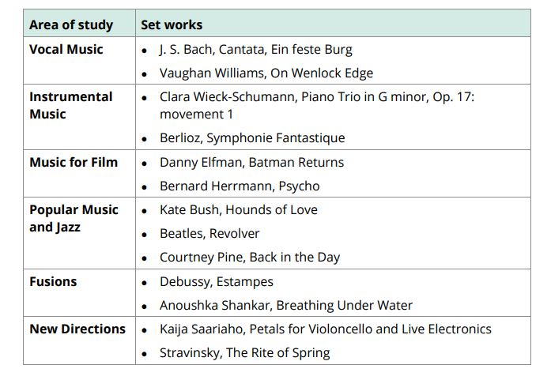

Provisional scheme of work

|  |  |  |  |
| --- | --- | --- | --- |
|  | **Unit 1** | **Unit 2** | **Unit 3** |
| Year 1 | | | |
| Half term 1 | Preparation for class recital and solo performances | Melody writing | Bach  Saariaho |
| Half term 2 | Recital consultation and recording no.1  (6 mins/grade 6) | Harmony basics | Stravinsky  Schumann |
| Half term 3 | Recital consultation and recording no.2  (6 mins/grade 6) | String quartet composition | Vaughan Williams  Debussy |
| Half term 4 | Preparation for recital recording no.3  (8 mins/grade 7) | String quartet composition completed  Bach Chorale | Beatles  Pine |
| Half term 5 | Recital consultation and recording no.3  (8 mins/grade 7) | Free composition  Bach Chorale | Revision of set works for benchmark 4 exam |
| Half term 6 | Preparation for recital recording no.4  (8 mins/grade 7) | Free composition  Bach Chorale | (Focus on other units) |
| Year 2 | | | |
| Half term 1 | Recital consultation and recording no.4  (8 mins/grade 7) | Free composition  Bach Chorale | Berlioz  Q5 instrumental & vocal |
| Half term 2 | Preparation for recital recording no.5  (8 mins/grade 7) | Free composition  Completed  Bach Chorale | Hermann  Elfman  Q5 film & pop/jazz |
| Half term 3 | Recital consultation and recording no.4  (8 mins/grade 7) | Bach Chorale exam technique | Shankar  Bush  Q5 fusions & new directions |
| Half term 4 | Final recital recording | Bach Chorale exam technique | Revision and exam practise |
| Half term 5 |  | Bach Chorale exam 6hrs | Revision and exam practise |

**Assessment**

When starting the course, it is important to know how the course is assessed. All assessed work is marked around what are known as **‘assessment objectives’** (AOs) which have been set by the exam board. You need to understand what each of these is and how many marks it carries for each type of question. If you can do this then you will know what skills to demonstrate and to what extent for each question on the exam.

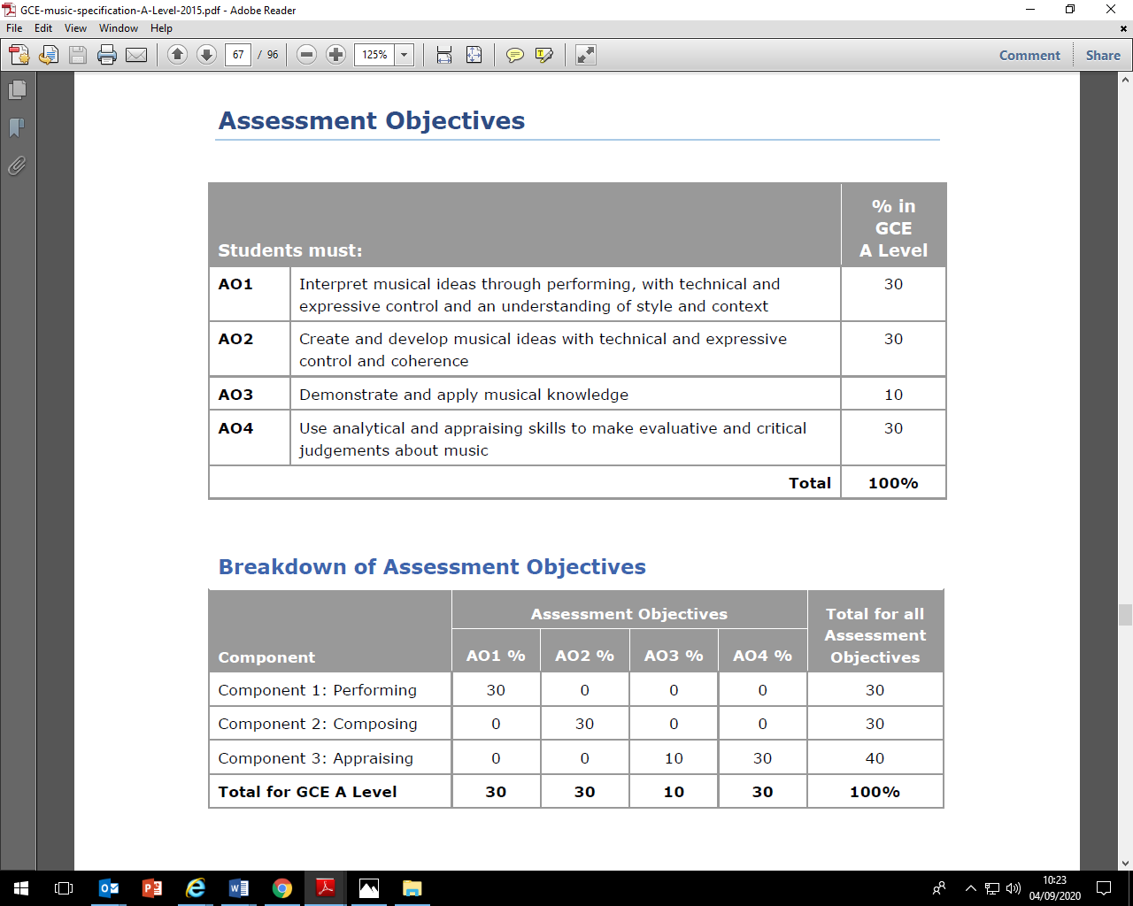

**A-Level Mark schemes**

**Component 1: Performing**

|  |  |  |
| --- | --- | --- |
| **Technical Control - Technique** | | |
| **Level 1**  1-2 | Poor  technique | The performance demonstrates poor technical control, as heard in poor coordination, breath control, diction and/or pedalling.  ● The demands of the music are beyond the current ability of the performer.  ● The handling of sonority is poor, as heard in dull, thin, coarse tone quality across the whole range and/or poor intonation throughout and/or poor use of filters and effects throughout. |
| **Level 2**  3-5 | Limited  technique | ● The performance demonstrates limited technical control, as heard in limited coordination, breath control, diction and/or pedalling.  ● There are several places where the demands of the music are beyond the current ability of the performer.  ● The handling of sonority is limited as heard in several passages where tone is less than acceptable (dull, coarse, thin, uneven) and/or several passages of poor intonation and/or limited use of filters and effects throughout. |
| **Level 3**  6–8 | Basic  technique | ● The performance demonstrates basic technical control of the instrument, as heard in basic coordination, breath control, diction and/or pedalling.  ● There are a few places where the demands of the music are beyond the current ability of the performer.  ● The handling of sonority is basic as heard in tone quality that is generally acceptable and/or several individual notes out of tune and/or basic use of filters and effects throughout. |
| **Level 4**  9–11 | Convincing  technique | ● The performance demonstrates convincing technical control of the instrument, as heard in convincing coordination, breath control, diction and/or pedalling.  ● There are only one or two places where the demands of the music are beyond the current ability of the performer.  ● The handling of sonority is convincing as heard in consistently good tone quality and awareness of tonal contrast, except at the extremities of the pitch range or at moments of technical difficulty, and/or generally good intonation with no more than a few out of tune notes and/or convincing use of filters and effects throughout. |
| **Level 5**  12–14 | Assured  technique | ● The performance demonstrates assured technical control of the instrument, as heard in assured coordination, breath control, diction and/or pedalling..  ● The demands of the music are within the current ability of the performer.  ● The handling of sonority is assured as heard in very good tone quality across the pitch range (satisfying, interesting and even as the music demands) and/or generally convincing intonation and/or assured use of filters and effects throughout. The performance will sensitively exploit tonal contrast in places, where appropriate. |
| **Level 6**  15–16 | Outstanding  technique | ● The performance will demonstrate complete control of the instrument.  ● The handling of sonority is outstanding as heard in excellent tone quality across the pitch range (exciting, vibrant, rich, resonant, sensitive and colourful, as the music demands) and/or entirely secure intonation (within only one or two out of tune notes at the lower end of the band) and/or excellent use of filters and effects throughout. The performance will sensitively exploit tonal contrast. |

|  |  |  |
| --- | --- | --- |
| **Technical control (Accuracy) and Expressive control (Fluency)** | | |
| **Level 1**  1–2 | Poor  accuracy  and fluency | ● Obtrusive errors of pitch and/or rhythm impact on many passages.  ● Performances at the lower end of the band are largely inaccurate, with many noticeable/obtrusive errors of pitch and/or rhythm.  ● Fluency is frequently compromised by breakdowns and/or omissions. |
| **Level 2**  3–5 | Limited  accuracy  and fluency | ● Performances in this band will have several noticeable/obtrusive errors in pitch and/or rhythm which impact on the success of the performance overall.  ● Fluency is compromised in several places and coherence is often lost. |
| **Level 3**  6–8 | Basic  accuracy  and fluency | ● Performances in this band will have more than two noticeable/obtrusive errors or omissions, or several errors that have little or no impact on the success of the performance overall, or several errors in just one (difficult) passage.  ● There will be moments where coherence is lost but the performance will still be reasonably fluent for the majority of piece. |
| **Level 4**  9–11 | Convincing  accuracy  and fluency | ● There will be no more than one or two noticeable/obtrusive errors or omissions in pitch and/or rhythm, or a few errors that have little or no impact on the success of the performance overall.  ● The performance will be mostly fluent despite the occasional hesitation and/or omission. |
| **Level 5**  12–14 | Assured  accuracy  and fluency | ● The performance will have a few minor errors in pitch and/or rhythm, but these errors will have no impact on the success of the performance overall.  ● Performances will be fluent despite the occasional very slight hesitation and/or omission. |
| **Level 6**  15–16 | Outstanding  accuracy  and fluency | ● The performance will demonstrate entirely accurate pitch and rhythm, with only one or two insignificant errors at the lower end of the band.  ● The performance should be fluent and entirely free from hesitation or omission. |

|  |  |  |
| --- | --- | --- |
| **Expressive control, style and context** | | |
| **Level 1**  1–2 | Poor  interpretation | Very few interpretative skills evident through:  ● an inconsistent tempo throughout(Expressive control)  ● little or no appropriate dynamic contrast, and little or no attention given to phrasing and articulation. (Style and context) |
| **Level 2**  3–5 | Limited  interpretation | An insecure interpretation through:  ● an inconsistent tempo for the majority of the piece (Expressive control)  ● limited use of dynamics, phrasing and articulation to shape the performance (Style and context)  ● a performance that struggles to communicate and may sound mechanical. (Style and context) |
| **Level 3**  6–8 | Basic  interpretation | A secure interpretation through:  ● several inconsistencies of tempo (perhaps around difficult passages) (Expressive control)  ● some use of dynamics, phrasing and articulation to shape the performance, but several opportunities, notated or otherwise,  are missed (Style and context)  ● some involvement with the music, but character and style are evident only intermittently. (Style and context) |
| **Level 4**  9–11 | Convincing  interpretation | A confident and engaging interpretation achieved through:  ● only a few minor inconsistencies of tempo (Expressive control)  ● some use of dynamics, phrasing and articulation to shape the performance, but a few opportunities, notated or otherwise, are missed (Style and context)  ● fairly successful communication, with one or two less successful moments lower in the band. (Style and context) |
| **Level 5**  12–14 | Assured  interpretation | An exciting and communicative interpretation achieved through:  ● the tempo being consistent with only one or two minor Inconsistencies (Expressive control)  ● the frequent use of dynamics, phrasing and articulation to shape the performance (Style and context)  ● characterful communication that is mostly idiomatic, and musically shaped. (Style and context) |
| **Level 6**  15–16 | Outstanding  interpretation | A mature, individual and imaginative interpretation achieved through:  ● the use of tempo that is always consistent (Expressive control) ● effective communication that is idiomatic, and musically shaped, with consistent use of dynamics, phrasing and articulation to shape the performance (Style and context) |

**Component 2: Composing**

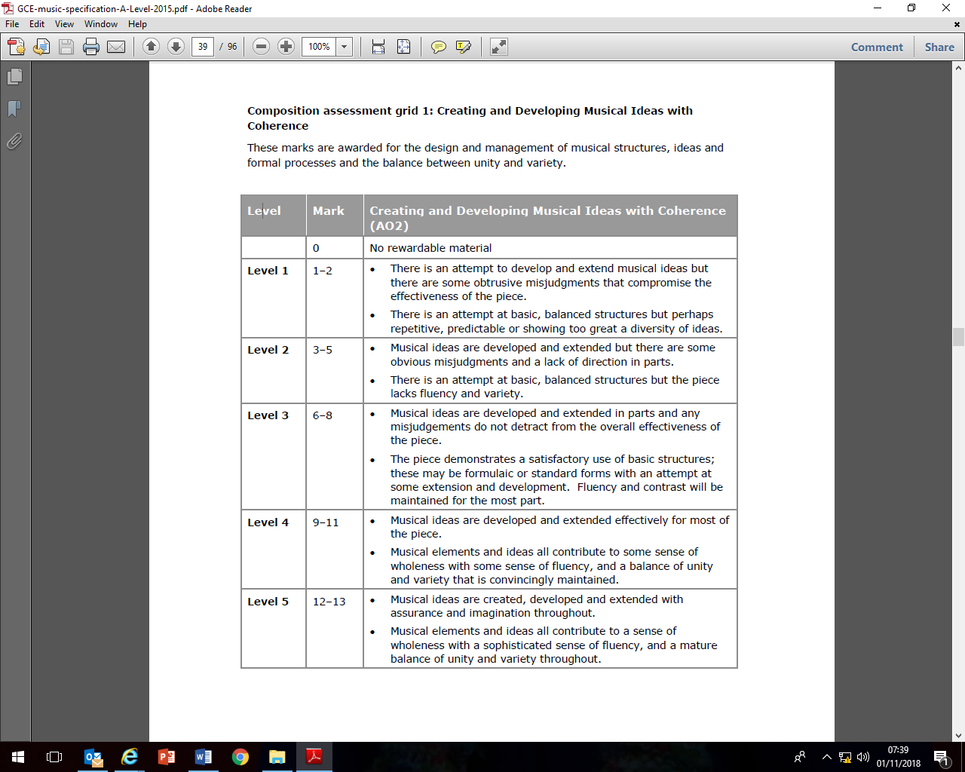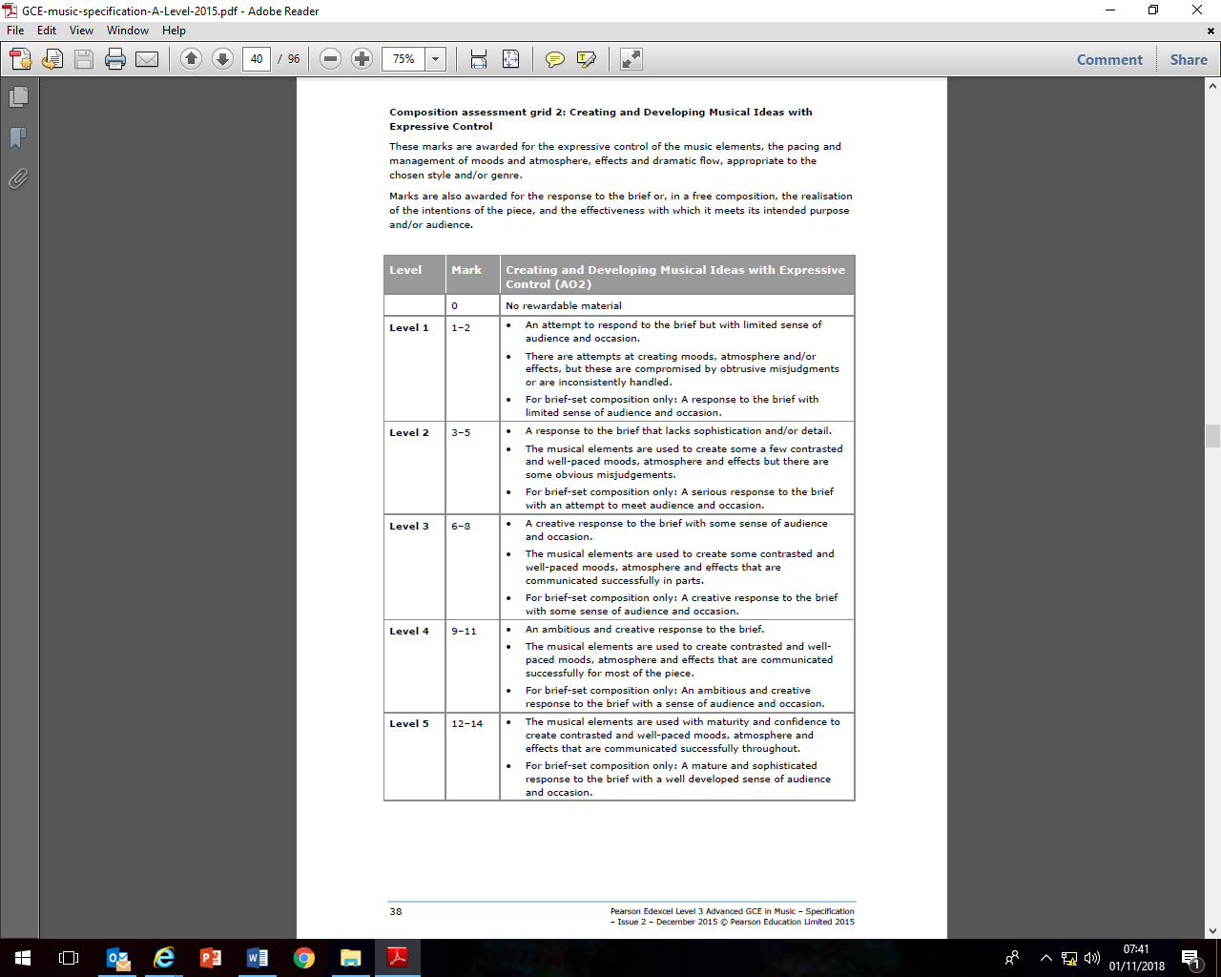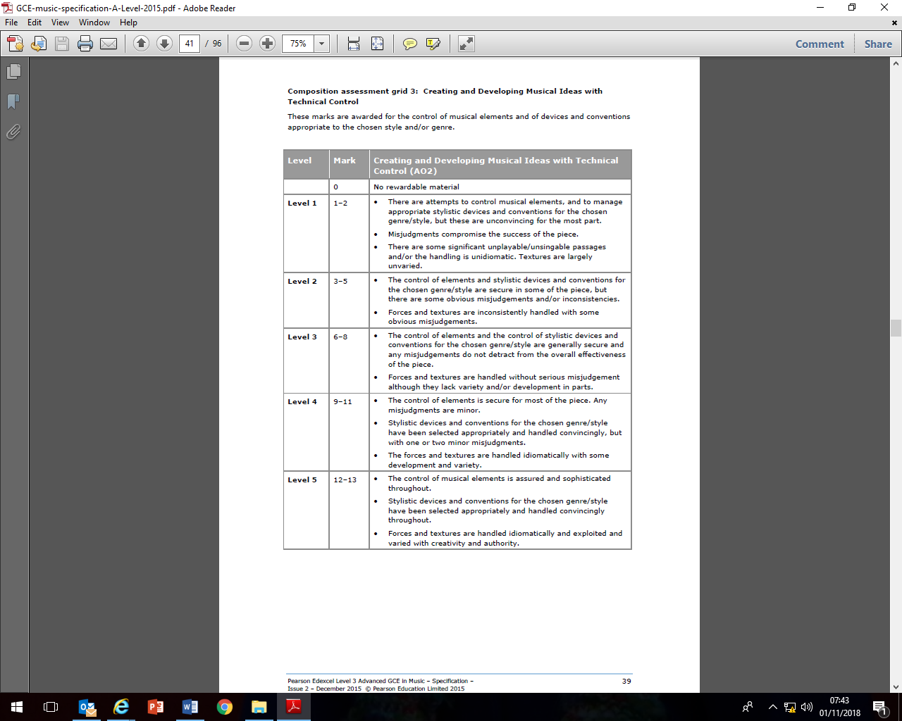

**Example Exam Paper**

**Component 3: Appraising**

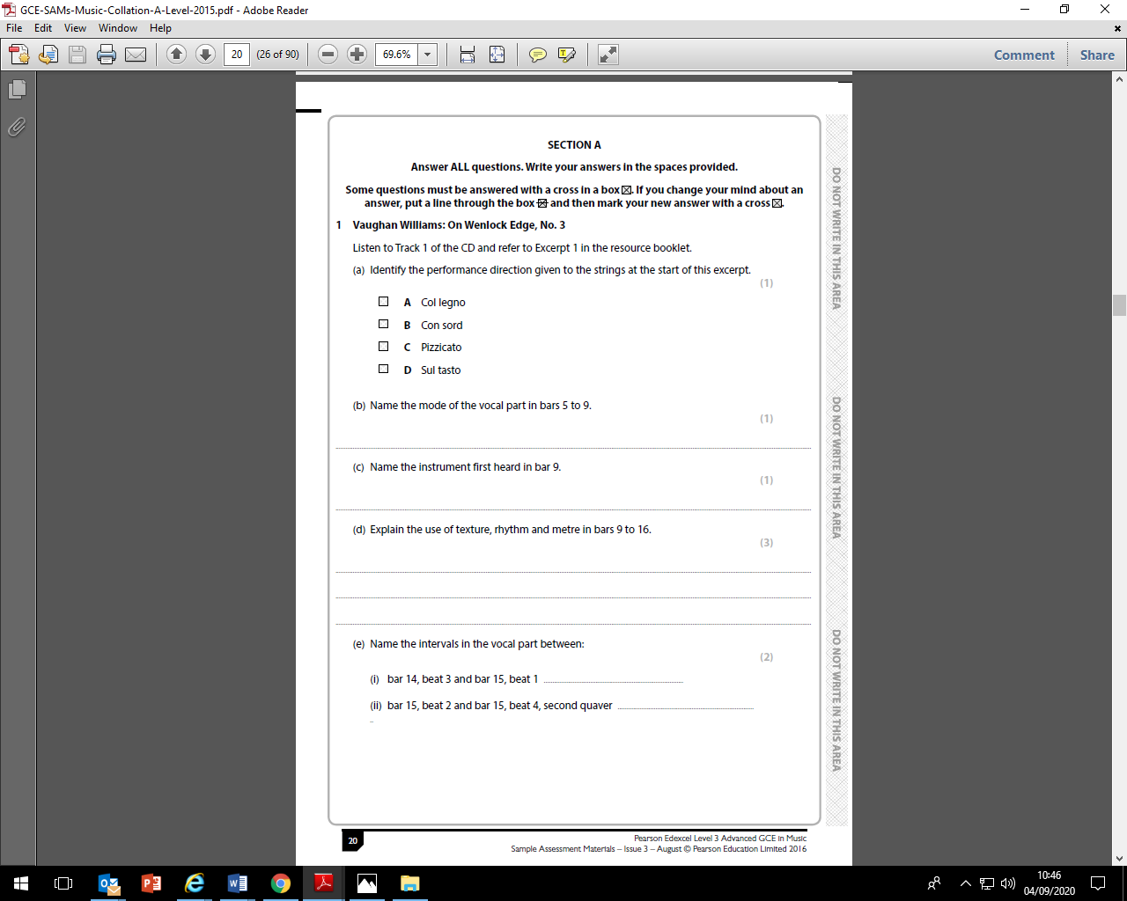

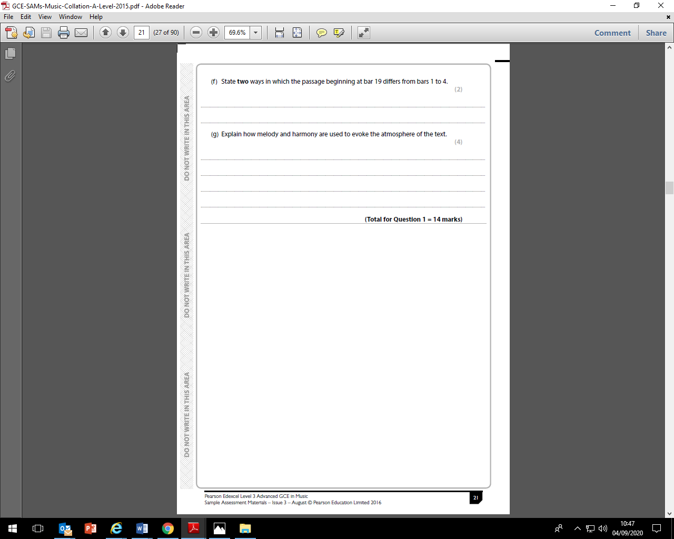

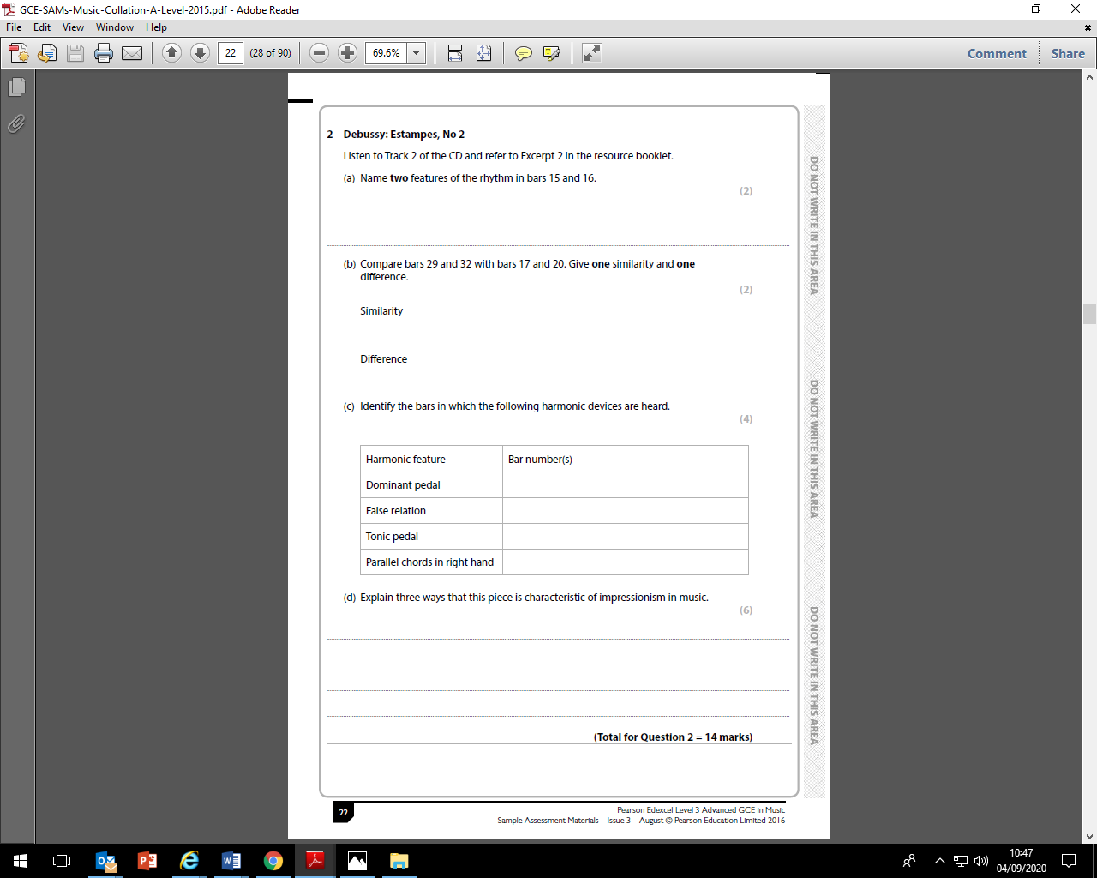

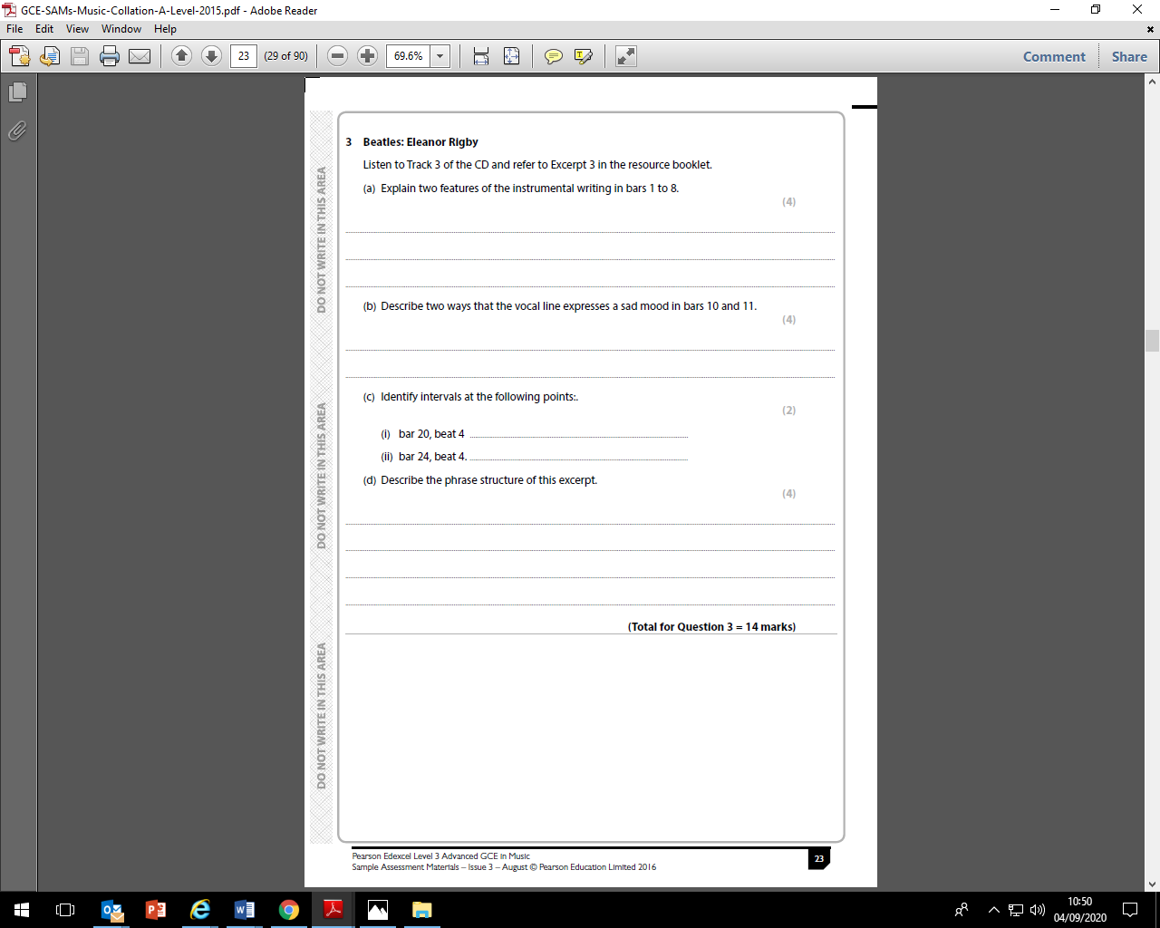

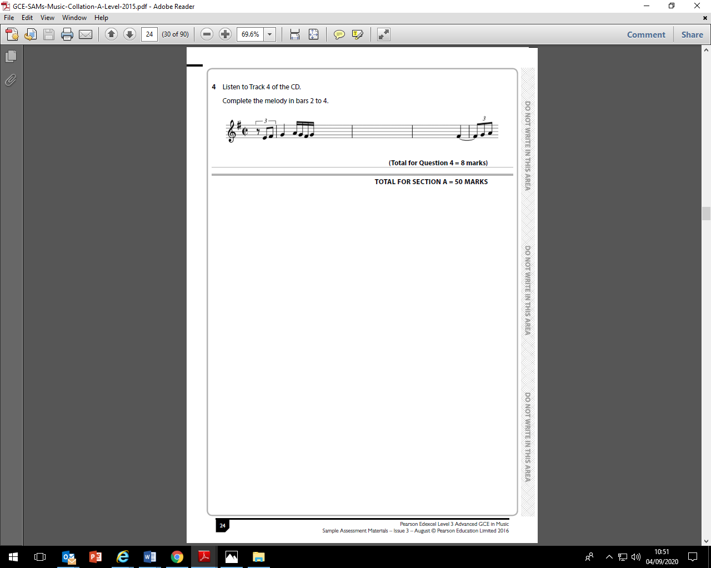

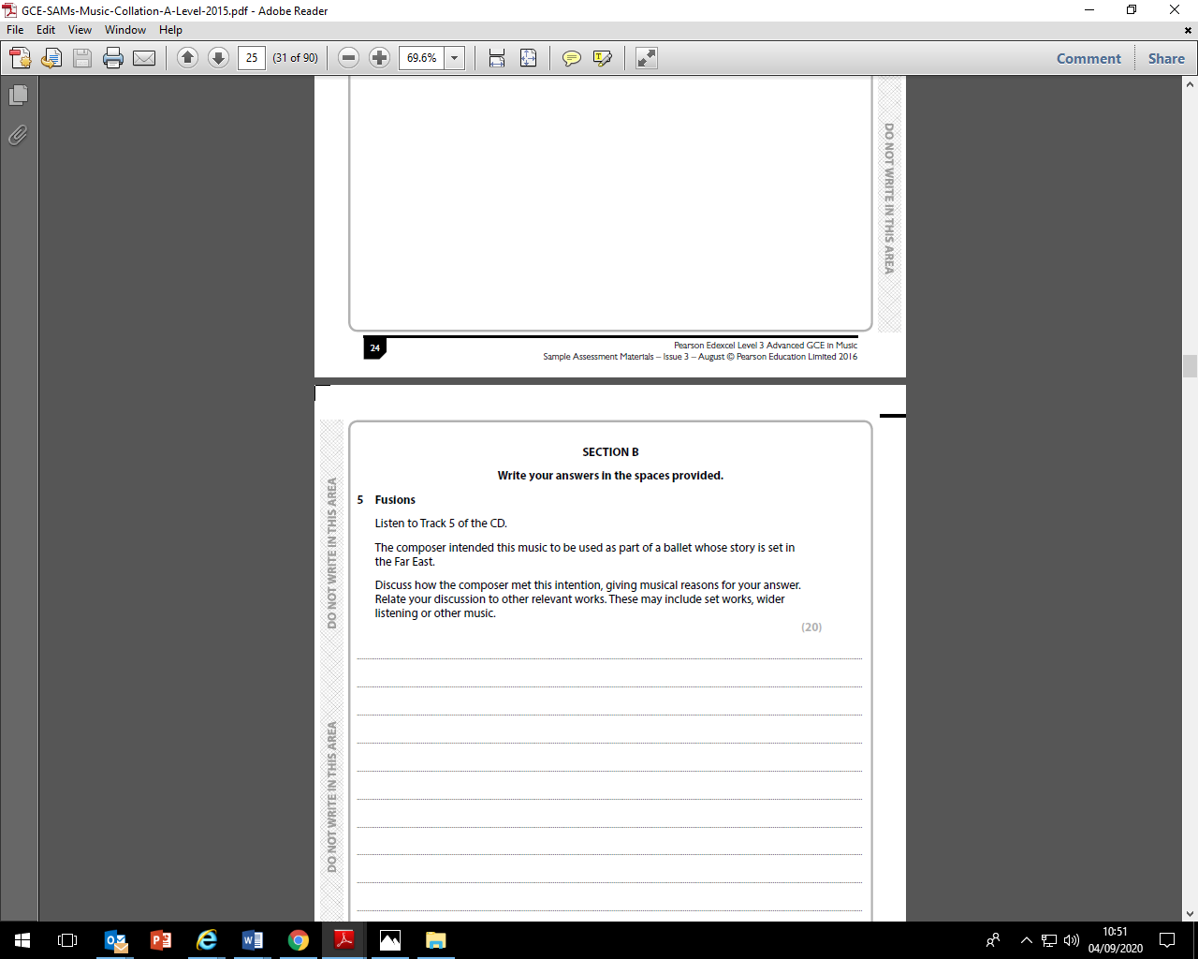

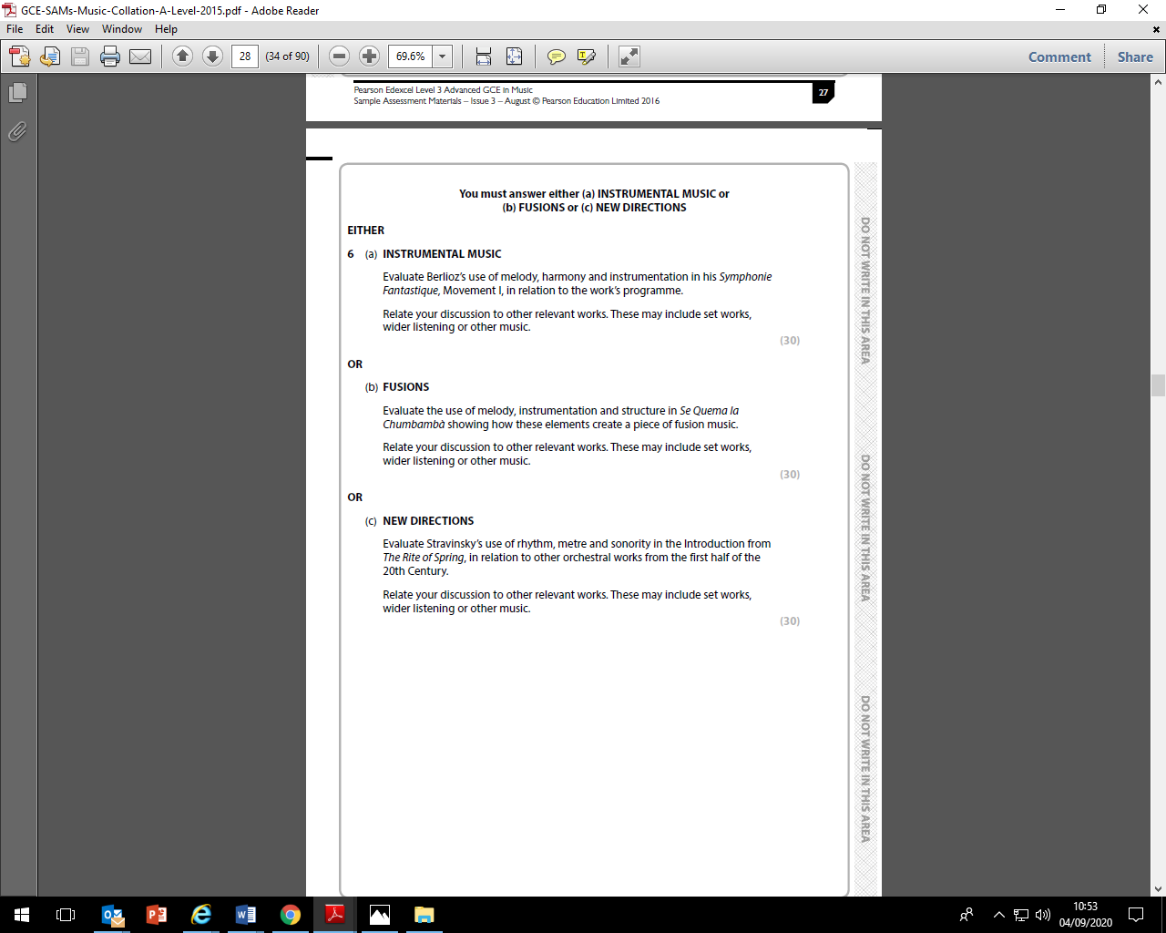

**Music A level Assessment Policy 2022-24**

**The Importance of Feedback and Learning Outside the Classroom – ‘50:50’**

Learning will not happen instantly and takes time; attending lessons is not enough, you also need to be working outside of class, to learn new information, practise your performance and composition skills, and consolidate learning. In the process, you will make mistakes but hopefully feedback will enable you to learn from these mistakes. Better to make a mistake during the year and correct it, than make your first mistake in the final assessment/exam! Feedback is essential for your learning and will consist of whole class (teacher runs a session in lessons), written (teacher marking), peer (where you feedback on someone else’s work in the class) and self (where you assess yourself).

There are 66 weeks of teaching weeks in total at College to help you learn and prepare for your final assessments. The classes taught between Ceilidh and Paul; Paul will be the Lead Subject Tutor who will be responsible for formalised 1-2-1s, seeing your parents at parents evening and for writing Action Plans, however both Ceilidh and Paul will write your student reviews.

In line with the College’s ‘50-50’ initiative, each week, homework will be set and could take between 4.5 to 6 hours in total. If the total amount of teacher-set homework in a week takes you 3 hours for example, then you will need to complete an additional 1.5 – 3 hours of independent study on top of this. Remember that you are expected to complete regular instrumental/vocal practise (ideally daily), time developing your composition each week, and revision of the set works. We won’t always prompt you to do this.

**The Final Assessment**

|  |  |  |
| --- | --- | --- |
| **COMPONENT 1 PERFORMANCE (30%)** | **COMPONENT 2 COMPOSITION (20%) & TECHNICAL STUDY (10%)** | **COMPONENT 3 APPRAISING EXAM** |
| * Solo performance lasting at least 8 minutes, of music of at least grade 7 standard * Recording and scores to be submitted to exam board for marking | * Composition score and recording to be submitted to exam board for marking * Bach Chorale assessment sat over 6 hours during lessons after the Easter holidays. Recording and score to be submitted to exam board for marking. * Both elements combined must last 6 minutes | * 2 hour exam sat in the summer term * Exam consists of:   Q1-3: 3xset work listening tests (42 marks)  Q4: Dictation test (8 marks)  Q5: Essay on an unfamiliar piece (20 marks)  Q6: Essay on a set work (30 marks) |

**Types of Assessment (and feedback)**

* **Homework (Weekly):** Homework does not necessarily need to be completed at home! You can use free periods during the day to complete these tasks outside of lessons. To keep a good work/life balance, you might like to treat College as an 0845 to 1615 day and use your free periods in the library or the Music department completing tasks. This will minimise the work you need to complete at home and might make you more productive. Homework tasks will vary, but typically consist of:

COMPONENT 1 PERFORMANCE: It is expected that you practise your instrument/voice very regularly, ideally every day. We recommend that you build this into your college timetable and use our practise rooms. These are almost always available – please just help yourself. As a minimum, you should practise for 30-45 minutes per day. Remember to complete focussed practise – start each session with an aim, thinking about recent feedback you have had from your instrumental/vocal teacher and Paul. Remember to work on the bars/passages that need work. Avoid playing pieces through from start to finish too often. Keeping a diary of your practise can help some students to progress.

COMPONENT 2 COMPOSITION: Some weeks there will be specific compositional techniques/tasks to complete for homework and often these will need to be completed on Sibelius software. You are welcome to use Room 820 whenever you like, but can also access the software on a PC in the library. Other weeks you will be expected to spend time developing your own compositions. Paul will set you targets and deadlines to help you manage your workload. You should aim to complete around 2 hours a week on your composition.

COMPONENT 2 BACH CHORALE: Teaching of this will start in the summer term of year 1 and continue throughout year 2. Weekly homework tasks will be set, with some needing to be completed on Sibelius software

COMPONENT 3 APPRAISING EXAM: There are 12 set works to cover in year 1 and 6 to cover in year 2. Each set work can take between 2-4 lessons to analyse as a class. As we finish each piece, you will have homework set to consolidate your knowledge. This will typically be some short questions, related research or connected wider listening. You will also be asked to regularly prepare for essay and listening test assessment on the set works.

* **Mock Exams/Benchmark Checkpoints/Coursework Assessment:** The calendar below shows the key assessment points for each unit.In Unit 1, you will receive the opportunity to complete 6 performance recordings under exam conditions across the two years. After each of the first 5 recordings, you will receive detailed feedback and a mark for your performance. It is assumed that you will improve during each recording and that your sixth recording will be the highest standard and will be the one submitted to the exam board. In Unit 2, you will receive regular feedback in lessons on your composition work in progress, and there will be official mid-point assessments where you will submit your composition and receive detailed feedback and a mark. Remember to access the 1-1 tutorials/workshops with Paul outside of lessons if you require additional support. Bach Chorale exercises will be assessed regularly and you will receive feedback and a mark for each one. In Unit 3, you will complete an essay assessment and a listening test in a lesson, in exam conditions, after the analysis of each work is complete. You will receive feedback and a mark each time. In half term 6 of year 1, you will receive a full mock exam on the 12 works studied. In half term 4 of year 2, you will receive a full mock on all 18 pieces. Thorough feedback and marks will be given with the mock exams. We will use the marks and data we have for you on all 3 units to calculate your benchmark grades at the points in the year shown on the calendar below.

**Tracking your Progress: Student Reviews, Action Plans and Parents Evenings**

The College’s policy is to deal with the student first but we also report to your parents at regular intervals to let them know how you are progressing and to inform them of what our expectations are through four Student Reviews (Reports) spread throughout the two years at College and also four parents evenings.

If the department feel you are under-performing based on evidence such as benchmark grades and your approach to learning in between these periods, then your Lead Subject Tutor may place you onto a Formal Department Action Plan and we will formally write to your parents after a 1-2-1 with yourself and to try and get you back on track in a supportive way

**Student Review 2, the ARG and Predicted Grades**

At the end of the first year, your Lead Tutor will have a 1-2-1 to discuss your Annual Review Grade or ARG and also finalise your Predicted Grade which might be used for UCAS applications for University and other destinations.

The ARG is determined by your Lead Tutor in communication with your other teacher and will rely on the following evidence base:

1. **Benchmark Checkpoints Performance Grades (1 to 4).**
2. **Approach to Learning :** How you are engaging in your learning, evidenced by attendance, punctuality, ability to meet weekly deadlines with quality work, how you have sought out extra support via workshops and your overall communication with your teachers.

The ARG plays a key part in determining the context in which you progress to the second year. Students who receive an A*-D grade (A-level) are encouraged to continue with their studies into the 2nd year. However for students who receive a U or E Grade (A-level) as their ARG, it suggests that for whatever reason they have struggled with the transition from Level 2 Courses (GCSE) to Level 3 Courses (A-level/BTEC). This will be evidenced by poor performances throughout their benchmarks and an inconsistent or poor approach to learning in their student reviews and via formal Action Plans. Students who receive a U Grade we would not recommend to continue with the course and they would need to speak to a Senior Tutor about alternative pathways.

The College adopts a consistent and optimistic approach to predicting grades to ensure that they are both aspirational and achievable. A predicted grade is what we believe a student is likely to achieve by the conclusion of their course in positive circumstances and the predicted grade provides universities and colleges with some understanding of a student’s academic potential alongside their Personal Statement and a written Reference from their Personal Tutor.

The ARG is important in forming the basis for the predicted grade as well but the predicted grade will also be aspirational for the students’ ambitions although it must remain realistic and cannot be based on the idea that only now will the student start to work harder in the second year!

**Other Considerations**

* *LATE POLICY:* In line with the ‘College Assessment Policy’, the department are under no obligation to provide feedback to a student who does not meet the internal deadlines for weekly independent tasks, benchmark assessments or coursework drafts. Please be warned that a failure to meet the final coursework deadline is the equivalent to missing the exam and it will be recommended that the student should be removed from the course. Students who fail to prepare adequately for the lesson as requested, maybe excluded for part of the lesson and asked to work independently at the back of the classroom. A continued failure to meet ‘PREP’ work requirements will result in a reference to the pastoral team and a phone call home to parents.
* *RETURNED WORK:* Work will be assessed and returned within 10 working days of it being submitted.
* *PLAGIARISIM:*  Plagiarism is submitting another person’s written work as one’s own original work or using someone else’s idea without referencing the source or using pictorial work without permission or referencing the source. If there is a suspicion of plagiarism, the Head of Department and Senior Tutor will be informed and a meeting will take place. If a student is found guilty, they will be subject to disciplinary action by the College and the awarding body will be informed. Students should be aware that the College is subscribed to software designed to detect plagiarism.

**Checkpoints: Benchmark, Student Reviews (Reports) and Mock Exams 2022-24**

Below is an overview of all the key assessment checkpoints

|  |  |  |
| --- | --- | --- |
| **CHECKPOINT** | **DATE** | **DETAILS** |
| **Benchmark 1 Checkpoint** | Nov 2022 | C1: Class Recital  C2: Melody composition completed  C3: Listening tests completed up until this point |
| **Parents Evening (For All)** | Nov 2022 | **Meetings with your parents to discuss how you have settled in and transferred from GCSE to A-level learning based upon:**   1. **Approach to learning** (how you are engaging in your learning, evidenced by attendance, punctuality, ability to meet weekly deadlines with quality work, how you have sought out extra support via workshops and your overall communication with your teachers) 2. **Performance Grade** in Benchmark 1 and from your homework tasks |
| **XMAS BREAK** |  |  |
| **Benchmark 2 Checkpoint** | Jan 2023 | C1: Recital 1 recording  C2: Composition 1-string quartet minimum 2 minutes  C3: Listening tests completed up until this point |
| **Student Review 1** | Jan 2023 | **A review of your progress in the first term (12-13 weeks of teaching) after a 1-2-1 with your Lead Tutor:**   1. **Performance grade (A to U)** (based on benchmark 1 and 2 but also your homework tasks) 2. **Approach to Learning** (how you are engaging in your learning, evidenced by attendance, punctuality, ability to meet weekly deadlines with quality work, how you have sought out extra support via workshops and your overall communication with your teachers). |
| **Parents Evening (Targeted)** | Mar 2023 | **Meetings with your parents primarily where teachers may have a concern about your progress since Student Review 1 in January.** |
| **Benchmark 3 Checkpoint** | Mar 2023 | C1: Recital 2 recording  C2: Composition 2-Free. Minimum 2 mins 30sec  C3: Listening tests completed up until this point |
| **EASTER BREAK** |  |  |
| **Benchmark 4 Checkpoint** | June 2023 | C1:Recital 3 recording  C2: Chorale assessment 90 min controlled assessment(20 marks) +average Comp 1 and 2(40 marks)  C3: Mock exam consisting of the set works we have studied up to this point. Q6 essay plus Q1-3 listening tests and q4 dictation task. |
| **Student Review 2** | June 2023 | **A review of your progress for the academic year (30-35 weeks of teaching) after a 1-2-1 with your Lead Tutor**   1. Approach to Learning 2. Performance Grade (Annual Review Grade or ‘ARG’ – performance for whole year (see notes above in main doc.) 3. Predicted Grade |
| **SUMMER BREAK** |  |  |
| **Benchmark 5 Checkpoint** | Oct 2023 | C1: Recital 4 recording  C2:Free composition first draft minimum 4:30  C3: Set works essay and listening test scores completed up until this point, as well as Q5 unfamiliar piece essay scores |
| **Parents Evening (All)** | Oct 2023 | **Meetings with your parents to discuss how you have settled in to the second phase of learning:**   1. **Approach to learning** (how you have engaged since Student Review 2 including completion of summer homework and the first five weeks of teaching – deadlines met, engagement in class and communication with teacher) 2. **Performance** with reference to your draft coursework mark and to talk about the final deadline for after half-term. 3. **How to support you:** Discuss how parents can further support you and what is coming up in this year |
| **Benchmark 6 Checkpoint** | Dec 2023 | C1: Recital 5 recording  C2: Free composition final draft minimum 4:30 and Chorale mock(3hrs)  C3: Set works essay and listening test scores completed up until this point, as well as Q5 unfamiliar piece essay scores |
| **Student Review 3** | Dec 2023 | **A review of your progress for the academic year since last Student Review (July) after a 1-2-1 with your Lead Tutor**   1. Approach to Learning 2. Performance Grade (based upon benchmark 6 and homework tasks) compared to Predicted Grade |
| **XMAS BREAK** |  |  |
| **Benchmark 7 Checkpoint** | Mar 2024 | C1: Final recital recording  C2: Coursework Deadline Final composition completed and full Chorale mock(6hrs)  C3: Full mock exam (2 hours 10 mins) SAT DURING MOCK WEEK  Q1-3: 3xset work listening tests (42 marks)  Q4: Dictation test (8 marks)  Q5: Essay on an unfamiliar piece (20 marks)  Q6: Essay on a set work (30 marks) |
| **Student Review 4** | Mar 2024 | **A review of your progress for the academic year (30-35 weeks of teaching) after a 1-2-1 with your Lead Tutor (see above)**   1. Approach to Learning 2. Performance Grade (based upon benchmark 7 Mock Exam only) compared to Predicted Grade |
| **Parents Evening (Targeted)** | Mar 2024 | **Meetings with your parents primarily where teachers may have a concern about your progress since Student Review 4.** |
| **EASTER BREAK** |  |  |

EXTRA SUPPORT OUTSIDE OF LESSONS

**C1 Performance**

If you would like Paul to listen to your recital at times other than mock and official recitals, please approach them about this. They are happy to listen to you perform and provide extra feedback during a mutually convenient time outside of lessons.

**C2 Composition**

One to one tutorials with Paul are available outside of lessons throughout the year. Please approach him if you would like some extra support.

**C3 Appraising**

Revision sessions will be held after college in the term leading up to the exam. It is our expectation that all students will make it a priority to attend these sessions. There may also be revision sessions at lunchtimes – please keep an eye on emails about this. Students are welcome to produce extra essays and or listening test answers at any point in the year. Paul will always mark extra work. One to one sessions with Paul are also available. Please approach her if you would like to book a session.

Don’t suffer in silence! We are always happy to help students!

Come and talk to us if you are ever worried about any aspect of the course. We want you to do as well as you possibly can.

☺

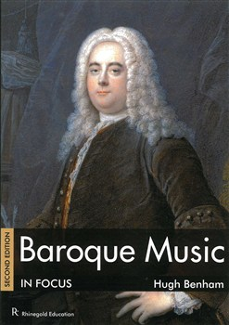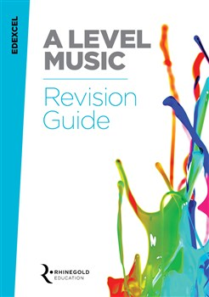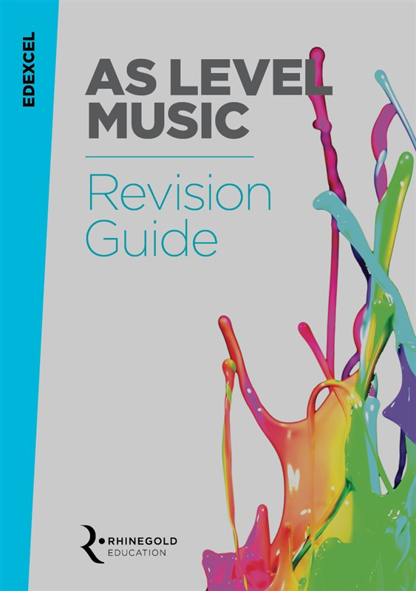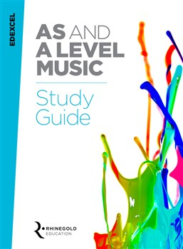SUGGESTED FURTHER READING

Film Music In Focus by David Ventura

Baroque Music In Focus by Hugh Benham

Edexcel A level Music Revision Guide

Edexcel AS level Music Revision Guide

*All books available for www.musicroom.com*

Edexcel AS & A level Music Study Guide

Modernism In Focus by Lucien Jenkins

bringing in instruments

There is an instrument store cupboard that students are welcome to use. The key for this cupboard in kept in the Music office and can be accessed at any time between 8.15am-4.30pm. The college cannot accept responsibility for instruments left in the cupboard and it is advised that you take out instrument insurance. It is not recommended that you leave your instruments in the cupboard for long periods of time without checking on them.

Using practise rooms

You are welcome to use practise rooms at any point during the college day. The key for the practise rooms is kept in the Music office and can be accessed at any time between 8.15-4.30pm. Currently we do not have a booking system for practise rooms as there is almost always one free. If there becomes a problem with availability then a booking system will be instigated. Please leave practise rooms tidy and clear them when you leave. NO EATING OR DRINKING ALLOWED.

Music activities

There are a wide range of music activities and ensembles for students to join. It is expected that all Music A level students commit to at least one ensemble and attend the weekly rehearsals, however it is common for Music students to want to attend several different ensembles. Details of the ensembles running each year will be given to you at the start of September.

College concerts

There will be at least 3 big college concerts each year either held internally or at an external venue. There are likely to be some smaller performer opportunities, such as Recital Evenings too. Dates of concerts will be given at the start of September. It is expected that all Music students will participate in the concerts through performing in an ensemble and solo performance opportunities.

Progression from

Music A level

Every year we have a number of students progressing to top Music Colleges and Universities to study Music at degree level.

Here are some of the institutions that our Music A level students have progressed to in the last two years:

Birmingham University

Manchester University

Cardiff University

Southampton University

Durham University

Kingston University

Trinity College Of Music

Royal Welsh College of Music & Drama

Brighton Institute of Modern Music

Birmingham Conservatoire

Royal College of Music

Royal Academy of Music

Leeds College of Music

Oxford University

Surrey University

Berkley College of Music (USA)

Royal Holloway University

Leeds University

[](http://www.google.co.uk/url?url=http://www.abdn.ac.uk/alumni/benefits-services/replacement-degree-certificates-192.php&rct=j&frm=1&q=&esrc=s&sa=U&ved=0ahUKEwjmipzF0crNAhUqB8AKHeslA0EQwW4IFjAA&usg=AFQjCNHVAxNQ343uYwpzLeK1iuWNIBcdJQ)CAREER PROGRESSION CAREER IDEAS FOR MUSIC GRADUATES

**Sound engineer**

**Music publishing**

**Performance**

**Arts administration**

**TV and radio production**

**Music journalism**

**Music therapy**

**Composing**

**Event management**

**Festival organising**

**Stage management**

**Teacher**

**Music software development**

**Record companies**

**Instrument technology**

**To find out more about Music careers, visit one of the following websites:**

**ISM Website (incorporated Society of Musicians) – “Careers with Music”**

<http://www.ism.org/training/article/careers_with_music_general_information>

**Careers in Music (more focused on popular music)**

[](https://www.google.co.uk/url?url=https://www.pinterest.com/explore/treble-clef/&rct=j&frm=1&q=&esrc=s&sa=U&ved=0ahUKEwiB-5rIpsjNAhWFK8AKHYt2BVwQwW4IKjAK&usg=AFQjCNEEYpjnzgRar28tr4WMibr0ol3AJg)<http://www.careersinmusic.co.uk/>

<http://www.careersinmusic.co.uk/music-jobs-and-opportunities/>

**UKP-Arts: Profiles of people working in music**

<http://www.ukperformingarts.co.uk/music/profiles/>

**Prospects – Graduate careers website**

<http://www.prospects.ac.uk/options_music.htm>