



Pearson QCF Specification

500/7872/0

BTEC Music Technology

**Course Handbook**

**NAME:**

**Introduction to the department**

Welcome to BTEC Music Technology! We hope that you enjoy your time in the department and find the process of studying the course a challenging and rewarding one.

The purpose of this guide is to provide you with a range of information and advice to help you organise your programme of study, learn independently, and equip you with important information about the department and how it can support you.

As a student of Music Technology you will be part of the music department, located in the 800’s building. Our department offers courses in both Music and Music Technology and also offers a range of spaces for your musical development and practice.

**Teaching Staff: Head of Department:**



**Paul Clifford**

*Teacher of A Level Music Technology and A Level Music* **PSC@godalming.ac.uk**

**Dean Ormsby**

*Teacher of BTEC & A Level Music Technology and Rockschool Music Practitioner’s Qualification*

**DNO@godalming.ac.uk**

**Technician:**



**Joe Barnes**

*Music & Music Technology Technician, Song writing and Extra Curricular*

**JCB@godalming.ac.uk**

**Director of Faculty:** Mark Woodward

Along with the names above, the following departments and places will be useful whilst studying on the course:

**The ILC** – your go-to place to complete work and independent study outside of lessons. The Silent Study area provides an area to work individually, whilst the library contains an excellent selection of wider reading. Make sure that you have familiarised yourself with the ILC when you start the course

**The Exams Office** – for any questions you have about your exam entries, exam timetable or remarks and script requests.

**Learning Support** – for any extra support or advice you need to help you study in general. If you are struggling to organise and manage your workload; need help refining your essay-writing technique; help with revision; or if you think you might be entitled to any exam concessions, learning support are the people to talk to.

**Careers** – when you start to think about your options after college, whether university or employment based, careers can give you advice on where to apply and help in producing a personal statement.

**ExpecTations**

**What is expected of students?**

1. **Attendance and punctuality** – learning cannot begin if you are not in lessons or if you arrive late to them and miss important content. Students should maintain full attendance and punctuality. Any unavoidable and legitimate absences should be accounted for properly, meaning that students get a parent or a guardian to contact college and then email their teacher(s) to catch up on missed work
2. **To maintain a mature and respectful learning environment** – this means behaving in and out of lessons in a way expected of a Sixth-Form student: listening carefully to the views of others and offering constructive contributions in class
3. **To stay up-to-date** – you will be set weekly structured preparation or homework tasks and it is essential that these are completed on time and in the required level of detail. We use structured homework to consolidate particular content or to set up lessons to come. If work is incomplete your understanding will be incomplete and you will under-perform. If you arrive at a lesson having not completed preparation work then your teacher may also ask you to leave and complete this elsewhere.
4. **To stay organised** – managing the demands of a minimum of three subjects is challenging, especially when you are being taught more than one unit in each. You need, therefore, to stay organised. This means preparing a folder for each of your units, bringing the correct materials to each lesson and recording homework in the same place every time
5. **To meet the 50/50** – students are expected to conduct 4.5 to 6 hours of independent study a week. This will include structured preparation or homework tasks set by your teachers along with proactive tasks you complete yourself to consolidate and extend your understanding. See the advice later in this booklet for more help on doing this.
6. **To make the most of feedback and support** – you will get a lot of feedback during your time on the course. This will come as written feedback on assessed work, verbal feedback on general class or homework, and targets set at formal 1-1s. Feedback needs to be recorded carefully by you and acted upon. When you get back assessed work, for example you will be asked to record your own targets based on this, and may, in addition, be asked to attend a lunchtime workshop to help process feedback.
7. **To be resilient** – any subject will at times be very challenging. At times you will not do as well as you want or will struggle to understand a new topic or idea. You need to be prepared to spend more time on areas such as these and to seek out extra help when needed. These experiences of finding areas where you are not doing so well and improving them are what lead to success.

**What can you expect of your teachers?**

1. **To deliver structured and engaging lessons** – your teachers will deliver lessons designed to challenge your understanding whilst also helping you to gradually build up your knowledge and skills. These lessons will follow the scheme of work, a version of which you can see in this handbook.
2. **Regular assessment and feedback** – the work that you complete throughout the year will be assessed and graded, with initial submissions given to you to sign and make note of your outcome. You will then have two weeks in which to make any changes to your initial submission towards improving your outcome.
3. **Structured weekly work** – you should expect to be given a significant amount of work to do by your teachers each week. You will be given guidance on how long this should take and completed work will be checked and/or taken in.
4. **Additional support** – your teachers will be happy to provide extra help outside of lessons either informally, by responding to emails, or more formally through departmental workshops. Workshops are the best opportunity to received additional help and work best when students come to lunchtime sessions with a specific area of confusion or set of questions to get answered

**Approach to remote teaching and learning**

Following the closure of schools and colleges in March 2020, teachers and students have adapted to a new environment of remote teaching and learning. How ‘remote’ this is depends on the wider context of COVID-19, but the department has clear plans, and expectations of its students, in each of the scenarios below.

1. ***Normal Opening: The College is open as normal; all students attend and follow a full, face-to-face timetable***

In this situation the department would run lessons, as normal and all of the expectations of students and teachers on the page before would apply

1. ***Blended Learning: students will receive a mixture of physical and remote lessons, attending college physically one week and remotely the other***

The department will continue to offer high quality lessons in this scenario although the exact nature of teaching and learning may vary depending on what content is being covered. Students should expect a mixture of:

* **Streamed lessons** – when appropriate, lessons including half of the class will be streamed live through Microsoft Teams to the other half of the class learning from home
* **Recorded content** – tutorials, demonstrations, presentations etc. will be pre-recorded for students to watch and complete a set of follow-up tasks
* **Structured independent work –** students may be longer project-style work, or work that is made up of several structured tasks and asked to work on this independently for a period of time, during which their teacher will be available for support
* **Preparation work** **–** class time may be used to set students independent work in the form of research or pre-learning to prepare them for a specific live lessons, which will then be used to assess students’ level of understanding of the work they have completed.
* **Homework** – students will also be expected to complete homework tasks

1. ***Remote Learning: students will receive remote lessons and assessment will be conducted remotely***

In the event that college is not open for physical lesson, teaching and learning will move online through the combined use of Microsoft Teams and Godalming Online. The specific nature of each week’s learning will vary depending on what is being covered, but students should expect a mixture of:

* **Live lessons through Microsoft Teams** – this is a fantastic platform that allows classes to video-call, watch presentations, take part in Q&A, group work, 1-1s all in real-time. Teams lessons will be the main part of remote teaching and learning but may take a slightly different form or length than physical lessons to help students engage fully. For example, a 1.5 hour physical lesson might translate to a 30-45 minute Teams lessons, made up of a brief teacher-led presentation and class Q&A, followed by 45 minutes of structured independent work, during which time the teacher conducts 1-1s with students
* **Online submissions** – students will upload work regularly to help their teacher monitor their progress and offer support when needed. This will be done through the ‘Assignments’ feature on Teams or through Godalming Online
* **Remote Workshops** – in addition to remote lessons, department workshops will continue remotely to provide students with extra points in the week to get 1-1 help on content, homework or remote learning in general

**Expectations of students in scenario 2&3 –** if students find themselves learning remotely or in a mixture of physical and remote lessons, then the department has clear expectations of how they should work in this environment. The department has considerable experience in delivering content remotely and key to this is students remaining engaged, establishing a clear working routine and communicating effectively with staff. More specifically it is expected that students will:



* Attend all remote lessons unless told otherwise by their teacher
* Actively take part in remote lessons e.g. contribute questions and answers, take part in group work, turn webcams on (with the background blurred) when asked to by their teacher
* Submit all work via Godalming Online or Microsoft Teams by the deadline set
* Communicate regularly with their teachers, either as part of scheduled 1-1s or more informally to discuss work or any problems they might be having. This will be through Email or Teams.

To identify where your remote strengths and weaknesses might be, complete the specific department audit below. This is made up of the essential skills you would need to learn in a remote or blended environment.

|  |  |
| --- | --- |
| **Remote Learning Skills Audit that you need to master to succeed on this course** | ***Tick*** |
| Log on to Office 365 using your college details (in college and at home) |  |
| Open Microsoft Teams and find a class team |  |
| Join a lesson on Teams and post a comment |  |
| Download the Teams app on your phone |  |
| Upload or attach documents in Teams |  |
| Save documents on OneDrive |  |
| Access your OneDrive files at home |  |
| Share documents, PowerPoints etc without attaching them to emails |  |
| Access Godalming Online course pages and download files |  |
| Upload work onto Godalming Online |  |
| Access E-textbooks needed on the course |  |
| Log on to any magazines or websites needed on the course |  |
| Access Estream to watch films/documentaries/pre-recorded content |  |



*[](https://www.google.co.uk/url?sa=i&url=https%3A%2F%2Flogotyp.us%2Flogo%2Fmicrosoft-teams%2F&psig=AOvVaw2Wl1l6bVS-gskR2jhCsLQD&ust=1594130388988000&source=images&cd=vfe&ved=0CAIQjRxqFwoTCNDg_8_kuOoCFQAAAAAdAAAAABAD)*There are lots of places you can go to get help with the skills listed above.

To begin with, speak to your teachers to get help with the basics of using Microsoft Teams or Godalming Online. This can be done at the start of the year through departmental surgeries and through workshops. A good idea would be to bring the completed audit above to a workshop and go through this with your teacher to fill in any gaps.

The IT Department are also available to offer more technical support or if you run into a problem your teacher cannot resolve. If in college, IT can be found on the top floor of the 300s. Also have a look at the IT Helpdesk on Godalming Online, which has help on using features such as Office 365. Finally IT are also contactable via [ITsupport@godaming.ac.uk](mailto:ITsupport@godaming.ac.uk)

If you are concerned about how to organise your time and working habits during a period of remote learning, then speak to your tutor for ideas and techniques to work independently. The Learning Support Department are also available to discuss specific concerns or individual learning needs further.

**STRUCTURE OF THE COURSE**

**STRUCTURE OF EACH UNIT**

Each unit will contain four assignments.

Each assignment will be awarded either a pass, merit or distinction grade.

* To achieve the **pass** grade for the unit you will need to achieve **4 pass grades.**
* To achieve the **merit** grade for the unit you will need to achieve **4 merit grades.**
* To achieve the **distinction** grade for the unit you will need to achieve **4 distinction grades.**

|  |  |  |  |
| --- | --- | --- | --- |
| **Year** | **Units covered** | **Amount of credits each unit is worth** | **Qualification Gained** |
| Lower Sixth | Unit 32: Sequencing Systems & Techniques | 10 credits | BTEC **Certificate** in Music Technology  **(30 credits completed)** |
| Unit 25: Music Production Techniques | 10 credits |
| Unit 29: Live Sound Techniques | 10 credits |
| Upper Sixth | Unit 43: Special Subject Investigation | 10 credits | BTEC **Subsidiary Diploma** in Music Technology  **(60 credits completed)** |
| Unit 9: Delivering A Music Product | 10 credits |
| Unit 20: Music and Sound for the Moving Image | 10 credits |

**HOW YOUR FINAL CERTIFICATE GRADE IS CALCULATED**

|  |  |
| --- | --- |
| **Overall Grade Awarded** | **Combination of outcomes for each**  **of the 3 units** |
| Pass | PPP, PPM |
| Merit | MMP, MMM, DPP, DMP |
| Distinction | MMD, DDP |
| Distinction* | DDM, DDD |

**HOW YOUR FINAL SUBSIDIARY DIPLOMA GRADE IS CALCULATED**

|  |  |
| --- | --- |
| **Overall Grade Awarded** | **Combination of outcomes for each**  **of the 6 units** |
| Pass | PPPPPP, PPPPPM, PPPMMM, PPPPPD |
| Merit | DDPPPP, MMMMPP, DMMMMP, DMMPPP, DDMMPP, MMMMMP |
| Distinction | DDMMMM, DDDMMP, DDDDPP, DDDDMP, DDDMMM |
| Distinction* | DDDDMM, DDDDDP, DDDDDM, DDDDDD |

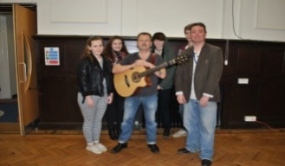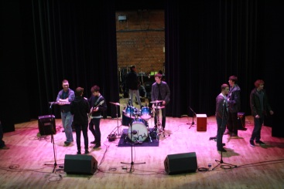**UNIT 29: LIVE SOUND ENGINEERING**

Aim and purpose

The aim of this unit is to develop skills in the use of live sound reinforcement equipment. Learners will become familiar with the sound equipment used in a music venue and will set up a sound system, use outboard equipment and set up monitor mixes.

Unit information

Live sound or ‘sound reinforcement’ systems utilise many of the skills applied in the recording studio but with significant differences. Accepted practice in the studio does not always transfer effectively to the live sound environment where acoustic properties cannot be relied on or controlled in the way that they can in a recording studio. The success of a performance relies on the ability of the live sound engineer to use the

audio equipment in real-time to create a workable mix on stage for the performers and out front for the audience. Throughout this unit learners will develop knowledge of a live sound system from the microphones they use to the mixing console, the outboard, monitor system and main loudspeaker system. Health and safety procedures must be adhered to at every stage.

Learning outcomes

1 Know the sound reinforcement equipment requirements for a music venue

2 Be able to set up a sound system showing due regard for health and safety procedures

3 Be able to set up outboard equipment for live sound reinforcement

4 Be able to establish an on-stage mix for a performer.

Professional Work Experience

As an enrichment part of the course we have arranged a number of opportunities for the live sound students to provide the sound at professional venues and to meet world renowned musicians even watch their sound-checks.

**[](http://www.google.co.uk/url?sa=i&rct=j&q=&esrc=s&source=images&cd=&cad=rja&uact=8&docid=1R6JOZZRLkvlPM&tbnid=F5bFAeoaYOtZZM:&ved=0CAYQjRw&url=http://www.coveralia.com/caratulas/Oasis-Don-t-Look-Back-In-Anger-(CD-Single)-Frontal.php&ei=tmwgU5b5EsO60QX_noHYCw&bvm=bv.62788935,d.ZGU&psig=AFQjCNEv65Mp_9A4IhJsUzdcm1h_3dpb7g&ust=1394720280873450)[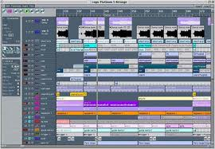](http://www.google.co.uk/url?sa=i&rct=j&q=&esrc=s&source=images&cd=&cad=rja&uact=8&docid=nRPFI6VZiOp0gM&tbnid=iQNsTLpCjv_Q8M:&ved=0CAYQjRw&url=http://www.muzoborudovanie.ru/equip/studio/seq/logic5.php&ei=i20gU6iTF8Se0wWFuoGQBA&bvm=bv.62788935,d.ZGU&psig=AFQjCNGMe6-_gBrHPeqic-VME5P-ujrWuQ&ust=1394720496797168)UNIT 32: SEQUENCING SYSTEMS & TECHNIQUES**

Learning outcomes

1 Be able to set up a computer and peripheral MIDI hardware safely

2 Be able to realise musical ideas using MIDI sequencing skills

3 Be able to realise musical ideas using audio sequencing skills

4 Understand the terminology associated with music sequencing techniques.

Unit information

The digital age has seen computers take centre stage in music production environments. The wealth of software tools and the power of computer-based systems has led to ‘ virtual studio’ environments capable of producing recordings of a quality only previously available from expensive hardware–based systems, and at a fraction of the cost. However it is still vitally important music technologist to be able to connect and configure the additional hardware required to sequence successfully, including external sound sources. MIDI and audio sequencing tools have put a vast range of creative possibilities into the hands of composers and performers of music, and created an environment where, alongside traditional composition methods, the manipulation of pre-existing sound is accepted as valid starting point for original creation. In this unit learners will create a portfolio of music using the tools available with the major sequencing software packages. Learners will work with MIDI and audio-based sequencing, each of which has a vast range of techniques that can be utilised in the production of modern music. Learners will be expected to create a range of music that demonstrates how these tools can be applied. It is expected that those attempting this unit will be musically creative and can originate ideas using the software and hardware explored in this unit. They should be able to create musical ideas from a blank canvas, as well as manipulate pre-existing musical ideas with the intention of putting their individual stamp on the material they had been given to work with. As they create their portfolios, learners will develop their knowledge by incorporating a wide range of sequencing techniques, and will be able to make decisions as to the correct tool or skill for each situation.

Aim and purpose

The aim of this unit is to develop learners’ knowledge of music sequencing software and the transferable skills that facilitate the realisation of musical ideas in both audio and MIDI environments. Learners will develop the skills to set up, use and discuss sequencing systems and techniques.

**[](http://www.google.co.uk/url?sa=i&rct=j&q=&esrc=s&source=images&cd=&cad=rja&uact=8&docid=N-3R_7NdpQnxRM&tbnid=ZMHEonelRFSSkM:&ved=0CAYQjRw&url=http://www.proaudiostar.com/apex-415-studio-condenser-mic.html&ei=SXggU_WvOuSv0QXSzoHYCw&bvm=bv.62788935,d.ZGU&psig=AFQjCNHUDvtQSxP_qlr9WkJR2ISIj6-MtQ&ust=1394723251742568)[](http://www.google.co.uk/url?sa=i&rct=j&q=&esrc=s&source=images&cd=&cad=rja&uact=8&docid=D3ObUth4l5rawM&tbnid=bCn2IAnW21lJhM:&ved=0CAYQjRw&url=http://wallpaperscraft.com/download/milo_ventimiglia_brunette_microphone_recording_studio_34903/1920x1080&ei=gXggU8u1Icqb0QWqyoDICw&bvm=bv.62788935,d.ZGU&psig=AFQjCNHUDvtQSxP_qlr9WkJR2ISIj6-MtQ&ust=1394723251742568)UNIT 25: MUSIC PRODUCTION TECHNIQUES**

Aim and purpose

The aim of this unit is to develop learners’ awareness of the equipment and techniques used in recording studios to the extent that they can produce a complete studio recording.

Unit information

Despite developments in computer software, the elements required to produce a studio recording remain

little changed. There is a huge range of equipment available, so choosing which equipment to use depends on

being able to match the specification of the equipment to the sonic characteristics of the sound source to be

captured. Learners will be required to demonstrate every aspect of the recording process. Setting up the chosen

equipment to suit the musical situation is only one part of this process. It is also vital that the learners

understand the importance of setting up equipment appropriately, and with an awareness of the health and

safety issues involved. Capturing performances as multitrack recordings involves a mixture of skills, not just technical, but also musical and organisational. Learners will also be required to mix their recordings to a format suitable for distribution to a non-technical audience, as a conclusion to the unit.

Learning outcomes

1 Understand manufacturers’ specifications for a range of audio recording equipment

2 Be able to set up the equipment required for a recording session

3 Be able to capture audio sources using multitrack recording techniques

4 Be able to mix multitrack recordings.

**UNIT 43: SPECIAL SUBJECT INVESTIGATON**

Unit information

This unit gives learners the opportunity to carry out an in-depth and practical investigation into a chosen area of interest. The potential for areas of exploration is wide, and learners will be expected to choose an appropriate area of study, which they can then justify as suitable for investigation, promising ample scope for detailed study. Suggested examples of the types of topic for investigation include the history and development of a style of music or dance; the work of a drama practitioner, theatre company or set designer; the career of a particular musician, composer or choreographer; a development in music or theatre technology; social and cultural influences of and on a music or drama genre etc. Learners will submit a proposal, identifying their choice of subject matter along with intended resources and materials. Learners will work independently in identifying information sources, extracting, collating and interpreting information and keeping a record of their research trail. The eventual presentation of their findings and conclusions will be delivered to others in the cohort, encouraging sharing of knowledge and information. The unit content and assessment requirements will benefit any learner, enhancing both academic and vocational skills, and provide valuable preparation for learners wishing to progress to higher education. The self-directed nature of the unit will encourage learners to work with independence. This unit could serve as grounding for learners who might wish to progress to careers in, for example, writing, journalism, teaching, publicity or promotion.

Aim and purpose

This unit gives learners the opportunity to carry out an in-depth and practical investigation into a chosen area of interest.

**[](https://www.google.co.uk/url?sa=i&rct=j&q=&esrc=s&frm=1&source=images&cd=&cad=rja&uact=8&ved=0CAcQjRxqFQoTCMrYpdiw9sgCFUXWFAodq34DbA&url=https://charlmartin.wordpress.com/sub-genre-music-magazine-research/&bvm=bv.106379543,d.d24&psig=AFQjCNEeV91KOYJZjB0e7Er_3sXiVAKv6w&ust=1446713158274494)**

Learning outcomes

1 Know how to identify an appropriate subject area for investigation

2 Be able to plan a research project

3 Be able to carry out research

4 Be able to produce and present results of an investigation.

**[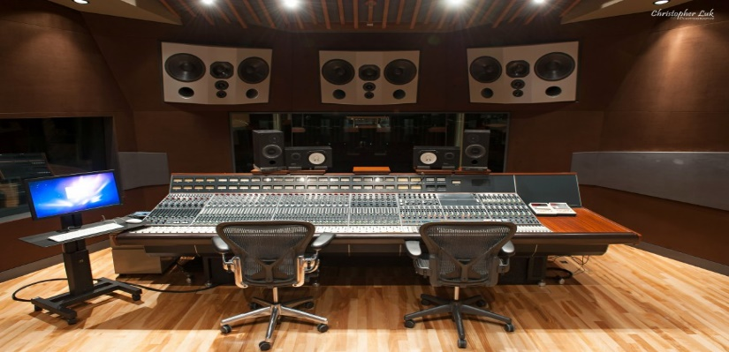](http://www.google.co.uk/url?sa=i&rct=j&q=&esrc=s&source=images&cd=&cad=rja&uact=8&docid=oYxidma4DZWp1M&tbnid=zuvDS0yHM8Fz5M:&ved=0CAYQjRw&url=http://chrisluk.com/2013/02/revolution-recording-music-recording-mixing-engineering-and-production-day-2-toronto-photographer/&ei=ZHkgU4_gFsKl0AXHq4DoCw&bvm=bv.62788935,d.ZGU&psig=AFQjCNHoRZvzqbBpNHUwpG_sfq3kpuIRbg&ust=1394723501944558)[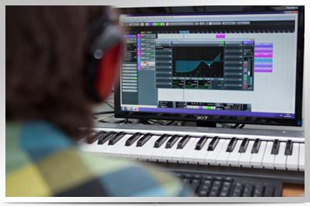](http://www.google.co.uk/url?sa=i&rct=j&q=&esrc=s&source=images&cd=&cad=rja&uact=8&docid=2DiLl_wpH3Ox9M&tbnid=enYYn4o_k5N6RM:&ved=0CAYQjRw&url=http://www.bigjamstudios.co.uk/tuition/&ei=MnkgU67FB8aN0AXxmYGgDQ&bvm=bv.62788935,d.ZGU&psig=AFQjCNHoRZvzqbBpNHUwpG_sfq3kpuIRbg&ust=1394723501944558)UNIT 9: DELIVERING A MUSIC PRODUCT**

Learning outcomes

1 Know how to plan and set up recording sessions that encompass a variety of techniques

2 Be able to undertake a range of roles in the recording and production of contrasting multi-track material

3 Be able to complete effective stereo mixes of the multi-track recordings

4 Be able to edit and master the material.

Unit information

There are many roles within the music industry that contribute to the effective creation and delivery of a commercial music product. Alongside the artist, key roles are those of the recording engineer and the producer. This unit will encourage learners to undertake a range of roles in the studio as part of a team, with the aim of creating a product that satisfies current technical and creative trends whilst utilising the best of current technology. Each team will plan and create an audio CD with a number of tracks. Material can be derived from any style of performance, including live musicians, MIDI sequences, sample-based material and DJ techniques. Material used can be original compositions written by team members or sourced elsewhere, or it can be ‘cover versions’ of material from any source. When working with existing material, correct copyright procedures must be followed. If the material is original, each writer will be credited and the work protected effectively. Each team member will be ‘The Producer’ for a range of contrasting material and participate in the remainder of the tracks. The focus for the unit is on teamwork, where each team member will have clearly-defined roles in the studio whilst creating a series of recordings. All learners will perform a range of roles and be expected to demonstrate effectively and record their skills in these areas. All learners must also ‘engineer’ for other producers in the team, but can perform these duties whilst ‘producing’ if appropriate to the style of music. On completion of this unit each learner will have participated in the production of a fully finished, mastered audio CD recording.

Aim and purpose

The aim of this unit is to enable learners to experience the process of creating and delivering a product – probably a CD recording within guidelines typical within the music industry.

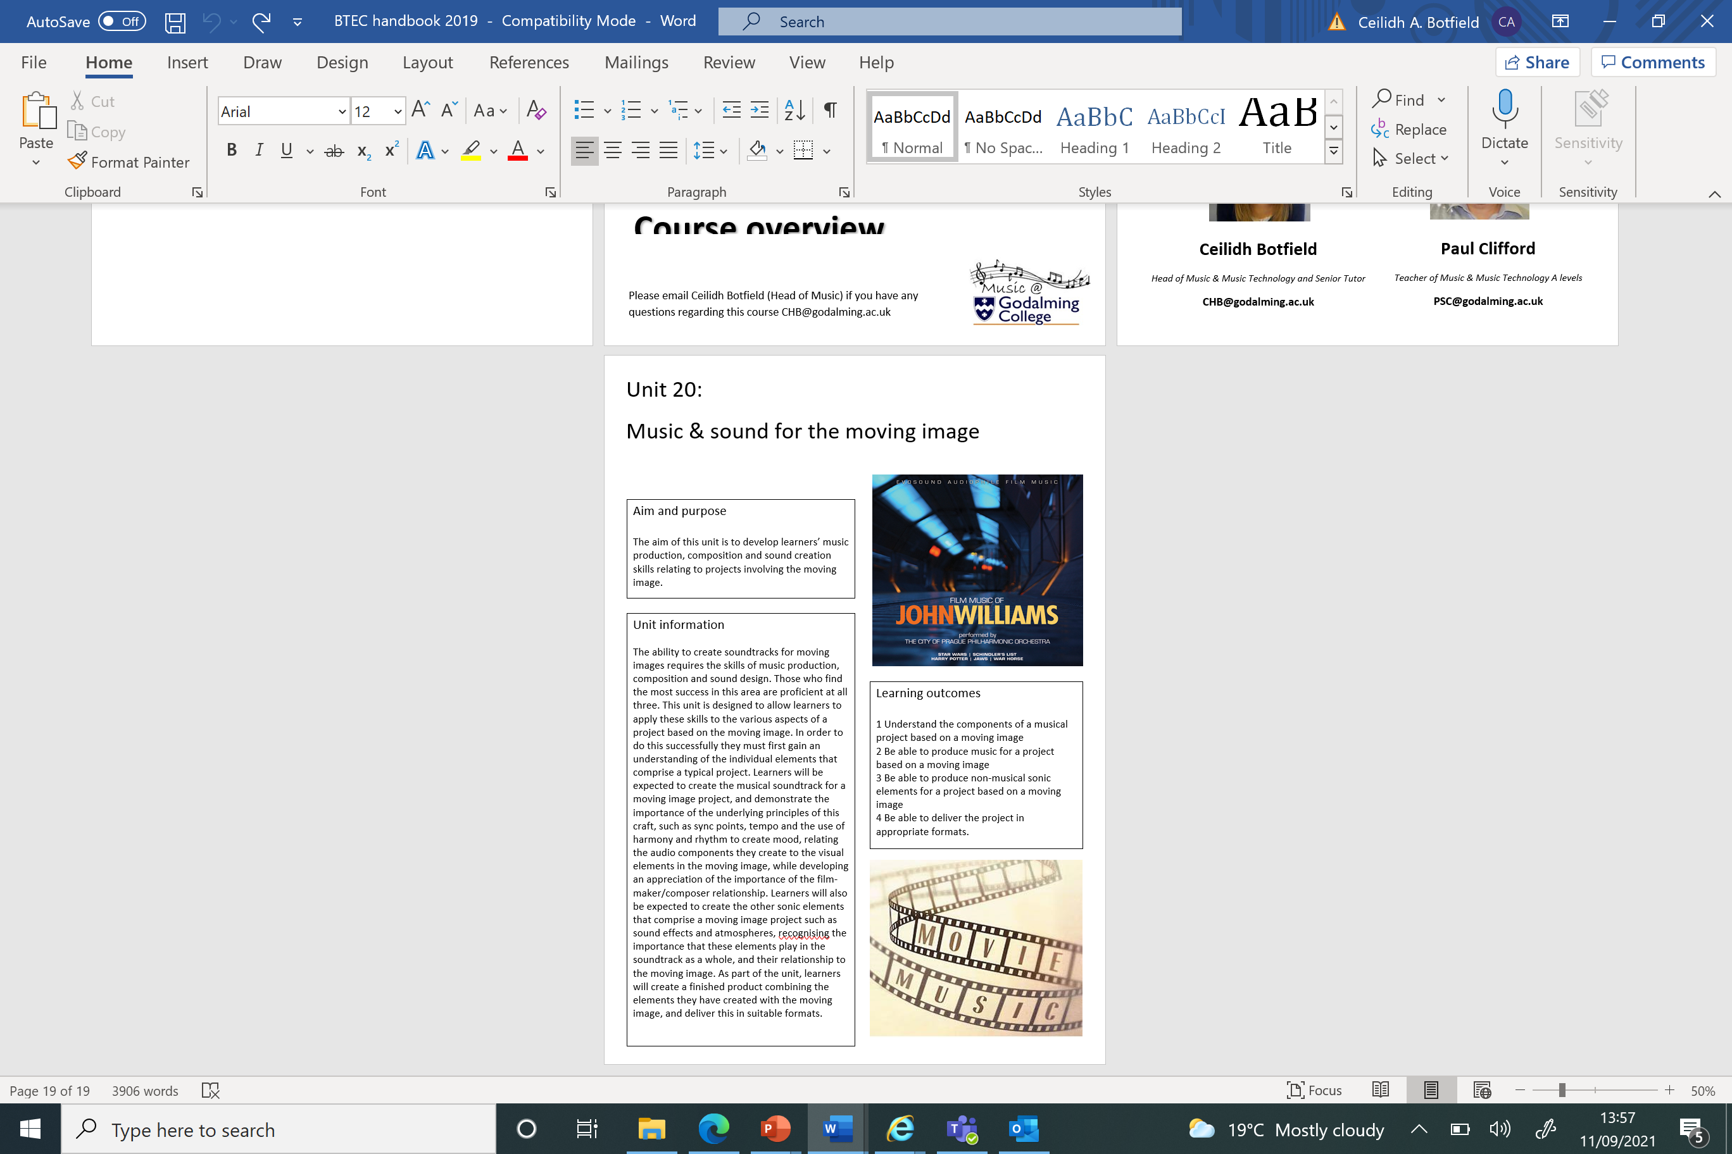**UNIT 20: MUSIC & SOUND FOR THE MOVING IMAGE**

**PROVISIONAL SCHEME OF WORK 2022-2024**

|  |  |  |  |
| --- | --- | --- | --- |
| **FIRST YEAR** | | | |
|  | **UNIT 25** | **UNIT 29** | **UNIT 32** |
| **Half term 1** | **Assignment 2&3** | **Assignment 1** | **Assignment 3** |
| **Half term 2** | **Assignment 1&4** |
| **Half term 3** | **Assignment 1** | **Assignment 2** |
| **Half term 4** | **Assignment 4** | **Assignment 3** | **Assignment 2** |
| **Half term 5** | **(Start unit 9)** | **Assignment 4** | **(Start unit 43)** |
| **Half term 6** | **(Work on units 9 & 43)** |
| **SECOND YEAR** | | | |
|  | **UNIT 9** | **UNIT 20** | **UNIT 43** |
| **Half term 1** | **Assignment 1** | **Assignment 1** | **Assignment 1** |
| **Half term 2** | **Assignment 2** | **Assignment 2&3** | **Assignment 2** |
| **Half term 3** | **Assignment 3** |
| **Half term 4** | **Assignment 4** | **Assignment 4** | **(Work on units 9 & 20)** |
| **Half term 5** | **Resubmissions as needed** | | |

**BTEC Music Technology**

**50:50Help and Advice**

Key to your success whilst studying in the Department is the level of effort and work you put into your subjects outside of lessons. The college’s expectation is that you match every hour of class time with an hour of independent study – **50:50**. This will include completing **structured homework** tasks set by your teachers but will also require you to **work independently**; finding ways to consolidate and extend your understanding. To help you to do this, the list below gives some ideas or activities to consider each week.

**coursework *(Suggested time = 1.5 hours per lesson/per assignment)***

Your BTEC coursework will require both practical and written time and both elements will be demanding. Most practical assignments will involve a written element to allow you to explain and justify your approaches and understanding. Assignments can only be passed with all tasks completed. You should spend your 50:50 time working on the written aspects on your assignments in a focussed environment. You are also able to book studio spaces in the department for developing your practical work.

**WATCH VIDEO TUTORIALS AND MASTERCLASSES *(Suggested time = 1 hour per week)***

A wide and varied range of subject specific tutorials are available on YouTube; from microphone and recording approaches to Logic tutorials. Further masterclasses are available from leading online providers such as Produce like a Pro, Audio Masterclass and Audio Legends for more specifically focussed lessons.

**CREATE YOUR OWN MUSIC *(Suggested time = 15 minutes per week)***

If you have access to Logic Pro then this could be invaluable, however this requires having an Apple Mac computer and the software, both costly items. You can however practice your composition and production skills for free using the online Digital Audio Workstation platform Bandlab. This is a simplified DAW which provides enough features to produce music of your own and practice the skills required for this course.

**Watch a documentary *(Suggested time = 45 minutes per week)***

YouTube has a small number of subject related documentaries available that will allow you to gain some insight into the way that the industry works and what it’s like to work as a freelancer. Documentaries such as Sound City, Tom Dowd and the Language of Music, Scratch, Classic Albums – Pink Floyd: Dark Side of the Moon or Moog.

**WORK EXPERIENCE *(Suggested time = 1 hour per week)***

There is no better way to develop your CV and portfolio then experience working in the industry. Call around Music venues and studios, offer your services for free (at first) and send follow up emails. Most jobs in the industry start out at the bottom end of the ladder, but setting up and moving equipment can develop into paid work behind a mixing console in time! Speak to your teacher or the careers department for tips on gaining work experience.





