[](http://www.basestudios1.co.uk/wp-content/uploads/2014/12/recording-studio1.jpg)****

Music Technology( Pearson/Edexcel)

9MT0

Music Technology A-Level

**Course Handbook**

**NAME:**

**Introduction to the department**

Welcome to

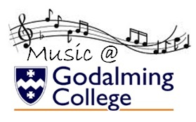

We are looking forward to teaching you!

The purpose of this guide is to provide you with a range of information and advice to help you organise your programme of study, learn independently, and equip you with important information about the department and how it can support you.

**Department staff:**



**Dean Orsmby**

**Teacher of BTEC Music Technology**

*MPQ and Arts Award Co-ordinator*

**DNO@godalming.ac.uk**

**Paul Clifford**

**Head of Music & Music Technology**

**PSC@godalming.ac.uk**



**Joe Barnes**

**Music Technician**

**JCB@godalming.ac.uk**

**Director of Faculty:**

Mark Woodward

Along with the names above, the following departments and places will be useful whilst studying on the course:

**The ILC** – your go-to place to complete work and independent study outside of lessons. The Silent Study area provides an area to work individually, whilst the library contains an excellent selection of wider reading. Make sure that you have familiarised yourself with the ILC when you start the course

**The Exams Office** – for any questions you have about your exam entries, exam timetable or remarks and script requests.

**Learning Support** – for any extra support or advice you need to help you study in general. If you are struggling to organise and manage your workload; need help refining your essay-writing technique; help with revision; or if you think you might be entitled to any exam concessions, learning support are the people to talk to.

**Careers** – when you start to think about your options after college, whether university or employment based, careers can give you advice on where to apply and help in producing a personal statement.

**ExpecTations**

**What is expected of students?**

1. **Attendance and punctuality** – learning cannot begin if you are not in lessons or if you arrive late to them and miss important content. Students should maintain full attendance and punctuality. Any unavoidable and legitimate absences should be accounted for properly, meaning that students get a parent or a guardian to contact college and then email their teacher(s) to catch up on missed work
2. **To maintain a mature and respectful learning environment** – this means behaving in and out of lessons in a way expected of a Sixth-Form student: listening carefully to the views of others and offering constructive contributions in class
3. **To stay up-to-date** – you will be set weekly structured preparation or homework tasks and it is essential that these are completed on time and in the required level of detail. We use structured homework to consolidate particular content or to set up lessons to come. If work is incomplete your understanding will be incomplete and you will under-perform. If you arrive at a lesson having not completed preparation work then your teacher may also ask you to leave and complete this elsewhere.
4. **To stay organised** – managing the demands of a minimum of three subjects is challenging, especially when you are being taught more than one unit in each. You need, therefore, to stay organised. This means preparing a folder for each of your units, bringing the correct materials to each lesson and recording homework in the same place every time
5. **To meet the 50/50** – students are expected to conduct 4.5 to 6 hours of independent study a week. This will include structured preparation or homework tasks set by your teachers along with proactive tasks you complete yourself to consolidate and extend your understanding. See the advice later in this booklet for more help on doing this.
6. **To make the most of feedback and support** – you will get a lot of feedback during your time on the course. This will come as written feedback on assessed work, verbal feedback on general class or homework, and targets set at formal 1-1s. Feedback needs to be recorded carefully by you and acted upon. When you get back assessed work, for example you will be asked to record your own targets based on this, and may, in addition, be asked to attend a lunchtime workshop to help process feedback.
7. **To be resilient** – any subject will at times be very challenging. At times you will not do as well as you want or will struggle to understand a new topic or idea. You need to be prepared to spend more time on areas such as these and to seek out extra help when needed. These experiences of finding areas where you are not doing so well and improving them are what lead to success.

**What can you expect of your teachers?**

1. **To deliver structured and engaging lessons** – your teachers will deliver lessons designed to challenge your understanding whilst also helping you to gradually build up your knowledge and skills. These lessons will follow the scheme of work, a version of which you can see in this handbook.
2. **Regular assessment and feedback** – in addition to your benchmark assessments (four in the first year and three in the second) your teachers will regularly set you exam-style questions to give you opportunities to practice and improve. Feedback will be given on standardised sheets which include the relevant mark scheme and clear developmental targets
3. **Structured weekly work** – you should expect to be given a significant amount of work to do by your teachers each week. You will be given guidance on how long this should take and completed work will be checked and/or taken in
4. **Additional support** – your teachers will be happy to provide extra help outside of lessons either informally, by responding to emails, or more formally through departmental workshops. Workshops are the best opportunity to received additional help and work best when students come to lunchtime sessions with a specific area of confusion or set of questions to get answered

**Approach to remote teaching and learning**

Following the closure of schools and colleges in March 2020, teachers and students have adapted to a new environment of remote teaching and learning. How ‘remote’ this is depends on the wider context of COVID-19, but the department has clear plans, and expectations of its students, in each of the scenarios below.

1. ***Normal Opening: The College is open as normal; all students attend and follow a full, face-to-face timetable***

In this situation the department would run lessons, as normal and all of the expectations of students and teachers on the page before would apply

1. ***Blended Learning: students will receive a mixture of physical and remote lessons, attending college physically one week and remotely the other***

The department will continue to offer high quality lessons in this scenario although the exact nature of teaching and learning may vary depending on what content is being covered. Students should expect a mixture of:

* **Streamed lessons** – when appropriate, lessons including half of the class will be streamed live through Microsoft Teams to the other half of the class learning from home
* **Recorded content** – tutorials, demonstrations, presentations etc. will be pre-recorded for students to watch and complete a set of follow-up tasks
* **Structured independent work –** students may be longer project-style work, or work that is made up of several structured tasks and asked to work on this independently for a period of time, during which their teacher will be available for support
* **Preparation work** **–** class time may be used to set students independent work in the form of research or pre-learning to prepare them for a specific live lessons, which will then be used to assess students’ level of understanding of the work they have completed.
* **Homework** – students will also be expected to complete homework tasks

1. ***Remote Learning: students will receive remote lessons and assessment will be conducted remotely***

In the event that college is not open for physical lesson, teaching and learning will move online through the combined use of Microsoft Teams and Godalming Online. The specific nature of each week’s learning will vary depending on what is being covered, but students should expect a mixture of:

* **Live lessons through Microsoft Teams** – this is a fantastic platform that allows classes to video-call, watch presentations, take part in Q&A, group work, 1-1s all in real-time. Teams lessons will be the main part of remote teaching and learning but may take a slightly different form or length than physical lessons to help students engage fully. For example, a 1.5 hour physical lesson might translate to a 30-45 minute Teams lessons, made up of a brief teacher-led presentation and class Q&A, followed by 45 minutes of structured independent work, during which time the teacher conducts 1-1s with students
* **Online submissions** – students will upload work regularly to help their teacher monitor their progress and offer support when needed. This will be done through the ‘Assignments’ feature on Teams or through Godalming Online
* **Remote Workshops** – in addition to remote lessons, department workshops will continue remotely to provide students with extra points in the week to get 1-1 help on content, homework or remote learning in general

**Expectations of students in scenario 2&3 –** if students find themselves learning remotely or in a mixture of physical and remote lessons, then the department has clear expectations of how they should work in this environment. The department has considerable experience in delivering content remotely and key to this is students remaining engaged, establishing a clear working routine and communicating effectively with staff. More specifically it is expected that students will:



* Attend all remote lessons unless told otherwise by their teacher
* Actively take part in remote lessons e.g. contribute questions and answers, take part in group work, turn webcams on (with the background blurred) when asked to by their teacher
* Submit all work via Godalming Online or Microsoft Teams by the deadline set
* Communicate regularly with their teachers, either as part of scheduled 1-1s or more informally to discuss work or any problems they might be having. This will be through Email or Teams.

To identify where your remote strengths and weaknesses might be, complete the specific department audit below. This is made up of the essential skills you would need to learn in a remote or blended environment.

|  |  |
| --- | --- |
| **Remote Learning Skills Audit that you need to master to succeed on this course** | ***Tick*** |
| Log on to Office 365 using your college details (in college and at home) |  |
| Open Microsoft Teams and find a class team |  |
| Join a lesson on Teams and post a comment |  |
| Download the Teams app on your phone |  |
| Upload or attach documents in Teams |  |
| Save documents on OneDrive |  |
| Access your OneDrive files at home |  |
| Share documents, PowerPoints etc without attaching them to emails |  |
| Access Godalming Online course pages and download files |  |
| Upload work onto Godalming Online |  |
| Access E-textbooks needed on the course |  |
| Log on to any magazines or websites needed on the course |  |
| Access Estream to watch films/documentaries/pre-recorded content |  |
| Download free software DAW Bandlab or Garageband |  |
| Follow *godalmingcollegemusic* on Instagram to access live performances |  |

*[](https://www.google.co.uk/url?sa=i&url=https%3A%2F%2Flogotyp.us%2Flogo%2Fmicrosoft-teams%2F&psig=AOvVaw2Wl1l6bVS-gskR2jhCsLQD&ust=1594130388988000&source=images&cd=vfe&ved=0CAIQjRxqFwoTCNDg_8_kuOoCFQAAAAAdAAAAABAD)*There are lots of places you can go to get help with the skills listed above.

To begin with, speak to your teachers to get help with the basics of using Microsoft Teams or Godalming Online. This can be done at the start of the year through departmental surgeries and through workshops. A good idea would be to bring the completed audit above to a workshop and go through this with your teacher to fill in any gaps.

The IT Department are also available to offer more technical support or if you run into a problem your teacher cannot resolve. If in college, IT can be found on the top floor of the 300s. Also have a look at the IT Helpdesk on Godalming Online, which has help on using features such as Office 365. Finally IT are also contactable via [ITsupport@godaming.ac.uk](mailto:ITsupport@godaming.ac.uk)

If you are concerned about how to organise your time and working habits during a period of remote learning, then speak to your tutor for ideas and techniques to work independently. The Learning Support Department are also available to discuss specific concerns or individual learning needs further.

|  |  |  |  |
| --- | --- | --- | --- |
| **Year** | **Unit content** | | **Percentage of qualification** |
| First year | Coursework | Recording | 20% |
| Technology Based Composition | 20% |
| Exam | Listening & Analysing Exam | 25% |
| Producing & Analysing Exam | 35% |
| Second Year | Coursework | Recording | 20% |
| Technology Based Composition | 20% |
| Exam | Listening & Analysing Exam | 25% |
| Producing & Analysing Exam | 35% |

.

Structure of the course

Course overview

[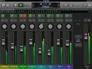](https://www.google.co.uk/url?url=https://gigaom.com/2013/08/03/making-the-switch-from-garageband-to-logic-pro-x/&rct=j&frm=1&q=&esrc=s&sa=U&ved=0ahUKEwjb2cWK-sDNAhWIDsAKHXRrCxYQwW4INjAQ&usg=AFQjCNHPAhc-Acj9ZwxLZ8hEeL9kWeLKcg)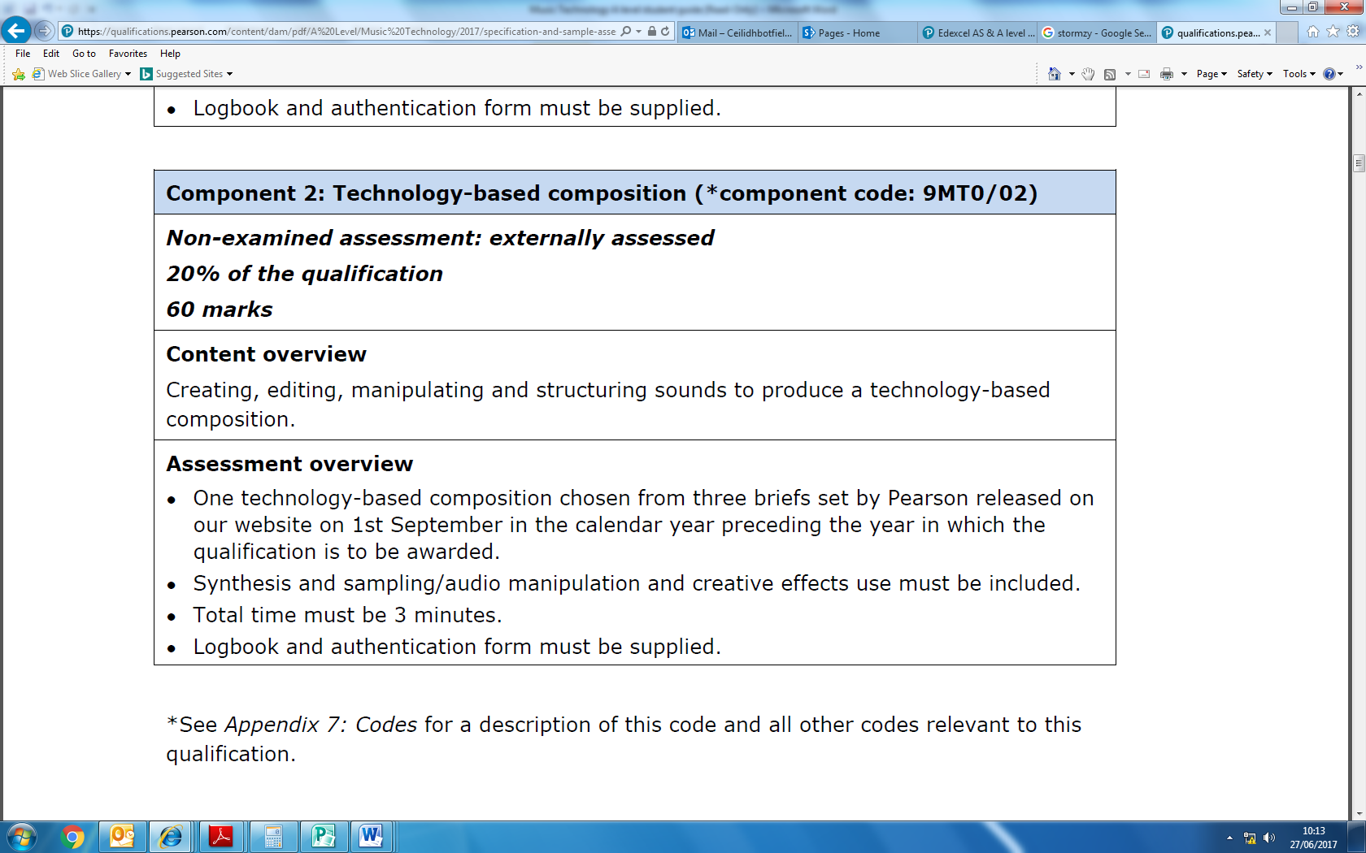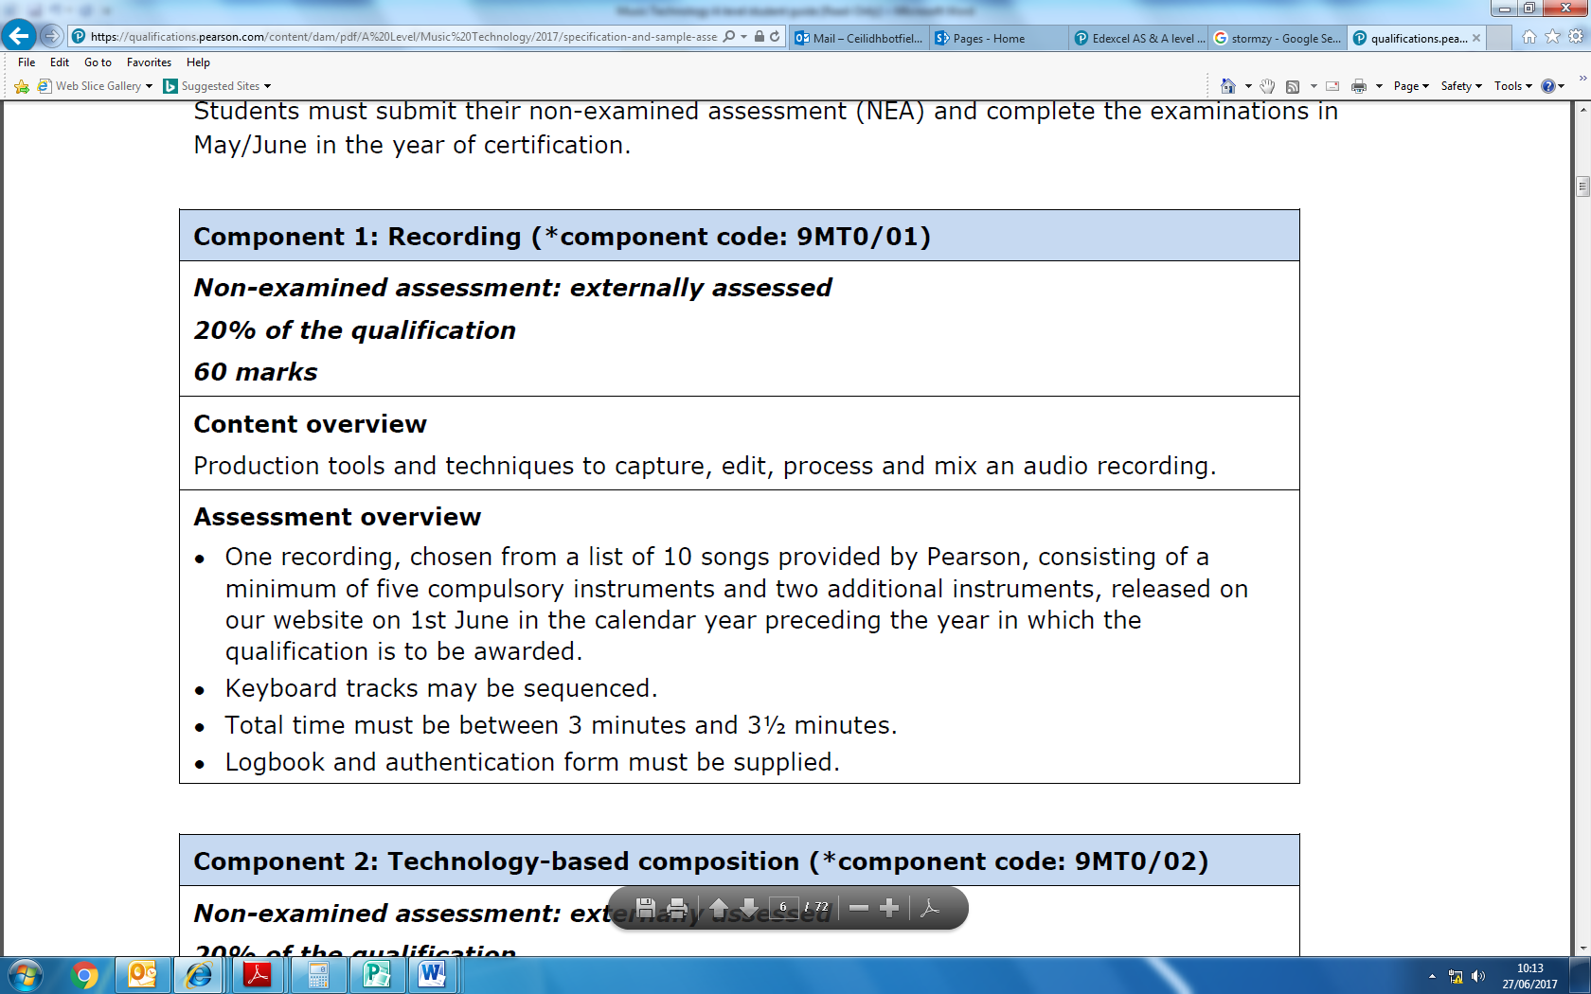[](http://www.google.co.uk/url?url=http://www.world-of-songwriting.com/recording-vocals.html&rct=j&frm=1&q=&esrc=s&sa=U&ved=0ahUKEwjAr621-cDNAhWlK8AKHU_MCJwQwW4IHDAD&usg=AFQjCNGeLOKPUWezpiu_bplsk5FCLIKNDg)[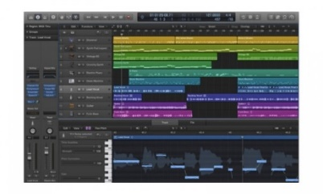](https://www.google.co.uk/url?sa=i&rct=j&q=&esrc=s&source=images&cd=&cad=rja&uact=8&ved=0ahUKEwiZr7W92N3UAhXMVRQKHZbpAkQQjRwIBw&url=https://www.hhb.co.uk/product/apple-logic-pro-x-(multi-seat-education-licence,-20-minimum)/3368/&psig=AFQjCNHUre_tKi32_3QxF4l2THmHIxJusg&ust=1498641358422268)COURSEWORK COMPONENTS

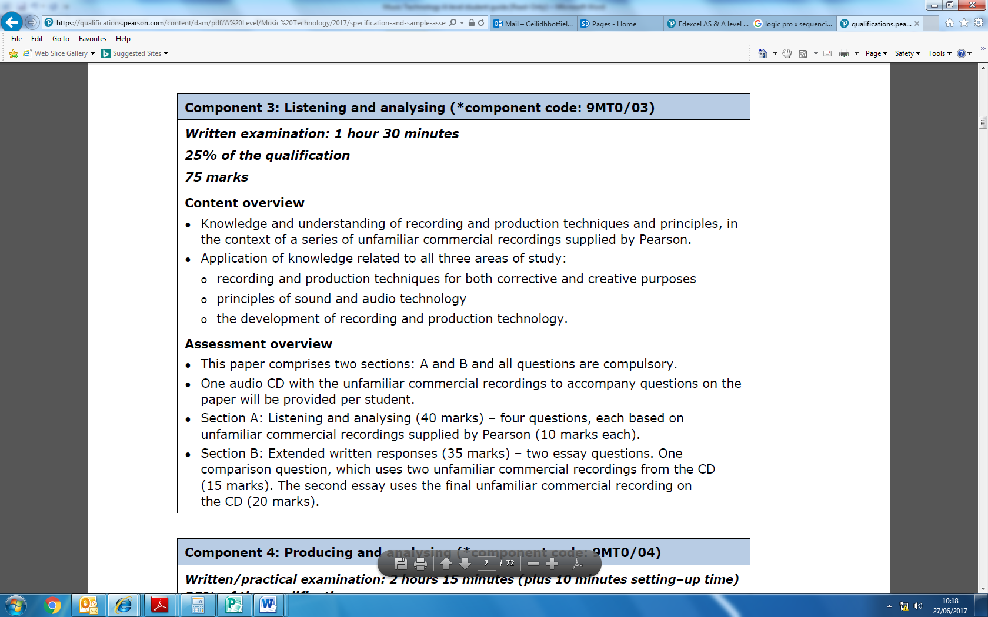[](http://www.google.co.uk/url?sa=i&rct=j&q=&esrc=s&source=images&cd=&cad=rja&uact=8&ved=0ahUKEwjV046Y2t3UAhXG8RQKHWZ8AdMQjRwIBw&url=http://www.uwgb.edu/acda/NEW%20WEBSITE/Members/Historian.htm&psig=AFQjCNExt_1hOVvyuOsiJ1hc1Rn1u_Araw&ust=1498641868768570)EXAM COMPONENTS

[](http://www.google.co.uk/url?sa=i&rct=j&q=&esrc=s&source=images&cd=&cad=rja&uact=8&ved=0ahUKEwilyYDa2d3UAhXGVhQKHe_1DucQjRwIBw&url=http://www.piehole.ie/TomD&psig=AFQjCNFtt_YuTnCrt5VEh_J2BFj2T7T2Tg&ust=1498641740599313)

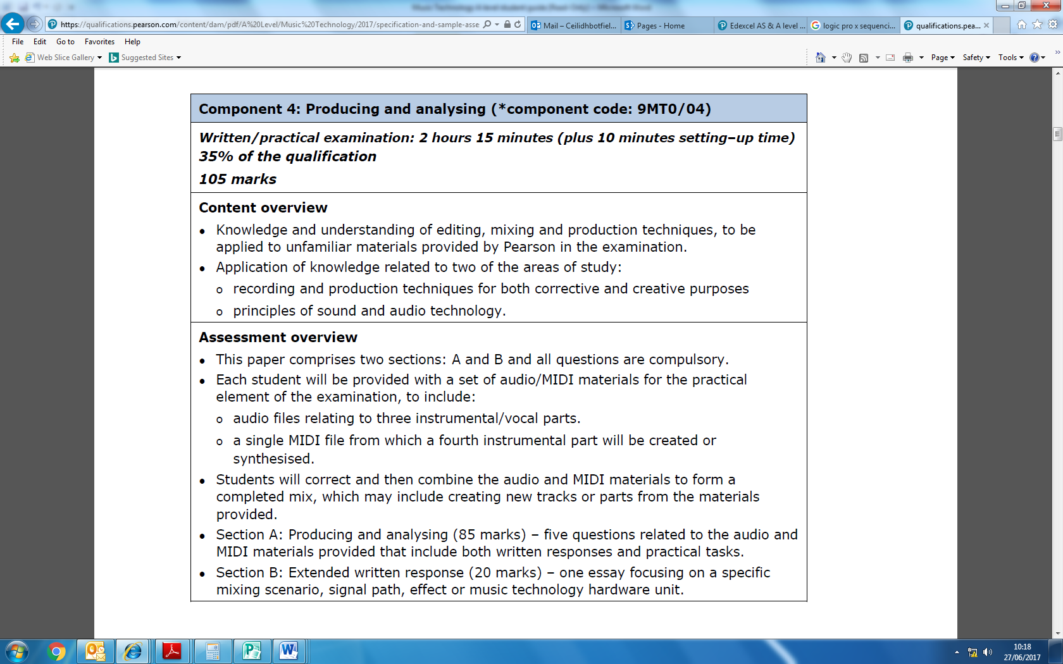

Provisional scheme of work

|  |  |  |  |  |
| --- | --- | --- | --- | --- |
|  | **Component 1** | **Component 2** | **Component 3** | **Component 4** |
| Year 1 | | | | |
| Half term 1 | Recording Vocals and Ac.Guitar | Sequencing Basics:  MIDI inputting and editing | History and development of music tech-Era 1 | Fundamentals of sound  DAW |
| Half term 2 | Recording Bass, E.Guitar and Piano | Sequencing Basics:  MIDI inputting and editing | History and development of music tech-Era 2 | Microphones  MIDI |
| Half term 3 | Mixing:  Vocals and Ac.Guitar | Composition Basics:  Structure, Rhythm and Texture | History and development of music tech-Era 3 | EQ  Dynamic Processing |
| Half term 4 | Mixing:  E.Guitar, Bass and Piano | Composition Basics:  Harmony and Melody | History and development of music tech-Era 4 | FX Processing  Analogue Theory |
| Half term 5 | Mastering  Final mix | Sound Design:  Synthesis  Comp 1 Final | History and development of music tech-Era 5 | Digital Audio  MIDI |
| Half term 6 | Recording Drums | Sound Design:  Sampling | Revision Benchmark 4 | |
| Year 2 | | | | |
| Half term 1 | All tracking completed | Sound Design:  Creative FX | Question 6 Wider impact essay technique | Numeracy:  Acoustics |
| Half term 2 | Mixing:  Drums | Responding to the set brief | Era 1 and 2 revisted | Numeracy:  Digital |
| Half term 3 | Draft Mix  Logbook | Draft composition  Logbook | Era 3 and 4 revisted | Advanced audio editing techniques |
| Half term 4 | Final mix and master | Final mix and master | Era 5 revisted | Advanced MIDI editing techniques |
| Half term 5 | Revision and exam technique | | | |

**Assessment**

When starting the course, it is important to know how the course is assessed. All assessed work is marked around what are known as **‘assessment objectives’** (AOs) which have been set by the exam board. You need to understand what each of these is and how many marks it carries for each type of question. If you can do this then you will know what skills to demonstrate and to what extent for each question on the exam.

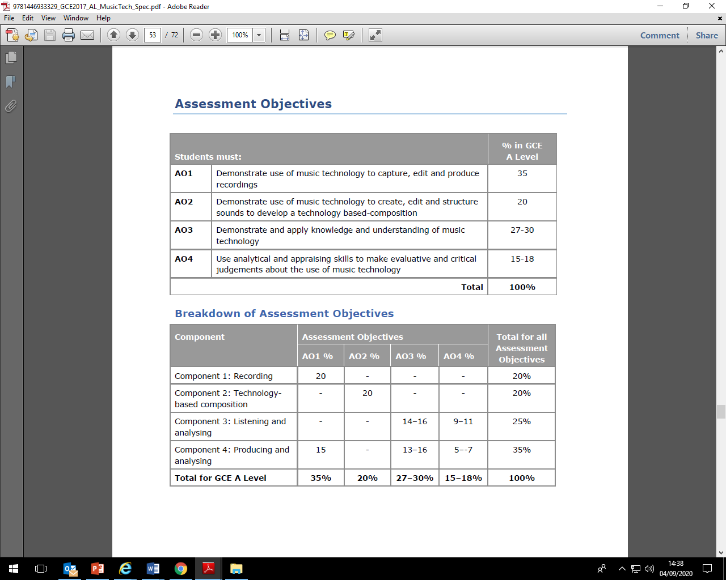

**A-Level Mark schemes**

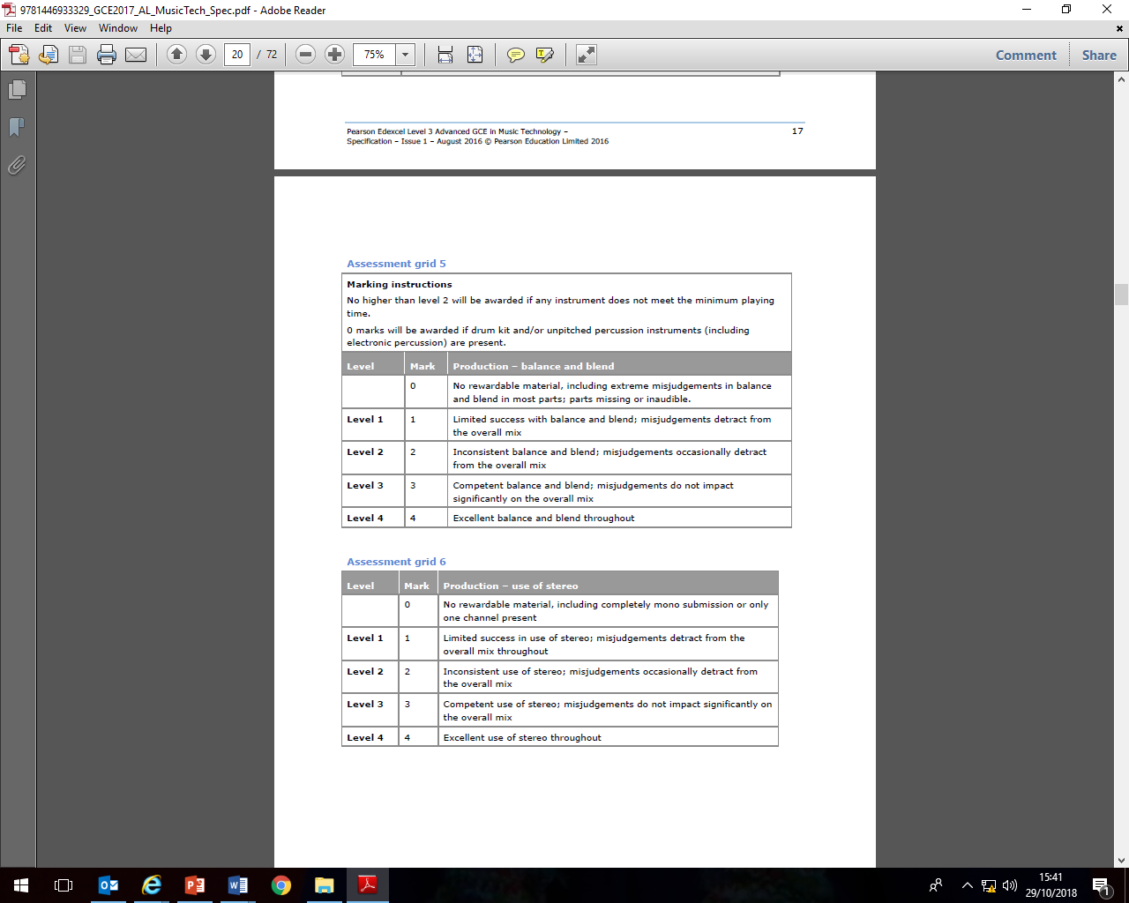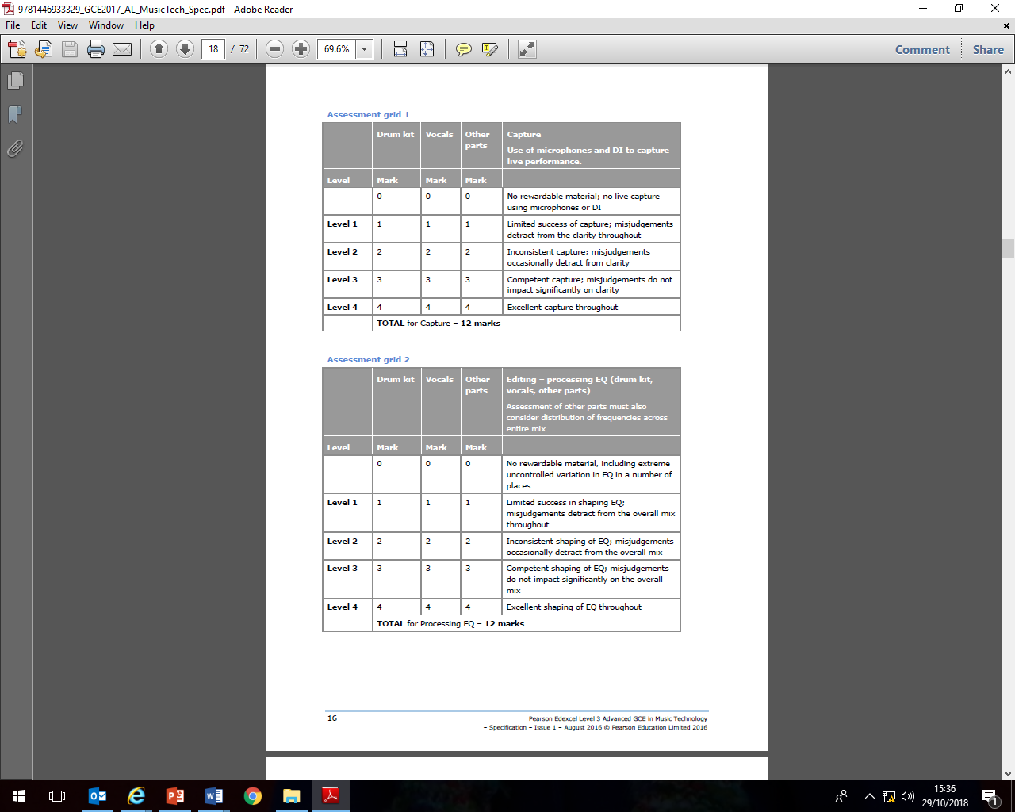Component 1: Recording

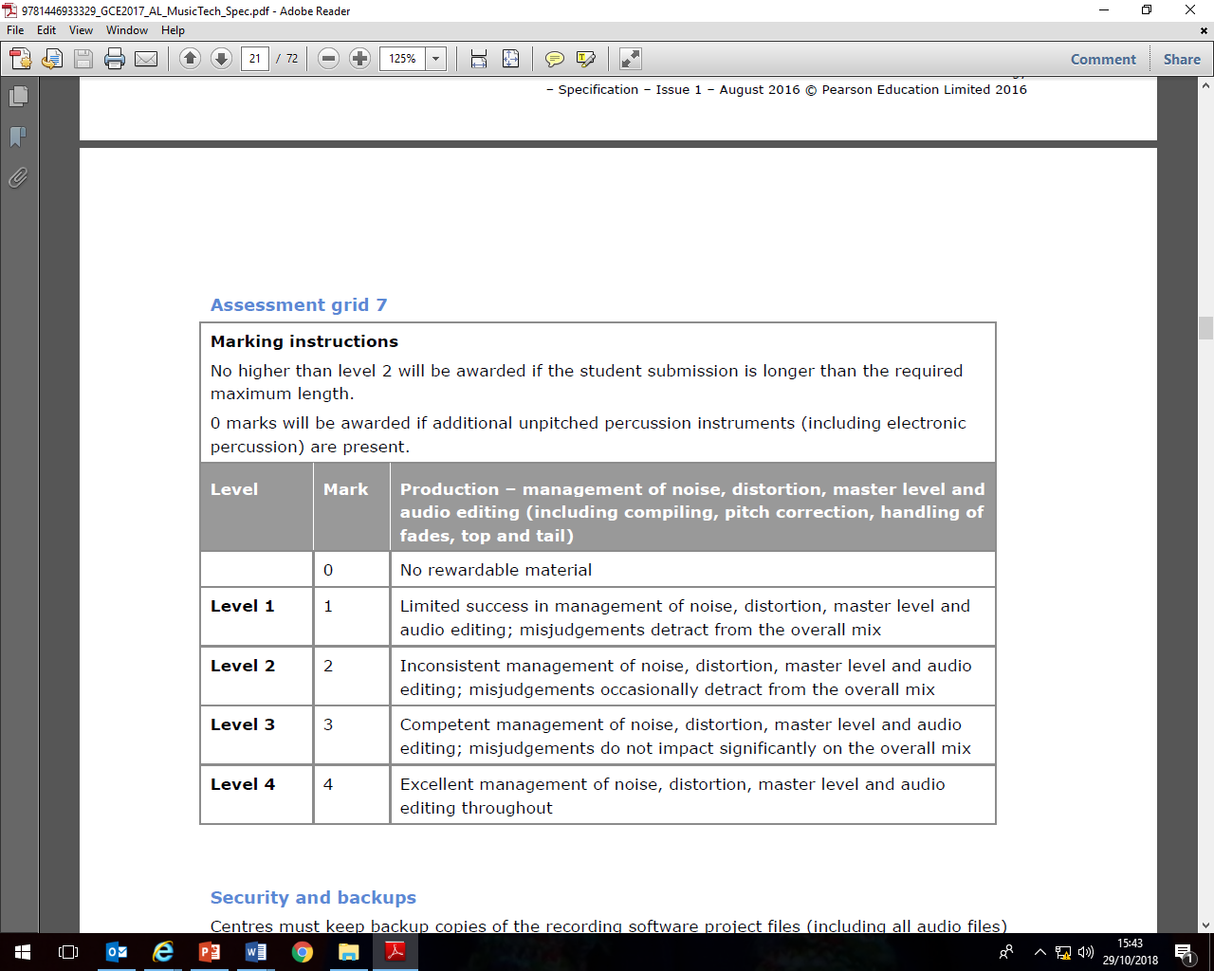

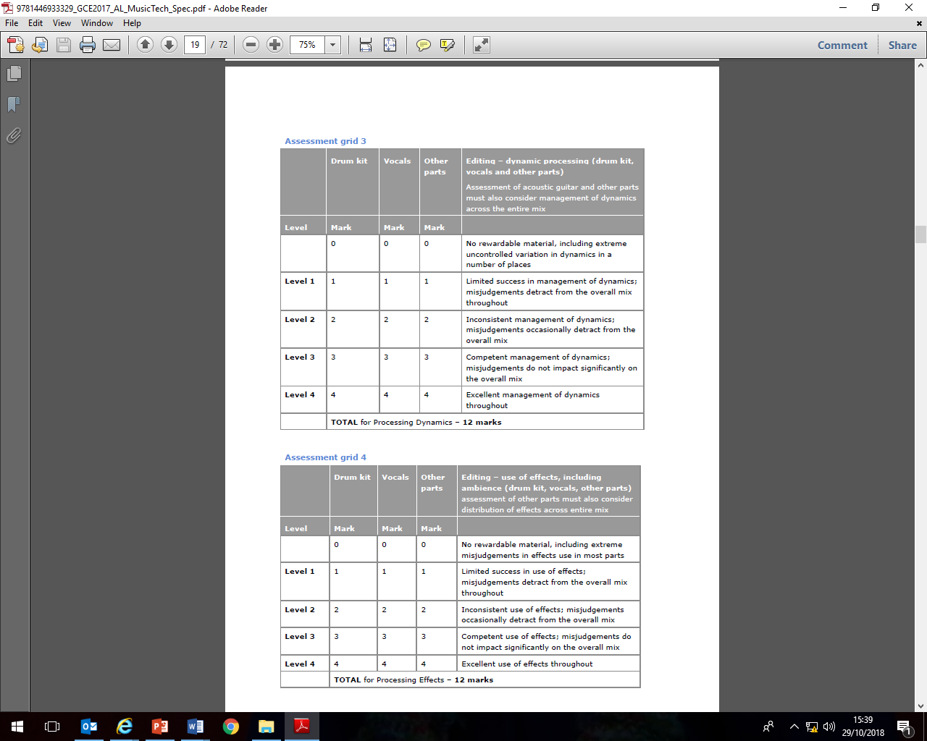

Comments

Component 2: TECH-BASED RECORDING

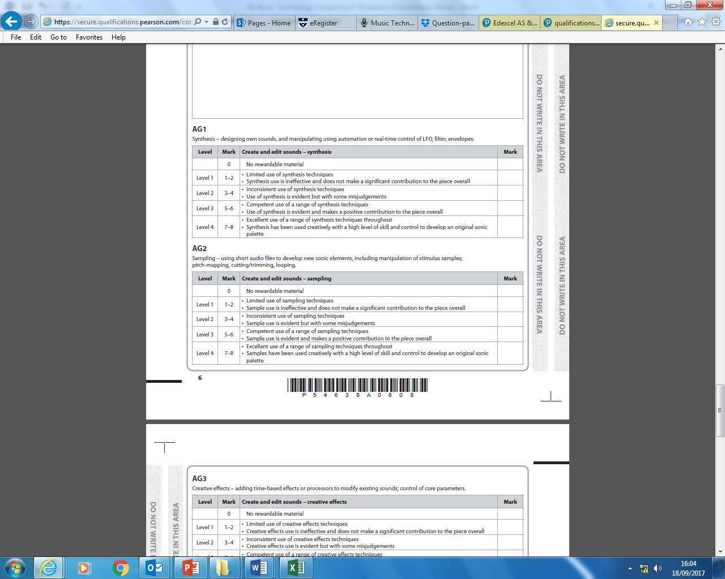

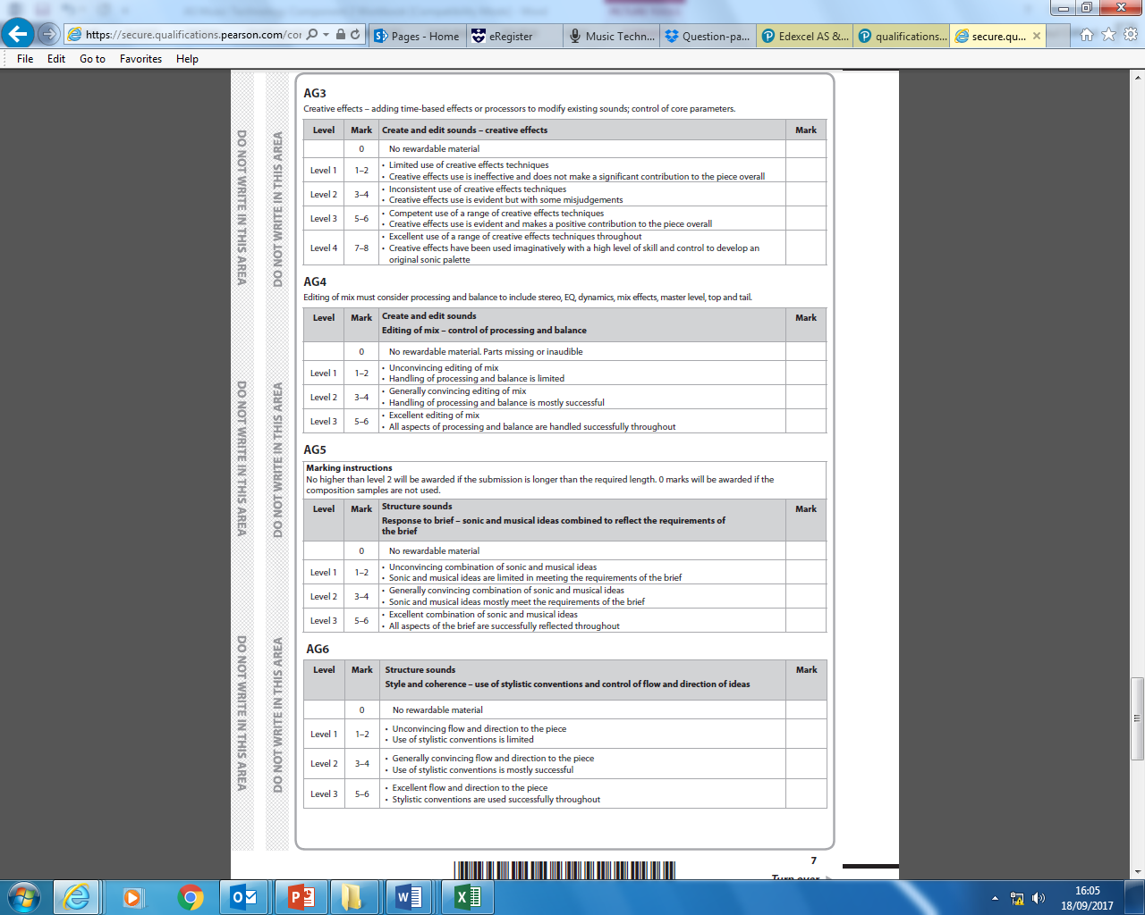

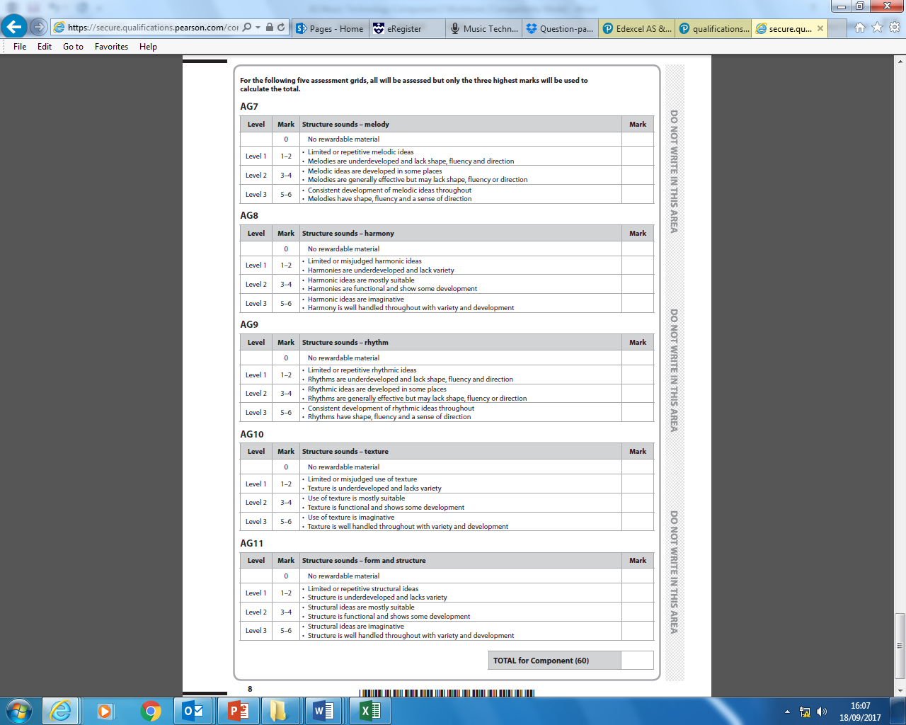

**Example Exam Paper**

Component 3: listening and analysing

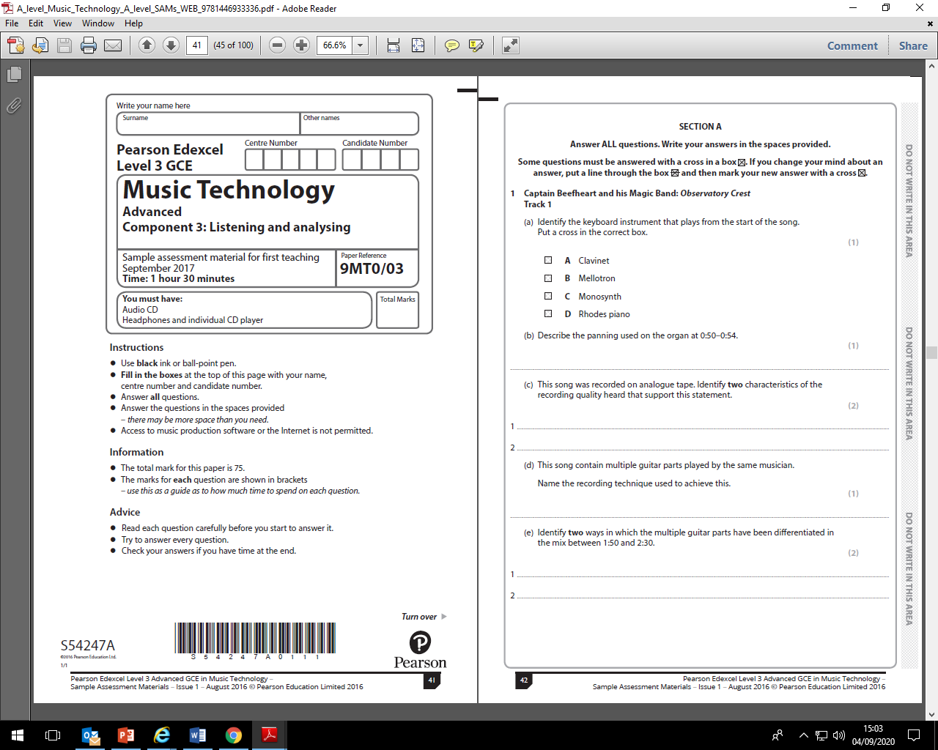

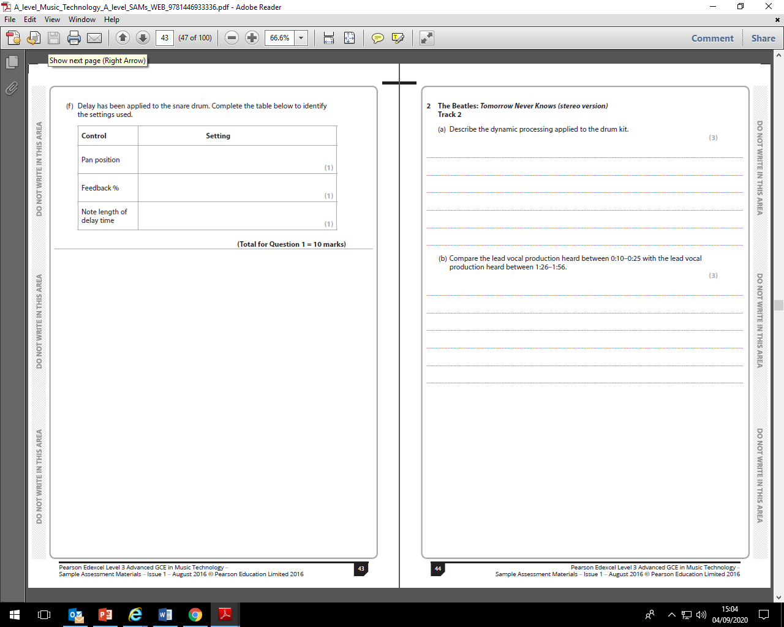

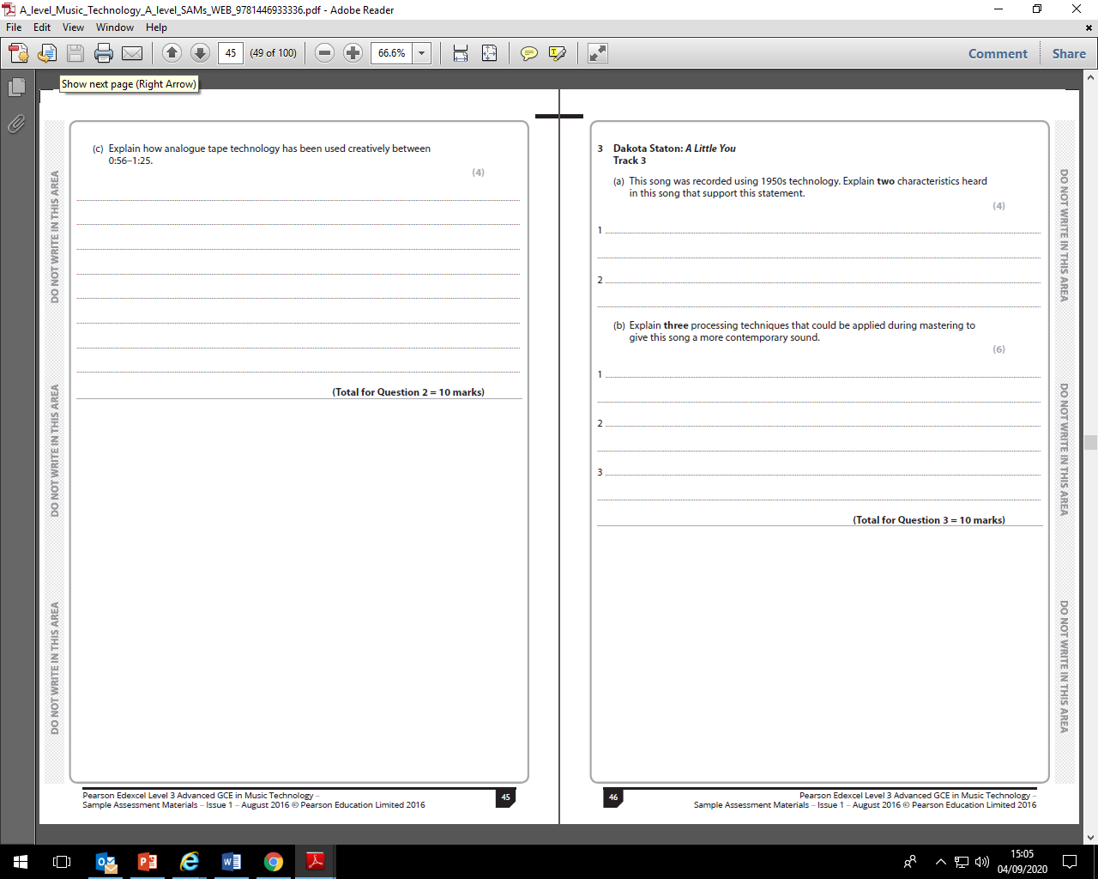

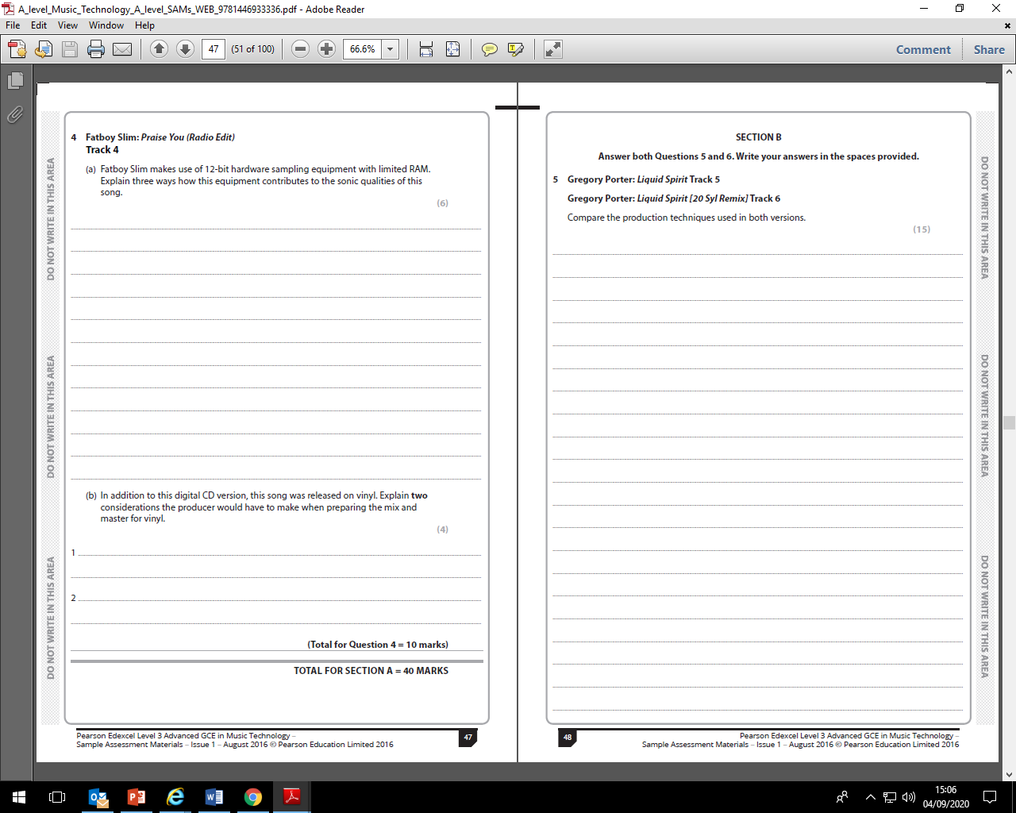

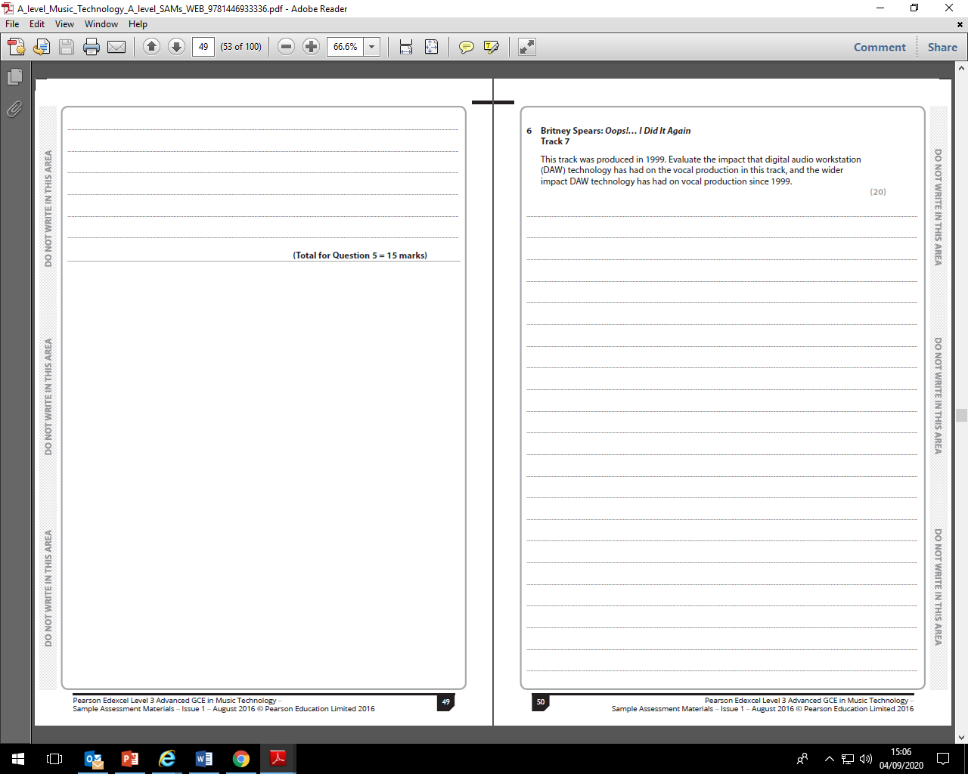

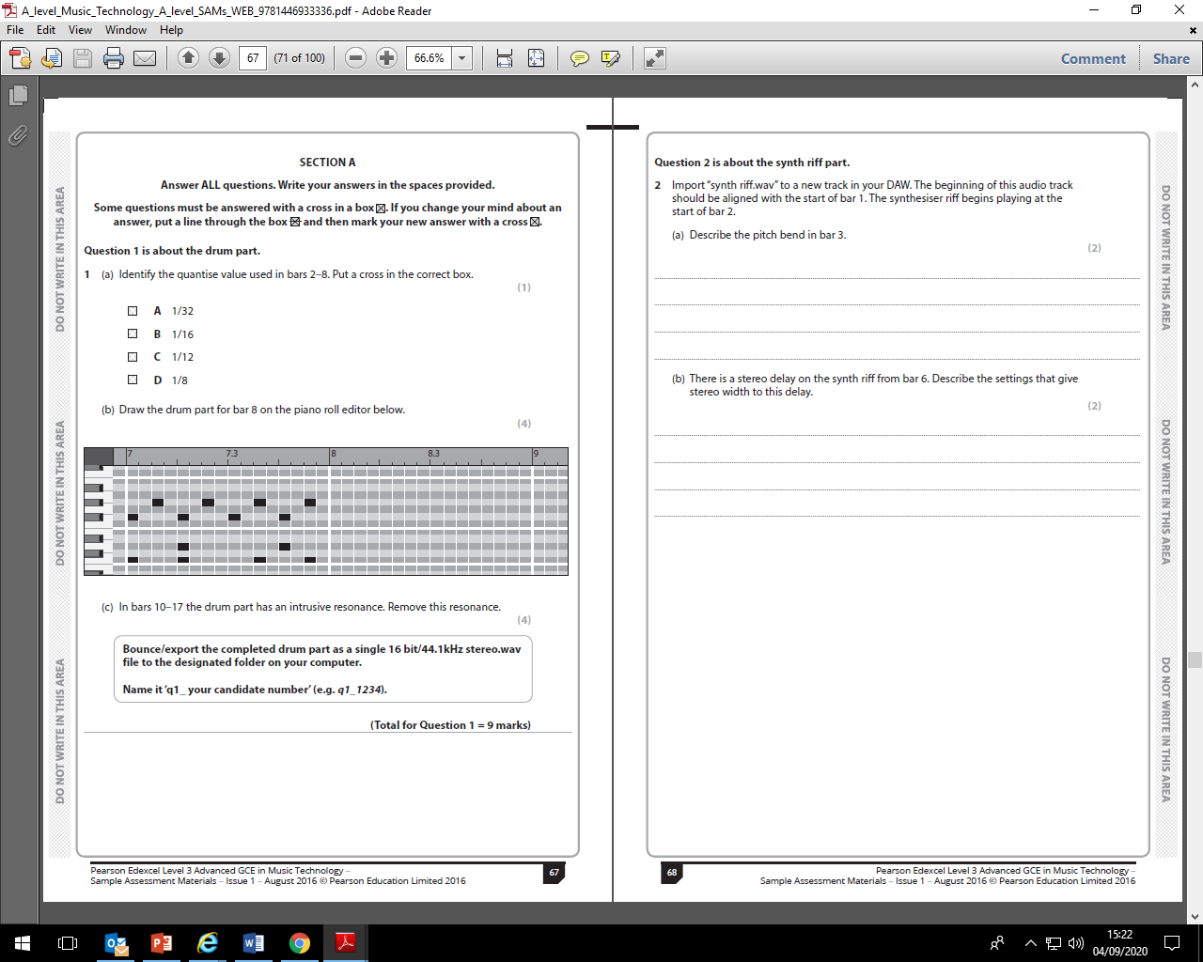Component 4: producing and analysing

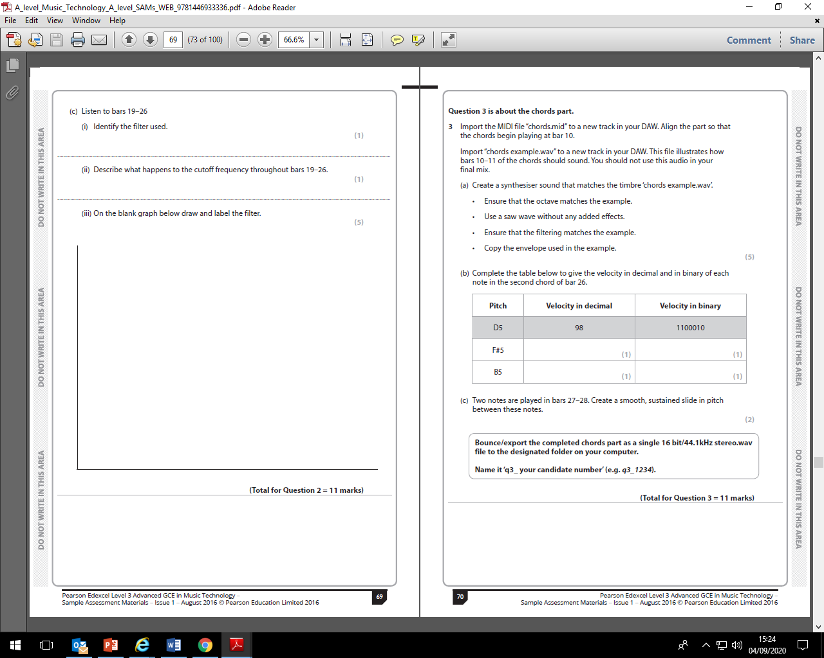

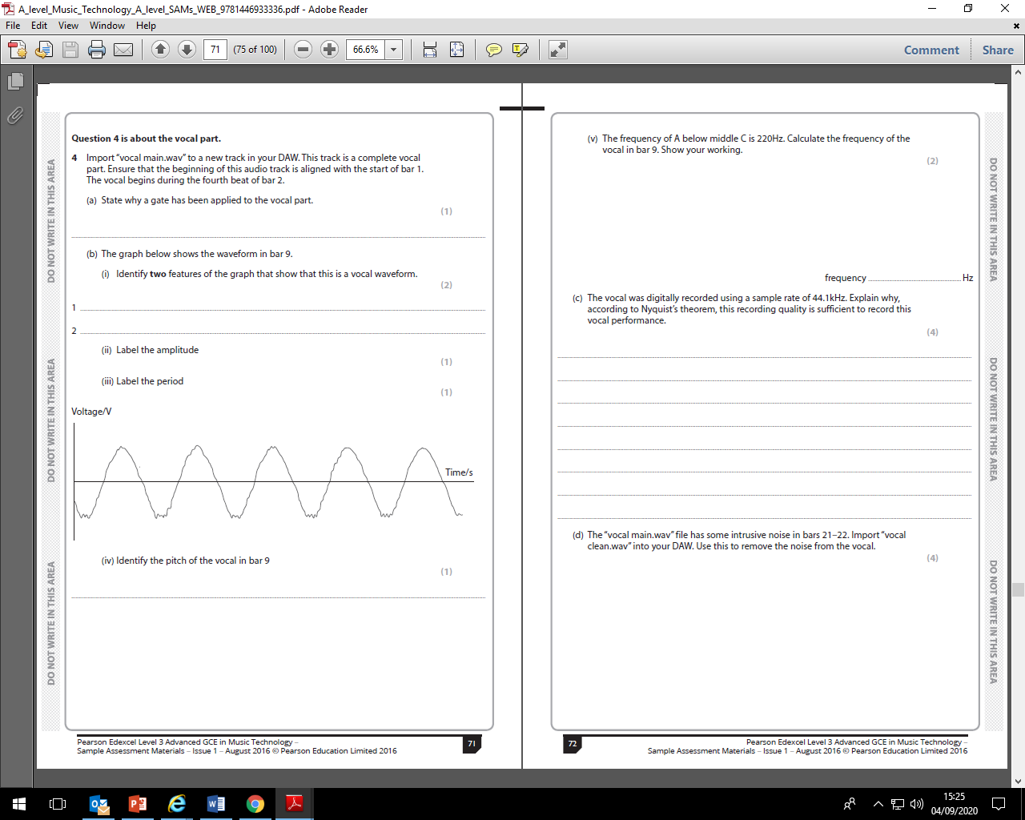

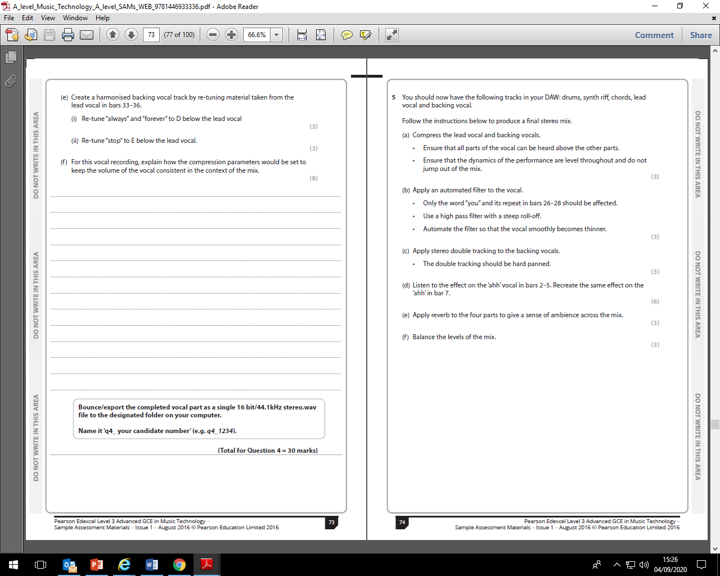

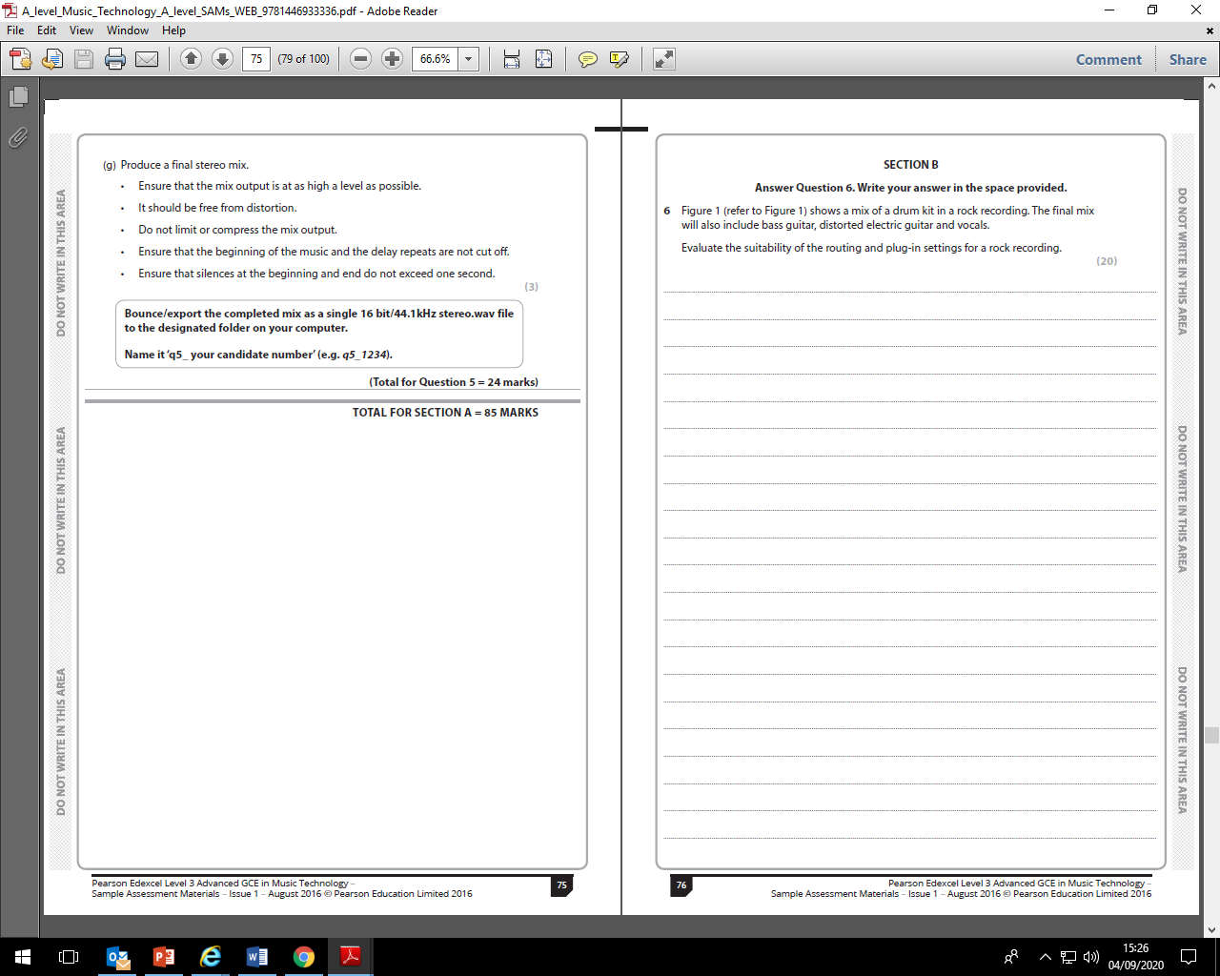

**Music Technology A level Assessment Policy 2022-24**

**The Importance of Feedback and Learning Outside the Classroom – ‘50:50’**

Learning will not happen instantly and takes time; attending lessons is not enough, you also need to be working outside of class, to learn new information, practise your sequencing and recording skills, and consolidate learning. In the process, you will make mistakes but hopefully feedback will enable you to learn from these mistakes. Better to make a mistake during the year and correct it, than make your first mistake in the final assessment/exam! Feedback is essential for your learning and will consist of whole class (teacher runs a session in lessons), written (teacher marking), peer (where you feedback on someone else’s work in the class) and self (where you assess yourself).

There are 66 weeks of teaching weeks in total at College to help you learn and prepare for your final assessments. The classes taught by the Lead Subject Tutor who will be responsible for formalised 1-2-1s, writing your Student Reviews, seeing your parents at parents evening and for writing Action Plans.

In line with the College’s ‘50-50’ initiative, each week, homework will be set and could take between 4.5 to 6 hours in total. If the total amount of teacher-set homework in a week takes you 3 hours for example, then you will need to complete an additional 1.5 – 3 hours of independent study on top of this. Remember that you are expected to book the studio to practise recording techniques regularly, set aside time daily to work on your Logic and composition skills, and revise exam content learnt in class. We won’t always prompt you to do this.

**The Final Assessment**

|  |  |  |  |
| --- | --- | --- | --- |
| **Component 1 Recording (20%)** | **Component 2 Sequencing (20%)** | **Component 3 Listening and Analysing (25%)** | **Component 3 Producing and Analysing (35%)** |
| * Choose a song to record from the list released by the exam board June 2023 * Record and mix compulsory and additional instruments * Final mix, Logic project and completed logbook submitted to exam board for marking | * Choose a brief set by the exam board September 2023 * Submit 3 minute tech-based composition, Logic project and completed logbook to exam board for marking | * 1hr 30 mins exam sat in the summer term * Section A: Q1-4(10 marks each) based on unfamiliar commercial recordings(40 marks) * Section B: 2 essay questions. Q5 is a comparison question of 2 unfamiliar commercial recordings. Q6 is a wider impact question of an unfamiliar recording. | * 2hr 15 min exam sat in the summer term * Section A: 5 questions relating to the audio and MIDI files provided that include both written responses and practical tasks completed in Logic Pro X. Each task is exported as a .wav file and the final task(Q5) is a mix question worth 24 marks   (85 marks)   * Section B: Essay on a specific mix scenario, signal path, effect or hardware device.   (20 marks) |

**Types of Assessment**

* **Homework (Weekly):** Homework does not necessarily need to be completed at home! You can use free periods during the day to complete these tasks outside of lessons. To keep a good work/life balance, you might like to treat College as an 0845 to 1615 day and use your free periods in the library or the Music department completing tasks. This will minimise the work you need to complete at home and might make you more productive. Homework tasks will vary, but typically consist of:

Coursework: You are expected to complete the majority of your recording and composing coursework outside lessons. It is your responsibility to manage your time effectively to ensure your meet coursework deadlines. This will include planning ahead, as you need to book the studio, equipment and musicians to complete your tasks. It is important to do all coursework at college and therefore you must check availability of the music technology and studios on weekly basis to get the most out of your free periods. Remember Component 1,2 and 4 tests your ability to use music production software and equipment, and it is therefore essential to get into a daily routine of using the studio and music tech suite to develop your skills. Assessment of coursework will be regular and varied, this will include formal assessment at various checkpoints, peer assessment where you share your progress with the class, 121s with your teacher and using a production log for self assessment.

Exam components:

We will cover the history and development of music technology which are divided into 5 eras. You are required to identify the fingerprint features of each era and you have to consolidate each era with a series of listening tasks consisting of short questions. You can supplement this with a listening diary and working your throught the essential listening list. In addition to the eras, we will cover 22 topics required to prepare you both exams. Each topic has an A3 revision sheet to complete. You can supplement this with a 3 week cycle production diary logging summaries of tutorial videos on eSTREAM, further listening and practical techniques.

**Mock Exams/Benchmark Checkpoints/Coursework Assessment:** The calendar below shows the key assessment points for each component.In Component 1, you will receive the opportunity to complete 2 recordings. The first consisting of a reduced ensemble of vocals, acoustic and electric guitar, and bass guitar. The second recording builds on the skills learnt by including drums and an additional melodic instrument. All recordings are assessed at the tracking, mix and final mix (mastering)stages of the production process. That is a total of 6 assessment points where feedback is given. Only the second recording will be submitted to the exam board. In Component 2, you will receive regular feedback in lessons on your composition work in progress, and there will be official mid-point assessments where you will submit your composition and receive detailed feedback and a mark. Remember to access the 1-1 tutorials/workshops with your teacher outside of lessons if you require additional support. In Component 3, you will complete a listening test in a lesson, in exam conditions, after the each completed era. You will receive feedback and a mark each time. In half term 6 of year 1, you will receive a full mock exam on all 5 era studied. This will include a comparison essay on 2 unfamiliar recording. Thorough feedback and marks will be given with the mock exams. In Component 4, you are tested on your Logic skills. As you use Logic in both Component 1 and 2, you expected to transfer these skills to this exam. There are multiple topics that are covered in other components from mix scenarios to hardware devices. A mock testing your knowledge of the topics will be completed after half term 6 in year 1 and full mock including practical and written task will be given at the final checkpoint. This will be supplemented by essay tasks and practical tasks in lessons, where feedback is given. We will use the marks and data we have for you on all 4 components to calculate your benchmark grades at the points in the year shown on the calendar below.

**Tracking your Progress: Student Reviews, Action Plans and Parents Evenings**

The College’s policy is to deal with the student first but we also report to your parents at regular intervals to let them know how you are progressing and to inform them of what our expectations are through four Student Reviews (Reports) spread throughout the two years at College and also four parents evenings.

If the department feel you are under-performing based on evidence such as benchmark grades and your approach to learning in between these periods, then your Lead Subject Tutor may place you onto a Formal Department Action Plan and we will formally write to your parents after a 1-2-1 with yourself and to try and get you back on track in a supportive way

**Student Review 2, the ARG and Predicted Grades**

At the end of the first year, your Lead Tutor will have a 1-2-1 to discuss your Annual Review Grade or ARG and also finalise your Predicted Grade which might be used for UCAS applications for University and other destinations.

The ARG is determined by your Lead Tutor in communication with your other teacher and will rely on the following evidence base:

1. **Benchmark Checkpoints Performance Grades (1 to 4).**
2. **Approach to Learning :** How you are engaging in your learning, evidenced by attendance, punctuality, ability to meet weekly deadlines with quality work, how you have sought out extra support via workshops and your overall communication with your teachers.

The ARG plays a key part in determining the context in which you progress to the second year. Students who receive an A*-D grade (A-level) are encouraged to continue with their studies into the 2nd year. However for students who receive a U or E Grade (A-level) as their ARG, it suggests that for whatever reason they have struggled with the transition from Level 2 Courses (GCSE) to Level 3 Courses (A-level/BTEC). This will be evidenced by poor performances throughout their benchmarks and an inconsistent or poor approach to learning in their student reviews and via formal Action Plans. Students who receive a U Grade we would not recommend to continue with the course and they would need to speak to a Senior Tutor about alternative pathways.

The College adopts a consistent and optimistic approach to predicting grades to ensure that they are both aspirational and achievable. A predicted grade is what we believe a student is likely to achieve by the conclusion of their course in positive circumstances and the predicted grade provides universities and colleges with some understanding of a student’s academic potential alongside their Personal Statement and a written Reference from their Personal Tutor.

The ARG is important in forming the basis for the predicted grade as well but the predicted grade will also be aspirational for the students’ ambitions although it must remain realistic and cannot be based on the idea that only now will the student start to work harder in the second year!

**Other Considerations**

* *LATE POLICY:* In line with the ‘College Assessment Policy’, the department are under no obligation to provide feedback to a student who does not meet the internal deadlines for weekly independent tasks, benchmark assessments or coursework drafts. Please be warned that a failure to meet the final coursework deadline is the equivalent to missing the exam and it will be recommended that the student should be removed from the course. Students who fail to prepare adequately for the lesson as requested, maybe excluded for part of the lesson and asked to work independently at the back of the classroom. A continued failure to meet ‘PREP’ work requirements will result in a reference to the pastoral team and a phone call home to parents.
* *RETURNED WORK:* Work will be assessed and returned within 10 working days of it being submitted.
* *PLAGIARISIM:*  Plagiarism is submitting another person’s written work as one’s own original work or using someone else’s idea without referencing the source or using pictorial work without permission or referencing the source. If there is a suspicion of plagiarism, the Head of Department and Senior Tutor will be informed and a meeting will take place. If a student is found guilty, they will be subject to disciplinary action by the College and the awarding body will be informed. Students should be aware that the College is subscribed to software designed to detect plagiarism.

**Benchmark Checkpoints, Student Reviews (Reports) and Mock Exams 2022-24**

Below is an overview of all the key assessment checkpoints

|  |  |  |
| --- | --- | --- |
| **CHECKPOINT** | **DATE** | **DETAILS** |
| **Benchmark 1 Checkpoint** | Nov 2022 | C1: Vocal and Guitar recording task  C2: Arrangement Task  C3: Era 1 listening test  C4: Recording scenario essay and microphone test(short questions) |
| **Parents Evening (For All)** | Nov 2022 | **Meetings with your parents to discuss how you have settled in and transferred from GCSE to A-level learning based upon:**   1. **Approach to learning** (how you are engaging in your learning, evidenced by attendance, punctuality, ability to meet weekly deadlines with quality work, how you have sought out extra support via workshops and your overall communication with your teachers) 2. **Performance Grade** in Benchmark 1 and from your homework tasks |
| **XMAS BREAK** |  |  |
| **Benchmark 2 Checkpoint** | Jan 2023 | C1: Recording of compulsory and additional instruments completed  C2: AS composition first draft  C3: Era 2 and 3 listening test  C4: Recording scenario essay and EQ test(short questions) |
| **Student Review 1** | Jan 2023 | **A review of your progress in the first term (12-13 weeks of teaching) after a 1-2-1 with your Lead Tutor:**   1. **Performance grade (A to U)** (based on benchmark 1 and 2 but also your homework tasks) 2. **Approach to Learning** (how you are engaging in your learning, evidenced by attendance, punctuality, ability to meet weekly deadlines with quality work, how you have sought out extra support via workshops and your overall communication with your teachers). |
| **Parents Evening (Targeted)** | Mar 2023 | **Meetings with your parents primarily where teachers may have a concern about your progress since Student Review 1 in January.** |
| **Benchmark 3 Checkpoint** | Mar 2023 | C1: Completed final mix, logic project and logbook  C2: Completed composition, logic project and logbook  C3: Era 4 listening test, and Q5 essay  C4: 2x Recording scenario essays (20 marks each) |
| **EASTER BREAK** |  |  |
| **Benchmark 4 Checkpoint** | June 2023 | C1: Tracking in June 2021, not possible due to Covid-19. Date set for September.  C3: Remote mock 1hr 15 mins listening paper:  Q1-4 unfamiliar commercial recordings(44 marks) and Q5 comparison essay (16 marks)  C4:Remote topics test 2x scenario/hardware essays(20 marks each) and short questions (80marks) |
| **Student Review 2** | June 2023 | **A review of your progress for the academic year (30-35 weeks of teaching) after a 1-2-1 with your Lead Tutor**   1. Approach to Learning 2. Performance Grade (Annual Review Grade or ‘ARG’ – performance for whole year (see notes above in main doc.) 3. Predicted Grade |
| **SUMMER BREAK** |  |  |
| **Benchmark 5 Checkpoint** | Oct 2023 | C1: Completed tracking of compulsory and additional instruments  C2: Composition plan  C3: Era 5 listening test(40 marks),Q5 comparison essay(16 marks),  C4: Q1-4 Audio and MIDI practical and written tasks (50 marks)and Q5 mix question(18 marks) |
| **Parents Evening (All)** | Oct 2023 | **Meetings with your parents to discuss how you have settled in to the second phase of learning:**   1. **Approach to learning** (how you have engaged since Student Review 2 including completion of summer homework and the first five weeks of teaching – deadlines met, engagement in class and communication with teacher) 2. **Performance** with reference to your draft coursework mark and to talk about the final deadline for after half-term. 3. **How to support you:** Discuss how parents can further support you and what is coming up in this year |
| **Benchmark 6 Checkpoint** | Dec 2023 | C1: Draft mix and logbook 60 marks  C2: Composition draft (60 marks)  C3: Era 1-5 listening test(40 marks), Q6 wider impact essay(20 marks)  C4: Q1-4 Audio and MIDI practical and written tasks(61 marks) and Q5 mix question(24 marks) |
| **Student Review 3** | Dec 2023 | **A review of your progress for the academic year since last Student Review (July) after a 1-2-1 with your Lead Tutor**   1. Approach to Learning 2. Performance Grade (based upon benchmark 6 and homework tasks) compared to Predicted Grade |
| **XMAS BREAK** |  |  |
| **Benchmark 7 Checkpoint** | Mar 2024 | C1: Completed final mix, Logic project and logbook (60 marks) .  C2: Completed final composition, Logic project and logbook (60 marks)  Remember the mark is just a guide, as the work is submitted to and marked by the exam board.  C3: Full listening mock 1hr 30mins:  Q1-4 based on unfamiliar commercial recordings(40 marks)  Q5 is a comparison question of 2 unfamiliar commercial recordings. (15 marks)  Q6 is a wider impact question of an unfamiliar recording.( 20 marks)  C4: Full mock 2hr 15 mins:  Q1-4 Audio and MIDI practical tasks completed on Logic and written responses (61 marks)  Q5 Mix question-series of practical tasks completed on Logic (24 marks)  Q6 Essay question- a specific mix scenario, signal path, effect or hardware device(20 marks) |
| **Student Review 4** | Mar 2024 | **A review of your progress for the academic year (30-35 weeks of teaching) after a 1-2-1 with your Lead Tutor (see above)**   1. Approach to Learning 2. Performance Grade (based upon benchmark 7 Mock Exam only) compared to Predicted Grade |
| **Parents Evening (Targeted)** | Mar 2024 | **Meetings with your parents primarily where teachers may have a concern about your progress since Student Review 4.** |
| **EASTER BREAK** |  |  |

Suggested further reading

Music Technology Study Guide by Tim Hallas

The exam board will be bringing out new books, specific to this course, soon! In the meantime consider buying the below. *All books available for www.musicroom.com*

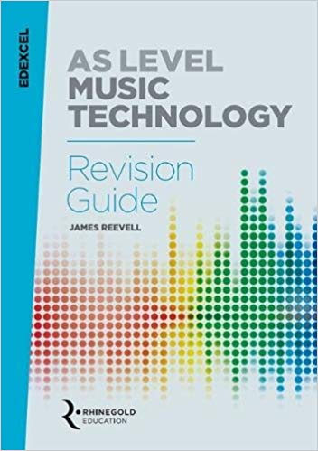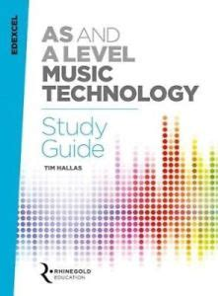

Music Technology A Level Revision Guide by James Reevell

Music Technology A Level Study Guide by Tim Hallas

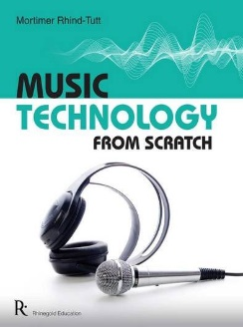



Music Technology from Scratch by Mortimer Rhind-Tutt

Understanding Popular Music by David Ventura

Bringing in instruments

There is an instrument store cupboard that students are welcome to use. The key for this cupboard in kept in the Music office and can be accessed at any time between 8.15am-4.30pm. The college cannot accept responsibility for instruments left in the cupboard and it is advised that you take out instrument insurance. It is not recommended that you leave your instruments in the cupboard for long periods of time without checking on them.

Using studios outside of lessons

You are welcome to use the studios/mastering suite at any point during the college day provided it isn’t being used for lessons. The key for the doors is kept in the Music office and can be accessed at any time between 8.15-4.30pm. Booking sheets are placed on each door. Be aware that towards deadlines the studios become completely booked up so you should try to book well in advance. Please leave studio rooms tidy and completely clear them of all equipment when you leave. **NO EATING OR DRINKING ALLOWED.**

Using practise rooms

You are welcome to use practise rooms at any point during the college day. The key for the practise rooms is kept in the Music office and can be accessed at any time between 8.15-4.30pm. Currently we do not have a booking system for practise rooms as there is almost always one free. If there becomes a problem with availability then a booking system will be instigated. Please leave practise rooms tidy and clear them when you leave. **NO EATING OR DRINKING ALLOWED.**

Music activities & concerts

There are a wide range of music activities and ensembles for students to join. Details of the ensembles running each year will be given to you at the start of September. There will be at least 3 big college concerts each year either held internally or at an external venue. If you are part of a college ensemble, concert dates will be given to you at the start of September. If you are interested in performing a solo in a concert please speak to Paul.

[](http://www.google.co.uk/url?sa=i&rct=j&q=&esrc=s&source=images&cd=&cad=rja&uact=8&ved=0ahUKEwj605SSu9fOAhXEtBoKHWN2BC8QjRwIBw&url=http://dailymusicnewsmag.com/category/drayter/&bvm=bv.129759880,d.ZGg&psig=AFQjCNEDUwvOaJGNXdGQVeut-zKupqEjdQ&ust=1472039081615465)

Rockschool Music practitioners qualification

You may be interested in taking the Rockschool Music Practitioners Qualification course. This is available in your second year at college as an additional study. The course allows you to develop your popular music performance skills in a band setting. There are also opportunities to study live sound engineering and to take responsibility for the sound engineering of the concerts. For more information speak to Dean.

Extra support

If you ever feel like you are struggling on this course, please let us know immediately. We are more than happy to meet with you outside of lessons to help you with your coursework and provide you with extra feedback. There will extra revision sessions in the lead up to the exam for components 3 and 4. Please check your emails for more information.

**50:50 Help and Advice**

Key to your success whilst studying in the Department is the level of effort and work you put into your subjects outside of lessons. The college’s expectation is that you match every hour of class time with an hour of independent study – **50:50**. This will include completing **structured homework** tasks set by your teachers but will also require you to **work independently**; finding ways to consolidate and extend your understanding. To help you to do this, the list below gives some ideas or activities to consider each week.

