# | Question + Solution
1 | Validate y-axis  The Y-Axis needs a presence, type and range check added  GetMoveCoordinate receives input from the user so this is the place to add the presence and type checks.  CheckValidMove validates the numeric coordinate that was entered so this is the place to add the range check.  def GetMoveCoordinates():  X = int(input('Enter x coordinate: '))  Y = int(input('Enter y coordinate: '))  return X, Y  def CheckValidMove(XCoordinate, YCoordinate, Board):  ValidMove = True  # Check x coordinate is valid  if (XCoordinate < 1) or (XCoordinate > 3):  ValidMove = False  return ValidMove  Input for the Y coordinate is converted to an int. So if you hit return without entering a Y value there will be a runtime error as an empty string cannot be converted to an integer.  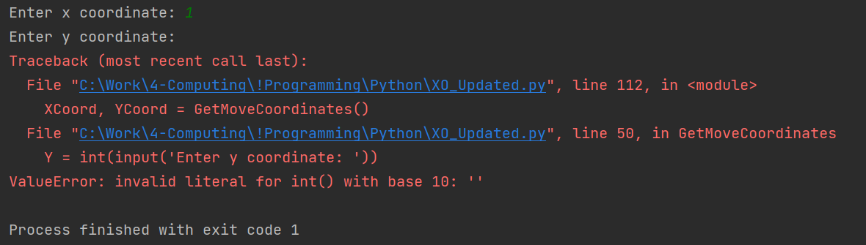  Therefore we need to add presence validation to ensure a value is entered.  We can add a try/except to catch the runtime error and request the user add a value (i.e. do a presence check). It will also do the type, i.e. datatype, validation:  def GetMoveCoordinates():  X = int(input('Enter x coordinate: '))  # 1) add presence and integer type check using try/except  valid = False  while not valid:  try:  Y = int(input('Enter y coordinate: '))  valid = True  except:  print("Please enter a numeric value for Y")  return X, Y  We add the valid boolean variable to ensure that the while loop iterates until the user enters a numeric value for the Y coordinate. Putting the Y = int(input('Enter y coordinate: ')) statement within a try block means that if it succeeds, the valid variable is set to True, so the while loop exits. If it fails then execution steps to the except: label, the error message is printed and the valid boolean variable remains false, so the while loop iterates again. This continues until the user enters an integer value.  While we’re here let’s also add this presence and type check for the X coordinate:  def GetMoveCoordinates():  # 1) add presence and integer type check using try/except  valid = False  while not valid:  try:  X = int(input('Enter x coordinate: '))  valid = True  except:  print("Please enter a numeric value for X")  valid = False  while not valid:  try:  Y = int(input('Enter y coordinate: '))  valid = True  except:  print("Please enter a numeric value for Y")  return X, Y  Now the user is repeatedly asked for X and Y values until until integer ones are input:  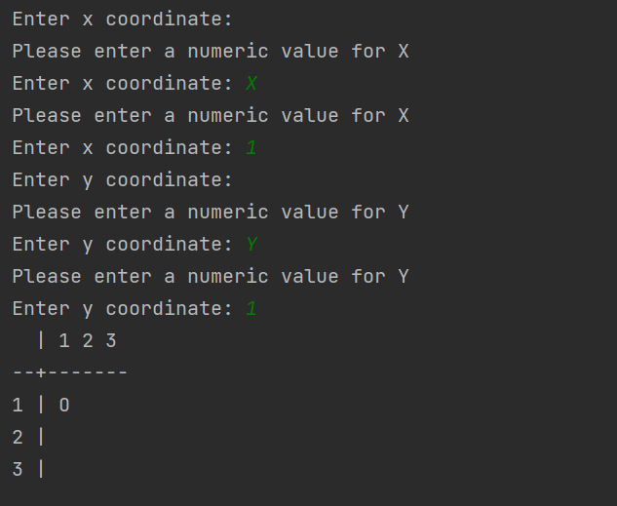  Now to add the range check for the Y coordinate. This is most easily done in the CheckValidMove function in the same way that the X coordinate range check is implemented.  def CheckValidMove(XCoordinate, YCoordinate, Board):  ValidMove = True  # Check x coordinate is valid  if (XCoordinate < 1) or (XCoordinate > 3):  ValidMove = False  # 1) add range check for Y coordinate  elif (YCoordinate < 1) or (YCoordinate > 3):  ValidMove = False  return ValidMove  So, now if the coordinate is less than 1 or greater than 3 (i.e. not between 1 and 3) then the coordinate will fail the range check. Note that the Y range check is added as an elif rather than a new if as there is no point running this branch of the selection if the X coordinate range check fails.  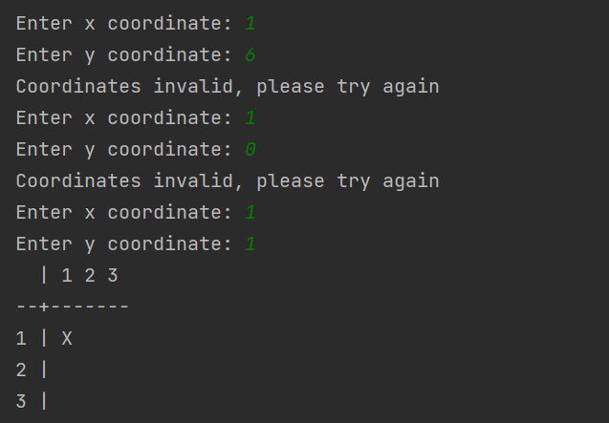
2 | Type/presence check validation on coordinates  and some for the x-axis too  We’ve already done this in 1) above.  However, note that this method of using try/except is perfectly acceptable, but an alternative way to do this is to take the coordinates as string inputs (i.e. do not convert the input to ints) and then simply test that the input is not an empty string and that it contains whole numbers, only (by using the Python isdigit function). This way you can output more specific error messages:  def GetMoveCoordinates():  valid = False  while not valid:  X = input('Enter x coordinate: ')  # 1) presence check  if X == '':  print("You did not input a value!")  # 1) type (integer) check  elif not X.isdigit():  print("You must input a whole number")  else:  valid = True  valid = False  while not valid:  Y = input('Enter y coordinate: ')  # 1) presence check  if Y == '':  print("You did not input a value!")  # 1) type (integer) check  elif not Y.isdigit():  print("You must input a whole number")  else:  valid = True  # 1) string X, Y output as integers  return int(X), int(Y)  With these validations we can be sure that (string) variables X and Y will convert to integers without error so the X and Y string values are returned as integers in the return statement.  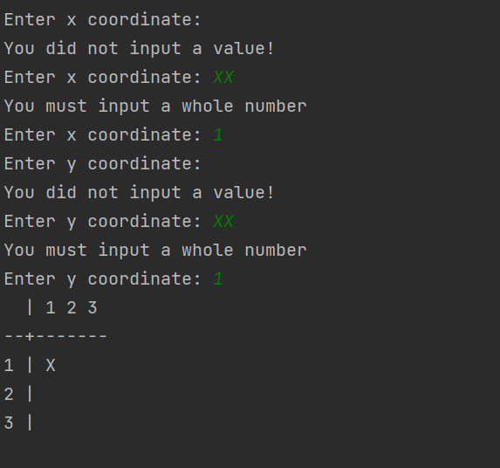
3 | Stop the overwriting of symbols  Currently you can choose a coordinate that already has a symbol  This test shows X added at (1,1) and then overwriting with O by entering I1,1) again:  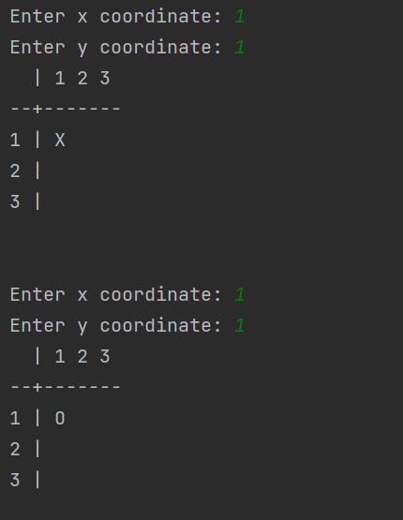  therefore change CheckValidMove and return False (i.e. the move is invalid) if the element in the Board array does not contain a blank string (i.e. it is X or Y). Add as elif rather than a new if because there is no point running this branch of the selection if either of the previous range checks have failed:  def CheckValidMove(XCoordinate, YCoordinate, Board):  ValidMove = True  # Check x coordinate is valid  if (XCoordinate < 1) or (XCoordinate > 3):  ValidMove = False  # 1) add range check for Y coordinate  elif (YCoordinate < 1) or (YCoordinate > 3):  ValidMove = False  # 3) check that the element is empty before allowing a symbol to be placed there  elif Board[XCoordinate][YCoordinate] != ' ':  ValidMove = False  return ValidMove  Now we see an error message when selecting a coordinate already occupied:  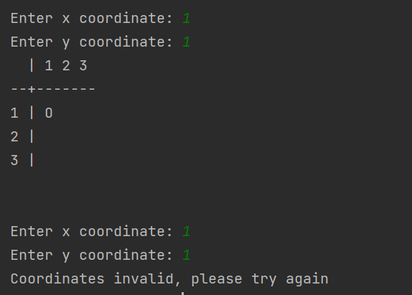
4 | Check diagonal for win  Currently diagonal lines don't win... change the code so they do  A winning line is determined in the CheckXOr0HasWon function. We need to add a couple of extra checks for the diagonals:  def CheckXOr0HasWon(Board):  XOrOHasWon = False  for Column in range(1, 4):  if (Board[Column][1] == Board[Column][2]) and (Board[Column][2] == Board[Column][3]) and (  Board[Column][2] != ' '):  XOrOHasWon = True  for Row in range(1, 4):  if (Board[1][Row] == Board[2][Row]) and (Board[2][Row] == Board[3][Row]) and (Board[2][Row] != ' '):  XOrOHasWon = True  # 4) set 'win' for downward diagonal  if Board[1][1] == Board[2][2] and Board[2][2] == Board[3][3] and Board[2][2] != ' ':  XOrOHasWon = True  # 4) set 'win' for upward diagonal  elif Board[3][1] == Board[2][2] and Board[2][2] == Board[1][3] and Board[2][2] != ' ':  XOrOHasWon = True  return XOrOHasWon  Note that the second diagonal check is added as an elif rather than a new if as there is no point checking this if the first diagonal check for a win succeeded.  Downwards diagonal wins: Board [1][1], [2][2], [3][3]:  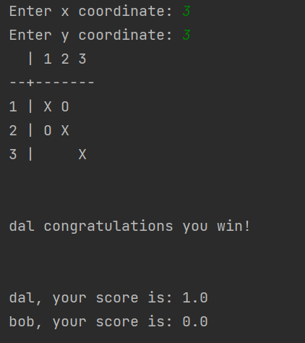  Upwards diagonal wins: [1][3], [2][2], [3][1]  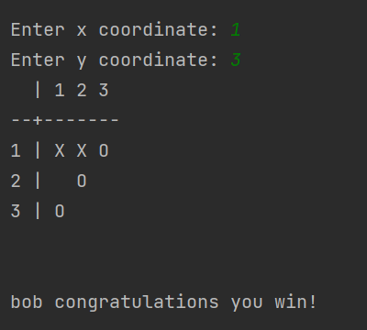
5 | Name the player's go  Have it so the code says it's Bob's turn etc..  Before the player enters their coordinates, output their name by checking the value of CurrentSymbol which contains either the value PlayerOneSymbol or the value PlayerTwoSymbol. If the CurrentSymbol has the same value as PlayerOneSymbol then we know it must be player one’s turn, else it must be player two’s turn. We can get the names from the PlayerOneName and PlayerTwoName variables. Note that the print statement uses “” so that we can output the single apostrophe (‘):  CurrentSymbol = StartSymbol  while (not GameHasBeenWon) and (not GameHasBeenDrawn): # Play until a player wins or the game is drawn  # 5) get player name based on current symbol  if CurrentSymbol == PlayerOneSymbol:  print(PlayerOneName + "'s turn")  else:  print(PlayerTwoName + "'s turn")  ValidMove = False;  while not ValidMove: # Get a valid move  output:  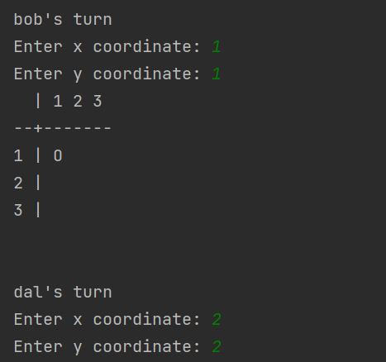
6 | Who is the winner?  The winner isn't named at the moment (just the symbol) add a nice msg naming the winner  Actually, this is already done!  if GameHasBeenWon: # Update scores and display result  if (PlayerOneSymbol == CurrentSymbol):  print(PlayerOneName + " congratulations you win!")  PlayerOneScore += 1  else:  print(PlayerTwoName + " congratulations you win!")  PlayerTwoScore += 1  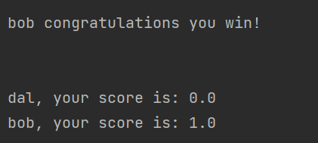
7 | Check both players don't have the same name  Having two players with the same name would be a pain.. validate this out  Currently, the same name can be added for both players:  if __name__ == "__main__":  PlayerOneName = input('What is the name of player one? ')  PlayerTwoName = input('What is the name of player two? ')  So add validation to ensure names are different:  if __name__ == "__main__":  # 7) data validation - ensure player names are different  while PlayerOneName == PlayerTwoName:  PlayerOneName = input('What is the name of player one? ')  PlayerTwoName = input('What is the name of player two? ')  if PlayerOneName == PlayerTwoName:  print("Players' names must be different!\n")  Output:  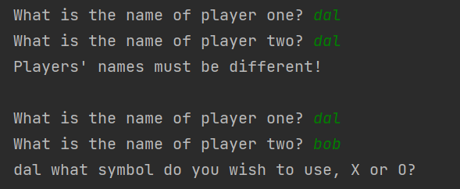
8 | Change the size of the grid  A 4x4 or 5x5 grid would be nice... but it's a surprising amount of work if you have it so 3 in a line wins  The quickest way to do this is to choose a maximum size (e.g. 5x5) , initialise the array accordingly:  Board = [[0, 0, 0, 0, 0, 0],  [0, 0, 0, 0, 0, 0],  [0, 0, 0, 0, 0, 0],  [0, 0, 0, 0, 0, 0],  [0, 0, 0, 0, 0, 0],  [0, 0, 0, 0, 0, 0],  ]  (note that we create a 6x6 array because row 0 and column 0 are not used in the code) and then we ensure that all existing iterations loop to 6 rather than 4, e.g.:  # 8) loop from 1 to 6 to play 5x5 XO  def DisplayBoard(Board):  print(' | 1 2 3 4 5')  print('--+-----------')  for Row in range(1, 6):  print(Row, '|', end=' ')  for Column in range(1, 6):  print(Board[Column][Row], end=' ')  print()  print('\n')  # 8) loop from 1 to 6 to play 5x5 XO  def ClearBoard(Board):  for Row in range(1, 6):  for Column in range(1, 6):  Board[Column][Row] = ' '  Coordinate validation should allow 1 to 5:  def CheckValidMove(XCoordinate, YCoordinate, Board):  ValidMove = True  # Check x coordinate is valid  # 9) validation check now allows coordinate values 1 to 5  if (XCoordinate < 1) or (XCoordinate > 5):  ValidMove = False  # 1) add range check for Y coordinate  elif (YCoordinate < 1) or (YCoordinate > 5):  ValidMove = False  # 3) check that the element is empty before allowing a symbol to be placed there  elif Board[XCoordinate][YCoordinate] != ' ':  ValidMove = False  return ValidMove  Number of moves for a draw becomes 5x5:  if not GameHasBeenWon:  # 8) Updated for 5x5 game  if NoOfMoves == 25: # Check if maximum number of allowed moves has been reached  GameHasBeenDrawn = True  The final and tricky part is checking for three consecutive symbols in the array. Something like the below does the trick. Note that rather than hardcoding to loop to element number 6, I have used variable: sizeOfBoard. This means that it’s easy to extend the game so that the user can input any size of board (e.g. 10) and the game will work. You’d need to intialise the array by using the append method in a loop, make sizeOfBoard a global variable and replace instances of 6 with sizeOfBoard…  def CheckXOr0HasWon(Board):  # 8) new variable SizeOfBoard so can extend if necessary (for 5x5 board)  sizeOfBoard = 5  XOrOHasWon = False  for Row in range(1, sizeOfBoard + 1):  # ...check if 3 consecutive elements across have the same symbol and are not empty  # ensure don't exceed columns by looping to SizeOfBoard - 2  for Column in range(1, sizeOfBoard - 1):  if Board[Column][Row] == Board[Column + 1][Row] and Board[Column][Row] == Board[Column + 2][Row] and Board[Column][Row] != ' ':  XOrOHasWon = True  # for each column...  for Column in range(1, sizeOfBoard + 1):  # ...check if 3 consecutive elements down have the same symbol and are not empty  # ensure don't exceed rows by looping to SizeOfBoard - 2  for Row in range(1, sizeOfBoard - 1):  if Board[Column][Row] == Board[Column][Row + 1] and Board[Column][Row] == Board[Column][Row + 2] and Board[Column][Row] != ' ':  XOrOHasWon = True  # diagonal down - 3 consecutive symbols the same and not empty  for Column in range(1, sizeOfBoard - 1):  for Row in range(1, sizeOfBoard - 1):  if Board[Column][Row] == Board[Column + 1][Row + 1] and Board[Column][Row] == Board[Column + 2][Row + 2] and Board[Column][Row] != ' ':  XOrOHasWon = True  # diagonal up - 3 consecutive symbols the same and not empty  # Row is inverse of Column  for Column in range(1, sizeOfBoard - 1):  for Row in range(3, sizeOfBoard + 1):  if Board[Column][Row] == Board[Column + 1][Row - 1] and Board[Column][Row] == Board[Column + 2][Row - 2] and Board[Column][Row] != ' ':  XOrOHasWon = True  return XOrOHasWon  Output example:  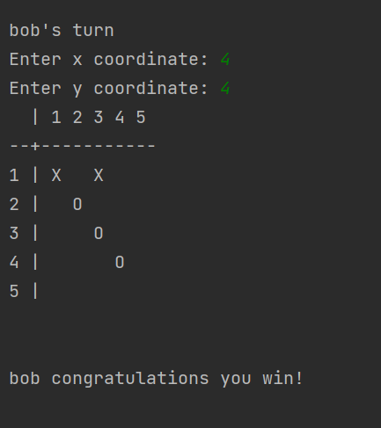
9 | Draw scores both players 0.5 points  Draws don't score at the moment. award each player 0.5 for a draw  Just two additional lines of code needed for this:  else:  print("A draw this time!")  # 9) Add 0.5 to both players' scores if a draw  PlayerOneScore += 0.5  PlayerTwoScore += 0.5  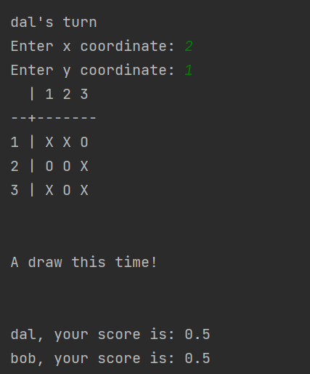
10 | Play the computer (random validated placing of scores)  Random is fairly easy... a player that follows a strategy is trickier but not impossible  First create and initialise a new global variable:  PlayComputer = False  Then determine if the user wishes to play the computer:  if __name__ == "__main__":  # 7) data validation - ensure player names are different  while PlayerOneName == PlayerTwoName:  PlayerOneName = input('What is the name of player one? ')  # 10) Determine if wish to play the computer  playComputer = ''  while playComputer not in ['Y', 'N']:  playComputer = input('Do you wish to play the computer (Y or N)? ').upper()  if playComputer not in ['Y', 'N']:  print('You must input Y or N')  if playComputer == 'Y':  PlayerTwoName = 'Computer'  else:  PlayerTwoName = input('What is the name of player two? ')  if PlayerOneName == PlayerTwoName:  print("Players' names must be different!\n")  if playComputer == 'Y':  PlayComputer = True  Then, when it’s player two’s turn, check if we are playing the computer (which will always be player two), and if so, rather than calling GetMoveCoordinates we call a new function that returns (valid) random coordinates, which we’ll call GetRandomCoordinates:  if CurrentSymbol == PlayerOneSymbol:  print(PlayerOneName + "'s turn")  else:  print(PlayerTwoName + "'s turn")  if PlayComputer and CurrentSymbol == PlayerTwoSymbol:  XCoord, YCoord = GetRandomCoordinates()  else:  ValidMove = False;  while not ValidMove: # Get a valid move  XCoord, YCoord = GetMoveCoordinates()  ValidMove = CheckValidMove(XCoord, YCoord, Board)  if not ValidMove:  print("Coordinates invalid, please try again")  And the function could look something like this:  def GetRandomCoordinates():  valid = False  while not valid:  X = random.randint(1, 3)  Y = random.randint(1, 3)  if Board[X][Y] == ' ':  valid = True  return X, Y  The output will look something like this if we allow the computer to win:  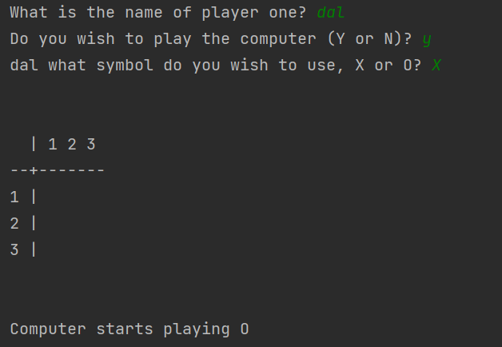  …  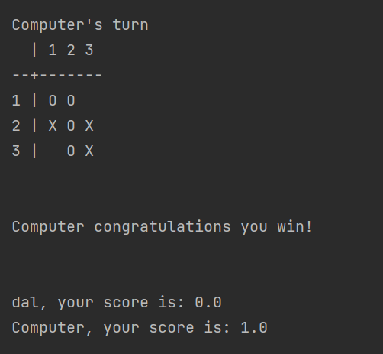  A winning strategy is for the computer to try every possible move that the opponent can make, test if any of them win, and then place a blocking symbol there. This can be extended using recursion to try every move in this way going forward, and weighting winning moves. Check out this video to see how this would work : https://www.youtube.com/watch?v=trKjYdBASyQ
11 | Place the section of code where the players enter their names in a separate procedure, with the appropriate parameters passed-in.  Don't fully factorize the code.. but have a go at a new procedure called EnterPlayerName  So, the part of the code which collects and validates the player names could to put into its own procedure like so:  def EnterPlayerName():  playerOneName = ''  playerTwoName = ''  playingComputer = False  while playerOneName == playerTwoName:  playerOneName = input('What is the name of player one? ')  # 10) Determine if wish to play the computer  playComputer = ''  while playComputer not in ['Y', 'N']:  playComputer = input('Do you wish to play the computer (Y or N)? ').upper()  if playComputer not in ['Y', 'N']:  print('You must input Y or N')  if playComputer == 'Y':  playerTwoName = 'Computer'  else:  playerTwoName = input('What is the name of player two? ')  if playerOneName == playerTwoName:  print("Players' names must be different!\n")  if playComputer == 'Y':  playingComputer = True  return playerOneName, playerTwoName, playingComputer  and call this new function at the start of the program execution:  if __name__ == "__main__":  PlayerOneName, PlayerTwoName, PlayComputer = EnterPlayerName()  Note that we could pass in PlayerOneName, PlayerTwoName and PlayComputer global variables as parameters to this function but it’s not necessary. Also, I have created local variables playerOneName, playerTwoName and playingComputer (by changing the case of the first character these are new variables) so as not to get them confused with the global variables.
12 | Convert Symbol to uppercase automatically if user inputs lowercase x or o  Rather than validate the X O choice just convert it to upper case  For this we use the upper function/method to convert a string to upper case, so the code:  while PlayerOneSymbol not in ['X', 'O']:  # Choose player one's symbol  PlayerOneSymbol = input(PlayerOneName + ' what symbol do you wish to use, X or O? ')  if PlayerOneSymbol not in ['X', 'O']:  print('Symbol to play must be uppercase X or O')  becomes:  while PlayerOneSymbol not in ['X', 'O']:  # Choose player one's symbol  PlayerOneSymbol = input(PlayerOneName + ' what symbol do you wish to use, X or O? ').upper()  if PlayerOneSymbol not in ['X', 'O']:  print('Symbol to play must be X or O')  We’ve removed the ‘uppercase’ part of the error message as that’s nolonger required:  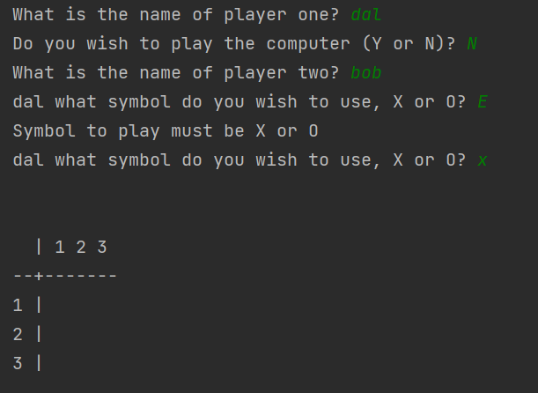

The full code:
# Skeleton Program Code for AQA Comp1 Summer 2010 Examination
# this code should be used in conjunction with the Preliminary
# Materials
# written by the AQA COMP1 Programmer Team
# developed using Python v3.0
import random
Board = [[0, 0, 0, 0, 0, 0],
[0, 0, 0, 0, 0, 0],
[0, 0, 0, 0, 0, 0],
[0, 0, 0, 0, 0, 0],
[0, 0, 0, 0, 0, 0],
[0, 0, 0, 0, 0, 0],
]
PlayerOneName = ""
PlayerTwoName = ""
XCoord = 0
YCoord = 0
NoOfMoves = 0
ValidMove = False
GameHasBeenWon = False
GameHasBeenDrawn = False
CurrentSymbol = ''
StartSymbol = ''
PlayerOneSymbol = ''
PlayerTwoSymbol = ''
Answer = ''
PlayerOneScore = 0.0
PlayerTwoScore = 0.0
PlayComputer = False
# 8) loop from 1 to 6 to play 5x5 XO
def DisplayBoard(Board):
print(' | 1 2 3 4 5')
print('--+-----------')
for Row in range(1, 6):
print(Row, '|', end=' ')
for Column in range(1, 6):
print(Board[Column][Row], end=' ')
print()
print('\n')
# 8) loop from 1 to 6 to play 5x5 XO
def ClearBoard(Board):
for Row in range(1, 6):
for Column in range(1, 6):
Board[Column][Row] = ' '
def CheckValidMove(XCoordinate, YCoordinate, Board):
ValidMove = True
# Check x coordinate is valid
if (XCoordinate < 1) or (XCoordinate > 5):
ValidMove = False
# 1) add range check for Y coordinate
elif (YCoordinate < 1) or (YCoordinate > 5):
ValidMove = False
# 3) check that the element is empty before allowing a symbol to be placed there
elif Board[XCoordinate][YCoordinate] != ' ':
ValidMove = False
return ValidMove
def GetMoveCoordinates():
valid = False
while not valid:
X = input('Enter x coordinate: ')
# 1) presence check
if X == '':
print("You did not input a value!")
# 1) type (integer) check
elif not X.isdigit():
print("You must input a whole number")
else:
valid = True
valid = False
while not valid:
Y = input('Enter y coordinate: ')
# 1) presence check
if Y == '':
print("You did not input a value!")
# 1) type (integer) check
elif not Y.isdigit():
print("You must input a whole number")
else:
valid = True
# 1) string X, Y output as integers
return int(X), int(Y)
def GetRandomCoordinates():
valid = False
while not valid:
X = random.randint(1, 5)
Y = random.randint(1, 5)
if Board[X][Y] == ' ':
valid = True
return X, Y
def CheckXOr0HasWon(Board):
# 10) new variable SizeOfBoard so can extend if necessary
sizeOfBoard = 5
XOrOHasWon = False
for Row in range(1, sizeOfBoard + 1):
# ...check if 3 consecutive elements across have the same symbol and are not empty
# ensure don't exceed columns by looping to SizeOfBoard - 2
for Column in range(1, sizeOfBoard - 1):
if Board[Column][Row] == Board[Column + 1][Row] and Board[Column][Row] == Board[Column + 2][Row] and Board[Column][Row] != ' ':
XOrOHasWon = True
# for each column...
for Column in range(1, sizeOfBoard + 1):
# ...check if 3 consecutive elements down have the same symbol and are not empty
# ensure don't exceed rows by looping to SizeOfBoard - 2
for Row in range(1, sizeOfBoard - 1):
if Board[Column][Row] == Board[Column][Row + 1] and Board[Column][Row] == Board[Column][Row + 2] and Board[Column][Row] != ' ':
XOrOHasWon = True
# diagonal down - 3 consecutive symbols the same and not empty
for Column in range(1, sizeOfBoard - 1):
for Row in range(1, sizeOfBoard - 1):
if Board[Column][Row] == Board[Column + 1][Row + 1] and Board[Column][Row] == Board[Column + 2][Row + 2] and Board[Column][Row] != ' ':
XOrOHasWon = True
# diagonal up - 3 consecutive symbols the same and not empty
# Row is inverse of Column
for Column in range(1, sizeOfBoard - 1):
for Row in range(3, sizeOfBoard + 1):
if Board[Column][Row] == Board[Column + 1][Row - 1] and Board[Column][Row] == Board[Column + 2][Row - 2] and Board[Column][Row] != ' ':
XOrOHasWon = True
return XOrOHasWon
def GetWhoStarts():
RandomNo = random.randint(0, 100)
if (RandomNo % 2) == 0:
WhoStarts = 'X'
else:
WhoStarts = 'O'
return WhoStarts
def EnterPlayerName():
playerOneName = ''
playerTwoName = ''
playingComputer = False
while playerOneName == playerTwoName:
playerOneName = input('What is the name of player one? ')
# 10) Determine if wish to play the computer
playComputer = ''
while playComputer not in ['Y', 'N']:
playComputer = input('Do you wish to play the computer (Y or N)? ').upper()
if playComputer not in ['Y', 'N']:
print('You must input Y or N')
if playComputer == 'Y':
playerTwoName = 'Computer'
else:
playerTwoName = input('What is the name of player two? ')
if playerOneName == playerTwoName:
print("Players' names must be different!\n")
if playComputer == 'Y':
playingComputer = True
return playerOneName, playerTwoName, playingComputer
if __name__ == "__main__":
PlayerOneName, PlayerTwoName, PlayComputer = EnterPlayerName()
while PlayerOneSymbol not in ['X', 'O']:
# Choose player one's symbol
PlayerOneSymbol = input(PlayerOneName + ' what symbol do you wish to use, X or O? ').upper()
if PlayerOneSymbol not in ['X', 'O']:
print('Symbol to play must be X or O')
if PlayerOneSymbol == 'X':
PlayerTwoSymbol = 'O'
else:
PlayerTwoSymbol = 'X'
StartSymbol = GetWhoStarts()
while Answer not in ['N', 'n']: # Play a game
NoOfMoves = 0;
GameHasBeenDrawn = False;
GameHasBeenWon = False;
ClearBoard(Board);
print("\n")
DisplayBoard(Board);
if StartSymbol == PlayerOneSymbol:
print(PlayerOneName + " starts playing " + StartSymbol)
else:
print(PlayerTwoName + " starts playing " + StartSymbol)
print("\n")
CurrentSymbol = StartSymbol
while (not GameHasBeenWon) and (not GameHasBeenDrawn): # Play until a player wins or the game is drawn
# 5) get player name based on current symbol
if CurrentSymbol == PlayerOneSymbol:
print(PlayerOneName + "'s turn")
else:
print(PlayerTwoName + "'s turn")
if PlayComputer and CurrentSymbol == PlayerTwoSymbol:
XCoord, YCoord = GetRandomCoordinates()
else:
ValidMove = False;
while not ValidMove: # Get a valid move
XCoord, YCoord = GetMoveCoordinates()
ValidMove = CheckValidMove(XCoord, YCoord, Board)
if not ValidMove:
print("Coordinates invalid, please try again")
Board[XCoord][YCoord] = CurrentSymbol
DisplayBoard(Board)
GameHasBeenWon = CheckXOr0HasWon(Board)
NoOfMoves += 1
if not GameHasBeenWon:
# 8) Updated for 5x5 game
if NoOfMoves == 25: # Check if maximum number of allowed moves has been reached
GameHasBeenDrawn = True
else:
if (CurrentSymbol == 'X'):
CurrentSymbol = 'O'
else:
CurrentSymbol = 'X'
if GameHasBeenWon: # Update scores and display result
if (PlayerOneSymbol == CurrentSymbol):
print(PlayerOneName + " congratulations you win!")
PlayerOneScore += 1
else:
print(PlayerTwoName + " congratulations you win!")
PlayerTwoScore += 1
else:
print("A draw this time!")
# 9) Add 0.5 to both players' scores if a draw
PlayerOneScore += 0.5
PlayerTwoScore += 0.5
print("\n")
print(PlayerOneName + ", your score is: " + str(PlayerOneScore))
print(PlayerTwoName + ", your score is: " + str(PlayerTwoScore))
print();
if (StartSymbol == PlayerOneSymbol):
StartSymbol = PlayerTwoSymbol
else:
StartSymbol = PlayerOneSymbol;
Answer = input("Another game Y/N? ")

