# Lesson 7: Promoting the wellbeing of children

This lesson will explore the welfare requirements that early years settings must adhere to so that they can support children’s wellbeing.

|  |  |
| --- | --- |
| **Learning outcomes** |  |
| By the end of the lesson, you must be able to:   * **Define** children’s wellbeing. * **Describe** how early years settings can support children’s wellbeing.   You may also be able to:   * **Explain** how children’s wellbeing relates to their ability to learn and develop. | |

## What do we mean by wellbeing?

is …….

**Wellbeing means “the state of being comfortable, healthy, or happy.”**

This is what the Oxford English Dictionary defines as wellbeing.

What one person feels is their perfect state of wellbeing may be completely different to another person. We are all individuals and have different goals, ambitions and personalities so our wellbeing and how we feel depends on many factors.

**Here are some areas that relate to children’s wellbeing**

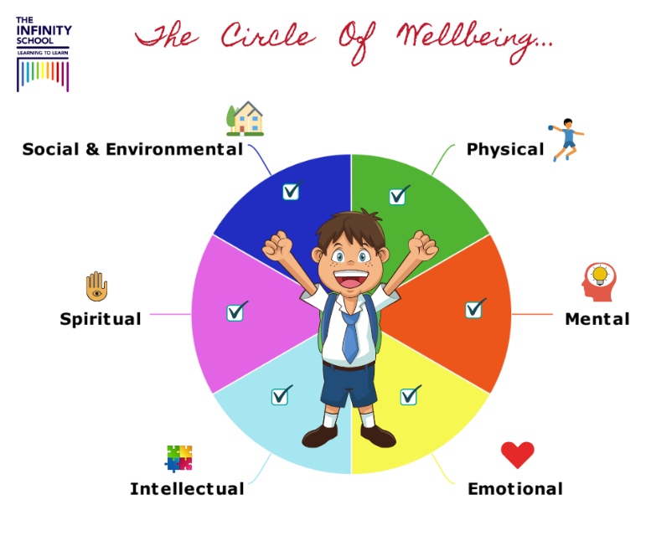

**Wellbeing is the way that a child feels physically and mentally. In early years a child’s wellbeing is referred to as ‘the welfare of the child.’**

The Children Act 1989 says that the welfare of the child is paramount. This means that ensuring children’s wellbeing is maintained is vital.

|  |  |
| --- | --- |
| **Activity: Wellbeing Questions** |  |
| **What do we mean by wellbeing?** | |
|  | |
| **List five ways that a child’s wellbeing can be affected?** | |
|  | |
| **If working with children list how you could support their daily wellbeing?** | |
|  | |

Class Feedback

## Welfare in the EYFS

The EYFS states that “Children learn best when they are healthy, safe and secure, when their individual needs are met, and when they have positive relationships with the adults caring for them.”

If children’s welfare is not prioritised it can prevent children from learning and developing to their full potential.

This is why the EYFS outlines how to meet children’s welfare (wellbeing needs).

**The EYFS outlines expectations for children’s welfare including the following categories:**

1. Health.
2. Accidents and injuries.
3. Managing behaviour.
4. Safety of the environment.
5. Safeguarding.

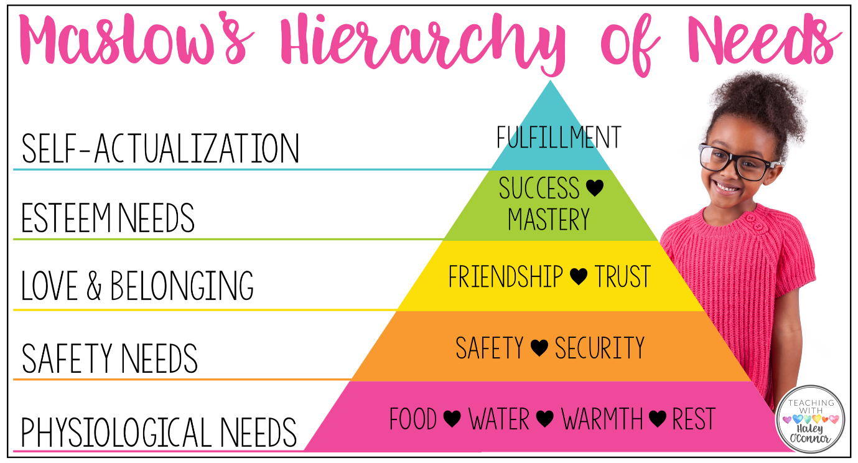

Abraham Maslow was a theorist who identified that ALL human being have five different types of needs, as shown above.

|  |  |
| --- | --- |
| **Activity: Meeting the welfare requirements** |  |
| * You will be allocated a category of welfare. * Consider what an early years setting might need to do to ensure the welfare of the child is protected within this category. | |
| **Allocated category of welfare:** | |
|  | |
| What does an early years setting need to ensure the welfare of the child is protected within this category? | |
|  | |

Early years settings can help support a child’s welfare by ensuring that they follow the suggestions below:

**Health:**

* Keep everything clean and hygienic to prevent the spread of infection.
* Have a policy on how to deal with an ill child and how to administer medicine.
* Provide children with access to drinking water at all times.
* Provide a healthy menu for settings that provide meals and snacks.

**Accidents and injuries:**

* Ensure staff are trained to provide first aid.
* Have a first aid box available on the premises.
* Have a policy for dealing with accidents and injuries, including informing parents and carers.
* Record accidents and injuries to reduce future risks.

**Managing behaviour:**

* Do not use any punishment that could affect a child’s wellbeing in a negative way.
* Support children to self-regulate through co-regulation.
* Have a policy to provide guidance on how to respond to challenging behaviour.

**Safety of the environment:**

* Complete a risk assessment to identify any potential hazards and risks.
* Put actions in place to reduce the identified risks.
* Keep doors locked so children can’t wander off and visitors can’t get in without supervision.
* Ensure resources are age and stage appropriate.
* Supervise children at all times.

**Safeguarding:**

* Train staff to identify concerns and respond appropriately to keep children safe from harm.
* Follow statutory guidance such as Working Together to Safeguard Children 2018, Prevent Duty Guidance for England and Wales and Keeping Children Safe in Education 2021.
* Have a policy and procedure for safeguarding.
* Make sure staff have a clear DBS check.

|  |  |
| --- | --- |
| **Key term** |  |
| **Wellbeing:** the way a child feels physically and mentally. | |

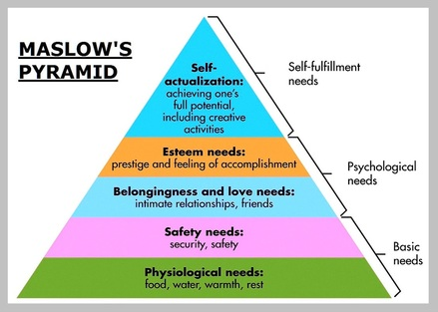

| **Progress check** |  |
| --- | --- |
| Fill in the gaps.   1. Wellbeing is the way children feel _________________ and mentally. 2. Working together to Safeguard Children was most recently updated in ________. 3. Early years practitioners can support children to self-regulate through __________________. 4. It is important to keep doors ______________. 5. Children must always be given access to _________________. 6. In case of accidents, settings must have a ____________________ on the premises. 7. What are Maslow’s Basic Needs: ____________________ and ___________ 8. What are Maslow’s 3 other needs: _______________, _______________ and ________________________ | |

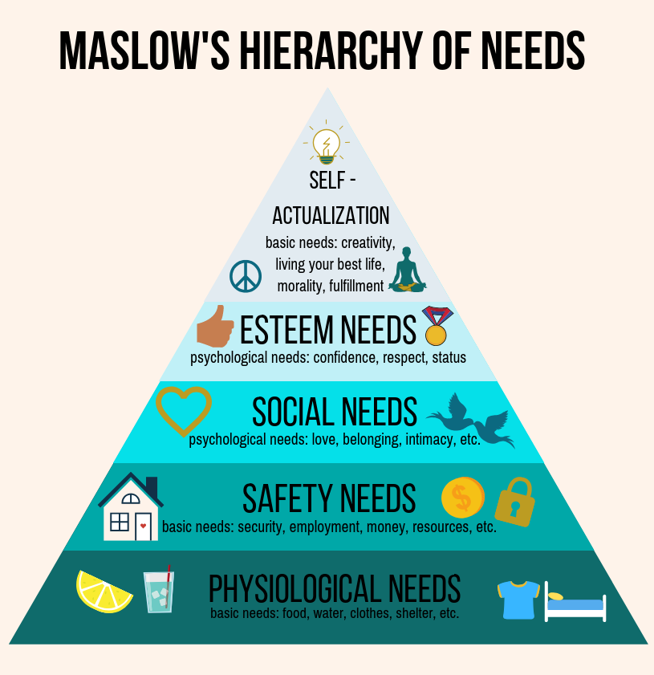

|  |  |
| --- | --- |
| **Home study: Welfare research** |  |
| Read the **welfare section** of the EYFS.  **Early years foundation stage (EYFS) statutory framework:**  <https://www.gov.uk/government/publications/early-years-foundation-stage-framework--2>  (Accessed November 2022)  Make a note of anything you think is interesting or useful for an early years practitioner. | |
|  | |

|  |  |
| --- | --- |
| **Additional resources** |  |
| These websites can help you understand how to keep children safe.  **Working together to safeguard children guidance document:** <https://www.gov.uk/government/publications/working-together-to-safeguard-children--2>  (Accessed November 2022)  **Revised Prevent duty guidance: for England and Wales:** <https://www.gov.uk/government/publications/prevent-duty-guidance/revised-prevent-duty-guidance-for-england-and-wales>  (Accessed November 2022)  **Keeping children safe in education guidance document:** <https://www.gov.uk/government/publications/keeping-children-safe-in-education--2>  (Accessed November 2022) | |

# Lesson 8: Variation in early years provision

This lesson will look at the differences between settings and how these might influence parental options and availability of provision for children and their families.

|  |  |
| --- | --- |
| **Learning outcomes** |  |
| By the end of the lesson, you must be able to:   * **Identify** factors that can vary across early years provision. * **Provide specific examples** of the varying factors within early years provision.   You may also be able to:   * **Explain** how these variations across early years settings can affect parental choice. | |

Although all early years settings must follow the EYFS statutory guidance, there are still variations to the childcare offered.

|  |  |
| --- | --- |
| **Activity: How do settings differ?** |  |
| Although early years settings MUST follow the EYFS Statutory Guidance, there are variations (differences) in what they can offer to children and families.  Read through the list of variations that parents and families may find when they are looking for childcare in their local area:  Then answer the questions below: | |

Here are some variations to childcare settings that parents may be looking at for their children to attend:

**Accessibility to the setting:**

* Cost.
* Eligibility and admissions criteria.
* Location.
* Opening times.

**Capacity of the setting:**

* Number of children.
* Ratio of staff to children.
* Flexibility.

**Facilities of the setting:**

* Indoor environment.
* Outdoor environment.
* Resources.

**Approach of the setting:**

* To learning activities.
* Policies.
* Procedures.

|  |  |
| --- | --- |
| **Activity: QUESTIONS about variations** |  |

## 

## What are the 4 categories of variations to childcare settings that parents need to be aware of?

1. What cost variations could there be?
2. How can learning activities vary?
3. What are the ratios of staff to children for these age groups:

Under 2 years

2 years old

3 years and over

## The impact of variation

The variations can help parents to make decisions about which setting they want their child to attend and can also restrict access for some parents to particular settings.

Let’s look at how the variations can influence parental choices and options.

|  |  |
| --- | --- |
| **Activity 2: Parental options and availability of provision** |  |
| In small groups you will be allocated one of the following variations:   * Accessibility. * Capacity. * Facilities. * Approach.   Discuss how these factors might influence parental options and the availability of childcare provision. | |
| **Allocated variation:** | |
|  | |
| **Influence on parental options and availability of childcare provision:** | |
|  | |

Did you identify some of these potential impacts?

**Accessibility to the setting:**

* **Cost** – Can they afford the fees if they don’t get funding? Does the setting offer a discount for more than one sibling? Do they pay for holidays?
* **Eligibility and admissions criteria** – How soon can children start? Do they meet the admissions criteria – local to the area, special needs, sibling in the school? Are they the age that is accepted? Are they eligible for funded places?
* **Location –** Is the setting easy for parents to get to? Is it easy for other relatives to collect the child? Is there access by public transport?
* **Opening times** – Do the times suit the parents’ needs – for example, working hours? Is the setting term time only or are they available in the school holidays?

**Capacity of the setting:**

* **Number of children –** Is it a large setting that can accept a lot of children or is it limited to small numbers?
* **Ratio of staff to children –** How many children does each adult look after? The EYFS has stated ratios, but some settings might have more staff to provide more personal care.
* **Flexibility –** Is the setting big enough to be flexible on the days and hours children attend if a parent does shift work or is space limited and therefore change of days/times is not always possible?

**Facilities of the setting:**

* **Indoor environment** – What resources and activities do they offer? Is it cosy and welcoming? Does it look well cared for or is it run-down?
* **Outdoor environment** – Is there a safe outdoor space? What resources are there? How often do children have access to this area? What are the alternatives if there is no outdoor space?
* **Resources** – Do they have a wide range of resources? Are they natural or plastic? Are they age and stage appropriate? Do they look well looked after?

**Approach of the setting:**

* **To learning activities** – How does the setting support children’s learning and development? Is it an adult-led setting or child-initiated setting or a combination? Do children have access to all resources all the time?
* **Policies** – Does the setting have clear expectations identified in policies so that parents know what will happen in certain situations? for example If a child has special needs, the parents are likely to want to read the SEND policy to see how their child will be supported.
* **Procedures** – Does the setting have certain routines that everyone follows? What happens if a child is ill? Will the setting allow children to have medicines if needed?

| **Progress check** |  |
| --- | --- |
| Read the case study:  ABC Nursery is a large setting in a city centre. It accepts children from six weeks upwards. It has no outdoor facilities, but they take the children to the local park regularly. It offers early years funding for two-year-olds upwards.  **Which factors could influence parental choice and availability of provision?** | |
|  | |

|  |  |  |
| --- | --- | --- |
| **Learning recap** | |  |
| Can you now: | | |
|  | **Identify** factors that can vary across early years provision. | |
|  | **Provide specific examples** of the varying factors within early years provision. | |
|  | **Explain** how these variations across early years settings can affect parental choice. | |

# Lesson 9: Ofsted

This lesson will look at Ofsted inspections for early years settings and how these identify variation across the settings to help support parental choice and maintain high quality provision.

|  |  |
| --- | --- |
| **Learning outcomes** |  |
| By the end of the lesson, you must be able to:   * **Identify** the different judgements that Ofsted can make about early years provision. * **Describe** the areas of judgements.   You may also be able to:   * **Explain** how this may influence parental choice and accessibility for children. | |

|  |  |
| --- | --- |
| **Starter activity: Purpose of Ofsted in early years** |  |
| **What does OFSTED stand for?** | |
| Work in pairs to discuss and read the information on the next page.  **What are the 3 main roles of Ofsted?** | |
| **Give 3 reasons why Ofsted will inspect an early years setting?** | |

## Ofsted

Ofsted is a department of the UK government. Ofsted inspect services that provide education and skills for learners of all ages. Ofsted also inspect and regulate services that care for children and young people ([www.gov.uk](http://www.gov.uk))

**Ofsted is the Office for Standards in Education, Children’s Services and Skills.**

**Ofsted have 3 main roles:**

1. **Inspect** (visit and inspect the quality of the provision at least once every 6 years)
2. **Regulate** (make sure the service is suitable for children)
3. **Report** (publish and report on their findings)

**Ofsted might inspect an early years setting for the following reasons?**

* To check that the setting is following the statutory framework.
* To make sure children are well looked after and kept safe.
* To make sure children have opportunities to learn and develop.
* To provide feedback for parents and carers on the quality of the setting to support them to make choices about which setting to access.

**Ofsted will grade a school or early setting on a four-point scale:**

* Grade 1: Outstanding.
* Grade 2: Good.
* Grade 3: Requires improvement.
* Grade 4: Inadequate.

**Most early years settings have to register with Ofsted and only a few do not need to register.**

Those that do not need to register include:

* Settings that look after children for less than two hours per day.
* Creches that look after children for less than four hours and the parents stay nearby. There must be no long-term plan to look after the child regularly – If they look after the child regularly, they need to register.

|  |  |
| --- | --- |
| **Reflective question** |  |
| Can you identify the four Ofsted judgements that settings can receive following an inspection?  1. | |
| 2. | |
| 3. | |
| 4. | |

|  |  |
| --- | --- |
| **Ofsted research** |  |
| Go to the Ofsted website and choose a report to read from your local area.  Ofsted website, Find an inspection report: <https://reports.ofsted.gov.uk/>  Click on “childcare and early education” and then put in your home post code. You can choose any of the reports to read.  **What do Ofsted look at during an inspection in an early years setting?** | |
|  | |

## Focus of inspections

Share some of your findings about Ofsted from your home study task in the previous lesson.

Did you identify what types of factors are inspected?

Do you agree they might inspect:

* The environment in which children are looked after.
* The resources and activities available for children.
* The way children and staff interact with each other.
* How well children learn and develop.
* How children are valued and respected.
* If the setting is following the requirements of the EYFS statutory framework.
* If children are kept safe.
* If children’s needs are being met across all areas of development.

All factors within the early years Ofsted inspection will fit into one of 4 categories:

* Quality of education.
* Behaviour and attitudes.
* Personal development.
* Leadership and management.

|  |  |
| --- | --- |
| **Activity: Making judgements** |  |
| Work in pairs to sort these statements into categories of judgements.  Tick the correct box. | |
| | **Statement** | **Quality of education** | **Behaviour and attitudes** | **Personal development** | **Leadership and management** | | --- | --- | --- | --- | --- | | Practitioners use assessment to check children’s progress. |  |  |  |  | | Children have a key person who forms a strong relationship with them to support their wellbeing. |  |  |  |  | | The setting has strong shared values, policies, and practice. |  |  |  |  | | The curriculum meets the needs of all children, including those with special needs and disadvantaged backgrounds. |  |  |  |  | | Practitioners engage in high quality professional development activities. |  |  |  |  | | Children are confident in social situations. |  |  |  |  | | Practitioners teach children to take appropriate risks and face challenges positively. |  |  |  |  | | Leaders ensure the setting’s policies and procedures are followed consistently. |  |  |  |  | | Learning starts with what children already know and builds upon that knowledge. |  |  |  |  | | Children are starting to self-regulate and demonstrate positive behaviour. |  |  |  |  | | Children access a wide range of new experiences and are encouraged to follow their personal interests. |  |  |  |  | | Safeguarding is effective. |  |  |  |  | | Children show respect towards others. |  |  |  |  | | Equality and diversity is promoted and children are taught about British values. |  |  |  |  | | The activities and resources are planned and implemented to support children to learn and develop across the 7 areas of learning and development. |  |  |  |  | | Children are motivated and keen to try new things. |  |  |  |  | | |

**Quality of education:**

* The activities and resources are planned and implemented to support children to learn and develop across the 7 areas of learning and development.
* Learning starts with what children already know and builds upon that knowledge.
* The curriculum meets the needs of all children, including those with special needs and disadvantaged backgrounds.
* Practitioners use assessment to check children’s progress.

**Behaviour and attitudes:**

* Children are confident in social situations.
* Children show respect towards others.
* Children are motivated and keen to try new things.
* Children are starting to self-regulate and demonstrate positive behaviour.

**Personal development:**

* Children access a wide range of new experiences and are encouraged to follow their personal interests.
* Children have a key person who forms a strong relationship with them to support their wellbeing.
* Practitioners teach children to take appropriate risks and face challenges positively.
* Equality and diversity is promoted and children are taught about British values.

**Leadership and management:**

* The setting has strong shared values, policies, and practice.
* Practitioners engage in high quality professional development activities.
* Leaders ensure the setting’s policies and procedures are followed consistently.
* Safeguarding is effective.

## Impact of Ofsted judgements

The outcome of an Ofsted inspection will identify variance between early years settings through the judgements that are made.

**Outstanding and good judgements:**

* These settings are likely to be more popular as parent’s want their child to receive outstanding or good care and education.
* This will possibly make it harder to access as demand for places will be high.
* It may attract more experienced staff as they know there will be high quality leadership and development opportunities.

**Requires improvement and inadequate judgements:**

* These settings may be less popular are parents may be concerned about the quality of care and education.
* It may be easier to access these settings if there is less demand for places.
* If inadequate settings do not improve, they may not be able to offer funded places for three–four-year-olds and eligible two year olds.
* The judgement may not make any difference to the choices parents make if they are more concerned about factors such as location and cost.

| **Progress check** |  |
| --- | --- |
| 1. Name the **four** Ofsted judgements. | |
| 1. What are the **four** categories that settings are judged against? | |
| 1. Name **two** ways that Ofsted judgements might affect parental choice or accessibility to early years settings. | |

|  |  |  |
| --- | --- | --- |
| **Learning recap** | |  |
| Can you now: | | |
|  | **Identify** the different judgements that Ofsted can make about early years provision. | |
|  | **Describe** the areas of judgements. | |
|  | **Explain** how this may influence parental choice and accessibility for children. | |

|  |  |
| --- | --- |
| **Additional resources** |  |
| More information about Ofsted can be found in the Early Years inspection handbook for Ofsted-registered provision.  **Early years inspection handbook:** <https://www.gov.uk/government/publications/early-years-inspection-handbook-eif>  (Accessed November 2022) | |