|  |  |  |  |  |  |
| --- | --- | --- | --- | --- | --- |
| **Name:** |  | **Student No.:** |  | **Tutor Group:** |  |

**Organisation**

**Quick Activity**

In the arrow boxes below, make a note of (a) all the things you will need to have with you every day in your bag, and (b) all the things you might need to have available at home to help you study. Try to come up with at least seven items for each scenario.

[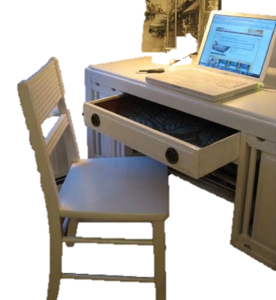](http://www.google.co.uk/url?sa=i&rct=j&q=&esrc=s&frm=1&source=images&cd=&cad=rja&uact=8&ved=0CAcQjRw&url=http://decorationchannel.com/bedroom/best-bedroom-desk-design/&ei=ZCs-VbnZMIK1Uc6_geAN&bvm=bv.91665533,d.d2s&psig=AFQjCNHTqB6bgmHAxv92muVLiWxi3m3Few&ust=1430224082181037)

[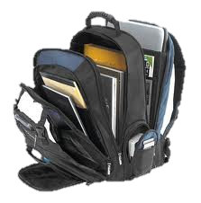](http://www.google.co.uk/url?sa=i&rct=j&q=&esrc=s&frm=1&source=images&cd=&cad=rja&uact=8&ved=0CAcQjRw&url=http://indianapolis-6914-39.gucci-menghuan2013.biz/&ei=SSo-VcHYOYPpUvzygPAM&bvm=bv.91665533,d.d2s&psig=AFQjCNGLF7Zv21objSwzvDw30VMmTGLYUw&ust=1430223815665579)

**A**

**B**

*Remember, College has a lot of student study space with access to computers, photocopiers, printers, and scanners if you do not have access to these at home.