Name: |  | Student No.: |  | Tutor Group:

Revision & Exam Technique - Quick Activity

1. How did you revise for your last set of exams/tests (e.g. GCSEs, benchmark assessments, etc.)?
(If you didn’t revise, note that down too!)

2. What sort of ‘brain’ did the Memory Style test say you have? (tick all that apply)
You like to learn by using:
Recency
Primacy
Sound
Locus
Real Names
Visual Features
Visual arrangement
Visual association
Semantic association
Being bizarre and unusual
Stories
Colour and activity
Musical association
Other:
No clear strategy

3. Are you a visual, auditory or kinaesthetic learner? (tick all that apply)
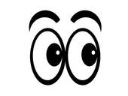  Visual | 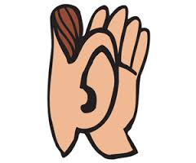  Auditory |   Kinaesthetic

4. What revision method(s) do you think you will now try to use for each of your subjects and why?
(You do not have to choose exclusively from the suggested list in this module, and you can suggest more than one for each subject.)

Subject | Revision method(s) | Why might this work best?

